**ASSIGNMENT-5**

Input: input.csv

Bob,likes,Alice  
Bob,likes,David  
Charlie,likes,Bob  
Charlie,likes,Fran  
David,likes,Alice  
Ed,likes,Bob  
Ed,likes,Charlie  
Ed,likes,Fran

The idea is to find the relation, that is who likes whom.

**Output:**

**Vertices:**

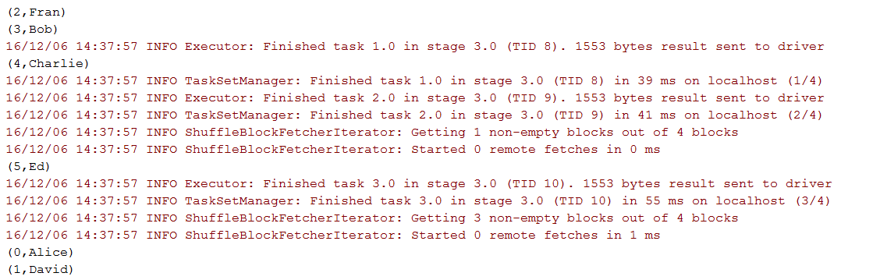

**Edges:**

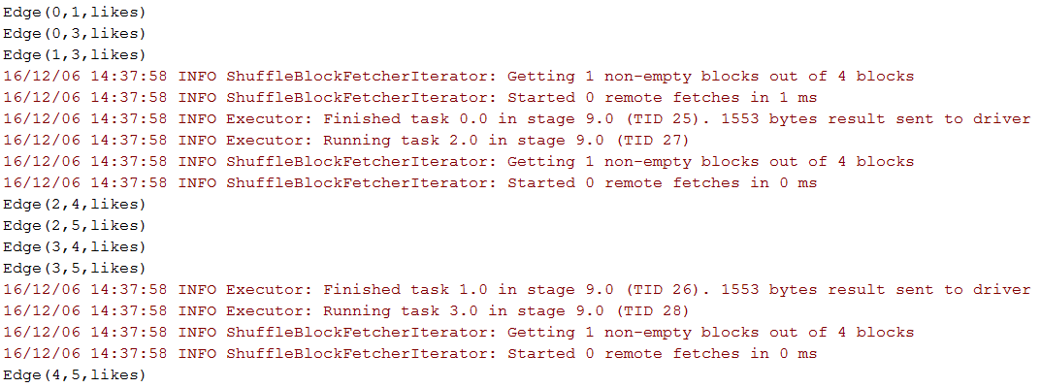

**Page Rank:**

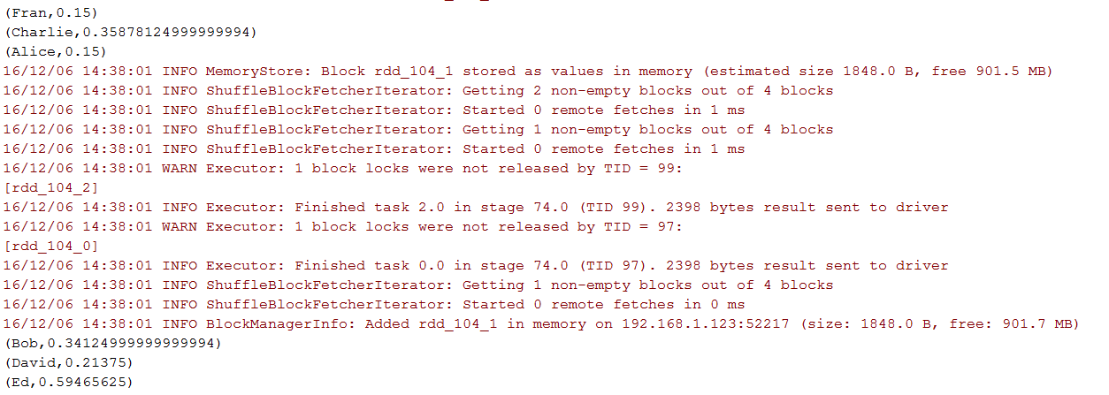

**Connected Components:**

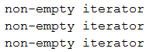

**Triangle Counting:**

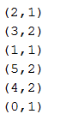

**The relation could be represented graphically as:**