TO WHOMSOEVER IT MAY CONCERN

This is to certify that Krishna Priya was employed at DataPattern in the position of Recruitment executive and Learning and development lead from 11 July 2022 to 24 July 2026.
During her tenure, she consistently demonstrated commendable dedication and professionalism. She successfully fulfilled her responsibilities, contributing to the overall success of our team. We found Krishna Priya to be a dedicated, reliable, and highly skilled professional. She displayed a positive attitude and adaptability, making valuable contributions to various projects and initiatives.
We wish her continued success in her future endeavors and express our gratitude for her dedicated service to DataPattern.

For DataPattern
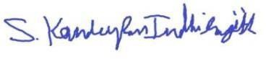

Indhirajith K
Head Operations Coimbatore

