Corn Disease Severity Prediction
Using UAV / Drone Data and XGBoost Machine Learning
US Corn Farming — AI Crop Health Monitoring
Project Documentation & Beginner Guide
Prepared: 13 June 2026

Contents

1. Project Overview
This project uses Artificial Intelligence (AI) to predict corn disease severity from drone (UAV) imagery. A drone flies over a corn field, captures multispectral images, and software converts them into vegetation indices (numerical health signals). A Machine Learning model — XGBoost — then learns the link between these signals and measured disease, so it can predict disease on new fields automatically.
UAV = Unmanned Aerial Vehicle (Drone). The goal: replace slow manual field scouting with fast, map-based AI predictions.

The processing pipeline
Drone Images -> Orthorectification -> Orthomosaic
-> Vegetation Index Calculation -> Excel Dataset
-> XGBoost AI Model -> Severity Prediction -> Dashboard

2. The Dataset
File: combined_vi_stats_with_disease_PPAC-B3.xlsx — 1 sheet, 4,320 rows x 56 columns.

What one row means
Each grid (POINT) is a 12 m field cell containing 6 corn plants. SEVERITY is the measured disease level of those 6 plants. The data covers 135 grids across 8 flight dates.

Column groups
Group | Columns | Role
Identity / Metadata | DATE, METHOD, SOIL, POINT, LATITUDE, LONGITUDE | Not predictors
Canopy | CANOPY_COVER | Feature (input)
Vegetation Indices | NDVI, NDRE, EXG, PSRI, RDVI, MCARI2, OSAVI (each MEAN/STD/MIN/MAX) | Features (input)
Spectral Bands | RED, GREEN, BLUE, REDEDGE, NIR (each MEAN/STD/MIN/MAX) | Features (input)
Target | SEVERITY | What we predict

Important data facts
- Problem type: Regression — SEVERITY is a continuous number (0.0 to 6.02), not categories
- Duplication: Each grid+date is stored 4 times: {whole, orthorectified} x {soil NO, soil YES}
- Real observations: 135 grids x 8 dates = 1,080 unique observations (x4 copies = 4,320 rows)
- Zero-inflated: Many grids are perfectly healthy (SEVERITY = 0)

3. Data Cleaning — Why 4,320 becomes 3,780
The raw file has 4,320 rows, but we cannot train on all of them. Training needs both an input AND a known answer. 540 rows have a BLANK severity, so they are removed.
Investigation showed all 540 blank rows belong to ONE flight date (3 Aug 2024) — on that day the drone flew but ground disease was not measured. That whole date is dropped.
Stage | Calculation | Rows
Raw file | 135 grids x 8 dates x 4 copies | 4,320
Dropped (blank severity) | 135 grids x 1 date x 4 copies | 540
Used for training | 135 grids x 7 dates x 4 copies | 3,780

Key point: 4,320 is the count BEFORE cleaning; 3,780 is what the model actually trains on.

4. Feature Selection — Why We Drop Columns
An input column should describe the CAUSE or SYMPTOM of disease (the plant's spectral colors), not an IDENTITY tag (who/where/when). Identity tags make the model memorize instead of learn — called data leakage.
Column dropped | Reason
SEVERITY | It is the answer. The model must predict it, not see it — else it just copies it (fake 100%).
DATE | A calendar number, not a plant measurement. Disease comes from spectral colors, not the date.
POINT | Just a grid ID. Using it makes the model memorize specific locations, failing on new fields.
LATITUDE / LONGITUDE | GPS position = where, not health. Same memorization risk; model should work anywhere.

METHOD and SOIL are text (e.g. 'whole', 'YES'). The model only understands numbers, so they are encoded to 0/1.

5. Train / Test Split — The Honest Exam
To test if the model truly learned (not memorized), we teach it on some grids and test it on different grids it has never seen — like giving a student practice questions, then testing on hidden ones.

The duplication trap
Because each grid has 4 identical-answer copies, a RANDOM split could put copy 1 of a grid in training and copy 3 in testing — the model would 'study' then be 'tested' on the same grid. That is cheating, and gave a falsely high score (R2 = 0.972).

The fix: GroupShuffleSplit by grid (POINT)
We group by POINT so all 4 copies of any grid stay on the SAME side. Result: 108 grids to train, 27 unseen grids to test — an honest evaluation.
groups = df['POINT'] # keep each grid together
gss = GroupShuffleSplit(test_size=0.2, random_state=42)
train_idx, test_idx = next(gss.split(X, y, groups))
# 108 train grids | 27 test grids (never seen)

6. The XGBoost Model
XGBoost = Extreme Gradient Boosting. It builds hundreds of small decision trees, where each new tree corrects the mistakes of the previous ones. Adding 600 such trees produces a highly accurate predictor.

Key settings (hyperparameters)
Setting | Value | Meaning
n_estimators | 600 | Number of trees (more = more learning)
learning_rate | 0.03 | How big each correction is (small = careful)
max_depth | 5 | Max questions per tree (limits complexity)
subsample | 0.8 | Each tree sees 80% of rows (adds variety)
colsample_bytree | 0.8 | Each tree sees 80% of columns
random_state | 42 | Makes results reproducible

7. Results & How to Read Them
Honest evaluation on 27 unseen grids:
Metric | Value | Plain meaning | Goal
R2 (R-squared) | 0.963 | Model captures 96% of the real disease pattern | Higher (max 1.0)
RMSE | 0.27 | Average error, big misses punished more | Lower
MAE | 0.10 | Typical guess is off by only 0.10 severity points | Lower

What each metric means
- MAE (Mean Absolute Error): the average size of a mistake. 0.10 is tiny on a 0-6 scale.
- RMSE (Root Mean Squared Error): like MAE but punishes large misses more. RMSE > MAE means a few hard grids miss by more.
- R2: percentage of the pattern explained. 1.0 = perfect, 0 = no better than guessing the average. 0.963 is excellent.

Most important features
These vegetation indices influence the prediction most. PSRI (a plant-stress index) and OSAVI/NDVI (greenness) ranking high confirms the model learned real biology.
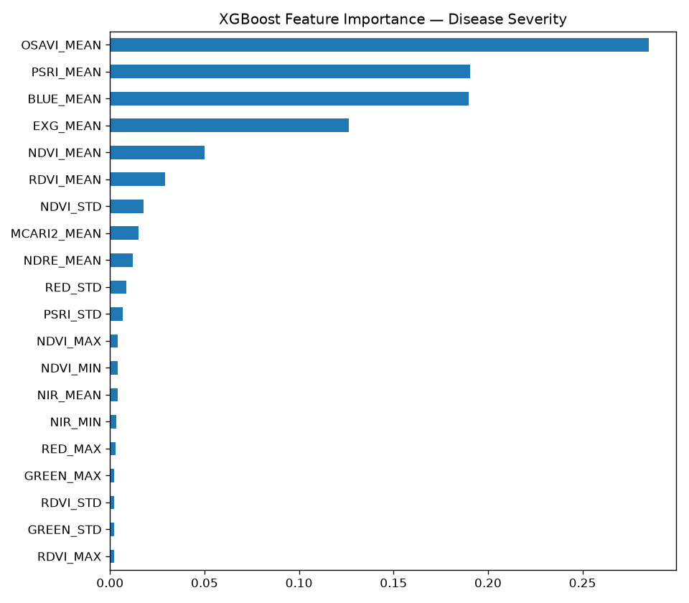

8. Project Files
File | Purpose | When to run
train_xgboost.py | Teaches the model from labeled data | Once (or on new data)
xgb_severity_model.json | The saved trained model (600 trees) | Created by training
predict.py | Batch predictions: Excel in, Excel out | Each new flight
app.py | Web dashboard: upload, map, charts, download | Anytime
requirements.txt | List of required libraries | When setting up
run_dashboard.bat | Double-click to launch the dashboard | Anytime
train_model.bat | Double-click to retrain | On new data

9. How to Run (with Virtual Environment)
A venv (virtual environment) keeps this project's libraries separate from the rest of the computer, avoiding version conflicts.

One-time setup
cd D:\AI_ANALYSIS
python -m venv venv
.\venv\Scripts\Activate.ps1
pip install -r requirements.txt

Daily use
cd D:\AI_ANALYSIS
.\venv\Scripts\Activate.ps1 # you should see (venv)
streamlit run app.py # launch the dashboard
# or just double-click run_dashboard.bat
Golden rule: always activate the venv (look for '(venv)' in the prompt) before running any project file.

10. The Dashboard
Built with Streamlit, the dashboard lets anyone upload a drone Excel and instantly see AI predictions — no coding needed.
- KPI cards: total grids and counts of Healthy / Moderate / Severe.
- Field Map: each grid plotted by GPS, colored red-to-green by severity.
- Over Time: disease progression across the flight dates.
- Feature Importance: which indices drive the prediction.
- Data + Download: full predictions table and one-click Excel export.

11. Real-World Workflow & Next Steps
New drone flight -> vegetation-index Excel -> open dashboard
-> upload -> AI predicts every grid in <1 second
-> map shows RED zones = diseased corn -> scout/spray there
-> download report; compare across dates to track spread

Recommended improvements
- Recover the missing 3 Aug date's ground measurements to add an 8th training date.
- Add a classification view (Healthy / Moderate / Severe) with agronomist-set thresholds.
- Use 5-fold grid cross-validation for an even more reliable score.
- Add time-series forecasting to predict FUTURE disease from early flights.

Appendix A — How the Metrics Work (Worked Example)
To make R2, RMSE and MAE concrete, here is a tiny example using just 5 grids. We know each grid's REAL severity and the model's PREDICTED severity. Every metric is built from the Error column (Real - Predicted).
Grid | Real severity | Predicted | Error (Real - Predicted)
1 | 2.0 | 1.8 | +0.2
2 | 0.0 | 0.3 | -0.3
3 | 4.0 | 3.5 | +0.5
4 | 1.0 | 1.2 | -0.2
5 | 3.0 | 3.0 | 0.0

MAE — Mean Absolute Error = 0.24
Rule: ignore +/- signs, then average the errors.
Absolute errors: 0.2, 0.3, 0.5, 0.2, 0.0
Sum : 0.2 + 0.3 + 0.5 + 0.2 + 0.0 = 1.2
Divide by 5 : 1.2 / 5 = 0.24 -> MAE
Meaning: on average the model is off by 0.24 severity points (a simple average mistake).

RMSE — Root Mean Squared Error = 0.29
Rule: square each error (punishes big misses), average, then take the square root.
Squared errors: 0.04, 0.09, 0.25, 0.04, 0.00 (0.5 -> 0.25 dominates)
Sum : 0.42
Divide by 5 : 0.42 / 5 = 0.084 (this is MSE)
Square root : sqrt(0.084) = 0.29 -> RMSE
RMSE (0.29) is bigger than MAE (0.24) because grid 3's larger error got squared. Lesson: RMSE > MAE means a few predictions missed by more than the rest.

R2 — R-squared = 0.958
Rule: compare the model's error against a 'lazy guesser' that always predicts the average (here, the average real severity is 2.0).
Model error (SS_res) = sum of squared errors = 0.42
Lazy error (SS_tot) = sum of (real - 2.0) squared:
0 + 4 + 4 + 1 + 1 = 10
R2 = 1 - (SS_res / SS_tot) = 1 - (0.42 / 10) = 0.958
Meaning: the model's error (0.42) is tiny next to the lazy guesser's (10), so it removes 95.8% of the error. R2 = 1.0 is perfect, 0 is no better than guessing the average.

Example vs. the real model
Metric | This example (5 grids) | Real model (27 grids) | Direction
MAE | 0.24 | 0.105 | Lower = better
RMSE | 0.29 | 0.272 | Lower = better
R2 | 0.958 | 0.963 | Higher = better (max 1.0)

Note: these three metrics are standard for ALL regression models (Linear Regression, Random Forest, XGBoost, Neural Networks). They evaluate the predictions, not the algorithm — so the same numbers let you fairly compare different models and pick the best one.

