Sending SMS over SMPP — removing the Vonage REST API
FootFall SMS Service (service-bulk-sms) · SMPP v3.4 over TCP · Draft for review
The Vonage REST API is completely removed. One persistent SMPP connection handles both directions: sending (submit_sm) and receiving (deliver_sm — delivery receipts and inbound replies). Two decisions at the end of this document determine how much of the receive direction we build.

1. What changes — today vs. target
Today every SMS is a separate HTTPS request to Vonage's REST API, and the return direction does not exist: the delivery-receipt webhook is a stub that was never wired up, so "sent" only ever means "the gateway accepted it". The target replaces this with a single long-lived TCP bind that works in both directions.
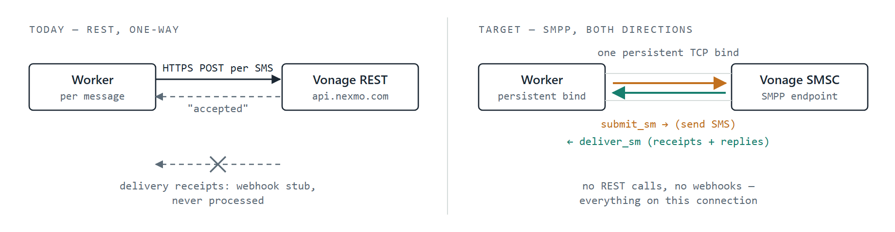
Figure 1 — The per-request HTTPS path (left) is replaced by one persistent SMPP bind (right) that both sends and receives. The unused webhook stub disappears entirely.

2. Target architecture
Our own HTTP API stays — it is how the CRM hands us messages. RabbitMQ replaces the MySQL jobs table as the queue transport, Redis holds cache/sessions and the message-ID correlation map, and the SMPP connection manager owns the socket to Vonage. Orange = outbound (submit_sm), green = inbound (deliver_sm).
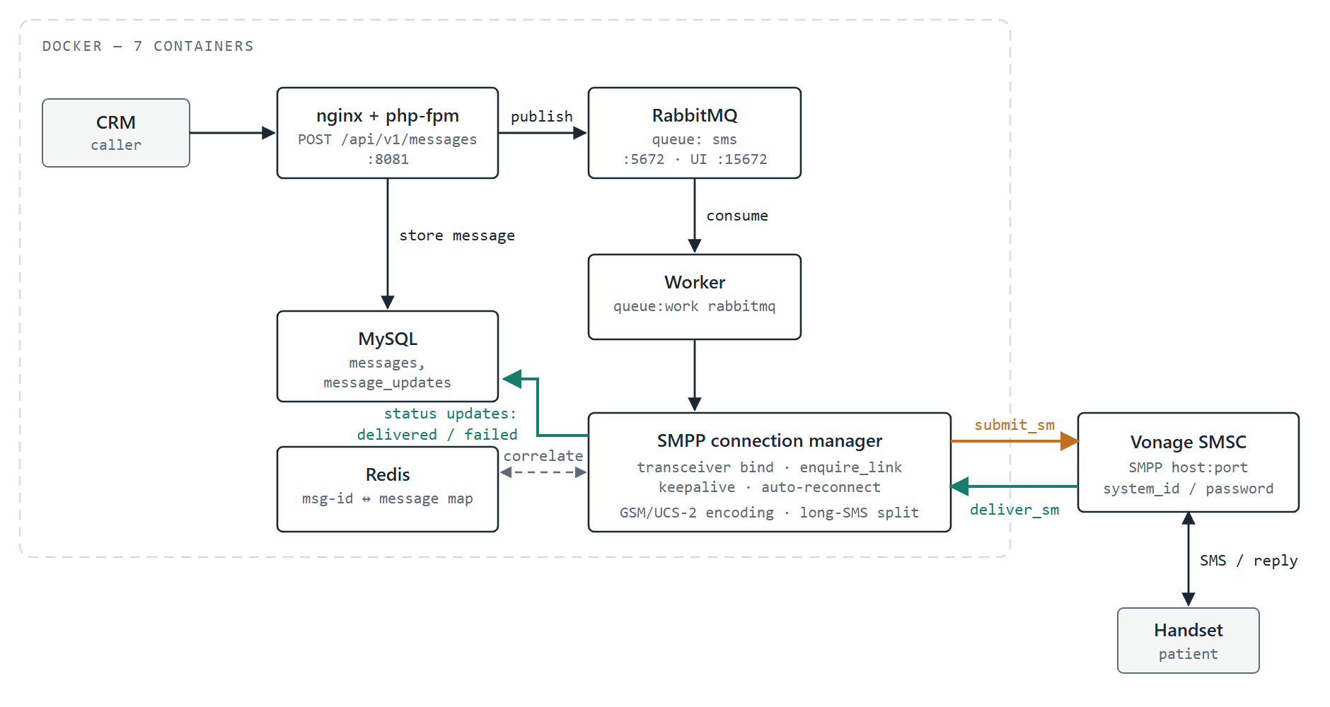
Figure 2 — Existing containers (nginx, php, worker, MySQL) plus new RabbitMQ and Redis containers. Only the worker talks SMPP; everything left of it is unchanged application flow.

3. Life of one message on the wire
Six exchanges cover everything this integration can do. The first three exist in any case; the last three are exactly what the two open decisions switch on or off.
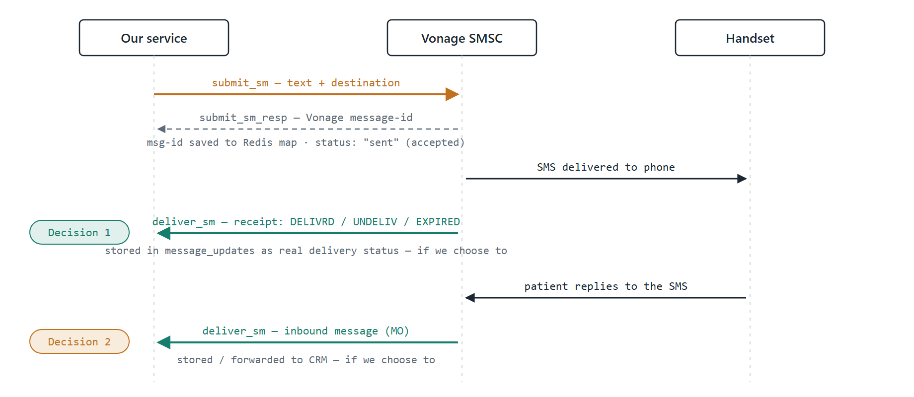
Figure 3 — Exchanges 1–3 are the send path and exist in every variant. The delivery receipt (Decision 1) and the inbound reply (Decision 2) both arrive as deliver_sm on the same connection.

4. Decisions needed before we build
Sending over SMPP is decided. What is open is how much of the return direction we implement — both kinds of inbound traffic arrive on the same connection, but each needs its own handling, storage and testing.

Decision 1 — Do we store delivery status (DLRs)?
Today a message's final status is "sent", which only means Vonage accepted it. Delivery receipts (DLRs) tell us what actually happened at the phone.
Option A — Yes, store them (recommended)
- Each receipt appended to message_updates: delivered, failed, expired.
- CRM sees true delivery state via the existing status API — no API change needed.
- Needs: transceiver bind, DLR parser, Redis correlation map.
Option B — No, ignore them
- Status stays "sent = gateway accepted", exactly as today.
- Smaller build; receipts are read off the socket and discarded.
- Undelivered messages are invisible — email fallback never triggers on late failure.

Decision 2 — Do we track inbound SMS (patient replies)?
If a patient replies to an SMS, the reply arrives on our SMPP connection. Today there is nowhere for it to go.
Option A — Yes, track them
- New inbound_messages table; reply linked to the original thread where possible.
- Optionally forwarded to the CRM by webhook so staff can see responses.
- Needs: sender number provisioned for two-way SMS on the Vonage account.
Option B — No, outbound only
- Replies are discarded; the service remains a pure notification sender.
- Fine if messages are informational and never ask for a response.
- Can be added later without reworking the send path.
If both answers are "No": we do not need the receive direction at all — a simpler transmitter-only bind is enough, with no Redis correlation map and no DLR parser. That roughly halves the SMPP work. If either answer is "Yes", we bind as transceiver and build the shared inbound handler once.

5. Implementation phases
- Phase A — Infrastructure. Add RabbitMQ and Redis containers to docker-compose; PHP extensions (sockets, bcmath, redis); environment configuration.
- Phase B — Queue swap. Move the job queue from the MySQL jobs table to RabbitMQ (Laravel queue driver — no business-logic change); cache and sessions to Redis.
- Phase C — SMPP driver. Mirror the SMPP client already integrated in sms_expert_new-BE; new vonage_smpp provider driver in this project's existing pluggable-provider design; connection manager with keepalive and reconnect. The admin UI picks the new provider up automatically.
- Phase D — Return direction. DLR storage and/or inbound tracking — scope depends on Decisions 1 and 2.

6. Prerequisites and risks
- Vonage SMPP credentials. SMPP access is not enabled by default — it requires a Vonage account approved for SMPP, with separately issued system_id/password and host/port. A trial account cannot bind. Until credentials exist, we develop against a local SMPP simulator container.
- PHP 7.4 compatibility. This service runs Laravel 6 on PHP 7.4; the SMPP and RabbitMQ libraries must be pinned to versions that support it.
- A stateful connection is a new operational concern. Unlike REST, a dropped bind means nothing sends until reconnect — the connection manager's keepalive/reconnect logic and a health check on the bind become part of monitoring.
- Two-way sender number. Replies require a virtual number or shortcode on the account; an alphanumeric sender name like "TestSMS" cannot receive. (Only needed if Decision 2 = Yes.)

