Supplementary Material S1
AridHab-Q: Illustrated field guide, 37 attributes and computational formulas | 2026.10
Each attribute is accompanied by a separate full-colour plate displayed in the Shiny application and distributed as www/attribute_guides/attribute_NN.png. The guide below reproduces the operational rating text; blank original categories are intentionally unavailable.

Field assessment instructions
Record site ID, date, coordinates, habitat, assessor, ecological reference, season/rainfall and photographs. For each attribute record an observed value (with units if applicable), field evidence, the selected valid rating and a verification note. Rating 1 = least degradation; rating 5 = greatest degradation. Do not assign an absent class.

01. Removal of plant parts (%)
Degradation rating | Published / proposed description
1 | Up to 65
2 | 66–75
3 | 76–85
4 | 86–95
5 | Over 95
Field evidence: ______________________________ Measurement and units: ______________________________ Selected rating: ______
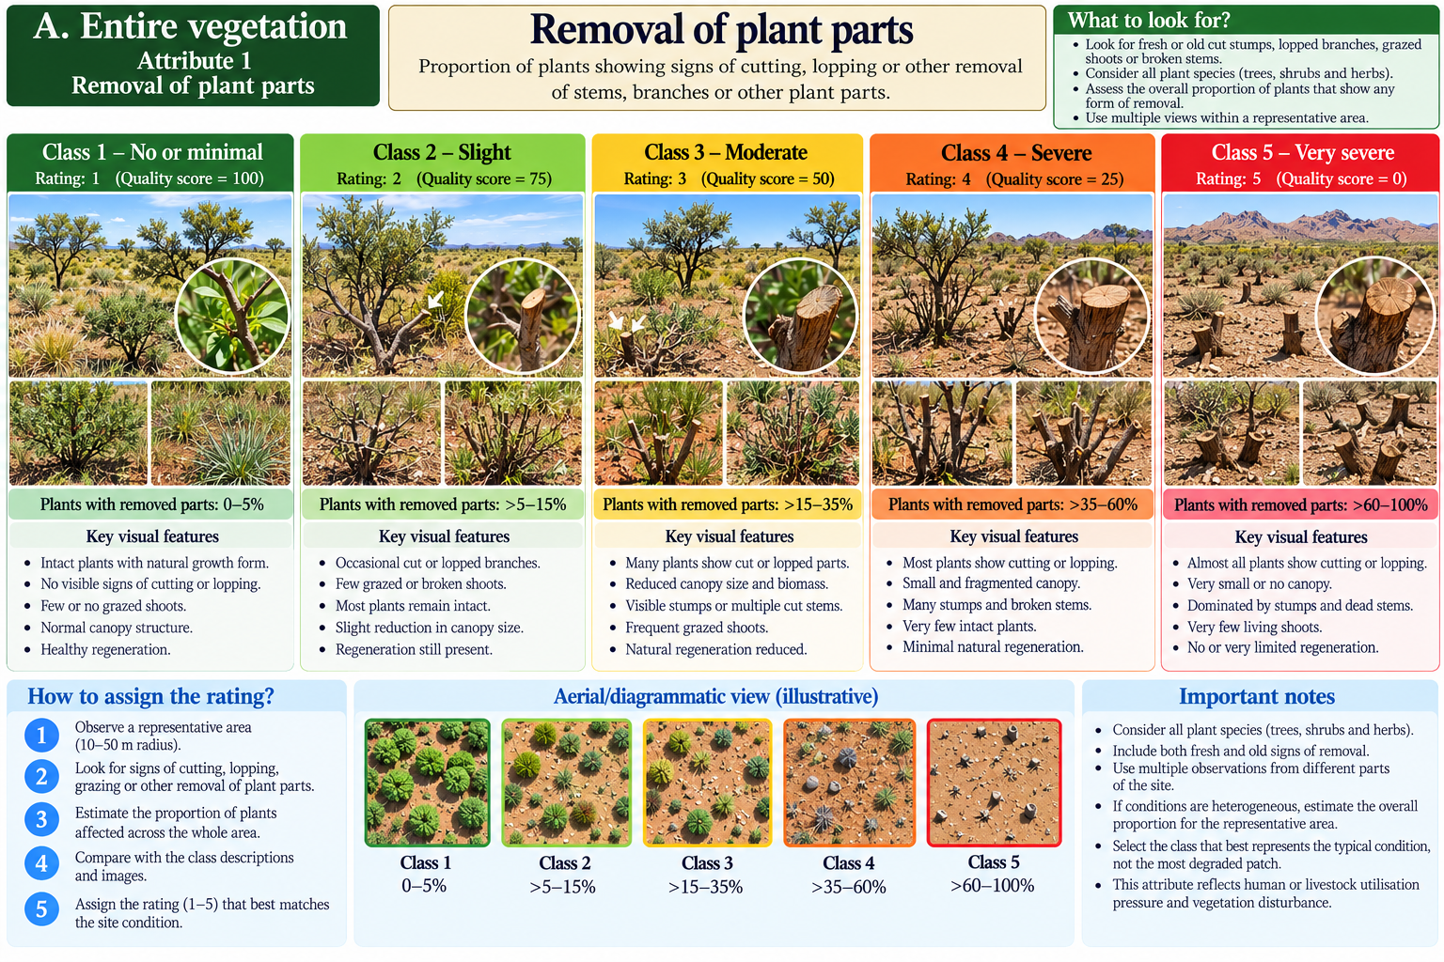

02. Bare surface area (%)
Degradation rating | Published / proposed description
1 | 0–10
2 | 11–20
3 | 21–40
4 | 41–70
5 | Over 70
Field evidence: ______________________________ Measurement and units: ______________________________ Selected rating: ______
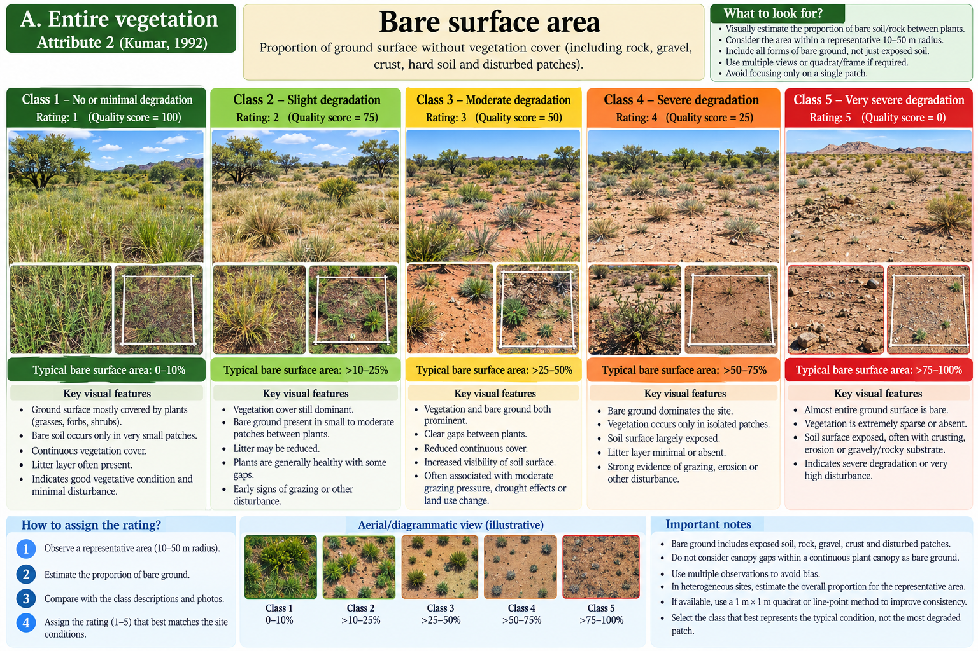

03. Litter quantity
Degradation rating | Published / proposed description
1 | Heavy
2 | Moderate
3 | Sporadic
4 | None
5 | Not available in this rubric
Field caution: Four categories in original.
Field evidence: ______________________________ Measurement and units: ______________________________ Selected rating: ______
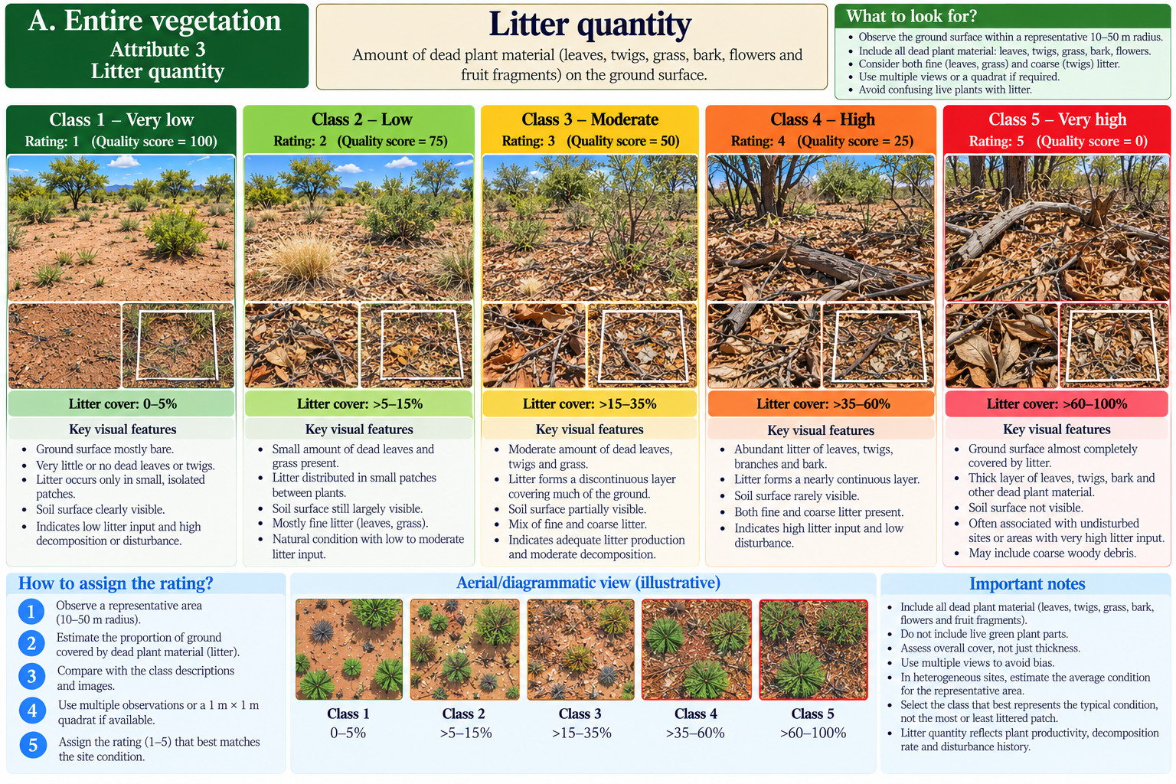

04. Litter condition
Degradation rating | Published / proposed description
1 | Accumulating
2 | Replacing
3 | None
4 | Not available in this rubric
5 | Not available in this rubric
Field caution: Three categories in original.
Field evidence: ______________________________ Measurement and units: ______________________________ Selected rating: ______
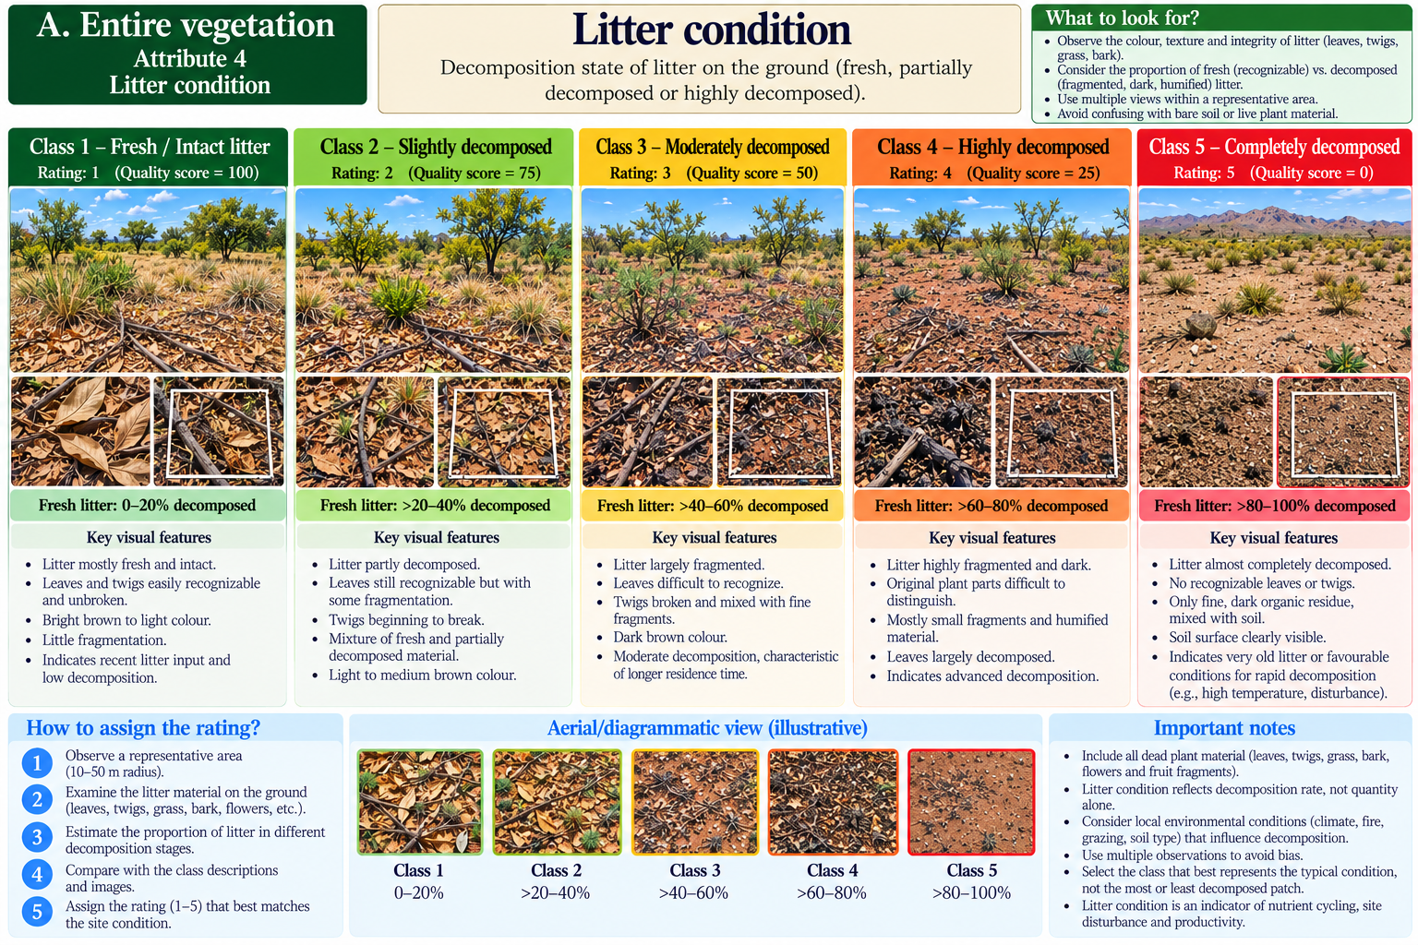

05. Therophyte increase (%) over standard
Degradation rating | Published / proposed description
1 | 25
2 | 26–50
3 | 51–75
4 | 76–90
5 | Over 90
Field caution: Requires a standard; 25 is transcribed as printed.
Field evidence: ______________________________ Measurement and units: ______________________________ Selected rating: ______
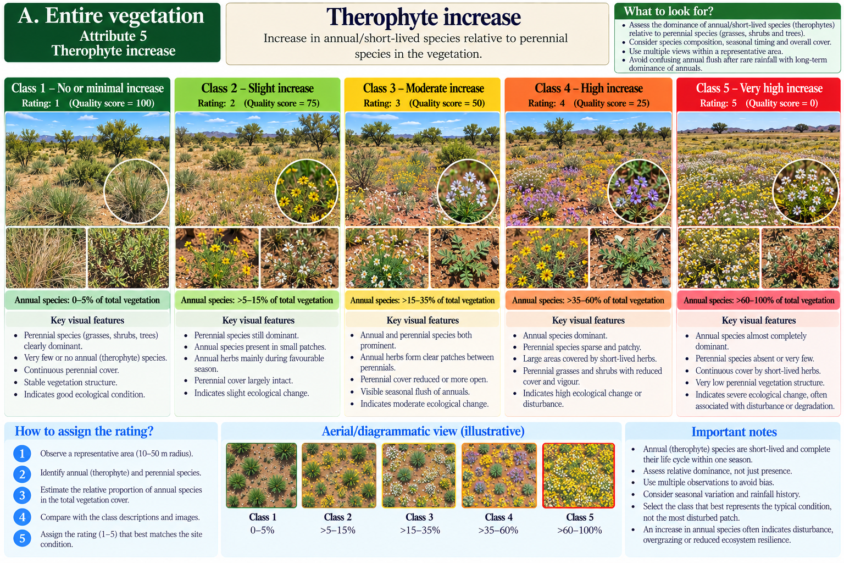

06. Decline in species richness (%)
Degradation rating | Published / proposed description
1 | 25
2 | 26–50
3 | 51–75
4 | 76–90
5 | Over 90
Field caution: Requires baseline/standard; 25 is transcribed as printed.
Field evidence: ______________________________ Measurement and units: ______________________________ Selected rating: ______
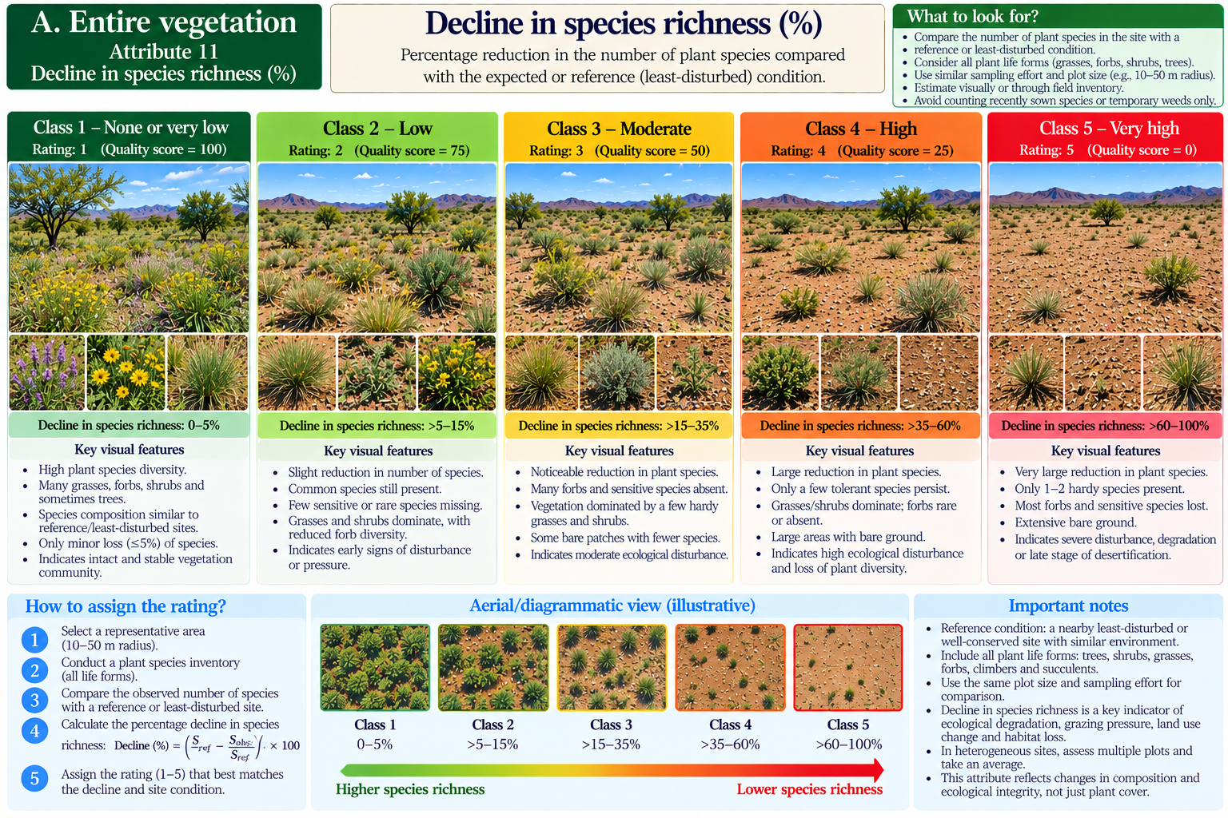

07. Age distribution (key species)
Degradation rating | Published / proposed description
1 | Sufficient
2 | Insufficient
3 | Few
4 | Not available in this rubric
5 | Not available in this rubric
Field caution: Three categories in original.
Field evidence: ______________________________ Measurement and units: ______________________________ Selected rating: ______
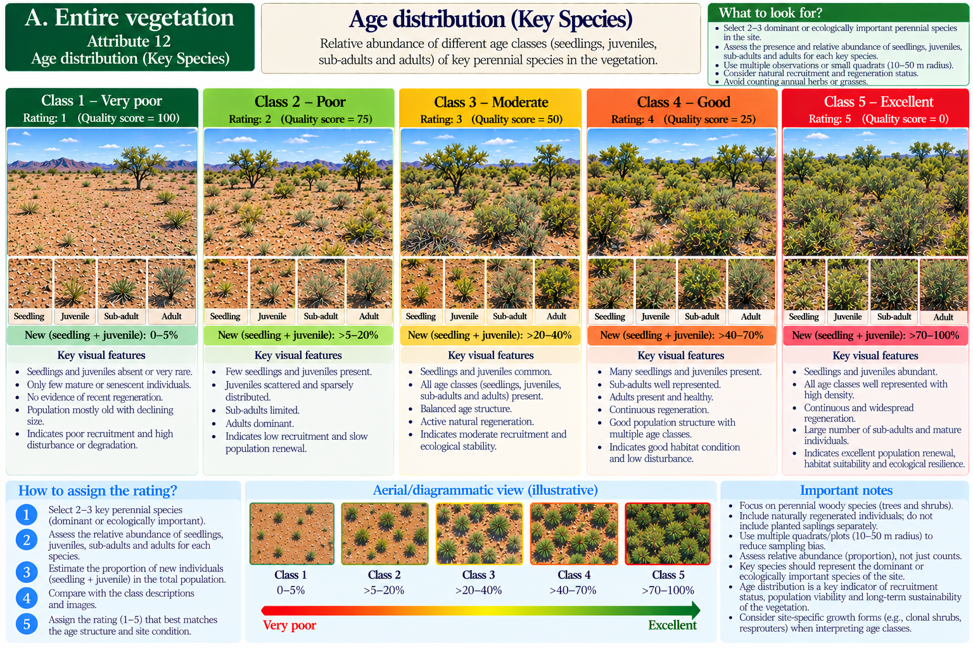

08. Vigour
Degradation rating | Published / proposed description
1 | Optimum
2 | Slightly pedestalled
3 | Pedestalled
4 | Pale, highly pedestalled
5 | Not available in this rubric
Field caution: Four categories in original.
Field evidence: ______________________________ Measurement and units: ______________________________ Selected rating: ______
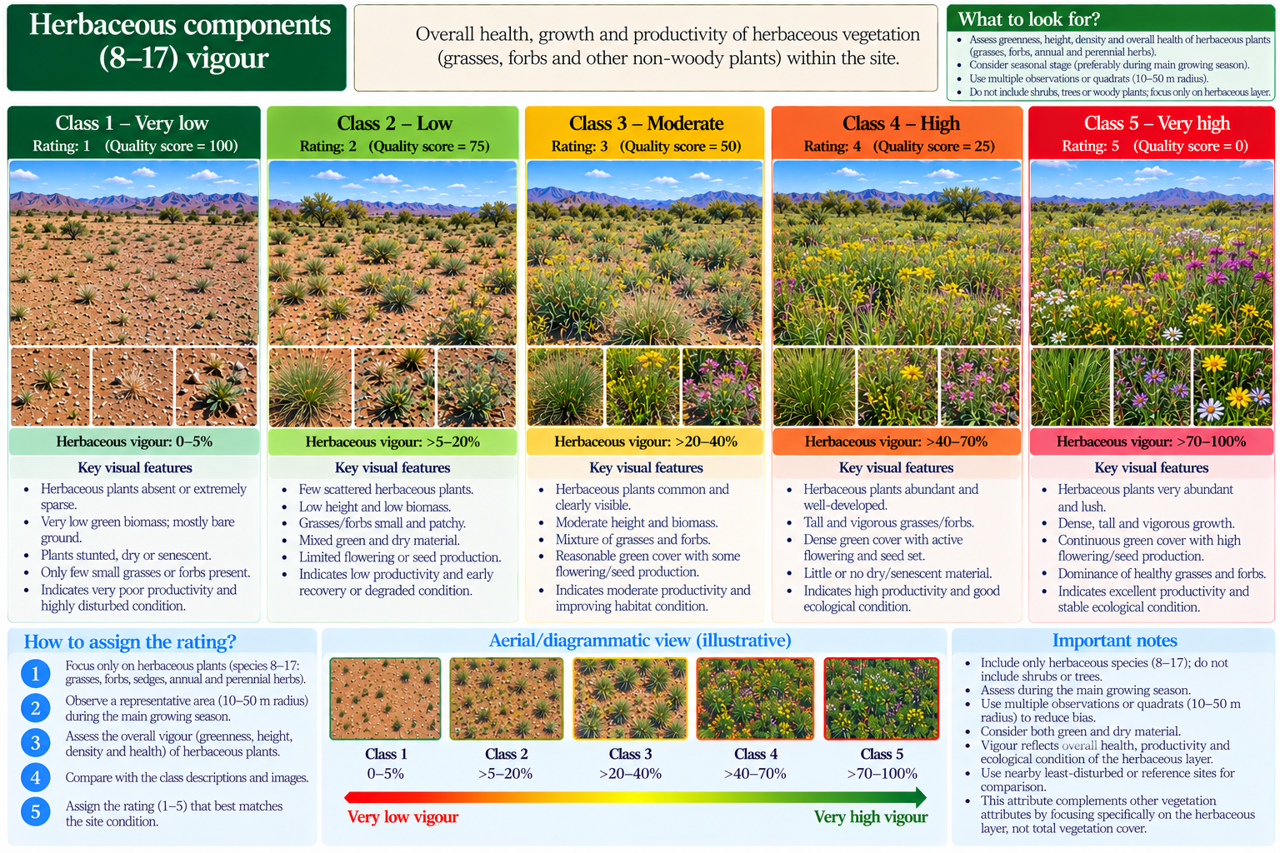

09. Seeds of climax species in soil
Degradation rating | Published / proposed description
1 | Abundant
2 | Moderate
3 | Slight
4 | Sporadic
5 | None
Field evidence: ______________________________ Measurement and units: ______________________________ Selected rating: ______
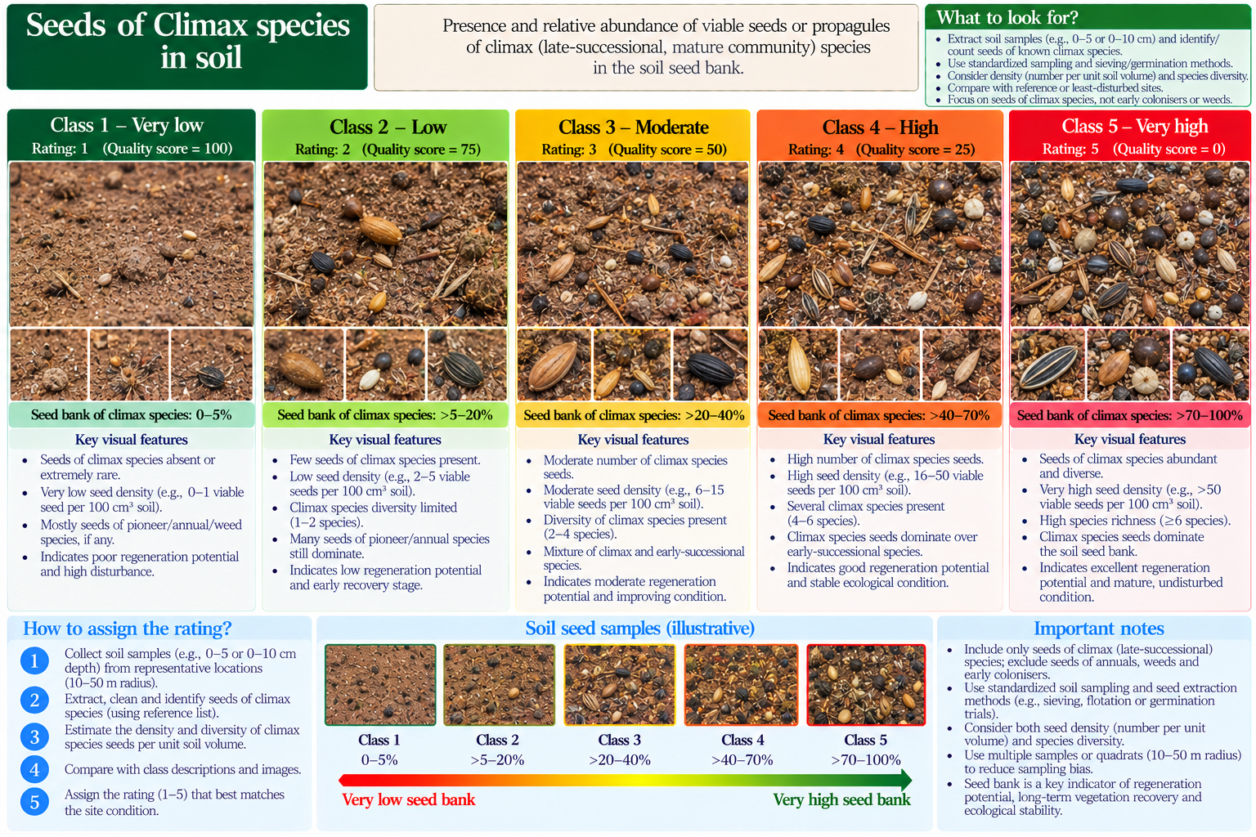

10. Botanical composition of climax species
Degradation rating | Published / proposed description
1 | 25–40
2 | 10–<25
3 | 1–<10
4 | <1
5 | Not available in this rubric
Field caution: Four categories in original.
Field evidence: ______________________________ Measurement and units: ______________________________ Selected rating: ______
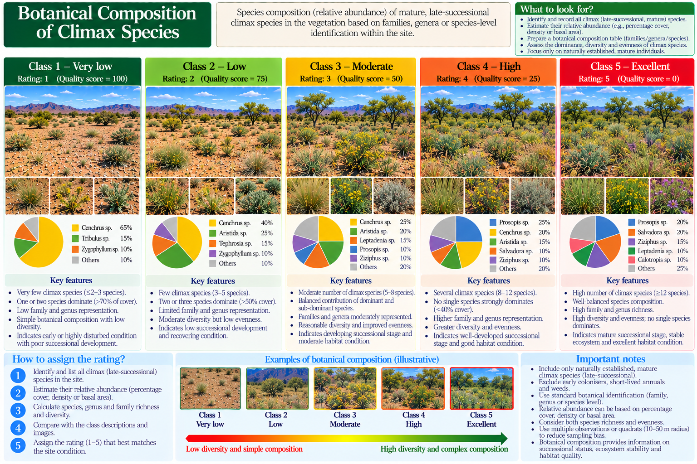

11. Total basal cover (%)
Degradation rating | Published / proposed description
1 | 4–8
2 | 3–6
3 | 2
4 | 1
5 | <1
Field caution: Ranges overlap in the published table; manual verification required.
Field evidence: ______________________________ Measurement and units: ______________________________ Selected rating: ______
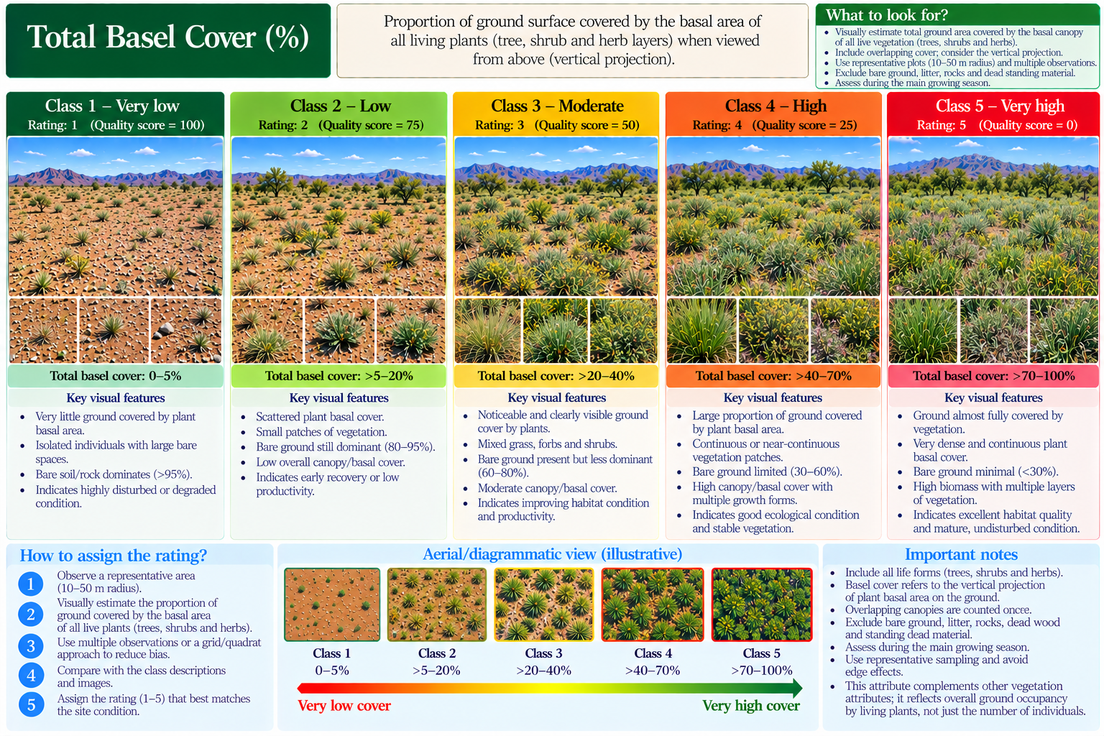

12. Basal cover of climax species (%)
Degradation rating | Published / proposed description
1 | Over 50
2 | 25–<25
3 | 20–<25
4 | 5–<20
5 | <5
Field caution: Rating 2 is internally inconsistent in scanned source; do not auto-classify.
Field evidence: ______________________________ Measurement and units: ______________________________ Selected rating: ______
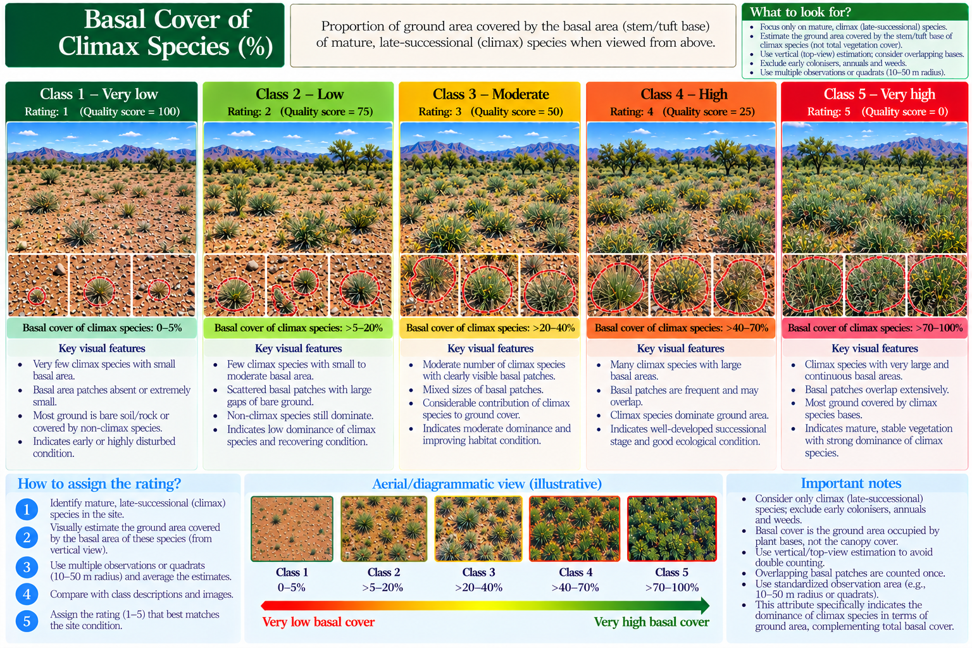

13. RIV of climax species
Degradation rating | Published / proposed description
1 | Over 25
2 | 10–<25
3 | 6–<10
4 | 1–<6
5 | <1
Field evidence: ______________________________ Measurement and units: ______________________________ Selected rating: ______
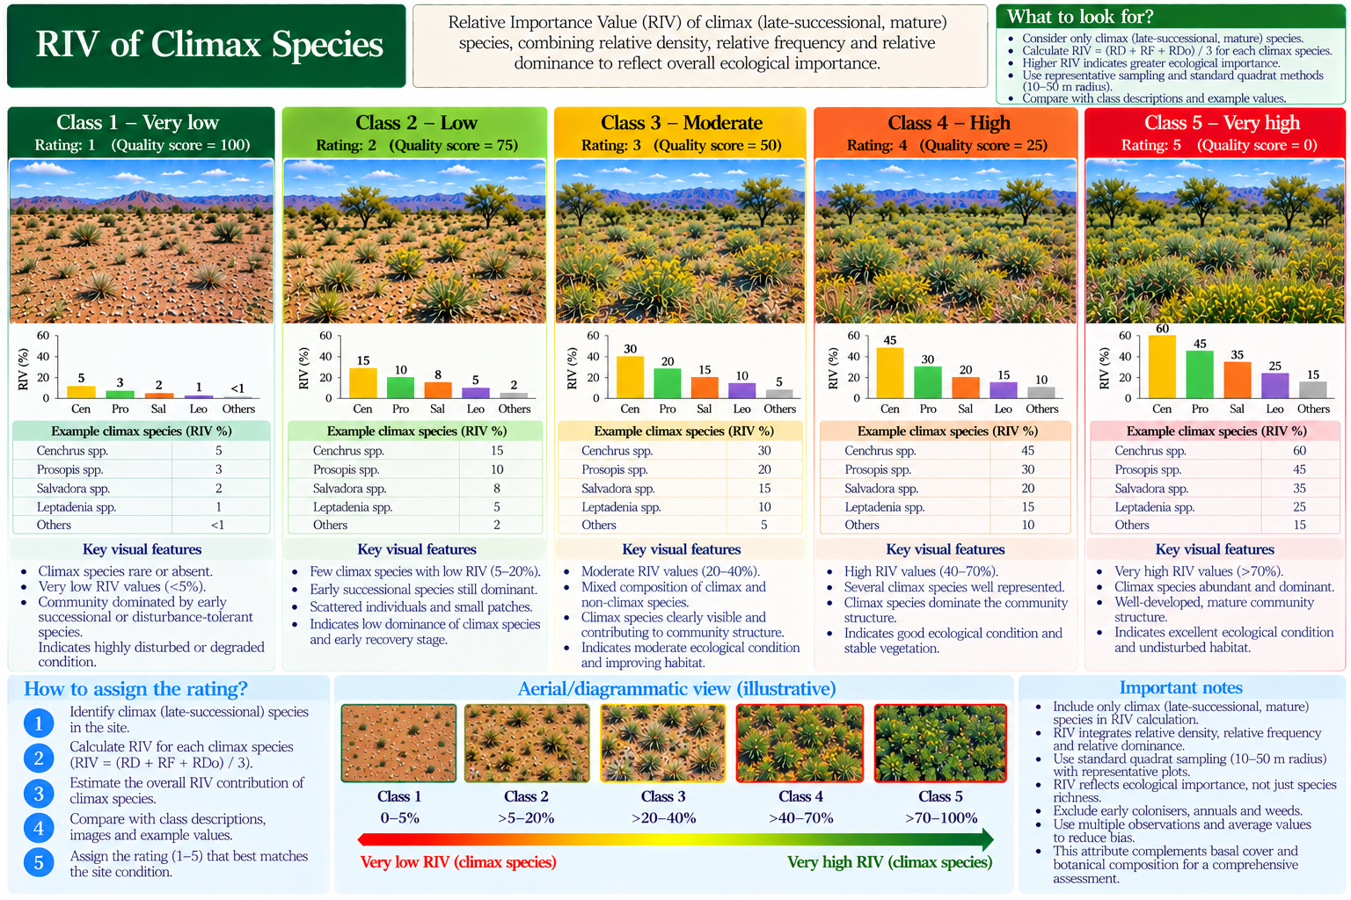

14. Biomass contribution of climax species (%)
Degradation rating | Published / proposed description
1 | Over 50
2 | 25–<50
3 | 10–<25
4 | 5–<10
5 | <1
Field caution: Original table has an apparent gap between 1 and 5; manual review.
Field evidence: ______________________________ Measurement and units: ______________________________ Selected rating: ______
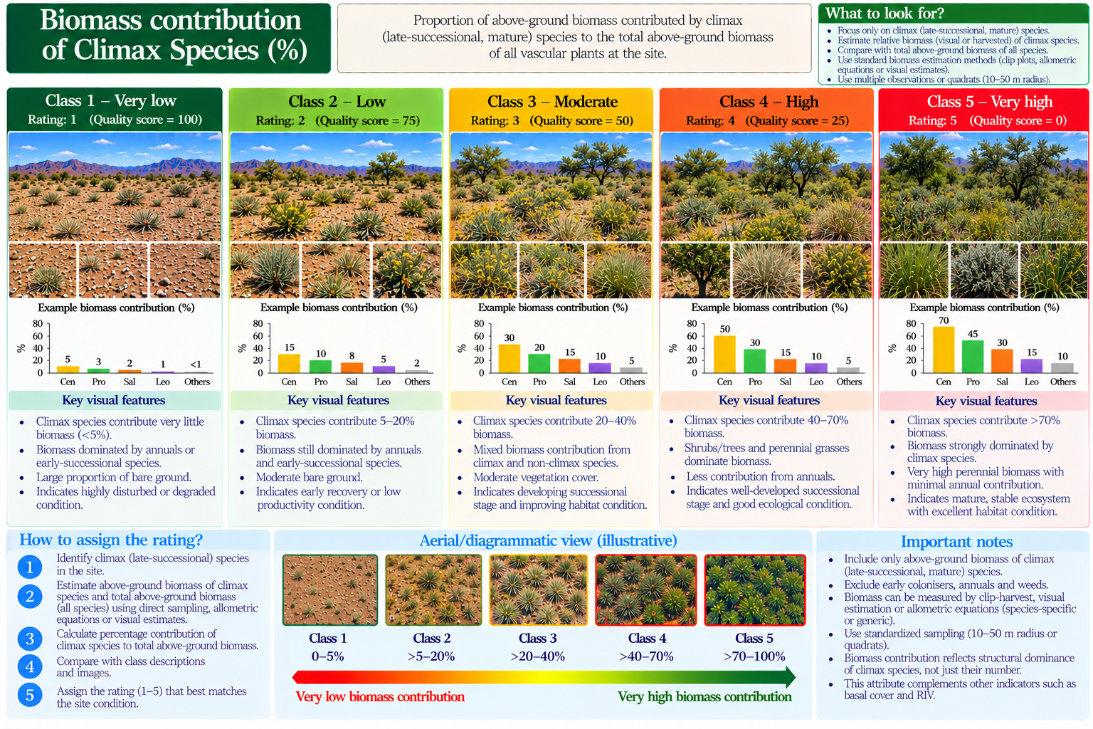

15. Existing biomass as % potential biomass
Degradation rating | Published / proposed description
1 | Over 60
2 | 40–<60
3 | 25–<40
4 | 10–<25
5 | <10
Field caution: Requires potential biomass estimate.
Field evidence: ______________________________ Measurement and units: ______________________________ Selected rating: ______
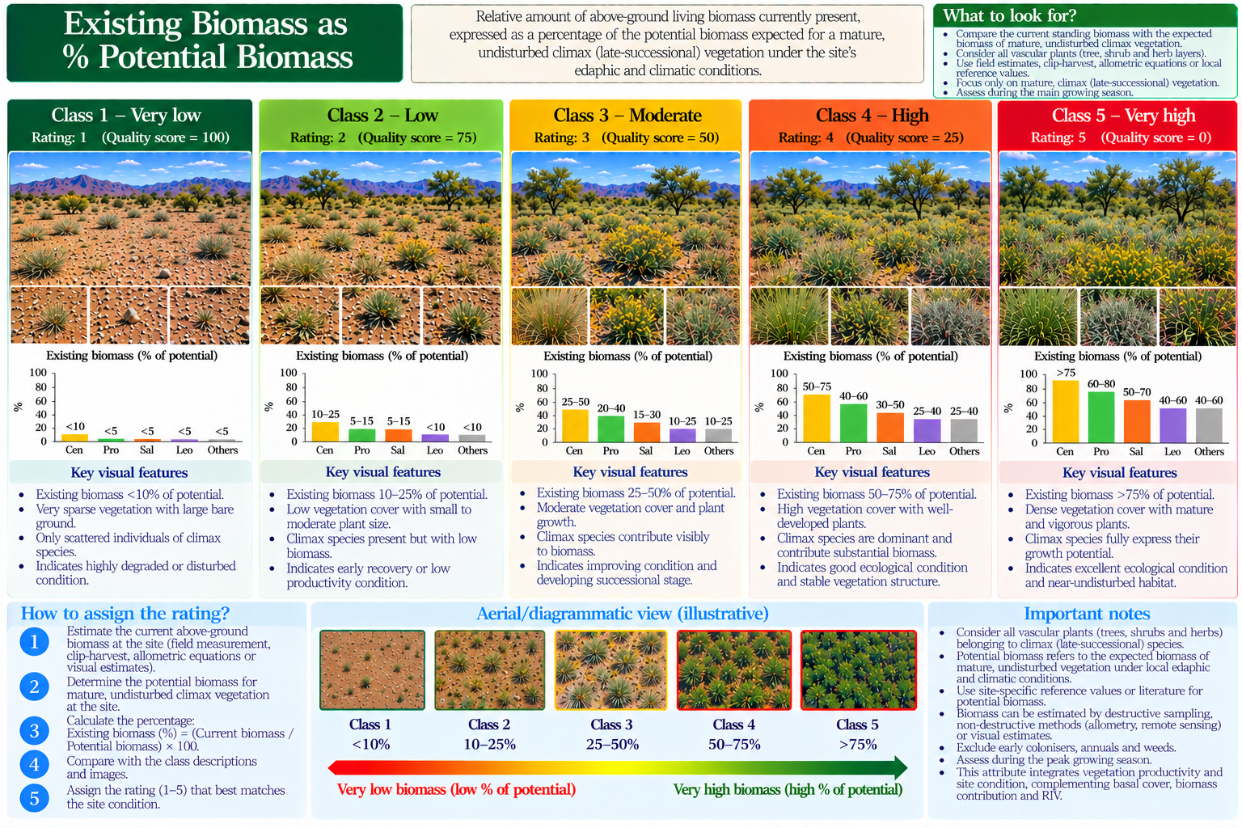

16. Carrying capacity (ACU/100 ha)
Degradation rating | Published / proposed description
1 | 20
2 | 17
3 | 13
4 | 5
5 | None
Field caution: Discrete values as printed; Table 5 provides further context.
Field evidence: ______________________________ Measurement and units: ______________________________ Selected rating: ______
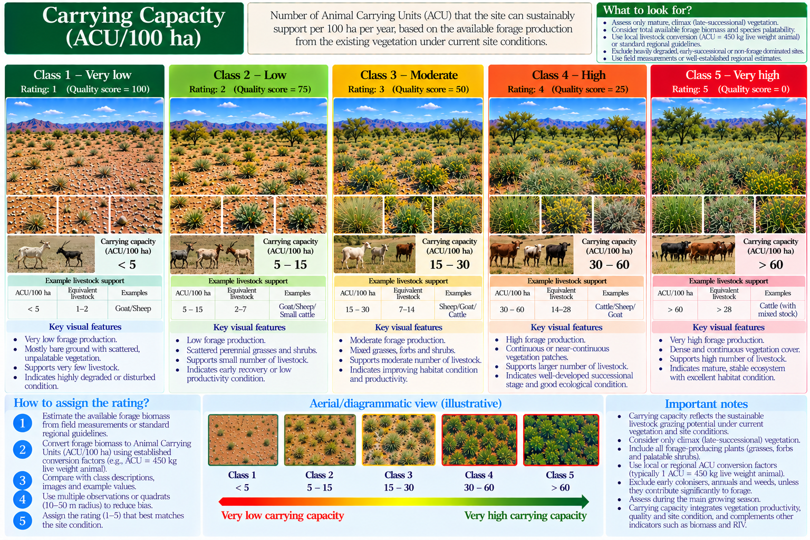

17. Grazing intensity
Degradation rating | Published / proposed description
1 | Light
2 | Moderate
3 | Heavy
4 | Very heavy
5 | Not available in this rubric
Field caution: Four categories in original.
Field evidence: ______________________________ Measurement and units: ______________________________ Selected rating: ______
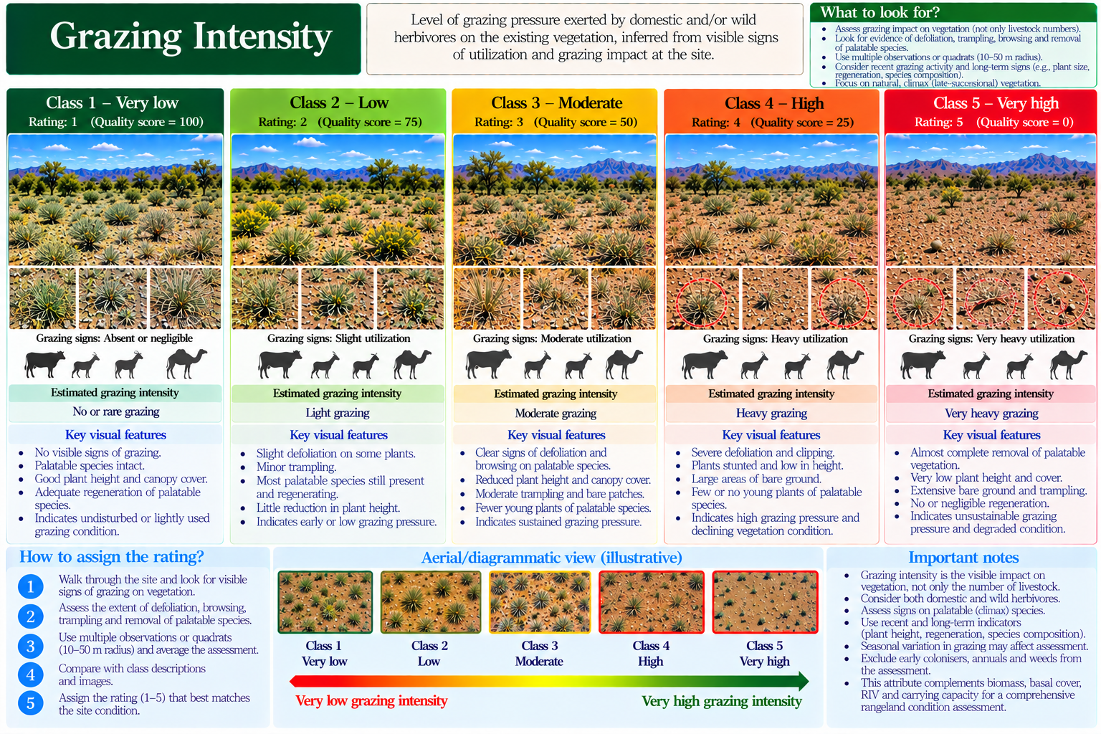

18. Percent plants showing hedging
Degradation rating | Published / proposed description
1 | Absent
2 | 50
3 | 75
4 | 100
5 | Not available in this rubric
Field caution: Four categories in Table 7; Table 1 also describes hedging.
Field evidence: ______________________________ Measurement and units: ______________________________ Selected rating: ______
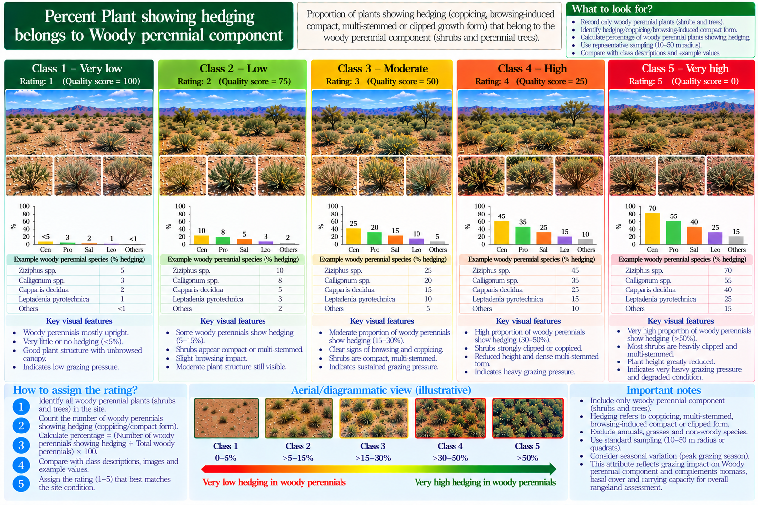

19. Browse lines
Degradation rating | Published / proposed description
1 | Absent
2 | Apparent
3 | Evident
4 | Not available in this rubric
5 | Not available in this rubric
Field caution: Three categories in original.
Field evidence: ______________________________ Measurement and units: ______________________________ Selected rating: ______
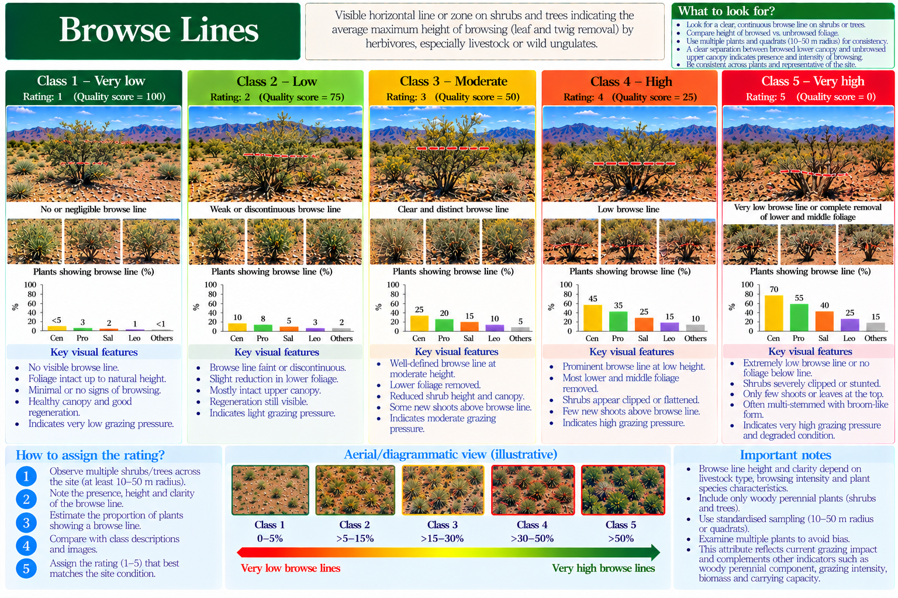

20. Browsing damage
Degradation rating | Published / proposed description
1 | Light
2 | Light to moderate
3 | Moderate
4 | Moderate to heavy
5 | Heavy
Field caution: Table 3 separately gives ocular damage ratings 0–6.
Field evidence: ______________________________ Measurement and units: ______________________________ Selected rating: ______
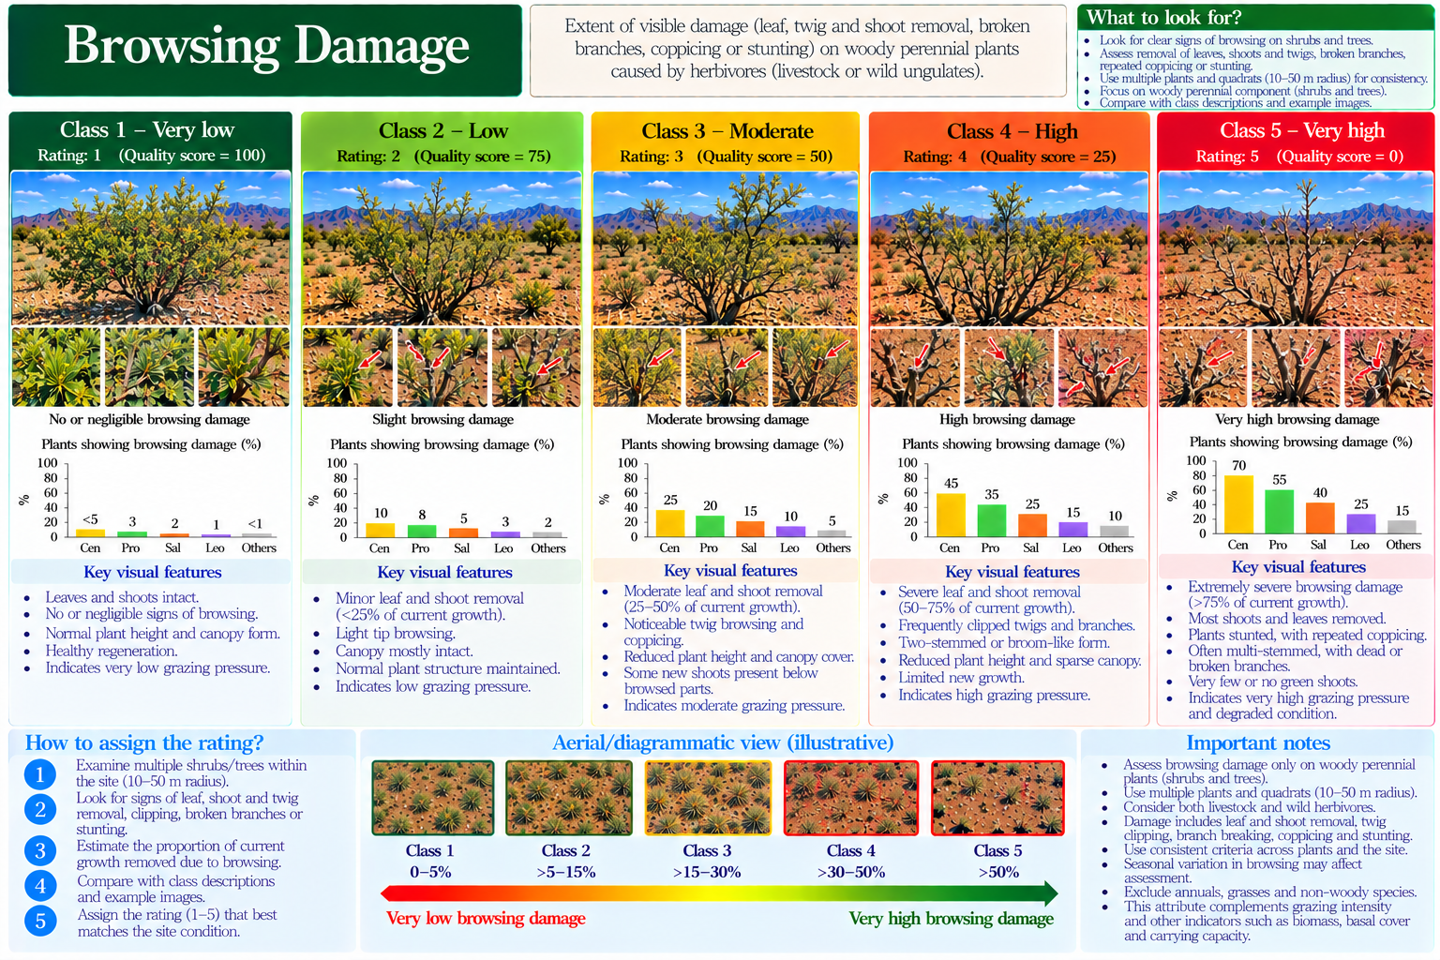

21. Increase in relative density of unpalatable species
Degradation rating | Published / proposed description
1 | 10–20
2 | 21–40
3 | 41–60
4 | 61–80
5 | >80
Field evidence: ______________________________ Measurement and units: ______________________________ Selected rating: ______
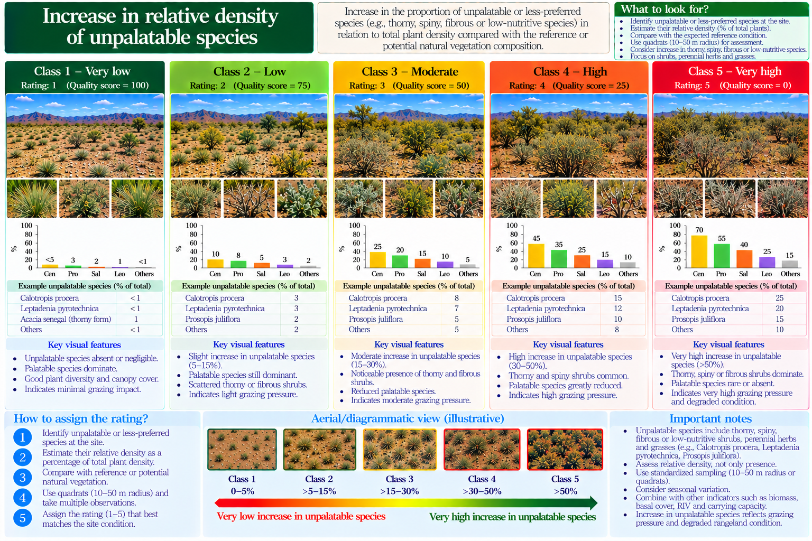

22. Relative density of key/climax species
Degradation rating | Published / proposed description
1 | 40
2 | 30–<40
3 | 10–<30
4 | 1–<10
5 | <1
Field caution: 40 is transcribed as printed.
Field evidence: ______________________________ Measurement and units: ______________________________ Selected rating: ______
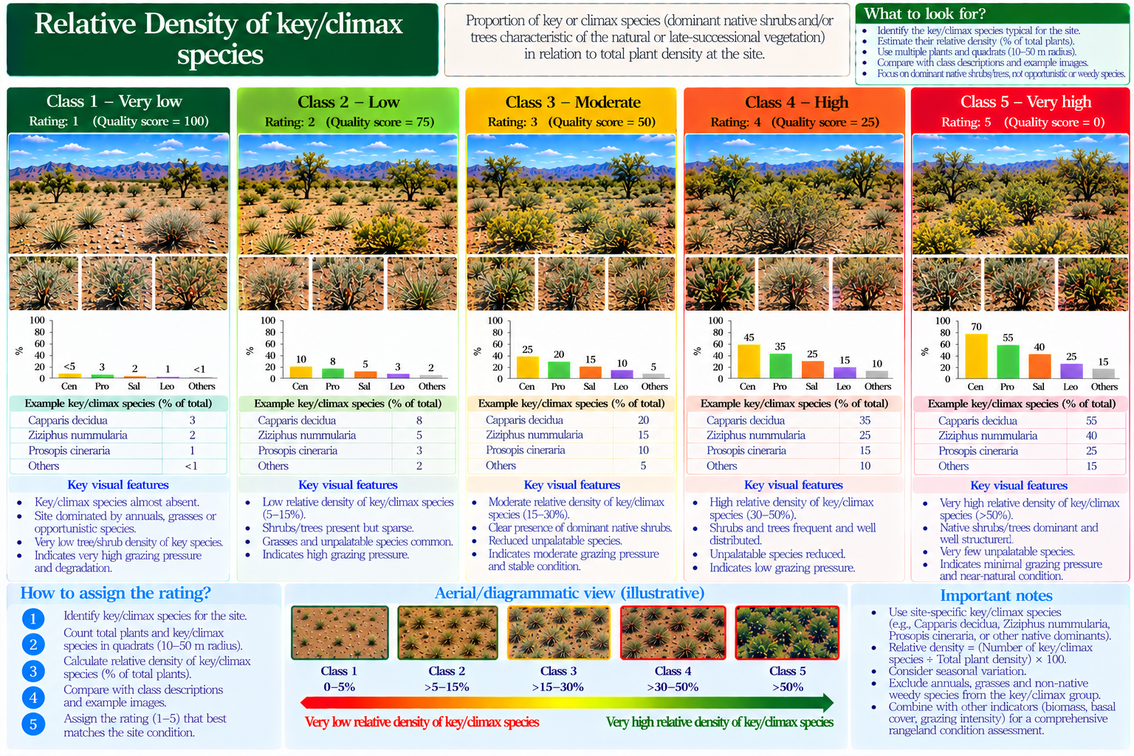

23. RIV of key/climax species
Degradation rating | Published / proposed description
1 | Over 20
2 | 10–<20
3 | 5–<10
4 | 1–<5
5 | <1
Field evidence: ______________________________ Measurement and units: ______________________________ Selected rating: ______
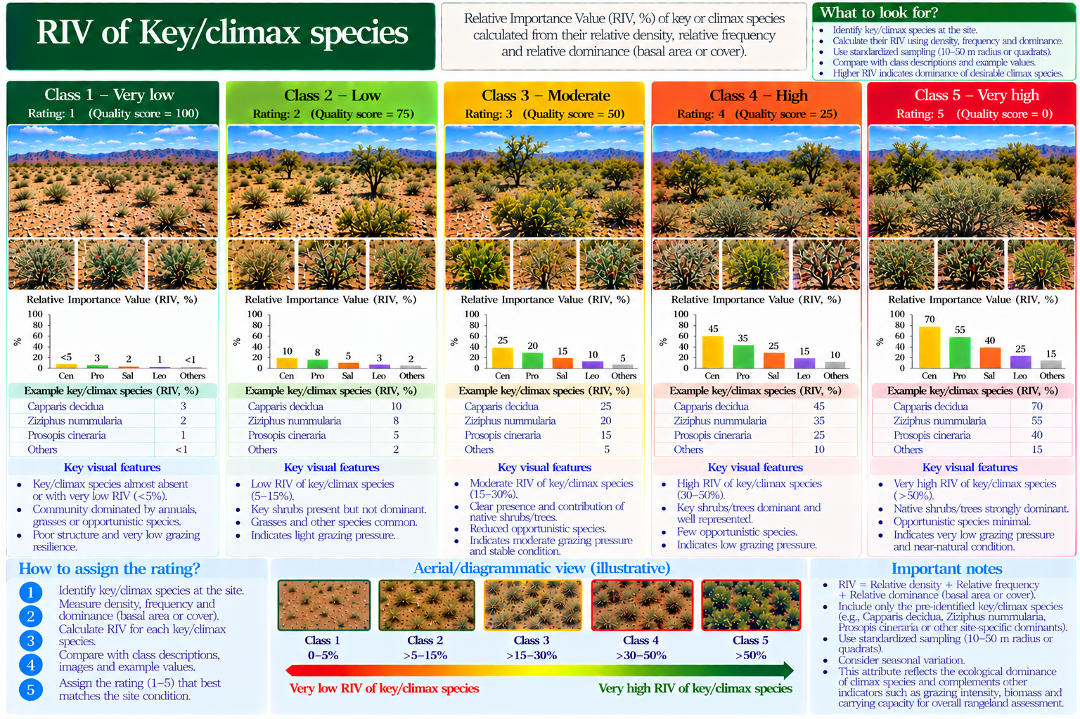

24. % decline in total number of plants/ha
Degradation rating | Published / proposed description
1 | 50
2 | 26–40
3 | 41–60
4 | 61–80
5 | >80
Field caution: First value appears as 50 in Table 7; conflicts with prose on page 57; do not auto-classify.
Field evidence: ______________________________ Measurement and units: ______________________________ Selected rating: ______
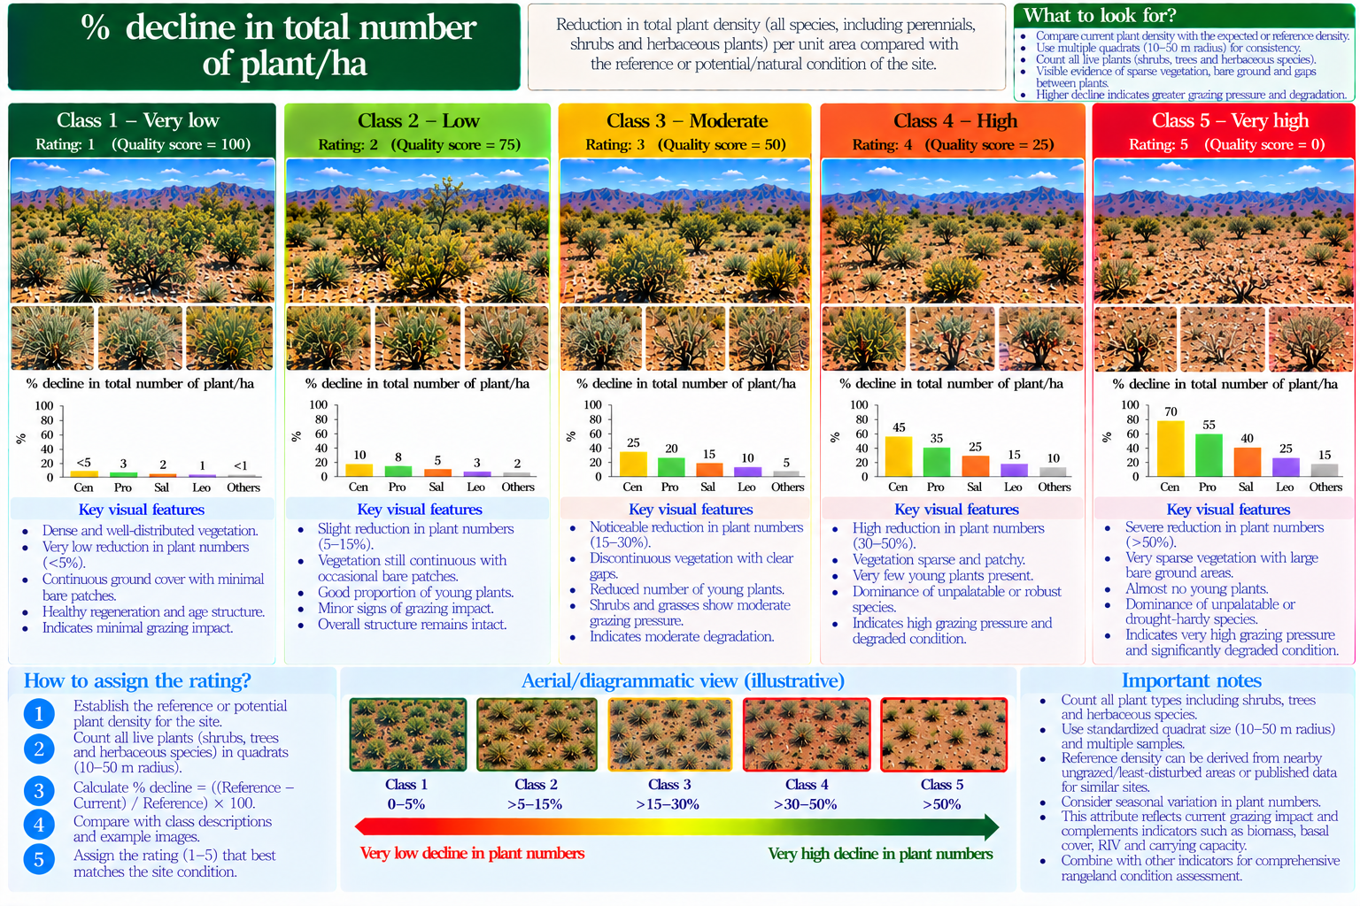

25. Dominance–diversity curves
Degradation rating | Published / proposed description
1 | Lognormal
2 | Partly lognormal
3 | Lognormal to geometric
4 | Geometric
5 | Not available in this rubric
Field caution: Four categories in original.
Field evidence: ______________________________ Measurement and units: ______________________________ Selected rating: ______
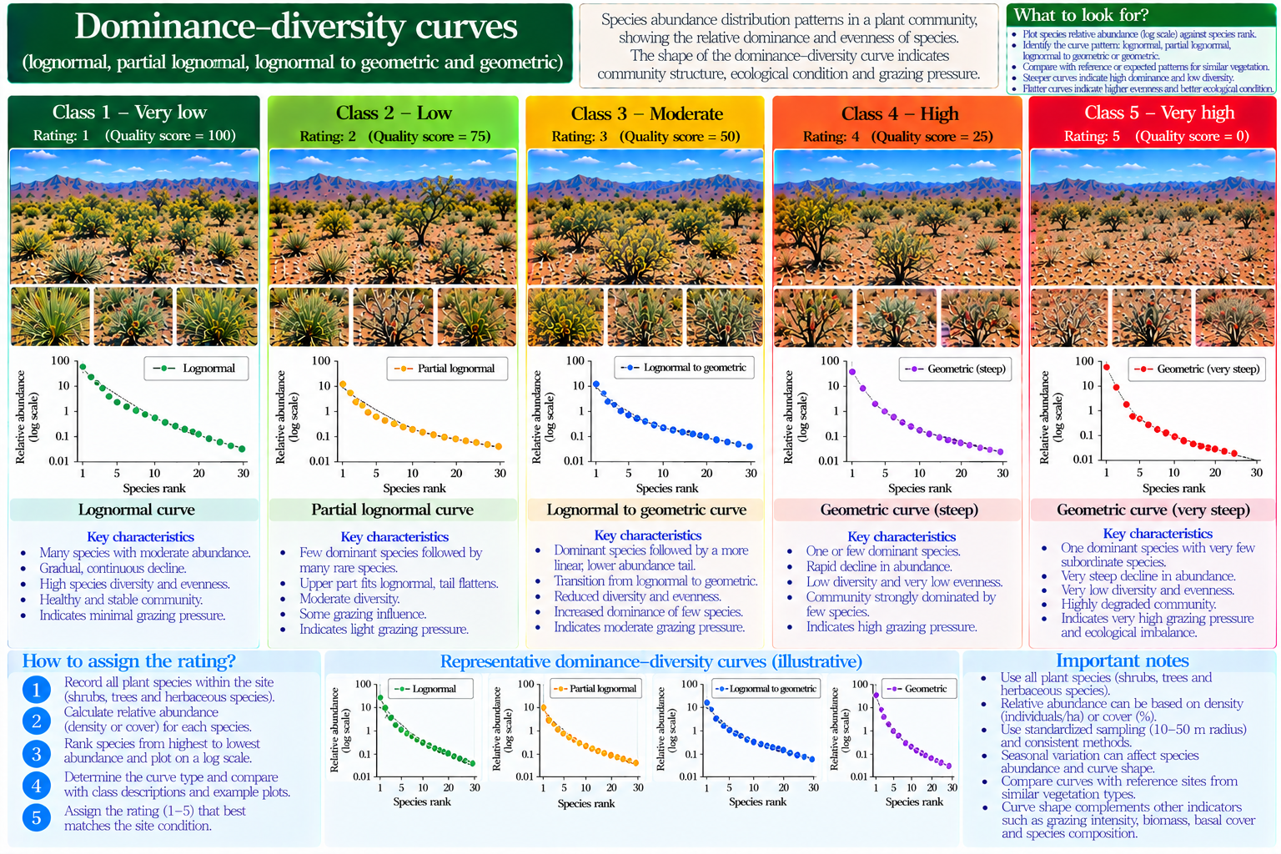

26. Biocrust integrity
Degradation rating | Published / proposed description
1 | Intact expected crusts
2 | Minor localized crust damage
3 | Patchy loss of expected crusts
4 | Extensive disturbed crust patches
5 | Near-complete destruction where crust expected
Field caution: Use only where biocrust is naturally expected; distinguish intact bare soils from degraded crust.
Field evidence: ______________________________ Measurement and units: ______________________________ Selected rating: ______
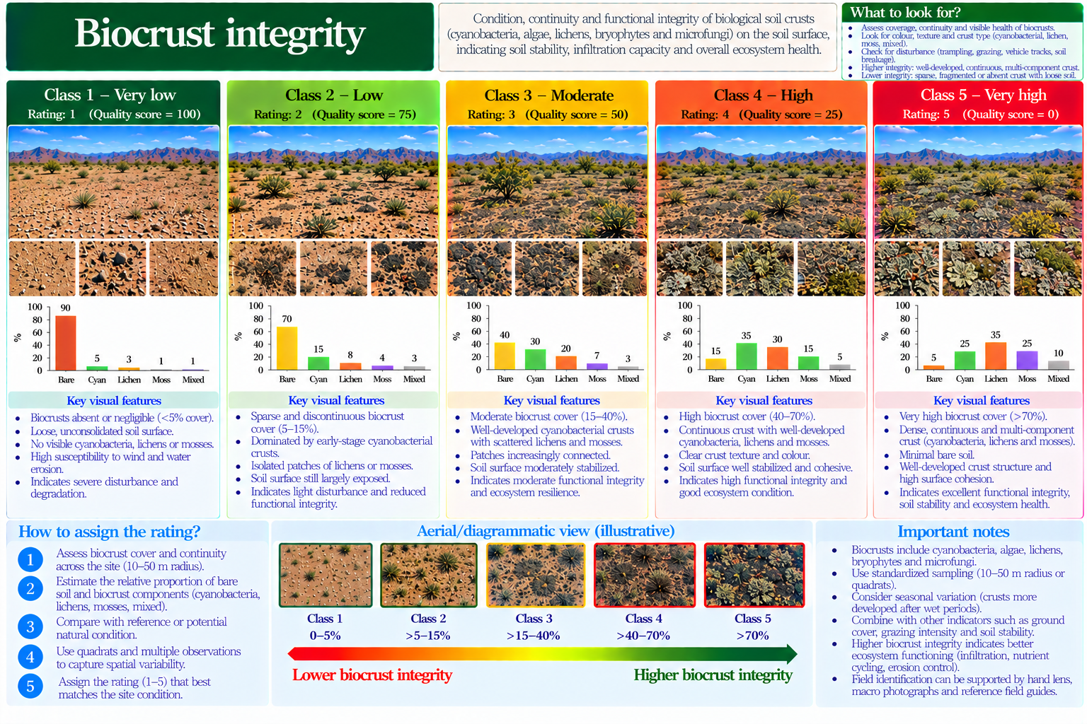

27. Surface infiltration visual proxy
Degradation rating | Published / proposed description
1 | No abnormal ponding under comparable rainfall
2 | Rare short-lived ponding
3 | Localized persistent ponding or runoff
4 | Frequent runoff on comparable soil
5 | Widespread persistent runoff or ponding
Field caution: Visual proxy only; actual infiltration requires a standardized field test.
Field evidence: ______________________________ Measurement and units: ______________________________ Selected rating: ______
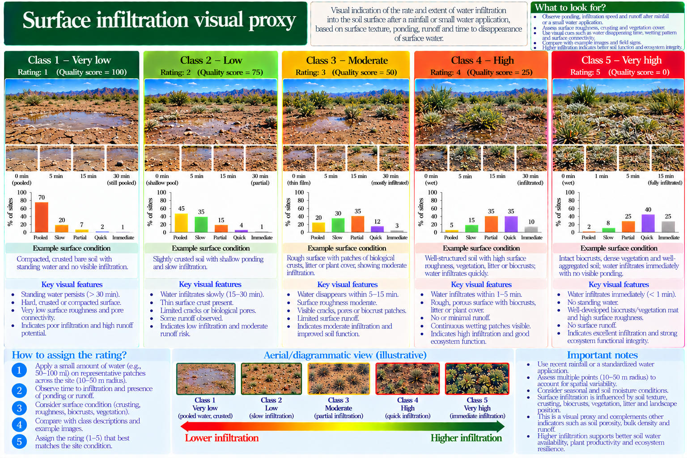

28. Active soil erosion
Degradation rating | Published / proposed description
1 | No active erosion evidence
2 | Occasional minor surface erosion
3 | Localized rills or exposed roots
4 | Extensive rilling and sediment movement
5 | Widespread severe active erosion
Field caution: Distinguish old stable features from active erosion.
Field evidence: ______________________________ Measurement and units: ______________________________ Selected rating: ______
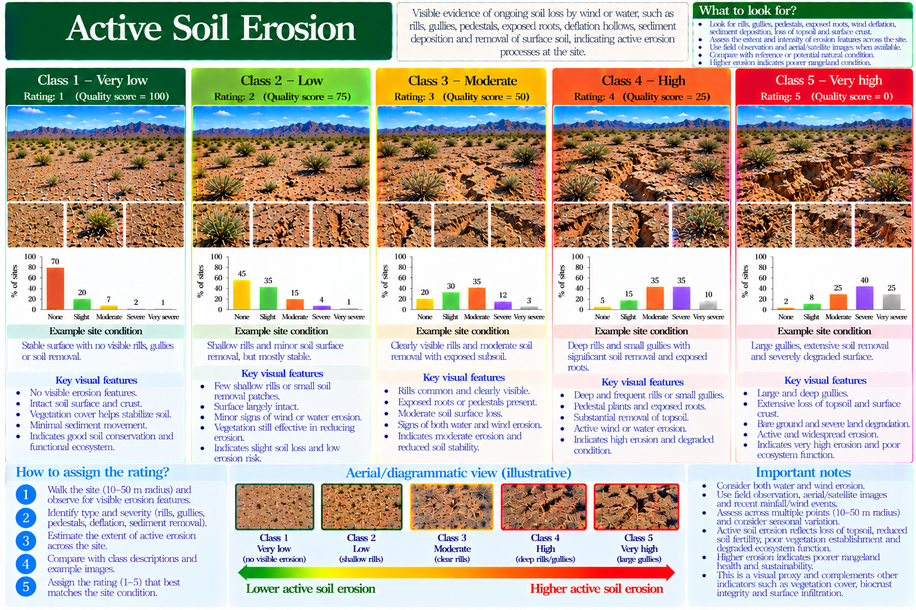

29. Vegetation patch connectivity
Degradation rating | Published / proposed description
1 | Expected functional patches connected
2 | Minor patch separation
3 | Several partly isolated patches
4 | Most patches isolated
5 | Remnant patches severely isolated
Field caution: Compare like-for-like landforms; natural patchiness is not necessarily degradation.
Field evidence: ______________________________ Measurement and units: ______________________________ Selected rating: ______
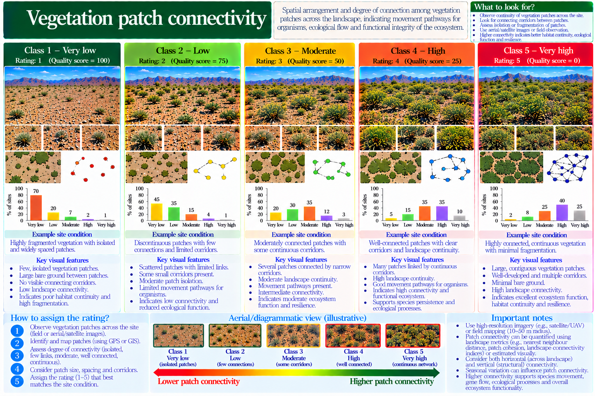

30. Bare-gap continuity
Degradation rating | Published / proposed description
1 | Short disconnected bare gaps
2 | Mostly short gaps with isolated long gaps
3 | Several connected exposed gaps
4 | Frequent long connected bare pathways
5 | Long bare pathways dominate
Field caution: Assess length and connectivity, not just percentage bare ground.
Field evidence: ______________________________ Measurement and units: ______________________________ Selected rating: ______
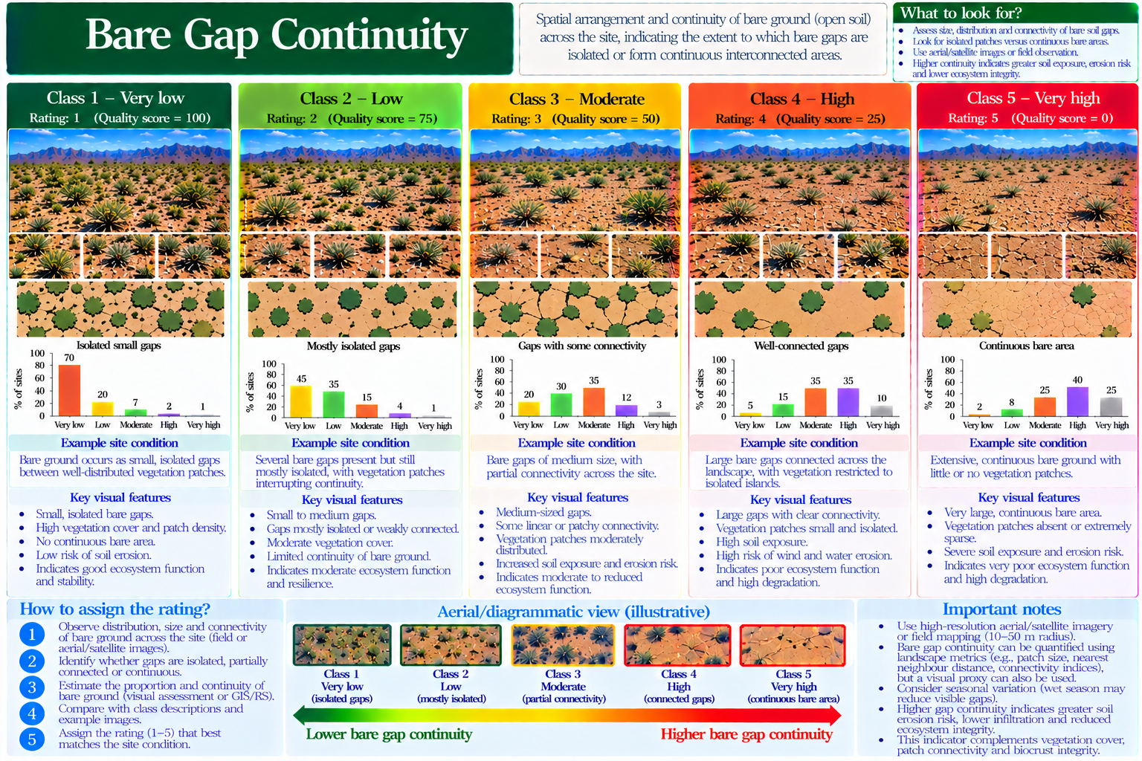

31. Perennial regeneration
Degradation rating | Published / proposed description
1 | Expected juveniles and adults represented
2 | Minor recruitment shortfall
3 | Limited recruitment
4 | Very few juveniles despite opportunity
5 | Persistent recruitment failure
Field caution: A single dry year without seedlings does not establish failure.
Field evidence: ______________________________ Measurement and units: ______________________________ Selected rating: ______
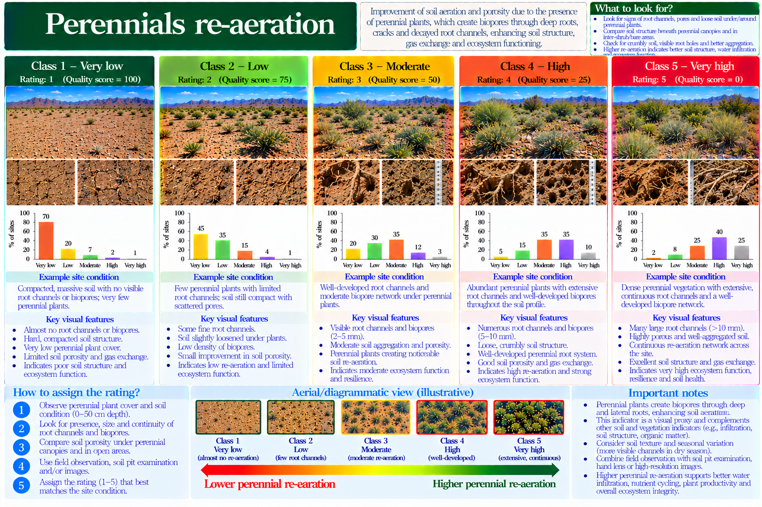

32. Seedling establishment
Degradation rating | Published / proposed description
1 | High documented cohort survival
2 | Minor seedling mortality
3 | Partial establishment failure
4 | Very low survival across observations
5 | Repeated near-total establishment failure
Field caution: Requires repeat observations; visual proxy if only one visit.
Field evidence: ______________________________ Measurement and units: ______________________________ Selected rating: ______
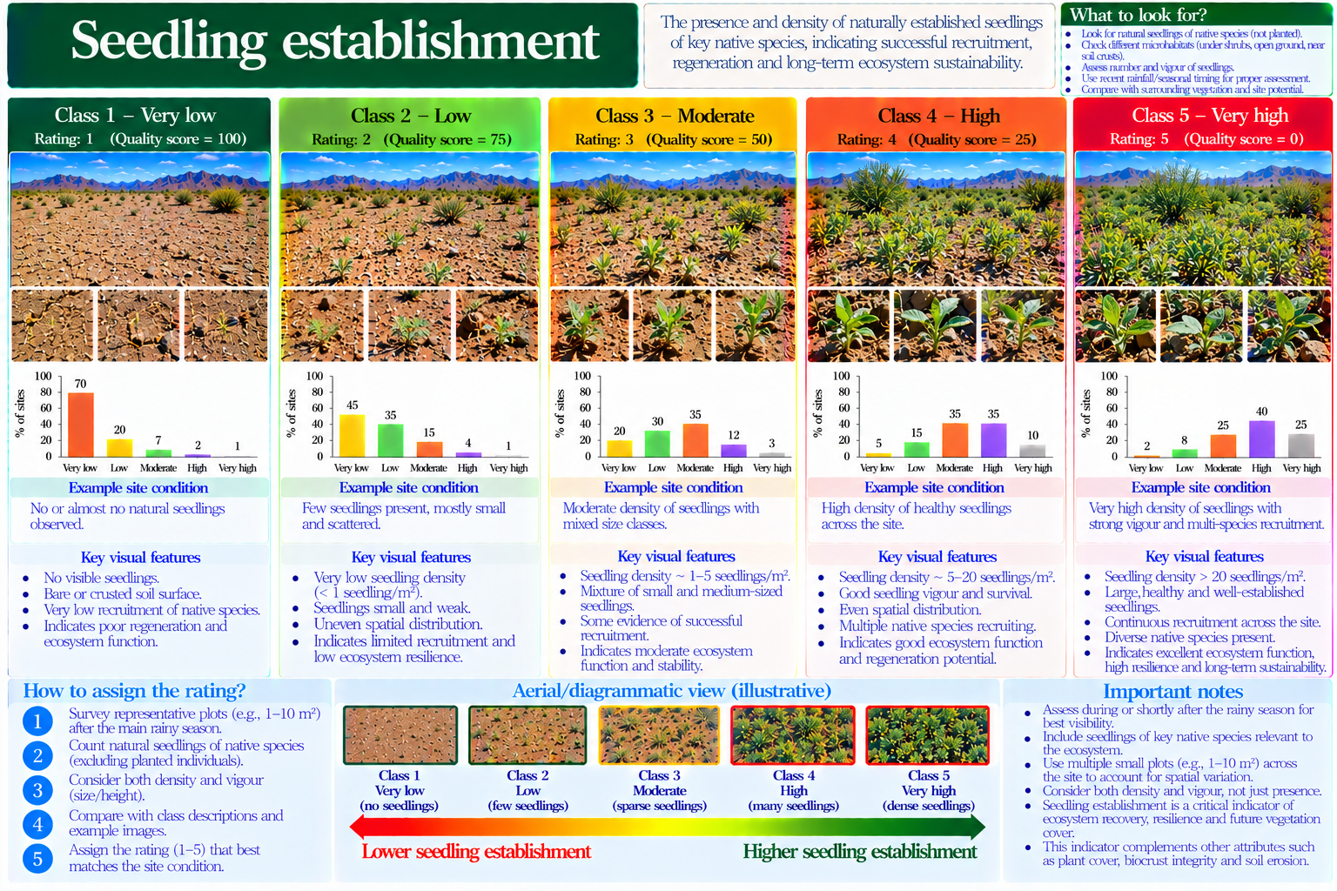

33. Expected functional groups
Degradation rating | Published / proposed description
1 | All expected native groups represented
2 | One expected group slightly reduced
3 | Several expected groups reduced
4 | Most expected groups missing
5 | Near-total loss of expected groups
Field caution: Define expected groups for habitat type before assessment.
Field evidence: ______________________________ Measurement and units: ______________________________ Selected rating: ______
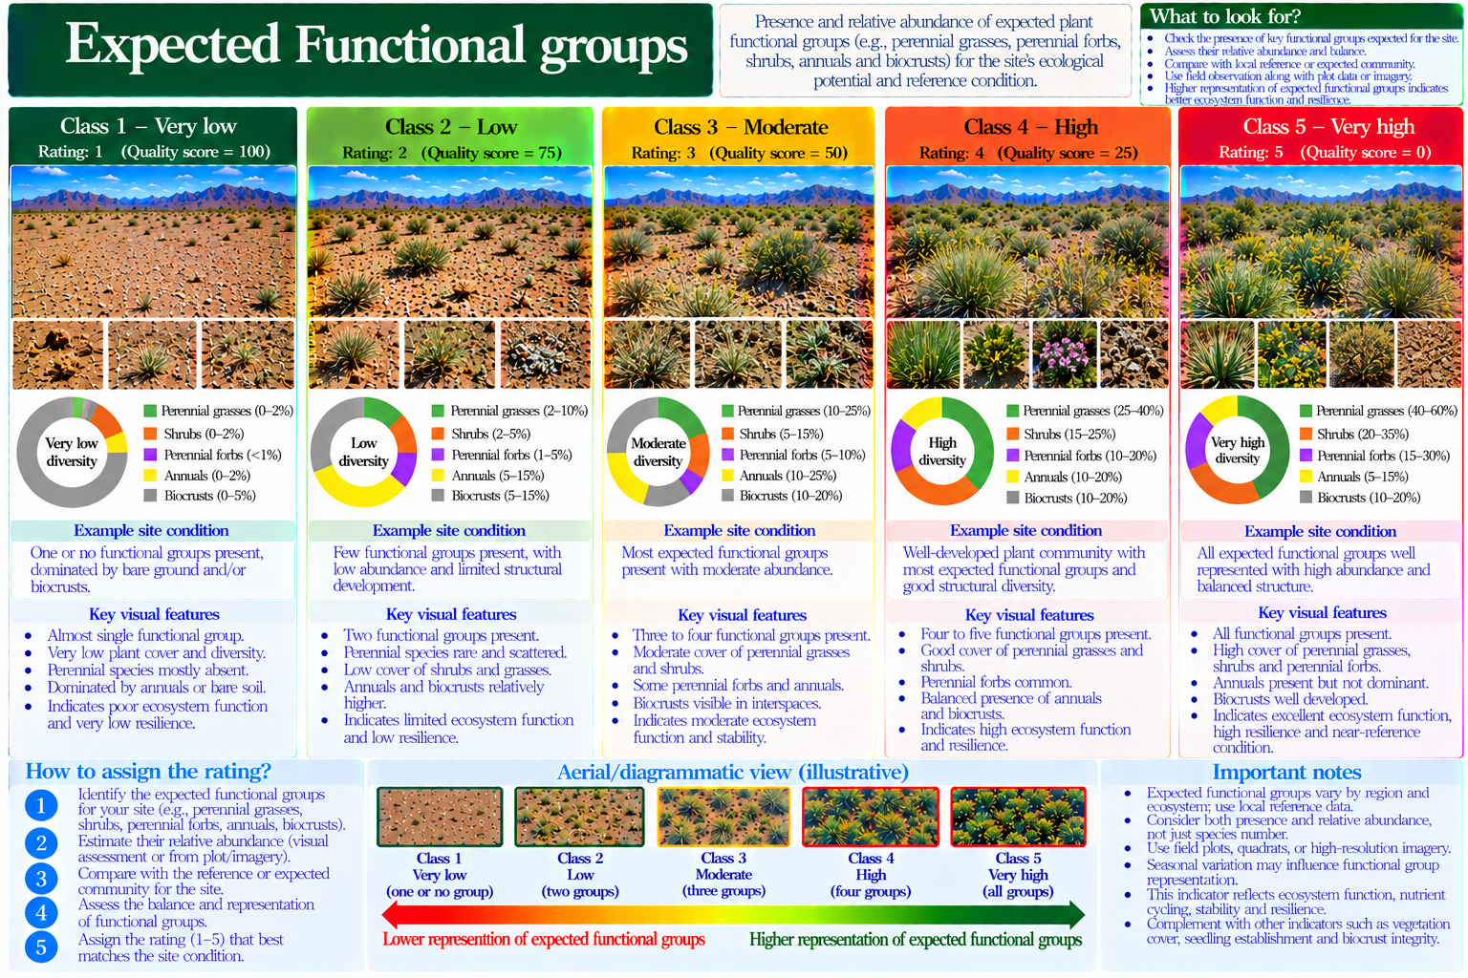

34. Perennial forage persistence
Degradation rating | Published / proposed description
1 | Expected native perennial forage well represented
2 | Minor decline in perennial forage
3 | Noticeable perennial forage reduction
4 | Sparse expected perennial forage
5 | Near absence of expected perennial forage
Field caution: Avoid double-counting Kumar climax-species biomass indicators.
Field evidence: ______________________________ Measurement and units: ______________________________ Selected rating: ______
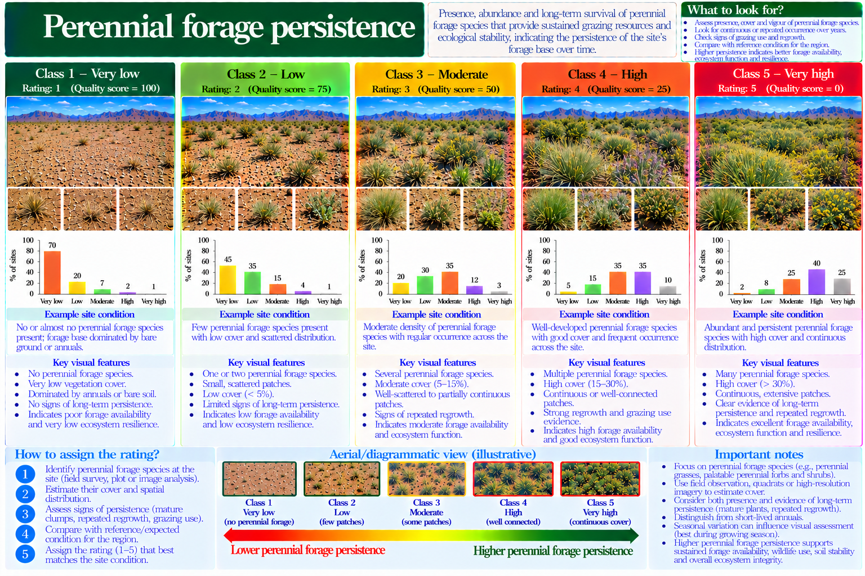

35. Vegetation recovery evidence
Degradation rating | Published / proposed description
1 | Strong documented post-disturbance recovery
2 | Recovery largely complete
3 | Slow or incomplete recovery
4 | Little recovery over repeat visits
5 | Persistent recovery failure
Field caution: Requires repeated visits and comparable rainfall or season.
Field evidence: ______________________________ Measurement and units: ______________________________ Selected rating: ______
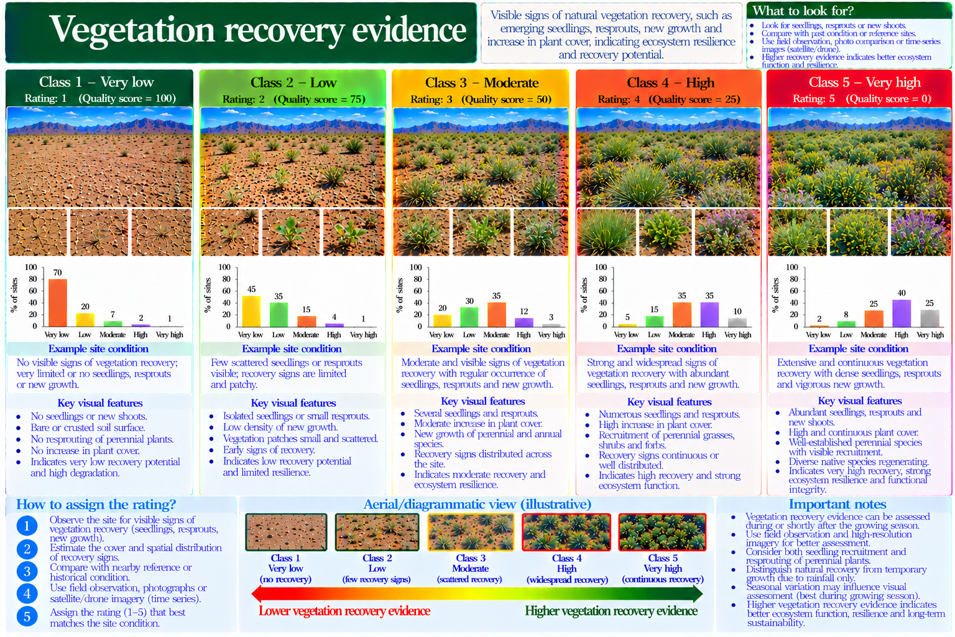

36. Rainfall-adjusted productivity proxy
Degradation rating | Published / proposed description
1 | Productivity consistent with rainfall expectations
2 | Slight repeated underperformance
3 | Moderate repeated underperformance
4 | Marked repeated underperformance
5 | Persistent severe underperformance
Field caution: A rainfall-productivity model is required for quantitative assessment.
Field evidence: ______________________________ Measurement and units: ______________________________ Selected rating: ______
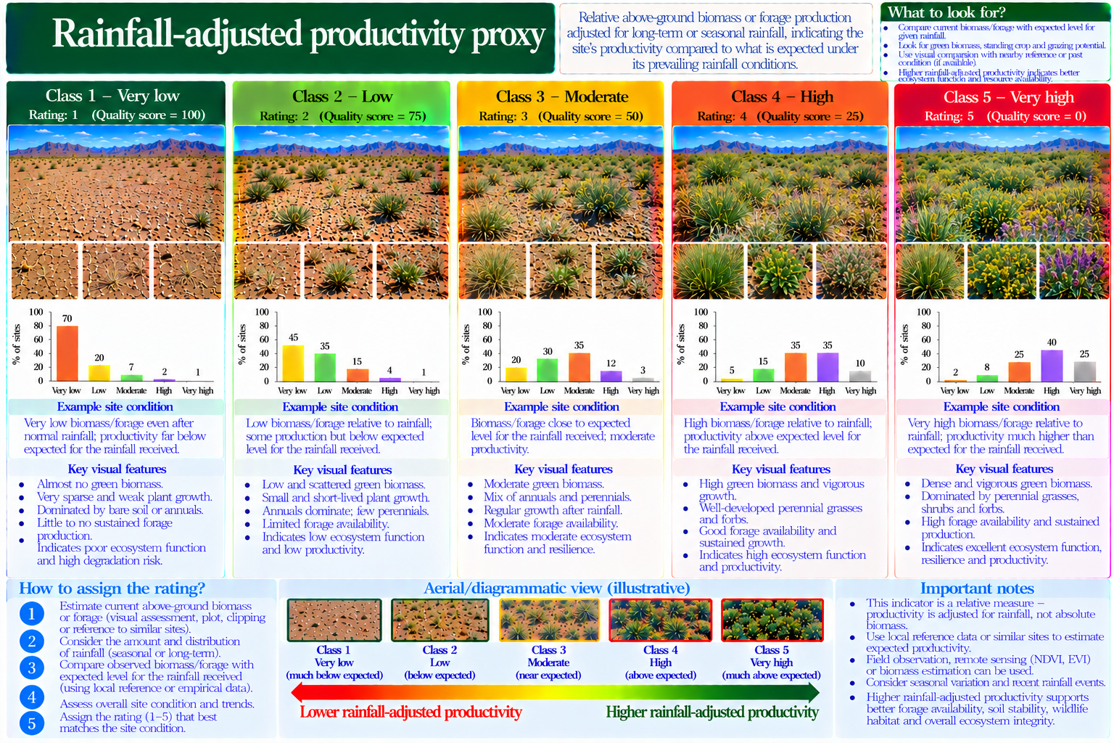

37. Soil surface disturbance
Degradation rating | Published / proposed description
1 | Little damaging surface disturbance
2 | Occasional localized disturbance
3 | Repeated localized trampling or scraping
4 | Extensive disturbed surface
5 | Widespread severe surface disturbance
Field caution: Record disturbance type and distinguish natural soil disturbance.
Field evidence: ______________________________ Measurement and units: ______________________________ Selected rating: ______
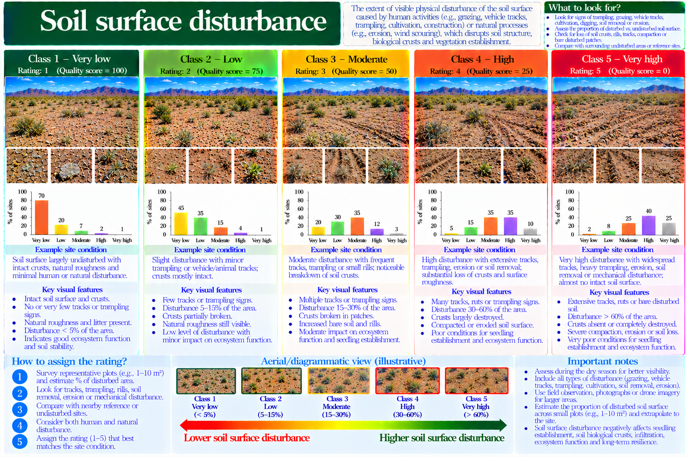

Calculation sheet and interpretation
Normalized degradation: d_i = 25(r_i − 1). Entire vegetation: D_E = Σ(d_1 … d_7)/7. Herbaceous: D_H = Σ(d_8 … d_17)/10. Woody: D_W = Σ(d_18 … d_25)/8. Functional integrity: D_F = Σ(d_26 … d_37)/12. Final: HQI_37 = (D_E + D_H + D_W + D_F)/4, if and only if all 37 indicators are rated.
Illustrative calculation: D_E = 25, D_H = 50, D_W = 25, D_F = 75 gives HQI = 43.75 (Slight, provisional). Higher HQI indicates greater degradation. Class limits: 0–25 None; >25–50 Slight; >50–70 Moderate; >70–90 Severe; >90–100 Very severe.
Methodological provenance: first 25 from Kumar (1992) as represented in the release scorecard; last 12 are proposed AridHab-Q rubrics. Supporting conceptual literature: USDA–NRCS Pasture Condition Score Sheet (2001) and Pyke et al. (2002).

