**DWDM MINI PROJECT**

**Aim: Data analyzing using orange software.**

1:First load csv file by clicking on import csv from menu, Now csv file import icon will be seen on the screen.

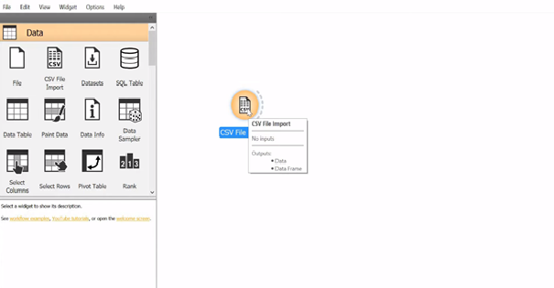

2:Now double click on the csv file and from the dropdown list select the csv file from your device.

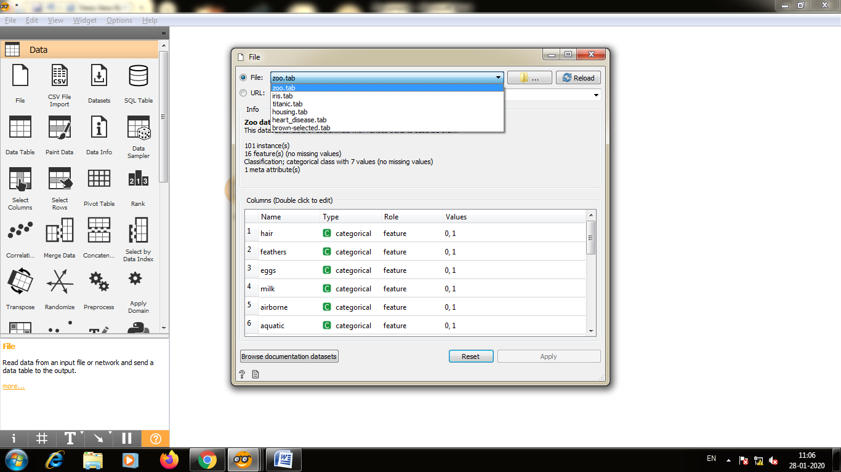

3: Now if you want to see data table click drag and type data table and click on it.

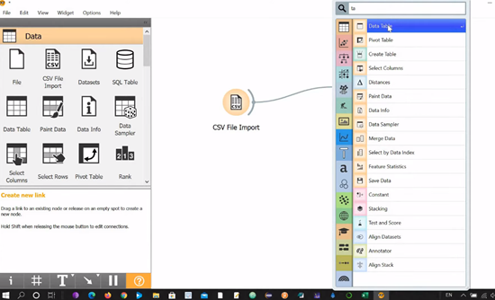

4: Double click on data table to view table

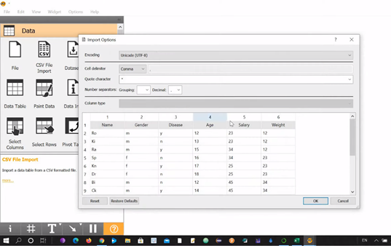

5.To view data in scatter plot, click on csv file drag a line and type scatter plot.

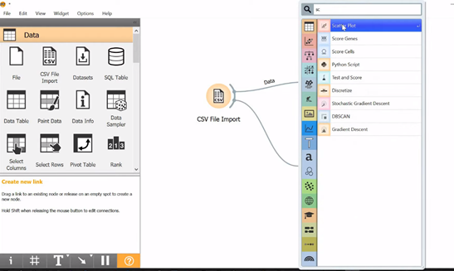

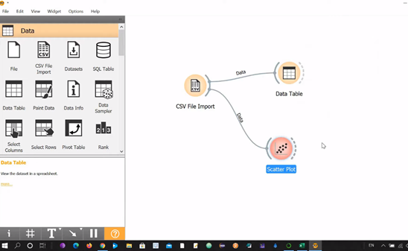

6.click on scatter plot to view scatter plot of the data table.



7.Now to view box plot drag a line from csv and type box plot.

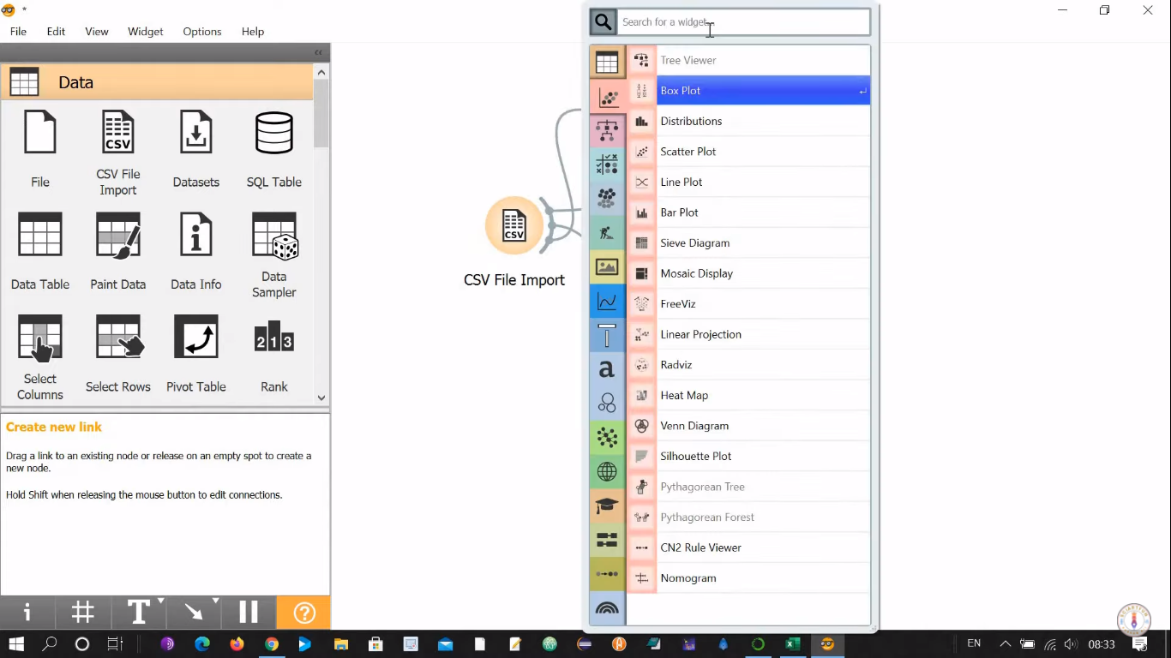

8.To view box plot on data table double click on the box plot.Box plot are seen for numeric data only.

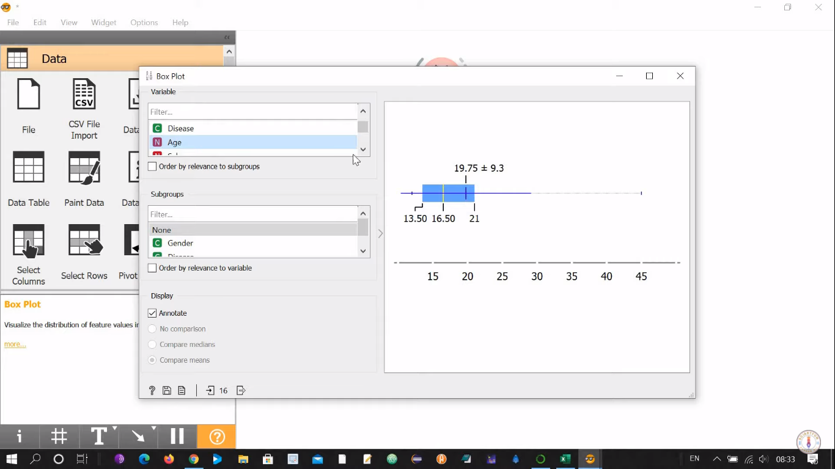

9.Now to view data in histogram drag a line type distribution.

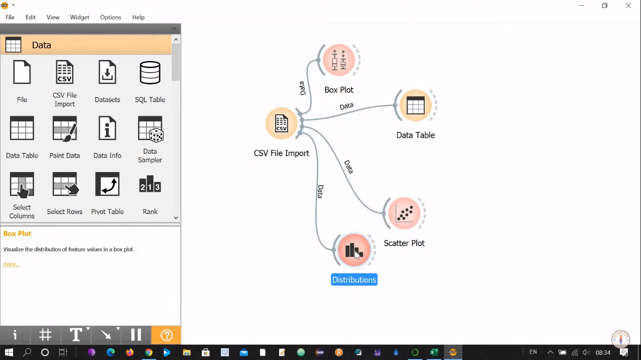

10.Double click on the distribution to view data in histogram format.

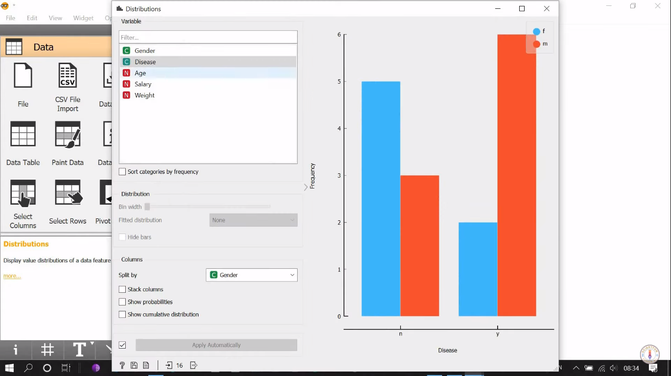

11.We can view different histogram for different columns.By clicking on the column.

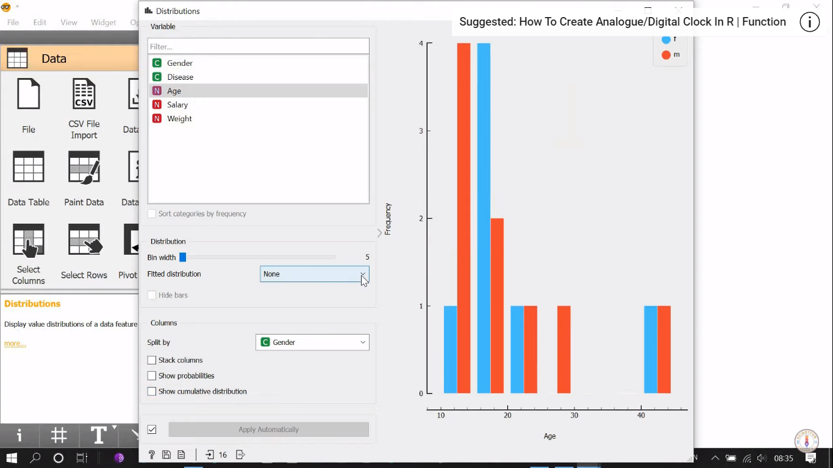

12.Now to view pie chart drag a line from csv and type pie chart

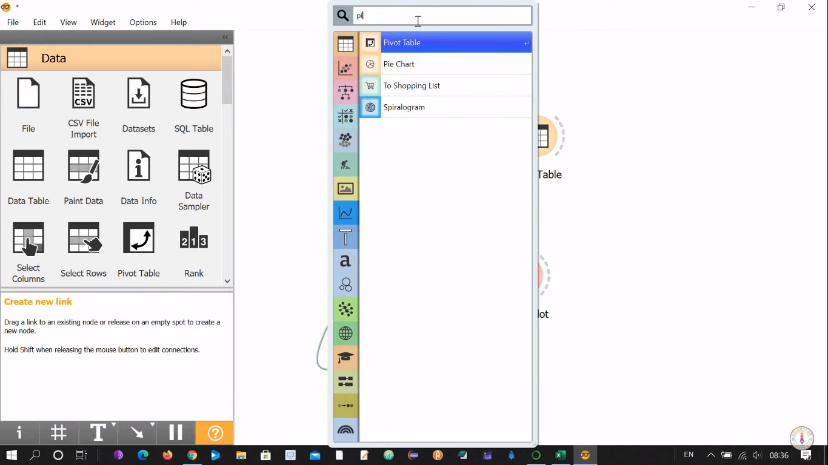

13.Double click on the pie chart to view pie chart for data table by choosing different columns we can view pie chart for that columns.

