Bioinformatics practical 6

Aim : **Perform a BLAST search on a specific gene sequence of a specify organism. Steps:**

1.Go to the National Center for Biotechnology Information Site https://www.ncbi.nlm.nih.gov/

2.Select Nucleotide from All Databases and find any organism in a search bar.

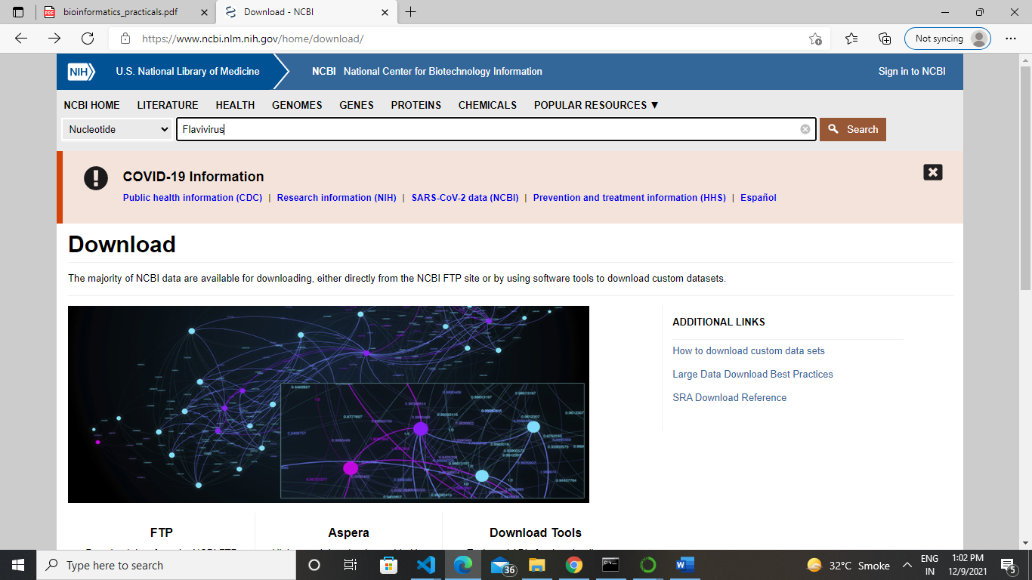

3. Now select anyone organism from the below displayed list.

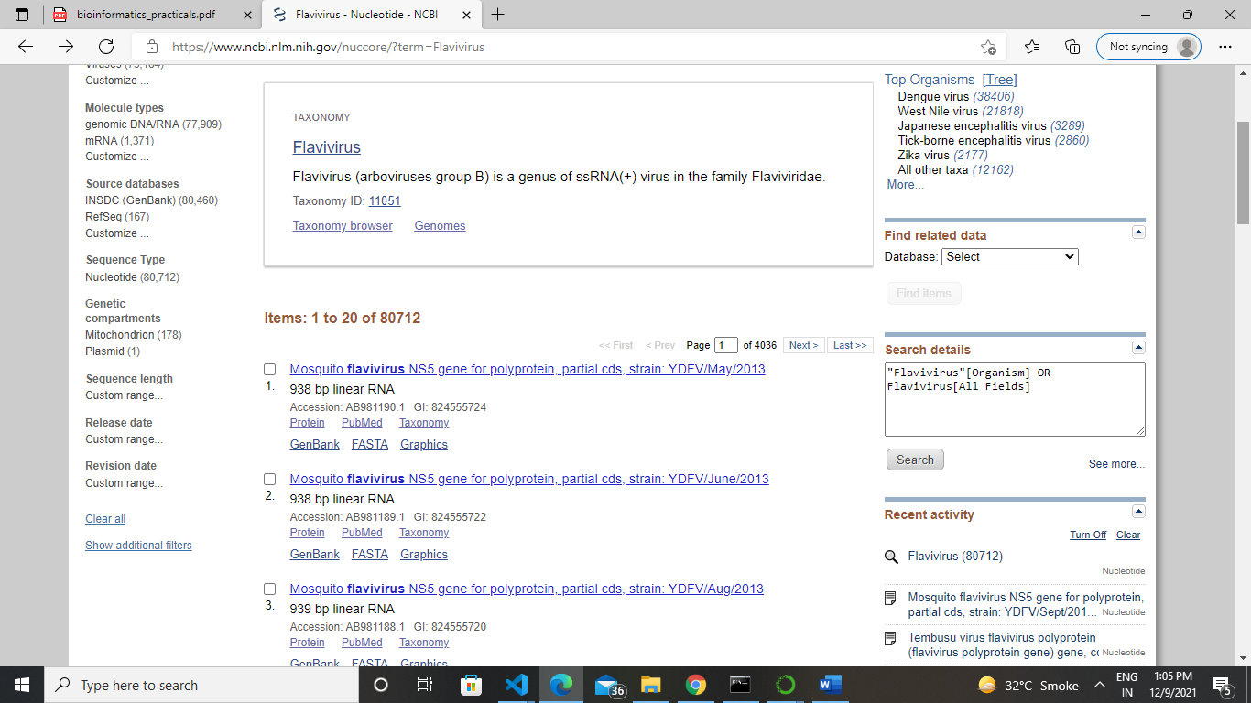

4. Now Run Blast

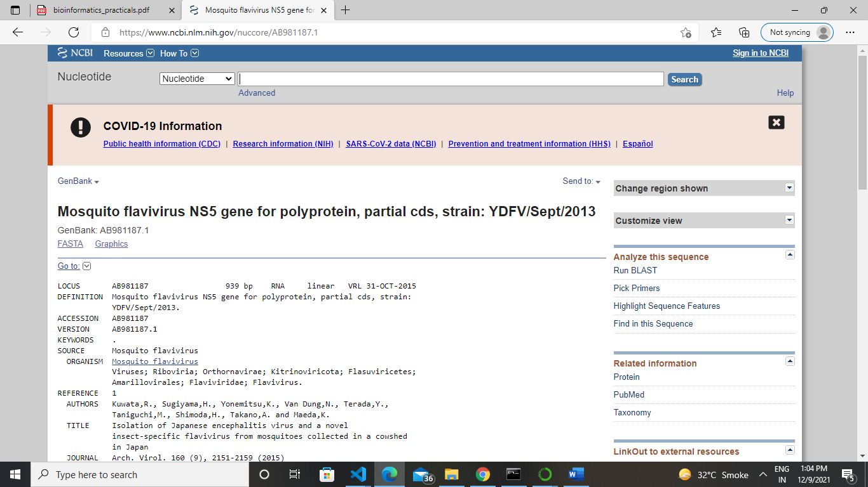

5. Now click on the blast button

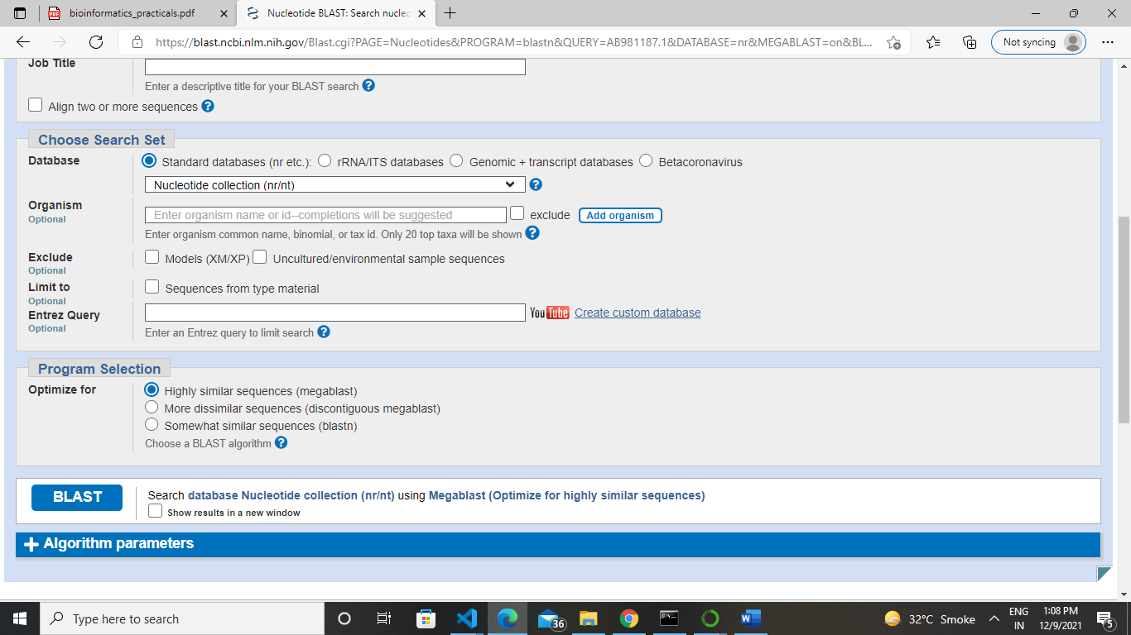

6.Now click on any below sequence.

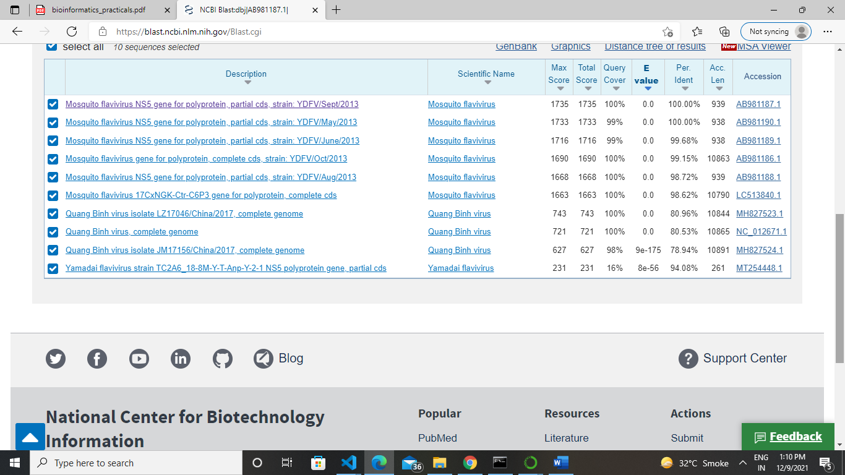

7. Here the result will be display

