**BIBD Mini Project**

**Name:Ravina yadav**

**Roll No. : 32**

**Subject:Msc-C.S part-1**

**Aim:** Implementation of NOSQL database using mongodb.

**Step1:** We need to download mongodb from <https://www.mongodb.com/> website.

**Step2:** After successfully downloading mongodb we need to install it in our system.

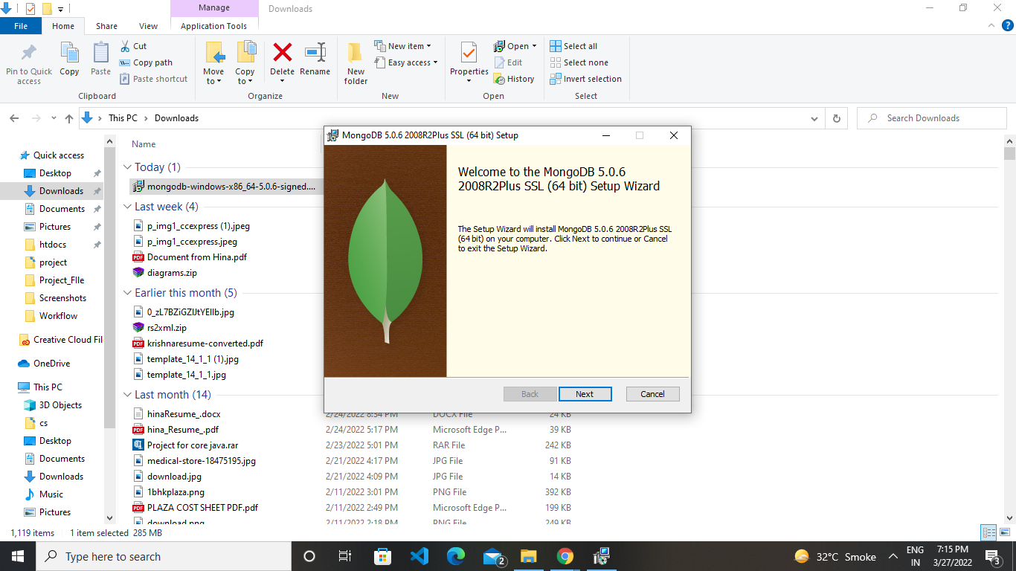

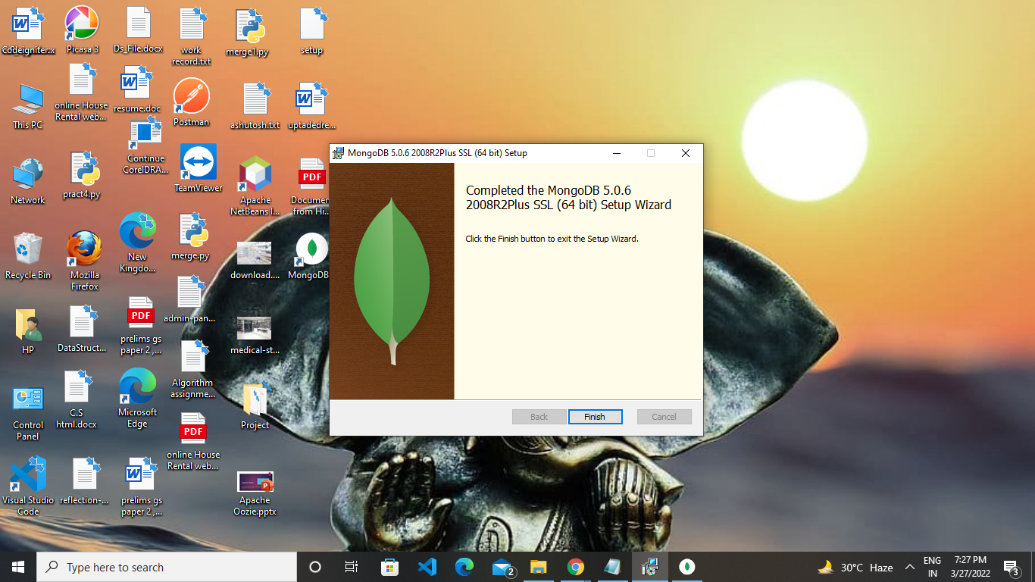

**Step3:** After successfully installation of the mongodb we need to set path variable of the bin file of mongodb in environment in system

.eg “C:\Program Files\MongoDB\Server\5.0\bin”

**Step4:** After setting path variable we can easily use mongo command in cmd and run mongodb shell.

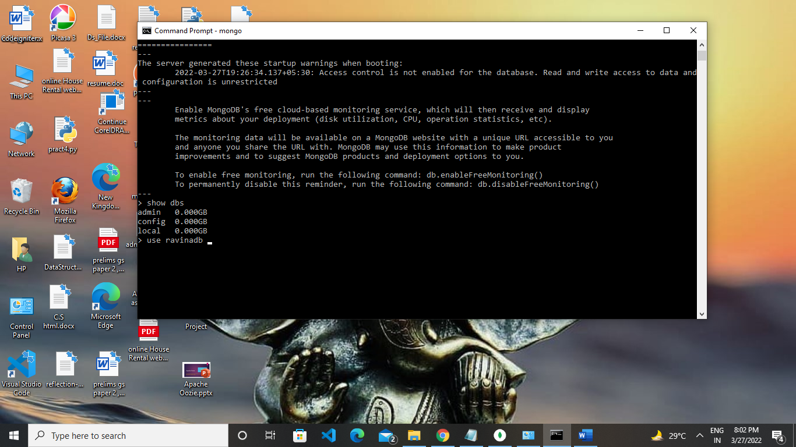

**Step5:** show dbs command shows the database available in mongodb.

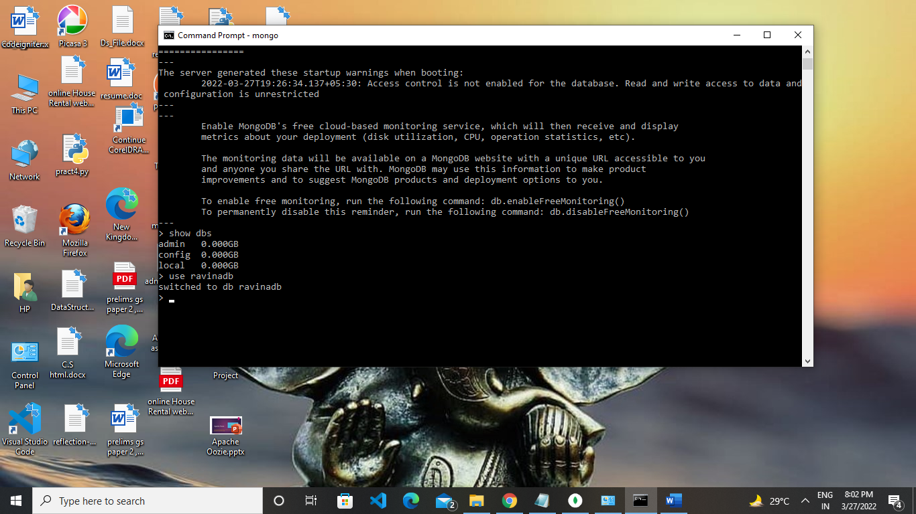

**Step6:** To create our own database in mongodb we need to write

“**use databasename”**

Eg. use ravinadb (here ravinadb is the name of data base)

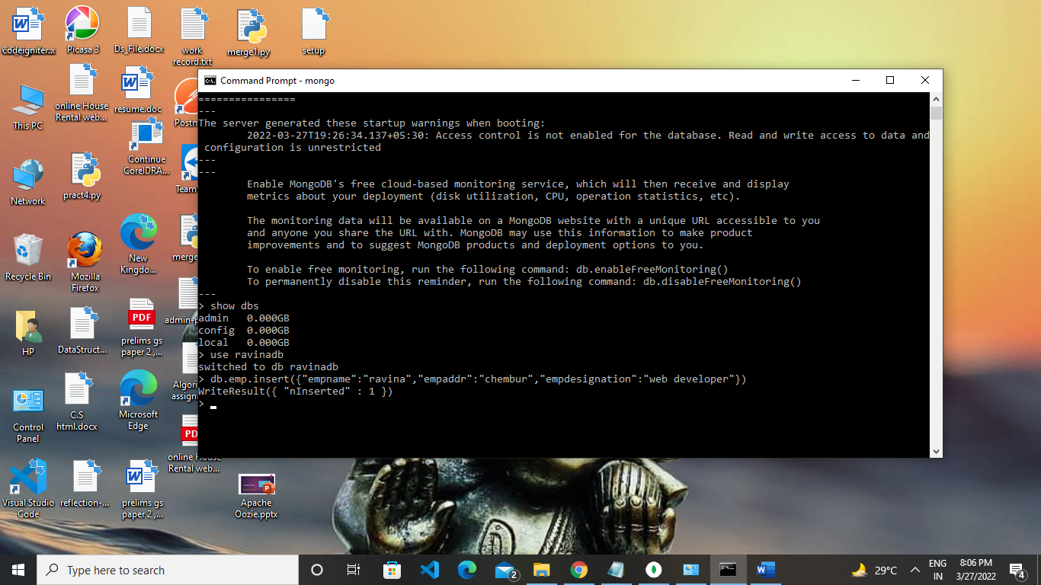

**Step7:** To create collection in database we need to write

**Code**:

db.emp.insert({"empname":"ravina","empaddr":"chembur","empdesignation":"web developer"})

**Output**:

WriteResult({ "nInserted" : 1 })

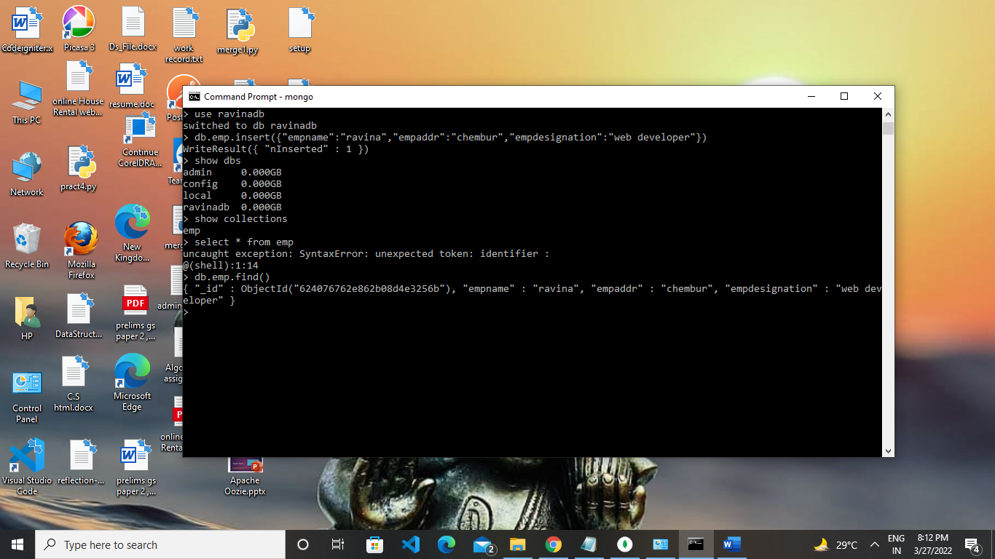

**Step8:** To view our collection we need command “**show collections**” and to display record of collection we need to write command “**db.emp.find()**” or “**db.emp.find().pretty()**”

