**PRACTICAL 1 (SIMPLE LINEAR REGRESSION)**

**CODE AND OUTPUTS:**

**import** numpy **as** np

**import** matplotlib.pyplot **as** plt

**import** pandas **as** pd

dataset **=** pd**.**read_csv("Salary_Data.csv")

X **=** dataset**.**iloc[ : , : **-**1]**.**values

y **=** dataset**.**iloc[ : , **-**1]**.**values

**from** sklearn.model_selection **import** train_test_split

X_train, X_test, y_train, y_test **=** train_test_split(X, y, test_size **=** 1**/**4, random_state **=** 0)

**from** sklearn.linear_model **import** LinearRegression

linear_regression **=** LinearRegression()

linear_regression**.**fit(X_train, y_train)

y_train_pred **=** linear_regression**.**predict(X_train)

y_test_pred **=** linear_regression**.**predict(X_test)

plt**.**scatter(X_train, y_train, color **=** "green", marker **=** "+", label **=** "Observed data")

plt**.**plot(X_train, y_train_pred, color **=** "red", label **=** "Predicted data")

plt**.**xlabel("Years of experience")

plt**.**ylabel("Salary")

plt**.**title("Years of experience v/s Salary (Training dataset)")

plt**.**legend()

plt**.**show()

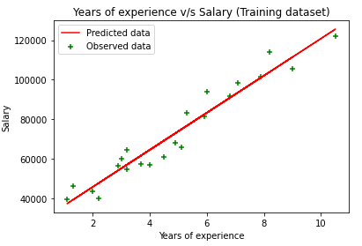

plt**.**scatter(X_test, y_test, color **=** "green", marker **=** "+", label **=** "Observed data")

plt**.**plot(X_test, y_test_pred, color **=** "red", label **=** "Predicted data")

plt**.**xlabel("Years of experience")

plt**.**ylabel("Salary")

plt**.**title("Years of experience v/s Salary (Testing dataset)")

plt**.**legend()

plt**.**show()

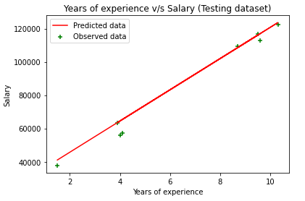

**PRACTICAL 2 (MULTIPLE LINEAR REGRESSION)**

**CODE AND OUTPUTS:**

**import** numpy **as** np

**import** matplotlib.pyplot **as** plt

**import** pandas **as** pd

dataset **=** pd**.**read_csv('/content/50_Startups-2.csv')

x **=** dataset**.**iloc[:, :**-**1]**.**values

y **=** dataset**.**iloc[:, **-**1]**.**values

**from** sklearn.compose **import** ColumnTransformer

**from** sklearn.preprocessing **import** OneHotEncoder

ct **=** ColumnTransformer(transformers**=**[('encoder', OneHotEncoder(), [3])], remainder**=**'passthrough')

x **=** np**.**array(ct**.**fit_transform(x))

**from** sklearn.model_selection **import** train_test_split

x_train, x_test, y_train, y_test **=** train_test_split(x, y, test_size**=**0.2, random_state**=**0)

In [10]:

**from** sklearn.linear_model **import** LinearRegression

regressor **=** LinearRegression()

regressor**.**fit(x_train, y_train)

y_pred **=** regressor**.**predict(x_test)

np**.**set_printoptions(precision**=**2)

print(np**.**concatenate((y_pred**.**reshape(len(y_pred),1), y_test**.**reshape(len(y_test),1)),1))

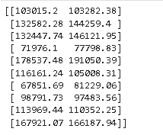

**PRACTICAL 3 (SUPPORT VECTOR MACHINE)**

**CODE AND OUTPUTS:**

**import** matplotlib.pyplot **as** plt

**import** numpy **as** np

**import** pandas **as** pd

dataset **=** pd**.**read_csv('/content/Social_Network_Ads.csv')

x **=** dataset**.**iloc[:, :**-**1]**.**values

y **=** dataset**.**iloc[:, **-**1]**.**values

**from** sklearn.model_selection **import** train_test_split

x_train, x_test, y_train, y_test **=** train_test_split(x, y, test_size**=**0.25, random_state**=**0)

**from** sklearn.preprocessing **import** StandardScaler

sc **=** StandardScaler()

x_train **=** sc**.**fit_transform(x_train)

x_test **=** sc**.**transform(x_test)

**from** sklearn.svm **import** SVC

classifier **=** SVC(kernel**=**'linear', random_state**=**0)

classifier**.**fit(x_train, y_train)

print(classifier**.**predict(sc**.**transform([[30,200000]])))

[1]

In [20]:

y_pred **=** classifier**.**predict(x_test)

print(np**.**concatenate((y_pred**.**reshape(len(y_pred),1), y_test**.**reshape(len(y_test),1)),1))

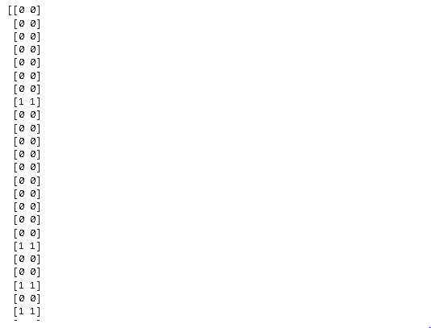

**from** sklearn.metrics **import** confusion_matrix, accuracy_score

cm **=** confusion_matrix(y_test, y_pred)

print(cm)

accuracy_score(y_test, y_pred)



**PRACTICAL 4 (KNN)**

**CODE AND OUTPUTS:**

**import** matplotlib.pyplot **as** plt

**import** pandas **as** pd

**import** numpy **as** np

In [22]:

dataset **=** pd**.**read_csv('/content/Social_Network_Ads.csv')

x **=** dataset**.**iloc[:, :**-**1]**.**values

y **=** dataset**.**iloc[:, **-**1]**.**values

**from** sklearn.model_selection **import** train_test_split

x_train, x_test, y_train, y_test **=** train_test_split(x, y, test_size**=**0.25, random_state**=**0)

**from** sklearn.preprocessing **import** StandardScaler

sc **=** StandardScaler()

x_train **=** sc**.**fit_transform(x_train)

x_test **=** sc**.**transform(x_test)

**from** sklearn.neighbors **import** KNeighborsClassifier

classifier **=** KNeighborsClassifier(n_neighbors**=**5, metric**=**'minkowski', p**=**2)

classifier**.**fit(x_train, y_train)

Out[33]:

KNeighborsClassifier()

In [34]:

print(classifier**.**predict(sc**.**transform([[40, 200000]])))

[1]

y_pred **=** classifier**.**predict(x_test)

print(np**.**concatenate((y_pred**.**reshape(len(y_pred),1), y_test**.**reshape(len(y_test),1)),1))

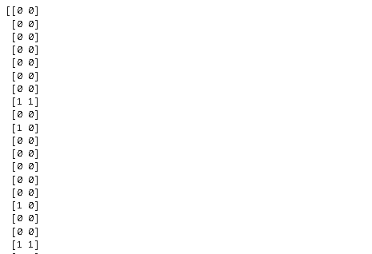

**from** sklearn.metrics **import** confusion_matrix, accuracy_score

cm **=** confusion_matrix(y_test, y_pred)

print(cm)

accuracy_score(y_test, y_pred)

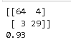

**PRACTICAL 5 (HEIRARCHICAL CLUSTERING)**

**CODE AND OUTPUTS:**

**import** numpy **as** np

**import** pandas **as** pd

**import** matplotlib.pyplot **as** plt

In [9]:

dataset **=** pd**.**read_csv('/content/Mall_Customers.csv')

X **=** dataset**.**iloc[:, [3,4]]**.**values

**from** sklearn.cluster **import** AgglomerativeClustering

hc **=** AgglomerativeClustering(n_clusters**=**5, affinity**=**'euclidean', linkage**=**'ward')

y_hc **=** hc**.**fit_predict(X)

plt**.**scatter(X[y_hc**==**0,0], X[y_hc**==**0,1], s**=**100, c**=**'red', label**=**'Cluster 1')

plt**.**scatter(X[y_hc**==**1,0], X[y_hc**==**1,1], s**=**100, c**=**'green', label**=**'Cluster 2')

plt**.**scatter(X[y_hc**==**2,0], X[y_hc**==**2,1], s**=**100, c**=**'blue', label**=**'Cluster 3')

plt**.**scatter(X[y_hc**==**3,0], X[y_hc**==**3,1], s**=**100, c**=**'cyan', label**=**'Cluster 4')

plt**.**scatter(X[y_hc**==**4,0], X[y_hc**==**4,1], s**=**100, c**=**'magenta', label**=**'Cluster 5')

plt**.**title('Clusters of customers')

plt**.**xlabel('Annual Income (k$)')

plt**.**ylabel('Spending Score (1-100)')

plt**.**legend()

plt**.**show()

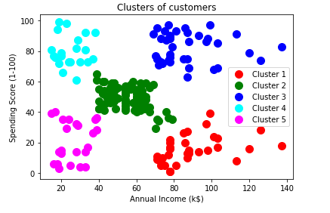

**PRACTICAL 6 (K MEANS CLUSTERING)**

**CODE AND OUTPUTS:**

**import** numpy **as** np

**import** matplotlib.pyplot **as** plt

**import** pandas **as** pd

In [2]:

dataset **=** pd**.**read_csv('Mall_Customers.csv')

X **=** dataset**.**iloc[:, [3, 4]]**.**values

In [3]:

**from** sklearn.cluster **import** KMeans

kmeans **=** KMeans(n_clusters **=** 5, init **=** 'k-means++', random_state **=** 42)

y_kmeans **=** kmeans**.**fit_predict(X)

print(y_kmeans)

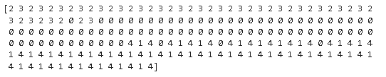

plt**.**scatter(X[y_kmeans **==** 0, 0], X[y_kmeans **==** 0, 1], s **=** 100, c **=** 'red', label **=** 'Cluster 1')

plt**.**scatter(X[y_kmeans **==** 1, 0], X[y_kmeans **==** 1, 1], s **=** 100, c **=** 'blue', label **=** 'Cluster 2')

plt**.**scatter(X[y_kmeans **==** 2, 0], X[y_kmeans **==** 2, 1], s **=** 100, c **=** 'green', label **=** 'Cluster 3')

plt**.**scatter(X[y_kmeans **==** 3, 0], X[y_kmeans **==** 3, 1], s **=** 100, c **=** 'cyan', label **=** 'Cluster 4')

plt**.**scatter(X[y_kmeans **==** 4, 0], X[y_kmeans **==** 4, 1], s **=** 100, c **=** 'magenta', label **=** 'Cluster 5')

plt**.**scatter(kmeans**.**cluster_centers_[:, 0], kmeans**.**cluster_centers_[:, 1], s **=** 300, c **=** 'yellow', label **=** 'Centroids')

plt**.**title('Clusters of customers')

plt**.**xlabel('Annual Income (k$)')

plt**.**ylabel('Spending Score (1-100)')

plt**.**legend()

plt**.**show()

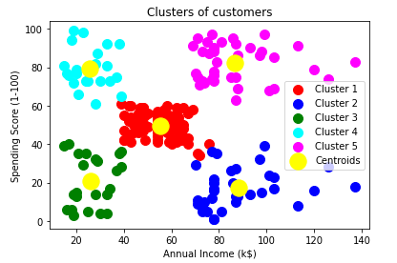

**PRACTICAL 7 (ANN)**

**CODE AND OUTPUTS:**

**import** numpy **as** np

**import** pandas **as** pd

**import** tensorflow **as** tf

In [3]:

dataset **=** pd**.**read_csv('Churn_Modelling.csv')

X **=** dataset**.**iloc[:, 3:**-**1]**.**values

y **=** dataset**.**iloc[:, **-**1]**.**values

**from** sklearn.preprocessing **import** LabelEncoder

le **=** LabelEncoder()

X[:, 2] **=** le**.**fit_transform(X[:, 2])

In [7]:

print(X)

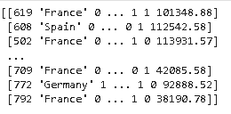

**from** sklearn.compose **import** ColumnTransformer

**from** sklearn.preprocessing **import** OneHotEncoder

ct **=** ColumnTransformer(transformers**=**[('encoder', OneHotEncoder(), [1])], remainder**=**'passthrough')

X **=** np**.**array(ct**.**fit_transform(X))

print(X)

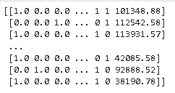

**from** sklearn.model_selection **import** train_test_split

X_train, X_test, y_train, y_test **=** train_test_split(X, y, test_size **=** 0.2, random_state **=** 0)

In [11]:

**from** sklearn.preprocessing **import** StandardScaler

sc **=** StandardScaler()

X_train **=** sc**.**fit_transform(X_train)

X_test **=** sc**.**transform(X_test)

In [12]:

ann **=** tf**.**keras**.**models**.**Sequential()

In [13]:

ann**.**add(tf**.**keras**.**layers**.**Dense(units**=**6, activation**=**'relu'))

In [14]:

ann**.**add(tf**.**keras**.**layers**.**Dense(units**=**6, activation**=**'relu'))

In [15]:

ann**.**add(tf**.**keras**.**layers**.**Dense(units**=**1, activation**=**'sigmoid'))

In [16]:

ann**.**compile(optimizer **=** 'adam', loss **=** 'binary_crossentropy', metrics **=** ['accuracy'])

In [17]:

ann**.**fit(X_train, y_train, batch_size **=** 32, epochs **=** 100)

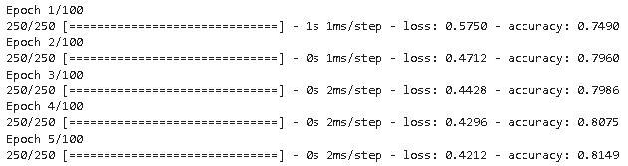

print(ann**.**predict(sc**.**transform([[1, 0, 0, 600, 1, 40, 3, 60000, 2, 1, 1, 50000]])) **>**0.5)



y_pred **=** ann**.**predict(X_test)

y_pred **=** (y_pred **>** 0.5)

print(np**.**concatenate((y_pred**.**reshape(len(y_pred),1), y_test**.**reshape(len(y_test),1)),1))

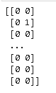

**from** sklearn.metrics **import** confusion_matrix, accuracy_score

cm **=** confusion_matrix(y_test, y_pred)

print(cm)

accuracy_score(y_test, y_pred)



**PRACTICAL 8 (CNN)**

**CODE AND OUTPUTS:**

**import** tensorflow **as** tf

**from** keras.preprocessing.image **import** ImageDataGenerator

In [46]:

train_datagen **=** ImageDataGenerator(rescale**=**1.**/**255, shear_range**=**0.2, zoom_range**=**0.2, horizontal_flip**=True**)

training_set **=** train_datagen**.**flow_from_directory('/content/drive/MyDrive/small_dataset/training_set', target_size**=**(64,64), batch_size**=**32, class_mode**=**'binary')

Found 10 images belonging to 2 classes.

In [48]:

train_datagen **=** ImageDataGenerator(rescale**=**1.**/**255, shear_range**=**0.2, zoom_range**=**0.2, horizontal_flip**=True**)

test_set **=** train_datagen**.**flow_from_directory('/content/drive/MyDrive/small_dataset/test_set', target_size**=**(64,64), batch_size**=**32, class_mode**=**'binary')

Found 10 images belonging to 2 classes.

In [49]:

cnn **=** tf**.**keras**.**models**.**Sequential()

In [50]:

cnn**.**add(tf**.**keras**.**layers**.**Conv2D(filters**=**32, kernel_size**=**3, activation**=**'relu', input_shape**=**[64,64,3]))

In [51]:

cnn**.**add(tf**.**keras**.**layers**.**MaxPool2D(pool_size**=**2, strides**=**2))

In [52]:

cnn**.**add(tf**.**keras**.**layers**.**Conv2D(filters**=**32, kernel_size**=**3, activation**=**'relu'))

cnn**.**add(tf**.**keras**.**layers**.**MaxPool2D(pool_size**=**2, strides**=**2))

In [53]:

cnn**.**add(tf**.**keras**.**layers**.**Flatten())

cnn**.**add(tf**.**keras**.**layers**.**Dense(units**=**128, activation**=**'relu'))

In [55]:

cnn**.**add(tf**.**keras**.**layers**.**Dense(units**=**1, activation**=**'sigmoid'))

In [56]:

cnn**.**compile(optimizer**=**'adam', loss**=**'binary_crossentropy', metrics**=**['accuracy'])

In [57]:

cnn**.**fit(x**=**training_set, validation_data**=**test_set, epochs**=**25)

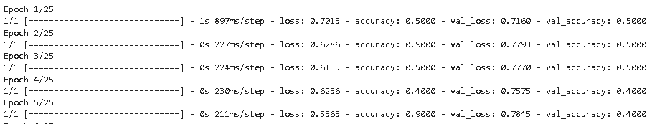

**import** numpy **as** np

**from** keras.preprocessing **import** image

test_image**=**image**.**load_img('/content/drive/MyDrive/small_dataset/single_prediction/cat_or_dog_1.jpg', target_size**=**(64,64))

test_image**=**image**.**img_to_array(test_image)

test_image**=**np**.**expand_dims(test_image, axis**=**0)

result**=**cnn**.**predict(test_image)

training_set**.**class_indices

**if** result[0][0]**==**1:

prediction**=**'dog'

**else**:

prediction**=**'cat'

In [63]:

print(prediction)

