First Round Analysis

Our primary list of customer provided by Salamander focuses on people residing in Ohio area based on which Applecart has generated two target population:

1. Random Target list, which does not specify connections.
2. First-degree connections list which is a target population consisting of first degree connections of the recent customers.

After launching the online ad Campain and sending the online advertisements to the target users we get to observe two distinct activities which include whether or not the user clicked on the advertisement and whether or not the user bought a car.

To know which list performed better we need to know which list prompted more clicks and purchases. Our second best scenario would be the list which prompted more click and no purchases. And for my first round of analysis, I did just that.

As the count of observations on both the lists is not same, I have considered the percentages of the results in the following table:

|  |  |  |
| --- | --- | --- |
|  | One_Degree_Target | Random_Target |
| Not Clicked_Not Bought | 45.78% | 66.28% |
| Not Clicked_Bought | 2.00% | 0.81% |
| Clicked_Not Bought | 50.25% | 32.91 |
| Clicked_Bought | 1.95% | 0 |

The numbers indicate that maximum activity was observed by users on the One_Degree_Target list where 2058 users out of 10553 clicked on the advertisement and bought a car which gives us our conversion rate and 53038 users clicked on the advertisement but did not buy the car which gives us our click rate. Here we can conclude that the One_Degree_Target list did better.

When we correlate these results with the People dataset, we get to observe our users demographics.

1. When we consider gender we can see that there isn't any significant difference between male and female activities. Both have equally chosen to explore the ad and performed to click action. 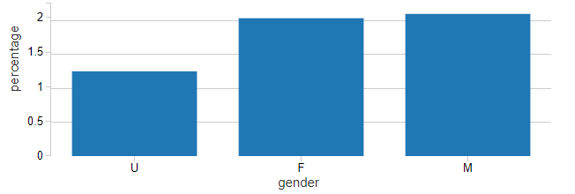
2. When we consider the race, we can see the South Asians have bought the cars by clicking on the ad.

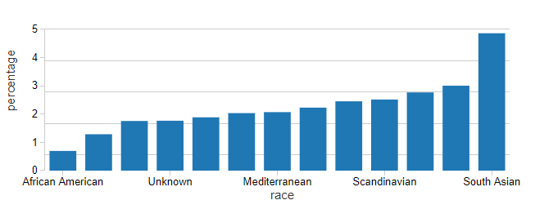

1. Religion-wise Sikhs are most likely to click on the ad and even buy the car.
2. When we look at the family income buckets, max users fall into 300K to 500K bucket
3. And lastly, when we consider the age buckets of our users we find that our max users fall into 51 - 69 age bucket.

Please [click here](https://community.cloud.databricks.com/?o=6033368243101281#notebook/3641334095132572/dashboard/347295811967330/present) to view all demographic related graphs!

To identify which connections fetched better results, we compared our one-degree target list with the graph dataset. It was observed that most positive results were seen between users and people who were colocated as to who were neighbors.

It would be beneficial if Salamander could have provided the date and time when his customers bought the car and also the date and time for when the users saw the add first. We wouldn't want the difference between these two entities to be big.

-Ravina Gaikwad