Automobile Spare Part Management System (ASPMS)

Proposed solution keeps the detail of the spare parts with its stored location. Categorization is available. Facilitate view stock details. Inventory records are handling with the GRN record. Sale is facilitated; Item sales are done by the employee. Inventory and Sales Reports are available.

Contents

Use case 2

Employee 2

Administrator 2

Technology 2

Prototype 3

User: Administrator 3

Add Item 3

Update Item 3

Search Item 4

Manage Category 4

Manage Store Area 5

User: Employee 5

Search Item 5

View Item Details 6

Sales History View 7

# Use case

In this section system users and their activities

## Employee

* Search Item
* Sale Item
* Generate Sales Receipt
* View Sales History
* View Stock
* Service Reservation
* View Service Reservation

## Administrator

* Category Manage
* Manage Stock Area
* Add Item
* Update Stocks
* Search Item
* View Stock Reports
* View Sales Reports

## Technology

PHP , Mysql

# Prototype

# User: Administrator

## Add Item

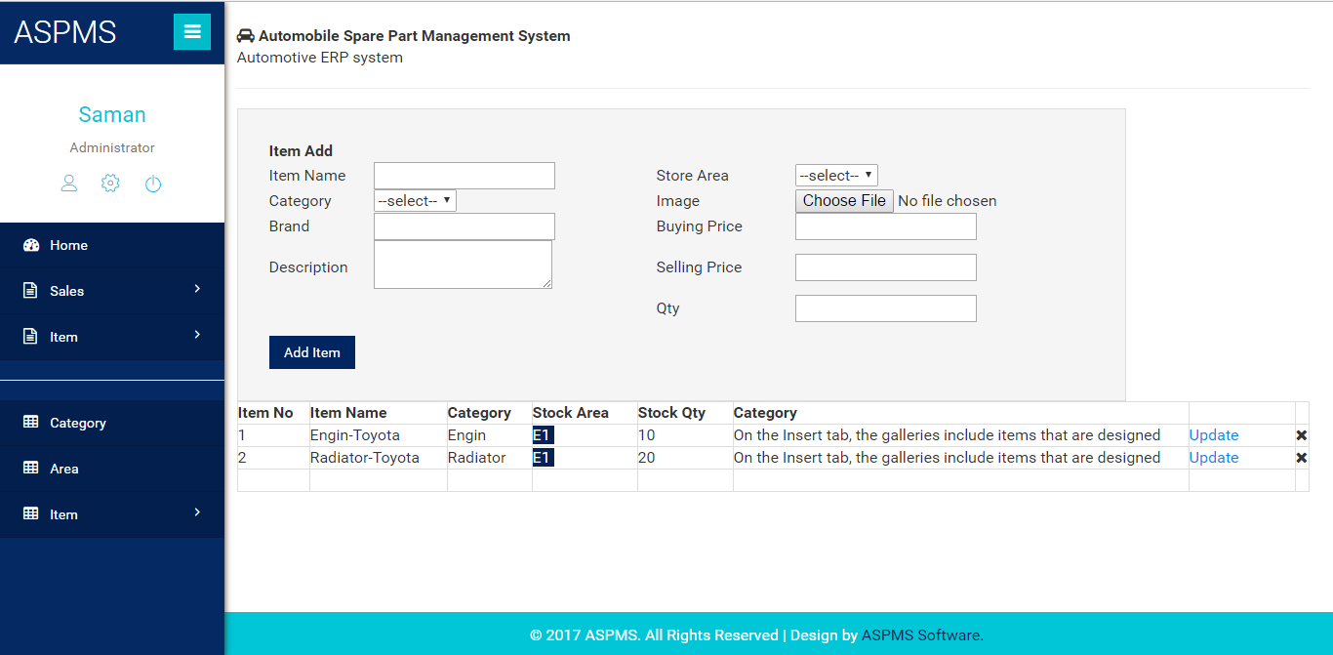

## Update Item

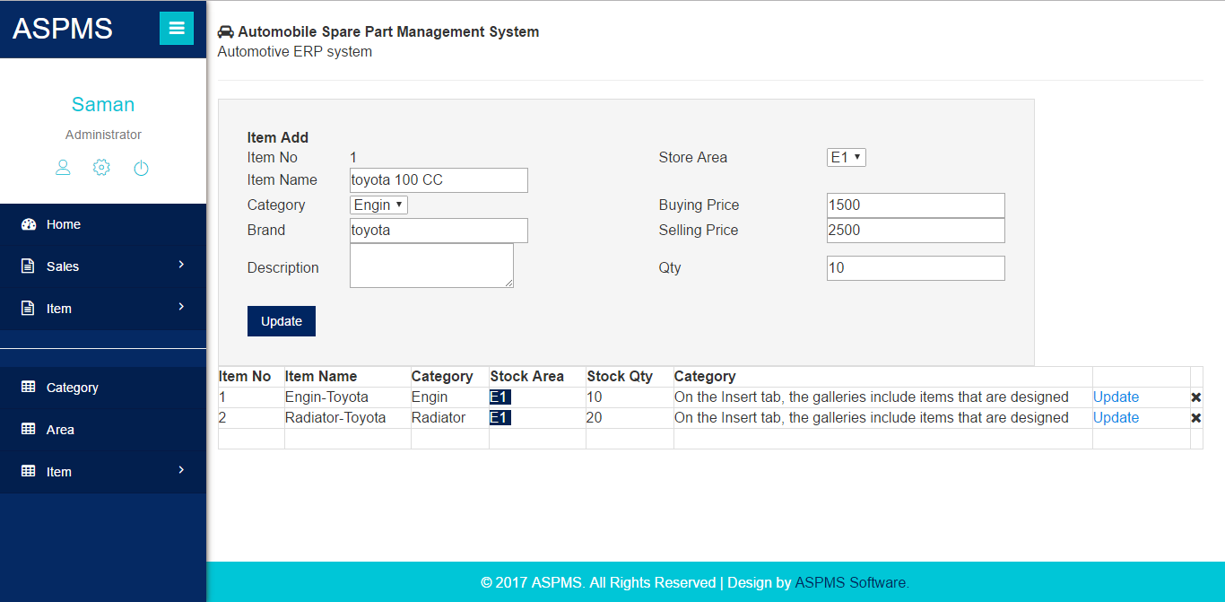

## Search Item

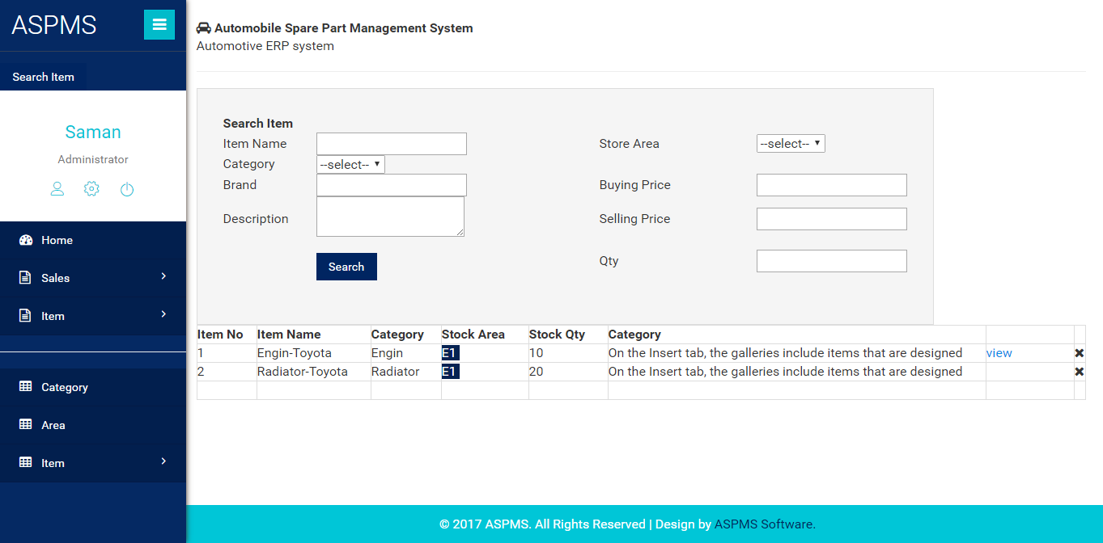

## Manage Category

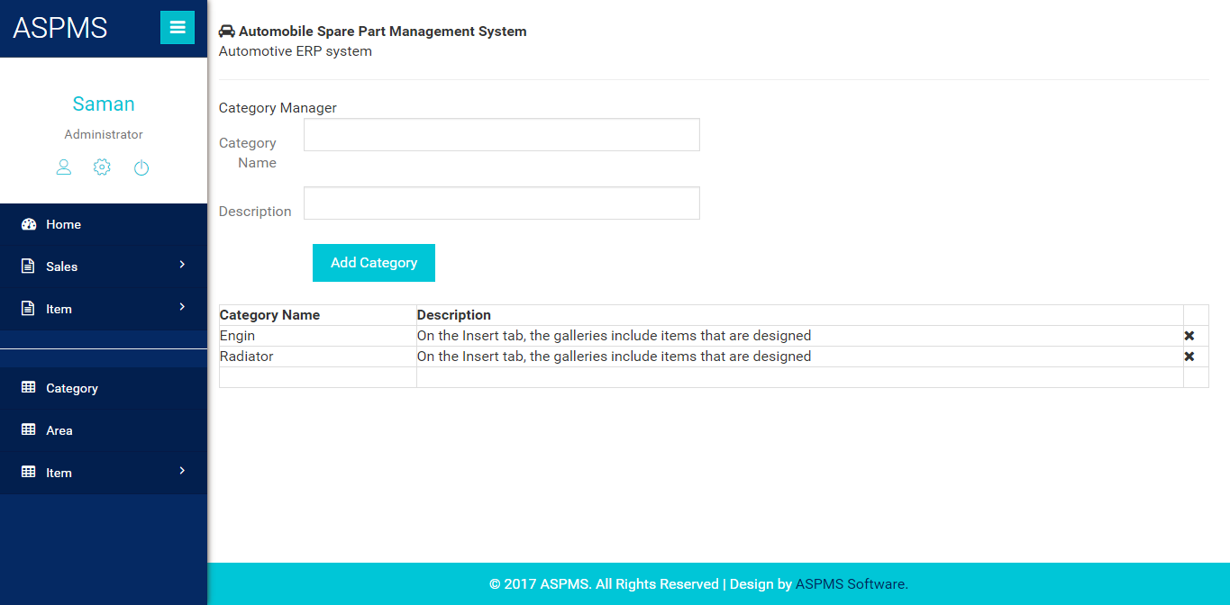

## Manage Store Area

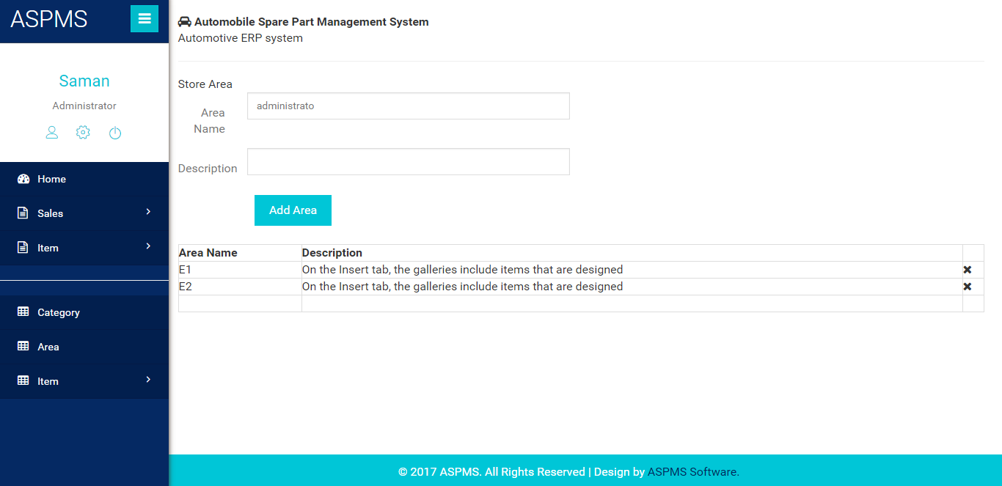

# User: Employee

## Search Item

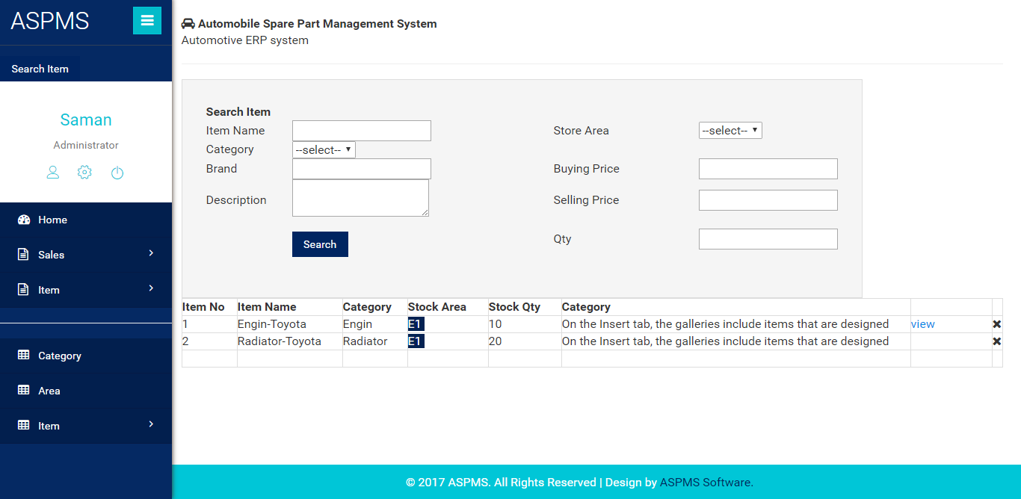

## View Item Details

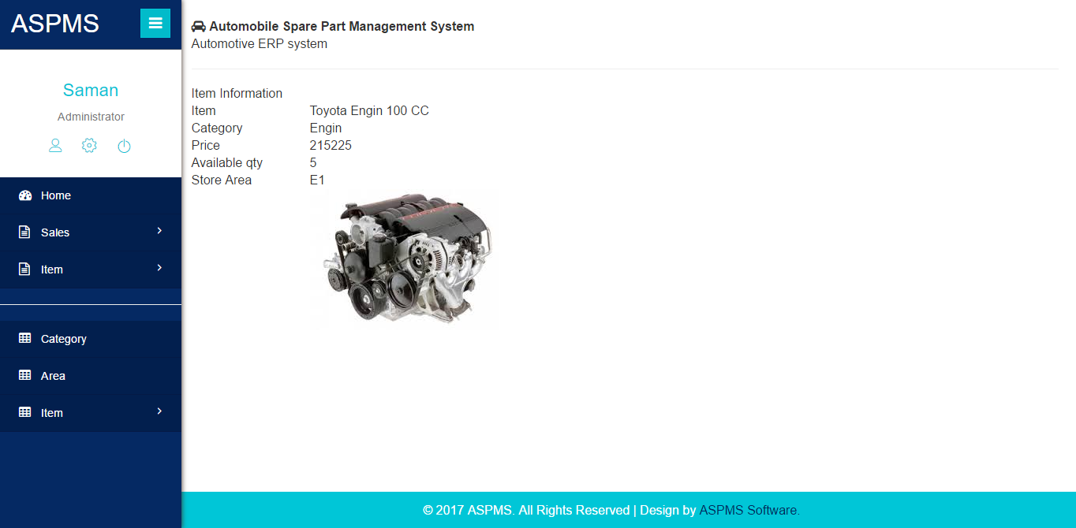  
Sales

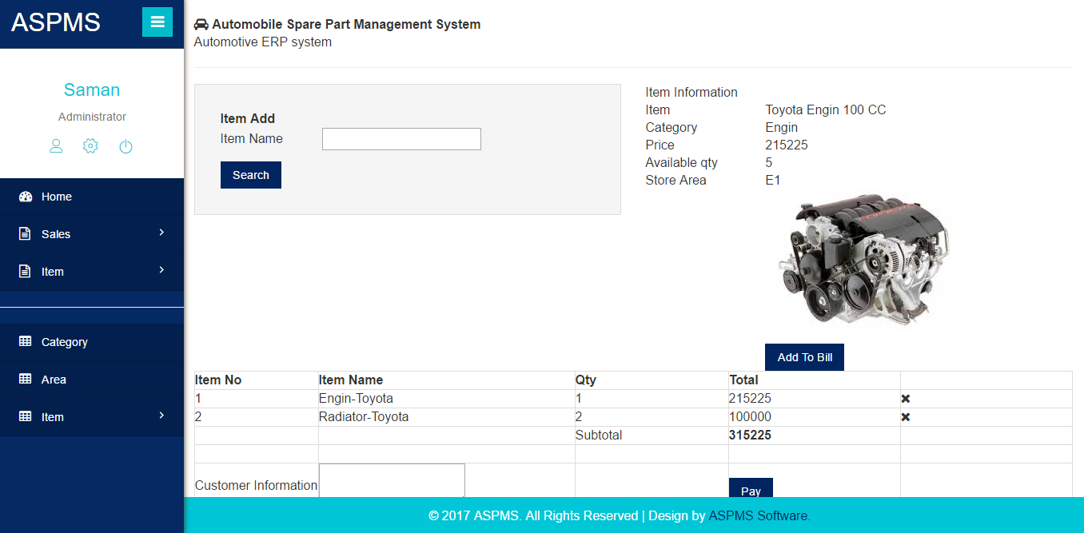

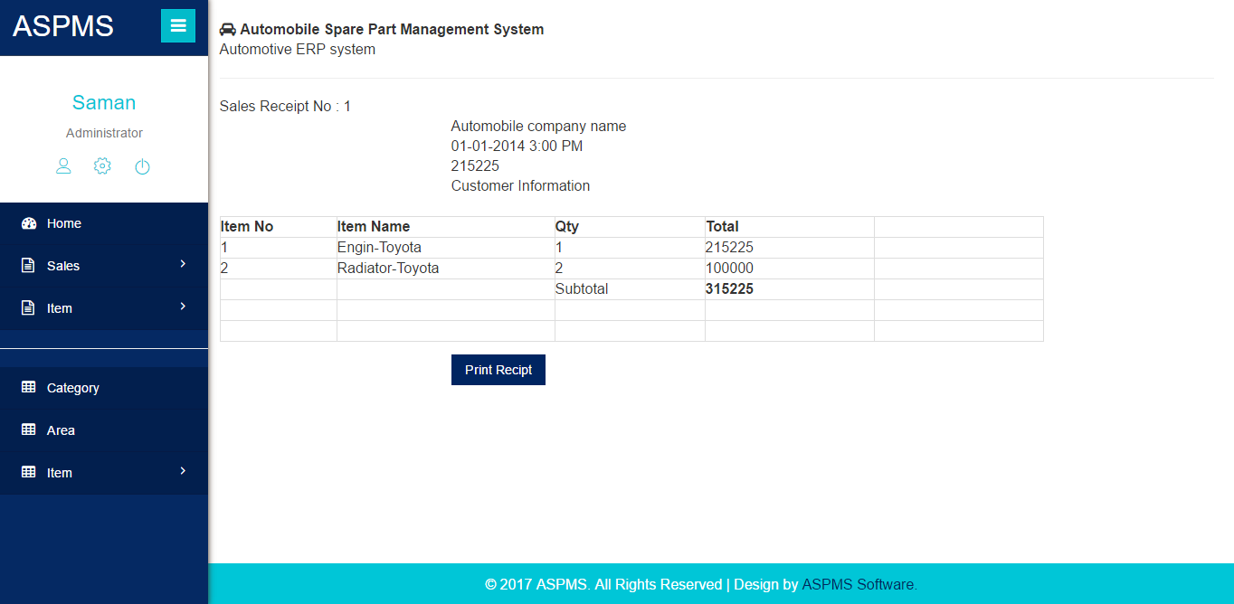

## Sales History View

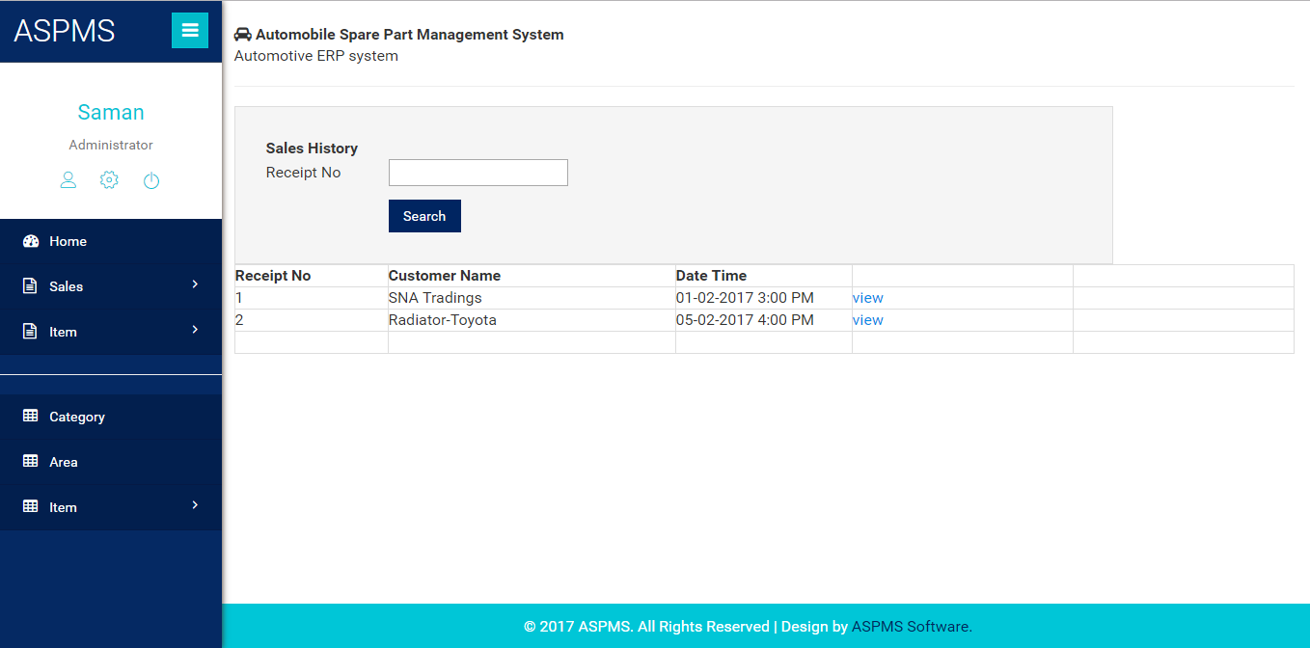

Report Modules is included