Login as User
User should not see the "List of Users" (this is for Admin only)
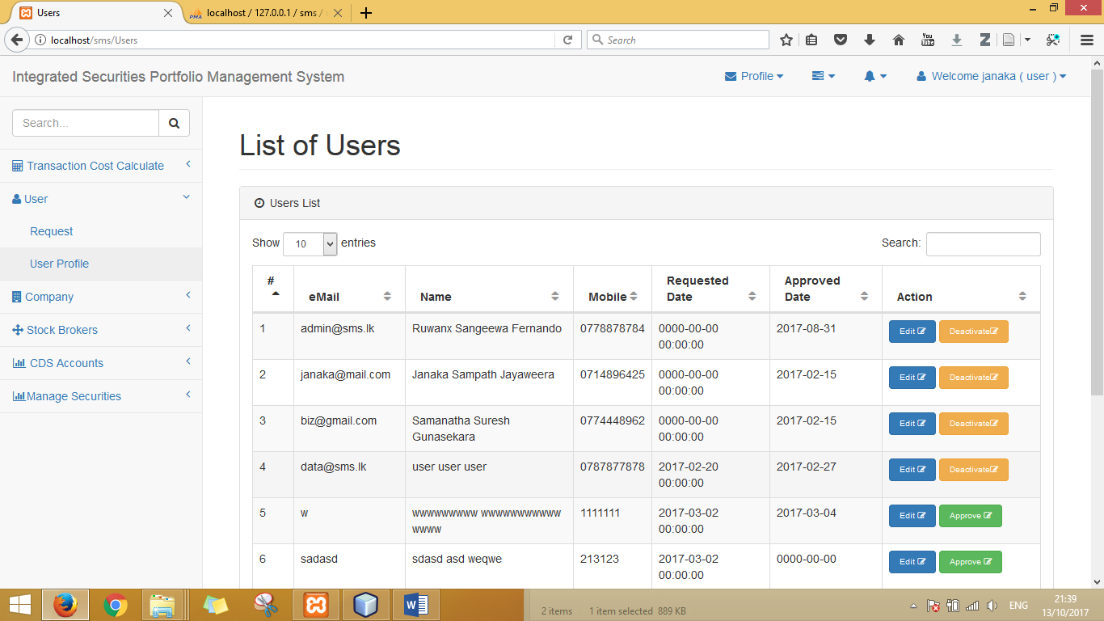
User shuld see only "User Profile"
- Personal details
- CDS accounts details (hiperlink to stockbroker company detail)
  - Broker company bank account detils
  - Web links
  - Other notes
- User can be added more deails
  - Bank details
  - Upload images

