Doctor -> profile

Admin -> remove patient user role

* PHARMACIST
  + Profile | report
  + Drug add not working
  + View stock

Transport

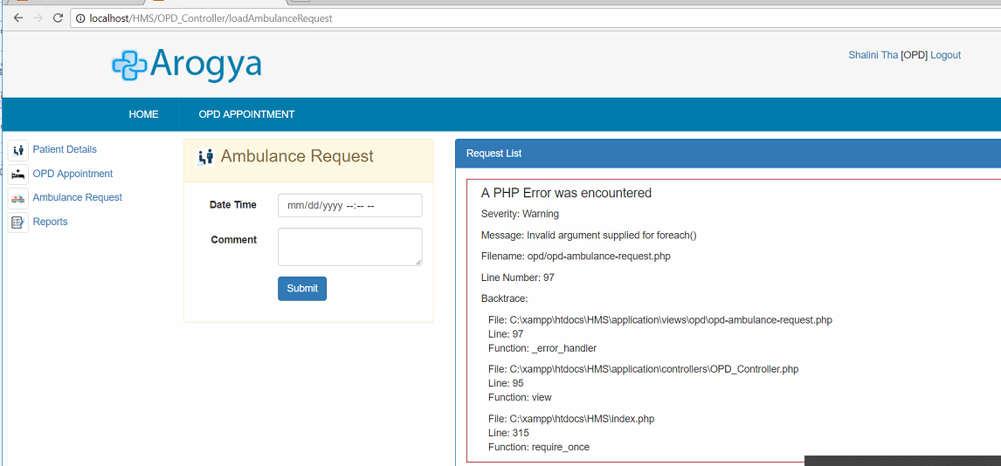

* Profile

Accountant

Back not working

Profile | report

Lab

Test details

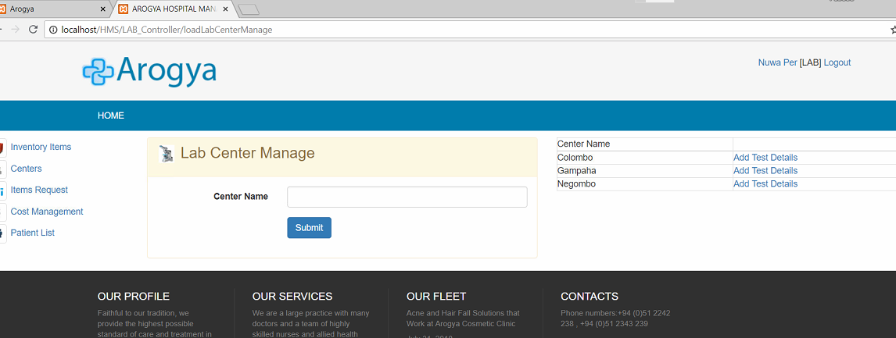

Report | profile

Ward

Recheck all functions | profike | report

Transport > travel history

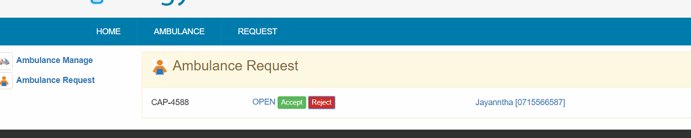

Profile | report