VEMS

Island Wide Vehicle Emmision Management System

# User Roles

* Visitor
* Customer
* Operator
* Manager
* Administrator

# User Activity

**Visitor**

Register: nic , fname,lname,address,city,mobile,**email**,password

**Customer**

|  |  |
| --- | --- |
| Log | Email,password |
| New Reservation | rsv_date,rsv_time | list already other reservation on the left slde area |
| Cancel Reservation | Only remove future reservation |
| View My Reservation |  |

**Operator**

|  |  |
| --- | --- |
| View Reservation |  |
| Remove Reservation | If not came to the reservation |
| Manual Registration | : nic , fname,lname,address,city,mobile,**email**, password will be sent to emai. |
| Vehicle Registration | Vehicle_year,brand[toyota,Volvo],vehicle_no,customer_id,category[car,van,bus] -> the details add and display in to a table . the price will be ccolected form the category table |
| Remove Vehicle Registration |  |
| Inspec Vehicle | celender_type,details......, -> add to the lit |
| Remove inspec |  |
| Emmision Test | Pass / Fail |
|  |  |
|  |  |
|  |  |

**Manager**

|  |  |
| --- | --- |
| Report View |  |
| Add Users for the center | Fname,lname,email,pword |
|  |  |

**Admin**

|  |  |
| --- | --- |
| Add Center |  |
| Add Managers | Fname,lname,email,pword |
| Report View |  |
|  |  |

Welcome page

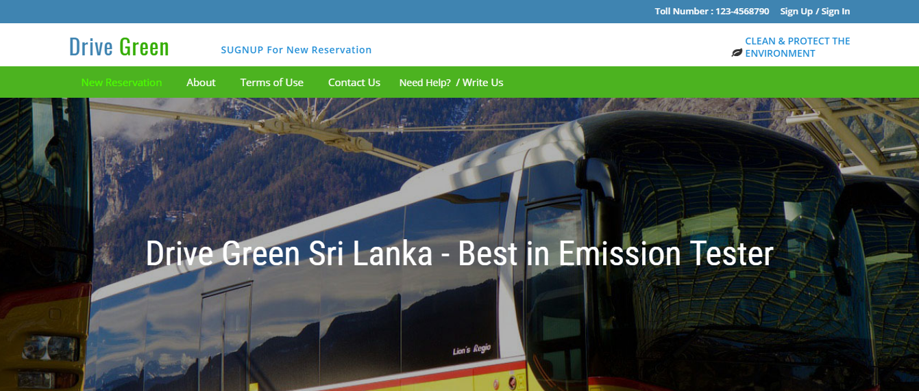

New customer registration

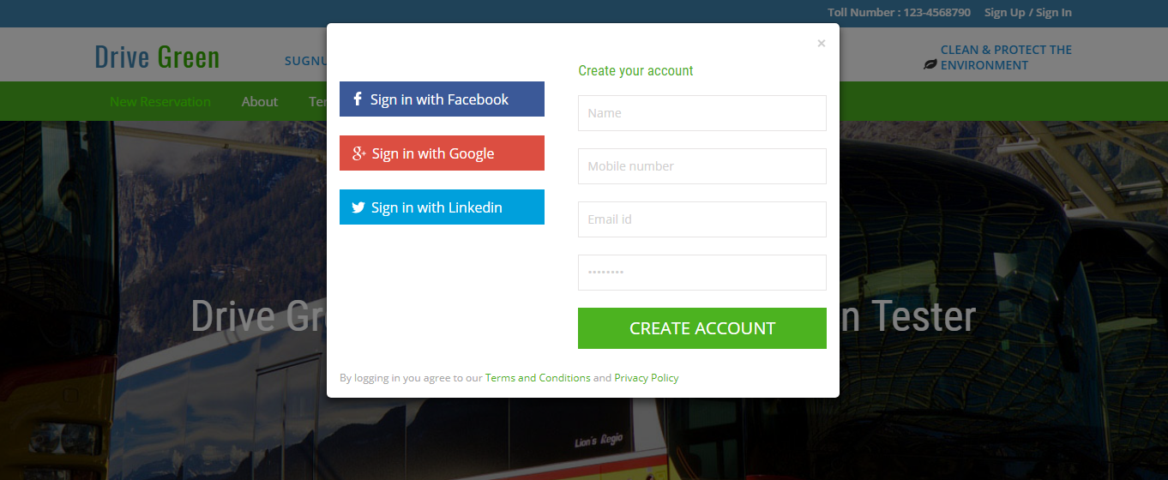

Login

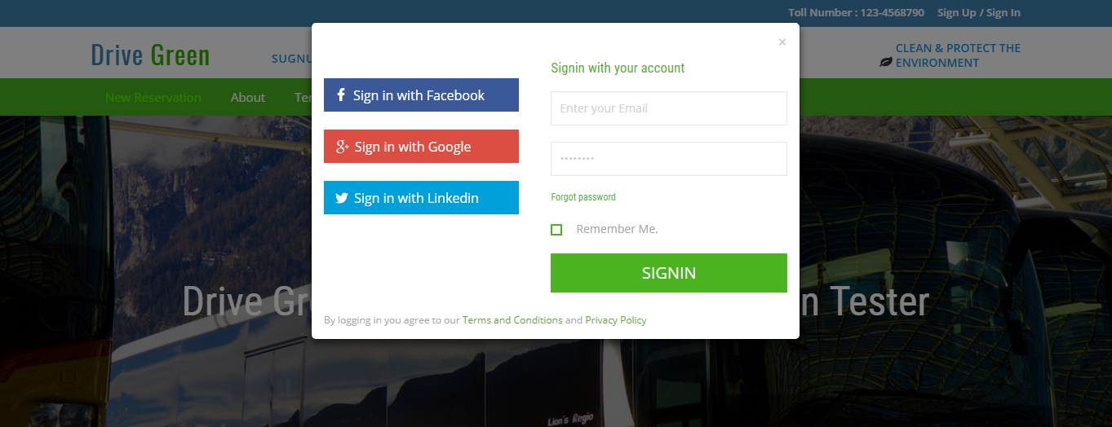

Customer new reservation

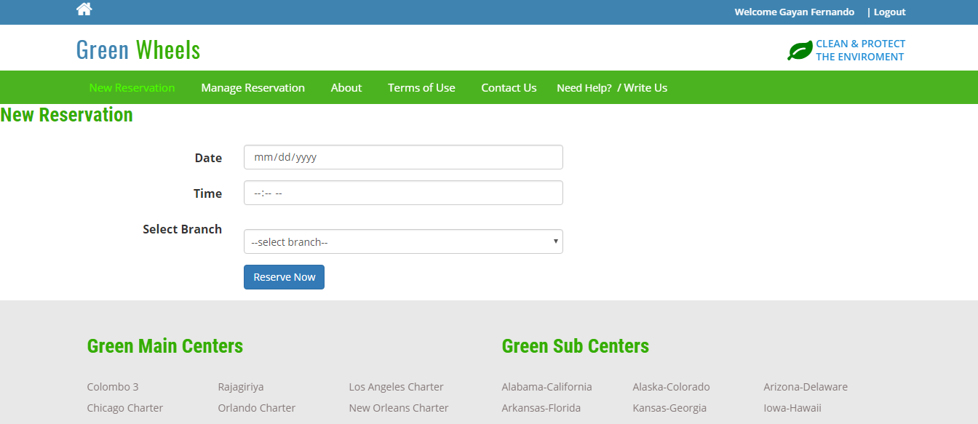

Manage Reservation

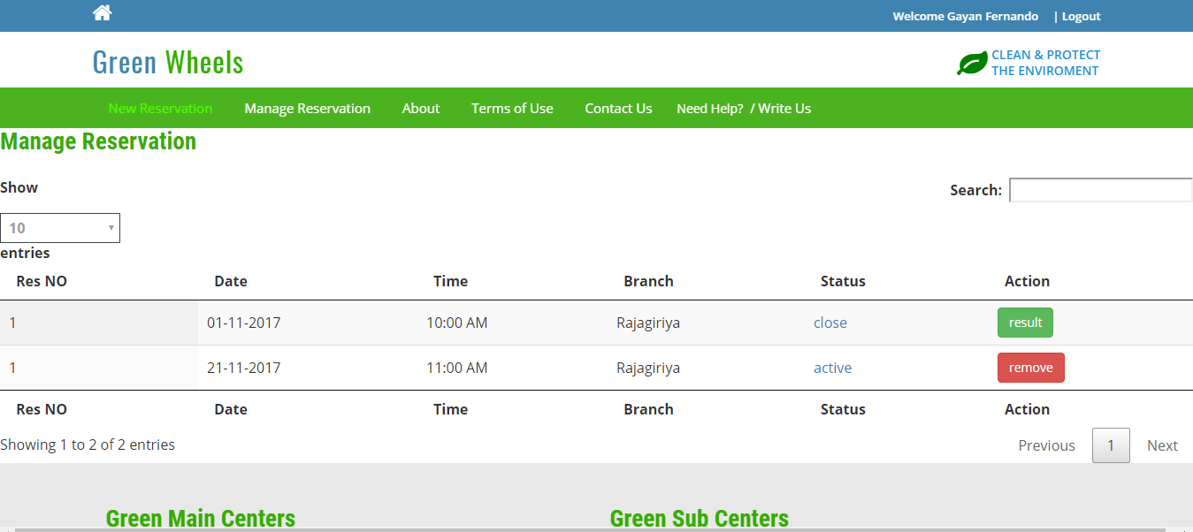

Vehicle Registration

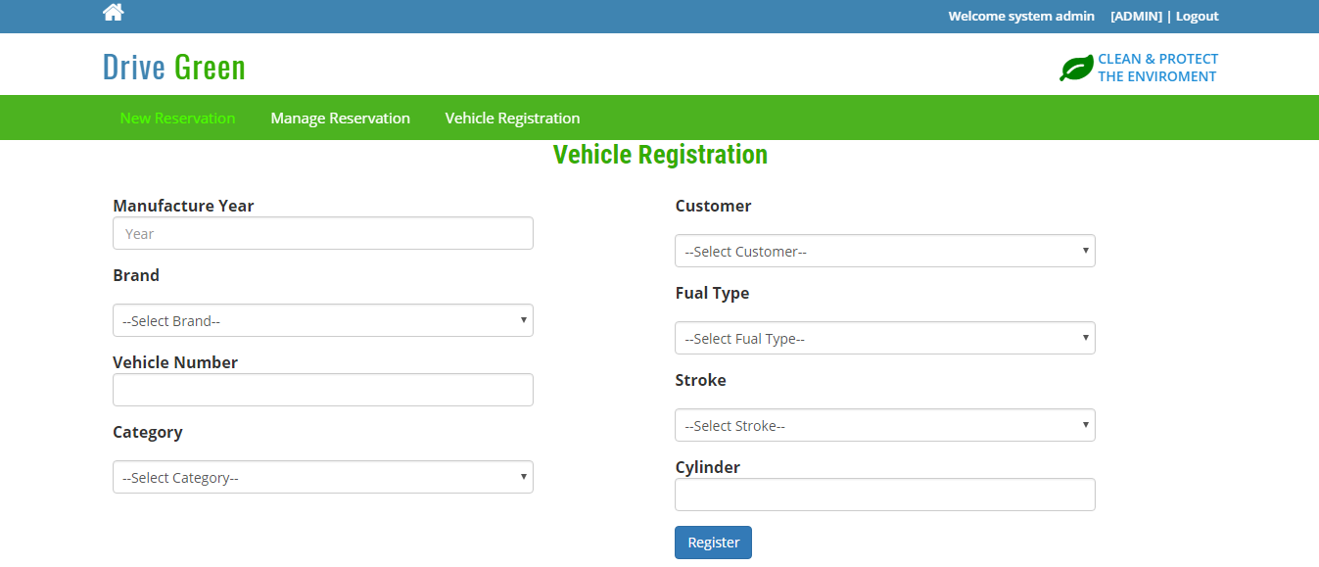

Inspection

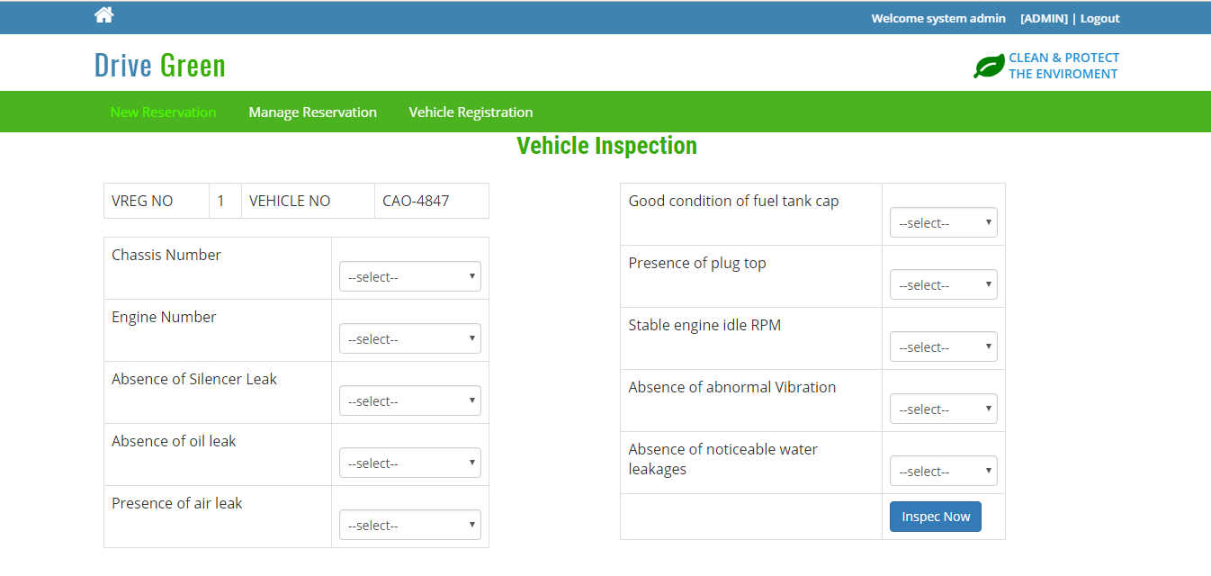

Inspection List

