***SemanticSpotter  
Generative Search System for Insurance Policy Documents***

**Introduction**

* Welcome to our presentation on Semantic Search and Response Generation for Insurance Policy Documents. In this project, we aimed to develop a system that efficiently provides accurate responses to user queries based on a single policy document using LlamaIndex.

**Project Overview**

* Our project workflow involves leveraging a single policy document as the primary data source. LlamaIndex uses advanced NLP techniques to parse and analyze insurance policy documents.
* It indexes the documents in a structured format, making it easy to search for specific terms, clauses, or information.
* The system generates responses to user queries based on the indexed data, providing accurate and relevant results.

**Problem Statement**

* Insurance companies deal with a vast amount of policy documents, ranging from individual policies to complex corporate contracts.
* These documents contain critical information such as coverage details, exclusions, premiums, and legal clauses.
* Manual processing of these documents is time-consuming, error-prone, and inefficient.

**Goals**

* Develop a generative search system capable of understanding and interpreting insurance policy documents.
* Provide accurate and relevant answers to user queries based on the content of the policy documents.
* Enhance search efficiency and user experience within the insurance domain.

**Data Preparation**

* For this project, we used a policy document titled Principal-Sample-Life-Insurance-Policy.

**Key Features**

* **Efficient indexing and retrieval of insurance policy documents:**
* LlamaIndex indexes insurance documents in a manner that facilitates quick and accurate retrieval of information.
* **Advanced natural language processing (NLP) techniques for accurate information extraction:**
* The system applies state-of-the-art NLP algorithms to extract key information frominsurance documents, including policy terms, clauses, and coverage details.
* **Scalability to handle large volumes of textual data:**
* LlamaIndex is designed to scale horizontally, allowing it to handle large datasets efficiently.
* **Customizable search queries for tailored results:**
* Users can formulate complex search queries to retrieve specific information from insurance documents, such as policy clauses related to a particular coverage type or exclusion.

**Step-by-Step Explanation of the Indexing Process**

* **Document retrieval:**
* LlamaIndex retrieves insurance documents from the designated data source, whether it's a local file system, cloud storage, or a document management system.
* **Information aggregation:**
* The system processes the retrieved documents, extracting relevant information such as policy terms, clauses, and metadata.
* **Query generation:**
* LlamaIndex generates responses to user queries based on the indexed data, using the RAG method to ensure accuracy and relevance.

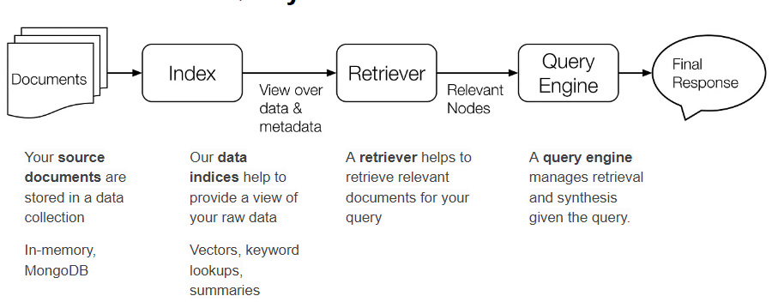

* **Prompt Sample**

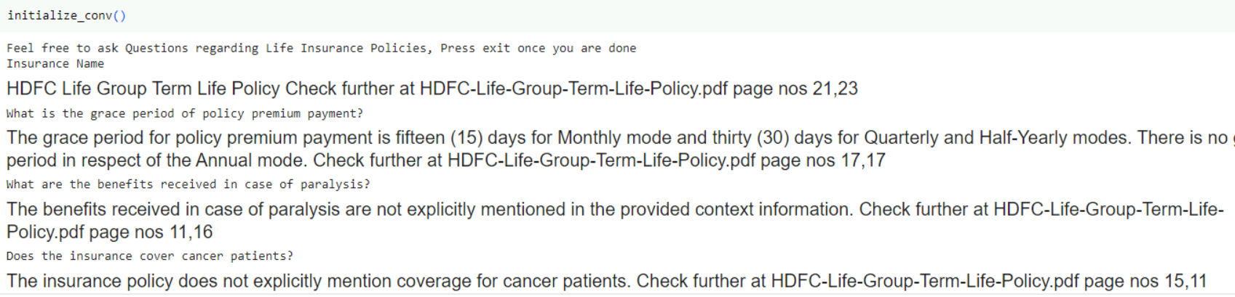

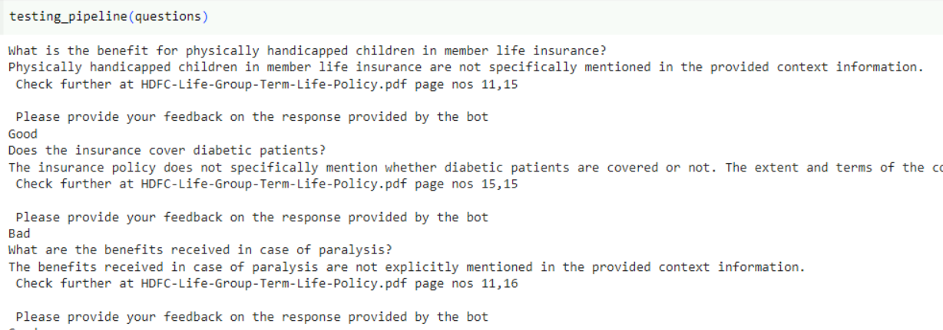

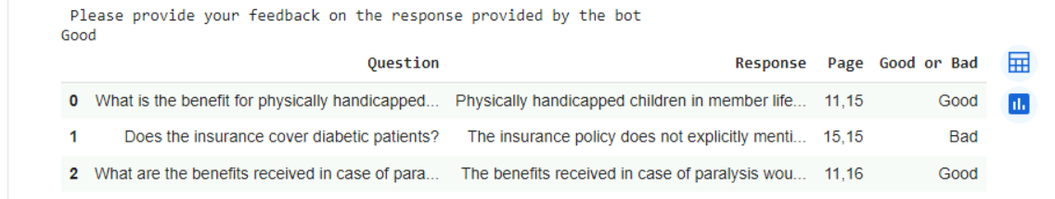

* **Future Directions**
* Future enhancements could involve integrating added policy documents to broaden coverage and improve accuracy.
* Further fine-tuning of models with domain-specific data could enhance performance and relevance of generated responses.
* Expansion of the system to support multi-document retrieval and generation would enable a more comprehensive and robust solution for users.