ADVENTURE WORKS
SALES & PROFIT ANALYSIS
Microsoft Excel Analytics & Interactive Dashboard Project
From raw Adventure Works tables to a modeled, validated and interactive reporting solution
PROJECT | DETAIL
Project Type | Data Analyst Portfolio Project
Primary Platform | Microsoft Excel
Data Preparation | Power Query
Data Modeling | Power Pivot / Excel Data Model
Analytics Layer | PivotTables + DAX Measures
Dashboarding | Interactive Excel Dashboard
Source Dataset | Adventure Works
Report Version | 1.0 | October 2026
Author | Ravinder Gupta
PROJECT OBJECTIVE
Build an advanced Excel reporting solution using a relational Data Model rather than a single denormalized worksheet. The project combines Power Query transformations, Power Pivot relationships, DAX measures, PivotTables and dashboard design.

1. Executive Summary
This project demonstrates an end-to-end Microsoft Excel analytics workflow built around the Adventure Works dataset. The solution uses Power Query for transformation, Power Pivot for relationships, DAX for reusable calculations, PivotTables for analysis and Excel dashboard objects for presentation.
CORE APPROACH
The project avoids flattening all tables into one worksheet. It uses a fact-and-dimension analytical model with relationships so the dashboard can behave more like a Power BI-style reporting solution.

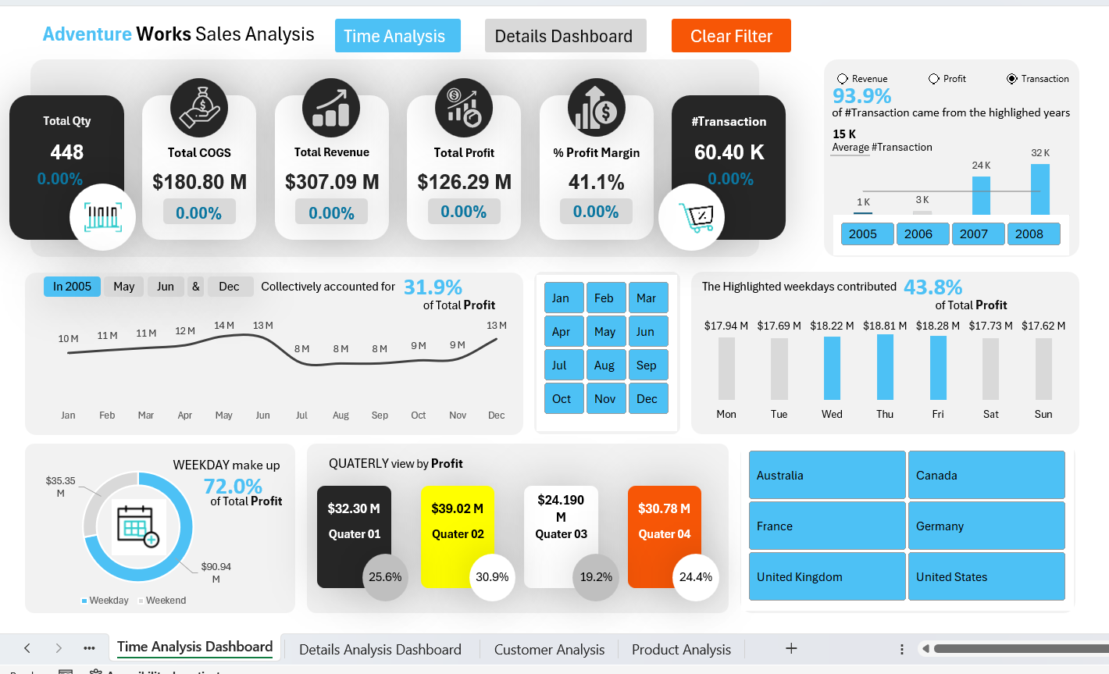
Figure 1. Final Time Analysis Dashboard — supplied implementation evidence.
The dashboard combines KPI cards, year filters, monthly profit trends, weekday analysis, quarterly performance and country filtering.

2. Business Problem & Objectives
The objective is to convert multiple Adventure Works tables into a reporting layer that can answer sales, profitability, product, customer, geography and time questions without repeatedly rebuilding the underlying data.
Objective | How the Project Addresses It
Measure sales activity | Transaction count and order quantity analysis
Measure financial performance | Revenue, COGS, total profit and profit margin
Understand time patterns | Year, month, weekday, week, quarter and day-of-week dimensions
Identify product concentration | Top products, sold/unsold products, product colors and pricing types
Understand customers | Top profitable customers, customer count, average age and gender split
Understand geography | Country-level profit contribution and country slicers
Support decisions | Interactive slicers, highlights, KPI cards and navigation

Key analytical questions
- How many transactions and units are represented?
- What are revenue, COGS, profit and profit margin?
- Which months, weekdays and quarters contribute most profit?
- Which products and customers contribute the most profit?
- How many products are sold versus unsold?
- Which age groups contribute most profit?
- How concentrated is profit across countries?
- How does product pricing relate to profit contribution?

3. Technical Environment & Project Architecture
Layer | Technology / Component | Purpose
Source | Adventure Works tables | Relational source data
ETL | Power Query | Cleaning, shaping and calculated columns
Model | Power Pivot / Data Model | Relationships between tables
Analysis | PivotTables | Intermediate analysis and evidence
Calculation | DAX | Reusable measures and KPI logic
Presentation | Excel Dashboard | Interactive reporting
Interaction | Slicers / Buttons / Hyperlinks | Filtering and navigation
Architecture: Source Tables → Power Query → Data Model → Relationships → DAX Measures → PivotTables → Dashboard
IMPLEMENTATION PRINCIPLE
The supplied tutorial describes this as an advanced Excel approach that resembles Power BI: tables are cleaned separately, loaded to the Data Model, connected through keys, and analyzed without creating one large denormalized table.

Workflow
- Import source workbook and tables
- Transform and clean in Power Query
- Keep analysis-relevant columns
- Create calculated and conditional columns
- Load tables to the Data Model
- Create one-to-many relationships
- Create an All Measures table
- Build DAX measures
- Create PivotTables from the Data Model
- Design dashboard sheets
- Add slicers, highlights and navigation
- Validate outputs

4. Dataset & Data Model
The source is the Adventure Works dataset. The evidence shows a transactional fact table supported by multiple dimension tables.
Table | Role | Important Fields
FactInternetSales | Transactional fact | ProductKey, OrderDateKey/OrderDate, CustomerKey, SalesTerritoryKey, OrderQuantity, UnitPrice, Cost
DimDate | Date dimension | Date, Year, Month Number, Month Name, Day Name, WeekTypes, Quarter, Day of Week
DimProduct | Product dimension | ProductKey, Product Name, Color
DimCustomer | Customer dimension | CustomerKey, GeographyKey, Full Name, BirthDate, Gender, Customer Age
DimSalesTerritory | Territory dimension | SalesTerritoryKey, region/country/group
DimGeography | Geography dimension | GeographyKey, City, Country, SalesTerritoryKey
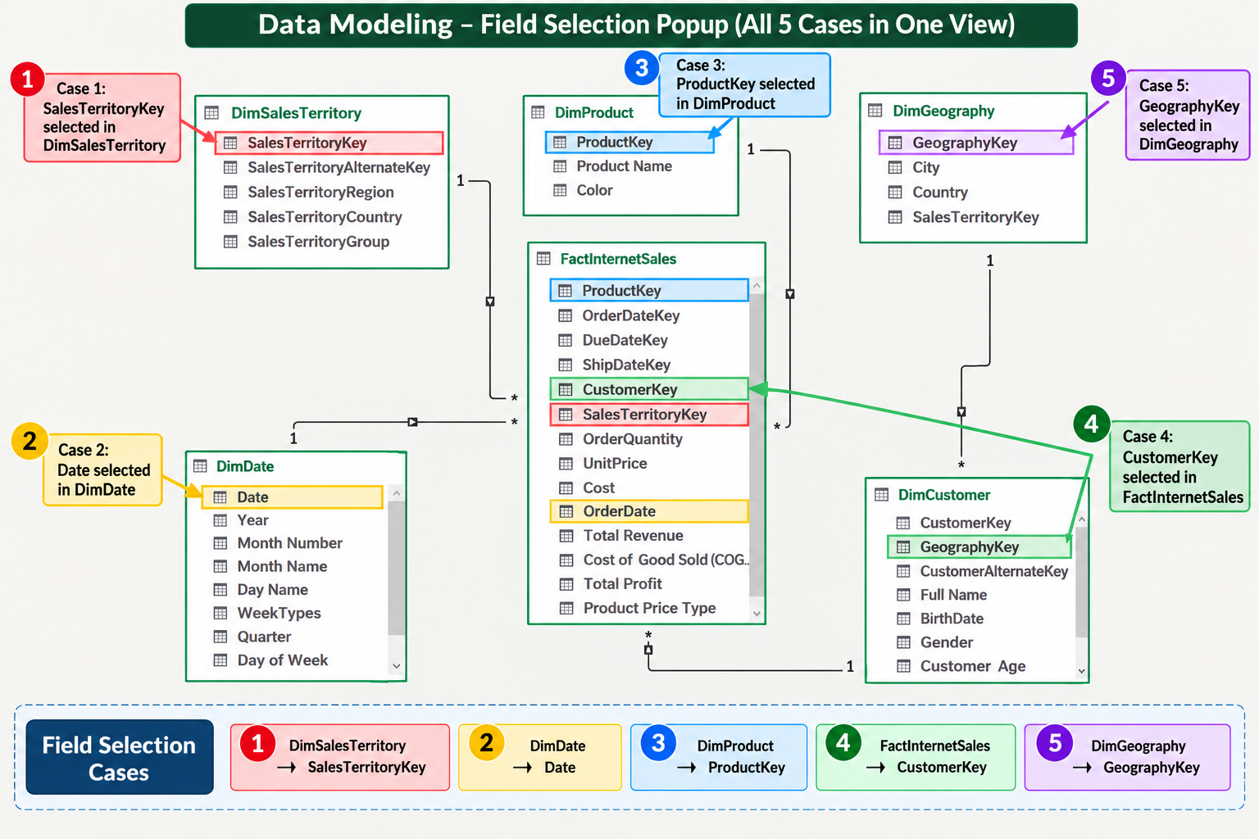
Figure 2. Data Model field-selection and relationship evidence.
The model evidence highlights relationship paths for SalesTerritoryKey, Date, ProductKey, CustomerKey and GeographyKey.

5. Power Query Data Preparation
Power Query is the transformation layer. The evidence shows selecting relevant columns, validating data types, renaming fields, filtering rows, creating custom columns and creating conditional categories before loading to the Data Model.
Transformation | Purpose
Choose Columns | Reduce model width and retain analytical fields
Data Type Validation | Ensure fields behave correctly
Rename Columns | Improve readability
Remove / Replace Values | Handle irrelevant or unspecified values
Custom Columns | Create revenue, COGS, profit and time attributes
Conditional Columns | Create price, week and age categories
Filter Rows | Restrict analysis period
Load to Data Model | Keep analytical model separate from worksheet

6. Custom Columns & Business Logic
The supplied screenshots provide direct evidence of the calculated fields used in the implementation.
Column | Formula / Logic | Meaning
Total Revenue | [OrderQuantity] * [UnitPrice] | Transaction-level sales value
Cost of Good Sold (COGS) | [OrderQuantity] * [Cost] | Transaction-level product cost
Total Profit | [Total Revenue] - [Cost of Good Sold (COGS)] | Revenue after product cost
Product Price Type | UnitPrice <= 150 → Less Expensive; otherwise Expensive | Price segmentation
Year | Date.Year([Date]) | Calendar year
Month | Date.Month([Date]) | Numeric month
WeekTypes | Sunday/Saturday → Weekend; otherwise Weekday | Weekday segmentation
Quarter | Date.QuarterOfYear([Date]) + prefix | Quarter label
Week of Year | Date.WeekOfYear([Date]) | Weekly analysis
Day of Week | Date.DayOfWeek([Date], Day.Monday) + 1 | Monday-based index
Age-Group | Conditional bands from Customer Age | Age segmentation

7. Date Dimension & Time Intelligence
A dedicated date table is enriched with calendar attributes used for time analysis and filtering.
Field | Use in Analysis
Date | Relationship anchor
Year | Year filtering
Month Number | Chronological ordering
Month Name | Readable monthly trend
Day Name | Weekday performance
WeekTypes | Weekday vs weekend
Quarter | Quarterly profit
Week of Year | Weekly analysis
Day of Week | Day-level analysis
DESIGN PRINCIPLE
The workflow uses Add Column when the original Date should be preserved while a new time attribute is created; Transform is used when the existing field itself needs to be changed.

8. Data Modeling & Relationships
The model follows a fact-and-dimension structure. The fact table sits at the center of the analytical model, while dimensions provide descriptive context.
Relationship Path | Purpose
DimSalesTerritory → FactInternetSales | Territory context
DimDate → FactInternetSales | Time filtering
DimProduct → FactInternetSales | Product analysis
DimCustomer → FactInternetSales | Customer analysis
DimGeography → DimCustomer | Country / geography context
Figure 3. Relationship and field-selection evidence.
WHY IT MATTERS
Using relationships avoids repeatedly denormalizing the source tables into one worksheet and lets PivotTables and measures respond to dimension filters.

9. DAX Measures & KPI Layer
The project uses an All Measures table to organize reusable calculations.
Measure / KPI | Logic / Purpose
#Transaction | COUNTROWS(FactInternetSales)
All Products | COUNTROWS(DimProduct)
Sold Products | DISTINCTCOUNT(FactInternetSales[ProductKey])
Unsold Products | All Products − Sold Products
% Profit Margin | DIVIDE([Total Profit],[Total Revenue],0)
# Customers | DISTINCTCOUNT(FactInternetSales[CustomerKey])
Revenue / COGS / Profit | Financial KPI aggregations
KPI SNAPSHOT
The supplied dashboard displays approximately 60.40K transactions, $180.80M COGS, $307.09M revenue, $126.29M profit and 41.1% profit margin, plus product and quantity indicators.

10. Dashboard 1 — Time Analysis
Figure 4. Final Time Analysis Dashboard.
KPI | Displayed Value
Transactions | 60.40 K
Total COGS | $180.80 M
Total Revenue | $307.09 M
Total Profit | $126.29 M
Profit Margin | 41.1%
Order Quantity | 631.92 K
All Products | 606
Sold Products | 158
Unsold Products | 448

Time-analysis evidence
- Monthly profit varies across the year; the supplied analysis highlights a 31.9% combined contribution for selected months.
- Weekday profit contribution is 72.0% versus 28.0% weekend.
- Highlighted weekdays contribute 43.8% in the supplied view.
- Quarterly profit: Q1 $32.30M, Q2 $39.02M, Q3 $24.190M, Q4 $30.78M.
- Country tiles and slicers support geographic filtering.

11. Dashboard 2 — Details Analysis
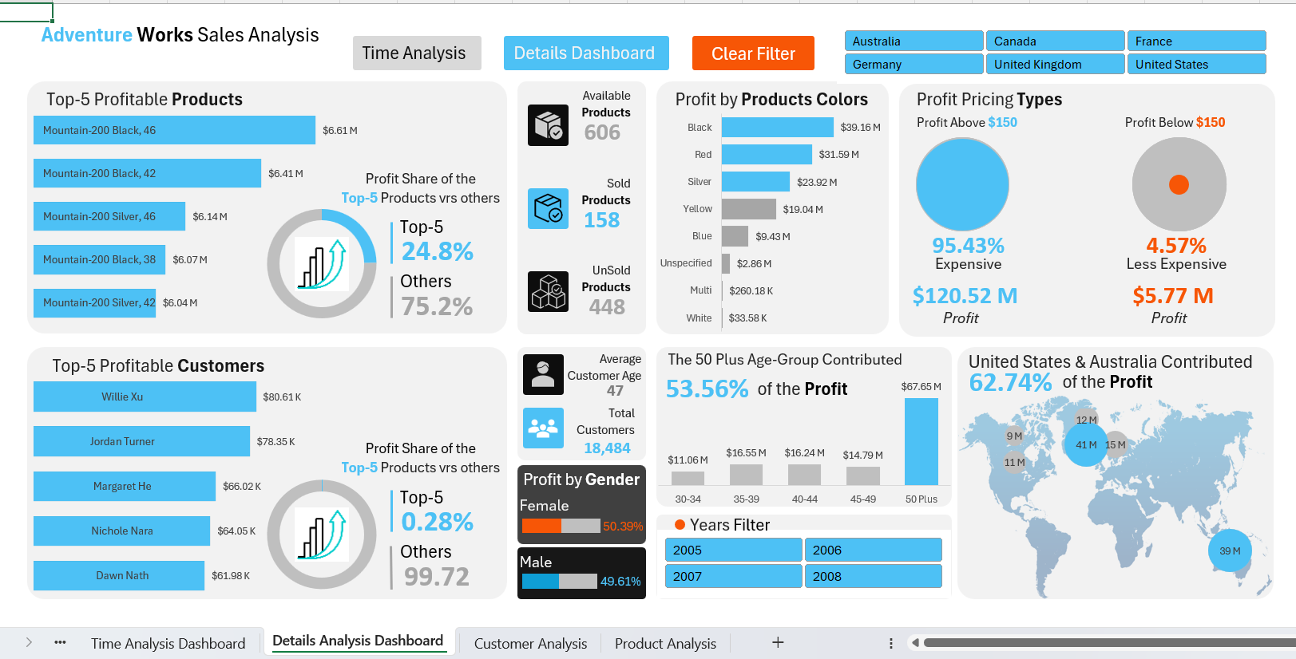
Figure 5. Final Details Analysis Dashboard.
Analysis Area | Displayed Evidence
Top-5 profitable products | Mountain-200 variants; top-five share 24.8%
Available / Sold / Unsold | 606 / 158 / 448
Profit by product color | Black, Red and Silver lead displayed profit
Profit pricing types | Expensive 95.43%; Less Expensive 4.57%
Top-5 profitable customers | Willie Xu, Jordan Turner, Margaret He, Nichole Nara, Dawn Nath
Top-5 customer share | 0.28%
Average customer age | 47
Total customers | 18,484
Gender profit split | Female 50.39%; Male 49.61%
50 Plus age group | 53.56% of profit
United States + Australia | 62.74% of profit
These figures are descriptive results from the supplied dashboard evidence; they are not causal conclusions or formal business recommendations.

12. Interactivity, Navigation & UX
Feature | Implementation Evidence
Year slicer | Filters dashboard by year
Country slicer | Filters product/customer/geography views
Month selection | Highlights time periods
Clear Filter | Clears active filtering
Dashboard buttons | Time Analysis / Details navigation
Hyperlinks | Moves between dashboard sheets
Highlights | Emphasizes important categories
KPI cards | Surfaces high-level metrics
Gridline removal | Creates a clean dashboard canvas
NAVIGATION
Dashboard objects can be linked to other sheets and given meaningful tooltips such as a next-dashboard action.

13. Key Business Insights
Portfolio Profitability: $126.29M profit on $307.09M revenue produces a displayed 41.1% margin.
Cost Exposure: COGS is displayed at $180.80M, making cost performance a major analytical dimension.
Time Variation: Monthly, weekday/weekend and quarterly views show non-uniform profit contribution.
Strongest Quarter: Q2 shows $39.02M, the highest displayed quarterly profit.
Weekday Dominance: Weekdays contribute 72.0% versus 28.0% weekend.
Product Concentration: 158 of 606 products are shown as sold; 448 are shown as unsold.
Top Product Contribution: The top five products account for 24.8% of displayed product profit.
Customer Concentration: The top five customers account for only 0.28% of displayed profit.
Age Mix: The 50 Plus group contributes 53.56% of displayed profit.
Geographic Concentration: United States and Australia together contribute 62.74% of displayed profit.
Pricing Mix: Expensive products account for 95.43% of displayed profit versus 4.57% for Less Expensive.

14. Validation & Quality Checks
Check | Evidence / Result
Model fields | Required keys and analytical fields visible
Relationship structure | Dimension-to-fact paths visible
Calculated columns | Power Query dialogs show no syntax errors
KPI reconciliation | Dashboard KPI cards match displayed analysis
Sold/unsold logic | 606 = 158 + 448
Profit margin | 41.1% displayed
Filter behavior | Year and country filters alter analysis
Navigation | Dashboard links move between views
QUALITY NOTE
This report is grounded in the supplied screenshots and project transcript. It does not invent additional row-level data-quality statistics that were not provided.

15. Skills Demonstrated
Skill | Evidence in Project
Microsoft Excel | Dashboard design, PivotTables, slicers, shapes, hyperlinks and formatting
Power Query | Column selection, data types, custom/conditional columns, filters and transformations
Power Pivot | Data Model management and relationship design
Data Modeling | Fact/dimension structure and one-to-many relationships
DAX | COUNTROWS, DISTINCTCOUNT, DIVIDE and reusable KPI measures
Business Analysis | Profitability, product, customer, geography and time analysis
Dashboard UX | KPI hierarchy, filters, highlights, navigation and presentation
Data Validation | Cross-checking calculations, relationships and dashboard outputs

16. Portfolio Summary
PROJECT PITCH
I built an Adventure Works sales and profit analytics dashboard in Microsoft Excel using Power Query, Power Pivot, DAX and PivotTables. I transformed the source tables, created analytical columns, modeled the data with relationships, created reusable KPI measures and presented the results through two interactive dashboards with slicers, highlights and navigation.

