BANK LOAN ANALYSIS
SQL / MYSQL DATA ANALYTICS PROJECT
From Raw Loan Transactions to Validated Lending Insights
PROJECT TYPE | Data Analyst Portfolio Project
DATABASE | MySQL
PRIMARY TABLE | financial_loan
ANALYTICAL LAYER | SQL / MySQL
REPORTING HANDOFF | Power BI
AUTHOR | Ravinder Gupta
VERSION | 1.0 | October 2026

PROJECT OBJECTIVE
Build a SQL-based analytical solution to evaluate loan portfolio performance, funding activity, repayment behavior, loan quality and borrower dimensions, while establishing validated metrics for downstream Power BI reporting.

38,576  Loan Applications | 86.18%  Good Loan Share | 13.82%  Bad Loan Share | Dec 2021  Latest Month
SQL • Data Validation • KPI Analysis • Portfolio Insights
Result screenshots are embedded as evidence against the corresponding SQL queries.

1. Executive Summary
This project analyzes a bank loan portfolio using MySQL to transform transaction-level lending data into a validated analytical foundation for Power BI reporting. The SQL layer covers applications, funded amount, repayments, interest rate, DTI, loan quality, loan status and borrower/loan dimensions.
The supplied validation establishes 38,576 applications and a converted date range from 2021-01-01 to 2021-12-12. December 2021 is therefore the latest month and November 2021 the comparison month.
Metric | Overall | December 2021 | MoM
Applications | 38,576 | 4,314 | 6.91%
Funded Amount | 435,757,075 | 53,981,425 | 13.04%
Amount Received | 473,070,933 | 58,074,380 | 15.84%
Avg Interest Rate | 12.049% | 12.356% | 3.47%
Avg DTI | 13.327% | 13.666% | 2.727%
Key Insights from SQL Analysis: 38,576 applications were analyzed. December showed strong momentum: applications +6.91%, funded amount +13.04%, and amount received +15.84% MoM. Portfolio quality was 86.18% Good Loans versus 13.82% Bad Loans. Good Loans recorded 435.7M received against 370.2M funded, while Bad Loans recorded 37.2M received against 65.5M funded.

2. Business Context & Domain Knowledge
The supplied domain material describes bank lending as a lifecycle from application and verification through credit assessment, approval/denial, disbursement, repayment and ongoing monitoring.
- Risk assessment
- Data-driven lending decisions
- Loan portfolio management
- Fraud detection
- Regulatory compliance
- Customer insights and segmentation
- Profitability analysis
- Market research
- Credit risk management
- Customer retention
The analytical objective is therefore not only to count loans, but to understand portfolio volume, quality, repayment behavior, concentration and movement over time.

3. Business Problem & Objectives
The business requirement is to create a Bank Loan Report that monitors lending activity, portfolio health and monthly changes, while allowing stakeholders to analyze the portfolio by loan status and borrower/loan dimensions.
- Core KPIs: Applications, Funded Amount, Amount Received, Average Interest Rate and Average DTI.
- Time comparison: Overall, MTD, PMTD and MoM% metrics.
- Loan quality: Good Loan and Bad Loan percentages, counts, funded and received amounts.
- Status analysis: Full-year and latest-month loan-status grids.
- Overview analysis: Monthly trend, state, loan term, employment length, purpose and home ownership.
- Power BI handoff: SQL outputs serve as a reconciliation/source-of-truth layer.

4. Dataset & Data Dictionary
Primary table used in this implementation: financial_loan.
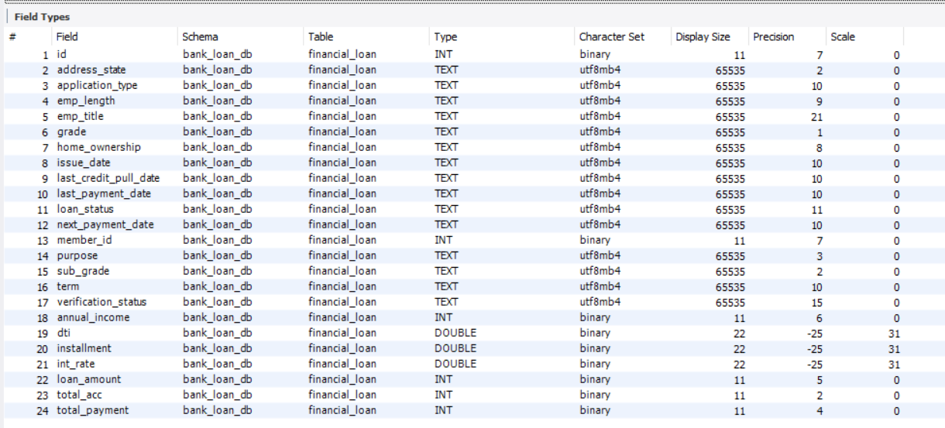
Figure 1 — MySQL schema / field-type evidence.

Field | Type | Business Meaning
id | INT | Unique application/loan identifier.
address_state | TEXT | Borrower state.
application_type | TEXT | Application classification.
emp_length | TEXT | Employment length.
emp_title | TEXT | Borrower occupation/title.
grade / sub_grade | TEXT | Risk classification.
home_ownership | TEXT | Housing status.
issue_date | TEXT | Origination date in DD-MM-YYYY text format.
loan_status | TEXT | Current loan state.
purpose | TEXT | Reason for borrowing.
term | TEXT | Loan duration.
verification_status | TEXT | Financial-information verification status.
annual_income | INT | Borrower annual income.
dti | DOUBLE | Debt-to-Income Ratio.
installment | DOUBLE | Monthly payment.
int_rate | DOUBLE | Annual interest rate stored as decimal.
loan_amount | INT | Principal funded.
total_payment | INT | Total amount received.

5. Technical Environment & MySQL Adaptation
The reference tutorial uses Microsoft SQL Server, while this implementation uses MySQL. The analytical intent is unchanged; syntax and date handling are adapted to MySQL.
Task | SQL Server Reference | MySQL Implementation
Month name | DATENAME(MONTH, issue_date) | MONTHNAME(issue_date)
Text → Date | Reference date handling | STR_TO_DATE(issue_date, '%d-%m-%Y')
Top N | TOP 10 | LIMIT 10
String concatenation | + | CONCAT()

Critical Date Handling
STR_TO_DATE(issue_date, '%d-%m-%Y')

issue_date is stored as TEXT in DD-MM-YYYY format. The query layer therefore converts it to a real MySQL DATE before applying MONTH(), YEAR() or MONTHNAME().

6. Project Architecture & Workflow
RAW DATA  financial_loan | MYSQL VALIDATION  Schema • dates • quality | KPI DEVELOPMENT  MTD • PMTD • MoM | ANALYTICAL LAYERS  Good/Bad • dimensions | POWER BI HANDOFF  Validated reporting

Workflow: Raw Data → MySQL Validation → KPI Development → Dimensional Analysis → Power BI Handoff
This architecture keeps business definitions and reconciliation logic in SQL before visualization. It also makes it easier to investigate any mismatch between SQL and Power BI.

7. Data Quality Audit
Basic validation was performed before KPI development to establish the analytical population, uniqueness, field completeness and date handling.

Check 1 — Row Count Validation
SELECT COUNT(*) AS Total_Rows FROM financial_loan;

Result: 38,576 rows. This confirms the application population used for the supplied analysis.

Check 2 — Duplicate ID Check
SELECT id, COUNT(*) AS cnt
FROM financial_loan
GROUP BY id
HAVING COUNT(*) > 1;
Result: No duplicate IDs found in the supplied validation.

Check 3 — Critical Field Completeness
Key analytical fields reviewed: id, issue_date, loan_status, loan_amount, total_payment, int_rate, dti, purpose and address_state.
Result: Core fields required for the KPI and dimensional workflow were available for analysis.

Check 4 — Date Range Validation
SELECT
MIN(STR_TO_DATE(issue_date, '%d-%m-%Y')) AS Min_Date,
MAX(STR_TO_DATE(issue_date, '%d-%m-%Y')) AS Max_Date
FROM financial_loan;
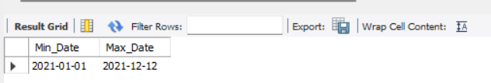
Date validation result: 2021-01-01 to 2021-12-12.

Check 5 — Date Format Handling
issue_date is TEXT in DD-MM-YYYY format; STR_TO_DATE(issue_date, '%d-%m-%Y') is used for date-based calculations.

Check 6 — Numeric Sanity Checks
Basic checks were applied to loan_amount, int_rate and dti for illogical negative values relevant to core KPI calculations.
Data Quality Outcome: The dataset was assessed as suitable for portfolio-level KPI development and dimensional analysis after date conversion and basic validation.

8. Dashboard 1 —

8.1 Core Application KPIs (Q1–Q4)
Q1 — Total Loan Applications
Purpose: Measure total loan application volume.
SELECT
COUNT(id) AS Total_Loan_Applications
FROM financial_loan;
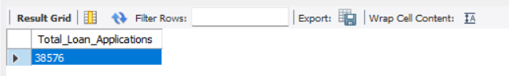
Result screenshot
Q2 — MTD (Month-to-Date) Loan Applications
Purpose: Measure applications in the latest month (December 2021).
SELECT
COUNT(id) AS MTD_Loan_Applications
FROM financial_loan
WHERE MONTH(STR_TO_DATE(issue_date, '%d-%m-%Y')) = 12
AND YEAR(STR_TO_DATE(issue_date, '%d-%m-%Y')) = 2021;
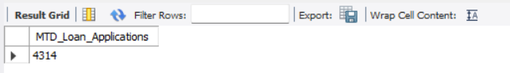
Result screenshot
Q3 — PMTD (Previous Month-to-Date) Loan Applications
Purpose: Measure applications in the previous month (November 2021).
SELECT
COUNT(id) AS PMTD_Loan_Applications
FROM financial_loan
WHERE MONTH(STR_TO_DATE(issue_date, '%d-%m-%Y')) = 11
AND YEAR(STR_TO_DATE(issue_date, '%d-%m-%Y')) = 2021;
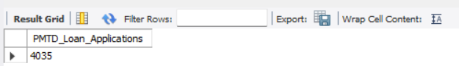
Result screenshot

Q4 — MoM% (Month-over-Month) Change in Loan Applications
Purpose: Calculate month-over-month application growth.
WITH clause.
-- A CTE lets us name a temporary result and reuse it later in the
-- query -- this keeps the final SELECT clean and easy to read,
-- instead of writing one giant nested query.
--
-- CROSS JOIN explanation: `mtd` and `pmtd` are each a temporary table
-- containing exactly ONE row (one number). CROSS JOIN simply places
-- these two single-row tables side by side so we can do math between
-- their columns in the same SELECT statement.
-- ------------------------------------------------------------------------
WITH mtd AS (
SELECT COUNT(id) AS MTD
FROM financial_loan
WHERE MONTH(STR_TO_DATE(issue_date, '%d-%m-%Y')) = 12
AND YEAR(STR_TO_DATE(issue_date, '%d-%m-%Y')) = 2021
),
pmtd AS (
SELECT COUNT(id) AS PMTD
FROM financial_loan
WHERE MONTH(STR_TO_DATE(issue_date, '%d-%m-%Y')) = 11
AND YEAR(STR_TO_DATE(issue_date, '%d-%m-%Y')) = 2021
)
SELECT
CONCAT(ROUND((MTD - PMTD) / PMTD * 100, 2), '%') AS MoM_Loan_Applications
FROM mtd
CROSS JOIN pmtd;
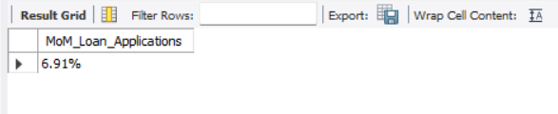
Result screenshot
Summary Insight: December 2021 was the strongest month in the latest-month comparison: applications rose 6.91% versus November. The four queries establish the reusable Overall → MTD → PMTD → MoM pattern.

8.2 Core Funding KPIs (Q5–Q8)
Q5 — Total Funded Amount
Purpose: Measure total principal funded by the bank.
SELECT
SUM(loan_amount) AS Total_Funded_Amount
FROM financial_loan;
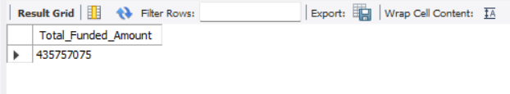
Result screenshot
Q6 — MTD Total Funded Amount
Purpose: Measure principal funded in December 2021.
SELECT
SUM(loan_amount) AS MTD_Total_Funded_Amount
FROM financial_loan
WHERE MONTH(STR_TO_DATE(issue_date, '%d-%m-%Y')) = 12
AND YEAR(STR_TO_DATE(issue_date, '%d-%m-%Y')) = 2021;
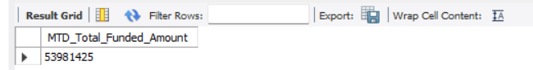
Result screenshot
Q7 — PMTD Total Funded Amount
Purpose: Measure principal funded in November 2021.
SELECT
SUM(loan_amount) AS PMTD_Total_Funded_Amount
FROM financial_loan
WHERE MONTH(STR_TO_DATE(issue_date, '%d-%m-%Y')) = 11
AND YEAR(STR_TO_DATE(issue_date, '%d-%m-%Y')) = 2021;
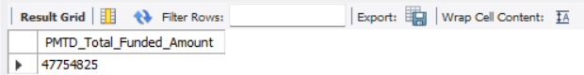
Result screenshot

Q8 — MoM% Change in Total Funded Amount
Purpose: Calculate month-over-month funding growth.
WITH mtd AS (
SELECT SUM(loan_amount) AS MTD
FROM financial_loan
WHERE MONTH(STR_TO_DATE(issue_date, '%d-%m-%Y')) = 12
AND YEAR(STR_TO_DATE(issue_date, '%d-%m-%Y')) = 2021
),
pmtd AS (
SELECT SUM(loan_amount) AS PMTD
FROM financial_loan
WHERE MONTH(STR_TO_DATE(issue_date, '%d-%m-%Y')) = 11
AND YEAR(STR_TO_DATE(issue_date, '%d-%m-%Y')) = 2021
)
SELECT
CONCAT(ROUND((MTD - PMTD) / PMTD * 100, 2), '%') AS MoM_Funded_Amount
FROM mtd
CROSS JOIN pmtd;
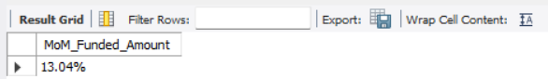
Result screenshot
Summary Insight: Funded amount increased 13.04% from November to December, indicating stronger disbursement activity in the latest month.

8.3 Core Collection KPIs (Q9–Q12)
Q9 — Total Amount Received
Purpose: Measure total borrower payments received.
SELECT
SUM(total_payment) AS Total_Amount_Received
FROM financial_loan;
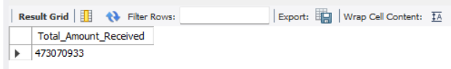
Result screenshot
Q10 — MTD Total Amount Received
Purpose: Measure borrower payments received in December 2021.
SELECT
SUM(total_payment) AS MTD_Total_Amount_Received
FROM financial_loan
WHERE MONTH(STR_TO_DATE(issue_date, '%d-%m-%Y')) = 12
AND YEAR(STR_TO_DATE(issue_date, '%d-%m-%Y')) = 2021;
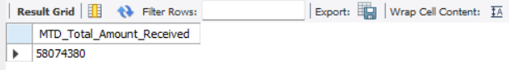
Result screenshot
Q11 — PMTD Total Amount Received
Purpose: Measure borrower payments received in November 2021.
SELECT
SUM(total_payment) AS PMTD_Total_Amount_Received
FROM financial_loan
WHERE MONTH(STR_TO_DATE(issue_date, '%d-%m-%Y')) = 11
AND YEAR(STR_TO_DATE(issue_date, '%d-%m-%Y')) = 2021;
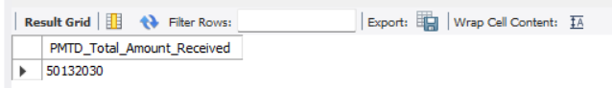
Result screenshot
Q12 — MoM% Change in Total Amount Received
Purpose: Calculate month-over-month collection growth.
WITH mtd AS (
SELECT SUM(total_payment) AS MTD
FROM financial_loan
WHERE MONTH(STR_TO_DATE(issue_date, '%d-%m-%Y')) = 12
AND YEAR(STR_TO_DATE(issue_date, '%d-%m-%Y')) = 2021
),
pmtd AS (
SELECT SUM(total_payment) AS PMTD
FROM financial_loan
WHERE MONTH(STR_TO_DATE(issue_date, '%d-%m-%Y')) = 11
AND YEAR(STR_TO_DATE(issue_date, '%d-%m-%Y')) = 2021
)
SELECT
CONCAT(ROUND((MTD - PMTD) / PMTD * 100, 2), '%') AS MoM_Amount_Received
FROM mtd
CROSS JOIN pmtd;
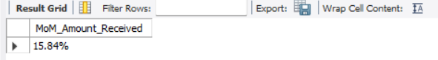
Result screenshot
Summary Insight: Amount received increased 15.84% MoM, the strongest growth among the three main volume KPIs.

8.4 Interest Rate KPIs (Q13–Q16)
Q13 — Average Interest Rate
Purpose: Measure the portfolio-wide average interest rate.
SELECT
CONCAT(ROUND(AVG(int_rate) * 100, 3), '%') AS Avg_Interest_Rate
FROM financial_loan;
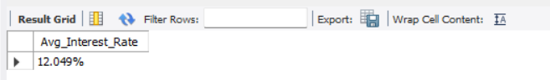
Result screenshot
Q14 — MTD Average Interest Rate
Purpose: Measure average interest rate in December 2021.
SELECT
CONCAT(ROUND(AVG(int_rate) * 100, 3), '%') AS MTD_Avg_Interest_Rate
FROM financial_loan
WHERE MONTH(STR_TO_DATE(issue_date, '%d-%m-%Y')) = 12
AND YEAR(STR_TO_DATE(issue_date, '%d-%m-%Y')) = 2021;
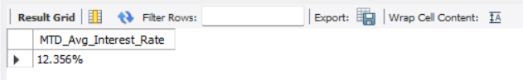
Result screenshot
Q15 — PMTD Average Interest Rate
Purpose: Measure average interest rate in November 2021.
SELECT
CONCAT(ROUND(AVG(int_rate) * 100, 3), '%') AS PMTD_Avg_Interest_Rate
FROM financial_loan
WHERE MONTH(STR_TO_DATE(issue_date, '%d-%m-%Y')) = 11
AND YEAR(STR_TO_DATE(issue_date, '%d-%m-%Y')) = 2021;
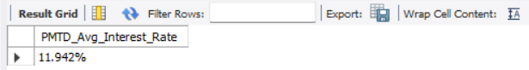
Result screenshot
Q16 — MoM% Change in Average Interest Rate
Purpose: Calculate month-over-month interest-rate movement.
WITH mtd AS (
SELECT AVG(int_rate) * 100 AS MTD
FROM financial_loan
WHERE MONTH(STR_TO_DATE(issue_date, '%d-%m-%Y')) = 12
AND YEAR(STR_TO_DATE(issue_date, '%d-%m-%Y')) = 2021
),
pmtd AS (
SELECT AVG(int_rate) * 100 AS PMTD
FROM financial_loan
WHERE MONTH(STR_TO_DATE(issue_date, '%d-%m-%Y')) = 11
AND YEAR(STR_TO_DATE(issue_date, '%d-%m-%Y')) = 2021
)
SELECT
CONCAT(ROUND((MTD - PMTD) / PMTD * 100, 3), '%') AS MoM_Interest_Rate
FROM mtd
CROSS JOIN pmtd;
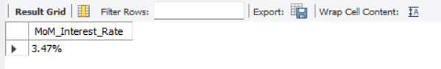
Result screenshot
Summary Insight: Average interest rate increased 3.47% MoM, moving from 11.942% in November to 12.356% in December.

8.5 DTI KPIs (Q17–Q20)
Q17 — Average DTI (Debt-to-Income Ratio)
Purpose: Measure the portfolio-wide average Debt-to-Income Ratio.
SELECT
CONCAT(ROUND(AVG(dti) * 100, 3), '%') AS Avg_DTI
FROM financial_loan;
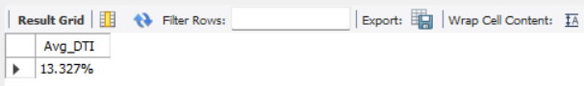
Result screenshot
Q18 — MTD Average DTI
Purpose: Measure average DTI in December 2021.
SELECT
CONCAT(ROUND(AVG(dti) * 100, 3), '%') AS MTD_Avg_DTI
FROM financial_loan
WHERE MONTH(STR_TO_DATE(issue_date, '%d-%m-%Y')) = 12
AND YEAR(STR_TO_DATE(issue_date, '%d-%m-%Y')) = 2021;
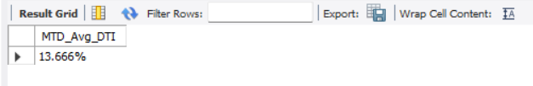
Result screenshot
Q19 — PMTD Average DTI
Purpose: Measure average DTI in November 2021.
SELECT
CONCAT(ROUND(AVG(dti) * 100, 3), '%') AS PMTD_Avg_DTI
FROM financial_loan
WHERE MONTH(STR_TO_DATE(issue_date, '%d-%m-%Y')) = 11
AND YEAR(STR_TO_DATE(issue_date, '%d-%m-%Y')) = 2021;
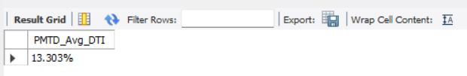
Result screenshot

Q20 — MoM% Change in Average DTI
Purpose: Calculate month-over-month DTI movement.
WITH mtd AS (
SELECT AVG(dti) * 100 AS MTD
FROM financial_loan
WHERE MONTH(STR_TO_DATE(issue_date, '%d-%m-%Y')) = 12
AND YEAR(STR_TO_DATE(issue_date, '%d-%m-%Y')) = 2021
),
pmtd AS (
SELECT AVG(dti) * 100 AS PMTD
FROM financial_loan
WHERE MONTH(STR_TO_DATE(issue_date, '%d-%m-%Y')) = 11
AND YEAR(STR_TO_DATE(issue_date, '%d-%m-%Y')) = 2021
)
SELECT
CONCAT(ROUND((MTD - PMTD) / PMTD * 100, 3), '%') AS MoM_DTI
FROM mtd
CROSS JOIN pmtd;
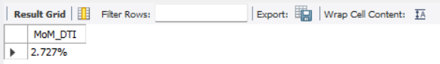
Result screenshot
Summary Insight: Average DTI increased 2.727% MoM, from 13.303% to 13.666%. This is a descriptive movement in borrower-level financial characteristics, not proof of causation.

9. Dashboard 1 —

9.1 Good Loan vs Bad Loan (Q21–Q24)
Q21 — Good Loan Application Percentage
Purpose: Measure the percentage of applications classified as Good Loans.
WITH CTE AS (
SELECT
COUNT(CASE
WHEN loan_status IN ('Fully Paid', 'Current') THEN id
END) AS Good_Loan_Applications,
COUNT(id) AS Total_Applications
FROM financial_loan
)
SELECT
CONCAT(ROUND((Good_Loan_Applications / Total_Applications) * 100, 2), '%')
AS Good_Loan_Percentage
FROM CTE;
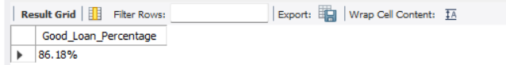
Result screenshot
Q22 — Good Loan Applications (Count)
Purpose: Count Fully Paid and Current applications.
SELECT
COUNT(id) AS Good_Loan_Applications
FROM financial_loan
WHERE loan_status IN ('Fully Paid', 'Current');
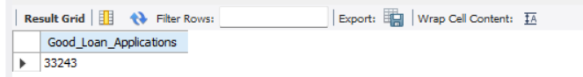
Result screenshot
Q23 — Good Loan Funded Amount
Purpose: Measure principal funded to Good Loans.
SELECT
SUM(loan_amount) AS Good_Loan_Funded_Amount
FROM financial_loan
WHERE loan_status IN ('Fully Paid', 'Current');
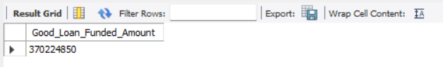
Result screenshot
Q24 — Good Loan Total Received Amount
Purpose: Measure payments received from Good Loans.
SELECT
SUM(total_payment) AS Good_Loan_Total_Received_Amount
FROM financial_loan
WHERE loan_status IN ('Fully Paid', 'Current');
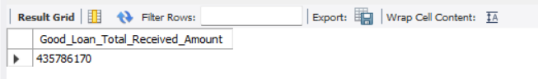
Result screenshot
Summary Insight: Good Loans represent 86.18% of applications. They show 370.2M funded versus 435.8M received in the supplied results.

9.2 Dashboard 1 — Bad Loan Analysis (Q25–Q28)
Q25 — Bad Loan Application Percentage
Purpose: Measure the percentage of applications classified as Bad Loans.
WITH CTE AS (
SELECT
COUNT(CASE
WHEN loan_status = 'Charged Off' THEN id
END) AS Bad_Loan_Applications,
COUNT(id) AS Total_Applications
FROM financial_loan
)
SELECT
CONCAT(ROUND((Bad_Loan_Applications / Total_Applications) * 100, 2), '%')
AS Bad_Loan_Percentage
FROM CTE;
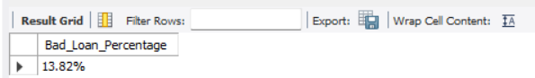
Result screenshot

Q26 — Bad Loan Applications (Count)
Purpose: Count Charged Off applications.
SELECT
COUNT(id) AS Bad_Loan_Applications
FROM financial_loan
WHERE loan_status = 'Charged Off';
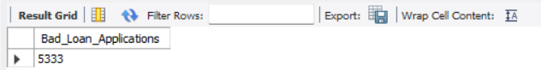
Result screenshot
Q27 — Bad Loan Funded Amount
Purpose: Measure principal funded to Charged Off loans.
SELECT
SUM(loan_amount) AS Bad_Loan_Funded_Amount
FROM financial_loan
WHERE loan_status = 'Charged Off';
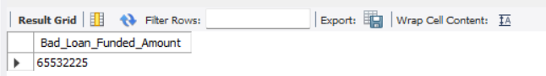
Result screenshot
Q28 — Bad Loan Total Received Amount
Purpose: Measure payments received from Charged Off loans.
SELECT
SUM(total_payment) AS Bad_Loan_Total_Received_Amount
FROM financial_loan
WHERE loan_status = 'Charged Off';
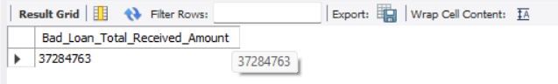
Result screenshot
Summary Insight: Bad Loans represent 13.82% of applications and show a clear recovery gap: 65.5M funded versus 37.2M received.

Charged Off recovery ratio: 37,284,763 ÷ 65,532,225 ≈ 56.9%.
This ratio describes the share of funded amount represented by recorded received amount for the Charged Off segment in the supplied result.
Key Insight — Loan Quality: 86.18% of applications are Good Loans (Fully Paid + Current), while 13.82% are Bad Loans (Charged Off). The Charged Off segment requires closer monitoring because recorded received amount is substantially below funded amount.

10. Dashboard 1 —

10.1 Loan Status Grids (Q29–Q30)
Q29 — Loan Status Summary Grid (Full Year)
Purpose: Create a consolidated full-year view by loan status.
SELECT
loan_status,
COUNT(id) AS Loan_Count,
SUM(total_payment) AS Total_Amount_Received,
SUM(loan_amount) AS Total_Funded_Amount,
CONCAT(ROUND(AVG(int_rate * 100), 2), '%') AS Avg_Interest_Rate,
CONCAT(ROUND(AVG(dti * 100), 2), '%') AS Avg_DTI
FROM financial_loan
GROUP BY loan_status
ORDER BY loan_status;
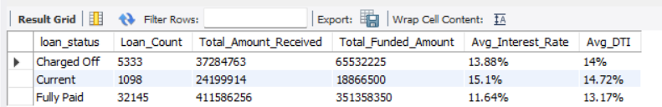
Result screenshot
Q30 — MTD Loan Status Grid (Latest Month = December 2021)
Purpose: Create the latest-month loan-status view.
SELECT
loan_status,
SUM(total_payment) AS MTD_Total_Amount_Received,
SUM(loan_amount) AS MTD_Total_Funded_Amount
FROM financial_loan
WHERE MONTH(STR_TO_DATE(issue_date, '%d-%m-%Y')) = 12
AND YEAR(STR_TO_DATE(issue_date, '%d-%m-%Y')) = 2021
GROUP BY loan_status
ORDER BY loan_status;
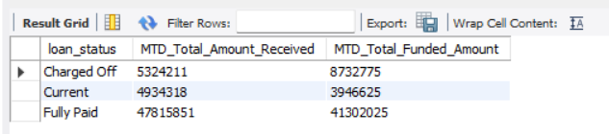
Result screenshot
Summary Insight: Fully Paid is the largest status group, followed by Current and Charged Off. The December MTD grid provides the latest-month status-level view.

11. Dashboard 2 —

11.1 Overview Analysis
Q31 — Monthly Trends by Issue Date
Purpose: Measure total loan application volume.
SELECT
MONTH(STR_TO_DATE(issue_date, '%d-%m-%Y')) AS Month_Number,
MONTHNAME(STR_TO_DATE(issue_date, '%d-%m-%Y')) AS Month_Name,
COUNT(id) AS Total_Loan_Applications,
SUM(loan_amount) AS Total_Funded_Amount,
SUM(total_payment) AS Total_Amount_Received
FROM financial_loan
GROUP BY
MONTH(STR_TO_DATE(issue_date, '%d-%m-%Y')),
MONTHNAME(STR_TO_DATE(issue_date, '%d-%m-%Y'))
ORDER BY Month_Number;
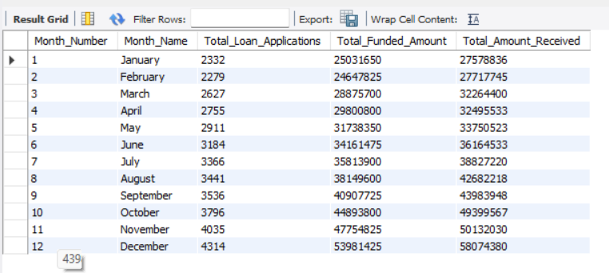
Result screenshot
Insight: December recorded 4,314 applications, the highest monthly application volume in the supplied monthly result.

Q32 — Regional Analysis by State
Purpose: Analyze lending activity by state
SELECT
address_state AS State,
COUNT(id) AS Total_Loan_Applications,
SUM(loan_amount) AS Total_Funded_Amount,
SUM(total_payment) AS Total_Amount_Received
FROM financial_loan
GROUP BY address_state
ORDER BY Total_Funded_Amount DESC;
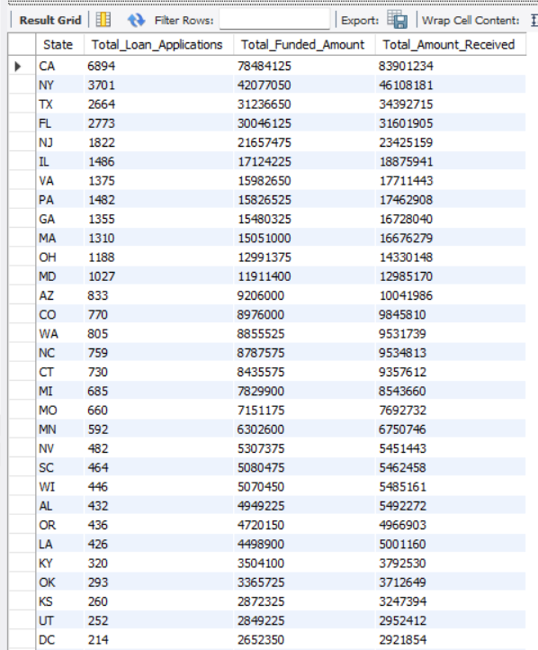

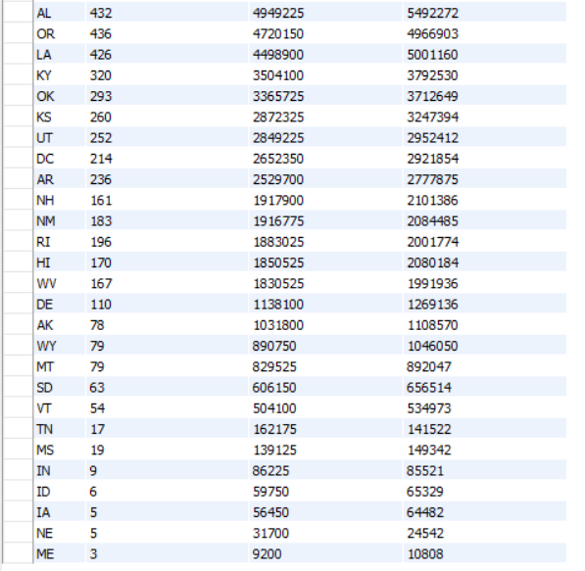

Result screenshot Result screenshot
Insight: California (CA) has the highest funded amount in the supplied state-level output, indicating notable regional concentration.
Q33 — Loan Term Analysis
Purpose: Compare 36-month vs 60-month loans
SELECT
term AS Term,
COUNT(id) AS Total_Loan_Applications,
SUM(loan_amount) AS Total_Funded_Amount,
SUM(total_payment) AS Total_Amount_Received
FROM financial_loan
GROUP BY term
ORDER BY term;
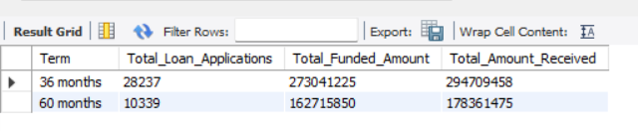
Result screenshot
Insight: 36-month loans dominate with 28,237 applications versus 10,339 for 60-month loans.
Q34 — Employee Length Analysis
Purpose: Analyze lending by employment length
SELECT
emp_length AS Employee_Length,
COUNT(id) AS Total_Loan_Applications,
SUM(loan_amount) AS Total_Funded_Amount,
SUM(total_payment) AS Total_Amount_Received
FROM financial_loan
GROUP BY emp_length
ORDER BY emp_length;
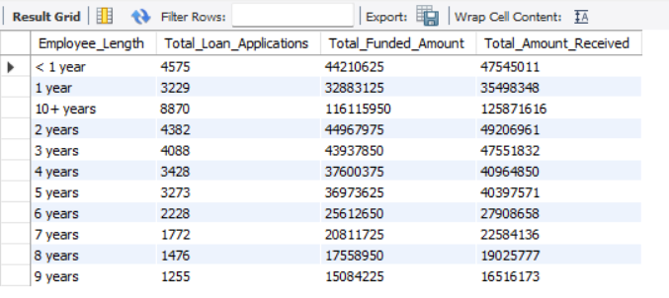
Result screenshot
Insight: Lending is distributed across employment-length categories, providing a borrower-stability segmentation dimension.
Q35 — Loan Purpose Analysis
Purpose: Analyze lending by loan purpose
SELECT
purpose AS Purpose,
COUNT(id) AS Total_Loan_Applications,
SUM(loan_amount) AS Total_Funded_Amount,
SUM(total_payment) AS Total_Amount_Received
FROM financial_loan
GROUP BY purpose
ORDER BY Total_Funded_Amount DESC;
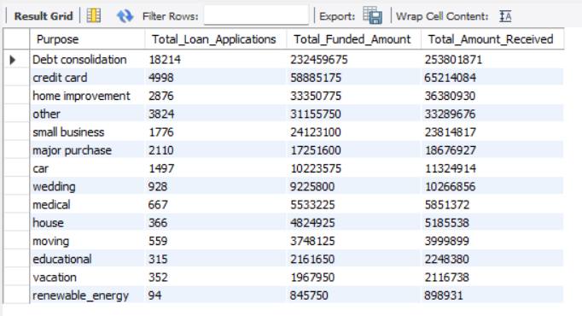
Result screenshot
Insight: Debt Consolidation is the dominant loan purpose in the supplied full-purpose output.
Q36 — Home Ownership Analysis
Purpose: Analyze lending by home ownership status
SELECT
home_ownership AS Home_Ownership,
COUNT(id) AS Total_Loan_Applications,
SUM(loan_amount) AS Total_Funded_Amount,
SUM(total_payment) AS Total_Amount_Received
FROM financial_loan
GROUP BY home_ownership
ORDER BY home_ownership;
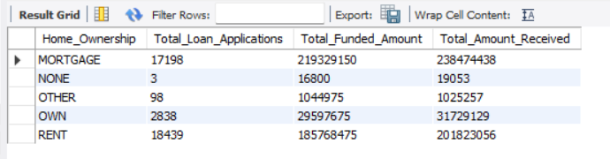
Result screenshot
Insight: Mortgage and Rent represent major home-ownership categories and provide useful portfolio segmentation.
Q37 — Filtered Analysis Example (Grade = 'A')
Purpose: Analyze purpose distribution for Grade A loans
-- So here, MySQL first filters the table down to ONLY Grade 'A' rows,
-- and THEN groups those filtered rows by purpose. This is useful for
-- demonstrating how dashboard filters (like a "Grade" slicer in
-- Power BI) would affect the underlying numbers.

-- ------------------------------------------------------------------------
SELECT
purpose AS Purpose,
COUNT(id) AS Total_Loan_Applications,
SUM(loan_amount) AS Total_Funded_Amount,
SUM(total_payment) AS Total_Amount_Received
FROM financial_loan
WHERE grade = 'A'
GROUP BY purpose
ORDER BY Total_Funded_Amount DESC;
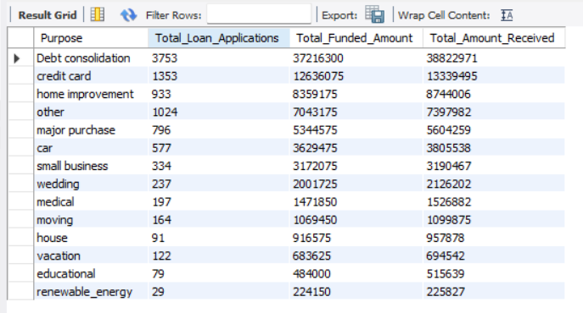
Result screenshot
Insight: Within Grade A loans, Debt Consolidation remains a major purpose, showing purpose concentration within the filtered risk segment.

12. Key Business Insights
The following insights are derived directly from the validated MySQL results. They describe observed patterns in the 2021 loan portfolio and should not be treated as causal conclusions or financial advice.
1. Portfolio Volume
The dataset contains 38,576 loan applications for the year 2021, providing a complete view of the bank’s lending activity for the period.
2. Latest Month Momentum (December 2021)
Applications increased by 6.91%, funded amount increased by 13.04%, and amount received increased by 15.84% versus November. This indicates stronger lending and collection activity in the final month.
3. Loan Quality Distribution
Good Loans (Fully Paid + Current) account for 86.18% of applications, while Bad Loans (Charged Off) account for 13.82%.
4. Good Loan Performance
Good Loans show 370,224,850 funded and 435,786,170 received. Received amount is higher than funded amount in the supplied result.
5. Bad Loan Recovery Gap
Charged Off loans show 65,532,225 funded versus 37,284,763 received, highlighting a substantial recovery gap.
6. Loan Term Preference
36-month loans dominate the portfolio with 28,237 applications versus 10,339 for 60-month loans.
7. Geographic Concentration
California (CA) has the highest funded amount among states in the supplied output, indicating notable regional concentration.
8. Loan Purpose Concentration
Debt Consolidation is the most common loan purpose in the supplied portfolio output.
9. Interest Rate & DTI Movement
Average Interest Rate increased 3.47% MoM and average DTI increased 2.727% MoM. These are descriptive movements in the latest-month portfolio characteristics.
Overall Summary: The 2021 portfolio shows strong end-of-year volume momentum, a majority Good Loan population and positive recorded repayment performance in the Good Loan segment. The key monitoring areas are the Charged Off recovery gap and concentration by state and loan purpose.

13. Business Recommendations
The following recommendations are based on the validated SQL findings from the 2021 loan portfolio. They are analytical observations for monitoring and reporting, not formal credit policy or individual lending decisions.
Recommendation 1 — Monitor Charged Off Exposure
Regularly track the volume, funded amount and received amount of Charged Off loans. This segment represents 13.82% of applications and shows a clear recovery gap.
Recommendation 2 — Track Recovery Performance
Use the received-to-funded ratio for Charged Off loans as a monitoring metric. In the supplied dataset, approximately 56.9% of the funded amount was recorded as received for this segment.
Recommendation 3 — Monitor Geographic Concentration
California recorded the highest funded amount among states. Regional concentration should be monitored to understand portfolio exposure.
Recommendation 4 — Monitor Purpose Concentration
Debt Consolidation is the dominant loan purpose. Concentration in a single borrowing use-case should be reviewed periodically.
Recommendation 5 — Track Monthly Momentum
December showed positive growth in applications (+6.91%), funded amount (+13.04%) and amount received (+15.84%). Monthly trend monitoring can help identify changes in portfolio activity.
Recommendation 6 — Segment Analysis by Loan Term
36-month loans form the majority of the portfolio (28,237 applications) compared with 60-month loans (10,339). Comparing performance and loan quality by term can provide deeper portfolio understanding.
Disclaimer: These recommendations support further investigation and reporting. They do not replace formal credit risk models, compliance checks or professional lending judgment.

14. Validation & Power BI Handoff
The SQL layer is the reconciliation/source-of-truth layer for the downstream Power BI dashboard. The dashboard should use the same business definitions for dates, loan quality and KPI calculations.
Validation Layer | What Is Checked | Power BI Use
Schema | Fields and types | Source-model validation
Date range | Min/Max converted date | Time-period filters
Core KPIs | Applications, funding, received, interest, DTI | Dashboard cards
Loan quality | Good/Bad counts and percentages | Quality visuals
Status grid | Status-level aggregates | Matrix/grid
Dimensions | Month, state, term, employment, purpose, ownership | Charts and slicers
Filtered analysis | Grade-A purpose output | Filter-context validation
If Power BI and SQL disagree, compare date conversion, filter context, aggregation, status definitions and dimensional filters before changing the dashboard.

15. Limitations & Responsible Use
- issue_date is stored as TEXT and requires explicit MySQL date conversion.
- MTD and PMTD are defined using the latest and previous calendar months represented in the dataset.
- Good Loan and Bad Loan are project-specific analytical definitions based on loan_status.
- Observed patterns are descriptive and should not automatically be treated as causal relationships.
- Loan analytics supports decision-making but does not replace formal credit policy, risk models, compliance checks or professional financial judgment.

16. Portfolio Summary
This project demonstrates a SQL-first Data Analyst workflow: understand the business problem, inspect the schema, resolve data-quality issues, build reusable KPI logic, validate outputs and hand validated metrics to Power BI.

Skills Demonstrated
Skill | Evidence
MySQL / SQL | 37 documented analytical queries and validation checks.
Data Quality | Schema, row count, uniqueness, completeness and date checks.
KPI Development | Overall, MTD, PMTD and MoM% metrics.
SQL Logic | CTEs, CASE WHEN, CROSS JOIN, GROUP BY, WHERE and ORDER BY.
Business Analysis | Good/Bad Loans, status, trend and dimensional analysis.
BI Reconciliation | SQL outputs prepared for Power BI validation.

