Customer Churn Analysis
Complete Project Report
Python + Pandas + NumPy + Matplotlib + Seaborn
An end-to-end customer churn analytics project that integrates data loading from an Excel workbook, data cleaning, feature engineering, customer-level analysis, statistical exploration, visualization and actionable retention insights on a 10,000-customer dataset.
Metric | Result | Metric | Result
Customers in final analysis | 10,000 | Churn Rate | 27.27%
Churned Customers | 2,727 | Retention Rate | 72.73%
ARPU (average monthly charge) | $26.55 | Monthly Revenue at Risk | $73,267.54
Escalation Rate (customers) | 15.19% | Customers with Support Records | 3,800 (38%)
High-Risk Customers (churn score 70+) | 2,727 | Churn / Escalation Correlation | 0.00

1. Executive Summary
This Customer Churn Analysis project was developed as a practical analytics workflow for understanding why customers leave a subscription-based service and where retention opportunities may exist. The project uses an Excel workbook with three linked sheets: customer demographics (10,000 rows), subscription information (10,000 rows) and customer-support records (4,647 rows covering 3,800 customers). Python was used to load the sheets, clean the data, engineer analytical features, merge the tables into one customer-level master dataset and perform exploratory analysis.
The project deliberately focuses on the descriptive and diagnostic questions of churn analysis: how many customers left, what share of monthly revenue they represent, and which customer, subscription and support characteristics are associated with churn. A churn flag, tenure, tenure group and churn-risk category were engineered; core KPIs, segment tables, support analysis and five visualizations were then produced. No predictive machine-learning model was built.
The main result is a churn rate of 27.27% (2,727 of 10,000 customers) with $73,267.54 of monthly revenue attached to churned customers. Churn is almost evenly spread across plan type, subscription type, contract type, escalation status and complaint volume (roughly 26% to 28%), so none of these characteristics is a strong stand-alone driver in this dataset. The strongest relationships are with tenure (correlation -0.73) and churn score (0.81), but both are derived from or aligned with the outcome and must be interpreted carefully (sections 10, 11 and 16).
Note: The dataset was generated with a Python generator script (random seed 42) and is simulated, not real customer data. Results describe this simulated dataset and should not be generalized to a real customer population.
2. Business Problem and Objectives
Subscription businesses depend heavily on customer retention. A cancellation affects both customer count and recurring revenue, so the business needs to know how many customers are leaving, how much monthly revenue they represent and whether any plan, region, contract, support or tenure pattern identifies customers who are likely to leave.
The objectives were to combine the three tables into one customer-level dataset, clean and standardize the data, create a churn flag and supporting features, calculate churn KPIs (churn rate, retention rate, ARPU, revenue at risk and escalation rate), compare churn across customer and subscription segments, examine the link between support activity and churn, and communicate the results through clear tables and charts.
3. Data Architecture and Source Tables
Table | Purpose | Key Fields
db_customer (10,000 rows, 8 columns) | Customer demographics | customerid, name, country, state, gender, dob, interests, pincode
db_subscription (10,000 rows, 11 columns) | Subscription, revenue and churn information | customerid, subscription_start_date, subscription_type, renewal_date, plan_type, contract_type, cancellation_date, cancellation_reason, monthly_charges, cltv, churn_score
db_support (4,647 rows, 6 columns) | Customer support / complaint records | customerid, complaint_date, escalations, csat_score, col_1, comment

All three sheets are related through customerid. The subscription table was selected as the base table because it contains one row for each of the 10,000 customers and the cancellation information used to define churn. The customer table matched all 10,000 customers. The support table contains 4,647 records for 3,800 unique customers, so one customer can have more than one support record; it was therefore aggregated to customer level before joining.
4. Technical Stack and Project Setup
Technology | Use
Python | Main analysis environment and data generation
Jupyter Notebook | Interactive development, validation and documentation
Excel workbook (openpyxl / pandas.read_excel) | Source data storage: three sheets loaded into DataFrames
Pandas | Data loading, cleaning, grouping, merging and aggregation
NumPy | Vectorized conditional logic (np.where) for feature creation
Matplotlib | Figure creation and chart customization
Seaborn | Bar charts and the correlation heatmap

The notebook imported pandas, NumPy, Matplotlib and Seaborn, applied a clean Seaborn white-grid theme and suppressed unnecessary warnings. The Excel workbook was loaded with pd.read_excel, one sheet per DataFrame, and the shapes were printed to confirm the load: 10,000 customer rows, 10,000 subscription rows and 4,647 support rows.

5. Project Architecture
Python Data Generator (seed 42)
↓
Excel Workbook (db_customer / db_subscription / db_support)
↓
Load Sheets into DataFrames
↓
Data Inspection (shape, nulls, unique values)
↓
Data Cleaning (gender, country, interests, spelling, dates)
↓
Feature Engineering (churn_flag, tenure_days, churn_risk, tenure_group)
↓
Support Aggregation to One Row per Customer
↓
Left Joins on customerid
↓
Customer-Level Master Dataset (10,000 rows, 26 columns)
↓
KPIs + Segment Analysis + Support Analysis
↓
Risk Validation, Visualization and Correlation Analysis
↓
Business Insights, Recommendations and Limitations
This architecture keeps the workflow reproducible: the data can be regenerated from the script, every cleaning and feature step is written in code, and each table is merged only after it has been reduced to one row per customer.

6. Data Cleaning and Preparation
The customer table was inspected for structure, data types and missing values. Column names were standardized to lowercase. The gender field contained inconsistent labels (Men and Women alongside Male and Female); these were standardized to Male and Female, giving 5,226 male and 4,774 female customers. The dob field was converted to a datetime type.
The country field had 694 missing values (6.94%) and the interests field had 3,371 missing values (33.71%). Instead of inferring them, both were filled with the label "Unknown", which keeps every customer in the analysis. The pincode column was completely empty (10,000 of 10,000 missing); it was not used in the analysis.
In the subscription table, subscription_start_date, renewal_date and cancellation_date were converted to datetime. The subscription_type value "Refferal" was corrected to "Referral". The cancellation_date and cancellation_reason columns each had 7,273 missing values, which is expected because they apply only to the 2,727 customers who cancelled; these blanks were deliberately kept and used to define churn.
In the support table, complaint_date was converted to datetime, the escalations codes Y and N were standardized to Yes and No (1,623 Yes and 3,024 No), and 977 missing comments were filled with "No comment". The col_1 column was empty for all 4,647 records and was not used.

7. Feature Engineering and Data Integration
A key feature was churn_flag. The project defines a customer as churned when a cancellation date is present and as active when it is missing. NumPy's np.where was used to create a binary 1/0 indicator, which makes it easy to calculate churn rate as the mean of the flag.
df_subscription_clean['churn_flag'] = np.where(
df_subscription_clean['cancellation_date'].notnull(), 1, 0
)
Tenure was engineered in days. For churned customers it is the cancellation date minus the subscription start date; for active customers it is the run date minus the start date (the notebook uses today's date, which makes tenure depend on when the notebook is run). A tenure_group column (0-6 Months, 6-12 Months, 1-2 Years, 2+ Years) was created with pd.cut. A churn_risk column was created from the existing churn_score: Low Risk below 40, Medium Risk 40 to 69 and High Risk 70 or above.
Because a customer can have several support records, the support table was grouped by customerid before merging. The aggregation produced total_complaints, total_escalations, avg_csat_score and last_complaint_date for each customer.
df_support_agg = (
df_support_clean.groupby('customerid').agg(
total_complaints = ('customerid', 'count'),
total_escalations = ('escalations', lambda x: (x == 'Yes').sum()),
avg_csat_score = ('csat_score', 'mean'),
last_complaint_date = ('complaint_date', 'max')
).reset_index()
)
The subscription table was first merged with the customer table (10,000 rows, 22 columns) and then with the aggregated support table using left joins on customerid. The final master dataset has 10,000 rows and 26 columns with exactly one row per customer, so the aggregation step prevented duplicated customers and inflated counts. Customers without any support record received 0 for total_complaints, total_escalations and avg_csat_score.

8. Core Analytical KPIs
KPI | Result | Business Meaning
Total Customers | 10,000 | Customers in the final master dataset
Total Churned | 2,727 | Customers with a cancellation date
Churn Rate | 27.27% | Share of customers who churned
Retention Rate | 72.73% | Share of customers retained (1 - churn rate)
ARPU | $26.55 | Average monthly charge per customer
Monthly Revenue at Risk | $73,267.54 | Monthly charges of churned customers
Escalation Rate | 15.19% | Share of customers (1,519) with at least one escalation

Overall churn rate was calculated as the mean of churn_flag, and retention rate as its complement. ARPU is the mean of monthly_charges and is shown in the notebook with a dollar sign. Revenue at Risk is the sum of monthly_charges for customers whose churn_flag is 1; it equals about $26.87 per churned customer, slightly above the overall ARPU. The escalation rate is the share of customers (not of tickets) with at least one escalated support record.

9. Segment-Level Churn Analysis
Plan-level analysis showed almost no difference in observed churn. Premium customers had the highest churn at 27.57%, followed by Basic at 27.43% and Standard at 26.95%, a spread of only 0.62 percentage points. The plans differ strongly in revenue: average monthly charges are $56.61 for Premium, $10.04 for Basic and $16.50 for Standard.

Plan Type | Customers | Churned | Churn Rate | Avg Monthly Charge
Premium | 2,967 | 818 | 27.57% | $56.61
Basic | 2,862 | 785 | 27.43% | $10.04
Standard | 4,171 | 1,124 | 26.95% | $16.50

Subscription type and contract type show the same pattern. Organic customers churned at 27.94% (954 of 3,415), Referral at 27.80% (899 of 3,234) and Paid at 26.08% (874 of 3,351). Monthly contracts churned at 27.39% (1,254 of 4,579) and Annual contracts at 27.17% (1,473 of 5,421); the contract type therefore made almost no difference.
Geographic analysis ranked states by churn rate. The ten highest were Odisha (30.68%), Uttar Pradesh (30.38%), Nagaland (30.00%), Chhattisgarh (29.30%), Punjab (28.91%), Delhi (28.86%), Karnataka (28.71%), Rajasthan (28.28%), Maharashtra (28.15%) and Madhya Pradesh (28.14%). Each state has roughly 400 to 600 customers, so a gap of one or two percentage points between states is small compared with normal sampling variation.

10. Tenure, Revenue and Customer Support Analysis
Tenure group is the only segment with large differences. Customers in the 0-6 Months group (530) and the 6-12 Months group (690) were 100% churned, the 1-2 Years group churned at 81.12% (1,169 of 1,441) and the 2+ Years group at 4.61% (338 of 7,339). The correlation between tenure_days and churn_flag is -0.73.

Tenure Group | Customers | Churned | Churn Rate
0-6 Months | 530 | 530 | 100.00%
6-12 Months | 690 | 690 | 100.00%
1-2 Years | 1,441 | 1,169 | 81.12%
2+ Years | 7,339 | 338 | 4.61%

This pattern should not be read as "new customers are very likely to leave". Tenure is measured differently for the two groups: churned customers stop at their cancellation date, while active customers keep counting until the notebook run date. All active customers started between 2019 and 2024, so every active customer already has more than about 640 days of tenure and cannot fall in the groups below one year. Short tenure therefore follows from having churned, which is partly a result of how the feature is defined.
Revenue at Risk was defined as the monthly revenue associated with customers who have already churned. The notebook value is $73,267.54. Using the average charge by plan, Premium customers (818 churned at about $56.61) account for roughly $46,300, or about 63% of this amount, while Basic and Standard together account for the rest. Revenue exposure therefore concentrates in Premium even though its churn rate is almost the same as other plans.
Support behavior was also analyzed. Customers with at least one escalation (1,519) churned at 27.39%, almost the same as customers without escalations (8,481), at 27.25%; escalated customers had more complaints on average (1.31 versus 0.31). By complaint volume, churn was 27.81% for customers with no complaint (6,200), 25.97% for one complaint (2,953) and 27.86% for two to three complaints (847); the 4+ complaints group is empty. Average CSAT was 19.98 for active customers and 19.32 for churned customers. These averages include a value of 0 for the 6,200 customers with no support record, which pulls both averages down. No support measure separates churned from active customers in this dataset.

11. Churn Risk Classification
A separate churn_risk feature was created from the existing churn_score using transparent thresholds: scores below 40 are Low Risk, scores from 40 to below 70 are Medium Risk, and scores of 70 or above are High Risk. The distribution is 4,230 Low Risk (42.3%), 3,043 Medium Risk (30.4%) and 2,727 High Risk (27.3%).
df_subscription_clean['churn_risk'] = pd.cut(
df_subscription_clean['churn_score'],
bins=[-1, 39, 69, 100],
labels=['Low Risk', 'Medium Risk', 'High Risk']
)
The risk categories were then compared with actual churn. High Risk customers were 100% churned (2,727 of 2,727), while Low Risk and Medium Risk customers had 0% churn. This perfect separation means the churn_score in this dataset is already aligned with the outcome; it cannot be treated as an early warning that was validated against future behavior. The category is useful for describing the data, not for proving that churn can be predicted.

12. Visualization
Visualizations were built with Matplotlib and Seaborn to compare churn rates across segments, show the risk distribution and show relationships between numeric variables. Each chart follows the same style: a clean white grid, a clear title, labeled axes and percentage labels on the bars.
Selected Visualization Gallery
The following figures are the project outputs generated during exploratory and statistical analysis. They are included to document the visual-analysis stage of the workflow.
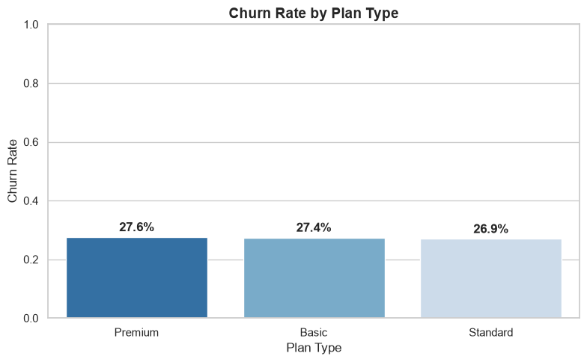
Figure 1. Churn Rate by Plan Type
The three bars are almost the same height (27.6%, 27.4% and 26.9%), which confirms that plan type does not separate churned from retained customers.
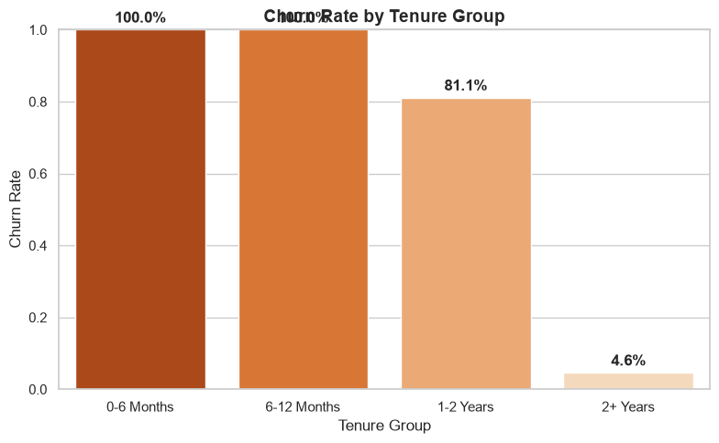
Figure 2. Churn Rate by Tenure Group
The tenure chart shows the largest contrast (100%, 100%, 81.1% and 4.6%); see the note on how tenure is defined in section 10.
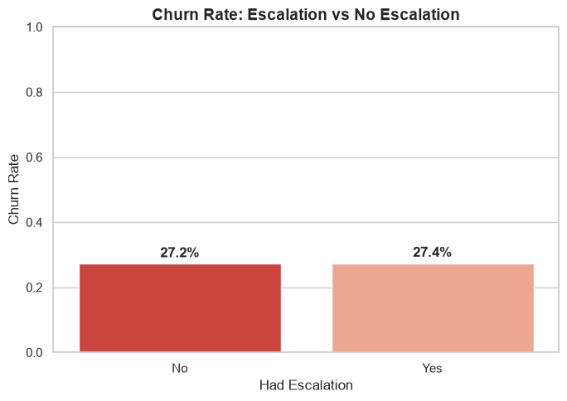
Figure 3. Churn Rate: Escalation vs No Escalation
Customers with and without escalations have nearly identical churn (27.4% and 27.2%).
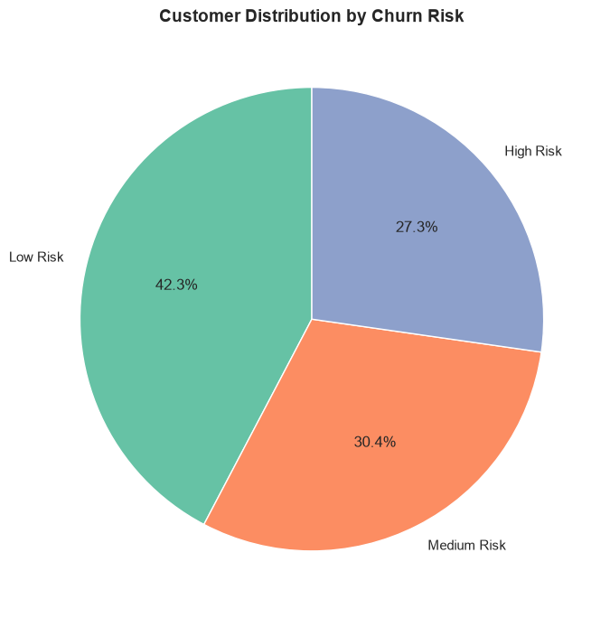
Figure 4. Customer Distribution by Churn Risk
The pie chart shows 42.3% Low Risk, 30.4% Medium Risk and 27.3% High Risk; the High Risk share equals the overall churn rate.
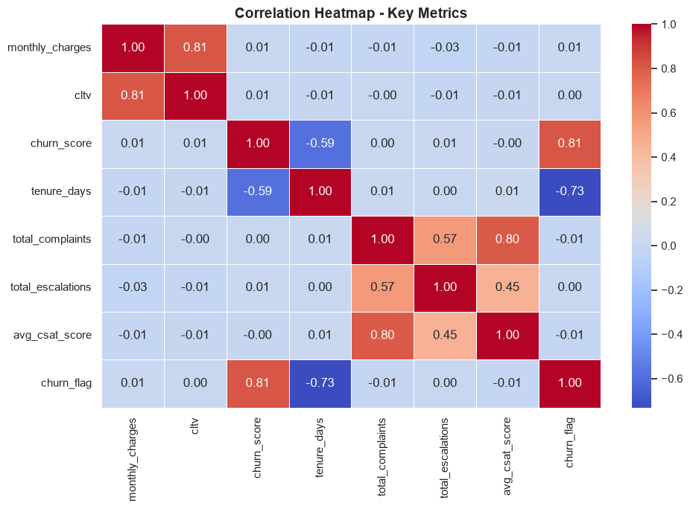
Figure 5. Correlation Heatmap - Key Metrics
The heatmap uses numeric fields only. churn_flag correlates strongly with churn_score (0.81) and negatively with tenure_days (-0.73), and has almost no correlation with monthly_charges (0.01), cltv (0.00), total_complaints (-0.01), total_escalations (0.00) or avg_csat_score (-0.01). Other relationships are monthly_charges with cltv (0.81), total_complaints with avg_csat_score (0.80) and with total_escalations (0.57), and churn_score with tenure_days (-0.59). The bar charts use a fixed 0 to 1 axis, so small differences between segments look flat, which is the right way to show that they are small.
13. Data Generation and Reproducibility
The workbook used in this project was produced by a Python generator script instead of being exported from a live system. The script sets random.seed(42) and np.random.seed(42), creates 10,000 customers with unique IDs, and writes the three sheets with openpyxl. Re-running the script reproduced the notebook results (10,000 customers, 2,727 churned customers and 4,647 support records), so the analysis is fully repeatable.
The generator deliberately builds in realistic data problems: gender labels such as Men and Women, a missing country for 7% of customers, empty interests for about one third of customers, an empty pincode column, the spelling "Refferal", an empty col_1 column and missing comments. These are the issues cleaned in section 6.
Example 1 — Churn assigned in the generator:
is_churn = np.random.rand() < 0.28
if is_churn:
cancel = start + timedelta(days=random.randint(30, 850))
score = random.randint(70, 99)
else:
cancel = None
score = random.randint(3, 65)
Example 2 — Support records in the generator:
support_cids = random.sample(list(df_customer['customerid']), k=int(N * 0.38))
'escalations': np.random.choice(['Y', 'N'], p=[0.35, 0.65]),
'csat_score': random.randint(10, 95)
These examples are taken from the generator script. Churn is drawn with a 28% probability, independently of plan, contract, state, subscription type and support activity, and churned customers receive churn scores of 70 to 99 while active customers receive 3 to 65. This explains why segment churn rates are almost identical, why High Risk equals churned customers, and why short tenure follows from cancelling within 30 to 850 days of the start date. The output file is named customer_churn_data_2500_clean.xlsx in the script although it contains 10,000 customers, and the notebook loads a copy named customer_churn_data.xlsx.

14. Technical Challenges and Lessons Learned
Challenge | Resolution | Learning
Missing country (694) and interests (3,371) | Filled with "Unknown" instead of guessing | Keep every customer and make missing values visible
Inconsistent gender labels (Men / Women) | Mapped to Male / Female | Standardize categories before grouping
Misspelled subscription type "Refferal" | Replaced with "Referral" | Fix labels so categories are not split
Empty columns (pincode, col_1) | Left unused in the analysis | Check completeness before choosing fields
Several support records per customer | Aggregated to one row per customer before the left join | Prevents duplicated customers and inflated counts
Customers without support records | Filled counts and CSAT with 0 | A 0 CSAT is not a real score and lowers the averages
Tenure for active customers uses today's date | Documented; a fixed analysis date is recommended | Tenure results change with the run date
Churn score identical to the outcome | Reported as an aligned label, not as validation | Check for leakage before trusting a score
Empty "4+ Complaints" group | Reported as empty | Choose bins that match the data

15. Key Insights and Business Value
The project produced a structured view of churn across customer, subscription, geographic, tenure and support dimensions. Overall churn is 27.27%: 2,727 of 10,000 customers left, with $73,267.54 of monthly revenue attached to them. Retention is 72.73%.
Plan type, subscription type, contract type, state, escalation and complaint volume all show similar churn rates (about 26% to 31%), and the correlations between churn and monthly charges, CLTV, complaints, escalations and CSAT are all close to zero (between -0.01 and 0.01). In this dataset none of these characteristics is a useful stand-alone predictor, and the data does not support the idea that escalated or heavily complaining customers churn more.
Premium customers pay about 5.6 times the Basic average charge (56.61 versus 10.04) with nearly the same churn rate, so most of the revenue at risk (about 63%) comes from Premium. Retention effort per customer is therefore worth more in Premium even though its churn rate is similar.
Recommended actions based on the measured results
First, treat the results as a method demonstration and rerun the same notebook on real customer data before designing campaigns. Second, protect Premium revenue first, because it carries the largest revenue exposure. Third, define tenure at a fixed analysis date and build a time-based churn analysis (cohorts by start month) instead of comparing tenure groups. Fourth, replace the existing churn score with a score validated on customers who had not yet churned. Fifth, track escalations, complaints and CSAT over time with proper handling of customers without tickets, and monitor the core KPIs monthly.

16. Limitations and Responsible Use
The dataset is simulated. Churn was assigned at random with a 28% probability, so segment-level findings (and their absence) reflect how the data was generated and not real customer behavior. The reported revenue at risk is the monthly charge of customers who have already churned and is shown in the notebook with a dollar sign; it is not a forecast of future loss.
The tenure feature depends on the run date and is shorter for churned customers by construction, and the churn score is aligned with the outcome, so neither is a valid early-warning signal. CSAT averages include zeros for customers without support records. Correlation does not establish causation. The analysis is descriptive: no predictive model, cohort analysis, cancellation-month trend or cancellation-reason analysis was performed. The general observation notes written in the notebook (for example that higher complaint counts go with higher churn) are not confirmed by the measured results.

17. Final Project Workflow and Conclusion
The project demonstrates a complete analytics lifecycle: relational data loading, inspection, cleaning, feature engineering, duplicate-safe aggregation and merging, KPI calculation, segmentation, support analysis, risk validation, visualization and business interpretation.
The solution is more than a set of charts: it shows how to turn three related tables into a customer-level analytical dataset, how to measure churn and revenue at risk, and, importantly, how to check whether a result is meaningful before acting on it. Here the checks showed that the segment differences are tiny and that tenure and churn score are tied to the outcome.
The project can be presented as a portfolio case study showing how a Data Analyst can turn customer data into structured retention analysis, while being transparent about the limits of a simulated dataset.

