EMPEROR RESTAURANT
POWER BI ANALYTICS
COMPLETE PROJECT REPORT & TECHNICAL HANDOVER
From restaurant operations data to decision-ready business insights

PROJECT FIELD | DETAIL
Project | Emperor Restaurant Power BI Analytics
Business context | Multi-branch restaurant operations in Malaysia
Currency | RM — Malaysian Ringgit
Reporting period | Dashboard date dimension is designed for 1 January–31 December 2025
Primary BI tool | Microsoft Power BI
Analytical components | Data modelling, DAX, KPI design, dashboard UX, operational analysis
Visible business areas | Sales, bookings, digital platforms, attribution, AI replies, staff, reviews, forecast and action plans
Prepared for | Portfolio demonstration and interview discussion
Version | 2.0 | October 2026

Evidence basis: user-supplied Power BI screenshots, visible report values, relationship register and DAX snippets.
Important: this is a detailed documentation of the evidence provided—not a substitute for validating the complete PBIX and underlying data.

Contents
- 1. How to Read This Report and Evidence Rules
- 2. Executive Summary
- 3. Business Context, Problem Statement and Objectives

3.4 Tools and Technologies Used
Tool / Technology | Role in the Project
Microsoft Power BI | Dashboard development, visuals, interactions and KPI presentation
Power Query | Data preparation, cleaning and model-ready transformations
DAX | Calculated columns, measures, KPI logic and segmentation
Excel / Source Workbooks | Source data inspection and supporting tables
Power BI Data Model | Dimensional model with shared dimensions and fact tables

- 4. Scope and Report Navigation Inventory

5.0 Project Architecture
Restaurant Source Data → Power Query Preparation → Dimensional Data Model (Dimensions + Fact Tables) → DAX Calculated Columns & Measures → Multi-Page Power BI Dashboards → Business Insights + Management Action Plan
- 5. Data Model: Dimensions, Facts, Grain and Relationships
- 6. Relationship Register Review
- 7. DAX Library — Calculated Columns and Helper Tables
- 8. KPI and Measure Definitions Visible in the Project
- 9. Dashboard Deep Dive — 10-Platform Overview
- 10. Dashboard Deep Dive — Omnichannel Attribution
- 11. Dashboard Deep Dive — Campaign ROI and Promotion Attribution
- 12. Dashboard Deep Dive — AI Auto-Reply Performance
- 13. Dashboard Deep Dive — Staff Performance
- 14. Dashboard Deep Dive — Customer Review and Satisfaction
- 15. Dashboard Deep Dive — RM20 Million Target and Forecast
- 16. Dashboard Deep Dive — Management Action Plan

17. Complete Dashboard Coverage — All 24 Pages
This register provides a consistent navigation-level explanation for all 24 pages. The major pages are also discussed in depth in the earlier dashboard sections. Screenshot values are repeated only where they are documented in the supplied evidence; unverified rankings are not invented.

Page 1 — Overview
Business Question: What is the overall restaurant performance at a glance?
Key Visuals / KPIs: Executive KPIs; sales vs target; bookings/enquiries; platform, staff and customer-feedback indicators.
Key Insight (from screenshot): Reported headline sales are RM20.69M against an RM20M target (103.5% achievement), subject to consistent filters.
Validation Note: Ensure all cards share the intended date/branch context and reconcile with detailed pages.

Page 2 — RM20 Million Target
Business Question: Are sales on track against the annual RM20M target?
Key Visuals / KPIs: Total Sales, Total Target, Sales Gap, achievement %, target status and monthly progress.
Key Insight (from screenshot): The reported RM20.69M sales headline is above the RM20M target; distinguish over-target amount from gap sign convention.
Validation Note: Confirm monthly/branch target allocation, target grain, date filtering and gap sign.

Page 3 — Branch Performance
Business Question: Which branches lead or lag?
Key Visuals / KPIs: Branch ranking; sales, bookings, average bill and operational/service metrics.
Key Insight (from screenshot): Compare branches on the same period and measure definitions; no unverified rank is asserted.
Validation Note: Branch totals must reconcile to overall sales; verify branch targets and label mappings.

Page 4 — Daily Sales Performance - 1
Business Question: How do sales change day by day?
Key Visuals / KPIs: Daily sales trend, date/branch filters, weekday/weekend split and daily peaks.
Key Insight (from screenshot): Use the trend to locate peaks and dips; the chart alone does not establish their cause.
Validation Note: Check date continuity, relationships, month sorting and zero-sales days.

Page 5 — Daily Sales Performance - 2
Business Question: What additional time-based detail helps explain daily sales?
Key Visuals / KPIs: Hour/daypart comparison, weekday/weekend details and supporting breakdowns.
Key Insight (from screenshot): This page should investigate patterns from Page 4 rather than duplicate the same view.
Validation Note: Keep filters consistent with Page 4 and define hour bands clearly.

Page 6 — Promotion Performance - 1
Business Question: Which promotions generate activity and sales?
Key Visuals / KPIs: Promotion-wise enquiries/bookings, promotion sales and performance comparisons.
Key Insight (from screenshot): Sales should only be attributed to a promotion when the data/filter context supports it.
Validation Note: Promo Sales sums all Fact_Sales bill amounts unless a promotion filter is active.

Page 7 — Promotion Performance - 2
Business Question: Which promotions merit efficiency review?
Key Visuals / KPIs: Promotion comparison/ranking, promotion type, discount and margin where available.
Key Insight (from screenshot): High sales alone does not prove profitability or incremental impact.
Validation Note: Do not label a measure ROI without cost/investment data and a documented formula.

Page 8 — Menu & Dish Sales - 1
Business Question: Which menu items and categories contribute most?
Key Visuals / KPIs: Top dishes, item quantity, net sales, category contribution and item comparison.
Key Insight (from screenshot): Use the visuals to identify high-volume/high-contribution items under current filters.
Validation Note: Use order-item grain; avoid duplicating bill-level amounts across item rows.

Page 9 — Menu & Dish Sales - 2
Business Question: What deeper menu opportunities are visible?
Key Visuals / KPIs: Further item/category breakdowns, low performers and menu patterns.
Key Insight (from screenshot): Provide a distinct lens such as category mix or item performance rather than repeating Page 8.
Validation Note: Do not infer profit from sales alone; validate costs, discounts and margin fields.

Page 10 — Booking Performance - 1
Business Question: How many enquiries and bookings are generated?
Key Visuals / KPIs: Enquiry/booking counts, conversion indicators, booking status and source.
Key Insight (from screenshot): The report shows about 13K total bookings in one view and about 9K attributed bookings in another; these may be different populations.
Validation Note: Use distinct stable IDs where fact rows repeat; define cancellations and no-shows.

Page 11 — Booking Performance - 2
Business Question: How do booking sources and outcomes compare?
Key Visuals / KPIs: Source/platform comparisons, conversion rates and booking outcomes.
Key Insight (from screenshot): Clearly distinguish all bookings from bookings attributed to a platform or campaign.
Validation Note: Document attribution rules and prevent multiple-credit double counting.

Page 12 — VIP Room & Event Sales
Business Question: What contribution and opportunity come from VIP rooms/events?
Key Visuals / KPIs: VIP/event revenue, enquiries, confirmed bookings, utilization and opportunity.
Key Insight (from screenshot): Separate realized revenue from pipeline or expected value.
Validation Note: Validate event status, occupancy denominator, dates and realized-versus-forecast definitions.

Page 13 — Membership
Business Question: What is the member base and tier mix?
Key Visuals / KPIs: Member counts, tier mix, acquisition cohorts and member/non-member sales.
Key Insight (from screenshot): Membership insights are meaningful only when the member population is accurately defined.
Validation Note: COUNTROWS(Dim_Customer) counts customer rows, not necessarily members.

Page 14 — Membership Wallet - 1
Business Question: How are wallet top-ups and payments performing?
Key Visuals / KPIs: Top-up amount, wallet payments, transaction count, average top-up and usage.
Key Insight (from screenshot): Read transaction counts alongside top-up/payment values to understand wallet activity.
Validation Note: Document amount sign conventions and the intended transaction grain.

Page 15 — Membership Wallet - 2
Business Question: What wallet balances, dormant users and liabilities need attention?
Key Visuals / KPIs: Remaining balance, dormant wallet users, liability and usage ratios.
Key Insight (from screenshot): Unused balances may indicate engagement opportunities and potential liabilities, depending on accounting rules.
Validation Note: Select latest balance by chronological transaction order per customer; MAX(BalanceAfter) may not be the latest.

Page 16 — 10-Platform Overview
Business Question: How are the ten digital platforms performing overall?
Key Visuals / KPIs: Followers, new followers, views, clicks, engagement and platform scorecard.
Key Insight (from screenshot): Screenshot figures include about 3M followers, 157K new followers, 63M views, 1M clicks and 4.6% engagement.
Validation Note: Define engagement numerator/denominator and confirm metrics can be summed across platforms/time.

Page 17 — 10-Platform Overview - 2
Business Question: How do platform audiences and engagement differ over time?
Key Visuals / KPIs: Platform comparisons, audience growth trends and engagement/content metrics.
Key Insight (from screenshot): Use this page to identify platforms for deeper investigation; followers may overlap across platforms.
Validation Note: Check period alignment, platform-specific metric definitions and missing data.

Page 18 — Omnichannel Attribution
Business Question: How do enquiries convert to attributed bookings and revenue?
Key Visuals / KPIs: Enquiries, attributed bookings, conversion, revenue per enquiry/booking and platform contribution.
Key Insight (from screenshot): Screenshot figures include about 12K enquiries, 9K attributed bookings and a 71.8% attributed booking rate.
Validation Note: Define attribution window, eligible enquiries and the distinction between attributed and total bookings.

Page 19 — Omnichannel Attribution - 2
Business Question: How do campaigns, promotions and channels compare under attribution?
Key Visuals / KPIs: Campaign/platform comparison, promotion attribution, conversion and revenue contribution.
Key Insight (from screenshot): Attribution totals may differ from total bookings if populations differ, but the difference must be explained.
Validation Note: Reconcile totals at the intended grain and check campaign joins/multi-touch credits.

Page 20 — AI Auto-Reply Performance
Business Question: How effective are automated replies and handovers?
Key Visuals / KPIs: AI success, human takeover, response time, booking conversion and failure/topic breakdowns.
Key Insight (from screenshot): Reported indicators include 78.3% success, 15.3% human takeover, 23.6% booking conversion and 63.2% efficiency score.
Validation Note: Confirm response-time unit, success definition and denominators for takeover/conversion.

Page 21 — Staff Performance
Business Question: How do staff contribute to sales, upselling and customer experience?
Key Visuals / KPIs: Staff sales, upsell revenue, average bill, ratings and complaints.
Key Insight (from screenshot): Reported summary values include RM20.69M staff sales, RM3.64M upsell, average bill 450.53, rating 4.08 and 123 complaints.
Validation Note: Staff-sales headline RM20.69M differs from a staff/branch matrix total reported as RM9.05M; reconcile filters, grain and allocations.

Page 22 — Customer Review & Satisfaction
Business Question: What are rating, sentiment and complaint patterns?
Key Visuals / KPIs: Average rating, positive share, complaint rate and branch scorecard.
Key Insight (from screenshot): Reported overall values: rating 4.08, positive share 76.6%, complaint rate 3.3%; Cheras is shown at 3.74 rating/7.4% complaints and KL at 4.39/0.4%.
Validation Note: Confirm rating scale, sentiment rules and complaint denominator; reconcile rates with counts.

Page 23 — Forecast & Growth - 1
Business Question: How does performance compare with the target and projected year-end result?
Key Visuals / KPIs: Forecast year-end sales, target line, gap, branch/member/reactivation opportunities and required daily sales.
Key Insight (from screenshot): Reported year-end sales forecast is RM20.69M vs RM20M target; remaining sales needed and required daily sales are shown as zero.
Validation Note: Document forecast method/history period and gap sign; zero required sales should only follow target achievement or period end.

Page 24 — Forecast & Growth - 2 / Management Action Plan
Business Question: What actions should management take, and how will impact be tracked?
Key Visuals / KPIs: Prioritized actions, findings, rationale, actions, expected RM impact and status/ownership.
Key Insight (from screenshot): The action plan translates findings into next steps; expected impact is an estimate, not guaranteed revenue.
Validation Note: Add owner, due date, baseline, target, assumptions and realized-vs-expected impact; deduplicate repeated actions or use opportunity IDs.
- 18. Cross-Dashboard Business Findings
- 19. Business Recommendations and Action Framework
- 20. Data Quality and Validation Checklist
- 21. DAX and Modelling Risks Requiring Attention
- 22. Visual Design and Usability Review
- 23. Refresh, Governance and Power BI Handoff
- 24. Limitations and Responsible Use
- 25. Interview Preparation

25.5 Skills Demonstrated
Skill Area | Evidence in Project
Power BI | Multi-page dashboard design, navigation, KPI cards and slicers
Data Modeling | Star-schema design, fact/dimension relationships and grain control
DAX | Calculated columns, measures, SWITCH logic and helper tables
Power Query | Data preparation and transformation layer
Business Analysis | Sales, bookings, attribution, AI performance, staff and reviews
KPI Design | Target achievement, conversion rates, engagement and ROI framing
Validation & Governance | Relationship checks, measure risks and reconciliation checklist
Storytelling | Executive monitoring → diagnostic analysis → action plan
Interview Communication | Clear pitch, talking points and technical explanation framework

- Appendix A. DAX Formula Reference
- Appendix B. Page-by-Page Acceptance Checklist
Navigation note: the workbook screenshots show more than 16 tabs. This report records the page names visible in the supplied screenshots rather than forcing the report into an older 16-page plan.

1. How to Read This Report and Evidence Rules
This report deliberately separates three kinds of statements so that the documentation remains credible.
Evidence label | Meaning | How it is used
Visible / reported | A value, label, chart, or relationship visible in a supplied screenshot. | Can be quoted as a dashboard-reported result, with the screenshot context noted.
DAX supplied | A formula explicitly pasted or shown by the user. | Can be explained line by line; the formula is not assumed to be the final formula for every visual.
Recommendation / validation item | A proposed improvement based on common BI quality principles or an observed ambiguity. | Must be validated in the PBIX before being described as already implemented.

Several screenshots display different slicer states, and some are cropped. A value shown on one page may not reconcile directly with a value on another page if the filter context, date range, attribution definition, or measure grain differs. Therefore, this report does not claim that every screenshot represents the same filter state.
The supplied evidence is not the same as direct access to the full PBIX, Power Query scripts, complete source workbook, or every DAX measure. Where a definition is not available, the report flags it for validation instead of inventing a calculation.

2. Executive Summary
The Emperor Restaurant Power BI project is a multi-page business intelligence report designed to consolidate operational and commercial performance across a multi-branch restaurant group. Its visible pages cover sales and target tracking, branch performance, daily sales, promotion performance, menu and dish sales, booking performance, VIP room and event sales, membership and wallet activity, digital-platform performance, omnichannel attribution, AI auto-replies, staff productivity, customer reviews, and forecast/growth opportunities.
The report uses a consistent burgundy, cream, and gold visual identity, a left-side page-navigation panel, slicers near the top, KPI cards, ranked bar charts, trend lines, scorecards, matrices, funnels, and an action-plan table. This creates a familiar interface across pages and supports both executive scanning and detailed exploration.

2.1 Selected headline values visible in the supplied screenshots
Area | Dashboard-reported value | Interpretation / qualification
Sales target | RM20.69M sales; RM20M target; 103.5% achievement | Shown on Forecast & Growth page; validate exact date/filter scope.
Booking attribution | ~12K enquiries; ~9K attributed bookings; 71.8% attributed booking rate | Shown on Omnichannel Attribution page; metric definition should be documented.
Bookings and revenue | ~13K total bookings; RM20.69M total sales | Rounded display values, not exact raw totals.
Digital platforms | 3M followers; 157K new followers; 63M views; 1M link clicks | Shown on 10-Platform Overview page.
Digital engagement | 4.6% engagement rate | Dashboard KPI; numerator/denominator not supplied here.
AI response | 78.3% AI success; 15.3% human takeover; average response time 15.37 | Response-time unit and AI-success definition need documentation.
AI booking conversion | 23.6% | Dashboard-reported percentage; validate denominator and conversion window.
Staff performance | RM20.69M staff sales; RM3.64M upsell revenue; staff rating 4.08 | Shown on Staff Performance page.
Customer feedback | Average rating 4.08; positive review share 76.6%; complaint rate 3.3% | Shown on Customer Review & Satisfaction page.
Complaints | 123 negative reviews / complaints as shown in KPI cards | Confirm whether negative reviews and staff complaints use the same definition.

Executive interpretation: the supplied report is strongest when it connects activity to a business outcome—for example, platform enquiries to attributed bookings, staff activity to sales, or customer reviews to branch-level service patterns. The most important next step is not adding more visuals; it is documenting measure definitions and validating filter behavior so the numbers can be trusted.

2.2 What this report covers
- Describes the visible dashboards and their business questions.
- Explains the DAX calculated columns and helper tables supplied in the conversation.
- Documents visible relationship patterns and the risks that still require testing.
- Distinguishes actual screenshot values from analytical recommendations.
- Provides a repeatable QA checklist for the final PBIX.

3. Business Context, Problem Statement and Objectives
Restaurant management must understand not only what happened, but also where, when, through which channel, and what action should follow. Sales totals alone do not explain whether marketing generates qualified enquiries, whether enquiries become bookings, whether bookings produce revenue, whether service quality differs by branch, or whether customer inactivity creates a reactivation opportunity.

3.1 Business problem
Operational information is distributed across sales, booking, customer, platform, promotion, staff, wallet, voucher, AI conversation, and review processes. Without a consistent semantic model, the same business concept can be counted differently on different pages. A Power BI model can reduce that inconsistency by reusing shared dimensions, defining reusable measures, and applying a consistent date and branch context.

3.2 Core objectives
- Measure sales against the RM20 million annual target and show the gap, achievement percentage, and trend.
- Compare branch performance using sales and relevant operational context.
- Monitor daily/monthly sales, day type, time band, and other useful business segments.
- Evaluate promotion and campaign performance using enquiries, bookings, revenue, and—where cost data exists—ROI.
- Measure digital platform reach, engagement, clicks, enquiries, and audience growth.
- Understand attribution from digital enquiries to bookings and sales without treating views or followers as revenue.
- Monitor AI reply success, response time, topic-level failures, human handover, and booking conversion.
- Review staff contribution and upselling while accounting for role, hours, workload, and branch context.
- Monitor customer ratings, sentiment, complaint types, and branch differences.
- Identify membership, wallet, voucher, customer-recency, event, and forecast opportunities.

3.3 Target reference
Target reference | Value | Calculation / note
Annual sales target | RM20,000,000 | Business target visible in page name and KPI.
Monthly equivalent | RM1,666,666.67 | RM20,000,000 ÷ 12; use as a planning benchmark, not necessarily the exact monthly Fact_Target allocation.
Daily equivalent | RM54,794.52 | RM20,000,000 ÷ 365; use only if target is distributed uniformly by calendar day.
Equal branch benchmark | RM4,000,000 per branch | RM20,000,000 ÷ 5 branches; a simple comparison benchmark, not necessarily the approved branch-specific target.

Important: actual performance must use Fact_Target or an approved target allocation by month/branch. The monthly, daily, and equal-branch numbers above are mathematical benchmarks only and should not replace the target table.

4. Scope and Report Navigation Inventory
The visible navigation panel contains more than 16 page tabs, including separate numbered pages for several topics. The inventory below records the labels visible in the supplied screenshots. Some pages have full screenshots in the evidence set; others are documented at a purpose level because a complete visual was not supplied.
No. | Visible page label | Primary business question
1 | Overview | What is the overall restaurant performance?
2 | RM20 Million Target | Are sales on track against the annual target?
3 | Branch Performance | Which branches lead or lag on key measures?
4 | Daily Sales Performance - 1 | How do sales vary by date, branch, and day/time segment?
5 | Daily Sales Performance - 2 | What additional daily-sales breakdown or detail supports investigation?
6 | Promotion Performance - 1 | Which promotions drive activity and commercial outcomes?
7 | Promotion Performance - 2 | Which promotions deserve further comparison or action?
8 | Menu & Dish Sales - 1 | Which menu items/categories drive sales?
9 | Menu & Dish Sales - 2 | What deeper menu or dish analysis is available?
10 | Booking Performance - 1 | How are enquiries and bookings performing?
11 | Booking Performance - 2 | How do booking sources, conversions, and outcomes compare?
12 | VIP Room & Event Sales | What is the contribution and opportunity in VIP rooms/events?
13 | Membership | What is the member/customer base and tier mix?
14 | Membership Wallet - 1 | How are wallet balances and transactions performing?
15 | Membership Wallet - 2 | What further wallet usage/liability detail is available?
16 | 10-Platform Overview | How are ten digital platforms performing?
17 | 10-Platform Overview - 2 | How do platform engagement and audience trends compare?
18 | Omnichannel Attribution | How do enquiries translate to bookings and revenue by platform?
19 | Omnichannel Attribution - 2 | How do campaigns/promotions and platform attribution compare?
20 | AI Auto-Reply Performance | How effective are automated responses and handovers?
21 | Staff Performance | How do staff sales, bookings, upselling, and feedback compare?
22 | Customer Review & Satisfaction | What are the rating, sentiment, and complaint patterns?
23 | Forecast & Growth - 1 | How does performance compare with targets and growth opportunities?
24 | Forecast & Growth - 2 | What management actions and expected impacts are listed?

The report pages and their names are not assumed to be an exact 16-page architecture because the supplied screenshots visibly show the extended navigation listed above. Where a page is not fully shown, this report describes its intended analytical purpose without inventing its exact visuals or results.

5. Data Model: Dimensions, Facts, Grain and Relationships
The relationship register shows a dimensional model with shared dimensions and multiple fact tables. This design is suitable for multi-process reporting when each fact table has a clearly defined grain and the shared dimensions use stable keys.

5.1 Dimension tables visible in the relationship register / model pane
Dimension | Role in analysis | Example use
Dim_Date | Common calendar and time attributes | Month trends, weekday/weekend, monthly targets, time slicing.
Dim_Branch | Branch identity and attributes | Branch comparison, regional filtering, branch names.
Dim_Customer | Customer/member attributes | Membership, recency, customer segmentation.
Dim_Platform | Digital platform/channel labels | Platform engagement, enquiries, attributed bookings.
Dim_Campaign | Campaign attributes | Campaign performance and content/campaign grouping.
Dim_Promotion | Promotion attributes | Promo names, types, event flags, target margin.
Dim_Staff | Staff identity and role attributes | Staff scorecards, sales and service contribution.
Dim_MenuItem | Menu item attributes | Dish/category sales, menu analysis.
Dim_PaymentMethod | Payment method | Payment mix and tender analysis.
Dim_Table | Table/seat context | Bookings and table-related analysis.
Dim_Voucher | Voucher campaign attributes | Voucher issue/redemption and campaign short names.

5.2 Fact tables visible in the relationship register
Fact table | Likely grain to verify | Analytical role
Fact_Sales | One row per bill/sale transaction—confirm | BillAmount, sales KPIs, member sale classification.
Fact_OrderItems | One row per bill line/menu item—confirm | Item-level sales and basket/menu analysis; links to Fact_Sales by BillID.
Fact_Booking | One row per booking or booking record—confirm | Booking counts, visit date, staff/branch/platform attribution.
Fact_PlatformEnquiry | One row per enquiry—confirm | Enquiry volume and enquiry-to-booking conversion.
Fact_PlatformContent | One row per content record—confirm | Content/campaign activity.
Fact_PlatformFollowers | One row per platform/time snapshot—confirm | Audience growth and follower trend.
Fact_AIReplyLog | One row per AI conversation/reply event—confirm | AI success, response time, topic and handover.
Fact_Review | One row per review—confirm | Ratings, sentiment, complaints, staff/menu mentions.
Fact_Target | One row per branch/month target—confirm | Target achievement and monthly target allocation.
Fact_Wallet | One row per wallet transaction—confirm | Top-ups, payments, balances and wallet usage.
Fact_Voucher | One row per voucher issue/redemption record—confirm | Issued value, redeemed value, status and liability.
Fact_ActionPlan | One row per action/opportunity—confirm | Management action, priority, category and expected impact.

5.3 Why grain matters
A fact table's grain defines what one row means. For example, one bill can contain multiple order-item rows. If a bill-level amount is summed after joining to item-level data, the bill amount may be repeated for each item and overstate sales. Similarly, one enquiry may be associated with more than one interaction or booking. Before building measures, record the grain, primary key, foreign keys, and expected uniqueness of each fact.

5.4 Star-schema principles to retain
- Use dimension tables to filter fact tables through keys, rather than creating unnecessary direct dimension-to-dimension relationships.
- Prefer one-to-many relationships from unique dimension keys to fact foreign keys.
- Use single-direction filtering by default unless a documented business case requires otherwise.
- Avoid ambiguous paths between facts and dimensions; test cross-filter behavior rather than relying on visual appearance.
- Use a marked date table with a unique Date column and a consistent relationship to date keys.
- Use explicit measures for business KPIs rather than summing columns in visuals without a documented definition.

6. Relationship Register Review
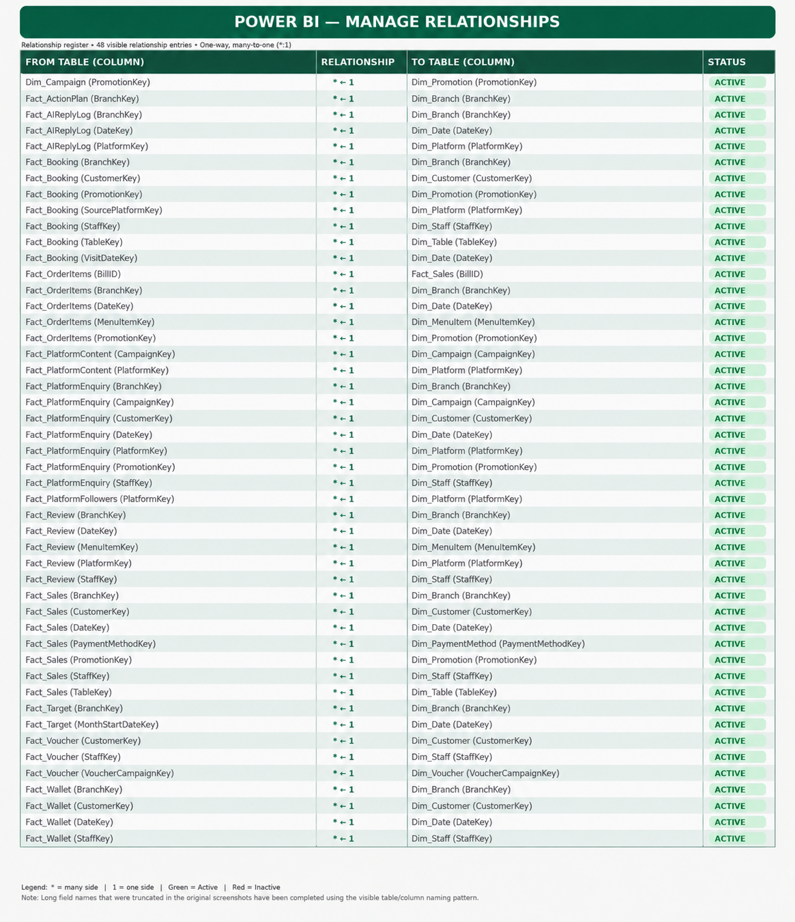
Figure 1. Supplied relationship register showing active relationships.
The supplied register reports 48 visible relationship entries and labels them active. The displayed pattern is mostly many-to-one from fact-side foreign keys to dimension-side keys. Examples include Fact_Sales to Dim_Date, Dim_Branch, Dim_Customer, Dim_Promotion, Dim_Staff, Dim_Table, and Dim_PaymentMethod; Fact_Booking to Dim_Branch, Dim_Customer, Dim_Promotion, Dim_Platform, Dim_Staff, Dim_Table, and Dim_Date; and Fact_Review to branch, date, menu item, platform, and staff.

6.1 Specific checks prompted by the register
- Fact_OrderItems (BillID) → Fact_Sales (BillID): confirm the cardinality and filter direction. If Fact_Sales has one row per BillID and Fact_OrderItems has multiple lines per BillID, the expected shape is one sales header to many item rows. Measures must not double-count header amounts after line-level joins.
- Fact_Target (MonthStartDateKey) → Dim_Date (DateKey): confirm that the target date key represents the first day of the month and that month-level targets filter correctly across a date table with daily rows.
- Fact_PlatformEnquiry uses multiple dimensions, including Campaign, Customer, Date, Platform, Promotion, Staff, and Branch. Verify that each foreign key is valid and that blank/unassigned values are handled deliberately.
- Fact_AIReplyLog includes Branch, Date, and Platform in the visible register. The topic field appears in the dashboard but its exact relationship is not shown in the relationship register screenshot.
- Fact_Voucher connects to Dim_Voucher by VoucherCampaignKey. Confirm that this key matches the dimension key and that campaign naming logic uses the intended source table.
- Confirm dimension key uniqueness and inspect inactive relationships separately; the supplied image is a register of active entries, not proof that all required relationships are active or correct.
This is a review checklist, not a declaration that a relationship is defective. The screenshot establishes the displayed links; only the PBIX model and data can confirm actual cardinality, uniqueness, direction, and filter results.

7. DAX Library — Calculated Columns and Helper Tables
The formulas below are transcribed from the user-supplied snippets/screenshots. The descriptions explain what the formulas do and what to validate. These formulas should be kept distinct from measures because calculated columns are evaluated at data refresh and usually do not change when a slicer changes.

7.1 BranchName
BranchName =
SWITCH(
Dim_Branch[Branch Name],
"Emperor Cuisine Restaurant KL", "KL",
"Emperor Cuisine Restaurant Klang", "Klang",
"Emperor Cuisine Restaurant Cheras", "Cheras",
"Emperor Cuisine Restaurant Puchong", "Puchong",
"Emperor Cuisine Restaurant Subang", "Subang"
)
Purpose: Creates short branch labels for chart axes and compact tables. SWITCH maps each listed long branch name to a shorter display label.
Validation: Add Dim_Branch[Branch Name] as the final fallback so a newly added or differently spelled branch does not return BLANK().

7.2 Join Month and Join Year
Join Month =
FORMAT(Dim_Customer[JoinDate], "MMM yyyy")
Join Year =
YEAR(Dim_Customer[JoinDate])
Purpose: Supports member-acquisition analysis by joining month and year. Join Month is a readable text cohort label.
Validation: Create a numeric YearMonth key (for example, YEAR(JoinDate) * 100 + MONTH(JoinDate)) and sort Join Month by that key to preserve chronological order.

7.3 Birthday Month Name and Birthday Month Sort
Birthday Month Name =
SWITCH(
Dim_Customer[BirthdayMonth],
1, "Jan",
2, "Feb",
3, "Mar",
4, "Apr",
5, "May",
6, "Jun",
7, "Jul",
8, "Aug",
9, "Sep",
10, "Oct",
11, "Nov",
12, "Dec",
"Unknown"
)
Birthday Month Sort =
MONTH(
DATE(
2025,
Dim_Customer[BirthdayMonth],
1
)
)
Purpose: Converts the numeric birthday month into a readable month label and a numeric sort key. The year 2025 is only a placeholder used to construct a date; the extracted result is the month number.
Validation: Confirm BirthdayMonth is an integer from 1 through 12, handle blanks/invalid values, and sort Birthday Month Name by Birthday Month Sort.

7.4 Visit Recency Bucket and Sort
Visit Recency Bucket =
SWITCH(
TRUE(),
Dim_Customer[DaysSinceLastVisit] <= 30, "0-30 Days",
Dim_Customer[DaysSinceLastVisit] <= 60, "31-60 Days",
Dim_Customer[DaysSinceLastVisit] <= 90, "61-90 Days",
Dim_Customer[DaysSinceLastVisit] <= 180, "91-180 Days",
"180+ Days"
)
Visit Recency Sort =
SWITCH(
TRUE(),
Dim_Customer[DaysSinceLastVisit] <= 30, 1,
Dim_Customer[DaysSinceLastVisit] <= 60, 2,
Dim_Customer[DaysSinceLastVisit] <= 90, 3,
Dim_Customer[DaysSinceLastVisit] <= 180, 4,
5
)
Purpose: Creates mutually exclusive visit-recency bands. SWITCH(TRUE()) evaluates conditions in order: up to 30, 31–60, 61–90, 91–180, and over 180 days.
Validation: Explicitly handle blank and negative DaysSinceLastVisit values. Sort Visit Recency Bucket by Visit Recency Sort.

7.5 Reactivation Bucket and Sort
Reactivation Bucket =
SWITCH(
TRUE(),
Dim_Customer[DaysSinceLastVisit] >= 90, "90+ Days",
Dim_Customer[DaysSinceLastVisit] >= 60, "60+ Days",
Dim_Customer[DaysSinceLastVisit] >= 30, "30+ Days",
"Active"
)
Reactivation Sort =
SWITCH(
TRUE(),
Dim_Customer[DaysSinceLastVisit] >= 90, 1,
Dim_Customer[DaysSinceLastVisit] >= 60, 2,
Dim_Customer[DaysSinceLastVisit] >= 30, 3,
4
)
Purpose: Assigns each customer to the highest qualifying inactivity threshold for reactivation analysis.
Validation: These are mutually exclusive segments, not cumulative counts. A customer inactive for 100 days is assigned only to 90+ Days. Review blanks and negative values before classifying.

7.6 Hour and Reactivation Segments helper tables
Hour =
GENERATESERIES(11, 22, 1)
Reactivation Segments =
DATATABLE(
"Segment", STRING,
{
{"30+ Days"},
{"60+ Days"},
{"90+ Days"}
}
)
Purpose: Creates a one-column numeric series from 11 through 22 inclusive for an hour axis or selector.
Validation: This is a helper table, not a calculated column. It remains disconnected unless a relationship is intentionally created; confirm whether the intended hour range matches the restaurant operating hours.
Purpose: Creates three selectable labels for reactivation-threshold analysis.
Validation: This is a disconnected helper table and will not filter Dim_Customer by itself. A measure should read SELECTEDVALUE(Reactivation Segments[Segment]) and apply the corresponding threshold; avoid adding an unnecessary direct relationship.

7.7 Member Types
Member Types =
IF(
Fact_Sales[IsMemberSale] = "Yes",
"Member",
"Non Member"
)
Purpose: Labels each Fact_Sales row as Member or Non Member using IsMemberSale. It is row-specific, so a calculated column is appropriate.
Validation: Confirm the source values are consistently Yes/No; handle blanks, alternate capitalization, and unexpected values explicitly if present.

7.8 Campaign Short Name
Campaign Short Name =
SWITCH(
'Dim_Voucher'[CampaignName],
"Birthday RM30 Treat", "RM30",
"CNY Reunion RM50 Voucher", "RM50",
"Free Dim Sum (Free Item)", "Free Item",
"Mooncake Festival RM25", "RM25",
"New Member RM20 Welcome", "RM20",
"No Voucher", "No Voucher",
"Reactivation RM40 Come-Back", "RM40",
"Top-Up 10% Bonus Voucher", "Top-Up 10%",
"Weekend 15% Off Dinner", "Weekend 15%",
'Dim_Voucher'[CampaignName]
)
Purpose: Shortens voucher campaign labels for compact visuals. The final SWITCH argument returns the original campaign name for any unlisted campaign.
Validation: The fallback is useful. Confirm whether Dim_Voucher or Dim_Campaign is the authoritative source for campaign/voucher labels and ensure the relationship/filter path matches the visual.

7.9 Promo Name
Promo Name =
SWITCH(
'Dim_Promotion'[PromoName],
"No Promotion", "No Promotion",
"RM21.80++ Value Package", "Value Set",
"RM3 Dim Sum Promo", "Dim Sum Deal",
"Wedding Package", "Wedding Event",
"Birthday Package", "Birthday Event",
"Parents Day Package ", "Family Event",
"Corporate Event Package", "Corporate Event",
"VIP Room Minimum Spend", "VIP Dining",
"Festive Set Menu", "Festive Menu",
"Signature Dish Promo", "Signature Special",
'Dim_Promotion'[PromoName]
)
Purpose: Standardizes long promotion labels for chart axes and tables. The original promotion name is returned when no mapping matches.
Validation: The supplied match for Parents Day Package contains a trailing space. Check source whitespace and spelling; do not assume the mapping matches without testing the actual value.

7.10 Weekend Type and Month Year
Weekend Type =
IF(
Dim_Date[IsWeekend] = "Yes",
"Weekend",
"Weekday"
)
Month Year =
FORMAT(Dim_Date[Date], "MMM yyyy")
Purpose: Groups dates into Weekday/Weekend and creates a readable Month Year label.
Validation: Confirm IsWeekend uses the expected data type (text Yes/No or Boolean TRUE/FALSE). Sort Month Year by a numeric YearMonth key to prevent alphabetical ordering.

7.11 Funnel Stage
Funnel Stage =
DATATABLE(
"Stage", STRING,
"Order", INTEGER,
{
{"Followers", 1},
{"Engagement", 2},
{"Enquiries", 3},
{"Bookings", 4}
}
)
Purpose: Creates a disconnected stage table with an explicit display order for Followers, Engagement, Enquiries, and Bookings.
Validation: Sort Stage by Order. A measure must map each selected stage to its metric; describe it as a true funnel only when values represent a consistent cohort, time period, and attribution journey.

7.12 DAX calculated-column
# 7. DAX Library — Calculated Columns and Helper Tables (Text Form)

### 7.1 BranchName

**Formula:**
BranchName =
SWITCH(
Dim_Branch[Branch Name],
"Emperor Cuisine Restaurant KL", "KL",
"Emperor Cuisine Restaurant Klang", "Klang",
"Emperor Cuisine Restaurant Cheras", "Cheras",
"Emperor Cuisine Restaurant Puchong", "Puchong",
"Emperor Cuisine Restaurant Subang", "Subang"
)

**Purpose:** Creates short branch labels for charts and compact tables.

**Validation:** Add a final fallback (Dim_Branch[Branch Name]) so unmatched names do not return BLANK.

---

### 7.2 Join Month & Join Year

**Formula:**
Join Month = FORMAT(Dim_Customer[JoinDate], "MMM yyyy")
Join Year = YEAR(Dim_Customer[JoinDate])

**Purpose:** Supports member acquisition analysis by cohort month and year.

**Validation:** Join Month is text. Create a numeric YearMonth key and use Sort by Column for chronological order.

---

### 7.3 Birthday Month Name & Sort

**Formula:**
Birthday Month Name =
SWITCH(
Dim_Customer[BirthdayMonth],
1, "Jan", 2, "Feb", 3, "Mar", 4, "Apr",
5, "May", 6, "Jun", 7, "Jul", 8, "Aug",
9, "Sep", 10, "Oct", 11, "Nov", 12, "Dec",
"Unknown"
)

Birthday Month Sort =
MONTH(DATE(2025, Dim_Customer[BirthdayMonth], 1))

**Purpose:** Converts numeric birthday month into a readable label and a sort key.

**Validation:** Confirm BirthdayMonth is an integer 1–12. Sort Birthday Month Name by Birthday Month Sort.

---

### 7.4 Visit Recency Bucket & Sort

**Formula:**
Visit Recency Bucket =
SWITCH(
TRUE(),
Dim_Customer[DaysSinceLastVisit] <= 30, "0-30 Days",
Dim_Customer[DaysSinceLastVisit] <= 60, "31-60 Days",
Dim_Customer[DaysSinceLastVisit] <= 90, "61-90 Days",
Dim_Customer[DaysSinceLastVisit] <= 180, "91-180 Days",
"180+ Days"
)

Visit Recency Sort =
SWITCH(
TRUE(),
Dim_Customer[DaysSinceLastVisit] <= 30, 1,
Dim_Customer[DaysSinceLastVisit] <= 60, 2,
Dim_Customer[DaysSinceLastVisit] <= 90, 3,
Dim_Customer[DaysSinceLastVisit] <= 180, 4,
5
)

**Purpose:** Creates mutually exclusive customer recency bands.

**Validation:** Review blank or negative DaysSinceLastVisit values. Sort the bucket column by the Sort column.

---

### 7.5 Reactivation Bucket & Sort

**Formula:**
Reactivation Bucket =
SWITCH(
TRUE(),
Dim_Customer[DaysSinceLastVisit] >= 90, "90+ Days",
Dim_Customer[DaysSinceLastVisit] >= 60, "60+ Days",
Dim_Customer[DaysSinceLastVisit] >= 30, "30+ Days",
"Active"
)

Reactivation Sort =
SWITCH(
TRUE(),
Dim_Customer[DaysSinceLastVisit] >= 90, 1,
Dim_Customer[DaysSinceLastVisit] >= 60, 2,
Dim_Customer[DaysSinceLastVisit] >= 30, 3,
4
)

**Purpose:** Classifies customers by highest qualifying inactivity threshold for reactivation analysis.

**Important:** These are mutually exclusive segments, not cumulative counts. A 100-day inactive customer is classified only as 90+ Days.

---

### 7.6 Helper Tables

**Hour**
Hour = GENERATESERIES(11, 22, 1)

**Purpose:** Creates a numeric hour series (11–22) for time-of-day analysis.

**Validation:** This is a disconnected table unless a relationship is intentionally created.

**Reactivation Segments**
Reactivation Segments =
DATATABLE(
"Segment", STRING,
{
{"30+ Days"},
{"60+ Days"},
{"90+ Days"}
}
)

**Purpose:** Provides segment labels for reactivation analysis.

**Validation:** Requires an explicit measure using SELECTEDVALUE to apply the threshold logic.

8. KPI and Measure Definitions Visible in the Project
The following measure definitions were supplied in the conversation. The report explains the intended calculation and highlights cases where a measure name or aggregation may need correction. These are not a replacement for reviewing every measure in the final PBIX.

8.1 Core measures
Average Rating =
AVERAGE(Fact_Review[Rating])
Customer =
DISTINCTCOUNT(Dim_Customer[CustomerKey])
Monthly Target =
SUM(Fact_Target[WeightedMonthlyTarget])
Promo Sales =
SUM(Fact_Sales[BillAmount])
Sales Gap =
[Total Target] - [Total Sales]
Target Achievement % =
DIVIDE([Total Sales], [Total Target])
Target Status =
SWITCH(
TRUE(),
[Target Achievement %] >= 1, "🟢 On Track",
[Target Achievement %] >= 0.95, "🟡 Watch",
"🔴 At Risk"
)
Total Bookings =
COUNTROWS(Fact_Booking)
Total Enquiries =
COUNTROWS(Fact_PlatformEnquiry)
Total Members =
COUNTROWS(Dim_Customer)
Total Sales =
SUM(Fact_Sales[BillAmount])
Total Target =
SUM(Fact_Target[WeightedMonthlyTarget])
Measure | What it calculates | Review note
Average Rating | Arithmetic average of review ratings. | Check blank handling, rating scale, and review grain.
Customer | Distinct count of CustomerKey. | Useful for customer count; name is generic, consider Total Customers.
Monthly Target | Sum of WeightedMonthlyTarget. | Correct only if the target table's grain and weighting are defined.
Promo Sales | Sum of Fact_Sales[BillAmount]. | This formula sums all sales in filter context; it is only promo sales if a promotion filter applies or the formula adds promo-specific logic.
Sales Gap | Total Target minus Total Sales. | Positive value means target exceeds sales; negative value means sales exceed target. Label should make this sign convention clear.
Target Achievement % | Total Sales divided by Total Target. | DIVIDE handles divide-by-zero more safely than `/`; add an alternate result if desired.
Target Status | Threshold-based text label. | At least 100% = On Track; 95%–under 100% = Watch; below 95% = At Risk.
Total Bookings | Counts rows in Fact_Booking. | If one booking can have multiple rows, use a distinct booking ID instead of COUNTROWS.
Total Enquiries | Counts rows in Fact_PlatformEnquiry. | If the table grain is one row per enquiry this is suitable; otherwise use a distinct enquiry ID.
Total Sales | Sum of BillAmount. | Validate currency, cancelled/refunded bills, and whether BillAmount is net or gross.
Total Target | Sum of WeightedMonthlyTarget. | Same underlying column as Monthly Target; naming may be redundant unless different context is intentional.

8.2 Wallet measures
Wallet Top Up =
CALCULATE(
SUM(Fact_Wallet[Amount]),
Fact_Wallet[TxnType] = "Top-Up"
)
Average Top Up =
DIVIDE(
[Wallet Top Up],
CALCULATE(
COUNTROWS(Fact_Wallet),
Fact_Wallet[TxnType] = "Top-Up"
)
)
Dormant Wallet Users =
CALCULATE(
COUNTROWS(Dim_Customer),
Dim_Customer[DaysSinceLastVisit] > 60,
Dim_Customer[HasWallet] = "Yes"
)
Latest Balance =
MAX(Fact_Wallet[BalanceAfter])
Remaining Wallet Balance =
SUMX(
VALUES(Fact_Wallet[CustomerKey]),
CALCULATE(MAX(Fact_Wallet[BalanceAfter]))
)
Wallet Payment =
ABS(
CALCULATE(
SUM(Fact_Wallet[Amount]),
Fact_Wallet[TxnType] = "Payment"
)
)
Wallet Transaction Amount =
SUMX(Fact_Wallet, ABS(Fact_Wallet[Amount]))
Wallet Transactions =
COUNTROWS(Fact_Wallet)
Wallet Usage Rate =
DIVIDE([Wallet Payment], [Wallet Top Up], 0)
Wallet Top Up sums transaction Amount for Top-Up rows. Average Top Up divides that sum by the number of Top-Up rows. Dormant Wallet Users counts customer rows with more than 60 days since last visit and HasWallet = Yes; COUNTROWS is appropriate only if the customer table has one row per customer. Latest Balance returns the maximum BalanceAfter in the current context, which is not necessarily the latest chronological balance. Remaining Wallet Balance sums each customer's maximum BalanceAfter; this approximates current balance only if BalanceAfter is a running balance and maximum balance equals latest balance, which is not guaranteed. Prefer selecting the last balance by transaction date/time. Wallet Payment uses ABS to show payment amounts as positive; document source sign convention. Wallet Usage Rate divides payment amount by top-up amount and returns zero when the denominator is zero; it is a ratio of payment amount to top-up amount, not necessarily the proportion of users who used the wallet.

8.3 Voucher measures
Redeemed Vouchers =
CALCULATE(
COUNTROWS(Fact_Voucher),
Fact_Voucher[Status] = "Redeemed"
)
Voucher Redeemed =
CALCULATE(
COUNTROWS(Fact_Voucher),
Fact_Voucher[Status] = "Redeemed"
)
Vouchers Issued =
COUNTROWS(Fact_Voucher)
Voucher Value Issued =
SUM(Fact_Voucher[FaceValue])
Voucher Value Redeemed =
SUM(Fact_Voucher[RedeemedAmount])
Voucher Redemption % =
DIVIDE([Redeemed Vouchers], [Vouchers Issued])
Unused Voucher Liability =
[Voucher Value Issued] - [Voucher Value Redeemed]
Redeemed Vouchers and Voucher Redeemed are duplicate definitions as supplied. Retain one canonical measure unless separate labels are intentionally needed for compatibility. Vouchers Issued counts rows, so validate that one row represents one voucher issued. Voucher Value Issued sums face value; Voucher Value Redeemed sums redeemed amount. Unused Voucher Liability is a simple issued-value minus redeemed-value calculation; actual accounting liability may require expiry, partial redemption, cancellation, and applicable policy rules.

8.4 Booking funnel measure snippet
The supplied source snippet begins a measure named Bookings Funnel using CALCULATE over Fact_PlatformEnquiry, but the full formula was not present in the excerpt available for this report. The full definition is therefore not reconstructed here. The visual should use a complete, explicit measure for each funnel stage and clearly define whether the funnel is based on unique users, enquiry IDs, booking IDs, or counts across stages.

8.5 Important measure corrections / checks
- Total Members = COUNTROWS(Dim_Customer) counts all customer records, not necessarily members. If the table includes non-members, filter the appropriate membership flag or count the actual member population.
- Total Bookings and Total Enquiries should use DISTINCTCOUNT of stable IDs if the fact grain permits duplicate event rows.
- Total Target and Monthly Target currently share the same formula. Confirm whether these are intentionally identical or whether one should be scoped to the selected month.
- Promo Sales as supplied does not itself filter to promotional sales. It relies on a promotion relationship/filter context; if no such filter is active, it returns total bill sales.
- Target achievement needs the correct target grain and date filtering. A monthly target related to the first day of a month may not behave correctly when daily date filters are applied unless the model or measure accounts for month-level allocation.
- Use consistent display units and labels, e.g., RM, RM '000, K/M, percentages, and the response-time unit.

9. Dashboard Deep Dive — 10-Platform Overview
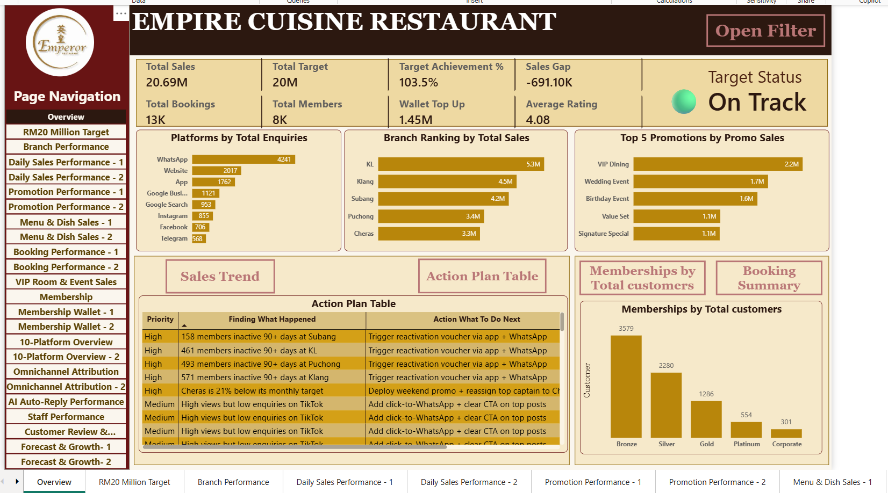
Figure 10. 10-Platform Overview: filters, KPI row, engagement by platform, rankings, scorecard and growth trend.

9.1 Business questions
- How large is the combined audience across the supported digital platforms?
- Which platforms have the strongest engagement percentage?
- Which platforms contribute followers, new followers, views, likes, comments, clicks, and enquiries?
- How does audience growth change over the year?
- Are high-reach platforms also generating measurable downstream enquiries?

9.2 Visible KPI interpretation
Displayed KPI | Visible value | Interpretation and caution
Total Followers | 3M | Large aggregate audience; verify whether platform audiences can overlap and whether each platform snapshot is current.
New Followers | 157K | Audience additions over the selected period; verify whether this is net growth or gross new follows.
Engagement Rate % | 4.6% | Engagement KPI; document exact formula and whether it is platform-weighted or a simple average.
Total Views | 63M | Reach/consumption indicator, not revenue.
Total Link Clicks | 1M | Traffic-intent signal; confirm whether all platforms use comparable click definitions.
Total Enquiries | 10 | Visible headline card in this screenshot; the platform ranking table contains small enquiry counts. Validate period and filters before using as a total.
Total Platform Members | 686K | Definition of platform members is unclear from screenshot alone; document the source and avoid conflating it with followers.
Total Subscribers | 152K | Subscriber total for platforms where the concept exists; confirm whether platforms without subscriptions are excluded.

9.3 Visual interpretation
The engagement-by-platform chart visibly ranges from about 3.9% to 5.2%. WhatsApp is shown near the top of the chart, while Xiaohongshu is shown at the low end in the displayed filter state. The platform comparison scorecard shows TikTok with about 1M followers, 77,675 new followers, 43M views, 2,489,767 likes, and 122,139 comments. These values are rounded/display-formatted and should be validated against the underlying measures.
The audience growth trend uses monthly labels from Jan through Nov in the visible screenshot. It appears to show different platform trajectories, but the legend is crowded and several series overlap or sit near the baseline. Consider a smaller selection of platforms, a small-multiples layout, or a platform selector for detailed trend inspection.

9.4 Recommended interpretation rules
- Do not infer sales from followers, views, likes, or comments.
- Use tracked link clicks and recorded enquiries to assess downstream activity.
- Document engagement rate formula and platform-specific numerator/denominator differences.
- Check for blank metric cells and distinguish zero activity from not-applicable or missing data.
- Ensure all platforms are compared over the same reporting period and with consistent definitions.

10. Dashboard Deep Dive — Omnichannel Attribution
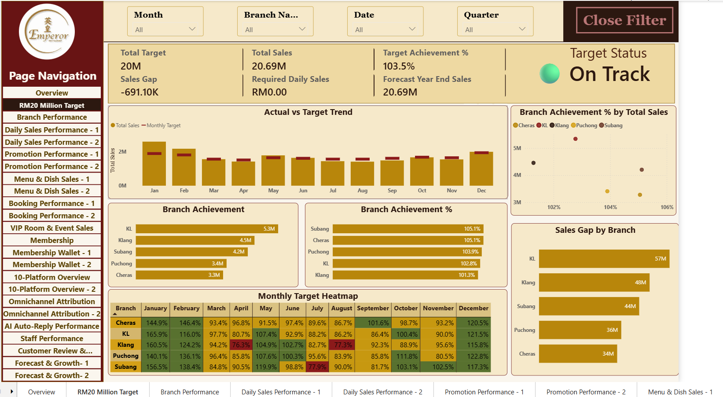
Figure 11. Omnichannel Attribution: enquiries by campaign/platform, revenue, conversion, funnel and branch revenue.

10.1 Business questions
- Which channels generate the highest enquiry volume?
- Which platforms convert enquiries to bookings at the highest rate?
- How much revenue is attributed to each platform?
- How do branch revenue and platform mix differ?
- How do campaign enquiries compare with attributed bookings and revenue?

10.2 Visible KPI row
Metric | Displayed value | Meaning / validation
Total Enquiries | 12K | Enquiry volume in the displayed context.
Attributed Bookings | 9K | Bookings attributed to the selected channel/campaign rules.
Attributed Booking Rate | 71.8% | Displayed attributed booking rate; verify whether denominator is all enquiries or only eligible/attributable enquiries.
Total Bookings | 13K | Total booking count shown; may differ from attributed bookings by definition.
Total Sales | RM20.69M | Sales value shown in the displayed report context.
Revenue Per Enquiry | 1.69K | Revenue per enquiry; confirm whether RM and whether numerator uses attributed sales.
Revenue Per Booking | 1.63K | Revenue per booking; confirm denominator and whether the KPI uses total or attributed bookings.

10.3 Channel findings visible in the screenshot
WhatsApp is the largest visible enquiry source at about 4.2K, followed by Website at about 2.0K and App at about 1.8K. In the platform conversion chart, App is displayed at 58.3%, Google Search at 52.4%, WhatsApp at 47.9%, Website at 44.6%, Google Business Profile at 36.7%, Instagram at 33.7%, Facebook at 24.2%, and Telegram at 20.6%. These values indicate that channel volume and conversion efficiency are not the same thing.
The revenue-by-platform chart shows WhatsApp, Website, App, Google Business Profile and Google Search among the higher displayed revenue contributors. The Top 5 table reports WhatsApp as rank 1 with 4,241 enquiries, 2,033 bookings, 47.9% conversion, and RM1,07,82,138.54 attributed sales in the visible screenshot. Website shows 2,017 enquiries, 899 bookings, 44.6% conversion, and RM95,28,329.28. App shows 1,762 enquiries, 1,028 bookings, 58.3% conversion, and RM93,08,816.16.

10.4 Funnel and attribution cautions
The funnel shows Followers, Enquiries, and Bookings, but the displayed Followers value is around 2,983.67K, Enquiries around 12.22K, and Bookings around 8.77K. These are different population sizes, and followers are not necessarily the first step of a traceable user journey. Treat the visual as a scale comparison unless person-level or campaign-level linkage proves a sequential funnel.
- Define attribution window, first-touch/last-touch rules, and what happens when multiple channels are involved.
- Distinguish total bookings from attributed bookings; do not label them interchangeably.
- Use unique enquiry and booking IDs if the source table can contain repeated interactions.
- Check branch revenue chart for missing categories and consistent platform colors.
- Confirm currency formatting and locale: RM amounts in the table use Malaysian-style comma/decimal formatting.

11. Dashboard Deep Dive — Campaign ROI and Promotion Attribution
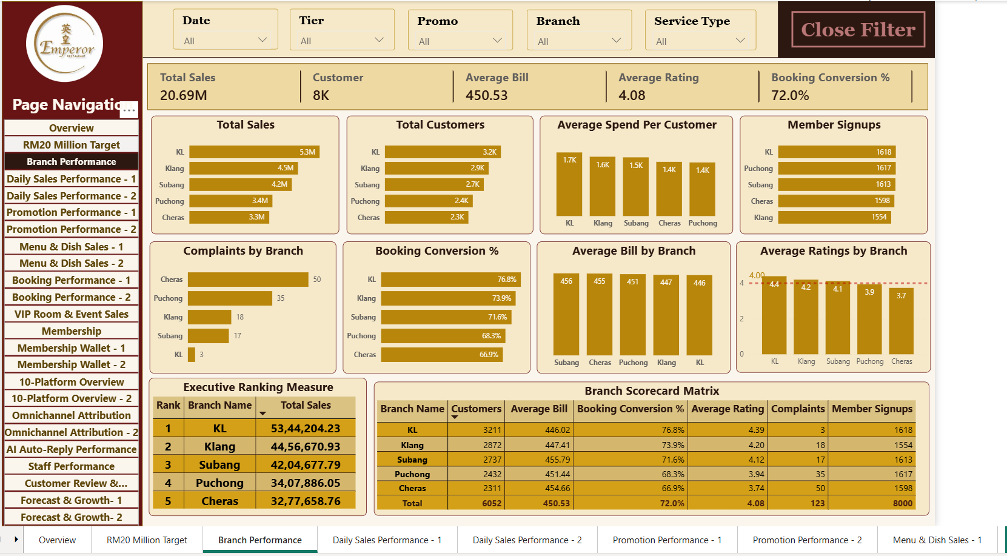
Figure 12. Campaign ROI quadrant, top revenue-generating platforms, promotion attribution and attribution scorecard.

11.1 Purpose and questions
This page connects campaign and promotion activity with enquiries, bookings, conversion, and revenue. The ROI quadrant appears to plot campaign-level volume against a monetary measure, while the Top 5 table ranks platforms and the Promotion Attribution table summarizes promotion outcomes.

11.2 Visible results
The visible Top 5 Revenue Generating Platforms table lists WhatsApp, Website, App, Google Business Profile, and Google Search. WhatsApp shows 4,241 enquiries, 2,033 total bookings, 47.9% conversion, and approximately RM1.078M in the table's displayed notation (shown as RM1,07,82,138.54). Website shows 2,017 enquiries, 899 bookings, 44.6% conversion, and RM95,28,329.28. The scorecard total row displays 12,223 enquiries, 8,774 attributed bookings, 71.8% platform conversion, attributed sales of RM1,41,17,177.41, revenue per enquiry of RM1,692.80, and revenue per booking of RM1,629.48.
The Promotion Attribution table shows visible rows such as Birthday Package (722 enquiries, 495 bookings, revenue 16,11,701.25), Corporate Event Package (696 enquiries, 335 bookings, revenue 10,60,560.29), and Festive Set Menu (0 enquiries, 336 bookings, revenue 10,51,541.32). The combination of zero enquiries and nonzero bookings in the displayed Festive Set Menu row is a validation prompt: it may reflect different event definitions, different filter context, or a data/linkage issue.

11.3 ROI terminology
In strict financial reporting, ROI generally requires a cost/investment denominator, e.g., (incremental return − campaign cost) ÷ campaign cost. A bubble chart that compares campaign enquiries and revenue is not automatically an ROI calculation. If campaign cost is unavailable, consider naming the visual 'Campaign Volume vs Revenue' or 'Campaign Performance Quadrant' rather than 'ROI'.

11.4 Recommended checks
- Verify whether the plotted value is revenue, expected value, campaign budget, or a calculated ROI ratio.
- Document promotion attribution logic and ensure the campaign and promotion dimensions do not conflict.
- Investigate bookings with no matching enquiry where the report expects an enquiry-led journey.
- Check duplicated action/attribution rows and the grain of the scorecard.
- Use one consistent reporting period for all rows in the platform and promotion tables.

12. Dashboard Deep Dive — AI Auto-Reply Performance
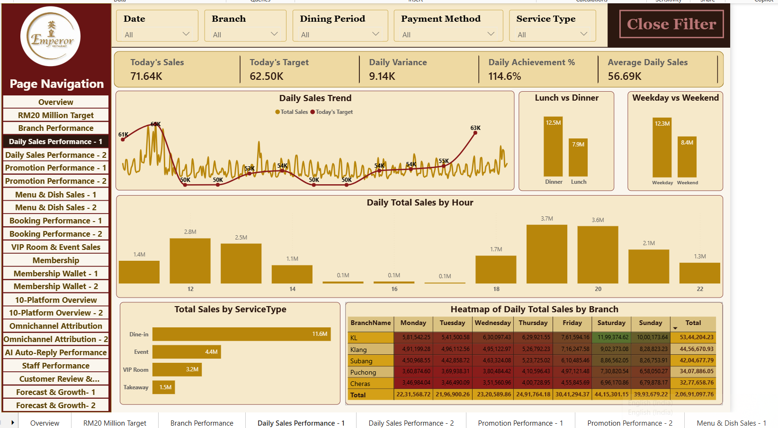
Figure 13. AI auto-reply performance: success, handover, response time, topic conversion, failure hotspots and trends.

12.1 Questions answered
- How many conversations were processed?
- What share were marked as successful?
- How often was a human takeover required?
- How quickly did the AI respond?
- Which topics are associated with higher booking conversion or more failures?
- How does AI success vary by month, branch, and platform?

12.2 KPI interpretation
KPI | Visible value | Interpretation / requirement
Total Conversations | 17K | The scorecard table shows 16,500 total; headline is rounded to 17K.
AI Success % | 78.3% | About four out of five conversations are marked successful by the dashboard's definition; definition must be documented.
AI Human Takeover % | 15.3% | Share requiring or involving human intervention; define whether denominator is all conversations or eligible AI conversations.
Average Response Time | 15.37 | Unit is not visible; explicitly label seconds/minutes and whether this is average, median, or another statistic.
Follow Ups Sent | 8K | Follow-up volume; validate whether one conversation can generate multiple follow-ups.
AI Booking Conversion | 4K / 23.6% shown | The card labels include AI Booking Conversion and Booking Conversion %, but the exact relationship between 4K and 23.6% needs a measure definition.
AI Efficiency Score | 63.2% | Composite metric; document formula and interpretation before executive use.

12.3 Topic and branch observations
The topic charts show Booking, Birthday, RM3 Dim Sum, Location/Waze, Parking, Menu, and VIP Room among the visible topic labels. The AI Failure Hotspots visual displays Booking (261) and Birthday (259) among the highest visible counts, followed by RM3 Dim Sum (259) and Location-related issues (257). Because topic volume may differ, raw failure counts alone do not identify the worst failure rate; compare failures divided by conversations for each topic.
The AI Success Trend labels vary across months, with a visible high near 80.8% in July and lower values around 76.8% in April/May and 77.3% in September. The Human Takeover Trend falls to about 12.7% in July and reaches around 16.4% in September. These are visual readings and should be confirmed from the underlying measure.

12.4 Recommendations
- Define success as a reproducible outcome: resolved request, correct answer, booking completed, or no human handover.
- Use topic-level failure rate and severity, not only failure counts.
- Review conversation samples for high-volume failure topics and define a clear escalation policy.
- Report response-time units and use median/p90 alongside average if the distribution is skewed.
- Validate AI booking conversion against confirmed booking IDs and attribution windows.
- Keep a human escalation path for complex or sensitive customer requests.

13. Dashboard Deep Dive — Staff Performance
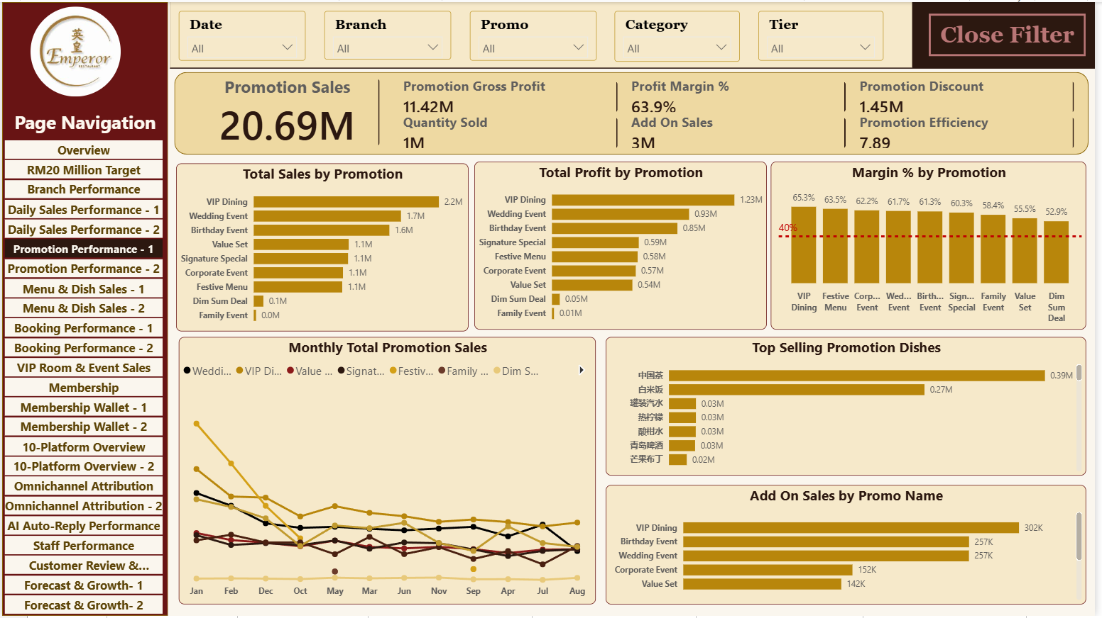
Figure 14. Staff performance: sales, bookings, enquiries, upselling, event sales and branch matrix.

13.1 Visible KPIs
Metric | Displayed value | Interpretation / caution
Staff Sales | RM20.69M | Sales attributed to staff in the displayed context; reconcile with Total Sales.
Bookings Managed | 13K | Count of bookings assigned to staff; validate unique booking grain.
Enquiries Handled | 12K | Enquiry count; validate distinct IDs and attribution.
Upsell Revenue | RM3.64M | Revenue classified as upsell; document how an upsell is identified.
Average Bill Value | 450.53 | Likely currency per bill, but the unit should be labeled RM.
Event Bookings | 2K | Booking count for event-related activity; define event criteria.
Staff Rating | 4.08 | Likely average staff rating; validate source and scale.
Staff Complaints | 123 | Complaint count; do not assume these are identical to negative reviews.

13.2 Visible analysis patterns
The Top 10 Staff by Sales visual shows several staff values around RM1.1M–RM1.3M. The Upselling Performance visual shows top staff contributions around RM0.16M–RM0.22M, and the Branch vs Staff matrix compares sales across Cheras, KL, Klang, Puchong, and Subang. The displayed total in the matrix is RM9,053,931.22, which does not match the RM20.69M staff sales KPI in the screenshot. This difference may arise from matrix filters, displayed subset, metric definition, or incomplete visible rows; it should be reconciled rather than assumed to be an error.

13.3 Fair comparison rules
- Compare staff over equivalent dates and shifts.
- Consider role, branch, working hours, assigned enquiries, and booking opportunities.
- Separate raw sales ranking from efficiency metrics such as sales per shift or conversion per assigned enquiry.
- Define staff complaints and customer mentions separately; mentions may be positive, neutral, or negative.
- Protect personally identifiable information and use rankings as diagnostic tools, not sole evidence for employment decisions.

14. Dashboard Deep Dive — Customer Review and Satisfaction
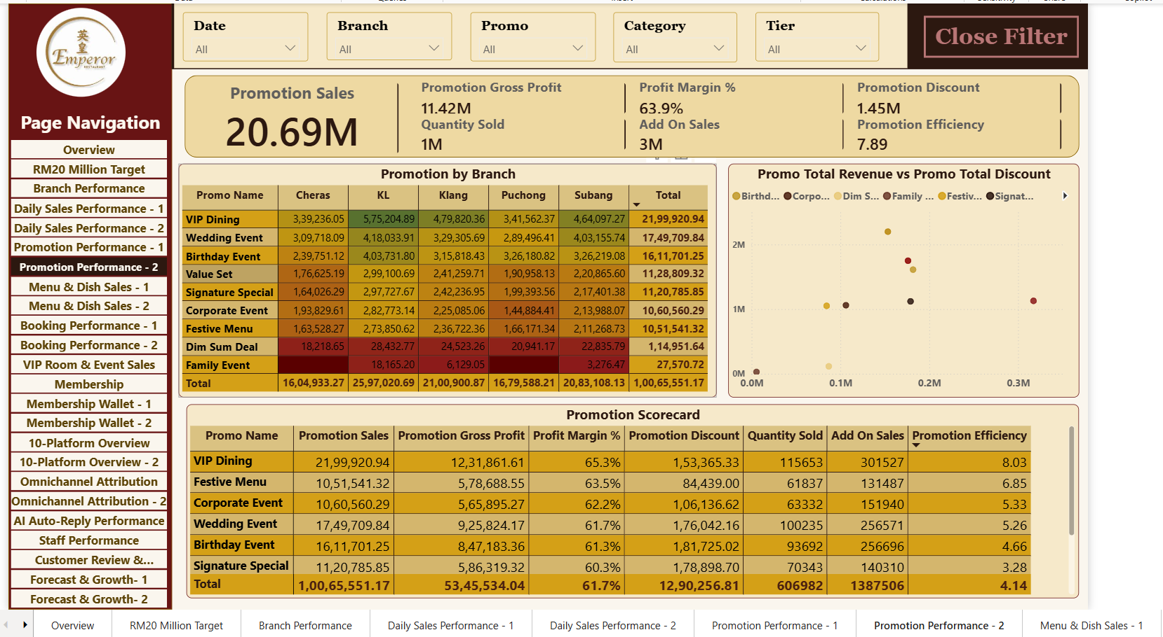
Figure 15. Customer review dashboard: ratings, sentiment, keywords, staff/menu mentions, complaints and branch scorecard.

14.1 Visible KPIs
Metric | Displayed value | Interpretation
Total Reviews | 4K | Rounded headline; scorecard total shows 3,703.
Average Rating | 4.08 | Average rating across the current filter context.
Positive Review % | 76.6% | Positive share; sentiment definitions and denominator need to be documented.
Complaint Rate | 3.3% | Complaint count or negative category relative to an eligible base; formula must be explicit.
Positive Reviews | 3K | Rounded count.
Negative Reviews | 123 | Negative review count shown.
Staff Mentions | 839 | Reviews or mentions containing staff references; not necessarily unique staff.
Dish Mentions | 848 | Mentions of dishes/menu items.
Reputation Score | 25.83 | Composite score; formula and scale not visible.
Complaint Severity | 3.3% | Card label repeats a percentage-like value; verify whether this is actually severity or a duplicate complaint-rate measure.

14.2 Branch scorecard
The visible branch scorecard shows KL at 4.39 average rating, 88.0% positive reviews, 3 complaints and 0.4% complaint rate. Klang shows 4.20 rating, 81.3% positive reviews, 18 complaints and 2.6% rate. Subang shows 4.12 rating, 78.8% positive reviews, 17 complaints and 2.2% rate. Puchong shows 3.94 rating, 72.3% positive reviews, 35 complaints and 4.5% rate. Cheras shows 3.74 rating, 60.9% positive reviews, 50 complaints and 7.4% rate. Total row: 3,703 reviews, average rating 4.08, positive review share 76.6%, 123 complaints, and 3.3% complaint rate.
Within the displayed context, Cheras is the clearest candidate for service investigation because it has the lowest shown average rating and highest complaint rate. This is a prioritization signal, not proof of root cause. Review count, channel mix, time period, complaint classification, and operational data should be checked before assigning corrective actions.

14.3 Customer review analysis guidance
- Define positive/neutral/negative sentiment and how neutral reviews are treated in the positive review percentage.
- Confirm whether the complaint rate denominator is total reviews, total visits, or another eligible population.
- Use review text and keywords as indicators, then validate themes through qualitative review.
- Compare branch complaint rates alongside review volume to avoid overreacting to small samples.
- Treat automatically extracted keywords and sentiment as imperfect classifications.

15. Dashboard Deep Dive — RM20 Million Target and Forecast
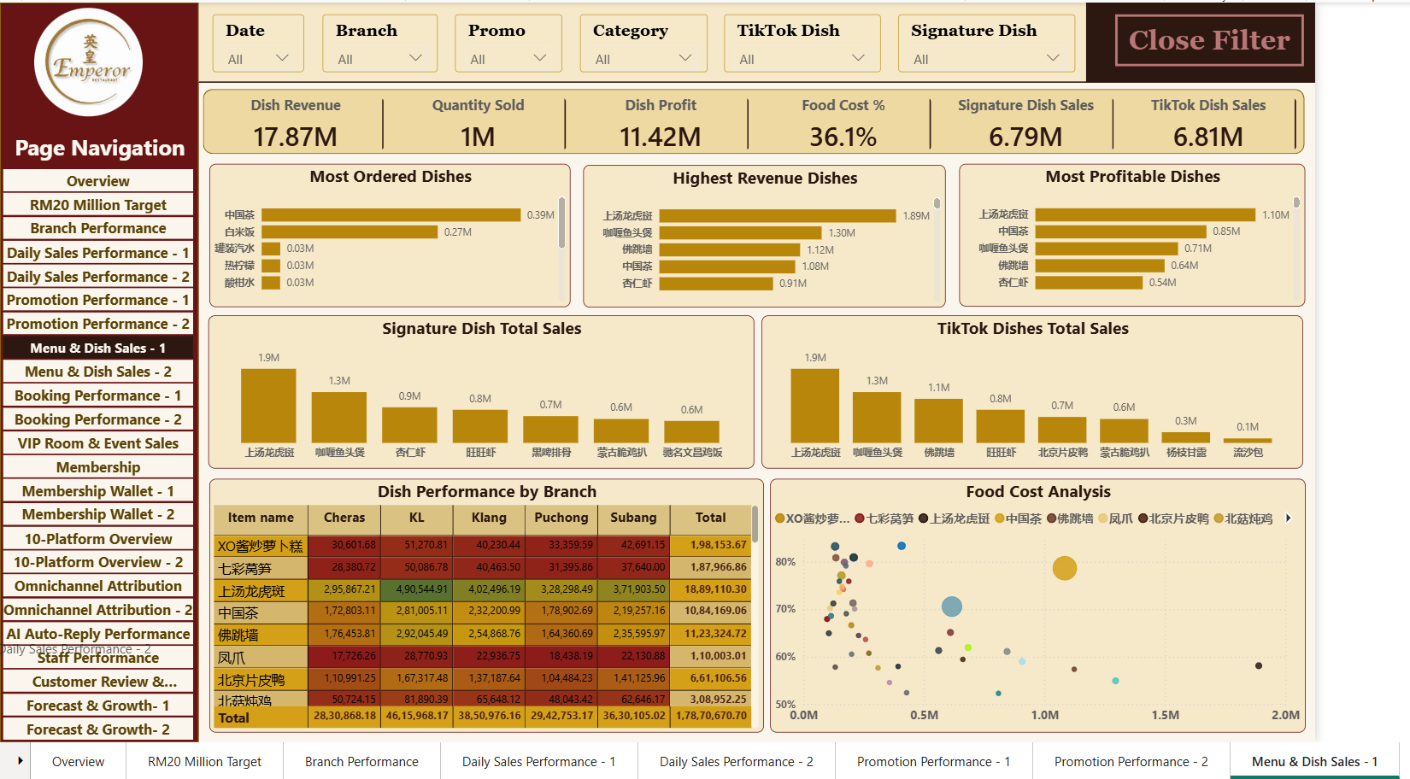
Figure 16. Target and forecast dashboard with branch opportunity, achievement, membership, reactivation, wallet and VIP visuals.

15.1 Visible KPI values
Metric | Displayed value | Interpretation
Total Sales | RM20.69M | Reported sales value.
Total Target | RM20M | Annual target shown on the page.
Target Achievement % | 103.5% | Sales divided by target; confirms target exceeded in this displayed view.
Forecast Year End Sales | RM20.69M | Forecast equals sales in the displayed screenshot; validate forecast logic.
Forecast Gap | -RM691.10K | Likely uses target-minus-sales sign convention; if sales exceed target, a negative gap may represent overachievement.
Remaining Sales Needed | RM0.00 | No additional sales needed to hit target in the displayed context.
Required Daily Sales | RM0.00 | Consistent with already achieving the target, if the measure is designed to floor remaining need at zero.
Target Status | On Track | Threshold-based label.

15.2 Opportunity visuals
The page includes Branch Opportunity Analysis and Branch Achievement %, Membership Opportunity, Reactivation Opportunity, Wallet Liability vs Spending Opportunity, Executive Opportunity Matrix, Event Growth Opportunity, Sales Trend Chart, and VIP Opportunity. These visuals attempt to convert performance monitoring into potential next actions rather than stopping at a KPI total.
The visible Reactivation Opportunity chart shows 90+ Days = 2,962, 30+ Days = 779, and 60+ Days = 675. Because these counts do not follow a simple cumulative ordering, they may represent mutually exclusive buckets, not cumulative thresholds; the chart labels and measure logic should be checked. If the labels are intended to be cumulative (30+ includes 60+ and 90+), the counts should generally be non-increasing as the threshold rises.

15.3 Target and forecast validation
- Confirm whether Total Target is annual, monthly, or selected-period target under the current filters.
- Ensure the target line uses Fact_Target values at the correct month/branch grain.
- Check that a target related to MonthStartDateKey filters correctly for all dates in the month.
- Document Forecast Year End Sales formula, training/history period, and assumptions.
- Rename Forecast Gap or reverse its sign if business users interpret a negative value as a shortfall.
- Keep Remaining Sales Needed and Required Daily Sales at zero only when target is already met or the time horizon has ended.

16. Dashboard Deep Dive — Management Action Plan
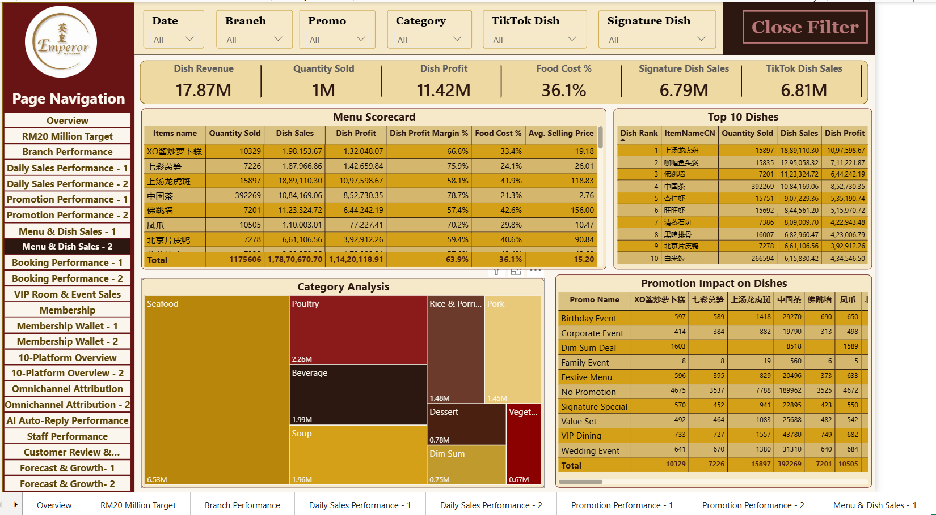
Figure 17. Management Action Plan table with priority, category, finding, rationale, action and expected RM impact.

16.1 What the table is designed to do
The action plan has columns for Priority, Category, Finding What Happened, Rationale Why It Matters, Action What To Do Next, and Expected Impact RM. This is a useful executive handoff pattern because it translates a detected issue into a proposed response and an estimated financial effect.

16.2 Examples visible in the screenshot
Category | Finding shown | Action shown | Validation required
Conversion | High views but low enquiries on TikTok | Add click-to-WhatsApp and a clearer call to action on top posts. | Verify actual views, enquiries, period, and whether rows represent separate content items.
Utilisation | VIP room occupancy low on weekdays at Cheras / KL / Klang | Promote corporate weekday packages to nearby offices. | Validate occupancy definition, available capacity, seasonality, and package margin.
Traffic | Weekday lunch is the weakest slot at several branches | Launch set-lunch promotion Monday–Thursday, 12–2pm. | Validate baseline covers, price elasticity, and contribution margin.
Margin | RM3 Dim Sum margin below target at branches | Bundle dim sum with a drink combo to increase ticket size. | Validate product margin, incremental attach rate, and cannibalization.
No-show | No-show rate elevated at a branch | Send WhatsApp confirmation 24 hours before and consider deposit policy. | Confirm no-show definition, legal/customer policy, and effect on bookings.

16.3 Expected RM impact is not guaranteed revenue
The table contains repeated-looking action rows with different Expected Impact RM values. Before management relies on these amounts, document the calculation formula, assumptions, time horizon, cost, confidence level, and whether multiple rows overlap. Expected impact should be labelled as an estimate or scenario, not realized revenue or a guaranteed uplift.
- Add an owner and due date for each action.
- Record baseline KPI, target KPI, and post-action result.
- Use a status field such as Not Started, In Progress, Validating, Complete.
- Track expected versus realized RM impact and note external factors.
- Deduplicate repeated actions or provide a clear opportunity ID.

17. Remaining Navigation Pages: Purpose and Required Analysis
The following pages appear in the visible navigation but do not all have a full, legible screenshot in the evidence provided. The sections below describe the business questions the page names imply and list the minimum analysis needed for a complete project handover. They do not claim that particular visuals or results are already present.

17.1 Overview
Business purpose: Executive landing page. Completeness check: Sales vs target, bookings, enquiries, rating, digital performance, branch rank, and top action items. Keep headline measures consistent with their detailed pages.

17.2 Branch Performance
Business purpose: Compare the five branches. Completeness check: Total Sales, target achievement, sales gap, average bill value, bookings, rating, complaint rate and branch rank. Check branch targets rather than assuming equal targets.

17.3 Daily Sales Performance - 1
Business purpose: Analyze sales over time. Completeness check: Daily trend, date and branch slicers, weekday/weekend split, daypart/time band, and anomaly investigation. Confirm date granularity and avoid an overcrowded daily axis.

17.4 Daily Sales Performance - 2
Business purpose: Provide a second daily-sales perspective. Completeness check: Use a clearly distinct purpose such as hour/daypart comparisons, weekday/weekend matrix, or transaction detail. Avoid duplicating Page 1 without a new question.

17.5 Promotion Performance - 1
Business purpose: Rank promotions by commercial outcomes. Completeness check: Promotion revenue, bills/bookings, discount, margin where available, and conversion. Separate promotional sales from all sales.

17.6 Promotion Performance - 2
Business purpose: Investigate promotion efficiency. Completeness check: Compare promo types, event flags, target margin, branch mix, and time period. Include cost data before calling a metric ROI.

17.7 Menu & Dish Sales - 1
Business purpose: Find high-volume menu items. Completeness check: Item quantity, net sales, category contribution, average selling price, and branch mix. Use order-item grain.

17.8 Menu & Dish Sales - 2
Business purpose: Assess menu economics. Completeness check: Margin/profitability, basket attachment, signature items, low-performing items, and preparation time if those fields exist. Do not infer profit from sales alone.

17.9 Booking Performance - 1
Business purpose: Track bookings and enquiries. Completeness check: Unique enquiry IDs, unique booking IDs, conversion, cancellations, no-shows, lead time, and source channel.

17.10 Booking Performance - 2
Business purpose: Explore booking quality and attribution. Completeness check: Platform, campaign, promotion, branch, staff, visit date, and attributed sales. Define attribution rules and prevent double-counting.

17.11 VIP Room & Event Sales
Business purpose: Monitor premium rooms and event pipeline. Completeness check: Event enquiry count, confirmed bookings, expected value, realized sales, room utilization, weekday/weekend mix, and conversion. Keep pipeline value separate from booked revenue.

17.12 Membership
Business purpose: Understand customer membership. Completeness check: Member count, tier mix, signups by month, repeat visits, spend per member, and member/non-member sales. Ensure non-members are not included in member totals.

17.13 Membership Wallet - 1
Business purpose: Track wallet activity. Completeness check: Top-up amount, wallet payments, transaction count, average top-up, and active wallet users. Define positive/negative amount conventions.

17.14 Membership Wallet - 2
Business purpose: Understand wallet balance and liability. Completeness check: Latest balance per customer, unused balance, dormant wallet users, and payment/top-up ratio. Latest balance should be selected chronologically, not simply as MAX(balance).

17.15 10-Platform Overview - 2
Business purpose: Deepen platform comparison. Completeness check: Monthly audience trend, likes/comments, followers/new followers, content performance, and platform-level data completeness.

17.16 Omnichannel Attribution - 2
Business purpose: Deepen campaign/promotion attribution. Completeness check: Top revenue platforms, campaign ROI if costs exist, promotion attribution, conversion rate, revenue per enquiry, and revenue per booking.

17.17 Forecast & Growth - 1
Business purpose: Estimate target trajectory and opportunity. Completeness check: Sales trend, target line, branch opportunity, required daily sales, forecast assumptions, and sensitivity.

17.18 Forecast & Growth - 2
Business purpose: Translate findings into management actions. Completeness check: Prioritized action plan, estimated impact, owner, timeline, validation status, and realized outcome.

18. Cross-Dashboard Business Findings
The following findings are grounded in visible values from the supplied screenshots. They are descriptive findings, not causal claims.
Finding | Evidence visible | Business meaning | Next validation
Sales target exceeded in displayed view | RM20.69M sales vs RM20M target; 103.5% achievement. | The target page reports that the annual target has been exceeded in its current context. | Confirm full-year date filter, target allocation, exclusions/refunds and measure grain.
WhatsApp is a major enquiry source | About 4.2K enquiries; 4,241 in the attribution table. | WhatsApp appears to be a high-volume lead channel. | Compare cost, qualified lead rate, confirmed booking and attributed sales.
App has high displayed conversion | App conversion shown at 58.3%. | App may convert fewer enquiries more efficiently than some higher-volume channels. | Validate same denominator/window and booking attribution rules.
Digital reach is large | 63M views and 3M followers displayed. | There is substantial audience exposure, but exposure alone does not establish commercial return. | Connect clicks/enquiries/bookings with traceable IDs and attribution.
AI success is not 100% | 78.3% AI success and 15.3% human takeover shown. | There is room to analyze failed topics and escalation effectiveness. | Define success, audit samples, compare failure rates by topic.
Cheras has a visible service signal | 3.74 average rating, 60.9% positive reviews, 7.4% complaint rate in scorecard. | Cheras is a candidate for review of customer-experience processes. | Validate review volume, timeframe, sentiment quality and complaint definitions.
Staff metrics need reconciliation | Staff sales KPI RM20.69M; branch-vs-staff matrix total RM9.05M. | The page's KPI and matrix do not visibly reconcile. | Check visual filters, omitted rows, measure definitions and staff assignment.
Promotion row has an anomaly to investigate | Festive Set Menu shows 0 enquiries but 336 bookings in visible table. | The metrics may use different grains or separate booking sources. | Review relationship keys, attribution logic, and filter context.
Reactivation counts may be bucketed, not cumulative | 90+ = 2,962; 30+ = 779; 60+ = 675 displayed. | Labels/measure logic may mix mutually exclusive buckets with cumulative thresholds. | Use mutually exclusive labels or cumulative measures consistently.
ROI naming needs evidence of cost | Campaign ROI quadrant is shown; cost definition is not visible. | A revenue/volume quadrant is not necessarily ROI. | Add campaign cost/investment data or rename visual.

18.1 Executive conclusion
The report provides broad operational coverage and a clear visual language. The most actionable evidence in the screenshots concerns target achievement, channel conversion differences, AI topic failure patterns, branch-level customer satisfaction, and the translation of analytics into a management action plan. The highest-priority improvement is metric governance: define the numerator, denominator, grain, filter context, and business meaning of every executive KPI.

19. Business Recommendations and Action Framework
- Channel investment — Evaluate channel performance using cost per qualified enquiry, confirmed booking conversion, attributed sales and contribution margin. Keep reach/engagement as leading indicators, not revenue proxies.
- WhatsApp journey — Investigate why WhatsApp generates high enquiry volume. Improve response routing and booking CTA where supported by evidence; measure incremental bookings rather than click volume alone.
- App conversion — Audit the high displayed App conversion rate, identify successful UX/offer patterns, and compare customer intent and attribution windows with other platforms.
- AI failure reduction — Prioritize topics with high failure rate and business impact. Review sample conversations, improve intent handling/knowledge content, and define safe escalation criteria.
- Cheras customer experience — Review complaint categories, service-time patterns, menu quality, and staff feedback. Set a time-bound test and monitor rating/complaint movement with sample-size context.
- Staff performance — Use workload-adjusted measures: sales per shift, conversion per assigned enquiry, upsell attachment rate, and customer feedback. Avoid relying only on raw sales rankings.
- Promotion governance — Require promotion cost/discount, eligible sales, baseline period and margin before reporting ROI. Track incrementality and cannibalization where feasible.
- Wallet liability — Calculate current wallet balance using the latest chronological transaction per customer. Reconcile top-ups, payments, adjustments and expiry rules.
- Reactivation — Use separate measures for 30+, 60+ and 90+ day inactivity; define campaign eligibility and measure actual return visits and incremental sales.
- Action-plan accountability — Give each opportunity an ID, owner, due date, baseline, target, expected impact, cost, status and realized result.

19.1 Action tracking template
Field | Purpose
Opportunity ID | Stable unique identifier; prevents duplicate action rows.
Finding / evidence | The observed metric and relevant period/filter.
Root-cause hypothesis | A testable explanation, not an established fact.
Action / owner | Specific task and accountable person/team.
Baseline / target | Numerical KPI before and after the action.
Expected impact RM | Estimate with assumptions, period, confidence and cost.
Due date / status | Implementation governance.
Actual outcome | Observed result after intervention.
Decision | Continue, revise, stop, or scale.

20. Data Quality and Validation Checklist
Check | Method / evidence | Acceptance condition
Dimension keys | Check duplicate counts for each dimension primary key. | No duplicate non-null keys.
Fact foreign keys | Anti-join fact keys against corresponding dimensions. | All expected keys match; unknown/unassigned cases are documented.
Fact grain | Document one row's meaning and primary key per fact. | No unintended duplicate business events.
Bill header vs order lines | Compare bill counts and amounts before/after using Fact_OrderItems. | No repeated header sales caused by item-level joins.
Date dimension | Confirm unique Date, continuous date coverage, date type and marked date table. | One row per calendar date; all facts map as expected.
Month target allocation | Test Fact_Target MonthStartDateKey across daily/monthly visuals. | Monthly target does not repeat incorrectly across dates or branches.
Sales reconciliation | Compare Total Sales to source totals under the same filters. | Totals reconcile after documented exclusions.
Booking/enquiry counts | Compare COUNTROWS with DISTINCTCOUNT of event IDs. | Use the count matching the business definition.
Membership count | Compare total customer count with member flag/tier criteria. | Non-members are not included in Total Members.
Wallet balance | Order wallet transactions by timestamp and select latest row per customer. | Balance reflects latest chronological transaction.
Voucher liability | Reconcile issued, redeemed, expired, cancelled and remaining values. | Definitions and expiry treatment are documented.
Review sentiment | Compare positive/neutral/negative classifications with total reviews. | Categories and denominator are consistent.
AI response time | Inspect unit, outliers, missing times and aggregation. | Unit is labelled; metric is reproducible.
Action plan | Check duplicate action IDs and repeated rows. | Each row represents a distinct opportunity or is clearly grouped.
Slicer propagation | Change each slicer and inspect all intended visuals. | Only intended visuals respond; interactions are documented.
Visual totals | Compare cards, matrix totals, and drill-through detail. | Differences are explainable by filter context/grain.

20.1 Screenshot-specific validation priorities
- Reconcile RM20.69M sales KPI with branch-vs-staff matrix total RM9.05M.
- Investigate Festive Set Menu bookings when enquiries are shown as zero.
- Confirm the exact meaning of Total Enquiries = 10 in the platform overview screenshot versus 12K on attribution pages; the screenshot filter/date context or definition may differ.
- Check why Total Bookings is shown as 13K while attributed bookings are about 9K; document the difference rather than forcing equality.
- Confirm the unit for AI average response time 15.37 and the formula for AI Efficiency Score 63.2%.
- Verify whether 3.3% Complaint Rate and 3.3% Complaint Severity are separate metrics or duplicated labels.
- Clarify the Forecast Gap sign convention where -RM691.10K appears alongside 103.5% target achievement.
- Check the Reactivation Opportunity counts against the intended mutually exclusive/cumulative threshold logic.

21. DAX and Modelling Risks Requiring Attention
Risk | Why it matters | Recommended action
COUNTROWS used for bookings/enquiries | May count repeated event rows rather than unique bookings/enquiries. | Use DISTINCTCOUNT on stable IDs when appropriate.
Total Members counts all customer rows | Customer dimension may include non-members. | Filter on membership status/tier or use an explicit member indicator.
Promo Sales formula is not inherently promo-only | It sums all Fact_Sales[BillAmount] in current context. | Ensure a promotion filter is active or implement explicit promotion logic.
Latest Balance uses MAX(BalanceAfter) | Largest historical balance may not be the current balance. | Select the latest row by transaction date/time per customer.
Wallet usage rate interpretation | Payment amount ÷ top-up amount is not a customer adoption rate. | Name the ratio precisely or calculate user-level usage rate separately.
Duplicate voucher measures | Voucher Redeemed and Redeemed Vouchers are identical. | Keep one canonical measure unless compatibility requires both.
Month labels can sort alphabetically | Text labels do not guarantee chronological order. | Sort by YearMonth numeric key.
SWITCH label mappings may not match source strings | Trailing spaces/spelling differences can bypass mapping. | Trim/standardize source labels or validate exact values.
Disconnected helper tables need measures | A disconnected slicer does not filter customer data by itself. | Use SELECTEDVALUE and explicit measure logic.
Target grain can repeat across daily dates | Month-start relationship may not naturally distribute monthly target across all dates. | Design target measure at month grain or allocate target by day explicitly.
ROI visual without cost data | Revenue or enquiry count alone is not ROI. | Add investment/cost and incremental return or rename the visual.
Fact-to-fact relationship risk | Can create ambiguous filtering or duplicate amounts. | Verify cardinality, direction, and bill-item grain.

22. Visual Design and Usability Review
The screenshots use a recognizable burgundy sidebar, cream background, gold chart accents, bordered visuals, and repeated filter cards. The layout creates a consistent brand identity across the report and the navigation list makes a large report easier to traverse.

22.1 Strengths
- Consistent color palette and page navigation.
- Top-of-page slicers make the selected context visible.
- KPI cards provide a quick executive scan.
- Ranked bars are effective for platform, staff, branch, and topic comparisons.
- Scorecards and matrices support detailed comparisons.
- Action-plan table creates a path from analytics to decisions.

22.2 Improvement opportunities
- Reduce truncation in titles such as Total Conversat... and Average Response Tim... by resizing cards or shortening labels deliberately.
- Increase contrast and font size for small table headers and crowded legends.
- Reduce the number of series in the audience trend; use a platform selector or small multiples.
- Use consistent decimal places and units; avoid mixing abbreviated KPI cards and long raw currency values without a tooltip.
- Add dynamic titles showing selected date range, branch, and platform.
- Use tooltips to define conversion rate, AI success, engagement rate, complaint rate and expected impact.
- Use conditional formatting only where the thresholds are documented.
- Ensure Close Filter buttons and navigation buttons work reliably and remain keyboard-accessible where possible.
- Review the action-plan page for duplicated rows and make expected impact values easy to audit.
- Use alt text and accessible color contrast; do not communicate On Track/Watch/At Risk by color alone.

22.3 Filter design acceptance tests
- Select one branch and verify branch-sensitive visuals update consistently.
- Select one month and verify sales, target, bookings, AI, and reviews use the intended date field.
- Select one platform and verify platform visuals update while unrelated measures remain unaffected by design.
- Select a promotion/campaign and inspect the distinction between all sales and attributed sales.
- Clear all slicers and compare default totals with the documented baseline.
- Test multi-select and no-selection behavior for every disconnected helper table.
- Check visual interactions so selecting a chart bar does not unintentionally suppress context needed by another visual.

23. Refresh, Governance and Power BI Handoff
A portfolio report should include a short handoff note so another analyst can maintain the PBIX. The screenshot evidence alone does not prove refresh configuration or deployment, so the following items are acceptance requirements rather than claims that the final model is already published.
Handoff item | Required documentation
Source inventory | File/table name, owner, location, refresh cadence, and source grain.
Power Query steps | Applied steps, type conversion, null handling, label cleanup and merge logic.
Model dictionary | Table description, key, grain, important columns, and relationship roles.
Measure dictionary | Measure name, business definition, formula, unit, format string and owner.
Date logic | Calendar range, fiscal/calendar assumptions, month sort key and target allocation.
Refresh | Credentials, gateway if applicable, schedule, failure monitoring and last successful refresh.
Security | Roles, sensitive fields, customer/staff privacy, and access review.
Deployment | Workspace/app location, audience, version, change log and rollback plan.
Known issues | Open validation items and their owner/status.
User guide | How to use slicers, drill-through, reset filters and export detail.

23.1 Suggested final acceptance gate
Before calling the project complete, refresh the PBIX, run the data-quality checklist, reconcile core totals, test each slicer, validate every disconnected table's measures, verify target calculations, and review all visible anomalies. Save a final version only after these checks pass and record which checks were completed.

24. Limitations and Responsible Use
- This report is based on screenshots and supplied formulas; the full PBIX and complete source data were not directly audited in this document-generation step.
- Some visuals are cropped or display abbreviated values. The report therefore labels numbers as displayed/reported rather than certified raw totals.
- Different pages may have different slicer selections and metric definitions. Cross-page totals are not assumed to reconcile until the filter context is aligned.
- Some page purposes are inferred from their visible navigation names where a full screenshot was not supplied; those sections are explicitly framed as required analysis rather than confirmed implementation.
- Forecasts and expected RM impacts are estimates unless the model documents assumptions and validates realized outcomes.
- Customer reactivation and staff performance analysis should be used with privacy safeguards, context, and human review.
- Sentiment, keyword extraction, and AI success classifications can be imperfect and should be validated against sampled records.

25. Interview Preparation

25.1 30-second answer
“I built a multi-page Power BI analytics solution for a multi-branch restaurant business. The report covers sales against an RM20 million target, branch performance, bookings and omnichannel attribution, digital-platform engagement, AI auto-reply outcomes, staff productivity, customer reviews, and growth opportunities. I used a dimensional model with shared dimensions and fact tables, created DAX calculated columns for standard labels and customer-recency segments, and documented validation risks such as distinct event counts, target grain, wallet balance logic, and attribution consistency.”

25.2 One-minute answer
“The business challenge was to connect operational measures that are often viewed separately. I structured the model around dimensions such as Date, Branch, Customer, Platform, Promotion, Campaign, Staff, Menu Item and Voucher, with fact tables for sales, order items, bookings, enquiries, reviews, wallet, vouchers, AI replies and targets. The dashboards move from executive KPIs to channel conversion, promotion attribution, AI topic performance, staff scorecards, customer sentiment and an action plan. I also reviewed DAX logic and identified checks needed before management use: unique booking/enquiry counts, monthly target allocation, latest wallet balance by transaction time, and consistency between related KPI cards and matrices.”

25.3 Three-minute explanation framework
Layer | What to explain
Business | What decisions the restaurant needs: target attainment, channel performance, booking conversion, service quality and growth actions.
Data | Dimensions and facts, key relationships, table grain, and why sales headers must not be duplicated by order-item rows.
DAX | Readable labels, chronological sort keys, recency buckets, helper tables, KPI measures and explicit filter context.
Visuals | Executive KPIs, ranked comparisons, trends, scorecards, funnel, matrix and action plan.
Validation | Reconcile totals, test slicers, validate relationship keys, define rates, check target grain and confirm estimated impacts.
Impact | Move from descriptive monitoring to measurable actions with owners, targets, and post-action outcomes.

25.4 Questions to prepare for
- Why use a star schema rather than a single flat table?
- What is the grain of Fact_Sales versus Fact_OrderItems?
- Why might COUNTROWS overcount bookings or enquiries?
- What is the difference between engagement and conversion?
- How should monthly targets be filtered by a daily date slicer?
- Why is MAX(BalanceAfter) not always the latest wallet balance?
- What does SWITCH(TRUE()) do in recency segmentation?
- How do disconnected tables such as Funnel Stage work?
- What is the difference between revenue attribution and ROI?
- How would you investigate a branch with a higher complaint rate?
- How do you validate that slicers filter the intended visuals?
- What would you do if the same KPI differs between a card and a matrix?

Appendix A. DAX Formula Reference
Formula / table | Object type | Purpose | Main check
BranchName | Calculated column | Short branch labels | Fallback for unmatched names.
Join Month | Calculated column | Join cohort month | Chronological sort.
Join Year | Calculated column | Join cohort year | Date type validity.
Birthday Month Name | Calculated column | Readable birthday month | Month range 1–12.
Birthday Month Sort | Calculated column | Sort month labels | Sort by this field.
Visit Recency Bucket | Calculated column | Mutually exclusive recency bands | Blank/negative day handling.
Visit Recency Sort | Calculated column | Sort recency bands | Match label order.
Reactivation Bucket | Calculated column | Highest qualifying inactivity threshold | Not a cumulative count.
Reactivation Sort | Calculated column | Order reactivation labels | Verify visual sort direction.
Hour | Calculated table | Integer series 11–22 | Disconnected unless related intentionally.
Reactivation Segments | Calculated table | 30+, 60+, 90+ segment labels | Requires a measure to apply threshold.
Member Types | Calculated column | Member / Non Member sales label | Check source values.
Campaign Short Name | Calculated column | Compact voucher campaign names | Confirm authoritative dimension.
Promo Name | Calculated column | Compact promotion names | Check trailing whitespace in source.
Weekend Type | Calculated column | Weekday/weekend label | Text vs Boolean source type.
Month Year | Calculated column | Readable month label | Sort by numeric year-month key.
Funnel Stage | Calculated table | Stage order for funnel | Needs a measure returning stage values.
Average Rating | Measure | Average review rating | Rating scale and blank handling.
Customer | Measure | Distinct customers | Consider a clearer name.
Monthly Target | Measure | Sum of weighted target | Validate target grain.
Promo Sales | Measure | BillAmount sum in context | Needs promotion filter/logic.
Sales Gap | Measure | Target minus sales | Document sign convention.
Target Achievement % | Measure | Sales / target | Target allocation and zero denominator.
Target Status | Measure | Status by achievement thresholds | Confirm threshold policy.
Total Bookings | Measure | Count booking rows | Distinct booking ID if needed.
Total Enquiries | Measure | Count enquiry rows | Distinct enquiry ID if needed.
Total Members | Measure | Counts customer rows | Exclude non-members if present.
Wallet Top Up | Measure | Top-Up transaction amount | Check amount sign and TxnType.
Average Top Up | Measure | Top-up amount per top-up row | Define transaction grain.
Dormant Wallet Users | Measure | Wallet customers inactive >60 days | Unique customer grain.
Latest Balance | Measure | Maximum BalanceAfter | May not be latest chronological value.
Remaining Wallet Balance | Measure | Sum per-customer maximum balance | Use latest transaction by time.
Wallet Payment | Measure | Absolute payment amount | Document sign convention.
Wallet Transaction Amount | Measure | Sum absolute transaction amounts | May combine inflows and outflows.
Wallet Transactions | Measure | Wallet row count | Distinct transaction ID if necessary.
Wallet Usage Rate | Measure | Payment amount / top-up amount | Not a user adoption rate.
Vouchers Issued | Measure | Voucher row count | One row per voucher?
Redeemed Vouchers | Measure | Redeemed voucher row count | Duplicate measure name exists.
Voucher Value Issued | Measure | Sum face value | Treatment of cancelled/expired vouchers.
Voucher Value Redeemed | Measure | Sum redeemed amount | Partial redemption policy.
Voucher Redemption % | Measure | Redeemed count / issued count | Unique voucher grain.
Unused Voucher Liability | Measure | Issued value minus redeemed value | Not necessarily accounting liability.

Appendix B. Page-by-Page Acceptance Checklist
Page / area | Acceptance checks
Overview | KPI totals reconcile; page title and filter context are clear; action items are traceable.
RM20 Million Target | Annual target and monthly allocation correct; gap sign and status thresholds documented.
Branch Performance | Branch totals reconcile; ranking changes correctly with slicers.
Daily Sales 1 / 2 | Date table is continuous; month/day sorting is correct; time segments have documented definitions.
Promotion 1 / 2 | Promotional sales are filtered correctly; ROI is used only if cost/investment exists.
Menu & Dish 1 / 2 | Item-level measures use Fact_OrderItems grain; revenue is not duplicated by joins.
Booking 1 / 2 | Unique booking/enquiry counts, cancellation/no-show definitions, and attribution rules documented.
VIP Room & Event Sales | Pipeline value is separated from realized sales; occupancy and conversion definitions clear.
Membership | Members exclude non-members; acquisition cohorts sort chronologically.
Wallet 1 / 2 | Top-up/payment signs, current balance, dormant users, and liability definitions are verified.
10-Platform 1 / 2 | Engagement definition, audience overlap, clicks, enquiries and platform comparability documented.
Omnichannel 1 / 2 | Attributed versus total bookings defined; campaign and platform totals reconcile at the intended grain.
AI Auto-Reply | Success, failure, response time, handover, and booking conversion formulas documented.
Staff Performance | Totals reconcile; staff comparisons account for workload and context.
Customer Review & Satisfaction | Sentiment definitions, complaint denominator, branch sample sizes and rating scale documented.
Forecast & Growth 1 / 2 | Forecast method, target gap sign, action impact assumptions, owners and outcome tracking documented.

