FRAUD INTELLIGENCE DASHBOARD
Power BI Data Analytics & Fraud Risk Intelligence Project
Power BI • Power Query • DAX • Data Modeling • AI-Powered Automation (Claude + MCP)

Project Attribute | Details
PROJECT TYPE | Data Analyst Portfolio Project
PRIMARY DATASET | Highbridge Fraud Detection Dataset
REPORTING TOOL | Microsoft Power BI
DATA MODEL | FraudTransactions + Calendar
ANALYTICAL LAYER | Power Query + DAX

PROJECT OBJECTIVE
Build an interactive fraud-intelligence dashboard that converts transaction-level data into executive KPIs, fraud-rate monitoring, risk segmentation and actionable control recommendations.

1. Project at a Glance
KPI | Value | Interpretation
Total Transactions | 38K | Transaction population represented in the executive dashboard
Confirmed Fraud Cases | 924 | Confirmed fraudulent transactions
Fraud Rate | 2.44% | Share of transactions confirmed as fraud
Value Exposed to Fraud | ₦19M | Transaction value associated with confirmed fraud
Customers Affected | 864 | Unique customers associated with confirmed fraud
Unique Customers | 8,878 | Customer population represented
Customers Affected Rate | 9.73% | Affected customers as a share of active/represented customers
Risk Score Comparison | 92.7 vs 48.3 | Average fraud risk score vs legitimate transaction risk score
Snapshot
The dashboard is designed so management can understand portfolio scale first, then fraud concentration, then the behavioral signals that deserve stronger controls.

2. Skills Demonstrated
Skill | Evidence in Project
Power BI | Data modeling, KPI cards, trend visuals, segmentation, interactive dashboard design
Power Query | Data profiling, row-level cleaning, data-type preparation, timestamp/date preparation
DAX | Fraud KPIs, filter context, risk-score comparisons, dynamic subtitles and segmentation logic
Data Modeling | FraudTransactions fact-style table connected to Calendar through Transaction Date
Risk Segmentation | Account tenure, channel, failed login attempts, foreign-IP activity and beneficiary behavior
Business Analysis | Observed risk uplift, fraud concentration and prioritized P1/P2/P3 recommendations
Storytelling | Executive KPI → diagnostic analysis → risk signals → recommended controls
Automation / MCP | Live model inspection, model changes, refresh and validation through Power BI Modeling MCP

3. Executive Summary
The Fraud Intelligence Dashboard is an end-to-end Power BI analytics project designed to turn transaction-level fraud data into an executive monitoring and investigation layer. The solution combines transaction volume, confirmed fraud, fraud rate, monetary exposure, customer impact and risk-score separation with diagnostic analysis by account tenure, month and channel.
The model contains 37,902 source rows before the documented broken-row removal and 37,901 rows after cleaning. The dashboard summarizes this population as approximately 38K transactions, with 924 confirmed fraud cases, a 2.44% confirmed fraud rate, approximately ₦19M in exposed transaction value and 864 affected customers.

Key Findings
- Foreign-IP transactions show a 24.8% fraud rate versus 2.4% overall — approximately 10.2× the overall rate.
- Transactions with 3+ failed login attempts show a 16.1% fraud rate versus 2.4% overall — approximately 6.6× the overall rate.
- Accounts under 30 days old show an 8.2% fraud rate versus 2.4% overall — approximately 3.4× the overall rate.
- USSD has the highest visible channel fraud rate at 3.44%, compared with 1.88% for POS Terminal.
- Transfer transactions contribute 47.9% of confirmed fraud cases, making them a major concentration point.
Analytical framing
These are observed patterns in the supplied dataset. They are risk-monitoring signals, not proof of causation and not automatic customer-level decision rules.

4. Business Problem and Objective
A transaction dataset can contain thousands of records but still leave management without a clear answer to where fraud risk is concentrated. The project therefore focuses on moving from raw transaction volume to measurable fraud exposure, customer impact, risk segmentation and prioritized control actions.

Business Questions
Business Question | Analytical Output
How large is the transaction population? | Total Transactions
How many transactions are confirmed as fraud? | Confirmed Fraud Cases
What proportion of transactions are fraudulent? | Confirmed Fraud Rate
How much transaction value is exposed? | Value Exposed to Fraud
How many customers are affected? | Customers Affected + Affected Rate
Do fraud and legitimate transactions differ in risk score? | Fraud vs Legitimate Risk Score
Which account-tenure segments show higher observed fraud? | Fraud Rate by Tenure Bucket
Which channels carry higher observed fraud rates? | Fraud Rate by Channel
Which behavioral signals deserve stronger controls? | Failed Login / Foreign-IP / Beneficiary Analysis
Where is fraud concentrated by transaction type? | Fraud Cases and Fraud Rate by Transaction Type

Project Objectives
- Create a reusable Power BI fraud analytics model rather than a static collection of charts.
- Centralize fraud definitions and KPI calculations in DAX.
- Build a Calendar relationship for time-based analysis.
- Identify high-risk observed segments and quantify their uplift against the overall fraud rate.
- Translate findings into prioritized P1/P2/P3 recommendations.
- Validate model changes and calculations through live queries and refresh checks.

5. Project Consolidation
The project consolidates data preparation, model engineering, KPI development, diagnostic analysis and recommendation writing into one connected Power BI solution. The same transaction population supports the executive view and the detailed risk analysis, so the dashboard tells one consistent analytical story.
Module | Purpose | Primary Outputs
Data Quality & Preparation | Make source records model-ready | Clean row, data types, timestamp/date handling
Executive KPI Layer | Quantify the overall fraud problem | Volume, fraud cases, fraud rate, value exposure, customers affected
Risk & Customer Layer | Understand who/what is affected | Affected customers, risk-score comparison
Behavioral Segmentation | Find higher-risk observed patterns | Tenure, failed logins, foreign IP, beneficiary behavior
Channel & Transaction Analysis | Locate concentration by operational dimension | Channel fraud rate, transaction-type fraud contribution
Recommendation Layer | Convert analysis into action | P1/P2/P3 control recommendations

6. Tools and Technologies Used
Tool / Technology | Role in the Project
Power BI Desktop | Dashboard development, visuals, interactions and KPI presentation
Power Query | Data profiling, preparation, date creation and model-ready transformations
DAX | Fraud KPIs, filter context, risk-score calculations, dynamic logic and segmentation
CSV / Source Data | Initial transaction population and source-level review
Calendar Table | Time intelligence and monthly trend analysis
Power BI Modeling MCP + Claude | Live model inspection, DAX execution, schema changes, refresh and verification
Technical principle
The report separates preparation logic from analytical logic: Power Query prepares the model, DAX defines reusable business measures, and visuals consume those measures.

7. Project Architecture
The project follows a controlled data-to-decision workflow:
Raw Fraud Transaction Data
↓
Power Query Profiling & Cleaning
↓
FraudTransactions Master Table
↓
Calendar / Transaction Date Relationship
↓
DAX Calculation Layer
↓
Executive + Diagnostic Dashboard
↓
Risk Signals & P1/P2/P3 Recommendations
↓
Validation & Management Decision Support
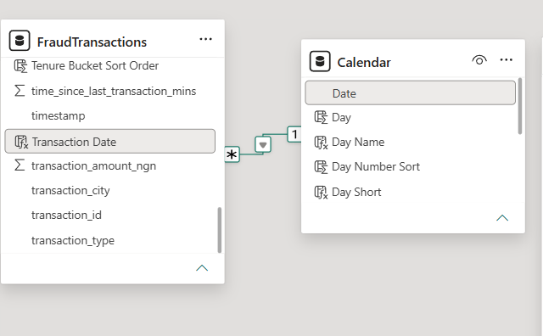
Figure 2. Data model relationship: Calendar[Date] → FraudTransactions[Transaction Date]

8. Master Dataset and Key Data Fields
The master analytical table is FraudTransactions. The source dataset contains transaction-level records with customer, account, channel, device, geographic, financial and behavioral attributes.
Field | Business Purpose | Power BI Use
transaction_id | Unique transaction identifier | Transaction count / uniqueness validation
timestamp | Exact transaction date and time | Source timestamp and date derivation
Transaction Date | Date-only analytical key | Calendar relationship / time analysis
customer_id | Customer identifier | Unique customers / affected customers
customer_signup_date | Customer onboarding date | Account-age context
account_tenure_days | Age of customer account | Tenure segmentation
transaction_type | Operational transaction category | Transaction-type risk analysis
channel | Transaction channel | Channel fraud-rate analysis
device_type / device_id | Device context | Behavioral investigation
ip_address / ip_country | Network / geography context | Foreign-IP risk analysis
transaction_city | Transaction location | Geographic investigation
merchant_category | Merchant context | Category analysis; documented n/a vs unknown distinction
transaction_amount_ngn | Transaction monetary value | Value exposed to fraud
balance_before_ngn / balance_after_ngn | Balance context | Financial behavior
is_new_beneficiary | Beneficiary behavior | First-time beneficiary risk signal
num_transactions_last_24h | Recent transaction frequency | Behavioral risk signal
time_since_last_transaction_mins | Transaction timing behavior | Behavioral segmentation
login_attempts_before_txn | Authentication behavior | Failed-login risk signal
is_foreign_transaction | Foreign transaction indicator | Foreign-IP / foreign-transaction analysis
risk_score | Risk scoring output | Fraud vs legitimate risk comparison
is_fraud | Confirmed fraud label | Fraud filtering and fraud rate
fraud_type | Fraud subtype | Fraud-type investigation

9. Power Query Transformations
Power Query was used as the controlled preparation layer before modeling and DAX work. The objective was to improve analytical reliability without changing the business meaning of source records.
Transformation / Check | Output / Purpose
Column Quality review | Checked valid, error and empty patterns across source fields
Broken-row investigation | Identified one fully broken row: TXN100035791
Duplicate transaction ID check | Confirmed no duplicate transaction IDs in the investigation
Data-type validation | Prepared timestamp, numeric and Boolean-like fields for modeling
Boolean conversion | Converted is_new_beneficiary, is_foreign_transaction and is_fraud to proper Boolean types
Timestamp parsing | Parsed timestamp into proper DateTime type
Transaction Date creation | Created date-only field so Calendar relationship matches transaction records
Tenure Bucket creation | Grouped account age into 0–30, 31–90, 91–365 and 365+ day buckets
Tenure Bucket Sort Order | Added helper field to keep tenure buckets in logical order
Merchant category documentation | Kept n/a and unknown separate and documented their different meanings
Null / blank handling | Retained source nulls where they do not break core KPI logic
Data-quality finding
The deeper investigation also identified approximately 750 transactions with placeholder/fake city names correlated with foreign transactions and a materially higher fraud rate. This was treated as a data-quality/risk-investigation signal rather than silently rewriting the source.

10. Business Rules / Analytical Logic
The fraud logic is intentionally transparent. Each rule is designed to explain what the dashboard is measuring and how the resulting signal should be interpreted.
Rule / Metric | Logic | Purpose
Total Transactions | COUNTROWS(FraudTransactions) | Overall transaction volume
Unique Customers | DISTINCTCOUNT(customer_id) | Customer population
Confirmed Fraud Cases | Transactions where is_fraud = TRUE | Fraud case count
Confirmed Fraud Rate | Confirmed Fraud Cases ÷ Total Transactions | Overall fraud prevalence
Total Transaction Value | SUM(transaction_amount_ngn) | Total transaction flow
Value Exposed to Fraud | Fraud-filtered transaction value | Monetary fraud exposure
Value Exposed to Fraud Rate | Fraud value ÷ total transaction value | Share of transaction value exposed
Customers Affected | Distinct customers with confirmed fraud | Customer impact
Customers Affected Rate | Customers Affected ÷ Unique Customers | Share of customer population affected
Fraud Risk Score | Average risk_score where is_fraud = TRUE | Fraud risk level
Legitimate Risk Score | Average risk_score where is_fraud = FALSE | Baseline comparison
Risk Separation | Fraud score vs legitimate score + dynamic label | Strength of separation
Fraud Rate by Segment | Fraud transactions within segment ÷ segment transactions | Risk segmentation
Interpretation rule
A segment with a higher observed fraud rate should be treated as a candidate for additional monitoring or control testing—not as proof that every transaction in that segment is fraudulent.

11. Core DAX Measures
The DAX layer centralizes fraud calculations so that all visuals respond consistently to filter context.

Total Transactions
Total Transactions =
COUNTROWS(FraudTransactions)

Unique Customers
Unique Customers =
DISTINCTCOUNT(FraudTransactions[customer_id])

Confirmed Fraud Cases
Confirmed Fraud Cases =
CALCULATE(
COUNTROWS(FraudTransactions),
FraudTransactions[is_fraud] = TRUE()
)

Confirmed Fraud Rate
Confirmed Fraud Rate =
DIVIDE(
[Confirmed Fraud Cases],
[Total Transactions]
)

Total Transaction Value
Total Transaction Value =
SUM(FraudTransactions[transaction_amount_ngn])

Value Exposed to Fraud
Value Exposed to Fraud =
CALCULATE(
[Total Transaction Value],
FraudTransactions[is_fraud] = TRUE()
)

Value Exposed to Fraud Rate
Value Exposed to Fraud Rate =
DIVIDE(
[Value Exposed to Fraud],
[Total Transaction Value]
)

Customers Affected
Customers Affected =
CALCULATE(
DISTINCTCOUNT(FraudTransactions[customer_id]),
FraudTransactions[is_fraud] = TRUE()
)

Customers Affected Rate
Customers Affected Rate =
DIVIDE(
[Customers Affected],
[Unique Customers]
)

Average Fraud Risk Score
Average Fraud Risk Score =
CALCULATE(
AVERAGE(FraudTransactions[risk_score]),
FraudTransactions[is_fraud] = TRUE()
)

Average Legitimate Risk Score
Average Legitimate Risk Score =
CALCULATE(
AVERAGE(FraudTransactions[risk_score]),
FraudTransactions[is_fraud] = FALSE()
)

Avg Risk Score
Avg Risk Score =
FORMAT([Average Fraud Risk Score], "0.0")
& " vs "
& FORMAT([Average Legitimate Risk Score], "0.0")

DAX implementation note
The project also uses supporting subtitle measures, VAR + FORMAT text measures, and SWITCH(TRUE()) logic for dynamic risk-separation labels. The exact model implementation evolved iteratively through live MCP validation.

12. Technical Challenges and Resolution
Challenge | Why It Matters | Resolution
Broken / invalid row | A malformed record can distort totals and downstream calculations | Removed TXN100035791 through Power Query and verified row count change
Boolean-like fields stored as text | Text values reduce reliable filtering and modeling | Converted fraud/foreign/new-beneficiary fields to Boolean
DateTime vs Date relationship | A date at midnight will not match timestamps containing time-of-day | Created Transaction Date and related Calendar[Date] to it
Tenure bucket ordering | Text buckets can sort alphabetically | Added Tenure Bucket Sort Order
Fraud rate vs transaction volume | High volume can hide or exaggerate perceived risk | Displayed volume and fraud rate together
Filtered vs full-dataset totals | Slicers can change KPI values | Validated measures with live DAX queries and cleared-filter checks
Multiple high-risk signals | Too many signals can reduce decision clarity | Ranked signals using P1/P2/P3 priority
Risk of over-interpreting patterns | Observed rates can be mistaken for causation | Framed findings as monitoring signals, not automatic decisions
Calendar modeling anomaly | Requested timestamp relationship would not match date-only Calendar values | Caught the issue before completion and fixed the model with Transaction Date

13. Dashboard Structure (Pages)
Page | Dashboard Page | Primary Purpose | Main Outputs
1 | Overview | Executive fraud monitoring | KPIs, tenure, monthly fraud rate, channel fraud rate, recommendation
2 | Descriptions | Risk narrative and prioritized actions | P1/P2/P3 risk signals and control recommendations
The dashboard is therefore organized as one analytical story: first understand the fraud problem, then inspect where risk concentrates, and finally translate those patterns into prioritized actions.

14. Page-by-Page Analytical Explanation

Page 1 — Overview
The Overview page is the executive entry point. The top KPI band presents Total Transactions, Confirmed Fraud Cases, Value Exposed to Fraud, Customers Affected and Risk Score Comparison. A second KPI row adds Unique Customers, Confirmed Fraud Rate, Value Exposed to Fraud Rate and Customers Affected Rate. The lower section then moves from overall fraud prevalence into tenure, monthly and channel diagnostics.

Page 2 — Descriptions
The Descriptions page converts the analysis into management-ready risk statements. Each recommendation is explicitly linked to an observed rate or concentration, with P1/P2/P3 priority labels. This prevents the dashboard from ending at descriptive charts and gives the user a concise decision-support layer.

15. Dashboard Design, UI/UX and Storytelling
Design Element | Implementation
KPI-first hierarchy | Headline fraud metrics appear at the top of the Overview page
Semantic color | Teal/green for primary KPI values, gold cards for secondary context, dark panels for risk narratives
Visual segmentation | Rounded containers separate KPI, diagnostic and recommendation areas
Risk narrative | Large recommendation panels make the action layer easy to scan
Comparison design | Fraud and legitimate risk scores are shown together to communicate separation
Time analysis | Monthly transaction bars are paired with fraud-rate line values
Channel analysis | Horizontal bars make channel ranking easy to compare
Tenure analysis | Donut + labeled bucket values provide a compact segment view
Progressive storytelling | Executive KPIs → segment diagnostics → recommendations
Storytelling principle
The dashboard is not just a collection of visuals. Each visual answers the next management question: how much risk, where is it concentrated, what signals are elevated, and what should be tested next.

16. Dashboard Screenshots
Evidence note: Dashboard screenshots are embedded in the report itself.
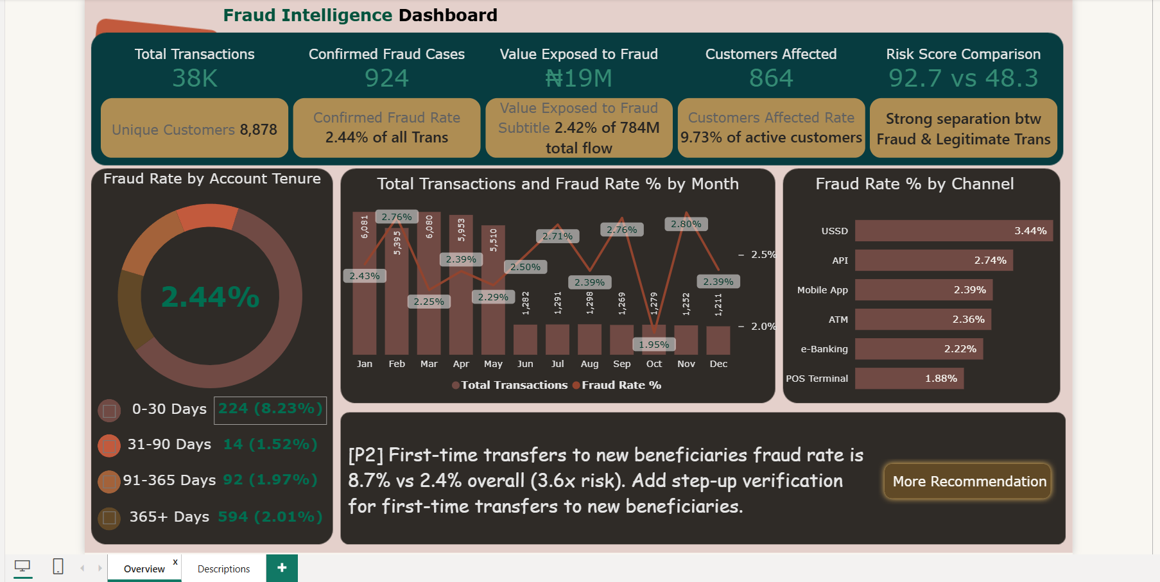
Figure 3. Page 1 — Overview: executive KPIs, tenure, monthly fraud rate and channel analysis
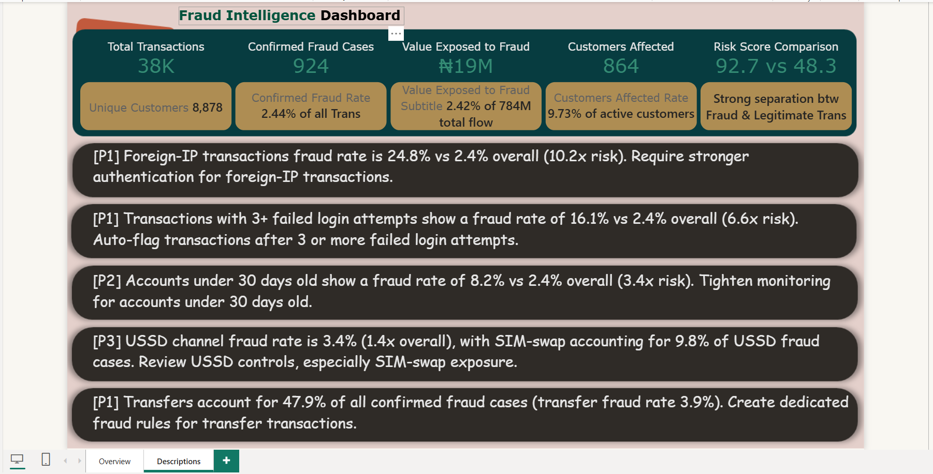
Figure 4. Page 2 — Descriptions: prioritized fraud-risk recommendations
Figure 5. Model view — FraudTransactions connected to Calendar through Transaction Date

17. Validation, Key Insights and Business Value

Validation
Validation Check | Result
Original source rows | 37,902
Post-cleaning rows | 37,901
Broken row removed | TXN100035791
Duplicate transaction IDs | None identified
Unique customers | 8,878
Confirmed fraud cases | 924
Confirmed fraud rate | 2.44%
Affected customers | 864
Average fraud risk score | 92.7
Average legitimate risk score | 48.3
Calendar relationship | Calendar[Date] → FraudTransactions[Transaction Date]

Key Insights
Observed Pattern | Source Result | Business Meaning
Overall fraud exposure | 924 cases / 2.44% rate / ~₦19M exposed value | Fraud is a minority event but a material monitoring problem
Risk-score separation | 92.7 fraud vs 48.3 legitimate | Risk score provides strong observed separation in this dataset
Foreign-IP activity | 24.8% vs 2.4% overall | Approximately 10.2× higher observed fraud rate
3+ failed login attempts | 16.1% vs 2.4% overall | Approximately 6.6× higher observed fraud rate
Accounts under 30 days | 8.2% vs 2.4% overall | Approximately 3.4× higher observed fraud rate
USSD channel | 3.44% fraud rate | Highest visible channel fraud rate
Transfer transactions | 47.9% of confirmed fraud cases | Major fraud-case concentration
First-time beneficiary pattern | 8.7% vs 2.4% overall | Approximately 3.6× higher observed fraud rate

Business Value
The solution connects three levels of analysis: executive monitoring, diagnostic segmentation and operational recommendation. A stakeholder can move from the headline fraud rate to the segments driving elevated risk and then to a prioritized control action without leaving the dashboard.
Level | Use
Executive | Monitor transaction volume, fraud cases, exposed value and customer impact
Analytical | Compare fraud rate across tenure, month, channel and behavior
Diagnostic | Investigate elevated signals and concentration patterns
Decision Support | Prioritize authentication, monitoring and rule-testing opportunities

18. Business Recommendations
Priority | Risk Signal | Evidence | Recommended Action
P1 | Foreign-IP transactions | 24.8% fraud rate vs 2.4% overall (10.2×) | Require stronger authentication / step-up verification for foreign-IP transactions.
P1 | 3+ failed login attempts | 16.1% vs 2.4% overall (6.6×) | Auto-flag transactions after 3 or more failed login attempts.
P1 | Transfer transactions | 47.9% of confirmed fraud cases; 3.9% transfer fraud rate | Create dedicated fraud rules for transfer transactions.
P2 | Accounts under 30 days | 8.2% vs 2.4% overall (3.4×) | Tighten monitoring for very new accounts.
P2 | First-time transfers / new beneficiaries | 8.7% vs 2.4% overall (3.6×) | Add step-up verification for first-time transfers to new beneficiaries.
P3 | USSD channel | 3.44% fraud rate (1.4× overall) | Review USSD controls, especially SIM-swap exposure.
Recommendation governance
Before production use, each rule should be evaluated using false-positive rate, customer friction, precision/recall, control effectiveness and operational capacity. The recommendations are analytical observations, not formal fraud policy.

19. Limitations and Responsible Use
- The dashboard is a fraud analytics portfolio solution, not a production fraud-decisioning system.
- Observed relationships and fraud-rate differences do not establish causation.
- A high-risk segment should not be treated as proof that every transaction in that segment is fraudulent.
- The quality of fraud labels directly affects KPI reliability and rule evaluation.
- The dataset contains synthetic/placeholder patterns, including the documented city-name anomaly and an uneven December data pattern; trend interpretation should therefore remain cautious.
- Customer-level actions should use appropriate privacy, fairness, security and access controls.
- Thresholds such as 3 failed logins or 30 days should be validated empirically before production deployment.
Responsible interpretation
Use the dashboard to prioritize investigation and control testing. Do not use a single dashboard signal as the sole basis for denying, blocking or penalizing an individual customer.

20. Final Outcome and Conclusion + Interview Pitch
The completed Fraud Intelligence Dashboard demonstrates an end-to-end Power BI workflow: source profiling, Power Query preparation, structured data modeling, reusable DAX, executive dashboard design, risk segmentation, validation and business recommendations.
The strongest aspect of the project is the progression from reporting to analysis and then to action. The dashboard does not stop at '2.44% fraud'; it explains which observed segments have materially higher fraud rates and turns those signals into prioritized P1/P2/P3 recommendations.
30-Second Interview Pitch
I built a Fraud Intelligence Dashboard in Power BI using transaction-level fraud data. I created a Calendar relationship, prepared the data through Power Query, and built reusable DAX measures for transaction volume, fraud cases, fraud rate, exposed value, affected customers and risk-score separation. I then analyzed fraud by account tenure, channel, month, foreign-IP activity, failed login behavior and beneficiary patterns. The key finding was that several behavioral segments showed materially higher observed fraud rates, so I translated those findings into prioritized monitoring and step-up authentication recommendations.

Final Analytical Chain
Raw Data → Power Query → Data Model → DAX → Dashboard → Validation → Insights → Recommendations

21. Appendix — DAX Catalogue
Selected core and supporting DAX patterns used or documented during the project.

Total Transaction Value
Total Transaction Value = SUM(FraudTransactions[transaction_amount_ngn])

Fraud Customers Count
Fraud Customers Count = CALCULATE(DISTINCTCOUNT(FraudTransactions[customer_id]), FraudTransactions[is_fraud] = TRUE())

Customers Affected Rate
Customers Affected Rate = DIVIDE([Customers Affected], [Unique Customers])

Average Fraud Risk Score
Average Fraud Risk Score = CALCULATE(AVERAGE(FraudTransactions[risk_score]), FraudTransactions[is_fraud] = TRUE())

Average Legitimate Risk Score
Average Legitimate Risk Score = CALCULATE(AVERAGE(FraudTransactions[risk_score]), FraudTransactions[is_fraud] = FALSE())

Avg Risk Score
Avg Risk Score = FORMAT([Average Fraud Risk Score], "0.0") & " vs " & FORMAT([Average Legitimate Risk Score], "0.0")

Tenure Bucket
SWITCH(TRUE(), account_tenure_days <= 30, "0-30 Days", account_tenure_days <= 90, "31-90 Days", account_tenure_days <= 365, "91-365 Days", "365+ Days")

Risk Separation Label
SWITCH(TRUE(), ABS([Average Fraud Risk Score]-[Average Legitimate Risk Score]) >= 20, "Strong separation", ABS([Average Fraud Risk Score]-[Average Legitimate Risk Score]) >= 10, "Moderate separation", "Weak separation")

Channel Display Name
SWITCH(channel, "api", "API", "internet_banking", "e-Banking", "mobile_app", "Mobile App", "pos_terminal", "POS Terminal", "atm", "ATM", "ussd", "USSD", channel)

Implementation note
The Appendix is a practical catalogue for portfolio review. Exact syntax should always match the final Power BI model data types and column names.

Report prepared for portfolio documentation • Fraud Intelligence Dashboard • October 2026

