HR. Workforce Intelligence Dashboard
Complete Project Report
Attrition Analysis • Workforce Intelligence • Decision Support
KPI | Value | KPI | Value
Total Employees | 2,925 | Active Employees | 2,433
Total Attrition | 492 | Attrition Rate | 17%
Promotion Review | 144 | Retrenchment Review | 234
Male / Female | 1,754 / 1,171 | Power BI Pages | 6
1. Executive Summary
The HR. Workforce Intelligence Dashboard is an end-to-end Power BI analytics and decision-support project created by combining two related HR use cases: Employee Attrition Analysis and Workforce Decision Support. The objective was to move beyond static HR reporting and convert employee-level data into meaningful workforce insights, transparent business-rule indicators, and employee-level review outputs.
d
The final solution contains six Power BI pages. Pages 1–3 form the Attrition Analysis module, while Pages 4–6 form the Decision Support module. The analytical journey is:
Raw HR Data → Data Cleaning & Transformation → HR Master Dataset → Analysis → Business Rules → Decision Support → Employee Review.
A key design decision was to use one 2,925-employee master dataset for the complete project. This avoided unnecessary duplication and ensured that attrition, workforce composition, promotion review, and retrenchment review were calculated from the same employee population. The dashboard is a decision-support tool: its promotion and retrenchment flags are screening categories based on defined rules, not automatic HR decisions.
2. Business Problem and Objective
HR departments usually have large employee datasets, but raw records do not immediately answer management questions. This project was designed to answer: How large is the workforce? How many employees have left? What is the attrition rate? Which departments and job roles show more attrition cases? How does attrition vary by age, gender, satisfaction, education, distance, tenure, and performance? Which employees meet the defined promotion-review rule? Which long-tenured employees meet the defined retrenchment-review rule?
The project follows a data-to-decision approach. The Attrition Analysis module explains where employee exits are visible, while the Decision Support module applies predefined HR rules to identify employees who require further review. The dashboard does not claim that a factor causes attrition and does not make final HR decisions.
3. Project Consolidation
This project combines two related HR analytical areas: Employee Attrition Analysis and Workforce Decision Support.
The first area focuses on understanding employee attrition across departments, job roles, demographics, satisfaction, tenure and performance. The second area uses predefined business rules to identify employees who fall into promotion and retrenchment review categories. A single 2,925-employee HR Master Dataset was used as the foundation for the complete Power BI solution. The promotion and retrenchment logic was recreated using the relevant fields available in this dataset, allowing both analytical areas to work consistently within the same model.
This approach resulted in one integrated six-page dashboard covering:
- Pages 1–3: Attrition Analysis
- Pages 4–6: Workforce Decision Support
Tools & Technologies Used
Tool / Technology | Role in the Project
Power BI Desktop | Dashboard development, visuals, interactions and KPI presentation
Power Query | Data cleaning, transformation, categorization and preparation
DAX | Dynamic measures, KPI calculations, filter context and rule-based counts
Excel | Initial data reference, source inspection and supporting HR analysis
5. Project Architecture
HR Source Data
↓
Power Query
↓
Data Cleaning & Transformation
↓
HR Master Dataset (2,925 Employees)
↓
DAX Measures & Business Rules
↓
┌─────────────────────────────┐
│ │
↓ ↓
Attrition Analysis Decision Support
Pages 1–3 Pages 4–6
│ │
↓ ↓
Attrition Patterns HR Review Rules
│
↓
Employee-Level Review
6. Master Dataset and Key Data Fields
Field | Business Purpose
Employee Number | Employee identification
Age | Demographic analysis
Gender | Workforce and attrition analysis
Department | Organizational analysis
Job Role | Role-level attrition and workforce analysis
Attrition | Employee exit status
Job Satisfaction | Satisfaction analysis
Performance Rating | Performance analysis
Years At Company | Tenure and retrenchment-review rule
Years Since Last Promotion | Promotion-review rule
OverTime | Workforce analysis
Distance From Home | Distance analysis

7. Power Query Transformations
Power Query was used to convert raw numerical fields into business-friendly analytical categories, making the dashboard easier to interpret.
Transformation | Output / Category
Age transformation | 18–25 / 26–35 / 36–45 / 46–55 / 56+
Job Level transformation | Entry / Junior / Mid / Senior / Executive
Performance Rating | High / Low
Job Satisfaction | Very Satisfied / Satisfied / Dissatisfied / Very Dissatisfied
Total Working Years | 0–10 / 11–20 / 21–30 / 31+
Distance From Home | Near by / Far / Very Far
Promotion logic | Promotion Status
Tenure logic | Retrenchment Status
A data-quality issue around employee names and gender mapping was identified and corrected so gender filtering remained consistent. The Gender field remained the analytical source of truth.
8. HR Business Rules and Decision Logic
Promotion Review Rule: Employees with Years Since Last Promotion between 10 and 15 years are classified as Due for Promotion. Result: 144 employees.
Retrenchment Review Rule: Employees with Years At Company greater than or equal to 18 years are classified as Due for Retrenchment. Result: 234 employees.
Promotion Status and Retrenchment Status were maintained as binary indicators, where 1 = rule is met and 0 = rule is not met. A Combined Decision Status can distinguish employees who meet neither rule, one rule, or both. An employee appearing in both categories is a review case; it is not an automatic instruction to promote or retrench.
The rules were applied to the full 2,925-employee population. Active Employees were calculated separately using Attrition = No, giving 2,433 active employees.
9. Core DAX Measures
Measure | Purpose
Total Employees | Total workforce count
Total Attrition | Employees where Attrition = Yes
Active Employees | Employees where Attrition = No
Active % | Active workforce percentage
Attrition Rate / % Attrition | Overall attrition percentage
Male / Female | Gender workforce counts
Male Attrition / Female Attrition | Gender-wise attrition counts
Due for Promotion | Promotion-rule employee count
Due for Retrenchment | Retrenchment-rule employee count
Promotion % | Promotion-review percentage
Retrenchment % | Retrenchment-review percentage

Total Employees =
COUNTROWS('HR Master Data')
Total Attrition =
CALCULATE(
[Total Employees],
'HR Master Data'[Attrition] = "Yes"
)
Active Employees =
CALCULATE(
[Total Employees],
'HR Master Data'[Attrition] = "No"
)
Due for Promotion =
CALCULATE(
[Total Employees],
'HR Master Data'[Promotion Status] = "1"
)
These measures respond to filter context, so gender, department and other applicable selections dynamically update the relevant KPIs and visuals.
10. Technical Challenge & Resolution
During development, Promotion Status was stored as text ("1"/"0"), while the initial DAX expression attempted to compare it with numeric 1. Power BI generated a text-versus-integer mismatch. The issue was resolved by comparing the field with the text value "1", or alternatively by converting the column to a numeric type before using a numeric comparison.
Due for Promotion
Due for Promotion =
CALCULATE(
[Total Employees],
'HR Master Data'[Promotion Status] = "1"
)
Key Learning: Data types should be validated before implementing DAX filters and business logic.
11. Six-Page Dashboard Structure
Page | Dashboard Page | Module | Primary Purpose
1 | Attrition Overview | Attrition Analysis | Executive attrition summary
2 | Job Role Attrition | Attrition Analysis | Role and education deep dive
3 | Age & Gender Attrition | Attrition Analysis | Demographic and performance analysis
4 | Workforce Overview | Decision Support | Workforce composition and decision KPIs
5 | HR Actions | Decision Support | Employee-level promotion/retrenchment review
6 | Workforce Detail | Decision Support | Department, satisfaction, overtime and job-role analysis

12. Page-by-Page Analytical Explanation
Page 1 — Attrition Overview presents Total Employees (2,925), Total Attrition (492), Attrition Rate (17%), Male Attrition (312), and Female Attrition (180). It also analyzes attrition by distance to work, working years, satisfaction, and department. R&D shows 282 attrition cases, Sales 186, and HR 24 in the displayed analysis.
Page 2 — Job Role Attrition moves to role-level analysis. It compares attrition across job roles and adds working-year and education context. Laboratory Technician, Sales Executive, and Research Scientist appear among the higher displayed attrition categories.
Page 3 — Age & Gender Attrition provides demographic analysis using age buckets 18–25, 26–35, 36–45, 46–55, and 56+. Gender filtering allows focused analysis of female or male employees, while performance-related attrition indicators provide additional context.
Page 4 — Workforce Overview shows Total Employees (2,925), Male (1,754), Female (1,171), Not Due for Promotion (2,781), Due for Promotion (144), Due for Retrenchment (234), and Active Workers (2,433). Supporting visuals cover distance, tenure, and job level.
Page 5 — HR Actions provides employee-level tables for Retrenchment Review and Promotion Review. The displayed totals are 234 and 144, respectively. A guidance panel explains that these employees are identified for review using defined HR business rules.
Page 6 — Workforce Detail combines Promotion and Retrenchment by Department, Overtime Distribution, Job Satisfaction, Performance Rating Mix, and a Job Role table containing Total Employees, Due for Promotion, and Due for Retrenchment.
13. Dashboard Design, UI/UX and Storytelling
A consistent visual identity was maintained across all six pages: dark navy/charcoal backgrounds, pink or magenta accents, light text, rounded containers, KPI cards, structured spacing, and clean visual hierarchy. The common project title is “HR. Workforce Intelligence Dashboard,” with the section tags “Attrition Analysis” and “Decision Support.”
The storytelling is progressive: first understand attrition, then investigate roles and demographic patterns, and finally move into workforce composition and employee review categories. This makes the six pages look and behave as one integrated project rather than two unrelated dashboards.
14. Dashboard Screenshots
The following screenshots document the final six-page Power BI implementation.
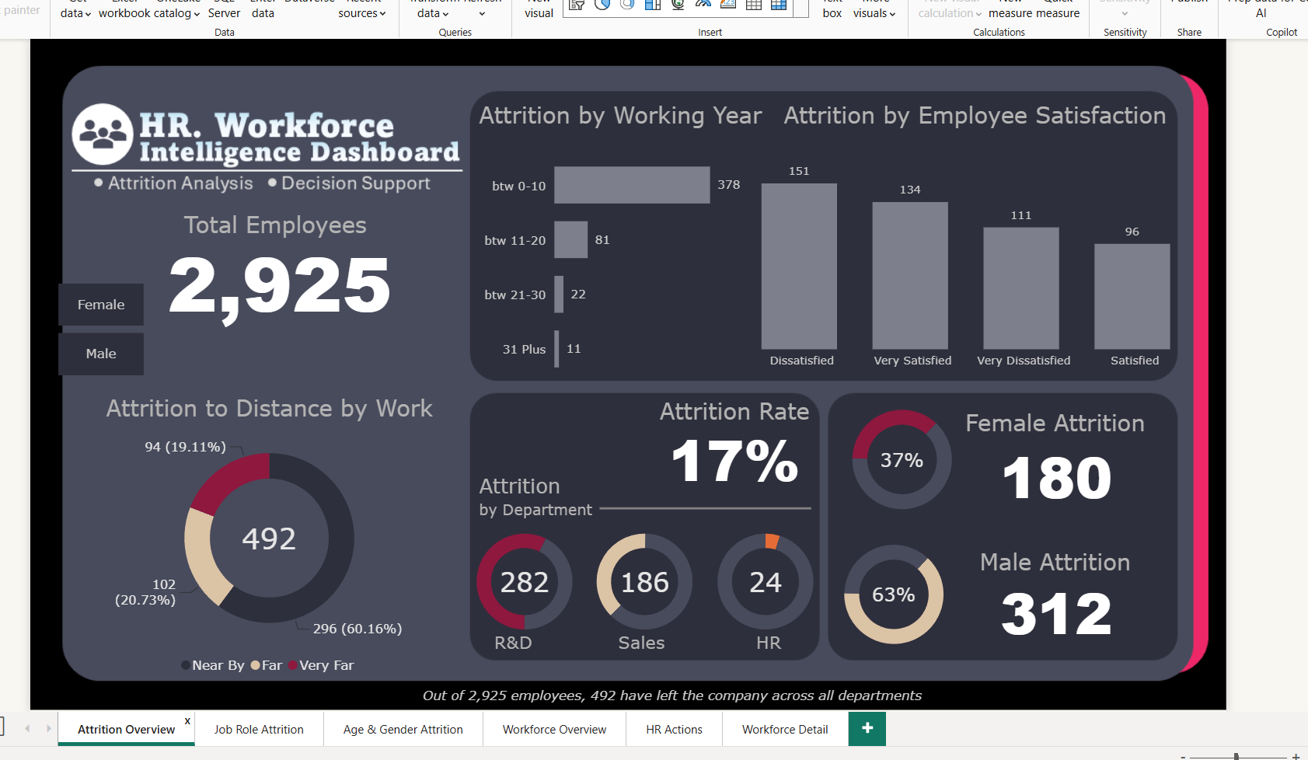
Page 1 — Attrition Overview

Executive attrition view showing workforce size, attrition rate, department, tenure, satisfaction and distance-related analysis.

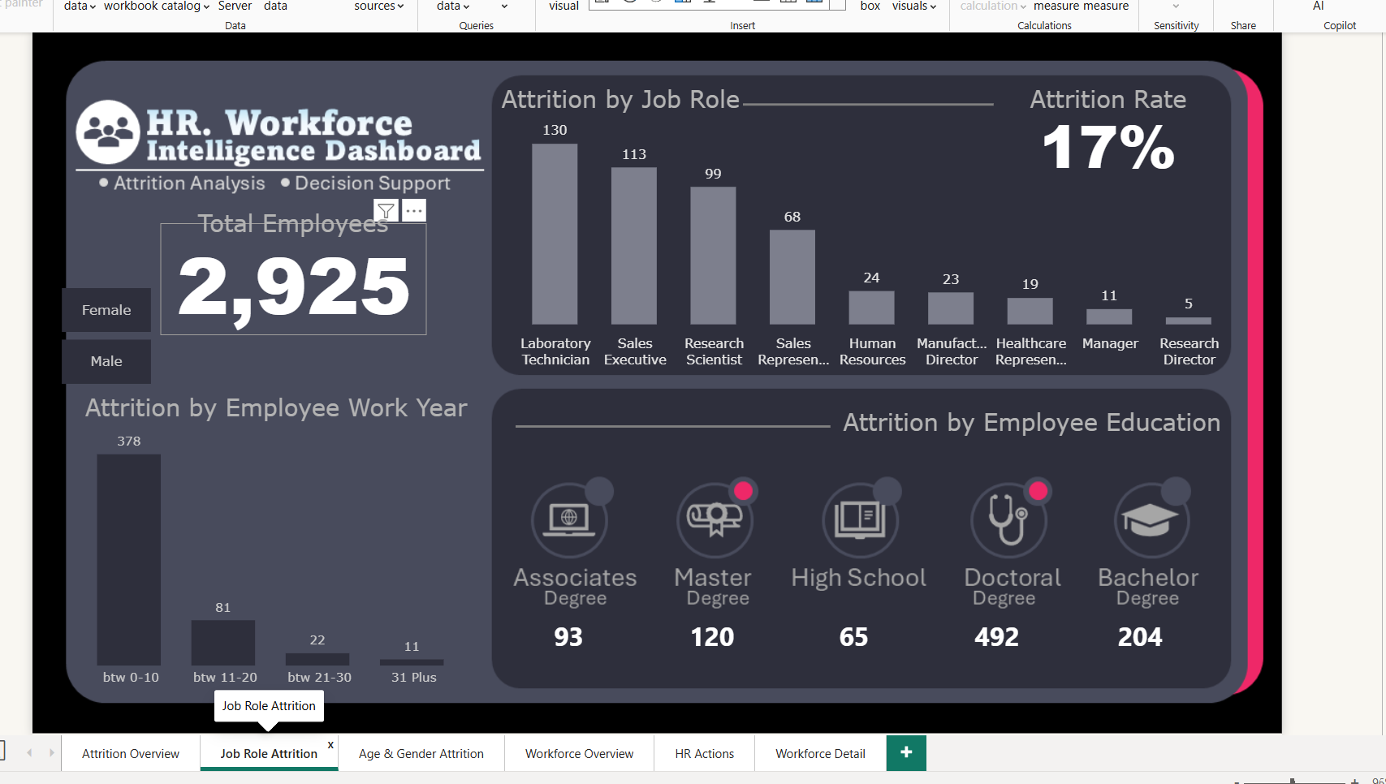
Page 2 — Job Role Attrition
Role-level attrition analysis supported by working-year and education context.
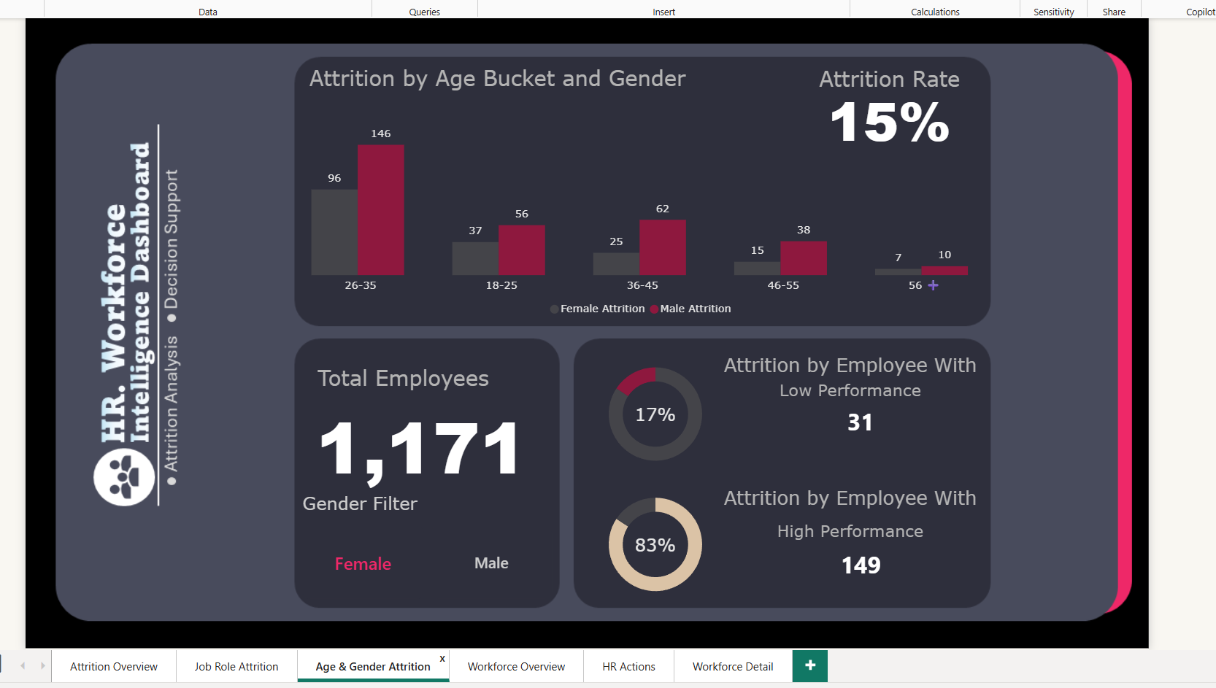
Page 3 — Age & Gender Attrition
Demographic deep dive with age buckets, gender filtering and performance-related attrition indicators.
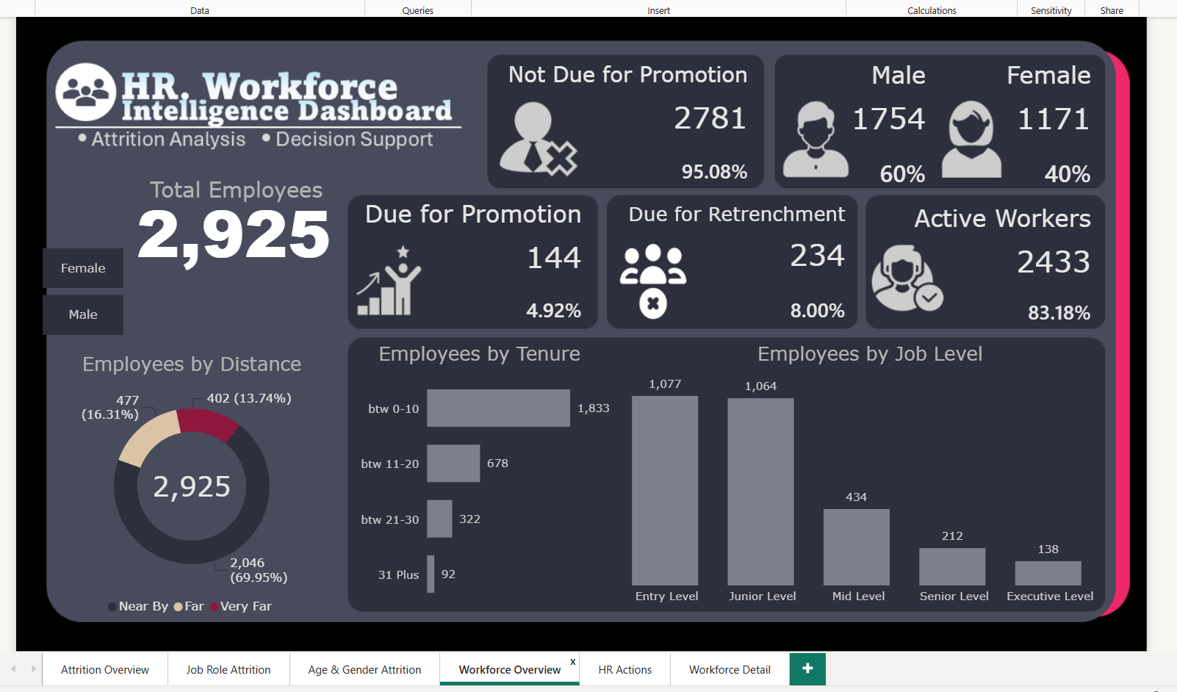
Page 4 — Workforce Overview
Workforce composition and decision-support KPIs including promotion, retrenchment and active-worker measures.
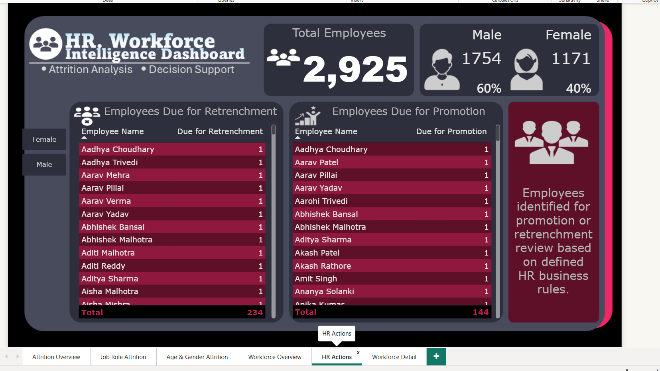
Page 5 — HR Actions
Employee-level review lists for promotion and retrenchment, with rule-based guidance.
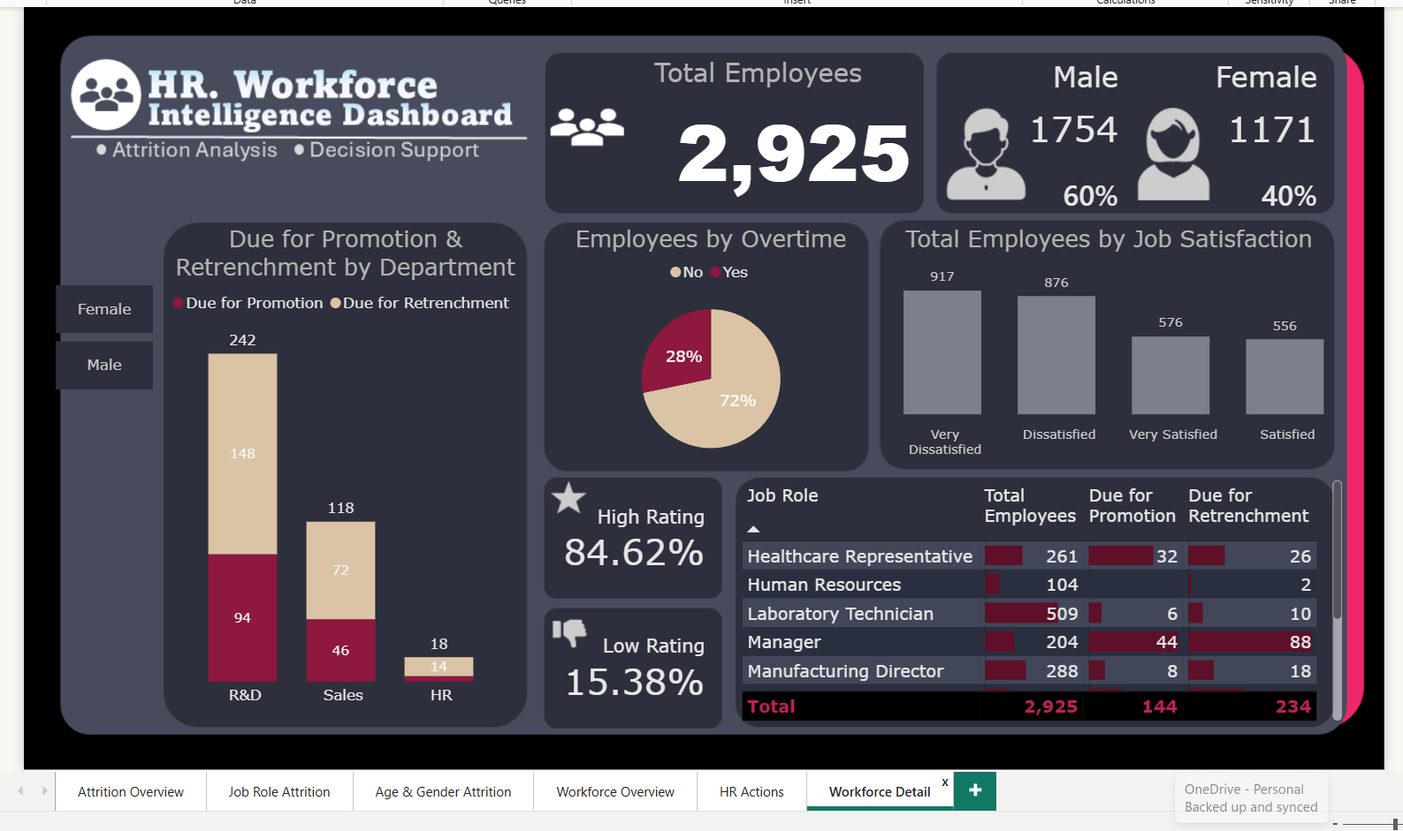
Page 6 — Workforce Detail
Department, overtime, satisfaction, performance and job-role decision analysis.
15. Validation, Key Insights and Business Value
Validation covered employee counts, attrition, active employees, promotion and retrenchment counts, employee identifiers, name mapping, gender consistency, and decision-status fields. The final population remained 2,925 employees, with 492 attrition cases, 2,433 active employees, 144 promotion-review employees, and 234 retrenchment-review employees.
Key observations from the displayed analysis include an overall attrition rate of approximately 17%, higher absolute attrition in R&D, the largest attrition count within the 0–10 working-year group, 312 male attrition cases and 180 female attrition cases, 144 promotion-review employees, and 234 retrenchment-review employees.
The business value comes from connecting three levels: executive KPIs, segment analysis, and employee-level review. HR can move from a high-level metric to a department or job-role pattern and then to the employee records behind a defined review rule.
16. Limitations and Responsible Use
- Promotion and retrenchment rules are predefined analytical criteria, not automatic HR decisions.
- Attrition patterns show relationships within the available dataset and should not automatically be interpreted as causal relationships.
- The dashboard should be used alongside HR policies, employee history, business requirements, and management review.
- Employee-level outputs should be handled according to organizational privacy and access policies.
- The dashboard reflects the available dataset and its defined business rules; additional HR factors may be required for actual decision-making.
17. Final Outcome and Conclusion
The completed HR. Workforce Intelligence Dashboard demonstrates a practical end-to-end Power BI workflow. It starts with raw HR information, creates a controlled master dataset, applies Power Query transformations, develops DAX measures, analyzes attrition, applies transparent promotion and retrenchment rules, and presents the results through six connected pages.
The strongest aspect of the project is the progression from reporting to analysis and then to decision support. It answers a sequence of increasingly useful questions: How many employees are there? How many have left? Where is attrition concentrated? How is the workforce structured? Which employees meet the defined review criteria? This creates a clear data-to-decision story.
The solution remains a decision-support system. A promotion or retrenchment flag is not a final HR decision, and the dashboard does not claim that a particular factor causes attrition or that an individual employee will definitely leave. Final HR actions require organizational policy, employee context, management review, and validation.
Overall, the project demonstrates practical skills in Power BI, Power Query, DAX, data preparation, KPI development, business-rule implementation, dashboard design, data validation, and business storytelling. The final six-page solution is suitable as a portfolio case study, interview project, viva explanation, and demonstration of an end-to-end HR analytics workflow.

