FAMILY FINANCIAL
Analysis & Personal Finance Intelligence Dashboard
Complete Project Report
Power BI • Power Query • DAX • Financial Analytics

Project at a Glance | Value
Transaction period | 01-Jan-2023 to 31-Dec-2024
Transactions | 2,216
Total Income | $1,820,299
Total Expense | $1,282,035
Net Balance | $538,264
Overall Saving Rate | 29.57%
Family members | 4
Primary analytical table | FactTable

Prepared from the supplied finance workbook, image workbook, Power BI model/dashboard screenshots and project DAX/transcript evidence.

1. Executive Summary
The Family Financial Analysis Dashboard is an end-to-end Power BI personal-finance analytics project designed to convert transaction-level income and expense data into an interactive management-style view of household financial performance. The solution combines executive KPIs, time-based analysis, savings monitoring, person-level comparison, spending analysis, contextual tooltips and transaction-level investigation.
The supplied source population contains 2,216 transactions covering 2023–2024 across four family members. The source calculations produce $1,820,299 of total income, $1,282,035 of total expense, $538,264 of net balance and a 29.57% overall saving rate.
The analytical journey is intentionally progressive: Raw Financial Data → Power Query → Master Transaction Dataset → Data Model → DAX Calculation Layer → Financial Performance Analysis → Savings & Spending Analysis → Transaction-Level Investigation.
Project Outcome | Evidence
Executive financial monitoring | Income, Expense, Net Balance and Saving Rate KPIs
Time-based analysis | 2023 vs 2024, monthly trends, YTD and prior-year YTD
Family-member analysis | Income, expense, balance and saving rate by person
Spending analysis | Expense categories and Need vs Want
Contextual analysis | Custom tooltip pages with person and month context
Detailed investigation | Person selection, category analysis and transaction table

2. Business Problem & Objective
Transaction-level financial data provides detail, but raw records do not immediately answer management questions. The dashboard was designed to make the financial position easier to monitor and investigate without changing the underlying transaction population.

Business Questions
Question | Analytical Output
How much income was generated? | Total Income
How much was spent? | Total Expense
What remained after expenses? | Net Balance
What percentage of income was saved? | Saving Rate
Is the saving rate meeting the configured benchmark? | Target / Savings Tracker
How is performance changing over time? | Monthly and yearly trend
How does current performance compare with prior year? | YTD vs Last Year YTD
How do family members differ? | Person-level comparison
Which categories contribute most to expenses? | Category analysis
How does Need vs Want spending compare? | Spending Type analysis
Which records explain the headline numbers? | Financial Details

Project Objectives
- Create a reusable Power BI financial analytics model rather than a static report.
- Develop consistent financial KPIs using DAX.
- Provide year-aware time analysis across 2023 and 2024.
- Monitor savings against the configured 30% analytical target.
- Allow users to move from executive KPIs to person, category and transaction detail.
- Use tooltips, Field Parameters and conditional formatting to make the dashboard interactive.
- Validate key dashboard outputs against the supplied source calculations.

3. Project Consolidation
The project consolidates several related financial analysis needs into one connected solution. All modules use the same transaction population and shared dimensions, so executive KPIs and detailed analysis remain consistent.
Module | Purpose | Primary Outputs
Financial Performance | Executive view of financial position | Income, Expense, Balance, Saving Rate
Savings Performance | Benchmark and time-intelligence analysis | YTD, LYTD, Growth, 30% Target
Family Member Analysis | Compare observed financial activity | Income, Expense, Balance, Saving Rate
Spending Analysis | Understand expense composition | Categories, Need vs Want
Contextual Tooltip Analysis | Provide focused detail without leaving the chart | Month/person financial context
Financial Investigation | Trace results to granular records | Transactions, categories, date granularity

Rather than treating these as separate dashboards, the implementation connects them through shared filters, DAX measures and the same FactTable. This is the central design principle of the project.

4. Tools & Technologies
Tool / Technology | Role in the Project
Power BI Desktop | Dashboard development, visuals, interactions and KPI presentation
Power Query | Data cleaning, transformation, header promotion and data-type validation
DAX | Financial KPIs, filter context, time intelligence, dynamic logic and formatting
Excel | Source inspection and numerical reconciliation
SVG / Data URI | Custom savings progress-ring visualization

5. Project Architecture
The model follows a controlled data-to-decision workflow. Data preparation is completed before analytical calculations are built, and the dashboard consumes reusable measures rather than embedding financial logic separately in each visual.
Financial Source Data
↓
Power Query Cleaning & Transformation
↓
Master Transaction Dataset — FactTable (2,216 transactions)
↓
Date + Category + Person/Image Dimensions
↓
DAX Calculation Layer
↓
Financial Performance • Savings • Spending • Person Analysis
↓
Dashboard Pages + Tooltips
↓
Transaction-Level Investigation & Financial Decision Support

Data Model Evidence
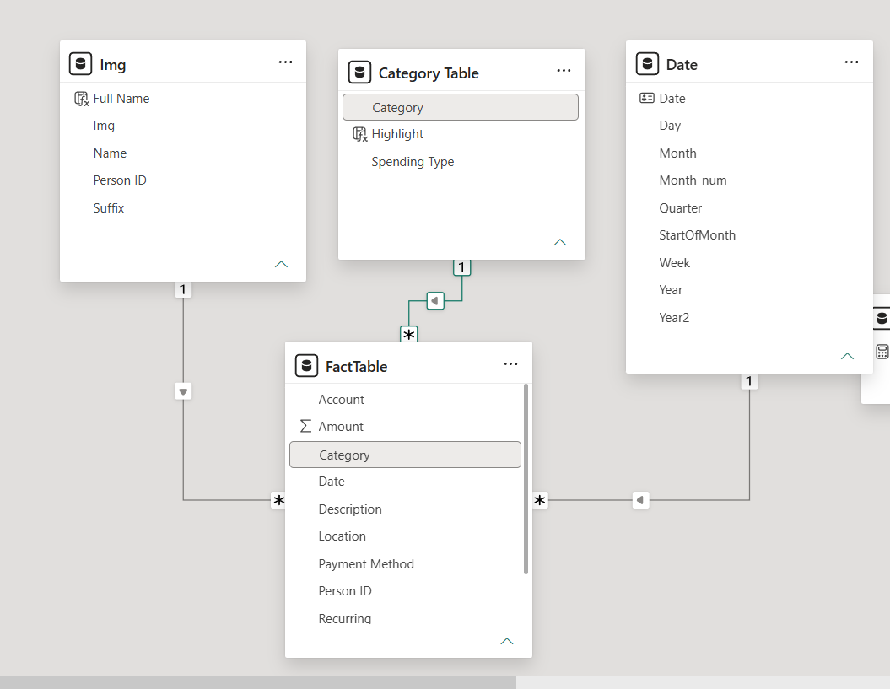
The model is centered on FactTable, with the supplied screenshots showing the Date, Category Table and Img relationships used for time, category and person analysis.
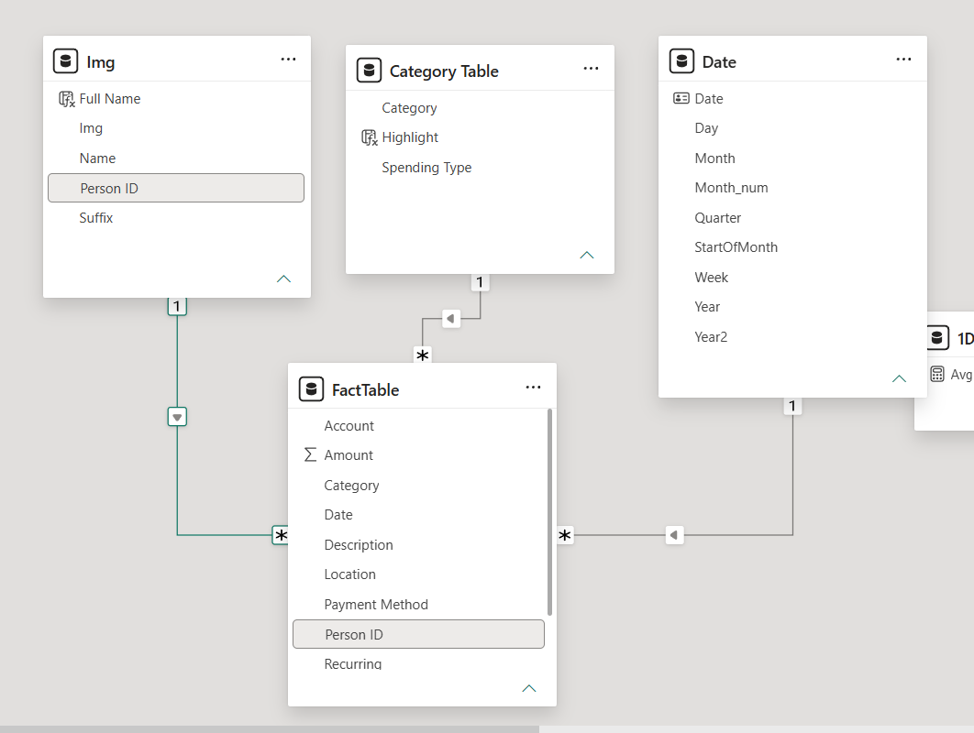

Figure 1. Model view — overall relationship structure. Figure 2. Model view — Category relationship.

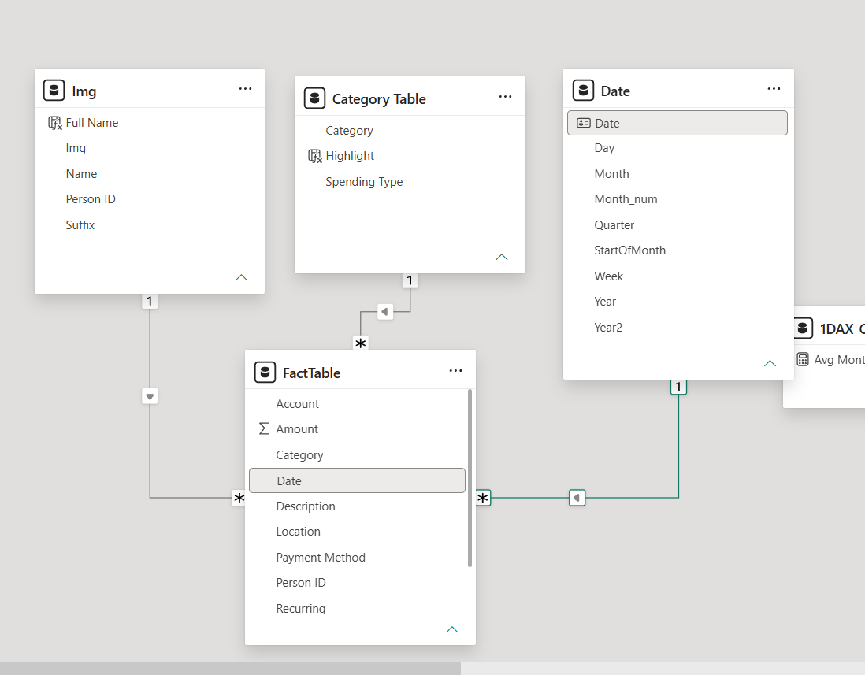

Figure 3. Model view — Person ID relationship.

6. Master Dataset & Key Data Fields
The transaction table is the analytical master population for the dashboard. The supplied workbook contains 2,216 populated records across 2023–2024. A separate image workbook provides the person/image mapping used by the Img table.
Field | Business Purpose
Date | Transaction date and relationship key to the Date table
Type | Income / Expense classification
Category | Financial business category
Amount | Primary transaction value
Description | Transaction-level narrative
Account | Account/source classification
Person ID | Family-member relationship key
Payment Method | Payment channel analysis
Spending Type | Need / Want classification
Recurring | Recurring transaction indicator
Location | Transaction location analysis
Year / Month | Source period attributes

7. Power Query Transformations
Power Query is used as the controlled preparation layer before relationships and DAX calculations are applied.
Transformation | Output / Purpose
Image workbook preparation | Image/name lookup prepared and query renamed to Img
Column Quality review | Empty and unusable source content identified
Column cleanup | Unusable columns/content removed
Header promotion | Actual first row converted to field headers
Data-type validation | Date and numeric fields prepared for modeling
Transaction loading | Clean transaction data loaded as FactTable
Date table creation | Calendar and year-aware attributes created
Month sorting | Month label ordered using month number
Date-table configuration | Dedicated Date table marked for time intelligence

Date Table Design
The supplied Date table uses CALENDARAUTO and creates Year2, Year, Month, MN, StartOfMonth, Quarter, Week and Day. StartOfMonth is important because the dataset spans two years: a Month label such as Jan can otherwise combine January 2023 and January 2024. The project therefore uses StartOfMonth for the two-year monthly timeline.
Date table supplied in the project
Date =
ADDCOLUMNS(
CALENDARAUTO(),
"Year2", "Y-" & YEAR([Date]),
"Year", YEAR([Date]),
"Month", FORMAT([Date], "mmm"),
"MN", MONTH([Date]),
"StartOfMonth", DATE(YEAR([Date]), MONTH([Date]), 1),
"Quarter", "Q" & QUARTER([Date]),
"Week", WEEKNUM([Date], 2),
"Day", DAY([Date])
)

8. Financial Business Rules & Analytical Logic
The project uses transparent analytical rules to convert raw transaction values into management-style indicators. These rules describe the calculations shown by the dashboard; they are not personalized financial advice.
Rule / Metric | Logic | Purpose
Total Income | Sum of Amount where Type = Income | Headline inflow
Total Expense | Sum of Amount where Type = Expense | Headline outflow
Net Balance | Income − Expense | Remaining financial balance
Saving Rate | Net Balance ÷ Total Income | Savings performance
Target | 0.30 | Configured 30% analytical benchmark
Saving Rate YTD | YTD Net Balance ÷ YTD Income | Current-period savings
Saving Rate LYTD | Prior-year comparable YTD balance ÷ prior-year YTD income | Comparable baseline
Saving Growth | Current YTD rate vs prior-year YTD rate | Direction of change
Spending Type | Need vs Want | Spending composition
Category Contribution | Category expense ÷ selected expense base | Expense concentration

Conditional formatting follows threshold logic. Positive balance is represented separately from negative balance, and savings below the configured target receives a different visual treatment from savings that meet or exceed the target.

9. Core DAX Measures
The DAX layer centralizes financial logic so visuals respond consistently to filter context. The following are the core measures documented in the supplied project.
Total Income
Total Income =
CALCULATE(
SUM(FactTable[Amount]),
FactTable[Type] = "Income"
)

Total Expense — documented source version
Total Expense =
CALCULATE(
SUM(FactTable[Amount]),
FactTable[Type] = "Expenses"
)

Implementation note: the supplied source workbook uses Type = 'Expense' (singular), while one supplied DAX version contains 'Expenses'. The report preserves that evidence rather than silently changing it. For a production refresh, the filter must match the actual source value exactly.
Net Balance
Net Balance =
[Total Income] - [Total Expense]

Saving Rate (%)
Saving Rate (%) =
DIVIDE([Net Balance], [Total Income])

Saving Rate (YTD)
Saving Rate (YTD) =
DIVIDE(
TOTALYTD([Net Balance], 'Date'[Date]),
TOTALYTD([Total Income], 'Date'[Date])
)

Saving Rate (Last Year YTD)
Saving Rate (Last Year YTD) =
DIVIDE(
CALCULATE(
TOTALYTD([Net Balance], 'Date'[Date]),
SAMEPERIODLASTYEAR('Date'[Date])
),
CALCULATE(
TOTALYTD([Total Income], 'Date'[Date]),
SAMEPERIODLASTYEAR('Date'[Date])
)
)

The project also contains dynamic averages, Field Parameters, SELECTEDVALUE-driven titles, ALL/ALLSELECTED logic, conditional-formatting measures and an SVG-based savings indicator. The full catalogue is retained in Appendix A.

10. Technical Challenges & Resolution
Challenge | Resolution | Key Learning
Empty / invalid source columns | Column Quality review and cleanup in Power Query | Data preparation is part of model reliability
Headers not recognized | Use First Row as Headers | Source structure must be validated before modeling
Month behavior across two years | Dedicated Date table + StartOfMonth | Month labels alone are not year-aware
Month sorting | Month sorted by month-number field | Display labels and sort keys should be separated
Income and Expense mixed in SUM | CALCULATE with Type filter | Business logic belongs in measures
Average divided by 12 | Active-month count | KPI denominator must match selected period
Current vs prior-year savings | TOTALYTD + SAMEPERIODLASTYEAR | Comparable time context matters
Text growth indicator cannot drive numeric rules | Separate numeric CF measure | Display logic and calculation logic should be separated
Images render as text | Image URL data category | Model metadata affects visual behavior
Tooltip lacks context | Dedicated tooltip page + SELECTEDVALUE | Contextual detail can be built as a visual layer
Categories disappear under filters | Reference Category Table + ALL() | Reference dimensions can stabilize category analysis
Income/expense visual comparison | Reverse-expense measure | Visual direction should match the analytical question
Multiple metrics in decomposition view | Field Parameter | Parameters can make one visual serve multiple measures

The most important technical lesson is that dashboard quality depends on the interaction between data types, model structure, filter context and presentation logic—not on visuals alone.

11. Dashboard Structure
Page | Dashboard Page | Module | Primary Purpose
1 | Family Financial Overview | Financial Performance | Executive financial summary
2 | Savings & Balance Tracker | Savings Analysis | Benchmark, YTD/LYTD and balance monitoring
3 | Tooltip 01 / Tooltip 02 | Contextual Analysis | Person, category, spending-type and month context
4 | Family Financial Details | Transaction Analysis | Person, category, trend and transaction investigation

The dashboard is therefore organized as one analytical story rather than unrelated pages: first understand the financial position, then monitor savings performance, then investigate the context behind the numbers.

12. Page-by-Page Analytical Explanation

Page 1 — Family Financial Overview
The executive entry point presents Total Income, Total Expense, Net Balance and Saving Rate as headline KPIs. It then adds average monthly metrics, a two-year income-versus-expense trend, yearly comparison and a decomposition area. Person selection allows the user to focus the analysis on Ella, Jake, John or Mary.

Page 2 — Savings & Balance Tracker
The Tracker is the performance-monitoring layer. It compares saving rate against the 30% target, shows current YTD versus last-year YTD, provides a growth/decline indicator, and displays monthly and yearly balance. A person selector adds focused analysis.

Tooltip Pages — Tooltip 01 / Tooltip 02
The project uses custom tooltip pages instead of relying only on Power BI's default tooltip. Tooltip 01 provides compact person-level financial context with profile image, income, expense, balance and saving-rate visuals. Tooltip 02 provides Top-10 expense-category and Need vs Want context. The documented tooltip canvas is 351 × 366 pixels.

Page 4 — Family Financial Details
The Details page provides the operational deep dive. A person selector sits on the left, with expense-by-category and spending-type analysis. The center contains a Month/SOM/Week/Daily selector, an income-versus-expense chart and a transaction table. The right side contains income/expense summary cards and an income-versus-expense category view.

13. Dashboard Design, UI/UX & Storytelling
The supplied dashboard screenshots show a consistent executive-dashboard identity: white content cards, rounded containers, green/teal positive values, red expense or negative values, orange accents, dark supporting areas and person imagery.
Design Principle | Implementation in the Project
KPI-first hierarchy | Headline financial numbers appear at the top of the Overview
Semantic color | Green/teal for positive financial states, red for expense/negative states, orange for attention
Visual segmentation | Cards and containers separate executive, trend and diagnostic areas
Person recognition | Profile images reinforce the family-member selector
Contextual interaction | Custom tooltip pages provide additional detail on hover
Target monitoring | Tracker uses benchmark, monthly values and balance visuals
Granular investigation | Details page combines segmentation, trends and transactions

The storytelling is progressive: **financial position → savings performance → contextual analysis → transaction detail**. This is the same principle that makes the HR reference report read as one integrated project rather than a collection of visuals.

14. Dashboard Screenshots
The following screenshots document the supplied Power BI implementation and are included as visual evidence of the final design.
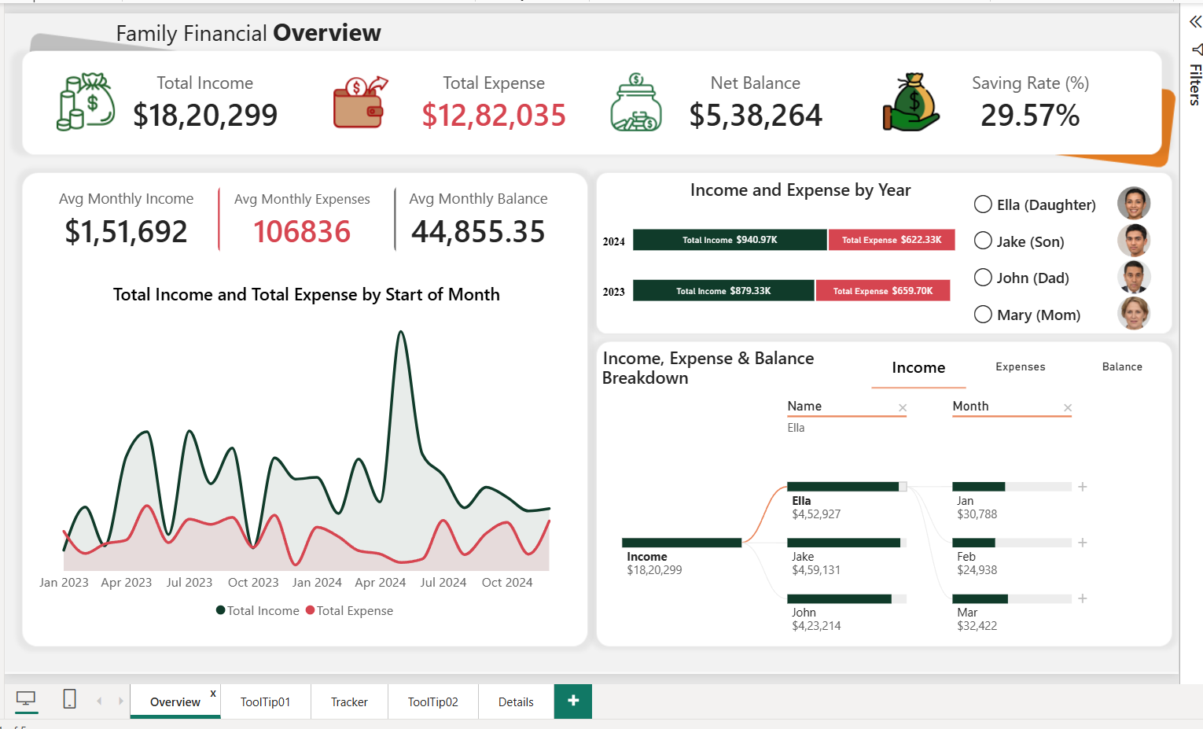
Figure 4. Page 1 — Family Financial Overview.
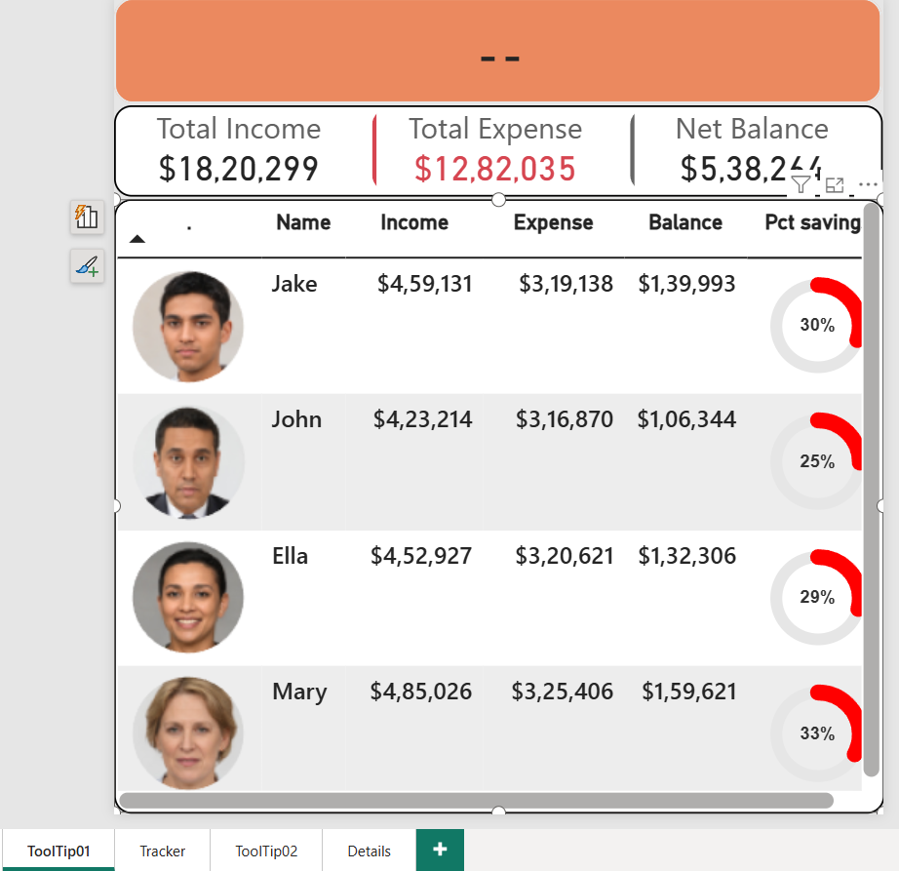
Figure 5. Tooltip 01 — Family member financial context.

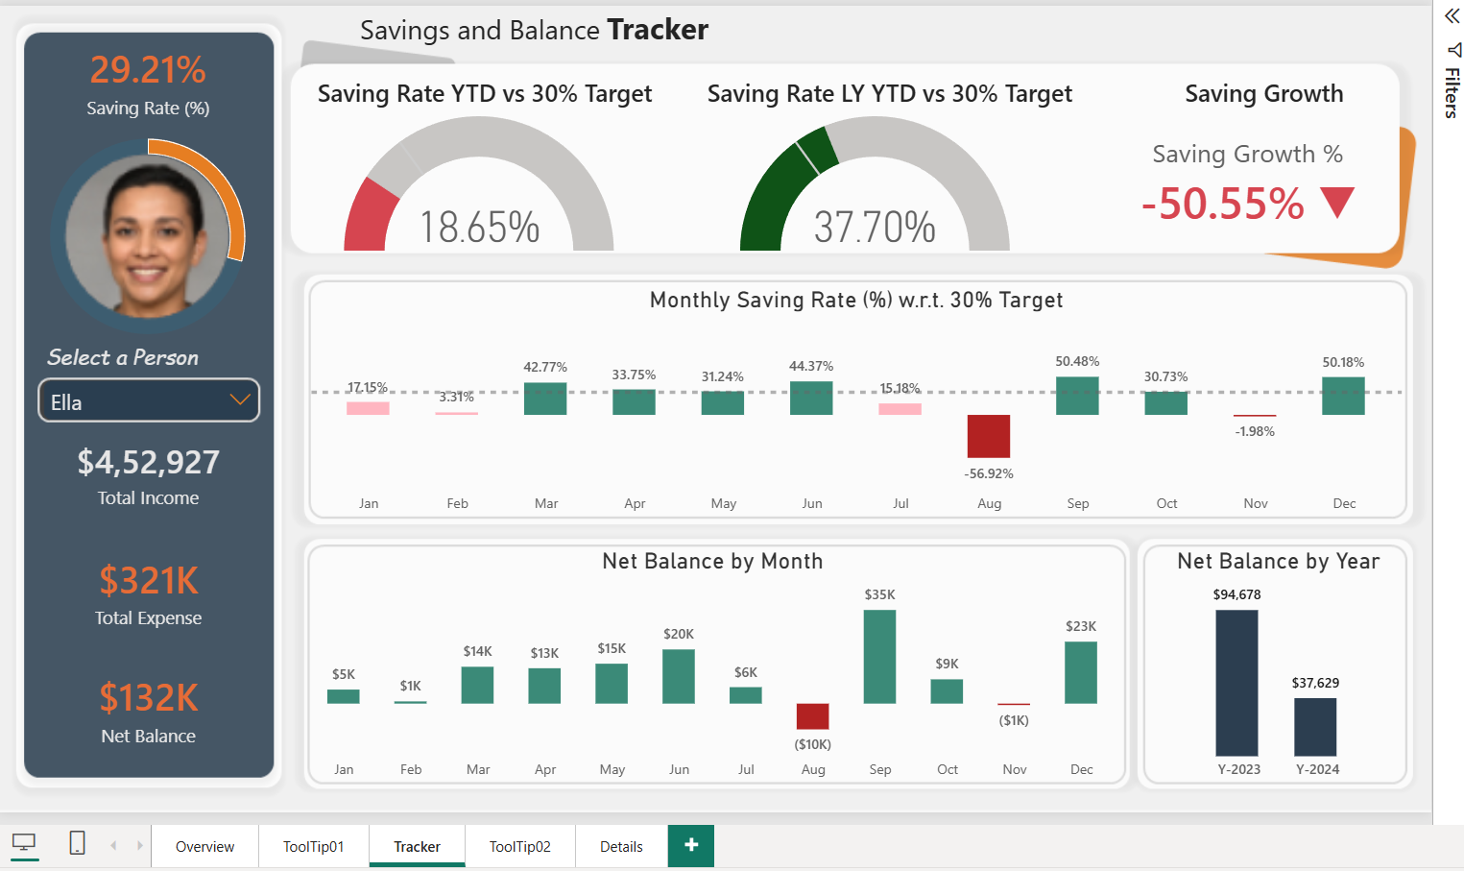
Figure 6. Page 2 — Savings & Balance Tracker.
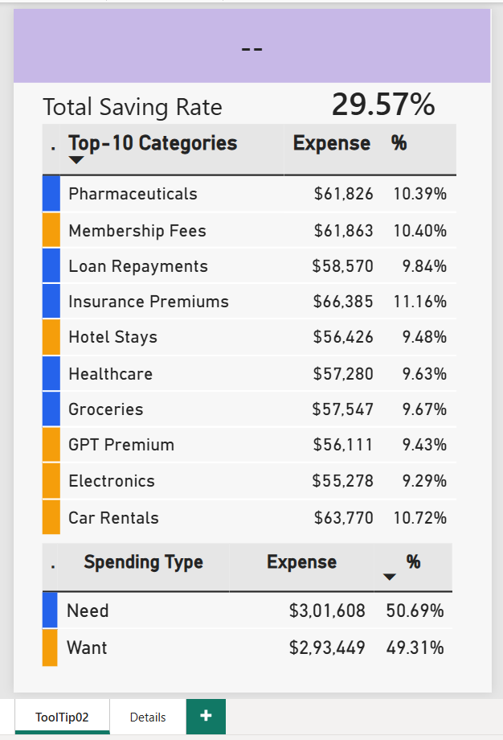
Figure 7. Tooltip 02 — Top-10 expense category and Need vs Want context.

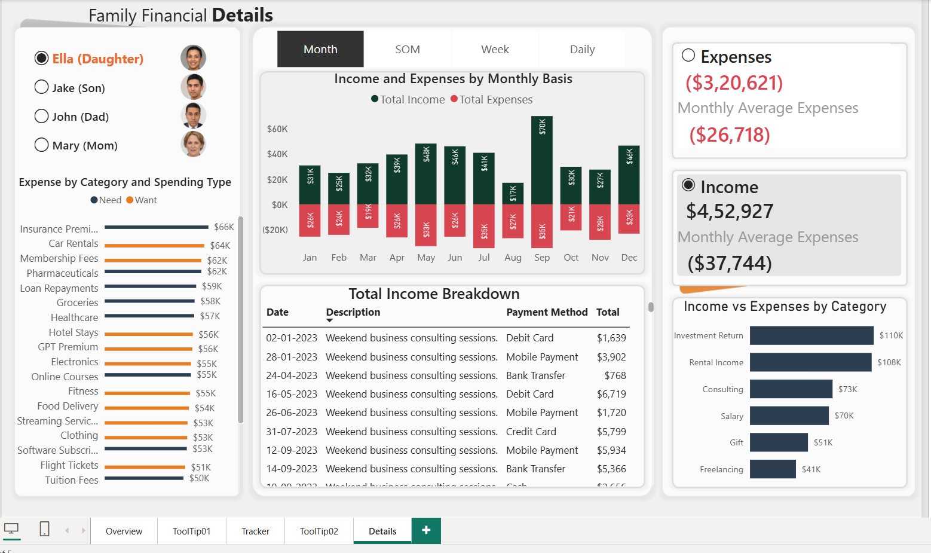
Figure 8. Page 4 — Family Financial Details.

15. Validation, Key Insights & Business Value

Validation
Validation Check | Result
Populated transaction rows | 2,216
Minimum transaction date | 01-Jan-2023
Maximum transaction date | 31-Dec-2024
Income records | 505
Expense records | 1,711
Family members | 4
Expense categories | 24
Payment methods | 5
Spending types | Need and Want

Model validation also covers the Date, Category and Person relationships shown in the supplied model screenshots. Calculation checks include Net Balance = Income − Expense, Saving Rate = Net Balance ÷ Income, reconciliation of person-level totals to overall totals, and year-level reconciliation.

Key Insights
Observed Pattern | Source Result
Overall financial position | $1,820,299 income, $1,282,035 expense, $538,264 balance, 29.57% saving rate
Year comparison | 2024 income $940,969 vs $879,329 in 2023; expense $622,333 vs $659,702
Saving rate by year | 2024: 33.86%; 2023: 24.98%
Person-level saving rates | Mary 33%, Jake 30%, Ella 29%, John 25%
Largest displayed expense category | Insurance Premiums — $66,385
Largest displayed income category | Rental Income — $405,506
Spending type mix | Want $653,822 (51%); Need $628,213 (49%)

Business Value
The value of the solution comes from connecting three levels of analysis: **executive KPIs, segment analysis and transaction-level review**. A user can move from a headline financial metric to a person/category pattern and then to the records that support the result.
Level | Use
Executive | Monitor income, expense, balance and saving rate
Analytical | Compare time, people, categories and spending type
Diagnostic | Use tooltips, decomposition and details to investigate results

16. Limitations & Responsible Use
- The project is a financial analytics portfolio solution and should not be presented as regulated or personalized financial advice.
- The 30% saving target is a configured analytical benchmark used by the dashboard; it is not a universal financial standard.
- Historical dashboard patterns describe the supplied dataset and should not automatically be treated as forecasts.
- Need/Want classifications and other labels depend on the source data and project definitions.
- Person-level financial information should be handled according to appropriate privacy and access controls.
- Dashboard relationships and trends describe the available data; they do not by themselves establish causal relationships.
- The supplied DAX contains a documented 'Expenses' versus source 'Expense' value mismatch for Total Expense; a production refresh should use the exact source value.

17. Final Outcome & Conclusion
The completed Family Financial Analysis Dashboard demonstrates a practical end-to-end Power BI workflow. It starts with transaction-level financial information, prepares the data through Power Query, builds a structured model, develops reusable DAX measures and presents the results through connected analytical pages.
The project answers a sequence of increasingly useful questions: **How much income was generated? How much was spent? What balance remained? What is the saving rate? How is savings performing against the benchmark? Which people and categories contribute to the observed pattern? Which transactions explain the result?**
The strongest aspect of the solution is the progression from reporting to analysis and then to investigation. The combination of Power Query cleaning, fact/dimension modeling, DAX, time intelligence, Field Parameters, conditional formatting, Image URL handling, SVG visualization, custom tooltips and detailed transaction analysis demonstrates practical BI development rather than visual formatting alone.
Final analytical chain: Raw Data → Cleaning → Modeling → DAX → Dashboard → Validation → Insights → Decision Support.

Appendix A — Selected DAX Catalogue
Avg Monthly Income — supplied pattern
Avg Monthly Income =
VAR __Income = [Total Income]
VAR __ActiveMonth =
CALCULATE(
DISTINCTCOUNT('Date'[Month]),
FILTER(FactTable, FactTable[Amount] > 0)
)
RETURN
DIVIDE(__Income, __ActiveMonth)

Avg Monthly Expenses — supplied pattern
Avg Monthly Expenses =
VAR __Expenses = [Total Expense]
VAR __ActiveMonth =
CALCULATE(
DISTINCTCOUNT('Date'[Month]),
FILTER(FactTable, FactTable[Amount] > 0)
)
RETURN
DIVIDE(__Expenses, __ActiveMonth)

Income vs Expenses
Income vs Expenses =
IF(
SELECTEDVALUE(FactTable[Type]) = "Income",
[Total Income],
[Total Expense]
)

Dynamic Tooltip Title
Title Tooltips =
VAR __ActiveSTM = SELECTEDVALUE('Date'[StartOfMonth])
RETURN
IF(
__ActiveSTM <> BLANK(),
FORMAT(__ActiveSTM, "d/mmm/yyyy") &
" Income vs Expenses"
)

Target
Target = 0.3

Category Highlighting
CF highlight =
SWITCH(
SELECTEDVALUE('Category Table'[Spending Type]),
"Want", "#F59E0B",
"Need", "#2563EB"
)

Category Reference Table
Category Table =
ALL(
FactTable[Category],
FactTable[Spending Type]
)

Reverse Expense Measures
Reversed Total Expenses = -[Total Expense]
Reverse Monthly Avg Expenses = -[Avg Monthly Expenses]
Reverse Montly Avg Income = -[Avg Monthly Income]

The complete supplied measure catalogue also contains CF Type, CF Balance color, CF Saving Rate Color, CF Saving Growth %, CF Saving Rate YTD/LY YTD, PCT GrandTotal, Remainder, Table Title, Title Cat Tooltip and the SVG-based Pct savings measure.

Appendix B — Source Numerical Profile
Metric | 2023 | 2024 | Change / Observation
Income | $879,329 | $940,969 | 7.0% change
Expense | $659,702 | $622,333 | -5.7% change
Saving Rate | 24.98% | 33.86% | Higher in 2024 based on source totals

Person | Income | Expense | Net Balance | Saving Rate
Mary (Mom) | $485,026 | $325,406 | $159,621 | 33%
Jake (Son) | $459,131 | $319,138 | $139,993 | 30%
Ella (Daughter) | $452,927 | $320,621 | $132,306 | 29%
John (Dad) | $423,214 | $316,870 | $106,344 | 25%

Top 10 Expense Categories
Rank | Expense Category | Expense | % of Total Expenses
1 | Insurance Premiums | $66,385 | 5.18%
2 | Car Rentals | $63,770 | 4.97%
3 | Membership Fees | $61,863 | 4.83%
4 | Pharmaceuticals | $61,826 | 4.82%
5 | Loan Repayments | $58,570 | 4.57%
6 | Groceries | $57,547 | 4.49%
7 | Healthcare | $57,280 | 4.47%
8 | Hotel Stays | $56,426 | 4.40%
9 | GPT Premium | $56,111 | 4.38%
10 | Electronics | $55,278 | 4.31%

Income Categories
Income Category | Income | % of Total Income
Rental Income | $405,506 | 22.28%
Investment Return | $385,379 | 21.17%
Salary | $281,115 | 15.44%
Consulting | $260,393 | 14.30%
Gift | $259,855 | 14.28%
Freelancing | $228,051 | 12.53%

Spending Type
Spending Type | Expense | % of Expenses
Want | $653,822 | 51.00%
Need | $628,213 | 49.00%

