TRANSPORT TRANSACTION DASHBOARD
Claude MCP + Microsoft Excel | Power Query • Power Pivot • DAX • Manual Dashboard Design
From Raw Ridership Data to a Decision-Ready Excel Dashboard

PROJECT ATTRIBUTE | DETAIL
Project Type | Data Analyst / Excel Analytics Portfolio Project
Primary Platform | Microsoft Excel
AI / Automation Layer | Claude Desktop connected through MCP Server
Analytics Stack | Power Query • Power Pivot / Data Model • DAX • PivotTables
Fact Table | Facttable_ridership
Dimension Tables | Dim_buses • Dim_routes • Dim_demographics • Dim_DateTable
Calculation Layer | Calculations table with reusable DAX measures
Dashboard Build | Manual Excel dashboard layout and visual design
Author | Ravinder Gupta
Version | 1.0 | October 2026

PROJECT POSITIONING
Claude MCP-powered analytical workflow + manually designed Excel dashboard

1. Executive Summary
This project demonstrates an end-to-end transportation analytics workflow built in Microsoft Excel. The analytical model combines Power Query transformations, Power Pivot data modeling, DAX measures, PivotTable-based analysis and a manually designed dark-theme dashboard.
The project is specifically positioned as a Claude MCP-powered Excel workflow because the data-preparation and analytical workflow was carried out with Claude connected to Excel through an MCP server. The final dashboard canvas, visual arrangement, formatting, shapes, spacing and presentation were manually designed in Excel.
The resulting dashboard turns raw ridership records into operational KPIs covering passenger volume, average riders per trip, route performance, time-of-day demand, monthly movement, weekday behavior, bus utilization and AM/PM distribution.

Headline Results
KPI | Observed Result | Business Meaning
Total Passengers | 6,587 | Total passenger/rider volume represented in the modeled transaction data.
Average Riders per Trip | 33 | Typical rider volume per recorded trip, shown as a rounded whole-number KPI.
Busiest Route | East-West Express — 1,322 | Highest rider volume among the route-level result shown.
Least Busy Route | South Line — 185 | Lowest rider volume among the route-level result shown.
Well-Utilized Buses | 36 / 43% | Largest bus-utilization category in the dashboard.
Over-Utilized Buses | 29 / 35% | Substantial portion of buses operating at high utilization.
Under-Utilized Buses | 19 / 23% | Smaller but meaningful unused-capacity segment.
PM Rider Share | 64.61% | Passenger activity is higher in PM than AM in the dashboard.

2. Business Context, Problem & Objectives
Transportation operations generate large volumes of trip-level records, but raw rows alone do not immediately show where passenger demand is concentrated, which routes are busiest, when demand peaks, or whether bus capacity is being used efficiently.
The project addresses this gap by building a reusable analytical layer in Excel before presenting the results through a management-style dashboard.

Business Questions
- How many passengers/riders are represented in the dataset?
- What is the average rider volume per trip?
- Which route is busiest and which is least busy?
- Which time ranges carry the highest passenger volume?
- How is passenger activity distributed across months and years?
- Which weekdays are above the overall weekday average?
- What proportion of buses are under-utilized, well-utilized or over-utilized?
- How does ridership differ between AM and PM operations?

Project Objectives
- Prepare and transform raw data using Power Query.
- Build a relational Power Pivot data model using fact and dimension tables.
- Create reusable DAX measures for core KPIs.
- Create analytical helper columns such as Age Group, Operation Moment, Time Group and Bus Utilization Category.
- Create a dedicated Date dimension with calendar attributes.
- Validate calculations through PivotTables and intermediate evidence tables.
- Manually design a professional Excel dashboard for business consumption.

3. Technical Environment & Claude MCP Workflow
Layer | Technology | Role
Source / Workbook | Microsoft Excel | Project workspace and final dashboard platform.
AI Interface | Claude Desktop | Natural-language assistance and workflow execution.
Integration | MCP Server | Connects Claude to the Excel environment for supported operations.
Transformation | Power Query / M | Cleaning, grouping, custom columns, merges and date attributes.
Modeling | Power Pivot / Data Model | Relationships between fact and dimension tables.
Calculation | DAX | Measures for aggregation and KPI calculations.
Validation | PivotTables / supporting tables | Cross-checking values and building evidence.
Presentation | Manual Excel Dashboard | Final visual layout, shapes, cards, charts and formatting.
Important implementation distinction: the project is presented as Claude MCP-powered because the analytical workflow used Claude through MCP. The dashboard itself was manually constructed in Excel. This distinction is important for an honest portfolio description and accurately communicates both AI-assisted productivity and hands-on Excel dashboarding skill.

Workflow
- Connect Claude Desktop to the Excel workflow through MCP.
- Inspect the workbook structure and source tables.
- Transform the fact table and create analytical helper columns.
- Merge bus capacity into the ridership fact table.
- Create utilization percentage and utilization categories.
- Build a custom Date dimension and calendar attributes.
- Create DAX measures in the Calculations table.
- Validate measures through PivotTables and evidence tables.
- Build the final dashboard manually using Excel shapes, charts, text boxes and linked values.
- Review the dashboard for layout, spacing, hierarchy and business readability.
3.1 Tools and Technologies Used
Tool / Technology | Role in the Project
Microsoft Excel | Main platform for modeling, PivotTables and final dashboard
Power Query | Data cleaning, custom columns, merges and transformations
Power Pivot / Data Model | Fact and dimension relationships
DAX | Reusable measures for KPIs
PivotTables | Validation and intermediate analysis
Claude Desktop + MCP | AI-assisted analytical workflow and Excel operations
Manual Excel Design | Dashboard layout, shapes, charts, formatting and presentation

4. Dataset & Data Model
The model follows a fact-and-dimension structure. Facttable_ridership acts as the central transaction-level table, while buses, routes, demographics and date attributes provide descriptive context.
Table | Role | Key / Important Fields
Facttable_ridership | Fact / transaction table | RecordID, BusID, Date, Time, NumberOfRiders, RiderID, Operation Moment, Time Group, Capacity, Utilization Pct, Bus Utilization Category
Dim_buses | Bus dimension | BusID, RouteID, BusNumber, Capacity
Dim_routes | Route dimension | RouteID, RouteName, StartLocation, EndLocation, TripFee
Dim_demographics | Rider dimension | RiderID, Age, Gender, Occupation, Age Group
Dim_DateTable | Date dimension | Date, Year, Month Name, Month Number, Day Name, Day of Week, WeekType
Calculations | Measure layer | Average Age, Avg. Riders Per Trip, Total Buses, Total Riders, Total Transaction
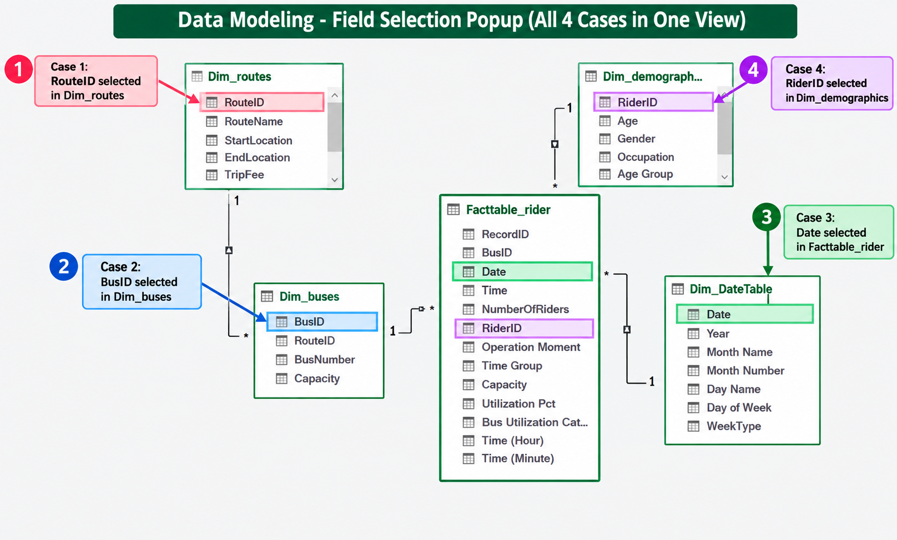
Figure 1. Data-model relationship evidence and selected key fields.
The model evidence shows one-to-many relationships from descriptive dimensions into the central ridership fact table. Date is linked from Dim_DateTable to Facttable_ridership, while BusID, RiderID and RouteID provide the main entity relationships.

5. Power Query Data Preparation
Power Query is used as the controlled preparation layer. The screenshots supplied with the project show conditional columns, custom M expressions, merges, expansions and calculated fields.

5.1 Age Group
Age is transformed into readable bands: 0–19, 20–29, 30–39, 40–49, 50–59 and Above 60. This converts a continuous age field into a segmentation dimension suitable for PivotTables and dashboard analysis.
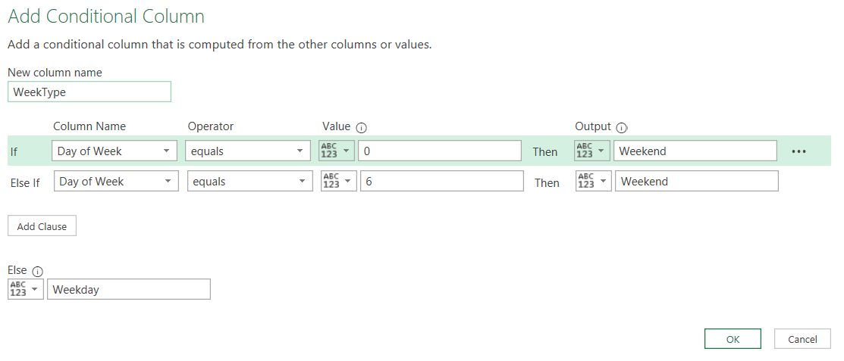
Figure 2. Age Group conditional-column setup.

5.2 Operation Moment
Time is converted into an AM/PM operational classification. The conditional rule uses 12:00:00 as the boundary: times before noon are classified as AM; the remaining records are classified as PM.
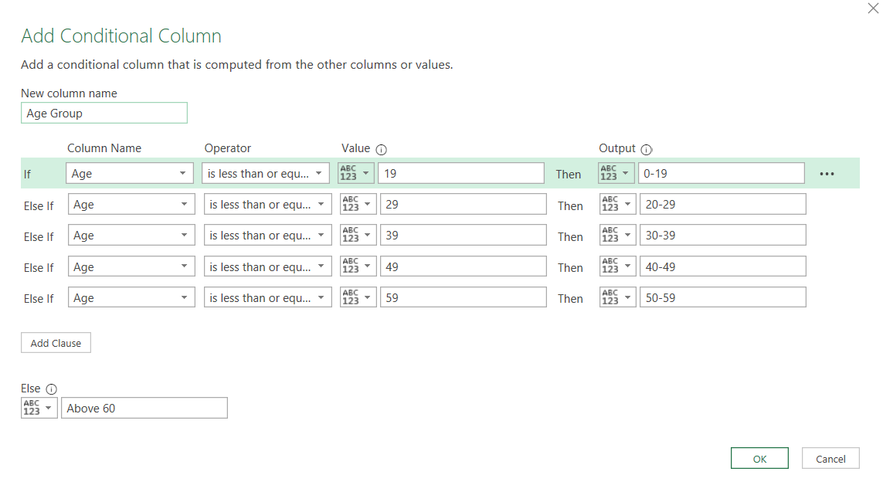
Figure 3. Operation Moment conditional column.

5.3 Time Group
A custom M expression uses Time.Hour([Time]) to create business-friendly operating windows. The final grouping shown in the project includes 12:00 AM–3:00 AM, 3:00 AM–6:00 AM, 6:00 AM–9:00 AM, 9:00 AM–12:00 PM, 12:00 PM–3:00 PM, 3:00 PM–6:00 PM, 6:00 PM–9:00 PM and 9:00 PM–12:00 AM.
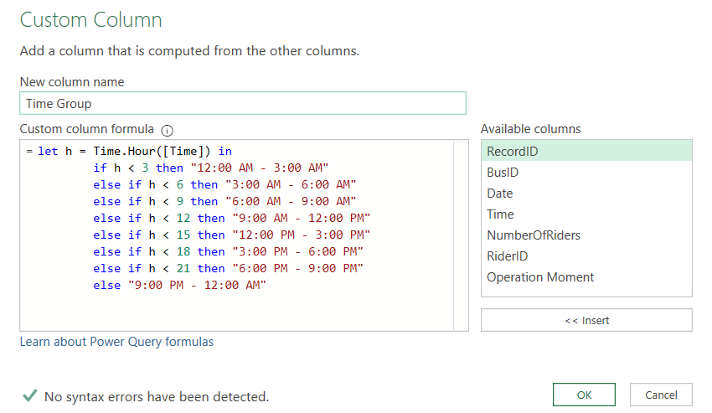
Figure 4. Time Group custom M expression.

5.4 Bus Capacity Merge
Bus capacity is not stored directly in the ridership fact records, so Dim_buses is merged into Facttable_ridership using BusID. A Left Outer join keeps all fact records while bringing in matching bus capacity.
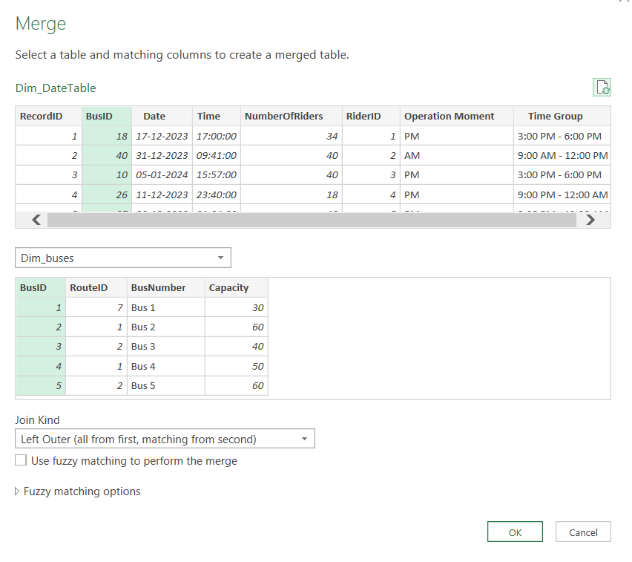
Figure 5. Merge Facttable_ridership with Dim_buses on BusID.
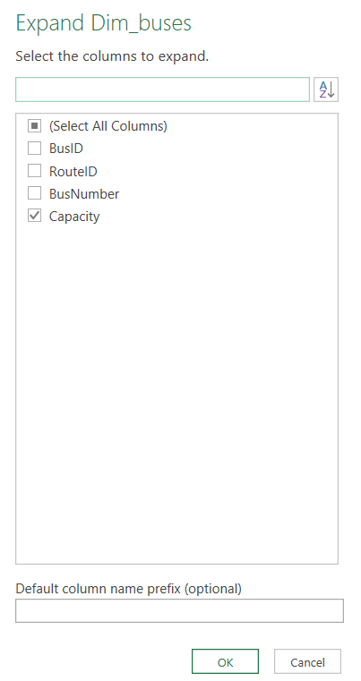
Figure 6. Expand the merged table and keep Capacity.
The resulting Capacity field is then used to calculate Utilization Pct as rider volume divided by bus capacity.
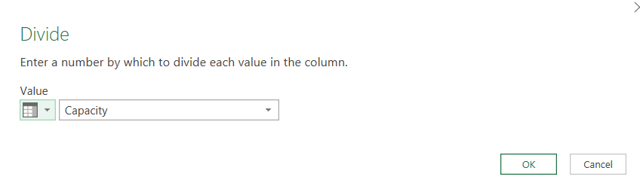
Figure 7. Capacity-based calculation step.

5.5 Bus Utilization Category
The final categorization separates buses into Under-Utilized, Well-Utilized and Over-Utilized groups. The project logic uses 50% and 90% as the key thresholds: below 50% is Under-Utilized, 50% to below 90% is Well-Utilized, and 90% or above is Over-Utilized.
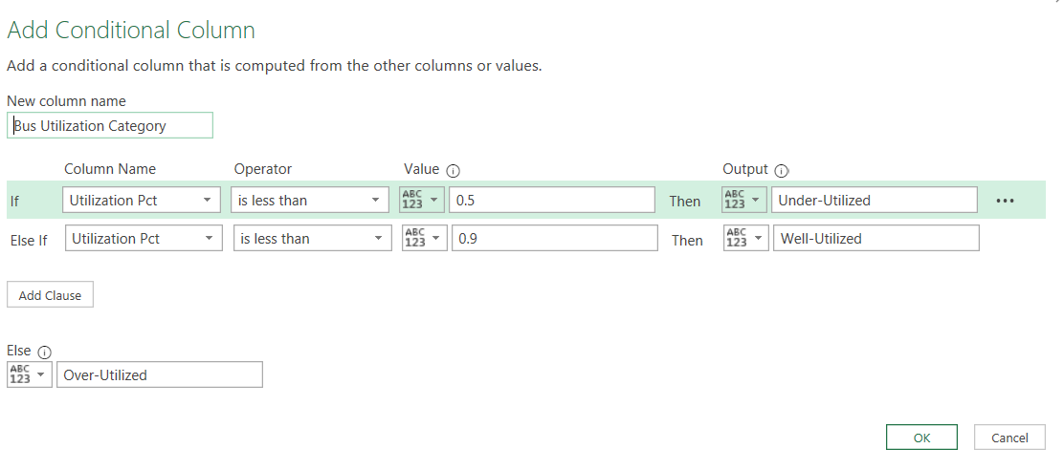
Figure 8. Bus Utilization Category conditional logic.

6. Custom Date Dimension
A dedicated Dim_DateTable is created to support time-based analysis. The project uses custom calendar attributes rather than relying only on Excel's default date behavior.
Attribute | Purpose
Date | Primary date key and relationship field.
Year | Year-level analysis.
Month Name | Readable month label.
Month Number | Supports chronological month sorting.
Day Name | Readable weekday label.
Day of Week | Numeric weekday index.
WeekType | Weekend versus Weekday classification.
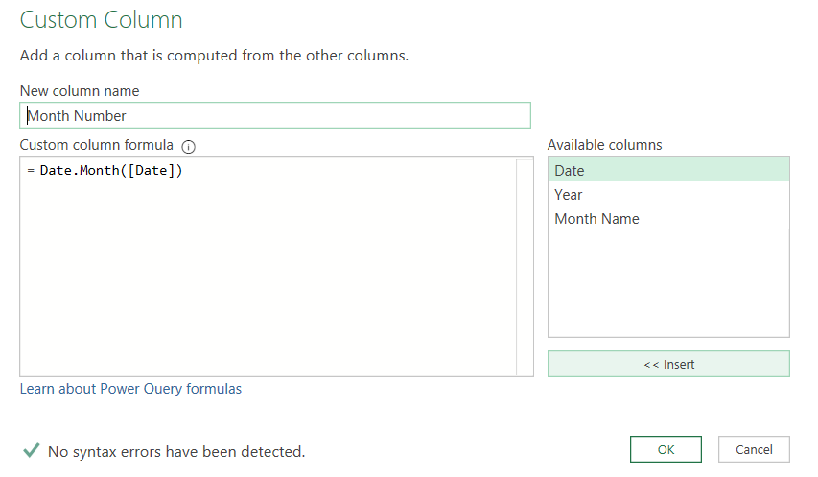
Figure 9. Year custom column.
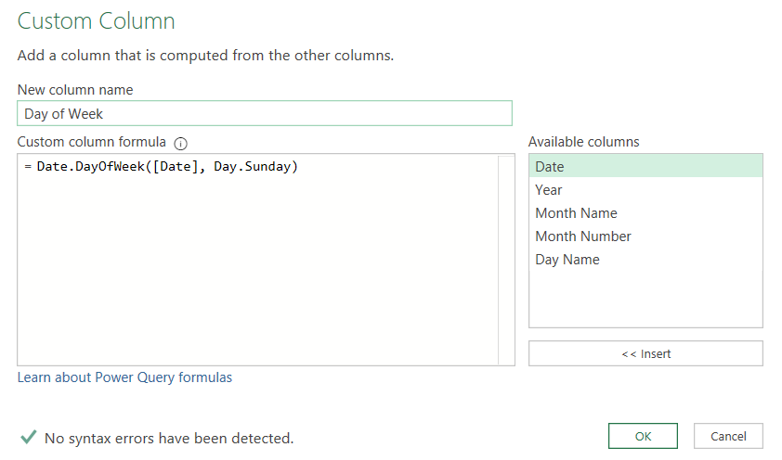
Figure 10. Day of Week custom column.
Month Name is extracted from the Date field and a Month Number is created with Date.Month([Date]) so month labels can be sorted chronologically.
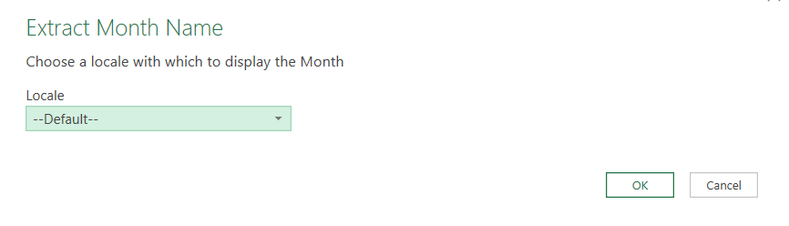
Figure 11. Month Name extraction.

7. DAX Measures & Calculation Layer
The Calculations table is used as a centralized measure layer. This improves organization and makes the dashboard easier to maintain because KPI logic is separated from the visual layer.
Measure | DAX Logic | Purpose
Total Riders (Passengers) | SUM(Facttable_ridership[NumberOfRiders]) | Total passenger volume.
Avg. Riders Per Trip | AVERAGE(Facttable_ridership[NumberOfRiders]) | Average riders per recorded trip.
Total Buses | DISTINCTCOUNT(Facttable_ridership[BusID]) | Unique buses represented in the fact data.
Total Transaction | COUNTROWS(Facttable_ridership) | Number of fact-table records.
Average Age | AVERAGE(Dim_demographics[Age]) | Average rider age.
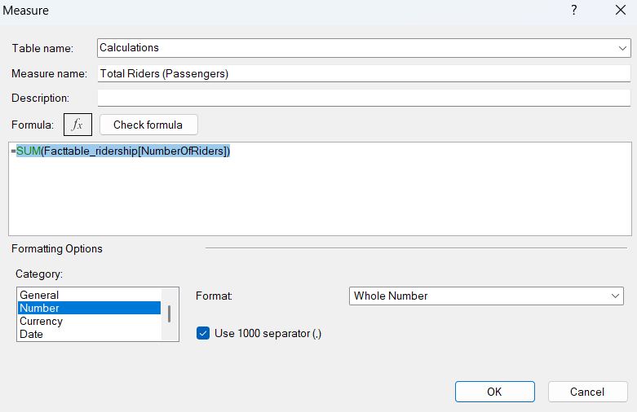
Figure 12. Total Riders measure.
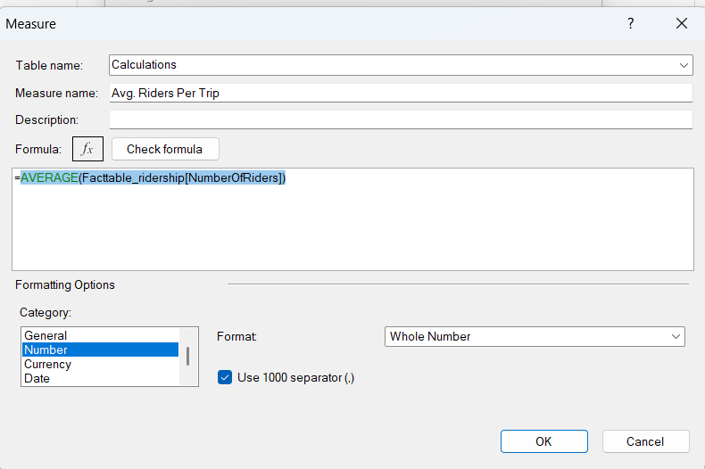
Figure 13. Avg. Riders Per Trip measure.
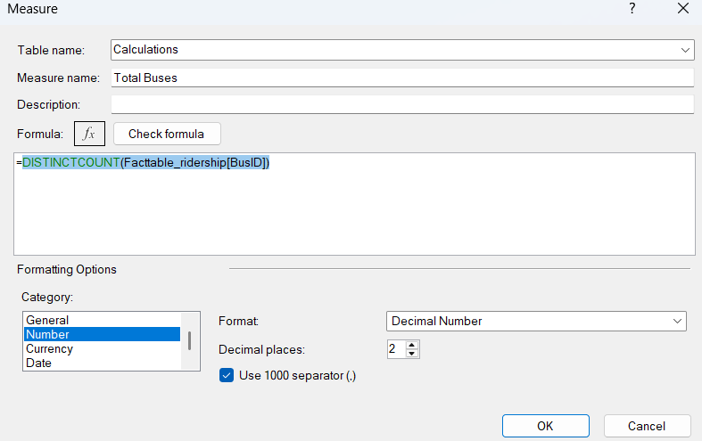
Figure 14. Total Buses measure.
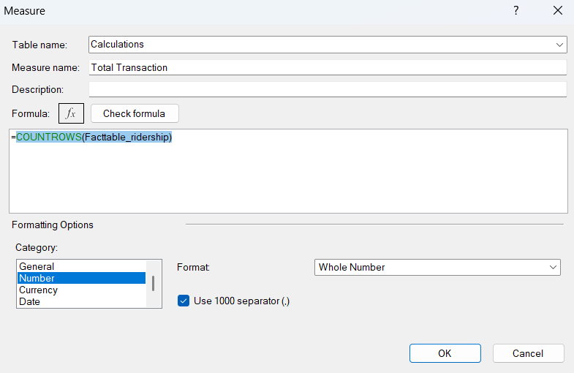
Figure 15. Total Transaction measure.
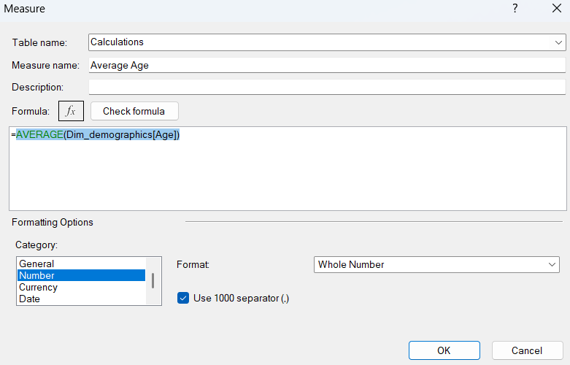
Figure 16. Average Age measure.

8. Validation & Analytical Evidence
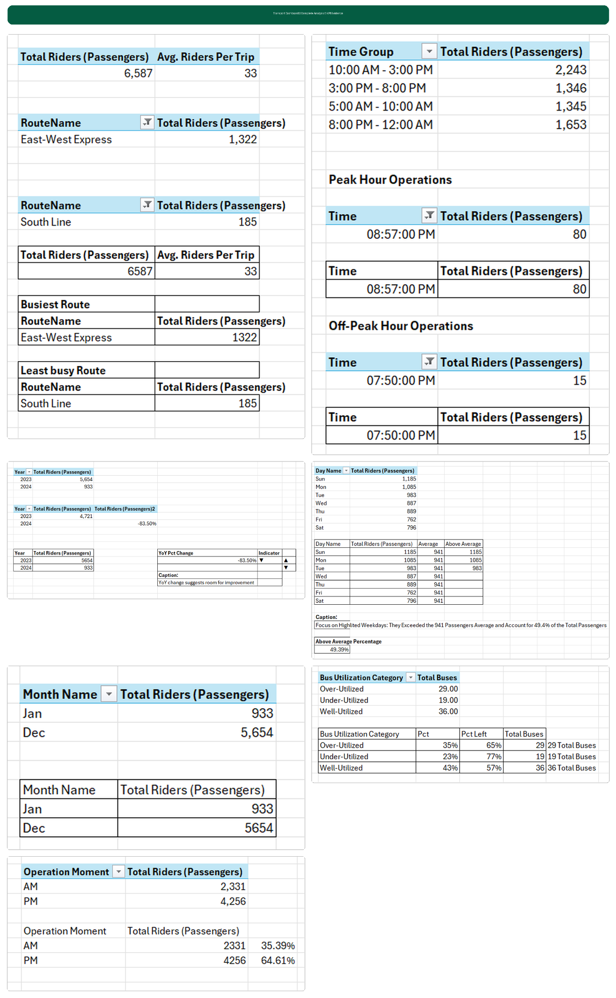
The project uses intermediate PivotTables and supporting tables to validate KPI outputs before placing them on the dashboard. This creates an auditable path from the underlying model to the final visual.

Figure 17. Consolidated KPI evidence used to validate dashboard outputs.
The evidence includes total riders, average riders per trip, busiest and least-busy route results, time-group totals, peak and off-peak operating times, year-over-year comparison, weekday averages, month-level results, bus utilization categories and AM/PM percentages.

9. Manual Excel Dashboard Design
The final dashboard was manually designed in Excel rather than generated automatically by Claude. The design uses a dark visual theme, rounded containers, KPI cards, bar and line charts, donut-style utilization visuals, supporting text, icons and carefully controlled spacing.

Design Principles Used
- Gridlines and unnecessary worksheet chrome are removed to create a dashboard canvas.
- A dark background is used to create strong contrast with KPI values and charts.
- KPI cards are separated into clear information blocks.
- Consistent spacing and alignment are maintained across the dashboard.
- Chart titles and supporting labels are manually positioned for visual hierarchy.
- Color is used selectively to distinguish utilization categories and AM/PM segments.
- The final page prioritizes operational KPIs over decorative elements.
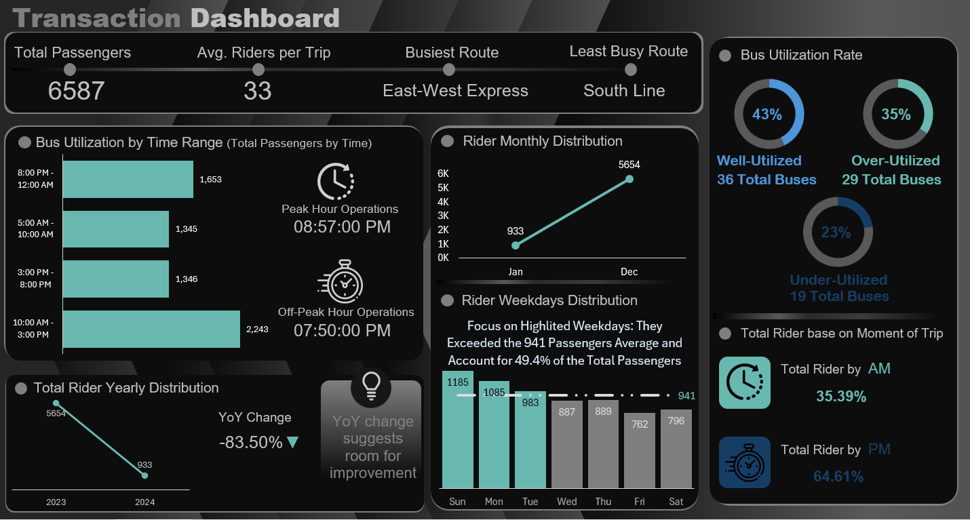
Figure 18. Final Transaction Dashboard — manually designed in Excel.
The final dashboard combines six major analytical areas: headline KPIs, time-range ridership, monthly distribution, weekday distribution, bus utilization and AM/PM operational mix.

10. Dashboard Results & Business Insights
9.1 Dashboard Layout Explanation
The final dashboard is organized into clear analytical zones:
• Top KPI Row — Shows Total Passengers, Average Riders per Trip, Busiest Route and Least Busy Route for quick operational overview.
• Time-of-Day Analysis — Displays passenger volume across different time windows to identify peak and off-peak demand.
• Monthly / Yearly Movement — Shows ridership distribution across months and the year-over-year comparison visible in the workbook.
• Weekday Distribution — Compares daily ridership against the overall weekday average.
• Bus Utilization — Categorizes buses into Under-Utilized, Well-Utilized and Over-Utilized groups based on capacity usage.
• AM vs PM Split — Shows the operational balance between morning and evening ridership.
This layout follows a progressive story: overall volume → when demand occurs → how the fleet is used → operational timing.

10.1 Overall Volume
The dashboard reports 6,587 total passengers/riders and an average of 33 riders per trip. These values form the primary operational baseline for the analysis.

10.2 Route Performance
East-West Express is the busiest route in the displayed route analysis with 1,322 riders, while South Line is the least busy with 185 riders. This creates a clear route-level demand contrast for operational review.

10.3 Time-of-Day Demand
Time Group | Passengers
10:00 AM – 3:00 PM | 2,243
8:00 PM – 12:00 AM | 1,653
3:00 PM – 8:00 PM | 1,346
5:00 AM – 10:00 AM | 1,345
The 10:00 AM–3:00 PM group has the highest passenger count among the displayed time groups, while the 5:00 AM–10:00 AM and 3:00 PM–8:00 PM groups are very close.

10.4 Monthly / Yearly Movement
The displayed monthly comparison shows 933 riders for January and 5,654 riders for December. The yearly view shows 5,654 riders in 2023 and 933 in 2024, producing a displayed YoY change of -83.50%. This should be interpreted strictly as the modeled period comparison shown in the workbook; it is not a full-year performance conclusion unless the source periods are confirmed as complete and comparable.

10.5 Weekday Distribution
The weekday evidence uses an average of 941 passengers as the comparison line. Sunday (1,185), Monday (1,085) and Tuesday (983) are above that average in the displayed table, while Wednesday through Saturday are below it.

10.6 Bus Utilization
Category | Buses | Share
Well-Utilized | 36 | 43%
Over-Utilized | 29 | 35%
Under-Utilized | 19 | 23%
Well-utilized buses form the largest category at 43%, followed by over-utilized buses at 35%. The presence of 29 over-utilized buses alongside 19 under-utilized buses indicates that utilization is not uniform across the fleet.

10.7 AM vs PM
Operation Moment | Passengers | Share
AM | 2,331 | 35.39%
PM | 4,256 | 64.61%
PM operations account for the larger share of recorded riders in the dashboard, with 64.61% compared with 35.39% in AM operations.

11. Data Model Evidence
Figure 19. Relationship and field-selection evidence.
The model separates descriptive entities from the central transaction table. This supports reusable calculations and makes the same fact data available for route, bus, rider and date analysis.

Key Relationship Logic
- Dim_buses[BusID] → Facttable_ridership[BusID]
- Dim_routes[RouteID] → Dim_buses[RouteID]
- Dim_demographics[RiderID] → Facttable_ridership[RiderID]
- Dim_DateTable[Date] → Facttable_ridership[Date]

12. Skills Demonstrated
Skill | Evidence in Project
Microsoft Excel | End-to-end workbook, PivotTables, formulas, linked dashboard values, charts and manual dashboard design.
Power Query | Conditional columns, custom M formulas, time grouping, date attributes, merge and expansion.
Power Pivot / Data Model | Fact/dimension model, relationships and centralized calculation layer.
DAX | SUM, AVERAGE, DISTINCTCOUNT and COUNTROWS measures.
Data Modeling | Fact table with bus, route, demographic and date dimensions.
Data Transformation | Age Group, Operation Moment, Time Group, Capacity and Bus Utilization Category.
KPI Design | Total riders, average riders per trip, total buses and transaction count.
Dashboard Design | Dark theme, KPI cards, charts, containers, hierarchy, spacing and visual storytelling.
AI / MCP Workflow | Claude Desktop connected through MCP to support the Excel analytical workflow.
Business Analysis | Route, time, month, weekday, fleet utilization and operational-moment interpretation.

13. AI / MCP Contribution & Transparency
The project should be described as Claude MCP-powered without implying that every visual element was generated automatically.
Area | How It Was Used | Portfolio Wording
Excel + MCP integration | Claude connected to the Excel environment through MCP. | Claude MCP-powered Excel workflow
Power Query workflow | Transformation logic and analytical preparation were performed through the connected workflow. | AI-assisted data preparation and transformation
Power Pivot / DAX | Model and calculation work used Excel's analytical stack with MCP-assisted workflow. | MCP-assisted analytical modeling
Dashboard canvas | Shapes, spacing, chart placement, formatting and presentation were manually built. | Manual Excel dashboard development
Validation | Intermediate PivotTables/evidence tables were used to check outputs. | Validated KPI and dashboard evidence
This positioning is stronger for interviews because it shows both modern AI-tool usage and genuine hands-on Excel capability.

14. Limitations & Responsible Interpretation
Report Enhancement Note: The report includes a dedicated Tools & Technologies table and a dashboard layout explanation to make the technical stack and visual storytelling easier to review.
- The report describes the values visible in the supplied workbook/dashboard evidence; it does not claim a complete real-world transportation dataset unless the source is independently verified.
- The displayed 2023 versus 2024 comparison should not be treated as a full-year trend conclusion if the periods have unequal coverage.
- Utilization thresholds of 50% and 90% are analytical classification rules used in the project, not universal transportation-industry standards.
- Busiest and least-busy route conclusions refer to the displayed route-level result and should be revalidated if the source data changes.
- The dashboard supports operational analysis; it is not a substitute for scheduling, safety, financial or fleet-management policy decisions.

Quality Checks Applied
- Formula checks were performed for DAX measures.
- Merge logic was checked using BusID.
- Capacity was expanded from Dim_buses after the merge.
- Utilization classification logic was reviewed and corrected so the threshold conditions were logically ordered.
- Supporting PivotTables were compared with dashboard KPI values.
- Date, weekday, month and time-group fields were created explicitly to support consistent analysis.

15. Portfolio Summary
“I built a transportation transaction dashboard in Microsoft Excel using a Claude MCP-powered analytical workflow. I prepared the ridership data with Power Query, created a Power Pivot fact-and-dimension model, added DAX measures for core KPIs, engineered time and bus-utilization categories, and validated the outputs through PivotTables. I then manually designed the final Excel dashboard to analyze passenger volume, route performance, time-of-day demand, weekday patterns, monthly movement and fleet utilization.”

Appendix A — Evidence Index
Evidence | Source File
Age Group | image(20261005-055224).png
Operation Moment | image(20261005-054549).png
Time Group M formula | image(20261005-054806).png
Bus merge | image(20261005-054821).png
Capacity expansion | image(20261005-054845).png
Bus Utilization Category | image(20261005-054733).png
Date Year | image(20261005-055025).png
Day of Week | image(20261005-055218).png
DAX — Total Riders | image(20261005-062202).png
DAX — Avg Riders/Trip | image(20261005-062139).png
DAX — Total Buses | image(20261005-062151).png
DAX — Total Transaction | image(20261005-062215).png
DAX — Average Age | image(20261005-062121).png
Consolidated KPI evidence | Transport_Dashboard_All_KPI_Evidence_Combined(1).png
Data model | Power BI Data Model Field Selections(1).png
Final dashboard | image(20261005-062856).png

Appendix B — Core DAX Reference
Total Riders (Passengers) = SUM(Facttable_ridership[NumberOfRiders])
Avg. Riders Per Trip = AVERAGE(Facttable_ridership[NumberOfRiders])
Total Buses = DISTINCTCOUNT(Facttable_ridership[BusID])
Total Transaction = COUNTROWS(Facttable_ridership)
Average Age = AVERAGE(Dim_demographics[Age])

Appendix C — Final Project Statement
This project demonstrates practical Excel analytics rather than a single isolated chart. The strongest portfolio value comes from the complete chain: source data → Power Query transformations → Power Pivot model → DAX measures → validation evidence → manually designed dashboard → business interpretation.

