**SALES FORECASTING**

**How To Run Project**

***Submitted by:***

**RISHI RAJ SINGH (201B213)**

**UDAY TAMRAKAR (201B291)**

**RAVINDER SINGH (201B209)**

**Name of Supervisor: Dr. Mahesh Kumar**

***in Partial fulfillment for the Award of the Degree***

***of***

***Bachelor of Technology***

**IN**

**Department of Computer Science & Engineering**

**at**



**JAYPEE UNIVERSITY OF ENGINEERING & TECHNOLOGY,**

**A-B ROAD, RAGHOGARH, DT. GUNA - 473226, M.P., INDIA**

**AUG-DEC 2022**

**Steps To Run Project**

**Step 1: Install Python**

Go to <https://www.python.org/downloads/> and download the latest version for windows. If you want a specific version then use Active Python Releases section or scroll down to select the specific version to download.

**Step 2: Install Required Packages**

**Open Command prompt and run these commands to install packages.**

1. **NUMPY:** pip install numpy
2. **PANDAS:** pip install pandas
3. **Statsmodel:** pip install statsmodel
4. **Streamlit:** pip install streamlit

**Step 3:** Open command prompt go to the directory where your code is saved and run command **streamlit run file_name**

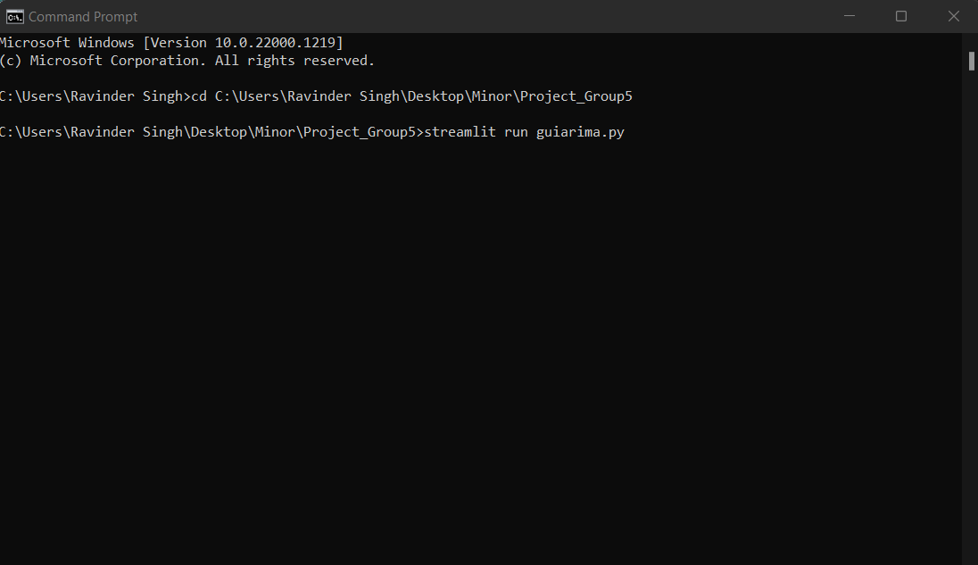

It will automatically redirect you to the web browser.

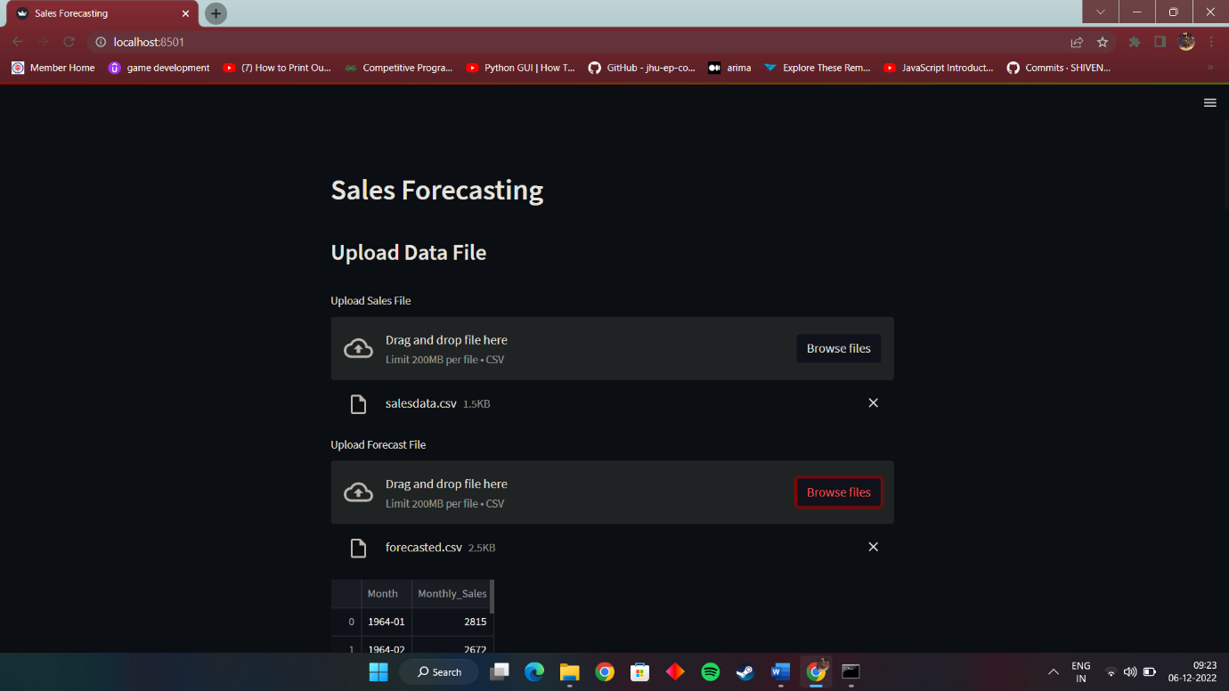

**Step 4 : Upload the required data into the upload field and it will forecast the future sales.**