In missing child project student asking to implement RESNET 50 and VGG 16 and compare their accuracy with CNN and to implement this algorithm we have written below code showing in screen shot

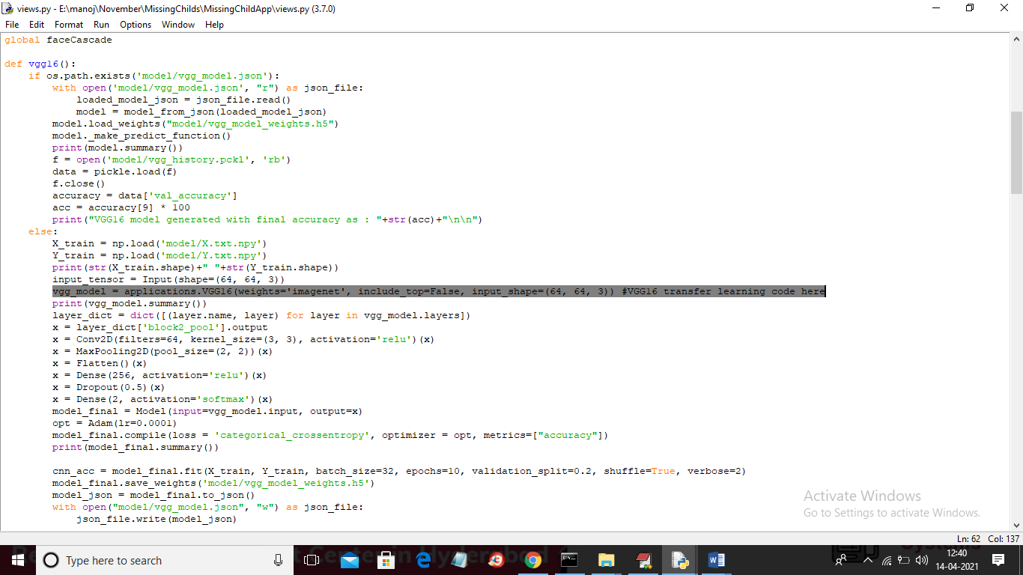

In above code views.py in selected text you can see we are using VGG16 transfer learning without missing child dataset and in below screen we are using RESNET 50

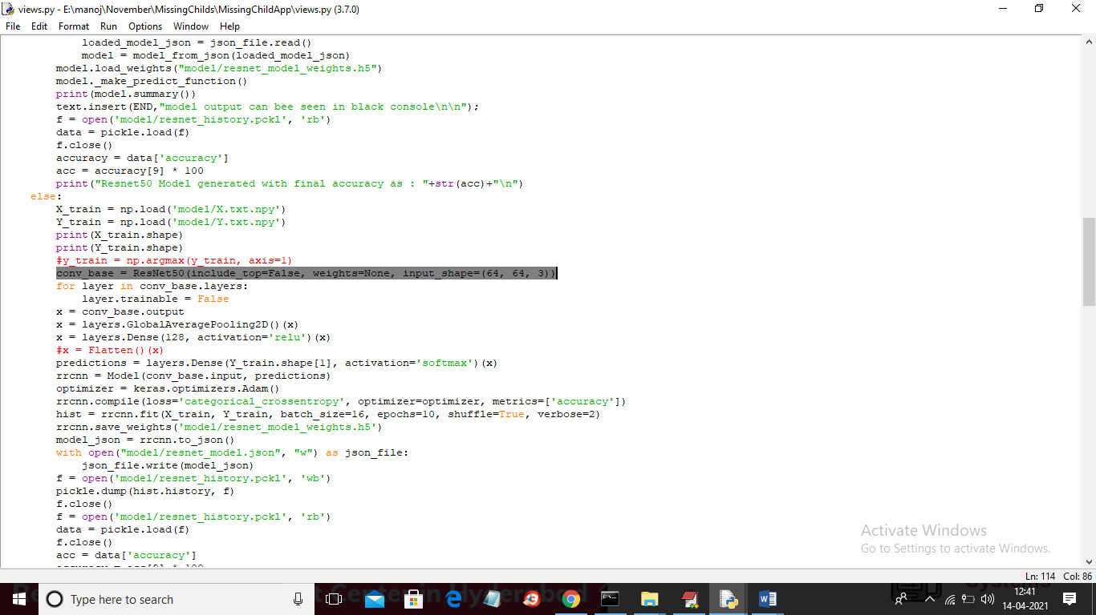

In above screen we are transfer learning with RESNET and while running code we can get comparison graph between RESNET, VGG and CNN. To see comparison graph login as OFFICIAL and then click on ‘Build Resnet 50, VGG 16 & CNN Model’ link to get below graph

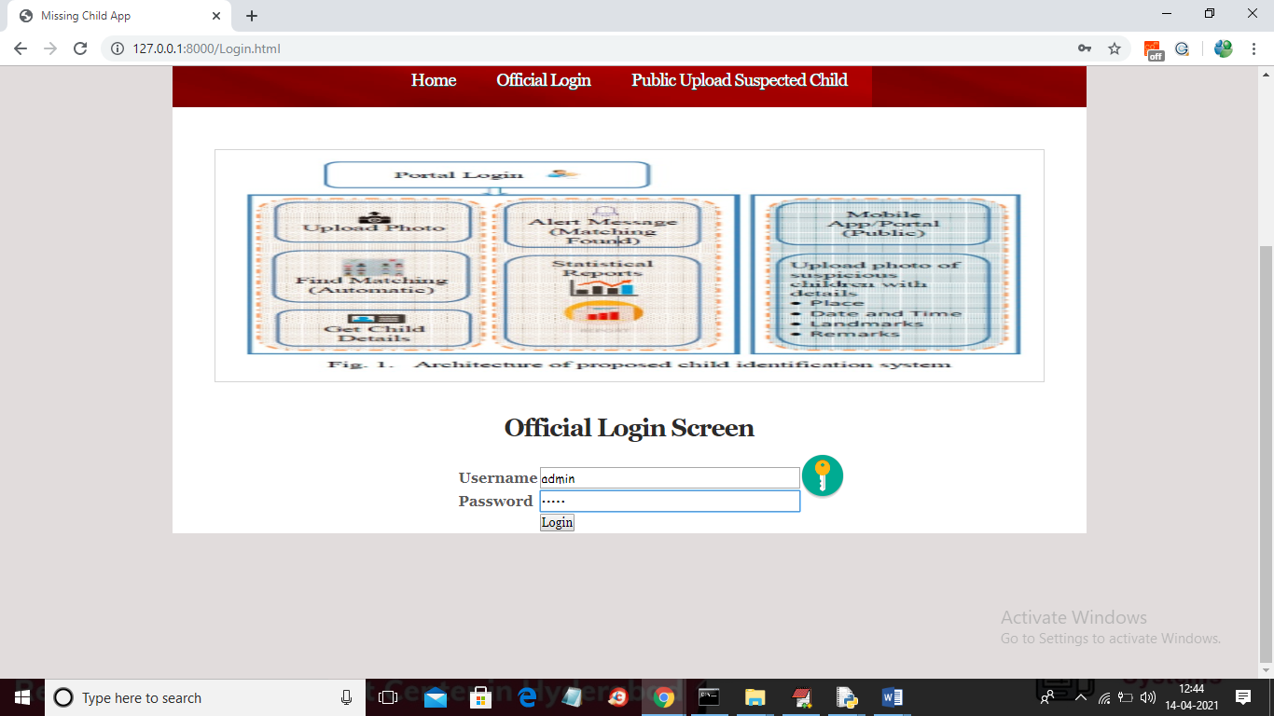

In above screen login as official and then click on ‘Login’ button to get below screen



In above screen now click on ‘Build Resnet 50, VGG 16 & CNN Model’ link to get below graph

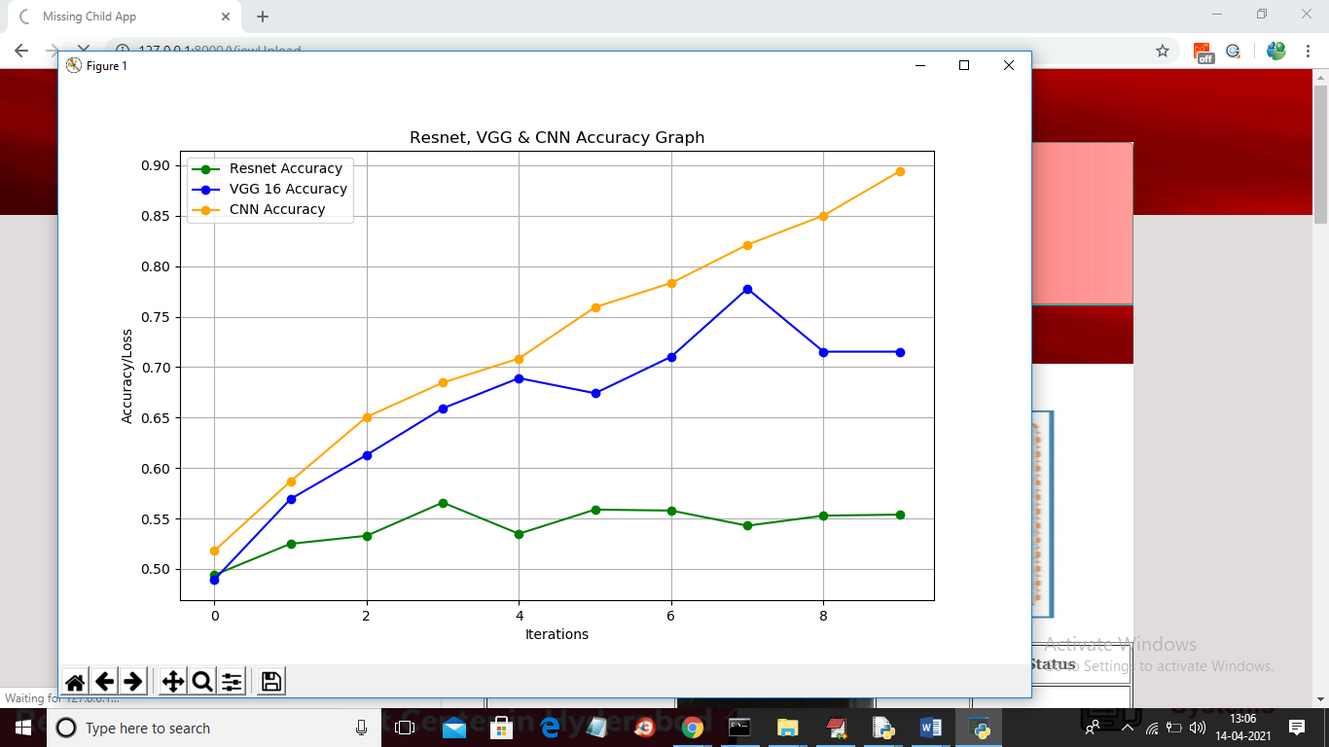

In above graph x-axis represents epoch/iteration and y-axis represents accuracy and in above graph with increasing epoch all algorithms accuracy is getting better and better and in above graph green line represents RESNET and blue line represents VGG 16 and orange line represents CNN accuracy and now close above graph to get below table

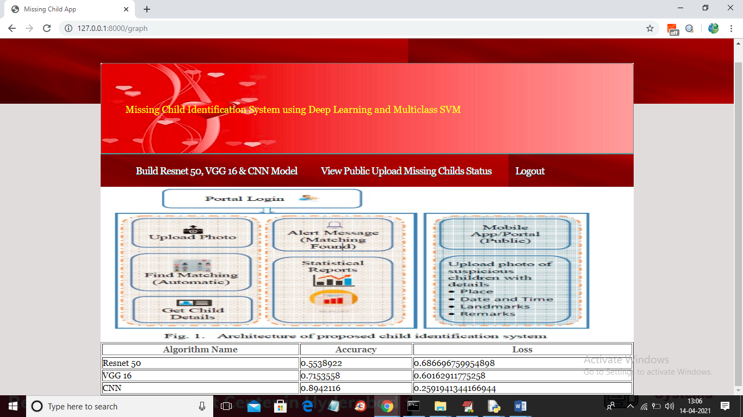

In above screen in table we can see final accuracy and loss value of each algorithm and to get better model algorithm accuracy must be high and loss must be low