Provisioning an Alexa Voice Service Device under an Amazon account

Back in 2017 , my company was working on a product that embedded Amazon Alexa Voice service on device and my team was involved in the onboarding solution for the device.

In order to better understand the use cases, I installed Amazon Alexa Voice service sdk on a Raspberry Pi . If you are interested in creating an Alexa device on Raspberry pi please follow the latest instructions using this link <https://developer.amazon.com/en-US/docs/alexa/avs-device-sdk/raspberry-pi.html>

Here is a video of a short interaction with Alexa Voice Service installed on Raspberry Pi <https://youtu.be/bajws_5RN8M>

If you are distributing such custom devices, you need to provide a way for the user to onboard Alexa under their Amazon account. I built a POC for this provisioning flow using Nodejs (and also a Java version). This post describes the steps involved.

1. Create a developer account under Amazon.
2. Browse to <https://developer.amazon.com/alexa/console/avs/products>
3. Click on Add New Product
4. Fill up the information regarding your device. Give it a Product Name and Product ID

Here are the other options I chose for my device

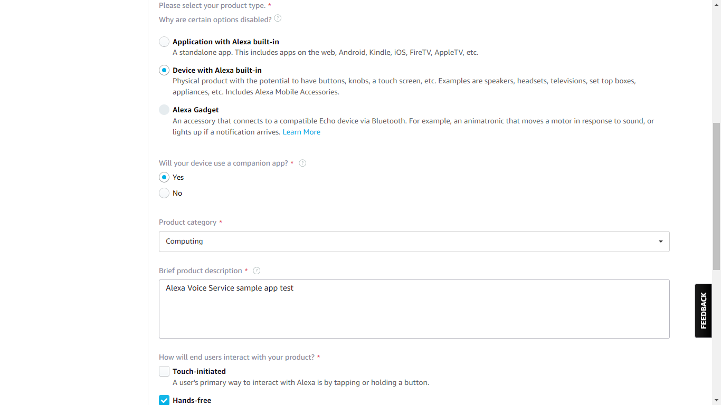

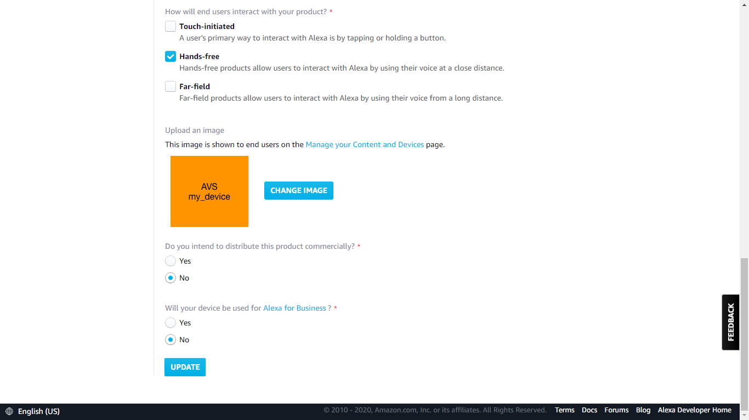

1. Save the product details
2. Choose Security Profile and select create new profile .
3. Fill up the option for security profile name and description and click Next .
4. The rest of the information like Profile ID, Client ID and Client secret are now automatically filled up for you .
5. I kept the options to just Web based flow but you may choose to add Android and iOS app integration (as we did in the final product)
6. Fill up the allowed origin and callback URL details. Callback URl is the address of the page to which Amazon authorization service will redirect to with the result of User authorization . This is the service or page that needs to handle the authorization response.

This is how the flow looks like

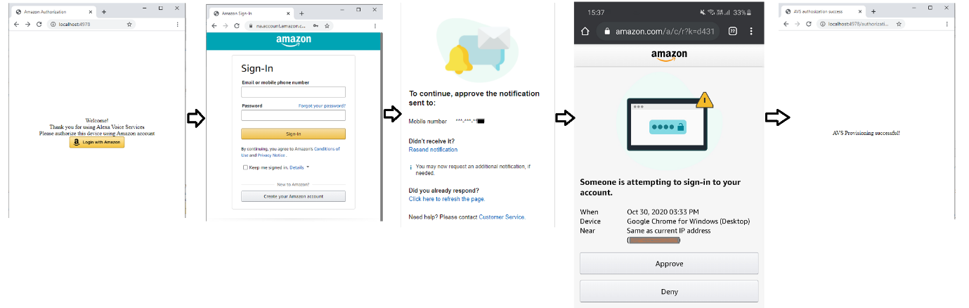

**const** options1 = {  
 **uri**: **'https://api.amazon.com/auth/o2/token'**,  
 **method**: **'POST'**,  
 **headers**: {  
  
 **'Content-Type'**: **'application/json'**,  
 **'Cache-Control'**: **'no-cache'** },  
 **body**: {  
 **grant_type**:**'authorization_code'**,  
 **code**:**""**,  
 **client_id**:**""**,  
 **client_secret**:**""**,  
 **redirect_uri**:**''** },  
 **json**: **true**};