1. Write a code for html webpage which displays your name, college name, and semester.

Ans.

<!DOCTYPE html>

<html lang="en">

<head>

<meta charset="UTF-8">

<meta http-equiv="X-UA-Compatible" content="IE=edge">

<meta name="viewport" content="width=device-width, initial-scale=1.0">

<title>Document</title>

</head>

<body>

<h1>

NAME: -MANTHAN RATHORE <br>

COLLEGE NAME: - DR. BHIM RAO AMBEDKAR POLYTHECHNIC COLLEGE, GWALIOR <br>

SEMESTER: - 4 <sup>th</sup>

</h1>

</body>

</html>

**Output: -** 

2. Write a code for html webpage which redirects to Google page (using tag).

Ans.

<!DOCTYPE html>

<html lang="en">

<head>

<meta charset="UTF-8">

<meta http-equiv="X-UA-Compatible" content="IE=edge">

<meta name="viewport" content="width=device-width, initial-scale=1.0">

<title>Document</title>

</head>

<body>

<h2>

MANTHAN RATHORE

</h2>

<p>Google link --&gt; <a href="https://google.com">Google.com</a></p> </body>

</html>

# Output: -

3.Write a code for html webpage which redirects to poly Gwalior website , Google and some docu ments using tag.

Ans.

<!DOCTYPE html>

<html lang="en">

<head>

<meta charset="UTF-8">

<meta http-equiv="X-UA-Compatible" content="IE=edge">

<meta name="viewport" content="width=device-width, initial-scale=1.0">

<title>Document</title>

</head>

<body>

<h1>Polygwalior Website</h1>

<p><a href="https://www.polygwalior.ac.in/">Redirect to PolyGwalior WebSite</a></p>

<h1>Google Website</h1>

<p><a href="https://www.google.com/">Google</a></p>

<h1>Image</h1>

<p><a href="https://images.pexels.com/photos/2058128/pexels-photo-

2058128.jpeg?auto=compress&amp;cs=tinysrgb&amp;dpr=1&amp;w=500">Click Here To See Image</a></p>

<h1>Admission Form</h1>

<p><a href="https://www.polygwalior.ac.in/file/prov_addmision.pdf">Click Here To See PDF</a></p>

</body>

</html>

## Output: -

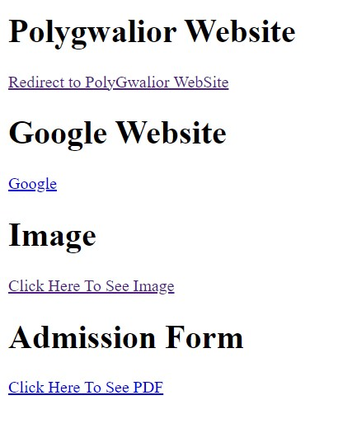

4.Write a code for html webpage which displays the image of Virat Kohli (using image tag).

Ans.

<!DOCTYPE html>

<html lang="en">

<head>

<meta charset="UTF-8">

<meta http-equiv="X-UA-Compatible" content="IE=edge">

<meta name="viewport" content="width=device-width, initial-scale=1.0">

<title>Document</title>

</head>

<body>

<h3>Virat Kohli </h3>

<img src="https://www.bing.com/th?id=ODL.3082e77b54ada983a1b51d59471c643e&a mp;w=143&amp;h=198&amp;c=8&amp;rs=1&amp;qlt=99&amp;pcl=faf9f7&amp;o =6&amp;pid=13.1" alt="Virat Kholi" data-pagespeed-url-hash="3786048974" onload="pagespeed. CriticalImages.checkImageForCriticality(this);">

</body>

</html>

### Output: -

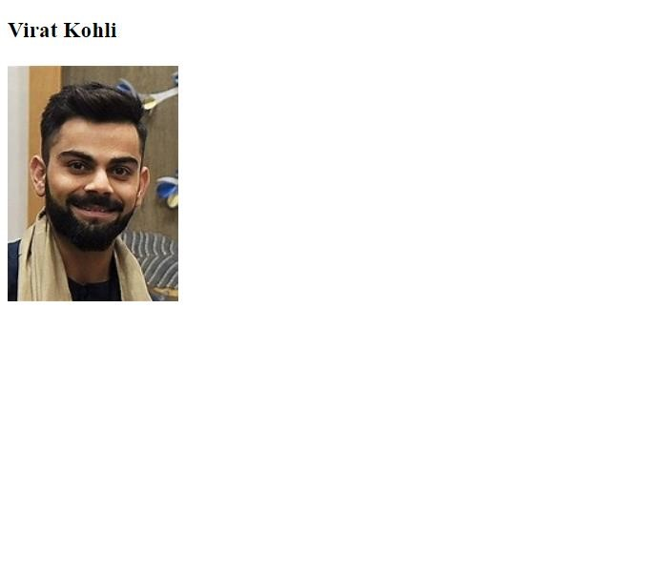

5. Write a code for html webpage which displays the image of Sachin Tendulkar

(using image tag) Ans.

<!DOCTYPE html>

<html lang="en">

<head>

<meta charset="UTF-8">

<meta http-equiv="X-UA-Compatible" content="IE=edge">

<meta name="viewport" content="width=device-width, initial-scale=1.0">

<title>Document</title>

</head>

<body>

<h2>Sachin Tendulkar </h2>

<img

src="https://www.bing.com/th?id=OIP.NgwiJJqQ7PJvaNlNRXUYzQHaFW&amp; w=176&amp;h=170&amp;c=8&amp;rs=1&amp;qlt=90&amp;o=6&amp;pid=3.1&a

mp;rm=2" alt="" data-pagespeed-url-hash="413458166" onload="pagespeed.CriticalImages.checkImageForCriticality(this);"> </body>

</html>

# Output: -

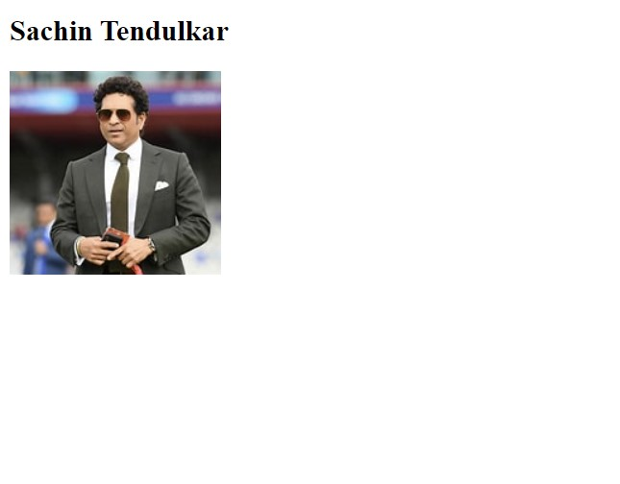

6. Write a code for html web page which displays your name in left , college name in right , and semester in center , your branch in red background color and text size - 50px.

Ans.

<!DOCTYPE html>

<html lang="en">

<head>

<meta charset="UTF-8">

<meta http-equiv="X-UA-Compatible" content="IE=edge">

<meta name="viewport" content="width=device-width, initial-scale=1.0">

<title>Document</title>

</head>

<body>

<h1 style="text-align: left;">Name – MANTHAN RATHORE </h1>

<h1 style="text-align: right;"> College Name- Dr. B.R. Ambedkar Polytechnic College Gwalior</h1>

<h1 style="text-align: center;">Semester - 4</h1>

<h1 style="background-color: red; color: #ffffff; font-size: 50px;">Branch - Computer Science &amp; Engineering </h1>

</body>

</html>

## Output: -

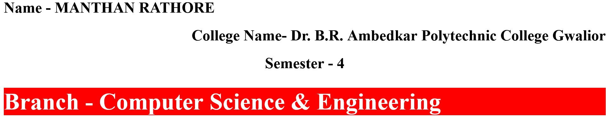

7 Write a code for html webpage which displays your name in H1 tag and also in blue color and < p> tag uses purple background color.

Ans.

<!DOCTYPE html>

<html lang="en">

<head>

<meta charset="UTF-8">

<meta http-equiv="X-UA-Compatible" content="IE=edge">

<meta name="viewport" content="width=device-width, initial-scale=1.0">

<title>Document</title>

</head>

<body>

<h1 style="text-align: center; color:purple;">

MANTHAN RATHORE

</h1>

<p>

MANTHONE RATHORE

</p>

</body>

</html>

## Output: -

8. Write a code for html webpage which displays some text formatting and uses < em> , < i> , < small> , < strong> , < sup> , < sub> , < ins> , < del> , < mark> tag.

Ans.

<html lang="en"><head>

    <meta charset="UTF-8">

    <meta http-equiv="X-UA-Compatible" content="IE=edge">

    <meta name="viewport" content="width=device-width, initial-scale=1.0">

    <title>Document</title>

    <style>body{background-color:#0ff}</style>

</head>

<body>

    <h1>MANTHAN </h1>

<p>Bold text :- MANTHAN <b>RATHORE</b></p>

  <h1>Important text :-MANTHAN <strong>RATHORE</strong></h1>

<h1>Italic text :-MANTHAN <i>RATHORE</i></h1>

<h1>Emphasized text :- MANTHAN<em> RATHORE</em></h1>

<h1>Marked text :- MANTHAN <mark>RATHORE</mark>ney</h1>

<h1>Smaller text :-MANTHAN <small>RATHORE </small></h1>

<h1>Deleted text :- MANTHAN <del> RATHORE</del></h1>

<h1>Inserted text :- MANTHAN<del>RATHORE</del><ins> RATHORE</ins></h1>

<h1>Subscript text :- MANTHAN <sub>MANTHAN </sub></h1>

 <h1>Superscript text :-MANTHAN <sup>MANTHAN </sup></h1>

</body>

</html>

Output: - ­­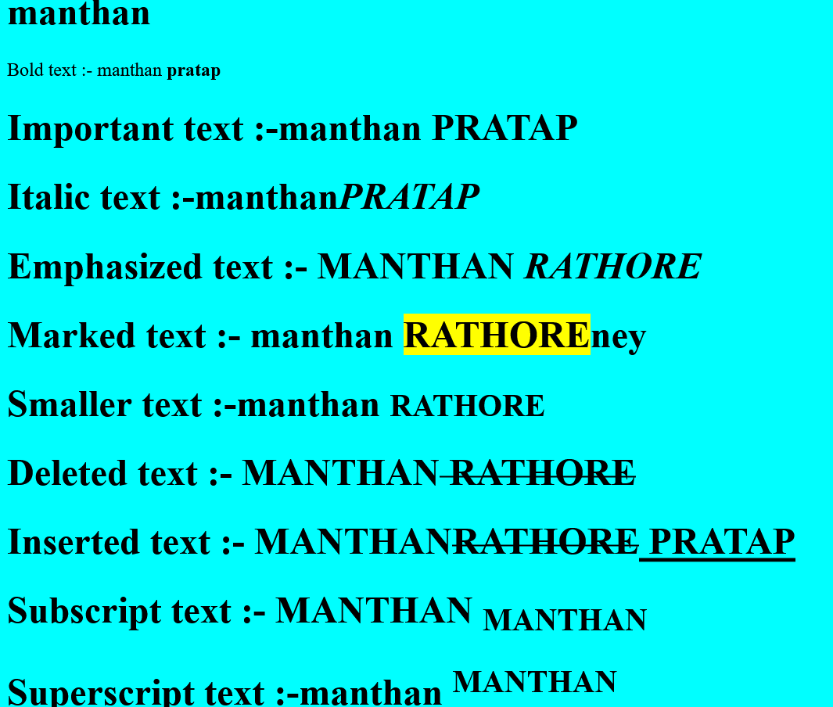

9. Write a code for html webpage which displays some background color and text of red colour.

Ans.

<!DOCTYPE html>

<html lang="en">

<head>

<meta charset="UTF-8">

<meta http-equiv="X-UA-Compatible" content="IE=edge">

<meta name="viewport" content="width=device-width, initial-scale=1.0">

<title>Document</title>

<style>

body{

background-color: aqua;

color: brown;

margin: 50px 20% 0px 20%;

}

text{

font-size: 50px;

}

</style>

</head>

<body>

<p class="text">Lorem ipsum dolour sit amet connecter adipisicing elit. Quo quibusdam asperiores voluptatum, veniam, debitis itaque aperiam laborum, accusamus expedita odit minus consequuntur quaerat consequatur. Tenetur eaque dolorum laudantium. Culpa, perferendis.

Lorem ipsum dolor sit amet consectetur adipisicing elit. Nemo, eveniet facere. Dolores repudiandae sint quo neque labore? Sed ratione exercitationem harum saepe qui placeat veniam repellendus commodi cumque accusamus! Non.

</p>

<p class="text">

Lorem ipsum dolor sit amet connecter adipescent elit. Necessitatibus, voluptates blanditiis consequatur esse velit optio? Est, quas totam enim libero autem, sapiente ducimus tempore quidem ut beatae architecto possum’s ensue? Lorem ipsum, dolor sit amet consectetur adipisicing elit. Consectetur cum exercitationem placeat ducimus velit eum est aut eligendi, qui explicabo aliquam beatae quisquam cupiditate minus! Eum aut nihil esse possimus? Lorem ipsum dolor sit amet, consectetur adipisicing elit. Magnam hic tempore dolorum nisi cupiditate perspiciatis nobis repellendus ab sapiente. Perspiciatis cupiditate aut, dolor inventore culpa nobis temporibus delectus voluptate ipsam!

</p>

</body>

</html>

## Output: -

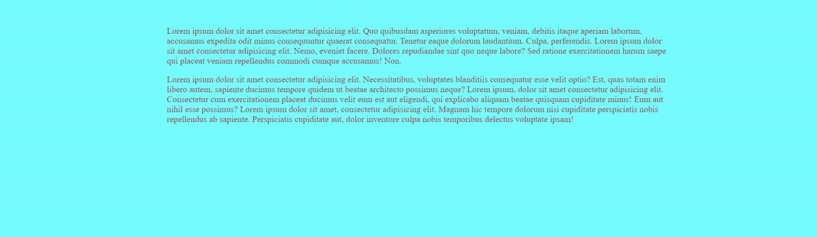

10 Write a CSS file and attached to any 3-html webpage.

Ans.

<!DOCTYPE html>

<html lang="en">

<head>

<meta charset="UTF-8">

<meta http-equiv="X-UA-Compatible" content="IE=edge">

<meta name="viewport" content="width=device-width, initial-scale=1.0">

<title>Document</title>

</head>

<body>

<pre style="word-wrap: break-word; white-space: pre-wrap;">body{ backgroundcolor:lightblue; color:aliceblue; };</pre>

</body>

</html>

## Output: -

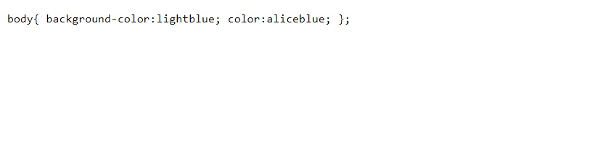

11. Write a code for html webpage which displays Virat Kohli image as background.

Ans.

<!DOCTYPE html>

<html lang="en">

<head>

<meta charset="UTF-8">

<meta http-equiv="X-UA-Compatible" content="IE=edge">

<meta name="viewport" content="width=device-width, initial-scale=1.0">

<title>Document</title>

<style>body{background-image:url(https://www.teahub.io/photos/full/1811812473_4k-ultra-hd-virat-kohli.jpg);background-repeat:no-repeat;backgroundsize:100% 100vh;background-size:cover}</style>

</head>

<body>

</body>

</html>

### Output: -



12. Write a code for html webpage which displays table using < tr> < td> tag.

Ans.

<!DOCTYPE html>

<html lang="en">

<head>

<meta charset="UTF-8">

<meta http-equiv="X-UA-Compatible" content="IE=edge">

<meta name="viewport" content="width=device-width, initial-scale=1.0">

<title>Document</title>

<style>

body {

padding: 0;

margin: 0

}

table {

font-family: Andalé Mono (monospace);

border-collapse: collapse;

width: 100%;

border: 1px solid #000

}

td,

th {

border: 1px solid #ddd;

text-align: left;

padding: 8px;

border: 1px solid #000

}

tr:nth-child(even) {

background-color: #ddd;

border: 1px solid #000

}

</style>

</head>

<body>

<table>

<tbody>

<tr>

<th>S.NO</th>

<th>title</th>

<th>description</th>

</tr>

<tr>

<td>1.</td>

<td>Lorem ipsum </td> <td>Lorem ipsum dolor sit, amet consectetur adipisicing elit. Deserunt ipsa beatae aspernatur placeat illum,

reprehenderit rem voluptatem consectetur labore corporis sunt excepturi quae cumque, ipsam eius asperiores.

Molestias, perspiciatis quidem.</td>

</tr>

<tr>

<td>2.</td>

<td>Lorem ipsum dolor sit</td>

<td>Lorem, ipsum dolor sit amet consectetur adipisicing elit. Deserunt sapiente et sint molestias. Ipsam sint

temporibus, qui ea hic delectus similique quibusdam quas, aut ut odit voluptatem. Tenetur, dolorum iusto?</td>

</tr>

<tr>

<td>3.</td>

<td>Lorem ipsum </td>

<td>Lorem ipsum dolor sit amet consectetur adipisicing elit. Voluptatum perspiciatis qui repudiandae, deleniti

praesentium labore consequuntur maxime voluptas soluta, saepe nesciunt dolores aliquam illo odit optio? Labore

quisquam tempora omnis?</td>

</tr>

<tr>

<td>4.</td>

<td>Lorem ipsum </td>

<td>Lorem ipsum dolor sit amet consectetur adipisicing elit. Voluptatum perspiciatis qui repudiandae, deleniti

praesentium labore consequuntur maxime voluptas soluta, saepe nesciunt dolores aliquam illo odit optio? Labore

quisquam tempora omnis?</td>

</tr>

<tr>

<td>5.</td>

<td>Lorem ipsum </td>

<td>Lorem ipsum dolor sit amet consectetur adipisicing elit. Voluptatum perspiciatis qui repaginate, deleniti

praesentium labore consequuntur maxime voluptas soluta, saepe nesciunt dolores aliquam illo odit optio? Labore

quisquam tempora omnis?</td>

</tr>

</tbody>

</table>

</body>

</html>

### Output: -

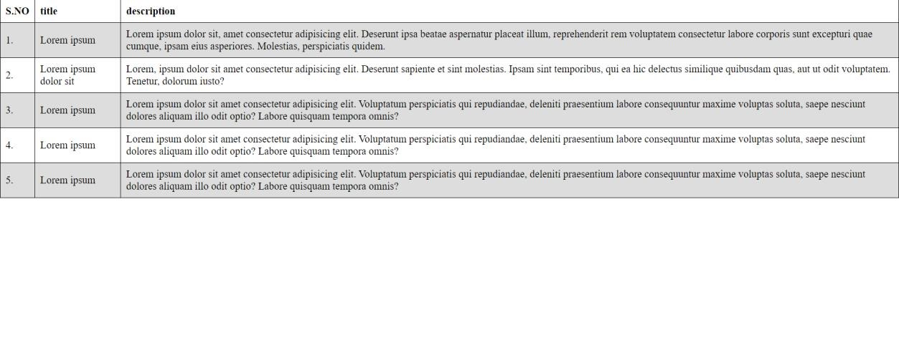

13. Make a form in html web page which takes all the details of person.

Ans.

<!DOCTYPE html>

<html lang="en">

<head>

<meta charset="UTF-8">

<meta http-equiv="X-UA-Compatible" content="IE=edge">

<meta name="viewport" content="width=device-width, initial-scale=1.0">

<title>Document</title>

<style>

body {

padding: 0;

margin: 0%

}

.form1 {

margin-top: 20px;

padding-top: 20px;

padding-bottom: 20px;

margin-bottom: 20px;

background-color: #0ff;

color: #000

}

</style>

</head>

<body>

<div class="form1">

<form action="" method="">

<table align="center">

<tbody>

<tr>

<td>First Name</td>

<td>:</td>

<td><input type="text" placeholder="First_Name" size="48"></td>

</tr>

<tr>

<td>Last Name</td>

<td>:</td>

<td><input type="text" placeholder="Last_Name" size="48"></td>

</tr>

<tr>

<td>E-mail id</td>

<td>:</td>

<td><input type="text" placeholder="E-mail_id" size="48"></td>

</tr>

<tr>

<td>Password</td>

<td>:</td>

<td><input type="password" placeholder="Password" size="48"></td>

</tr>

<tr>

<td>Confirm Password</td>

<td>:</td>

<td><input type="password" placeholder="Confirm_Password" size="48"></td>

</tr>

<tr>

<td>Date Of Birth</td>

<td>:</td>

<td>

<select name="Date" id="Date">

<option value="Date">Date</option>

<option value="1">1</option>

<option value="2">2</option>

<option value="3">3</option>

<option value="4">4</option>

<option value="5">5</option>

<option value="6">6</option>

<option value="7">7</option>

<option value="8">8</option>

<option value="9">9</option>

<option value="10">10</option>

<option value="11">11</option>

<option value="12">12</option>

<option value="13">13</option>

<option value="14">14</option>

<option value="15">15</option>

<option value="16">16</option>

<option value="17">17</option>

<option value="18">18</option>

<option value="19">19</option>

<option value="20">20</option>

<option value="21">21</option>

<option value="22">22</option>

<option value="23">23</option>

<option value="24">24</option>

<option value="25">25</option>

<option value="26">26</option>

<option value="27">27</option>

<option value="28">28</option>

<option value="29">29</option>

<option value="30">30</option> <option value="31">31</option>

</select>

<select name="Month" id="Month">

<option value="Month">Month</option>

<option value="1">January</option>

<option value="2">February</option>

<option value="3">March</option>

<option value="4">April</option>

<option value="5">May</option>

<option value="6">June</option>

<option value="7">July</option>

<option value="8">August</option>

<option value="9">September</option>

<option value="10">october</option>

<option value="11">November</option> <option value="12">December</option>

</select>

<select name="Year" id="Year">

<option value="Year">Year</option>

<option value="1">2021</option>

<option value="2">2020</option>

<option value="3">2019</option>

<option value="4">2018</option>

<option value="5">2017</option>

<option value="6">2016</option>

<option value="7">2015</option>

<option value="8">2014</option>

<option value="9">2013</option>

<option value="10">2012</option>

<option value="11">2011</option>

<option value="12">2010</option>

<option value="13">2009</option>

<option value="14">2008</option>

<option value="15">2007</option>

<option value="16">2006</option>

<option value="17">2005</option>

<option value="18">2004</option>

<option value="19">2003</option>

<option value="20">2002</option>

<option value="21">2001</option>

<option value="22">2000</option>

<option value="23">1999</option>

<option value="24">1998</option>

<option value="25">1997</option>

<option value="26">1996</option>

<option value="27">1995</option>

<option value="28">1994</option>

<option value="29">1993</option>

<option value="30">1992</option> <option value="31">1991</option>

</select>

</td>

</tr>

<tr>

<td>Gender</td>

<td>:</td>

<td>

<input type="radio" name="Male"

value="Gender"><span>Male</span>

<input type="radio" name="Female" value="Gender"><span>Female</span>

</td>

</tr>

<tr>

<td>Address</td>

<td>:</td>

<td><input type="text" placeholder="Type_Your_Address" size="48"></td>

</tr>

<tr>

<td>

<button type="submit">Submit</button>

</td>

</tr>

</tbody>

</table>

</form>

</div>

</body>

</html>

### Output: -



14. Make a form in html web page which takes all the details of person. (Ex- Name,

Password, Age, Date of Birth, Month of Admission, Year of 10 passed, Gender, Qualification, Select Branch, Cetegory (SC/ST/Gen/OBC) using datalist, Select Color, Select Range (0 to 100) , Submit button).

Ans.

<!DOCTYPE html>

<html lang="en">

<head>

<meta charset="UTF-8">

<meta http-equiv="X-UA-Compatible" content="IE=edge">

<meta name="viewport" content="width=device-width, initial-scale=1.0">

<title>Document</title>

<style>

body {

padding: 0;

margin: 0%

}

. form1 {

margin-top: 20px;

padding-top: 20px;

padding-bottom: 20px;

margin-bottom: 20px;

background-color: #0ff;

color: #000

}

</style>

</head>

<body>

<div class="form1">

<form action="" method="">

<table align="center">

<tbody>

<tr>

<td>First Name</td>

<td>:</td>

<td><input type="text" placeholder="First_Name" size="48"></td>

</tr>

<tr>

<td>Last Name</td>

<td>:</td>

<td><input type="text" placeholder="Last_Name" size="48"></td>

</tr>

<tr>

<td>E-mail id</td>

<td>:</td>

<td><input type="text" placeholder="E-mail_id" size="48"></td> </tr>

<tr>

<td>Password</td>

<td>:</td>

<td><input type="password" placeholder="Password" size="48"></td>

</tr>

<tr>

<td>Confirm Password</td>

<td>:</td>

<td><input type="password" placeholder="Confirm_Password" size="48"></td>

</tr>

<tr>

<td>Month Of Admission</td>

<td>:</td>

<td><input type="month" name="month" id="month" value="202202"></td>

</tr>

<tr>

<td>Year of 10 passed</td>

<td>:</td>

<td> <input type="text" name="Year" id="Year" placeholder="Enter Year of 10 passed" size="48">

</td>

</tr>

<tr>

<td>Gender</td>

<td>:</td>

<td> <input type="radio" name="gen" id="Male"><label for="Male"> Male</label>

<input type="radio" name="gen" id="Female"> <label for="Female"> Female</label>

<input type="radio" name="gen" id="Other"> <label for="Other"> Other</label>

</td>

</tr>

<tr>

<td>Qualification</td>

<td>:</td>

<td><input type="checkbox" name="q" id="ten">

<label for="ten"> 10<sup>th</sup></label>

<input type="checkbox" name="q" id="twe">

<label for="twe"> 12<sup>th</sup></label>

<input type="checkbox" name="q" id="Diploma">

<label for="Diploma"> Diploma</label>

<input type="checkbox" name="q" id="B.E">

<label for="B.E"> B.E./ B.Tech.</label>

<input type="checkbox" name="q" id="M.E">

<label for="M.E"> M.E./M.Tech.</label>

</td>

</tr>

<tr>

<td>Branch</td>

<td>:</td>

<td><select id="Branch">

<option value="">Select Branch</option>

<option value="civil"> Civil Engineering</option>

<option value="cse">Computer Science Engineering</option>

<option value="Electrical">Electrical Engineering</option>

<option value="HMCT">HMCT</option>

<option value="it">Information Technology</option>

<option value="Mechanical">Mechanical Engineering</option> <option value="Science">Science &amp; Humanity</option>

<option value="Textile">Textile Engineering</option>

</select></td>

</tr>

<tr>

<td>Cetegory</td>

<td>:</td>

<td><select id="Cetegory">

<option value="">Select Cetegory</option>

<option value="SC">SC</option>

<option value=" ST">ST</option>

<option value="general ">General</option>

<option value=" OBC">OBC</option>

</select></td>

</tr>

<tr>

<td>Select favorite color</td>

<td>:</td>

<td> <input type="Color" name="Color" id="Color"><br><br>

</td>

</tr>

<tr>

<td>Select Range</td>

<td>:</td>

<td><input type="Range" name="Range" min="0" max="100" id="Range"></td>

</tr>

<tr>

<td>

<input type="Submit" name="Submit" id="Submit">

</td>

</tr>

</tbody>

</table>

</form>

</div>

</body>

</html>

#### Output: -

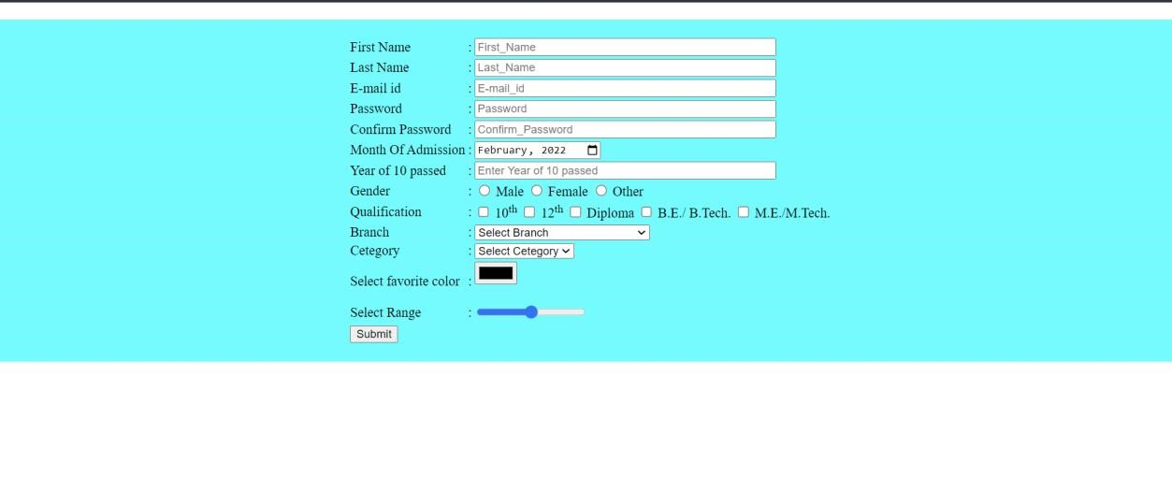

15 Use Class, ID selectors to style various elements of HTML Page. Ex: create four

< p> and four < h1> element Center align two < p> and two < h1> using

Class.Colour all < p> to blue using class.Last < h1> should colour in yellow using id.

Ans.

<!DOCTYPE html>

<html lang="en">

<head>

<meta charset="UTF-8">

<meta http-equiv="X-UA-Compatible" content="IE=edge">

<meta name="viewport" content="width=device-width, initial-scale=1.0">

<title>Document</title>

<style type="text/css">

* {

border: 1px solid

}

.Center {

text-align: center

}

p.colour {

color: #00f

}

#p {

text-align: center;

color: #000;

background-color: #ff1a1a

} #p1 {

text-align: left;

color: #000;

background-color: #ff1a1a

}

#p2 {

text-align: right;

background-color: #00fff2;

color: #000

}

</style>

</head>

<body>

<h1 class="Center">DR. B.R. AMBEDKAR POLYTECHNIC COLLEGE, GWALIOR</h1>

<h1 class="Center">Name : MANTHAN RATHORE</h1>

<h1>Lorem ipsum dolor sit amet consectetur adipisicing elit. Dignissimos accusamus exercitationem debitis ad neque

et eum consequatur, iure ullam. Eaque beatae quia fuga consectetur nihil, quos atque? Porro, saepe natus!</h1>

<p class="Center colour">Lorem ipsum dolor sit amet consectetur adipisicing elit.

Enim distinctio nam ipsum eos

eligendi repudiandae perspiciatis itaque voluptates vero voluptate in eaque

similique illo molestiae, nihil

voluptatum nobis! Repudiandae, harum.</p>

<p class="Center colour">Lorem ipsum dolor sit amet consectetur adipisicing elit.

Nobis, consequuntur. Consequatur

voluptatem, fugiat, quia impedit est alias deleniti incidunt porro in nihil laboriosam placeat autem architecto

cupiditate iure dolorum similique!</p>

<h1 id="p">Lorem ipsum dolor sit amet consectetur adipisicing elit. Nostrum nobis eum laboriosam voluptatem in, sit

optio quaerat officia iure exercitationem reiciendis accusantium laudantium ipsum. Eum qui consectetur non

soluta iure.</h1>

<p id="p1" class="colour">Lorem ipsum dolor sit, amet consectetur adipisicing elit. Temporibus animi suscipit

numquam placeat, atque labore voluptas minus doloribus minima possimus aliquam quasi dignissimos vitae

accusantium distinctio voluptatem accusamus asperiores corrupti!</p>

<p id="p2" class="colour">Lorem ipsum dolor sit amet consectetur adipisicing elit. Similique accusantium veritatis

eum in et explicabo facere perferendis nam dolorum veniam mollitia ducimus architecto quasi eos hic voluptate,

exercitationem repellat accusamus? </p>

</body>

</html>

## Output: -

16. Use Div and span in a page and color two words with different colour.

Ans.

<!DOCTYPE html>

<html lang="en">

<head>

<meta charset="UTF-8">

<meta http-equiv="X-UA-Compatible" content="IE=edge">

<meta name="viewport" content="width=device-width, initial-scale=1.0">

<title>Document</title>

<style>

body {

padding: 0%;

margin: 0%

}

. back1 {

padding-left: 10%;

padding-top: 50px;

padding-right: 10%;

padding-bottom: 50px;

margin-top: 50px;

margin-left: 20%;

margin-right: 20%;

background-color: #0ff;

border: none;

border-radius: 5px

}

. back2 {

padding-left: 10%;

padding-top: 50px;

padding-right: 10%; padding-bottom: 50px;

margin-top: 50px;

margin-left: 20%;

margin-right: 20%;

background-color: #0ff;

border: none;

border-radius: 5px

}

. span2 {

colour: #00f

}

</style>

</head>

<body>

<div class="back1"> <h1><span class="span2">Lorem ipsum</span> dolor sit amet </h1>

<p>Lorem ipsum dolor sit amet consectetur adipisicing elit. Illum aperiam animi ullam minima incidunt ipsum ut,

culpa earum dolore ipsa. Ea, provident quidem! Nesciunt harum numquam, eos iure quam sed! </p>

</div>

<div class="back2">

<h1><span class="span2">Lorem ipsum</span> dolor sit amet </h1>

<p>Lorem ipsum dolor sit amet consectetur adipisicing elit. Illum aperiam animi ullam minima incidunt ipsum ut,

culpa earum dolore ipsa. Ea, provident quidem! Nesciunt harum numquam, eos iure quam sed!</p>

</div>

</body>

</html>

## Output: -

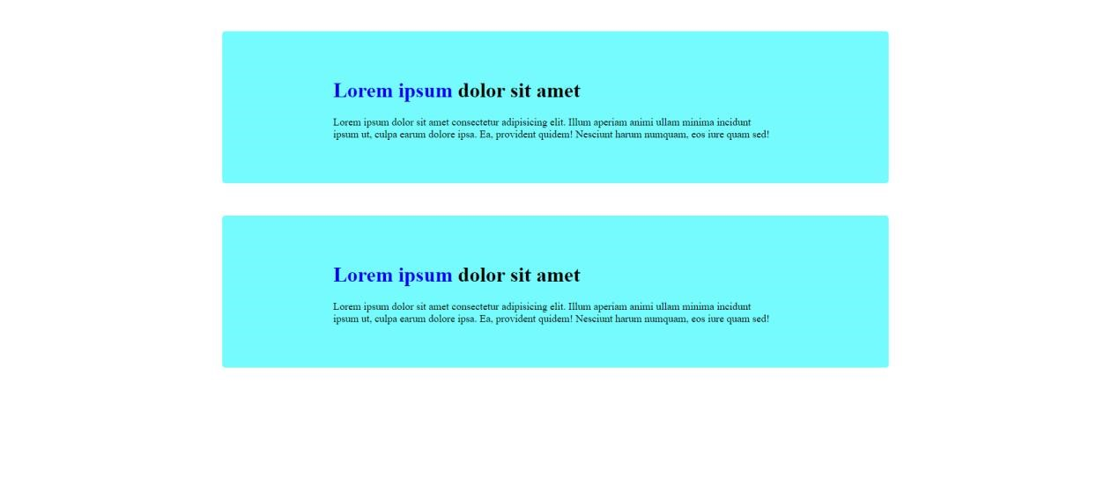

18. Write a code for html webpage which displays all practical on border, margin, padding of elements.

Ans.

<!DOCTYPE html>

<html lang="en">

<head>

<meta charset="UTF-8">

<meta http-equiv="X-UA-Compatible" content="IE=edge">

<meta name="viewport" content="width=device-width, initial-scale=1.0">

<title>Document</title>

<style>

body {

background-color: #ff8000;

text-align: center

}

h2,

h1 {

font-size: 400%;

background-color: #d3d3d3;

color: #00ff15

}

p {

font-size: 35px;

text-align: left

}

p.dotted {

border-style: dotted;

border-width: 5px

}

p.dashed {

border-style: dashed; border-width: medium

}

p.solid {

border-style: solid;

border-width: thick

}

p.double {

border-style: double;

border-color: #00f

}

p.groove {

border-style: groove;

border-color: #123456

}

p.ridge {

border-style: ridge;

border-radius: 5px

}

p.inset {

border-style: inset;

border-radius: 50px

}

p.outset {

border-style: outset

}

p.none {

border-style: none

}

p.hidden {

border-style: hidden

}

p.mix {

border-style: dotted dashed solid double;

border-left: 6px solid red;

background-color: #d3d3d3

}

p.solid_m {

border-style: solid;

border-width: thick;

margin: 50px

}

p. solid p {

border-style: solid;

border-width: thick;

margin: 50px;

padding: 50px

}

</style>

</head>

<body>

<h2>Border, Margin, Padding </h2>

<h2>Ankur Shukla</h2>

<h1>1. Border</h1>

<p class="dotted">A dotted border.width 5px</p>

<p class="dashed">A dashed border.width medium</p>

<p class="solid">A solid border. width thick</p>

<p class="double">A double border.color blue</p>

<p class="groove">A groove border.color #123456</p>

<p class="ridge">A ridge border. radius 5px</p>

<p class="inset">An inset border. radius 50px</p>

<p class="outset">An outset border.</p>

<p class="none">No border.</p>

<p class="hidden">A hidden border.</p>

<p class="mix">A mixed border.border-left 6px red,

background-color lightgrey</p>

<h1>2. Margin</h1>

<p class="solid_m">A solid border. width thick ,margin 50px</p>

<p class="solid">A solid border. width thick , without margin </p>

<h1>3. Padding</h1>

<p class="solid_p">A solid border. width thick ,margin 50px ,padding 50px</p>

<p class="solid">A solid border. width thick , without margin and padding </p>

</body>

</html>

Output: -

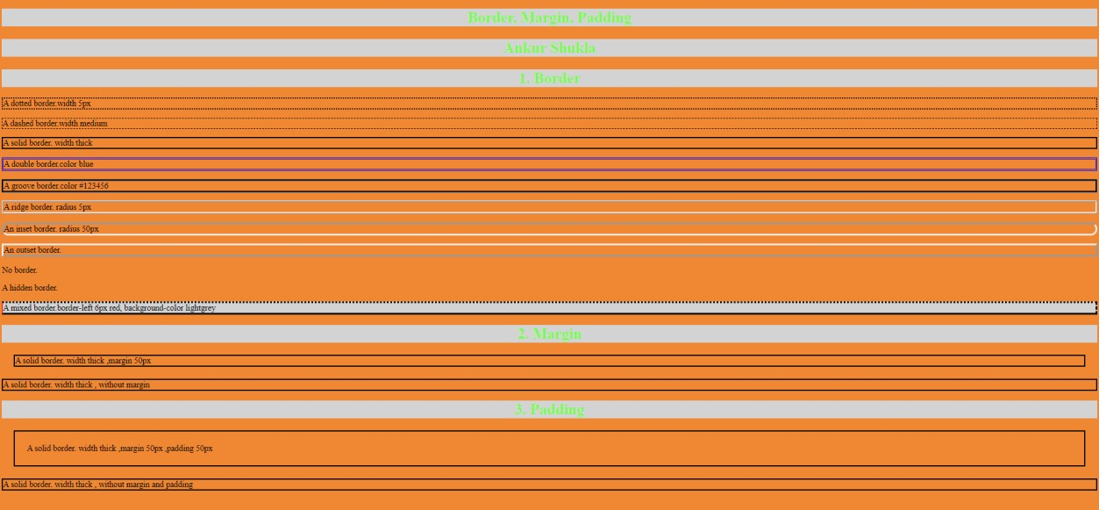

19. Write a code for html webpage which displays all practical on Text/ font formatting, width Height.

Ans.

<!DOCTYPE html>

<html lang="en">

<head>

<meta charset="UTF-8">

<meta http-equiv="X-UA-Compatible" content="IE=edge">

<meta name="viewport" content="width=device-width, initial-scale=1.0">

<title>Document</title> <style type="text/css">

body {

background-color: #0ff;

padding: 0;

margin: 0%

}

h1,h2

{

text-align: center;

letter-spacing: 2px;

line-height: 1;

font-family: "Lucida Console", "Courier New", monospace

}

.font {

border: none;

border-radius: 5px;

background-color: #8a2be2;

padding-top: 20px;

padding-bottom: 20px;

margin-left: 20%;

margin-right: 20%;

margin-top: 50px

}

</style>

</head>

<body>

<h1>Text/ font formatting, width Height</h1>

<hr>

<div class="font">

<h1>HELLO </h1>

<h2>MANTHAN RATHORE </h2>

</div>

<div id="text">

</div>

</body>

</html>

### Output: -

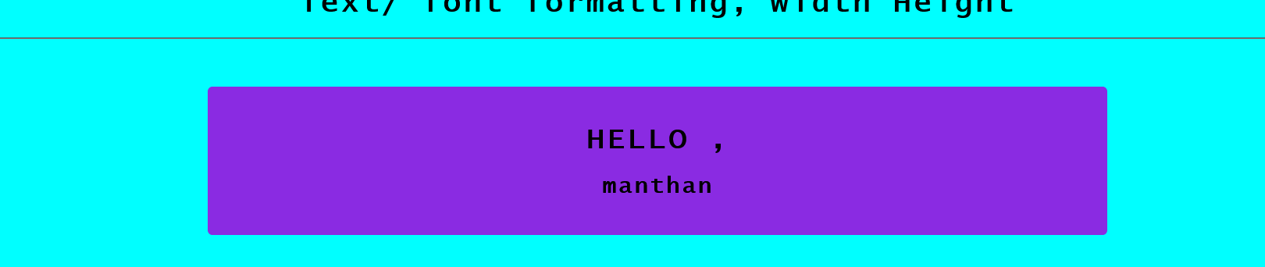

20. Write a code for html web page which changes HTML Content. (Using JavaScript).

Ans.

<!DOCTYPE html>

<html lang="en">

<head>

<meta charset="UTF-8">

<meta http-equiv="X-UA-Compatible" content="IE=edge">

<meta name="viewport" content="width=device-width, initial-scale=1.0">

<title>Document</title>

</head>

<body>

<h2>JavaScript Can Change HTML Content</h2>

<p id="java">RAVINDRA PRATAP</p>

<button type="button" onclick='document.getElementById("java").innerHTML = "DR. B.R. AMBEDKAR POLYTECHNIC COLLEGE, GWALIOR"'>College

Name</button>

<button type="button" onclick='document.getElementById("java").innerHTML = "Ankur Shukla"'>Student Name</button>

</body>

</html>

#### Output: -

21. Write a code for html web page which changes HTML Attribute Values. (Using JavaScript).

Ans.

<html lang="en">

<head>

<meta charset="UTF-8">

<meta http-equiv="X-UA-Compatible" content="IE=edge">

<meta name="viewport" content="width=device-width, initial-scale=1.0">

<title>Document</title>

</head>

<body>

<h2>JavaScript Can Change HTML Attribute Values</h2>

<p>MANTHAN RATHORE </p>

<button

onclick="document.getElementById('myImage').src='https://image.shutterstock.

com/image-vector/no-mobile-phone-sign-600w-268680011.jpg'">1.</button>

<img id="myImage" src="https://image.shutterstock.com/image-vector/no-mobilephone-sign-600w-268680011.jpg"

style="width:100px" data-pagespeed-url-hash="3642220358"

onload="pagespeed.CriticalImages.checkImageForCriticality(this);">

<button

onclick="document.getElementById('myImage').src='https://image.shutterstock.com/i mage-illustration/no-phone-sign-600w-540189352.jpg'">2.</button>

</body>

</html>

Output: - 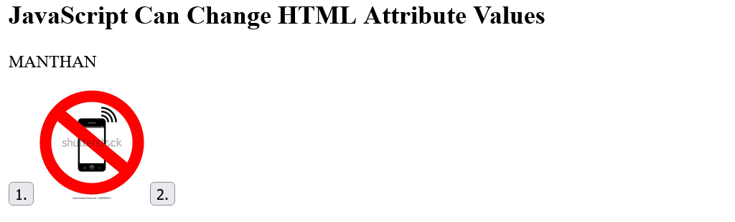

22. Write a code for html web page which changes HTML Styles (CSS). (using JavaScript).

Ans.

<html lang="en">

<head>

<meta charset="UTF-8">

<meta http-equiv="X-UA-Compatible" content="IE=edge">

<meta name="viewport" content="width=device-width, initial-scale=1.0">

<title>Document</title>

</head>

<body>

<h1 id="id1" style="font-size:50px; text-align: center;">Ankur Shukla</h1>

<button type="button" onclick="document.getElementById('id1').style.color = '#754ef9'">

Click Me!</button>

<button type=

"button" onclick="document.getElementById('id1').style.color = 'black'"> Back!

</button>

</body>

</html>

# Output:-



23. Write a code for html web page which Hide /Show HTML Elements. (using JavaScript).

Ans.

<!DOCTYPE html>

<html lang="en">

<head>

<meta charset="UTF-8">

<meta http-equiv="X-UA-Compatible" content="IE=edge">

<meta name="viewport" content="width=device-width, initial-scale=1.0">

<title>Document</title>

</head>

<body>

<h1>JavaScript Can Hide/Show HTML Elements</h1>

<h1>

<p id="demo">MANTHAN RATHORE </p>

<button type="button"

onclick="document.getElementById('demo').style.display='none'">Hide</button>

<button type="button"

onclick="document.getElementById('demo').style.display='block'">Show</button> </h1>

</body>

</html>

# Output: -



24. Create a html form which takes age as input and print (adult/ not adult/ invalid) using JavaScript.

Ans.

<!DOCTYPE html>

<html lang="en">

<head>

<meta charset="UTF-8">

<meta http-equiv="X-UA-Compatible" content="IE=edge">

<meta name="viewport" content="width=device-width, initial-scale=1.0">

<title>Document</title>

</head>

<body>

<h2>JavaScript Functions</h2>

<form>

Enter your age:

<input id="age" type="number" onchange="check()">

</form>

<p id="demo"></p> <script>

function check() {

let x = document.getElementById('age').value;

if (x < 0) { document.getElementById('demo').innerHTML = 'Invalid'; document.getElementById('demo').style.color = 'blue'; }

else if (x < 18) { document.getElementById('demo').innerHTML = 'Not Adult'; document.getElementById('demo').style.color = 'red'; }

else if (x < 120) { document.getElementById('demo').innerHTML = 'Adult'; document.getElementById('demo').style.color = 'green'; }

else { document.getElementById('demo').innerHTML = 'Invalid'; document.get ElementById('demo').style.color = 'blue'; }

}

</script>

</body>

</html>



**Output:**

**-**

25. Create a html form which takes age (type number) and gender (type radio button) as input and print (‘Eligible for marriage’/ ‘Not eligible for marriage’/ ‘invalid age’) using JavaScript.

Print “Not eligible for marriage” for Male: 0 to 20, Female 0 to 17

Print “Eligible for marriage” for

Male: 21 to 120, Female 18 to 120

Print “Invalid age” for

Male/ Female: not between (0 to 120)Ans.

<!DOCTYPE html>

<html lang="en">

<head>

<meta charset="UTF-8">

<meta http-equiv="X-UA-Compatible" content="IE=edge">

<meta name="viewport" content="width=device-width, initial-scale=1.0">

<title>Document</title>

</head>

<body>

<form>

Enter your age:

<input id="age" type="number" onchange="check()"> <br><br>Enter your Gender:

<input id="f" type="radio" name="gender" onchange="check()"><label for="f">Female</label>

<input id="m" type="radio" name="gender" onchange="check()"><label for="m">Male</label>

</form>

<p id="demo"></p>

<p id="test1"></p>

<p id="test"></p> <script>

function check() {

let x = document.getElementById('age').value; let m = document.getElementById('m').checked; let f = document.getElementById('f').checked; if (x < 0 || x > 120) { document.getElementById('demo').innerHTML = 'Invalid'; document.getElementById('demo').style.color = 'blue'; }

else if (m == true) {

document.getElementById('demo').innerHTML = '';

if (x < 21) { document.getElementById('test').innerHTML = 'Gender is Male.<br>Not eligible for marriage'; document.getElementById ('test').style.color =

'green'; }

else { document.getElementById('test').innerHTML = 'Gender is Male.<br>Eligible for marriage'; document.getElementById('test').style.color = 'green'; }

} else if (f == true) {

document.getElementById('demo').innerHTML = '';

if (x < 18) { document.getElementById('test').innerHTML = 'Gender is Female.<br>Not eligible for marriage'; document.getElementById('test').style.color =

'green'; }

else { document.getElementById('test').innerHTML = 'Gender is Female.<br>Eligible for marriage'; document.getElementById('test').style.color = 'green'; }

} else { document.getElementById('test').innerHTML = 'Gender not selected'; document.getElementById('test').style.color = 'red'; }

}

</script>

</body>

</html>

## Output: -



26. Create a html form which takes Select College (type Select) and Select Branch (type Select).

Ans.

<!DOCTYPE html>

<html lang="en">

<head>

<meta charset="UTF-8">

<meta http-equiv="X-UA-Compatible" content="IE=edge">

<meta name="viewport" content="width=device-width, initial-scale=1.0"> <title>js functions</title>

</head>

<body>

<form>

Select College:

<select onchange="check()" required="" id="college">

<option value="">Select College</option>

<option value="polygwl">Dr. Bhimrao Ambedkar Polytechnic College, Gwalior</option>

<option value="bhind">Government Polytechnic College, Bhind</option> </select>

<br><br>Select Branch:

<select onchange="check()" required="" id="branch">

<option value="">Select Branch</option>

<option id="cse" value="CSE">Computer Science and Engineering</option>

<option id="it" value="IT">Information Technology</option>

<option id="mech" value="MECH">Mechanical Engineering</option>

<option id="civil" value="CIVIL">Civil Technology</option>

</select>

<br><br>

<input type="submit">

</form>

<p id="demo"></p>

<p id="test1"></p>

<p id="test"></p>

<script>

function check() { let x = document.getElementById('college').value; document.getElementById('test1').innerHTML = x; if (x == "polygwl") { document.getElementById('test').innerHTML = "Gwalior College"; document.getElementById('cse').style.display = 'block'; document.getElementById('it').style.display = 'block'; document.getElementById('civil').style.display = 'none';

document.getElementById('mech').style.display = 'none'; } else if (x == "bhind") {

document.getElementById('test').innerHTML = "Bhind College"; document.getElementById('cse').style.display = 'none'; document.getElementById('it').style.display = 'none'; document.getElementById('civil').style.display = 'block'; document.getElementById('mech').style.display = 'block'; } else { document.getElementById('cse').style.display = 'block'; document.getElementById('it').style.display = 'block'; document.getElementById('civil').style.display = 'block'; document.getElementById('mech').style.display = 'block'; } }

</script>

</body>

</html> **Output:** 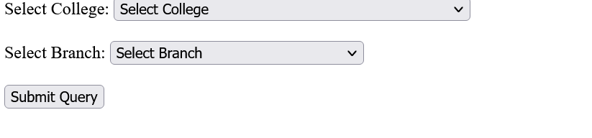

27. Write a code for html web page which changes background colour on clicking the button (using JavaScript).

Ans.

<!DOCTYPE html

<html lang="en">

<head>

<meta charset="UTF-8">

<meta http-equiv="X-UA-Compatible" content="IE=edge">

<meta name="viewport" content="width=device-width, initial-scale=1.0">

<title>Document</title>

<style>

div {

padding-top: 200px

}

</style>

</head>

<body>

<div>

<button style="color: #000000 ;font-size: 38px; background-color:#ffffff;" onclick="Background('#FFFFFF')">

WHITE</button>

<button style="color:#000000 ;font-size: 38px;background-color:#808080;"

onclick="Background('#808080')">GRAY</button>

<button style="color:#000000 ;font-size: 38px;background-color:#FF0000;"

onclick="Background('#FF0000')">RED</button>

<button style="color:#000000 ;font-size: 38px;background-color:#800000;"

onclick="Background('#800000')">MAROON</button>

<button style="color:#000000 ;font-size: 38px;background-color:#FFFF00;"

onclick="Background('#FFFF00')">YELLOW</button>

<button style="color:#000000 ;font-size: 38px;background-color:#008000;"

onclick="Background('#008000')">GREEN</button>

<button style="color:#000000 ;font-size: 38px;background-color:#0f0fff;" onclick="Background('#0000FF')">BLUE</button>

<button style="color:#000000 ;font-size: 38px;background-color:#800080;"

onclick="Background('#800080')">PURPLE</button>

<button style="color:#ffffff ;font-size: 38px;background-color:#000080;"

onclick="Background('#000080')">NAVY</button>

<button style="color:#000000 ;font-size: 38px;background-color:#C0C0C0;"

onclick="Background('#C0C0C0')">SILVER</button>

</div>

<script type="text/javascript">function Background(bg) { document.body.style.background = bg; }</script>

</body>

</html>

### Output: -



28. Write a code for html web page which changes background colour on clicking radio button (using JavaScript).

Ans

<!DOCTYPE html>

<html lang="en">

<head>

<meta charset="UTF-8">

<meta http-equiv="X-UA-Compatible" content="IE=edge">

<meta name="viewport" content="width=device-width, initial-scale=1.0">

<title>Document</title>

<style type="text/css">.color{font-size:32px;border-radius:50px}</style>

</head>

<body>

<div class="color">

<input type="radio" name="color" value="red" onclick="Background('#FF0000')"> Red<br>

<input type="radio" name="color" value="blue" onclick="Background('#0000FF')"> Blue<br>

<input type="radio" name="color" value="white" onclick="Background('#FFFFFF')"> White<br>

</div>

<script type="text/javascript">

function Background(bg){document.body.style.background=bg;}

</script>

</body>

</html>

### Output: -



29. Write a code for html web page which changes background colour on clicking checkboxes (using JavaScript) .

Ans.

<!DOCTYPE html>

<html lang="en">

<head>

<meta charset="UTF-8">

<meta http-equiv="X-UA-Compatible" content="IE=edge">

<meta name="viewport" content="width=device-width, initial-scale=1.0">

<title>Document</title>

<style type="text/css">.color{font-size:32px;border-radius:50px}</style>

</head>

<body>

<div class="color">

<input type="checkbox" name="color" value="red" onclick="Background('#FF0000')"> Red<br>

<input type="checkbox" name="color" value="blue" onclick="Background('#0000FF')"> Blue<br>

<input type="checkbox" name="color" value="white" onclick="Background('#FFFFFF')"> White<br>

</div>

<script type="text/javascript">

function Background(bg){document.body.style.background=bg;}

</script>

</body>

</html>

### Output: -



31. Write some php code which displays the information of html form into another webpage.

Ans.

<!DOCTYPE html>

<html lang="en">

<head>

<meta charset="UTF-8">

<meta http-equiv="X-UA-Compatible" content="IE=edge">

<meta name="viewport" content="width=device-width, initial-scale=1.0">

<title>Document</title>

<link

href="https://cdn.jsdelivr.net/npm/bootstrap@5.1.3/dist/css/bootstrap.min.css" rel="stylesheet"

integrity="sha384-

1BmE4kWBq78iYhFldvKuhfTAU6auU8tT94WrHftjDbrCEXSU1oBoqyl2QvZ6jIW3" crossorigin="anonymous">

<style>

.container {

padding: 25px;

border: none;

border-radius: 5px

}

</style>

</head>

<body>

<div class="container mt-3 bg-info">

<h2>Write some php code which displays the information of html form into another webpage. </h2>

<form class="needs-validation" novalidate=""

action="https://www.polygwalior.ac.in/student/20BRAPCCO06_62.php"

method="POST">

<div class="row g-3">

<div class="col-sm-6">

<label for="firstName" class="form-label">First name</label>

<input type="text" class="form-control" name="firstname" id="firstName" placeholder="" value=""

required="">

<div class="invalid-feedback"> Valid first name is required.

</div>

</div>

<div class="col-sm-6">

<label for="lastName" class="form-label">Last name</label>

<input type="text" class="form-control" name="lastname" id="lastName" placeholder="" value=""

required="">

<div class="invalid-feedback"> Valid last name is required.

</div>

</div>

<div class="col-12">

<label for="username" class="form-label">Username</label>

<div class="input-group has-validation">

<span class="input-group-text">@</span>

<input type="text" class="form-control" name="username" id="username" placeholder="Username"

required="">

<div class="invalid-feedback"> Your username is required.

</div>

</div>

</div>

<div class="col-12">

<label for="email" class="form-label">Email <span class="textmuted">(Optional)</span></label>

<input type="email" class="form-control" name="email" id="email" placeholder="you@example.com">

<div class="invalid-feedback">

Please enter a valid email address .

</div>

</div>

<div class="col-12">

<label for="address" class="form-label">Address</label>

<input type="text" class="form-control" name="address" id="address" placeholder="1234 Main St"

required="">

<div class="invalid-feedback"> Please enter your address.

</div>

</div>

<div class="col-12">

<label for="address2" class="form-label">Address 2 <span

class="text-muted">(Optional)</span></label>

<input type="text" class="form-control" name="address2" id="address2"

placeholder="Apartment or suite">

</div>

</div>

<hr class="my-4">

<button class="w-100 btn btn-primary btn-lg" type="submit">Submit</button>

</form>

</div>

</body>

</html>

## Output: -

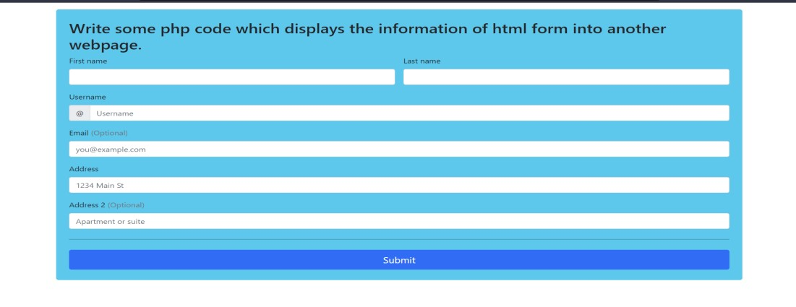

32. Write a HTML and PHP program which takes your name as input and print

> Print length of the name

>Print Reverse of name

> Print first name ,middle name & last name

Hint: use php string functions

Ans.

<html lang="en">

<head>

<meta charset="UTF-8">

<meta http-equiv="X-UA-Compatible" content="IE=edge">

<meta name="viewport" content="width=device-width, initial-scale=1.0">

<title>Document</title>

<!-- Font Awesome -->

<link href="https://cdn.jsdelivr.net/npm/bootstrap@5.0.2/dist/css/bootstrap.min.css" rel="stylesheet"

integrity="sha384-

EVSTQN3/azprG1Anm3QDgpJLIm9Nao0Yz1ztcQTwFspd3yD65VohhpuuCOmLASj C" crossorigin="anonymous">

<style> .form { border: none; border-radius: 10px; padding: 50px; margin-top: 200px; margin-left: 30%; margin-right: 30%; background-color: #ffa693

}

</style>

</head>

<body>

<form action="https://www.polygwalior.ac.in/student/20BRAPCCO06_64.php" method="POST">

<div class="form">

<div class="mb-3">

<label for="exampleInputEmail1" class="form-label">Name</label>

<input type="Text" class="form-control" id="exampleInputEmail1" ariadescribedby="emailHelp" name="name">

</div>

<button type="submit" class="btn btn-primary">Submit</button>

</div>

</form>

</body>

</html

### Output: -

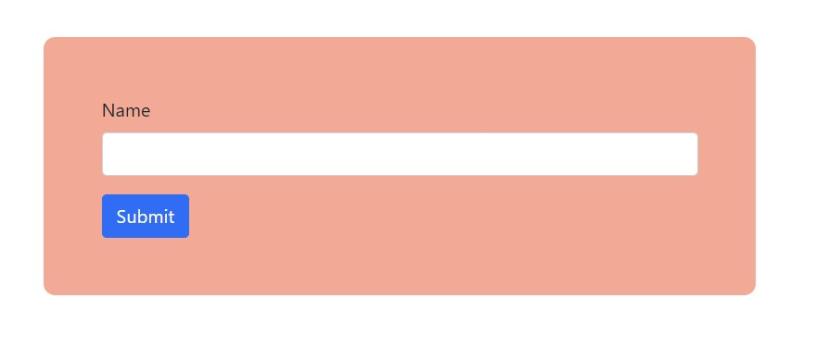

33. create a html form which takes two numbers from user and print

> sum of two numbers

> power = m n

> log m n

> factorial of first number

> biggest number

> print all numbers between first number to second numbert

> first number two n numbers > star program Ans.

<!DOCTYPE html>

<html lang="en">

<head>

<meta charset="UTF-8">

<meta http-equiv="X-UA-Compatible" content="IE=edge">

<meta name="viewport" content="width=device-width, initial-scale=1.0">

<title>Document</title>

<link

href="https://cdn.jsdelivr.net/npm/bootstrap@5.0.2/dist/css/bootstrap.min.css" rel="stylesheet"

integrity="sha384-

EVSTQN3/azprG1Anm3QDgpJLIm9Nao0Yz1ztcQTwFspd3yD65VohhpuuCOmLASj C" crossorigin="anonymous">

<link rel="stylesheet"

href="https://fonts.googleapis.com/css2?family=Poppins:wght@300;400;500;70 0;900&amp;display=swap">

<style>

*,

body {

font-family: 'Poppins', sans-serif;

font-weight: 400;

-webkit-font-smoothing: antialiased;

text-rendering: optimizeLegibility;

-moz-osx-font-smoothing: grayscale

}

html,

body {

height: 100%;

background-color: #152733;

overflow: hidden

}

.form-holder {

display: flex;

flex-direction: column;

justify-content: center;

align-items: center;

text-align: center;

min-height: 100vh

}

.form-holder .form-content {

position: relative;

text-align: center;

display: -webkit-box;

display: -moz-box;

display: -ms-flexbox;

display: -webkit-flex;

display: flex; -webkit-justify-content: center;

justify-content: center; -webkit-align-items: center;

align-items: center;

padding: 60px

}

.form-content .form-items {

border: 3px solid #fff;

padding: 40px;

display: inline-block;

width: 100%;

min-width: 540px; -webkit-border-radius: 10px; -moz-border-radius: 10px;

border-radius: 10px;

text-align: left; -webkit-transition: all .4s ease;

transition: all .4s ease

}

.form-content h3 {

color: #fff;

text-align: left;

font-size: 28px;

font-weight: 600;

margin-bottom: 5px

}

.form-content h3.form-title { margin-bottom: 30px

}

.form-content p {

color: #fff;

text-align: left;

font-size: 17px;

font-weight: 300;

line-height: 20px;

margin-bottom: 30px

}

.form-content label,

.was-validated .form-check-input:invalid~.form-check-label,

.was-validated .form-check-input:valid~.form-check-label {

color: #fff

}

.form-content input[type="text"],

.form-content input[type="password"],

.form-content input[type="email"], .form-content select {

width: 100%;

padding: 9px 20px;

text-align: left;

border: 0;

outline: 0;

border-radius: 6px;

background-color: #fff;

font-size: 15px;

font-weight: 300;

color: #8d8d8d;

-webkit-transition: all .3s ease;

transition: all .3s ease;

margin-top: 16px

}

.btn-primary {

background-color: #6c757d;

outline: none;

border: 0;

box-shadow: none

}

.btn-primary:hover,

.btn-primary:focus, .btn-primary:active {

background-color: #495056;

outline: none !important;

border: none !important; box-shadow: none

}

.form-content textarea {

position: static !important;

width: 100%;

padding: 8px 20px;

border-radius: 6px;

text-align: left;

background-color: #fff;

border: 0;

font-size: 15px;

font-weight: 300;

color: #8d8d8d;

outline: none;

resize: none;

height: 120px; -webkit-transition: none;

transition: none;

margin-bottom: 14px

}

.form-content textarea:hover, .form-content textarea:focus {

border: 0;

background-color: #ebeff8;

color: #8d8d8d

}

.mv-up {

margin-top: -9px !important;

margin-bottom: 8px !important

}

.invalid-feedback {

color: #ff606e

}

.valid-feedback {

color: #2acc80

}

</style>

</head>

<body>

<div class="form-body">

<div class="row">

<div class="form-holder">

<div class="form-content">

<div class="form-items">

<h3>Please Provide Details...</h3> <p>Fill in the data below.</p>

<form

action="https://www.polygwalior.ac.in/student/20BRAPCCO06_66.php" method="post">

<div class="col-md-12">

<input class="form-control" type="text" name="fno" placeholder="First Number"

required="">

</div>

<div class="col-md-12">

<input class="form-control" type="text" name="lno" placeholder="Second Number"

required="">

</div>

<div class="form-button mt-3">

<button id="submit" type="submit" name="submit" class="btn btn-primary">Submit</button>

</div>

</form>

</div>

</div>

</div>

</div>

</div>

</body>

</html>

## Output: -

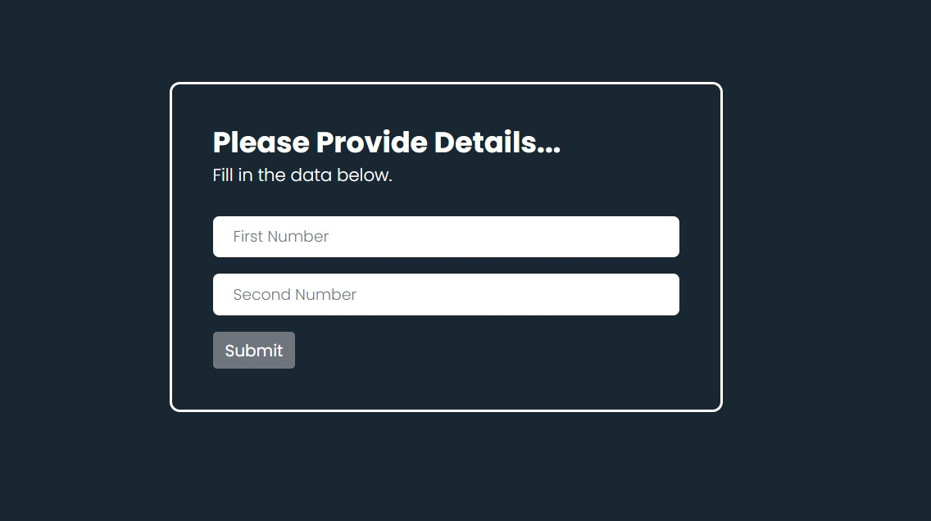

34. create a html form which takes two dob of two persons and print **let( date o birth = "01-07-2001")**

> print 12-july-2001 (DD-MON-YYYY)

> print 12/07/01 (DD/07/01)

> print 200110712

> print the age of the person > who is younger Ans.

<!DOCTYPE html>

<html lang="en">

<head>

<meta charset="UTF-8">

<meta http-equiv="X-UA-Compatible" content="IE=edge">

<meta name="viewport" content="width=device-width, initial-scale=1.0">

<title>Document</title>

<style>

* {

box-sizing: border-box

}

input[type="text"],

select,

textarea {

width: 100%;

padding: 12px;

border: 1px solid #ccc;

border-radius: 4px;

resize: vertical

}

label {

padding: 12px 12px 12px 0;

display: inline-block

}

input[type="submit"] {

background-color: #04aa6d; color: #fff;

padding: 12px 20px;

border: none;

border-radius: 4px;

cursor: pointer;

float: right

}

input[type="submit"]:hover {

background-color: #45a049

}

.container {

border-radius: 5px;

background-color: #f2f2f2;

padding: 20px

}

. col-25 {

float: left;

width: 25%;

margin-top: 6px

} . col-75 {

float: left;

width: 75%;

margin-top: 6px

} .button {

padding-top: 20px

}

.row:after {

content: "";

display: table;

clear: both

}

@media screen and (max-width:600px) {

. col-25, . col-75,

input[type="submit"] {

width: 100%;

margin-top: 0

}

}

</style>

</head>

<body>

<div class="container">

<form action="https://www.polygwalior.ac.in/student/20BRAPCCO06_68.php" method="POST">

<div class="row">

<div class="col-25">

<label for="fname">first date of birth</label>

</div>

<div class="col-75">

<input type="date" id="fname" name="A" placeholder="enter here.....">

</div>

</div>

<div class="row">

<div class="col-25">

<label for="lname">second date of birth</label>

</div>

<div class="col-75">

<input type="date" id="lname" name="B" placeholder="second dob enter here....">

</div>

</div>

<div class="row button">

<input type="submit" value="Submit">

</div>

</form>

</div>

</body>

</html>

Output: -

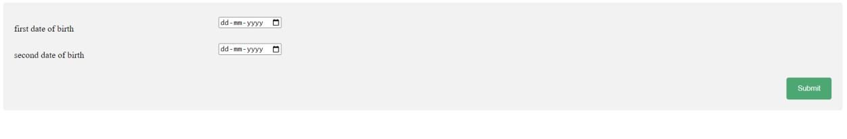

35. Basic JavaScript command.

Ans.

<html>

<head>

<title>

js

</title>

<style>body{margin:0}.content{background-color:#c9ffff;paddingtop:40px;padding-bottom:40px;padding-left:40%;padding-right:40%;alignitems:center;align-content:center}.button{background-

color:#005ce6;border:none;padding:20px;color:#f0f8ff}p{text-align:center;marginleft:2%;margin-right:2%;font-size:200%}</style>

</head>

<body>

<p id="heading">RAVINDRA PRATAPl<br>Dr. Bhim Rao AmbedKar Polythechnic College, Gwalior</p>

<br>

<div class="content">

<button type="button" class="button" onclick="first()">Red</button>

<button type="button" class="button" onclick="second()">Blue</button>

<button type="button" class="button" onclick="third()">green</button>

<br><br>

<button type="button" class="button" onclick="fourth()">12px</button>

<button type="button" class="button" onclick="fifth()">20px</button>

<button type="button" class="button" onclick="sixth()">40px</button>

<br><br>

<button type="button" class="button" onclick="seventh()">Show </button>

<button type="button" class="button" onclick="eighth()">Hide</button>

<br> <br>

<button type="button" class="button" onclick="nineth()">Bold </button>

<button type="button" class="button" onclick="tenth()">Normal</button>

<br><br>

<button type="button" class="button" onclick="eleventh()">left</button> <button type="button" class="button" onclick="twelth()">middle</button>

<button type="button" class="button" onclick="thirtenth()">right</button>

<br><br>

<button type="button" class="button" onclick="fourthenth()">red</button>

<button type="button" class="button" onclick="fifthenth()">pink</button>

<br><br>

<button type="button" class="button" onclick="sixthenth()">font1</button>

<button type="button" class="button" onclick="sevententh()">font2</button>

<button type="button" class="button" onclick="eightenth()">font3</button>

</div>

<script>function

first(){document.getElementById("heading").style.color="red";}function second(){document.getElementById("heading").style.color="blue";}function third(){document.getElementById("heading").style.color="green";}function fourth(){document.getElementById("heading").style.fontSize="12px";}function fifth(){document.getElementById("heading").style.fontSize="20px";}function sixth(){document.getElementById("heading").style.fontSize="40px";}function seventh(){document.getElementById("heading").style.display="block";}function eighth(){document.getElementById("heading").style.display="none";}function nineth(){document.getElementById("heading").style.fontWeight="bold";}function tenth(){document.getElementById("heading").style.fontWeight="normal";}function eleventh(){document.getElementById("heading").style.textAlign="left";}function twelth(){document.getElementById("heading").style.textAlign="center";}function thirtenth(){document.getElementById("heading").style.textAlign="right";}function thirtenth(){document.getElementById("heading").style.textAlign="right";}function fourthenth(){document.body.style.backgroundColor="red";}function fifthenth(){document.body.style.backgroundColor="pink";}function

sixthenth(){document.getElementById("heading").style.fontFamily="Impact,Charcoal, sans-serif";}function

sevententh(){document.getElementById("heading").style.fontFamily="Brush Script MT, cursive";}function

eightenth(){document.getElementById("heading").style.fontFamily="Courier New, monospace";}</script>

</body>

</html>

### Output: -

**36.** Write a code to make Attendance Table using HTML, CSS, and JavaScript.

Ans. <html>

<head>

    <link href="https://cdn.jsdelivr.net/npm/bootstrap@5.1.3/dist/css/bootstrap.min.css" rel="stylesheet">

    <script src="https://cdn.jsdelivr.net/npm/bootstrap@5.1.3/dist/js/bootstrap.bundle.min.js"></script>

    <style>

        table {

            font-family: Andalé Mono (monospace);

            border-collapse: collapse;

            width: 100%;

            border: 1px solid #000;

            margin-top: 40px

        }

        td,

        th {

            border: 1px solid #ddd;

            text-align: left;

            padding: 8px;

            border: 1px solid #000

        }

        tr:nth-child(even) {

            background-color: #ddd;

            border: 1px solid #000

        }

    </style>

</head>

<body>

    <div class="container mt-3">

        <form action="">

            <h2>Write a code to make Attendance Table using HTML , CSS and Javascript .</h2>

            <p></p>

            <table class="table" id="myTable">

                <thead>

                    <tr>

                        <th>Firstname</th>

                        <th>Lastname</th>

                        <th>Email</th>

                        <th><input type="radio" name="Present" id="P" onclick="selectAll(this)" class="present-button"

                                value="attend">All Present</th>

                        <th><input type="radio" name="Present" id="A" onclick="selectAll( this)" class="present-button"

                                value="not-attend">All Absent</th>

                    </tr>

                </thead>

                <tbody>

                    <tr>

                        <td>ravindra</td>

                        <td>pratap</td>

                        <td>ravindra@somemail.com</td>

                        <td><input type="radio" name="ravindra" class="present-button" value="attend"> Present</td>

                        <td><input type="radio" name="ravindra" class="present-button" value="not-attend">Absent</td>

                    </tr>

                    <tr class="table-primary">

                        <td>RAV</td>

                        <td>SINGH</td>

                        <td>RAV@example.com</td>

                        <td><input type="radio" name="Aryan" class="present-button" value="attend"> Present</td>

                        <td><input type="radio" name="Aryan" class="present-button" value="not-attend">Absent</td>

                    </tr>

                    <tr class="table-success">

                        <td>RAVINDR

                        </td>

                        <td>PRATAP</td>

                        <td>RAVINDRA@example.com</td>

                        <td><input type="radio" name="harshvardhan" class="present-button" value="attend"> Present</td>

                        <td><input type="radio" name="harshvardhan" class="present-button" value="not-attend">Absent

                        </td>

                    </tr>

                    <tr class="table-danger">

                        <td>RAVINDRA</td>

                        <td>RAVI</td>

                        <td>Ravil@example.com</td>

                        <td><input type="radio" name="Amul" class="present-button" value="attend"> Present</td>

                        <td><input type="radio" name="Amul" class="present-button" value="not-attend">Absent</td>

                    </tr>

                    <tr class="table-info">

                        <td>MANTHAN</td>

                        <td>RATHORE</td>

                        <td>manthan@example.com</td>

                        <td><input type="radio" name="tanuj" class="present-button" value="attend"> Present</td>

                        <td><input type="radio" name="tanuj" class="present-button" value="not-attend">Absent</td>

                    </tr>

                    <tr class="table-warning">

                        <td>RUDRANSH</td>

                        <td>VERMA</td>

                        <td>RUDRANSH@example.com</td>

                        <td><input type="radio" name="yuvraj" class="present-button" value="attend"> Present</td>

                        <td><input type="radio" name="yuvraj" class="present-button" value="not-attend">Absent</td>

                    </tr>

                    <tr class="table-active">

                        <td>KAUSHIK</td>

                        <td>RATHORE</td>

                        <td>KAUSHIK@example.com</td>

                        <td><input type="radio" name="om" class="present-button" value="attend"> Present</td>

                        <td><input type="radio" name="om" class="present-button" value="not-attend">Absent</td>

                    </tr>

                    <tr class="table-secondary">

                        <td>RAVU</td>

                        <td>RANJCV</td>

                        <td>RAVU@example.com</td>

                        <td><input type="radio" name="jatin" class="present-button" value="attend"> Present</td>

                        <td><input type="radio" name="jatin" class="present-button" value="not-attend">Absent</td>

                    </tr>

                    <tr class="table-light">

                        <td>MUSKAN</td>

                        <td>YADAV</td>

                        <td>MUSKAN@example.com</td>

                        <td><input type="radio" name="dev" class="present-button" value="attend"> Present</td>

                        <td><input type="radio" name="dev" class="present-button" value="not-attend">Absent</td>

                    </tr>

                    <tr class="table-info">

                        <td>VISHNU</td>

                        <td>PRATAP</td>

                        <td>VISHNU@example.com</td>

                        <td><input type="radio" name="Nikunj" class="present-button" value="attend"> Present</td>

                        <td><input type="radio" name="Nikunj" class="present-button" value="not-attend">Absent</td>

                    </tr>

                    <tr class="table-dark">

                        <td></td>

                        <td></td>

                        <td><b>Total number of student :- </b></td>

                        <td>

                            <p id="demo">10</p>

                        </td>

                        <td></td>

                    </tr>

                </tbody>

            </table>

        </form>

    </div>

    <!-- <p id="demo">Hello</p> -->

    <script

        type="text/javascript">function selectAll(check) { var radio, i = 0; while (radio = check.form.elements[i++]) if (radio.type == "radio" && radio.value == check.value) radio.checked = true; }; var x = document.getElementById("myTable").rows.length; var t = x - 2; document.getElementById("demo").innerHTML = t;</script>

</body>

</html>

### Output: -