This project is integration of machine learning and devOps. The Industry require is just a fully and complete Automation. I would like to Demostrate this Article with an TASK given to us by Mr. Vimal Daga Sir

So the task Given to us is as follows:-

1. Create container image that’s has Python3 and Keras or numpy installed using dockerfile

2. When we launch this image, it should automatically starts train the model in the container.

3. Create a job chain of job1, job2, job3, job4 and job5 using build pipeline plugin in Jenkins

4. Job1 : Pull the Github repo automatically when some developers push repo to Github.

5. Job2 : By looking at the code or program file, Jenkins should automatically start the respective machine learning software installed interpreter install image container to deploy code and start training( eg. If code uses CNN, then Jenkins should start the container that has already installed all the softwares required for the cnn processing).

6. Job3 : Train your model and predict accuracy or metrics.

7. Job4 : if metrics accuracy is less than 80% , then tweak the machine learning model architecture.

8. Job5: Retrain the model or notify that the best model is being created

9. Create One extra job job6 for monitor : If container where app is running. fails due to any reason then this job should automatically start the container again from where the last trained model left.

So by reading this task you must came to know how automated it is as it has removed all the hyper-parameters which we use to use in the Machine Learning.



So let’s see how to implement this project

First of all we have to set an environment on container to train our model on docker .

So for this we should start with building a dockerfile

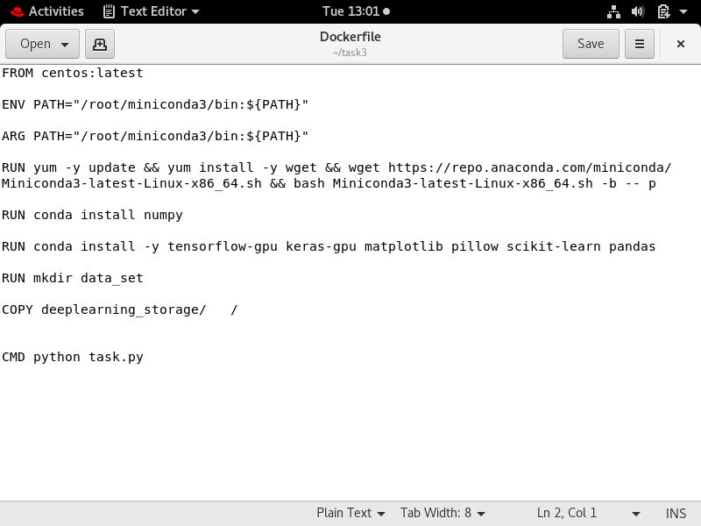

**BUILD THIS DOCKER FILE USING COMMAND**

docker build –t task:v1 .

Creating job1[git_hub_download] — in this i have used the github link to push the data automatically by poll scm and then made this data copy to a folder in base os /root/deeplearning_storage.

CMD USED FOR COPYING

sudo cp -v * /root/deeplearning_storage

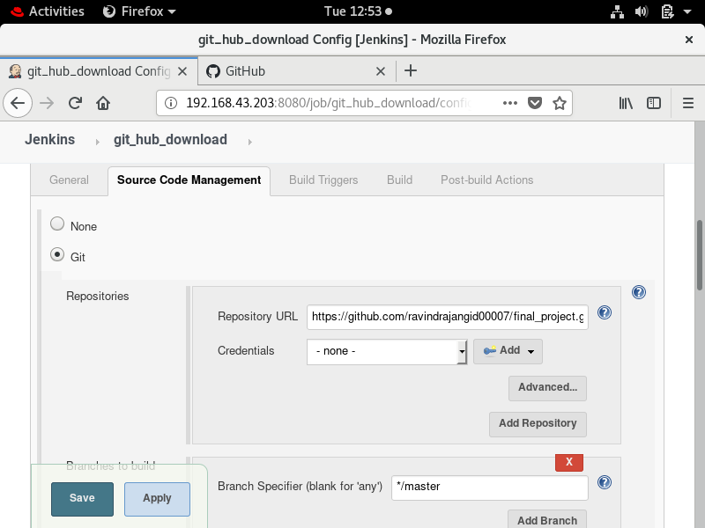

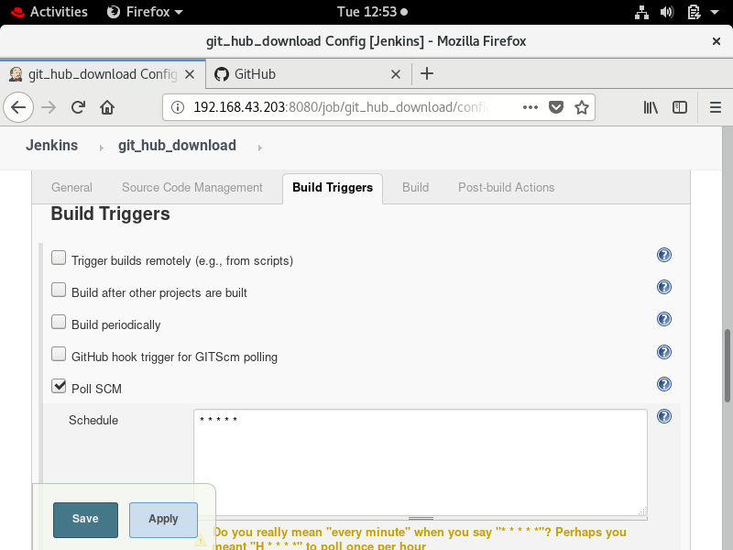

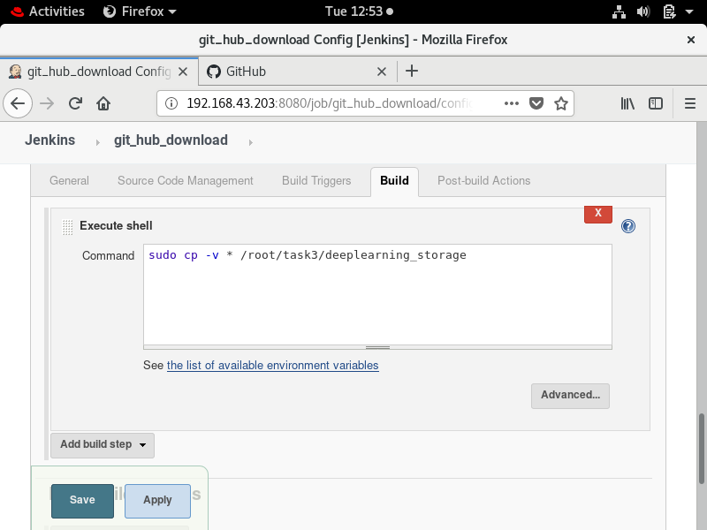

Creating job2[image_launcher] - JOB 2 is used for launhing an container from image in which we have setuped our environment .this job will automatically triggered after when job1 succesfully completed.

In this job I also enable trigger builds remotely which will be used in later of this project

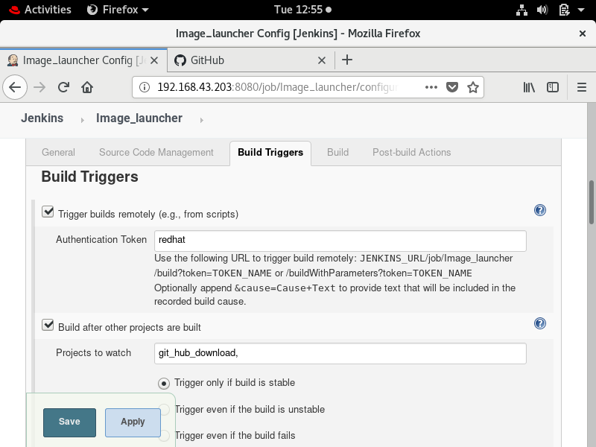

if sudo cat /root/deeplearning_storage/task.py |grep keras

then

if sudo docker container ps –a |grep program

then

sudo docker rm –f program

fi

sudo docker run –it –name program - /root/file_storage/:/data_set task:v1

else

exit 0

fi

[file_storage is host’s os dir. And data_set is container dir.]🡪to make data will be copy in data_set dir.

I also enable email extension for reciving email after successfully build or failer in both condation

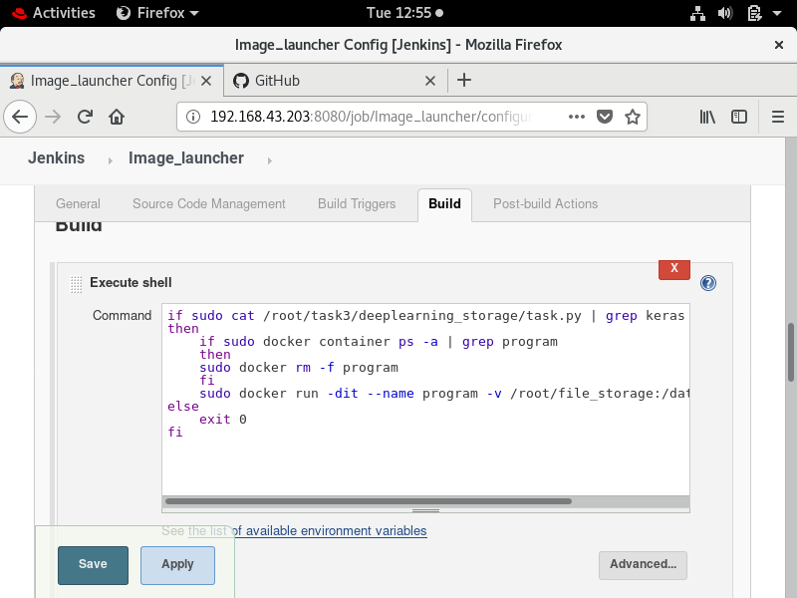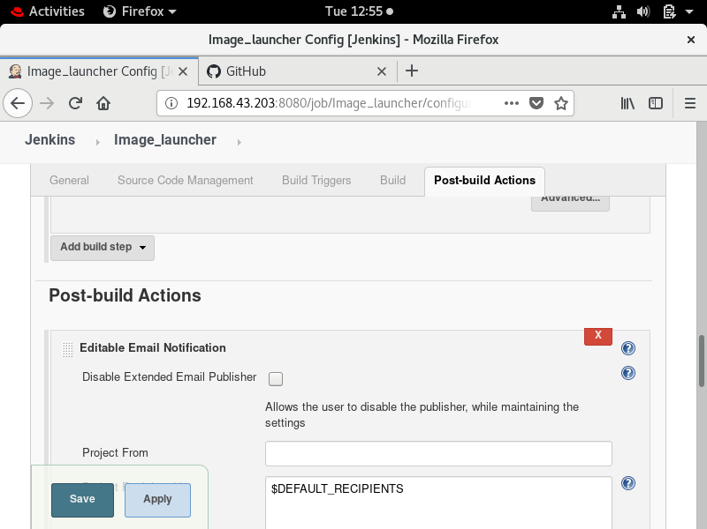

Creating job3 [accuracy _checker]- This job will be remote triggred by python program when it just become to terminate .

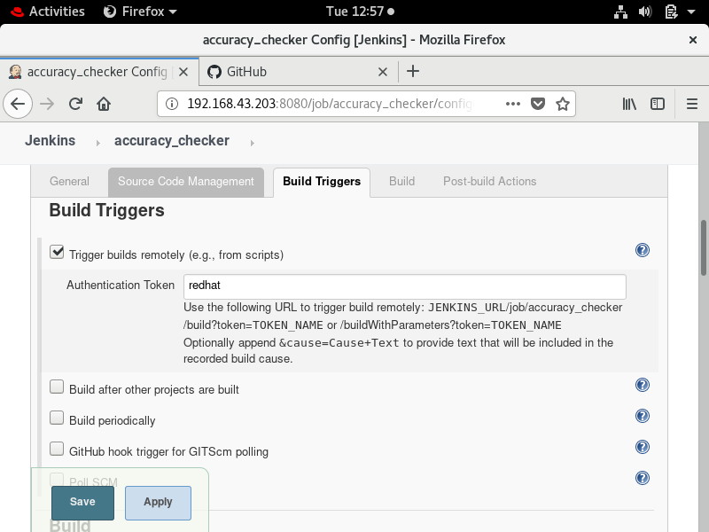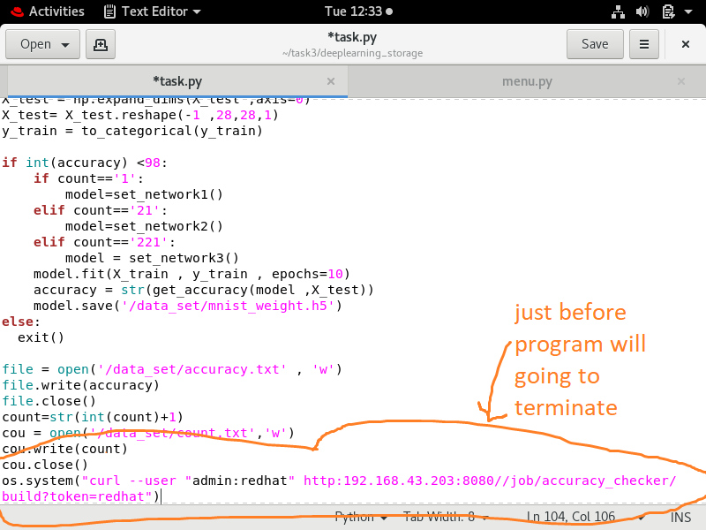

Now the main work of this job .this job will extract the accuracy form /root/file_storage/accuracy.txt and compare with required accuracy . if accuracy of model is not sufficient then it will again triggred the **job2[image_launcher]** and again trained the model with twicked code in file.

And if we achive the required accuracy then Jenkins will inform the developer by email. Otherwise job2 and job3 will be in loop until and unless we achive the required accuracy

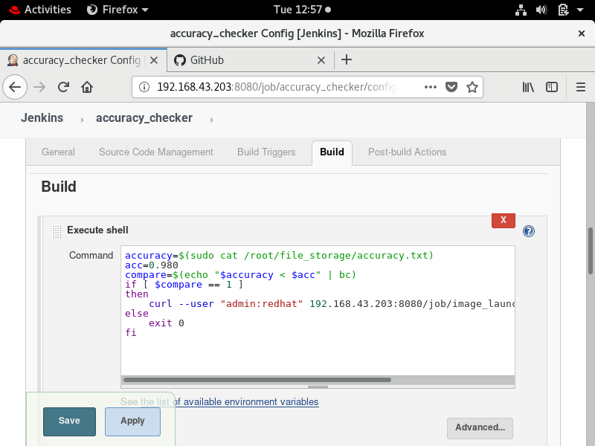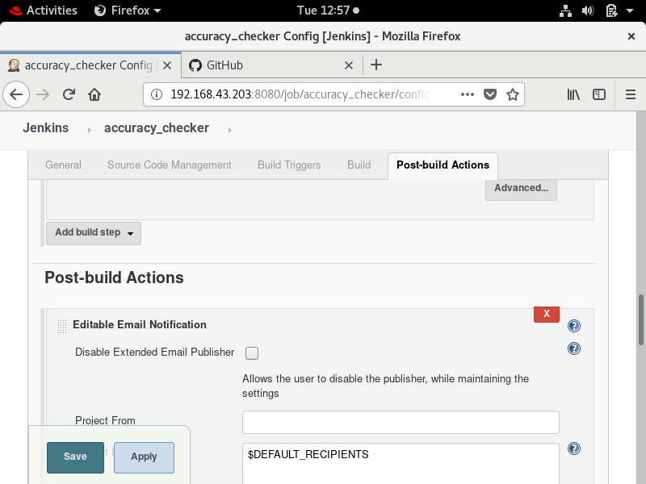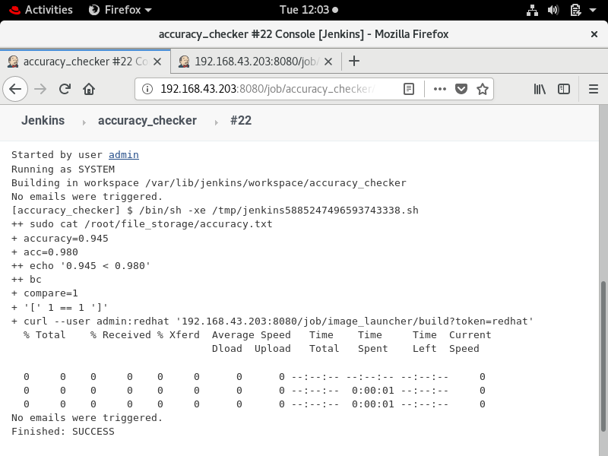

**Creating job 4[moniter]** – This job will moniter the program running in the container . if from any reason program inside container get terminate before finish then this job will be in seen .this job will be remote triggred by program if any exception come into the picture.for achiving this we haveto add a try except block in program.

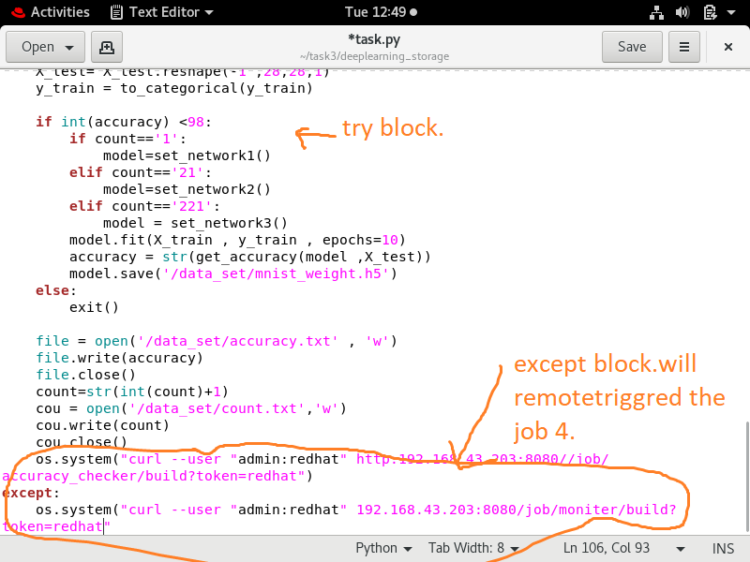

This job will again execute the job 2 and also inform the developer by email about this exception or failer.

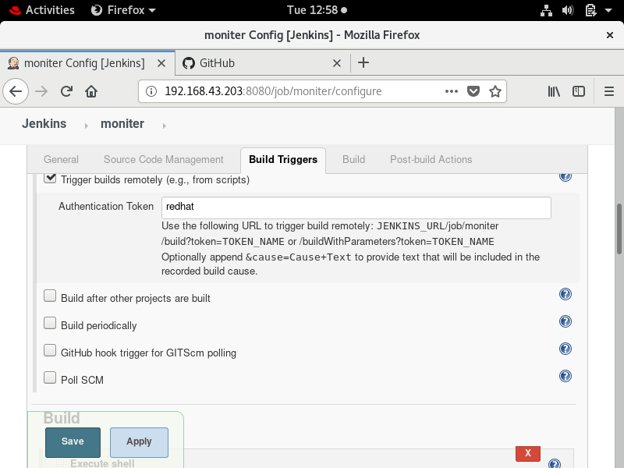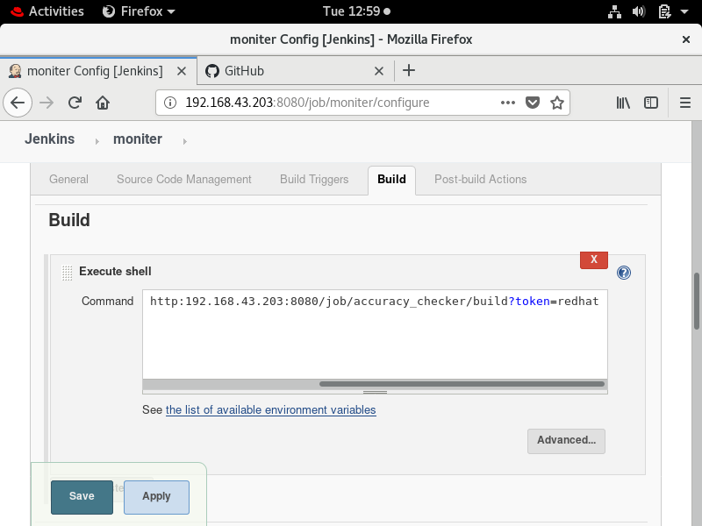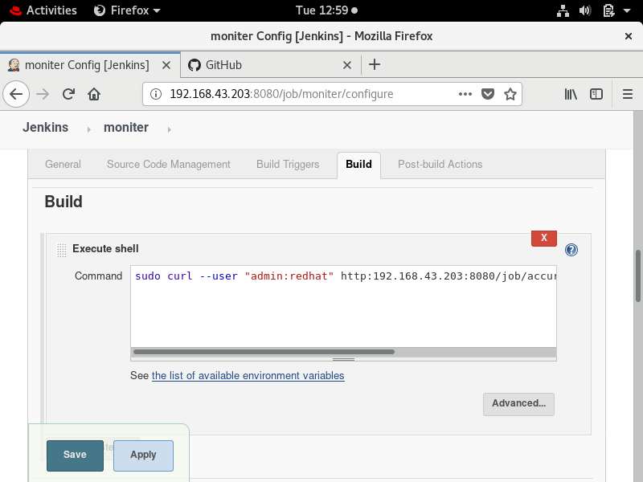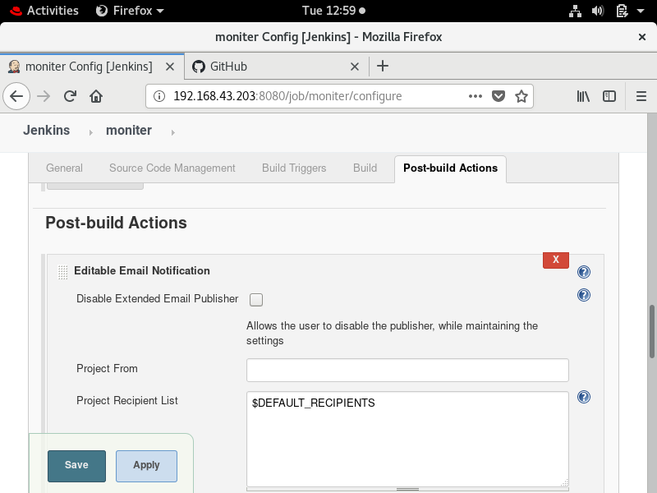

MODEL TRAIN………………

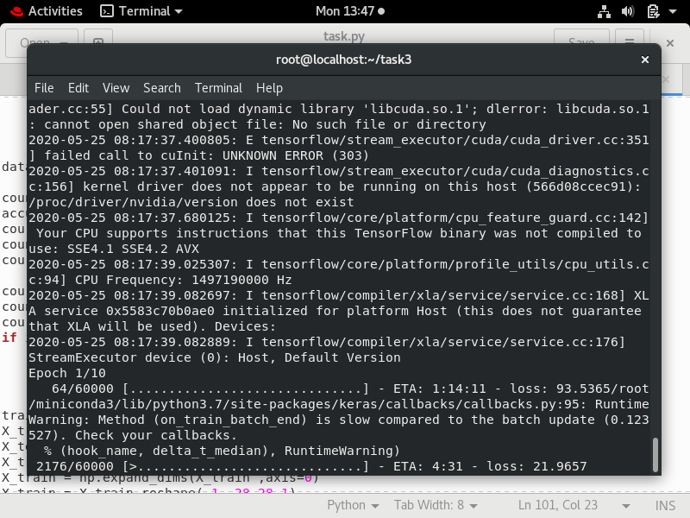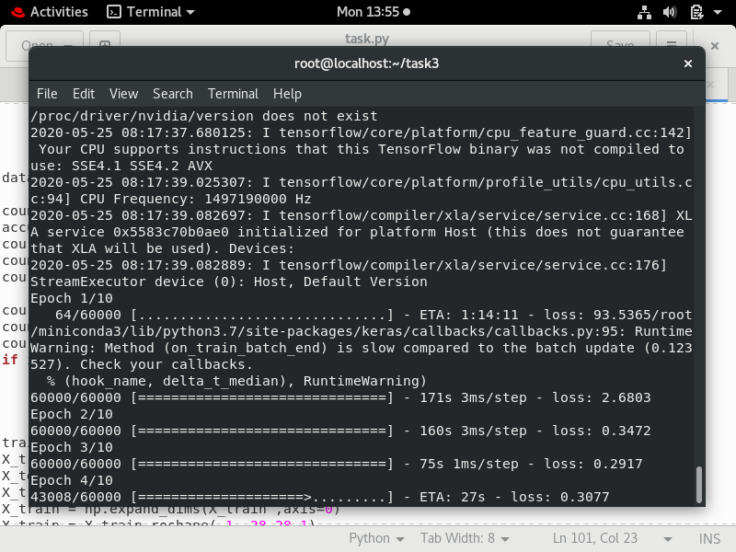

After completion of program accuracy.txt file and status file(count.txt) ,weigths of model(.h5) file will be in file_storage dir.

