**What is an agent:**  
A agent which should have three main components.

1. LLM to power the brain
2. Memory to keep track the state and context
3. Tool required for processing any task

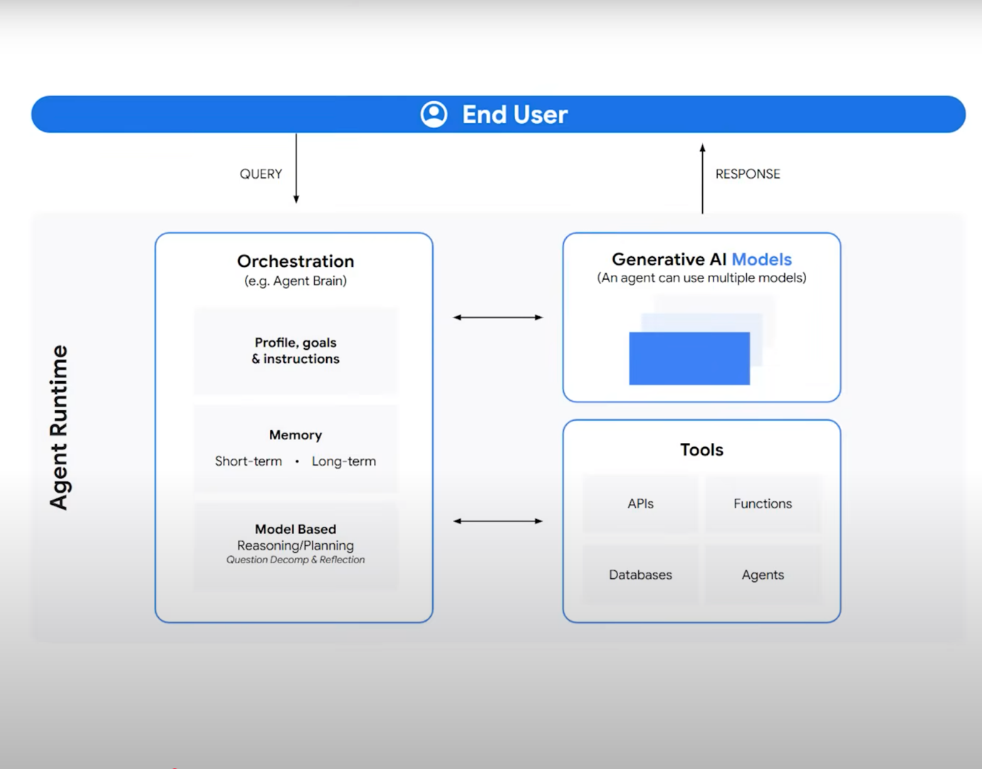

Example: For order issue support how agent can work

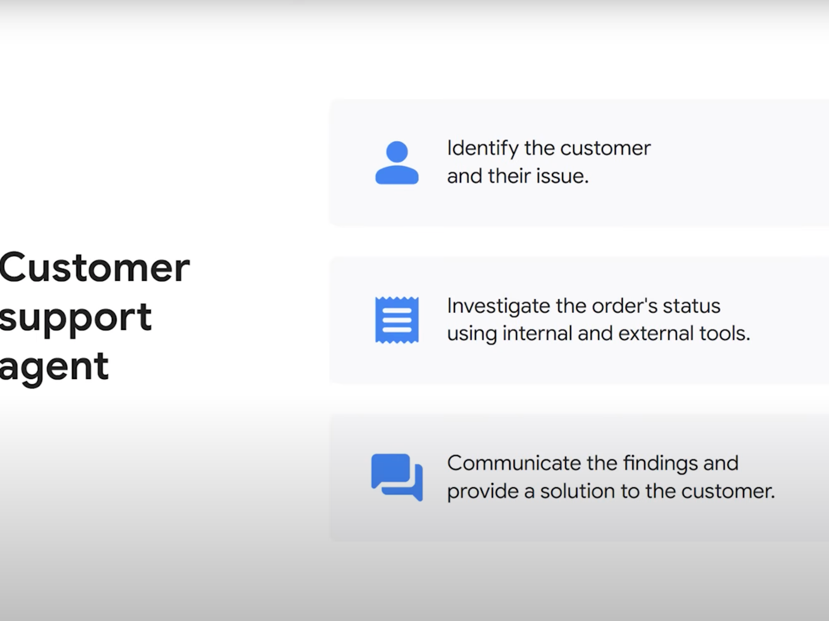

How it can work:  
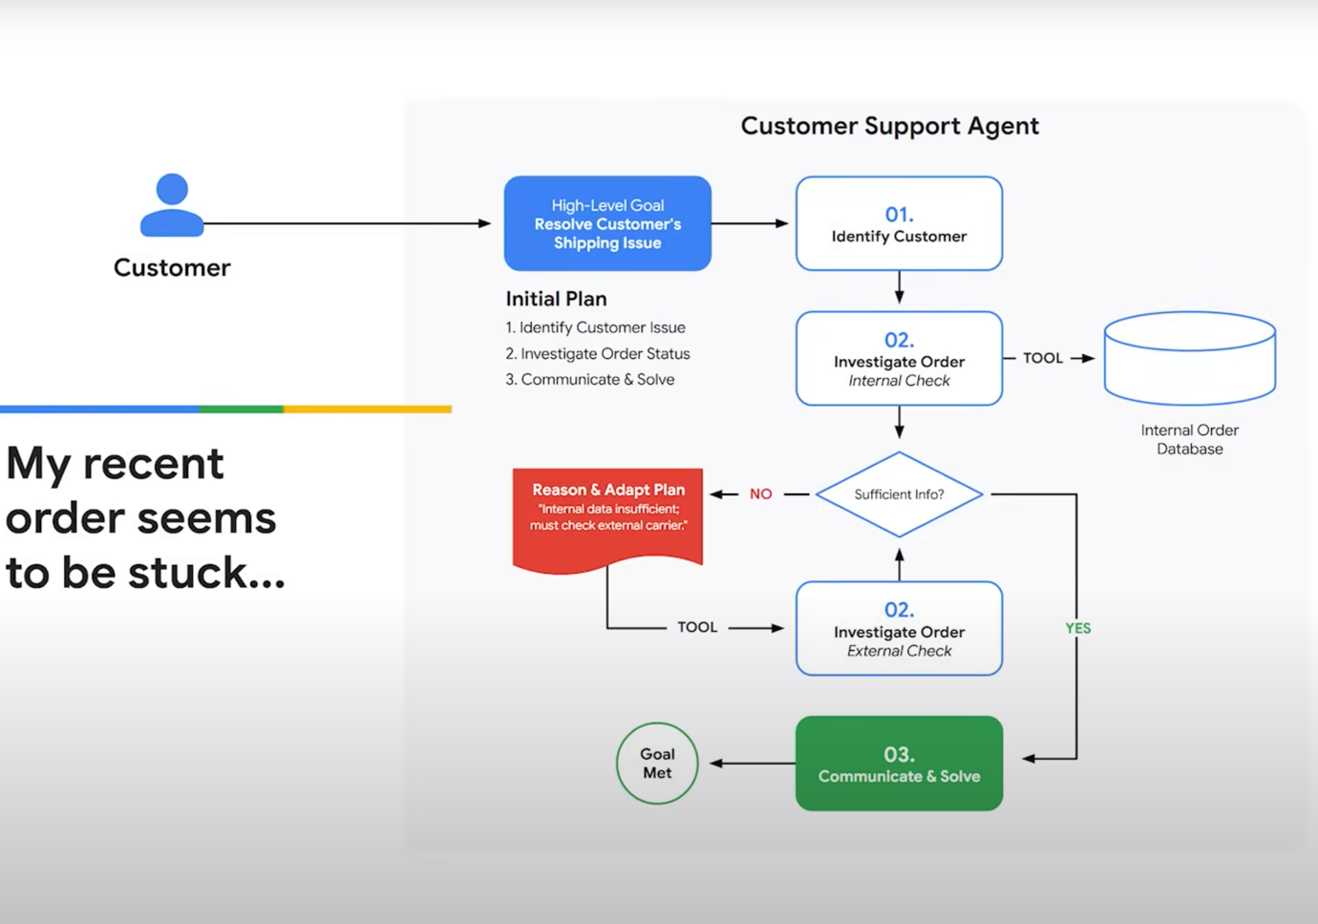

Logix Map:  
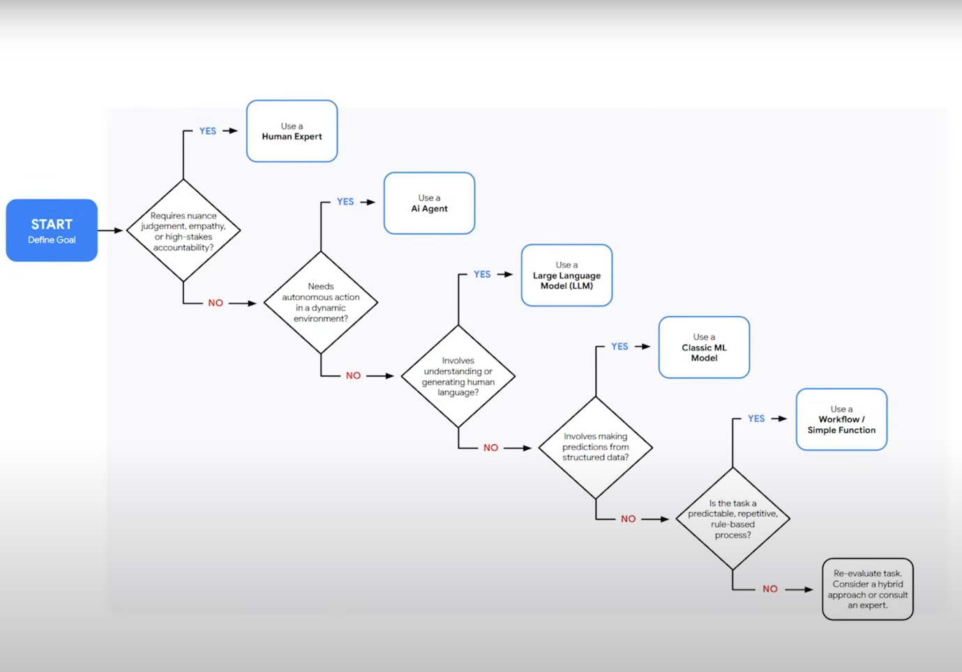

When to use Agent as tool or as sub-agent

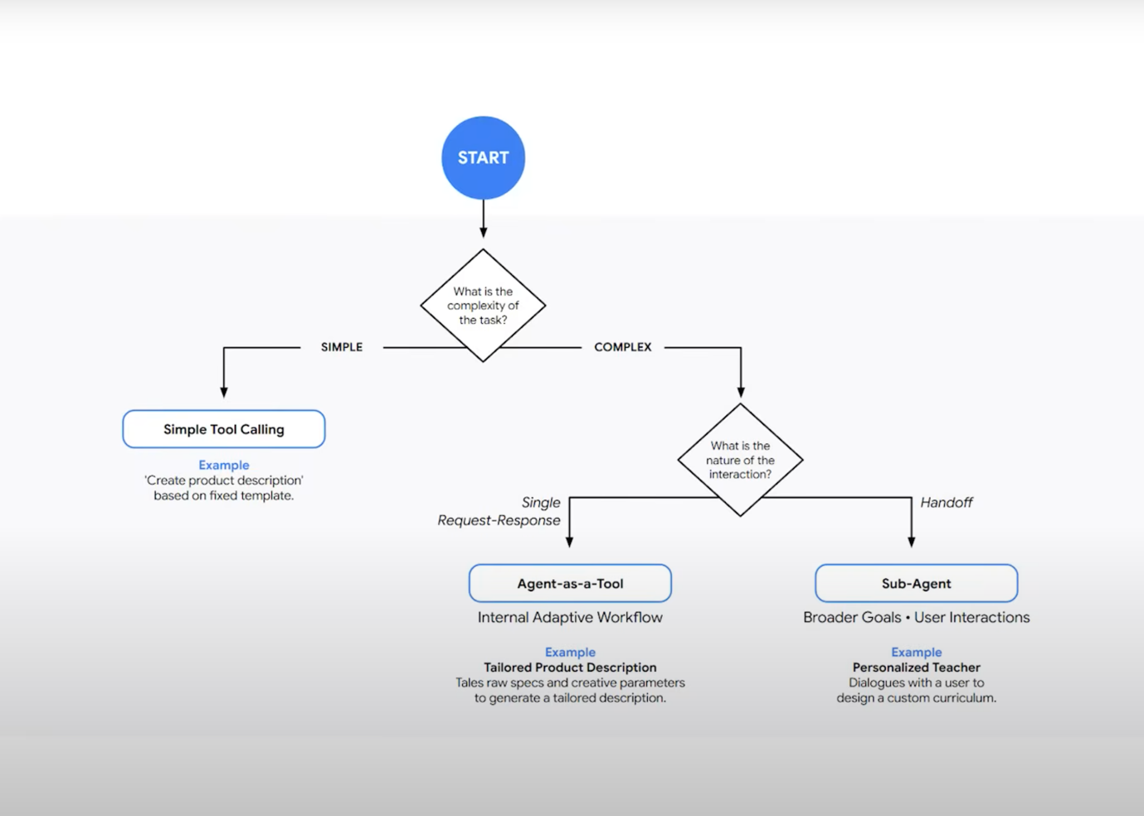

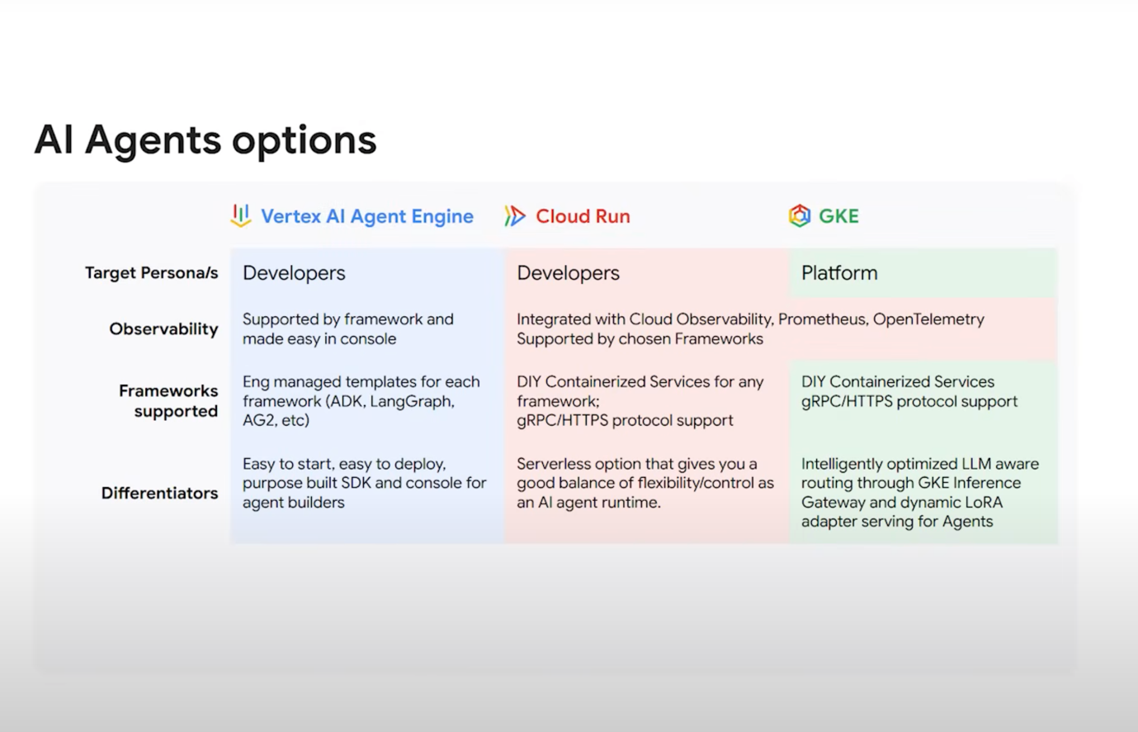

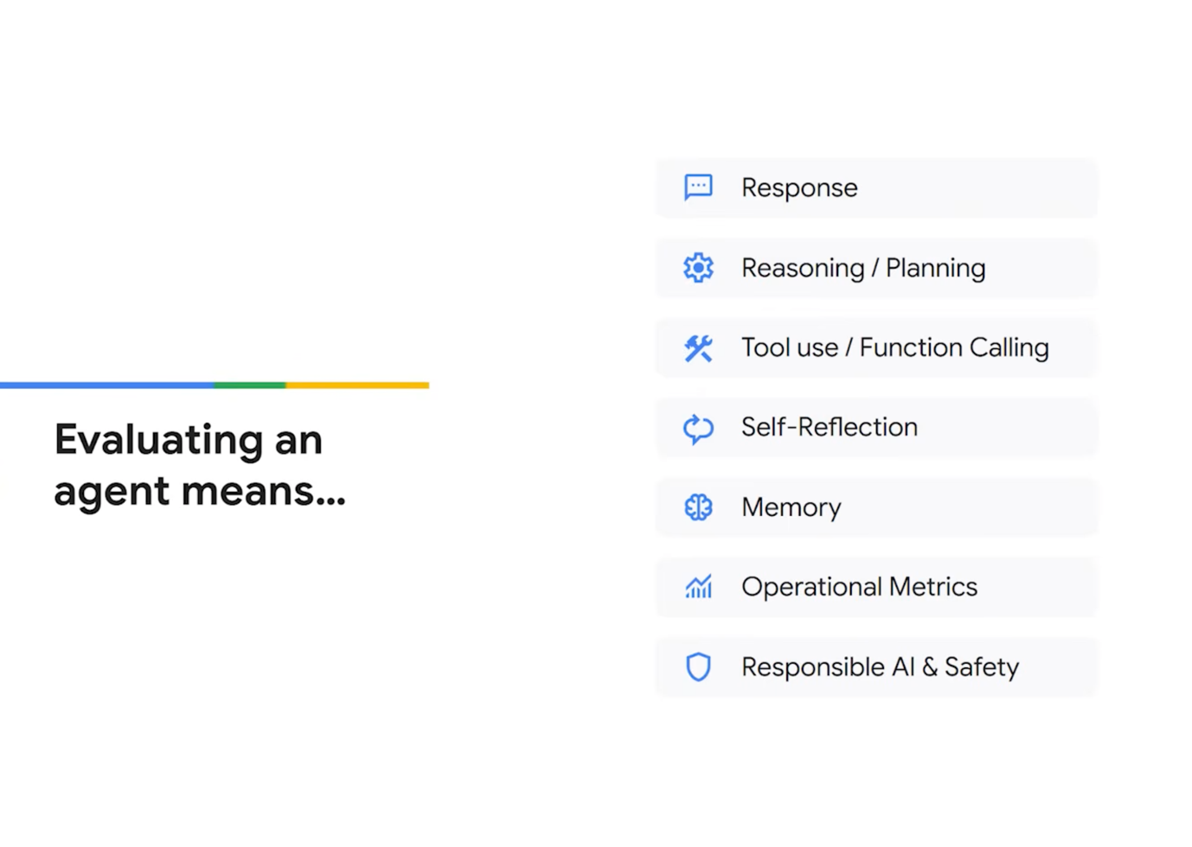

**Resources:**

**LangGraph Release Week Recap →https://goo.gle/43XsQs7**

**Benchmarking Multi-Agent Architectures → https://goo.gle/4kUG4vA**

**Release→https://goo.gle/4lm9WB2**

**Agent Development Kit (ADK) v1.0.0 Blog →https://goo.gle/468yBVd**

**Agent Development Kit (ADK)→ https://goo.gle/3TsHZM9**

**LangChain→https://goo.gle/4kpA9hn**

**LangGraph →https://goo.gle/40nl7RM**

**crewAI→https://goo.gle/45xXppw**

**Evaluation white paper→https://goo.gle/4nhhZkn**