# Introduction:

This is project is all about the Acme Pharmaceuticals, in which drugs are beings tested by the company on the random patients and making the observation of all the results. This organization has certain number of sites on which the patients are making his visits. Based on the visits company is collecting the data of the patients and the making the analysis on the patients.

The given below points are representing the tables, by which the company is collecting and maintain the records.

**Studies:** This table is collecting the number of studies, which contains two columns, where StudyID is marked as the primary key.

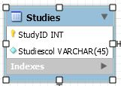

**Patients:** This table contains the information about the patients, here PatientID is representing the primary key and SiteID and GenderID is used as the foreign key.

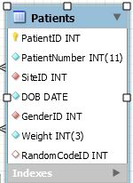

**Sites:** This tables contains the information about the sites of the organization where are the patients are going to visit. Here SiteID is the primary key and StudyID and StateID are the foreign key in this table.

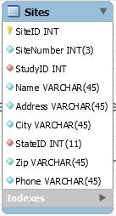

**Visits:** This table contains the information about the visits of the patients. Here VisitID is the primary key and the VisitTypeID and WithdrawREason are the foreign key in this table.

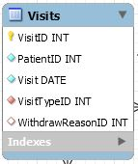

**RandomCodes:** This table is collecting the information of the patient about the availability and treatment of the patients. Here RandomCodeID is use as primary key and StudyID is used as the foreign key.

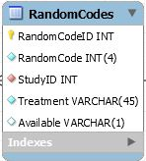

**DrugKits:** This table contains the information about the DrugKits. Here DrugKitID is used as the primary key and SiteID is used as the foreign key.

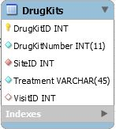

The ER diagram are given for the above database.

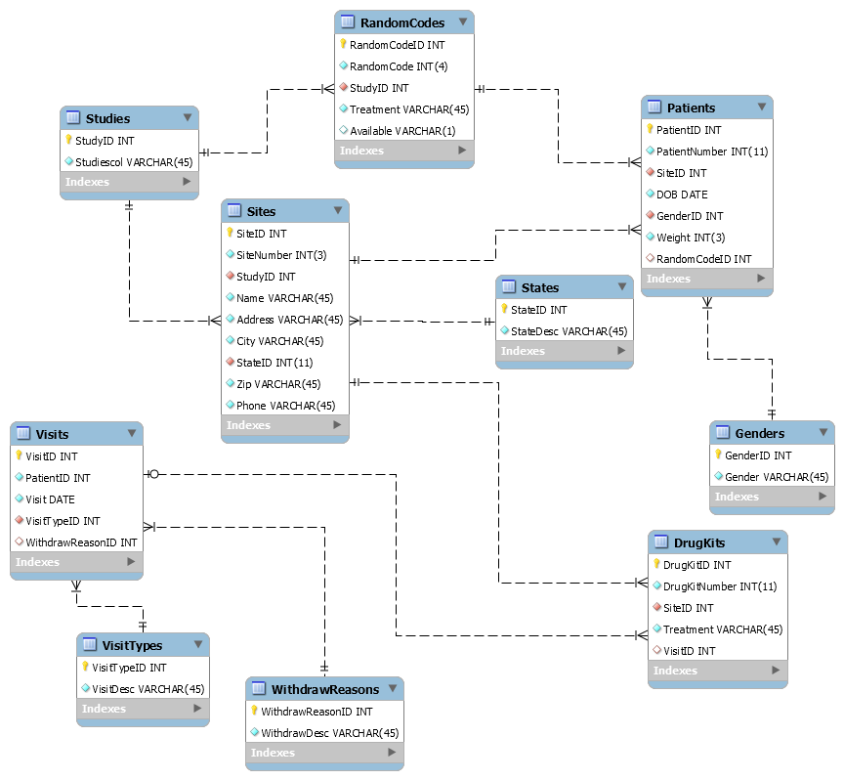

The views of the requirements are listed below.

The name of this view is availabledurgs, which represents the DrugKitNumber, siteNumber and Treatment of the patients.

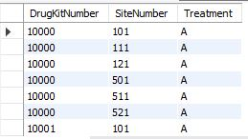

SELECT `availabledrugs`.`DrugKitNumber`,

`availabledrugs`.`SiteNumber`,

`availabledrugs`.`Treatment`

FROM `acme pharmaceuticals`.`availabledrugs`;

SELECT * FROM `acme pharmaceuticals`.withdraw_patient_status;

The name of the given view is AvailableRandomCode, which is showing the randomcode for the patients, studyID and studiesco.

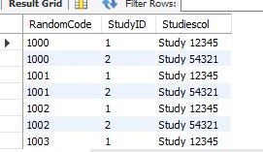

SELECT `availablerandomcode`.`RandomCode`,

`availablerandomcode`.`StudyID`,

`availablerandomcode`.`Studiescol`

FROM `acme pharmaceuticals`.`availablerandomcode`;

SELECT * FROM `acme pharmaceuticals`.availabledrugs;

All the requirements are implemented in the database which is attached with the docs.