Objective Questions
1-What is the total no. of tables present in the data?
There are two table present in the data.
2-What is the total no. of attributes present in the data?
There are 22 attributes.
3-How many categorical columns are there in the data? [Search about categorical and continuous data, and try to answer this question]
There are 18 categorical columns.
4-The data consists of some inconsistent and missing values so ensure that the data used for further analysis is cleaned.
- Firsly I checked the duplicate rows in the data there were no duplicate rows.
- I checked the missing values in the data there missing values in three columns. First one in latitude, second one in longitude. Basically these columns are not to much important for the data analysis purpose because it is already mentioned the county and city name then I deleted both the columns from the data.
- There were few missing values in cuisines column I replace these null values by using mode function on that column
- Datekey- opening was not in proper date format I replace “_” by “-“ in my data.
- I created 1 more table for the currency rate in inr then used the vlookup formula and retrieved all value in main table then I created the converted_average_cost_for_two by currency rate in inr and average_cost_for_two
5-Using the LookUp functions, fill up the countries in the original data using the country code.
Using the vlookup function fill the country in table 1

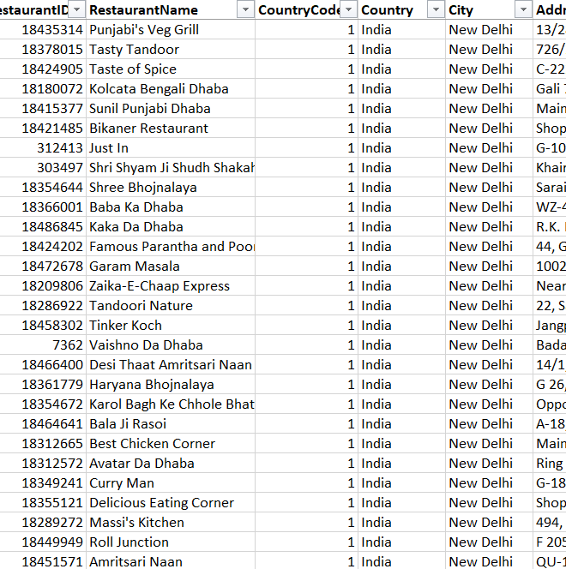

6-Create a table to represent the number of restaurants opened in each country.
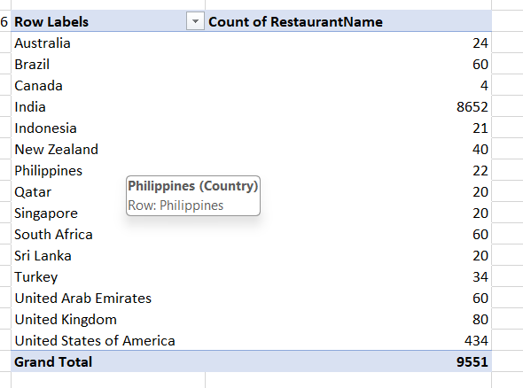

7-Also, the management wants to look at the number of restaurants opened each year, so provide them with something here.
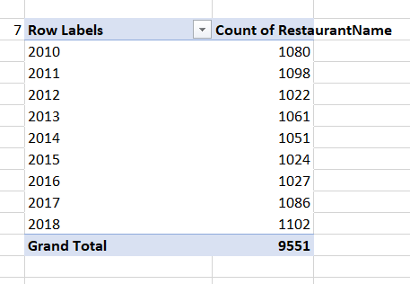

8-What is the total number of restaurants in India in the price range of 4?
There are 388 number of restaurant in india in the price range of 4.

9-What is the average number of voters for the restaurants in each country according to the data?
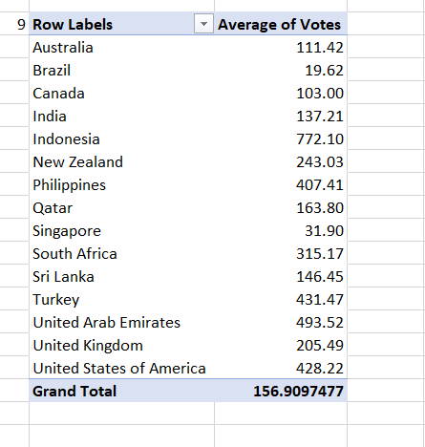
10-Calculate the average rating for all the restaurants that have price_range < 4 and provide online delivery. Use only the “IF” function, Logical Operators, and Aggregation functions to solve this problem. [Note: Don’t use Conditional aggregation in this question.]
I used here the formula to find the answer of this
{=AVERAGE(IF((Table_1[Price_range]<4)*(Table_1[Has_Online_delivery]="Yes"),(Table_1[Rating])))}
The average rating for given condition is 3.273811

11-Using Conditional formatting highlight the rows of restaurants that are located in the countries or cities that you’ve suggested to the management for opening new restaurants.
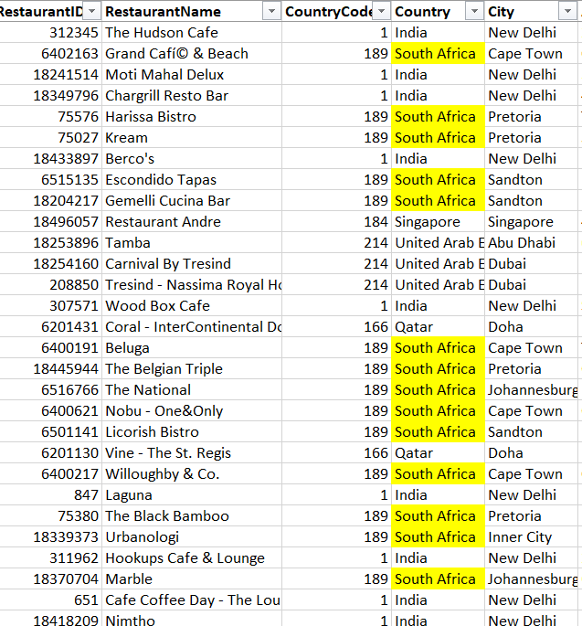
I went through from this approach in this task
Select the country column-Home tab – conditional formatting -new rule- format only cells that contains-specific text-containing- write the country which I had to highlight
Select the format color yellow for that and clicked ok

12-Create a new customized price column that consists of the abbreviation/symbol of the currency along with the Average_cost_for_two value. [Use string operations to do this task]
I used here concat function to get required output
=CONCAT("₹",[@[converted_avg_cost_for_two]])
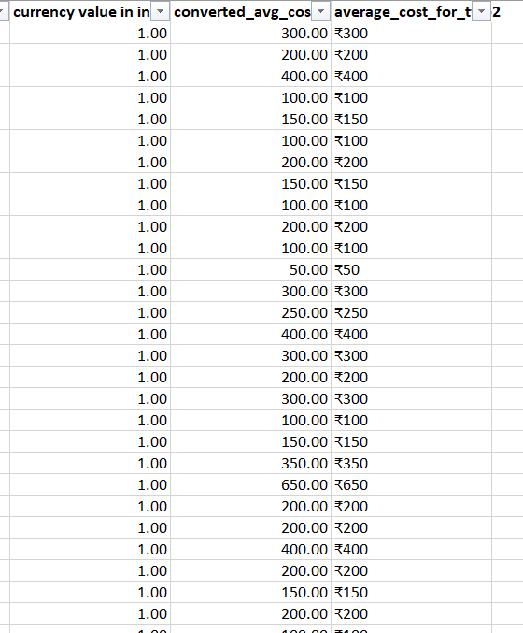

13-How can you create an array formula in Excel or Google Sheets to count the number of restaurants listed that do not offer online delivery, are in the lowest price range, and have an average cost for two people less than or equal to 250 Indian Rupees?
Using the formula – {=COUNTIFS(Table_1[Has_Online_delivery],"No",Table_1[Price_range],MIN(Table_1[Price_range]),Table_1[converted_avg_cost_for_two],"<=250")}
There are 1694 restaurant that do not offer online delivery, are in the lowest price range, and have an average cost for two people less than or equal to 250 Indian Rupees

Subjective questions
- Suggest a few countries where the team can open newer restaurants with lesser competition. Which visualization/technique will you use here to justify the suggestions?
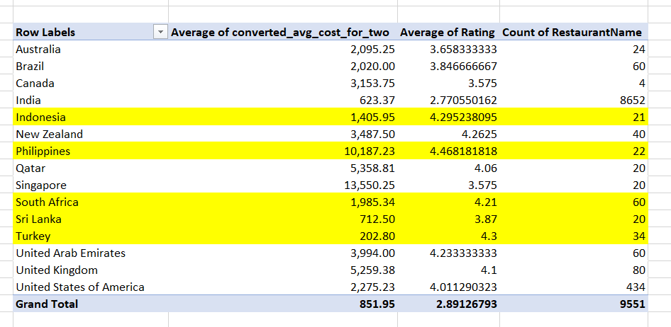
- Indonesia:
  - Average Cost for Two: ₹1,405.95 — Moderate pricing.
  - Average Rating: 4.29 — High customer satisfaction.
  - Number of Restaurants: 21 — Indicates lesser competition with promising customer interest.
- Philippines:
  - Average Cost for Two: ₹10,187.23 — Higher costs but excellent ratings (4.47), suggesting a market for premium dining experiences.
  - Number of Restaurants: 22 — Moderate competition, ideal for high-end restaurants.
- South Africa:
  - Average Cost for Two: ₹1,985.34 — Balanced cost with strong ratings (4.21).
  - Number of Restaurants: 60 — Competitive yet manageable market with strong customer satisfaction.
- Sri Lanka:
  - Average Cost for Two: ₹712.50 — Lowest average cost, providing an opportunity for budget-friendly restaurants.
  - Average Rating: 3.87 — Decent customer satisfaction, indicating growth potential.
- Turkey:
  - Average Cost for Two: ₹202.80 — Extremely affordable dining costs, attracting budget-conscious customers.
  - Average Rating: 4.3 — Strong customer approval.
  - Number of Restaurants: 34 — Lower competition, indicating significant market entry potential.
Conclusion
- Turkey and Sri Lanka are ideal for budget-friendly restaurant models.
- Indonesia and South Africa offer balanced cost-to-rating ratios, making them stable expansion choices.
- Philippines targets premium dining with strong ratings and moderate competition.
Recommendations
- Turkey & Sri Lanka:
  - Focus on budget-friendly restaurant models to attract price-conscious customers.
  - Offer local and affordable cuisine to maximize appeal.
  - Utilize low competition to establish a strong market presence.
- Indonesia & South Africa:
  - Leverage the balanced cost-to-rating ratio for stable restaurant expansion.
  - Position restaurants in the mid-range to premium category to cater to satisfied customers.
  - Use moderate competition as an advantage for strategic growth.
- Philippines:
  - Target the premium dining segment with high-quality food and exclusive experiences.
  - Focus on exceptional service and ambiance to justify the higher pricing.
  - Utilize moderate competition to establish a strong brand presence in the high-end market.
By tailoring investment strategies to each country’s cost, competition, and customer ratings, businesses can optimize success in these diverse markets.

2-Come up with the names of States and cities in the suggested countries suitable for opening restaurants.
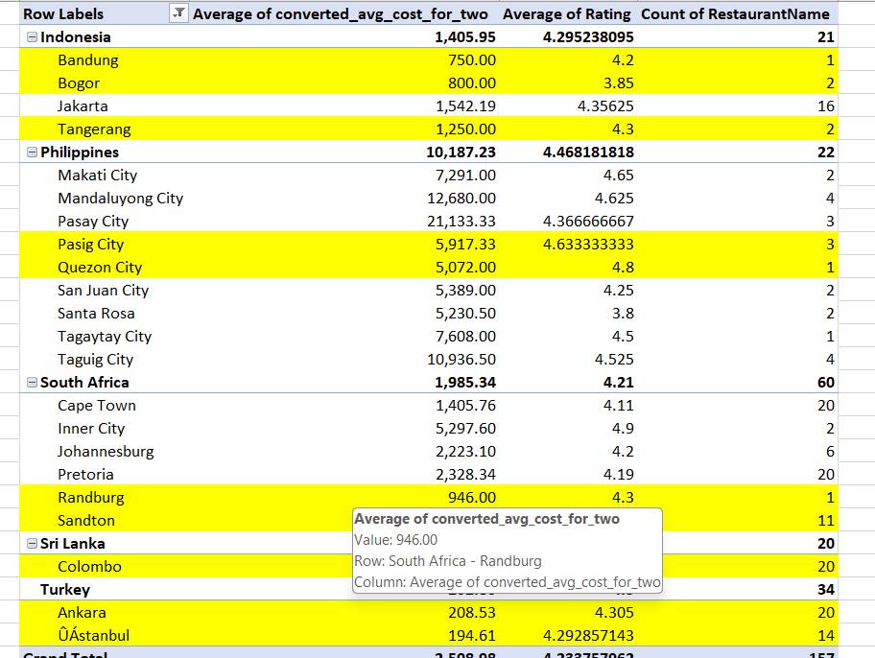
- Indonesia
  - Bandung (₹750, Rating: 4.2) – Affordable dining with strong customer feedback.
  - Bogor (₹800, Rating: 3.85) – A budget-friendly market with room for growth.
  - Tangerang (₹1,250, Rating: 4.3) – Balanced pricing with excellent customer satisfaction.
- Philippines
  - Pasig City (₹5,917, Rating: 4.63) – A premium dining hub with remarkable reviews.
  - Quezon City (₹5,072, Rating: 4.8) – Outstanding ratings suggest strong customer loyalty.
- South Africa
  - Randburg (₹946, Rating: 4.3) – Affordable with impressive customer ratings.
  - Sandton (₹1,778, Rating: 4.3) – Balanced pricing with high demand potential.
- Sri Lanka
  - Colombo (₹712.50, Rating: 3.87) – Budget dining with emerging customer interest.
- Turkey
  - Ankara (₹208.53, Rating: 4.3) – Extremely low dining costs with strong customer approval.
  - Istanbul (₹194.61, Rating: 4.29) – Budget-friendly yet highly rated dining destination.
📊 Key Takeaways for Expansion Strategy
- ✅ Affordable Markets: Turkey’s Ankara and Istanbul provide low-cost entry points with minimal risk.
✅ Premium Dining Potential: Cities like Pasig and Quezon City are ideal for high-end restaurant concepts.
✅ Emerging Hotspots: Cities such as Bandung, Randburg, and Colombo offer low-competition markets with steady customer interest.
Recommendations for Expansion Strategy
- ✅ Budget-Friendly Expansion:
  - Ankara & Istanbul (Turkey) – Extremely low dining costs with strong customer approval, ideal for budget-conscious restaurants with minimal risk.
  - Colombo (Sri Lanka) – A cost-effective market with emerging customer interest, suitable for affordable dining concepts.
- ✅ Mid-Range Market Opportunities:
  - Bandung (Indonesia) – Affordable pricing with strong customer feedback, making it a great choice for casual dining.
  - Randburg (South Africa) – Low-cost market with impressive ratings, suitable for quality dining at accessible prices.
  - Bogor (Indonesia) – Budget-friendly with growth potential, ideal for new entrants looking to establish a foothold.
- ✅ Balanced Cost & High Demand:
  - Tangerang (Indonesia) – A well-balanced market with excellent customer satisfaction, making it a stable investment.
  - Sandton (South Africa) – Moderate pricing with high demand potential, ideal for upscale casual dining.
- ✅ High-End & Premium Dining:
  - Pasig City & Quezon City (Philippines) – Strong customer loyalty and exceptional ratings indicate a strong market for luxury dining and premium restaurant concepts.
By aligning expansion plans with affordability, market demand, and customer ratings, businesses can optimize profitability and long-term success in these strategic locations.

3-According to the countries you suggested, what is the current quality regarding ratings for restaurants that are open there?
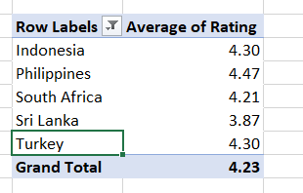
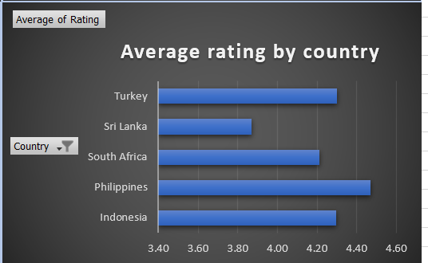
• Philippines – 4.47 ⭐
• Indonesia – 4.30 ⭐
• Turkey – 4.30 ⭐
• South Africa – 4.21 ⭐
• Sri Lanka – 3.87 ⭐

1. Philippines (4.47 ⭐) - Highest Rating
✅ Opportunity: The Philippines has the highest average rating, indicating a strong preference for dining out and a high level of customer satisfaction.
🔹 Recommendation:
- Focus on localizing flavors while maintaining international quality.
- Invest in great customer service and ambiance, as customers here seem to reward excellent experiences.
- Consider opening in tourist-heavy areas like Manila, Cebu, or Boracay to capitalize on both locals and visitors.
2. Indonesia (4.30 ⭐) & Turkey (4.30 ⭐) - Strong Market
✅ Opportunity: Both countries have similar ratings, suggesting a good balance of competition and customer satisfaction.
🔹 Indonesia:
- Jakarta and Bali are prime locations, with Bali offering high tourist traffic and Jakarta being a business hub.
- Trend-based dining (e.g., plant-based, fusion cuisine) could attract younger demographics.
- Focus on delivery services, as online food ordering is booming in major cities.
🔹 Turkey:
- Istanbul and Antalya are key locations with strong food cultures and tourism demand.
- Customers value authenticity, so a restaurant offering fusion cuisine with Turkish flavors could succeed.
- High demand for mid-range casual dining—targeting this segment could reduce competition from luxury restaurants.
3. South Africa (4.21 ⭐) - Competitive Market
✅ Opportunity: A slightly lower rating than Indonesia and Turkey, but still positive.
🔹 Recommendation:
- Johannesburg and Cape Town are prime locations for food businesses.
- Unique Afro-fusion or international cuisine concepts could attract foodies.
- Leverage digital marketing and influencer promotions to gain traction, as food blogging is popular.
4. Sri Lanka (3.87 ⭐) - Least Competitive Market
✅ Opportunity: The lowest rating suggests either lower customer satisfaction or fewer high-quality restaurants, meaning less competition.
🔹 Recommendation:
- Colombo is the safest bet as it's the business and tourism hub.
- Offering high-quality, affordable dining options can fill gaps in the market.
- A focus on international cuisine or premium casual dining could give you a competitive edge.
- Since the market is still developing, aggressive promotions and social media marketing will be crucial.
Final Recommendation:
If you're looking for high customer satisfaction and a stable market, go for the Philippines.
If you want a balanced opportunity with strong demand, Indonesia or Turkey would be ideal.
For less competition but a growing market, Sri Lanka could be a strategic long-term play.

4-Also, what is the current expenditure on food in the suggested countries, so we can keep our financial expenditure in control?
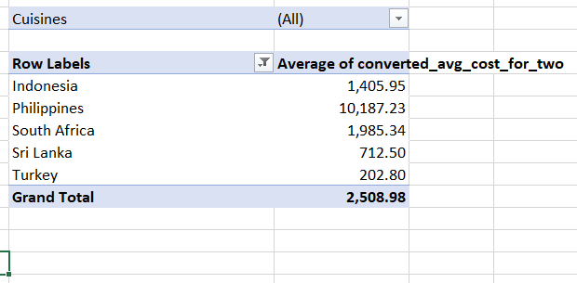
Approach
- Turkey – ₹202.80 (Lowest Cost)
  - With incredibly low dining costs, Turkey offers an ideal entry point for budget-friendly restaurants. This is a prime opportunity to tap into a price-conscious market with minimal investment.
- Sri Lanka – ₹712.50
  - With affordable dining expenses and emerging customer demand, Sri Lanka is perfect for launching mid-range restaurants that cater to locals and tourists alike.
- Indonesia – ₹1,405.95
  - Known for its rich food culture and growing dining scene, Indonesia offers a balanced mix of affordability and customer satisfaction, making it a stable investment choice.
- South Africa – ₹1,985.34
  - With slightly higher costs but a strong demand for dining experiences, South Africa is ideal for restaurants aiming to deliver quality meals at moderate prices.
- Philippines – ₹10,187.23
  - Despite higher costs, the Philippines presents an opportunity for premium dining experiences, catering to customers willing to pay more for quality food.

Conclusion
- Turkey (₹202.80) – The most cost-effective market, ideal for budget-friendly restaurants targeting price-conscious consumers.
- Sri Lanka (₹712.50) – A promising location for mid-range restaurants, appealing to both locals and tourists.
- Indonesia (₹1,405.95) – A stable investment choice with a balanced mix of affordability and customer satisfaction.
- South Africa (₹1,985.34) – Suitable for restaurants offering quality dining experiences at moderate prices.
- Philippines (₹10,187.23) – Best for premium dining establishments, catering to customers willing to spend more for high-quality food.

5-Come up with the names of restaurants from the recommended states that are our biggest competitors and also those that are rated in the lower brackets, i.e. 1-2 or 2-3.
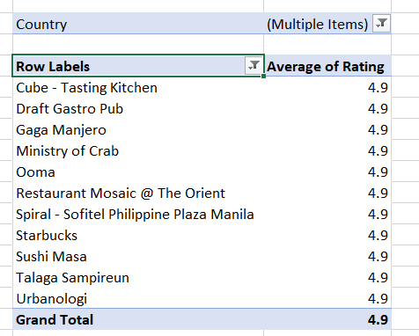
These are the top rated restaurant in recommended cities. All restaurants have 4.9 rating
These restaurant are biggest competitor for new opening restaurant.

Key Takeaways from Top-Rated Restaurants
- Diverse Cuisine & Specialization
  - Ministry of Crab (Sri Lanka) – Focuses on premium seafood, especially crabs, emphasizing quality over variety.
  - Sushi Masa (Indonesia) – Specializes in sushi, showcasing the power of niche-focused restaurants.
  - Talaga Sampireun (Indonesia) – Traditional Sundanese cuisine with an authentic local experience.
  - Ooma (Philippines) – Modern Japanese cuisine with a twist, showing the appeal of fusion and contemporary takes on traditional dishes.
- Luxury & Fine Dining Appeal
  - Spiral - Sofitel Philippine Plaza Manila (Philippines) – A renowned buffet offering a high-end, all-you-can-eat experience.
  - Restaurant Mosaic @ The Orient (South Africa) – Michelin-level fine dining, indicating a market for high-end gastronomy.
- Experience-Driven Dining
  - Cube - Tasting Kitchen (South Africa) – A chef’s table experience with innovative multi-course meals.
  - Urbanologi (South Africa) – Focuses on pairing craft beers with gourmet dishes, emphasizing experiential dining.
  - Draft Gastro Pub (Turkey or South Africa?) – A strong focus on pub culture, highlighting the demand for upscale casual drinking/dining spots.
- Global Chains with Local Appeal
  - Starbucks – Although a multinational brand, its presence in this list suggests that coffee culture and casual café experiences are valued in these regions.
Strategic Recommendations for a New Restaurant
🔹 Specialization Wins – Instead of offering everything, focus on a single niche (e.g., seafood, sushi, fusion cuisine).
🔹 Premium Dining is in Demand – High-rated places often provide luxury experiences, unique themes, or high-quality dishes.
🔹 Cultural Authenticity Works – Restaurants showcasing local flavors with a modern touch tend to succeed.
🔹 Experiential Dining Attracts Customers – Tasting menus, chef’s table concepts, or innovative pairings enhance customer engagement.
🔹 Casual & Mid-Range Can Thrive Too – The inclusion of Starbucks and Draft Gastro Pub suggests there is also demand for accessible yet high-quality casual dining.

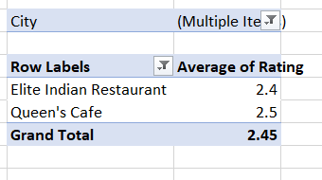
These are low rated restaurant in recommended cities.

6-Which cuisines should we focus on in the newer restaurants to get better feedback? Does the choice of cuisines affect the restaurant ratings?
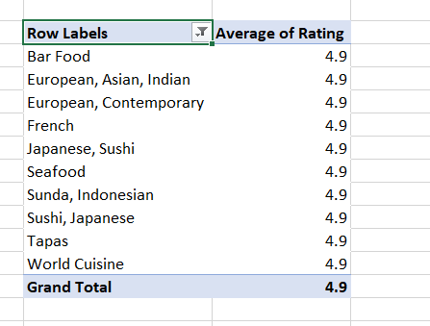
These are the top rated cuisines in recommended cities. Most of the customer gave positive response for these cuisines. Then we need to focus on these cuisines in our new restaurant for better feedback
Key Cuisine Trends for Success
- Bar Food – A popular choice for casual dining, perfect for vibrant nightlife hubs.
- European, Asian, Indian – Fusion cuisine that appeals to diverse taste preferences.
- European, Contemporary – Modern European dining ideal for premium restaurant concepts.
- French – A symbol of fine dining, attracting food connoisseurs.
- Japanese, Sushi – A global favorite known for its elegance and quality.
- Seafood – Loved worldwide, especially in coastal regions.
- Sunda, Indonesian – A local favorite in Indonesia, offering authentic regional flavors.
- Sushi, Japanese – Highlighting the growing love for Japanese cuisine worldwide.
- Tapas – Perfect for social dining with small plates and shared meals.
- World Cuisine – Diverse global flavors that cater to international diners.

Strategic Restaurant Concept Recommendation
🎯 Concept: Modern Global Fusion with a Japanese & Seafood Focus
A premium-casual restaurant that blends Asian, European, and global cuisines, with an emphasis on Japanese (sushi), seafood, and tapas-style dining—backed by trendy bar food and world cuisine elements.

✅ Why This Concept Works (Based on Data):
1. Customer-Driven Cuisine Choices
- Japanese & Sushi are mentioned twice in the top trends—clearly high in demand across all markets.
- Seafood (e.g., Ministry of Crab, Sushi Masa) ranks consistently high in ratings.
- Fusion (Asian/European/Indian) caters to diverse palates and adventurous diners.
- Bar Food + Tapas = Perfect for casual nights out, group dining, and urban vibes.
- World Cuisine allows flexibility to adapt seasonal or trending dishes globally.
2. Fits Multiple Market Tiers
- Can position it as:
  - Premium casual (affordable luxury, great ambiance)
  - High-end dining in cities like Istanbul, Manila, or Cape Town
  - Trendy gastro-pub model in urban hubs like Jakarta or Johannesburg

🌍 City-wise Execution Ideas:
🇵🇭 Philippines (e.g., Manila)
- Emphasize Japanese/Seafood fusion (Sushi x Tapas) + signature bar food.
- Include vibrant ambiance and modern presentation.
- Add local twists using Filipino ingredients in fusion dishes.
🇮🇩 Indonesia (e.g., Jakarta, Bali)
- Feature Sunda dishes alongside modern Japanese plates.
- Use shared platters and tapas for a communal, local dining style.
- Integrate cocktail pairings with seafood and sushi.
🇹🇷 Turkey (e.g., Istanbul)
- Lean into European-Asian fusion with small plates and rich flavors.
- Add a French-inspired dessert menu for a high-end finish.
- Design the space with artsy, contemporary interiors for Instagram appeal.
🇿🇦 South Africa (e.g., Cape Town, Johannesburg)
- Offer a chef’s tasting menu combining sushi, tapas, and global flavors.
- Include local seafood and wine pairings.
- Tap into the gastro-lounge trend with bar food in the evenings.
🇱🇰 Sri Lanka (e.g., Colombo)
- Leverage the popularity of Ministry of Crab-style seafood.
- Offer fusion dishes with South Asian spice influence.
- Create a chic yet relaxed space targeting upscale urban diners.

💡 Bonus Recommendations:
- Name Suggestion: Something sleek and global, like “FUSE | Sushi & Sea” or “Plate & Pour”.
- Interior Vibe: Minimalist-modern, cozy lighting, and Instagrammable plating.
- Menu Strategy: Seasonal tasting menus + core fusion staples.
- Tech Integration: QR menus, loyalty app, Insta-friendly plating to boost online reviews.

7-According to our current data, should we go for online delivery and table booking? Does that affect the customer’s ratings?
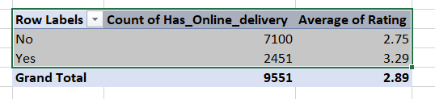

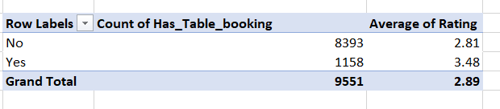

Enhancing Customer Experience: The Role of Online Delivery & Table Booking
Our data reveals crucial insights about how online delivery and table booking influence customer satisfaction.
📊 Key Findings
- Online Delivery Impact:
  - With Delivery: 3.29 average rating (higher satisfaction)
  - Without Delivery: 2.75 average rating
✅ Conclusion: Restaurants offering delivery services receive higher ratings, indicating improved customer convenience and satisfaction.
- Table Booking Impact:
  - With Table Booking: 3.48 average rating (significantly higher)
  - Without Table Booking: 2.81 average rating
✅ Conclusion: Restaurants with table booking options achieve higher customer satisfaction, suggesting smoother dining experiences and better service quality.
🔍 Key Insights for Growth Strategy
- Online Delivery Boosts Satisfaction: Implementing a reliable delivery system can cater to customers seeking convenience, driving better ratings.
- Table Booking Elevates Experience: Enabling reservations enhances customer comfort, reduces waiting times, and attracts groups or special-event diners.
- Combined Strategy for Maximum Impact: Restaurants that provide both delivery and table booking are likely to see the highest customer satisfaction rates.
🚀 Recommended Strategy
- ✅ Prioritize Online Delivery for increased convenience and broader customer reach.
✅ Introduce Table Booking in key locations to improve dine-in experiences.
✅ Combine Both Services to maximize customer satisfaction and build a strong competitive edge.
8- Should the team keep the rate of cuisines higher? Will that affect the feedback? According to our data are the rates of cuisines and ratings, correlated?
- yes we need to keep the rate of cuisines higher for new opening restaurant for better feed back. We already know from this data if we keep the rating higher then it will attract the more customer and it will provide the better feedback.
- According to data rates of cuisines and ratings are not correlated to each other by using
=CORREL(Table_1[converted_avg_cost_for_two],Table_1[Rating])
It gives 0.3070

9-What is the distribution of the number of restaurants of different price ranges in all the countries?
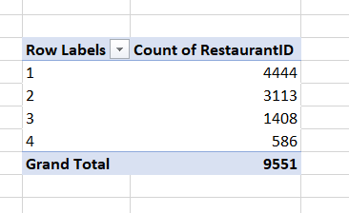
Price Range vs. Restaurant Availability: Key Insights for Expansion
Our data analysis reveals a clear distribution of restaurants across different price ranges, offering insights into customer preferences and market gaps.
📊 Price Range Analysis
- Price Range 1 (Lowest Price) – 4,444 restaurants
➔ Dominates the market, indicating strong demand for budget-friendly dining options.
- Price Range 2 (Moderate Pricing) – 3,113 restaurants
➔ Popular among customers seeking quality meals at reasonable prices.
- Price Range 3 (Premium Dining) – 1,408 restaurants
➔ A smaller yet significant segment catering to those willing to spend more for better quality and service.
- Price Range 4 (High-End Dining) – 586 restaurants
➔ The least competitive segment, presenting an opportunity for luxury dining concepts.

- 10- Explain your approach in brief for suggesting countries/cities in order to open new restaurants, if the objective and subjective questions would have not been given to assist you. [you have to give bullet pointers in order to answer this question]
Step-by-Step Approach for Selecting Countries/Cities for New Restaurant Expansion
1. Data-Driven Market Analysis
- Evaluate Customer Ratings – Identify countries with high Zomato ratings to gauge customer satisfaction.
- Assess Cost for Dining – Compare the average cost for two to determine whether the market supports budget, mid-range, or premium dining.
- Analyze Restaurant Density – Check the number of restaurants to assess competition levels.
2. Competition & Growth Potential
- Low Competition + High Ratings → Best Market for Entry (e.g., Indonesia’s Tangerang, Turkey’s Ankara).
- High Competition + High Ratings → Saturated but promising for premium dining (e.g., Philippines' Pasig City).
- Low Ratings + Low Competition → Market with potential for disruption (e.g., Sri Lanka’s Colombo).
3. Cuisine Preferences & Trends
- Match Popular Cuisines – Identify trending cuisines (e.g., sushi, seafood, bar food, fusion).
- Cultural & Regional Adaptability – Ensure the cuisine aligns with local preferences (e.g., Japanese-Sunda fusion in Indonesia).
4. Economic & Demographic Considerations
- Affordability Index – Consider the country’s spending power and cost of living.
- Urban vs. Suburban Demand – Focus on cities with high foot traffic (e.g., business hubs, tourist destinations).
5. Strategic City Selection Based on Market Positioning
- Budget-Friendly Markets → Target Turkey (Ankara, Istanbul) & Sri Lanka (Colombo) for low-cost, high-approval dining.
- Mid-Range Growth Opportunities → Indonesia (Bandung, Tangerang) & South Africa (Randburg, Sandton) for stable demand and affordability.
- Premium & Luxury Dining → Philippines (Pasig City, Quezon City) for high-end restaurants with strong customer loyalty.

🚀 Summary of Expansion Strategy
✅ Budget-Friendly Markets → Turkey & Sri Lanka → Low-cost entry, high approval, less competition.
✅ Mid-Range Expansion → Indonesia & South Africa → Strong ratings, balanced pricing, steady demand.
✅ Premium Dining → Philippines → High cost but strong loyalty, ideal for luxury restaurants.

