Design patterns - are **time tested solutions** for recurring **architectural problems**.

Non Gof

1. Repository pattern
2. CQRS

Gof – gang of four, 3 categories of design pattern –

1. Creational – problems and solutions **around objection creation issues**
   1. Prototype – a fully initialized instance to be copied or cloned
   2. Singleton – A class of which only a single instance can exist.
      1. Helps to create a single instance of an object.
      2. **Usage** 
         1. **Caching** – of data like countries, states and currencies and so on..
         2. **Global sharing** – of data like common themes, hit counters and so on.
2. Behavioral – Problems and solutions around communication between objects.
   1. Command – encapsulate a command request as an object.
   2. Chain of responsibility – a way of passing request between a chain of objects.
   3. Mediator –
   4. Memento
   5. Template method –
3. Structural – solving concerns around **class structure and object composition**
   1. Adapter – Match interfaces of difference classes
   2. Composite – A tree structure of simple and composite objects
   3. Decorator – Add responsibilities to object dynamically

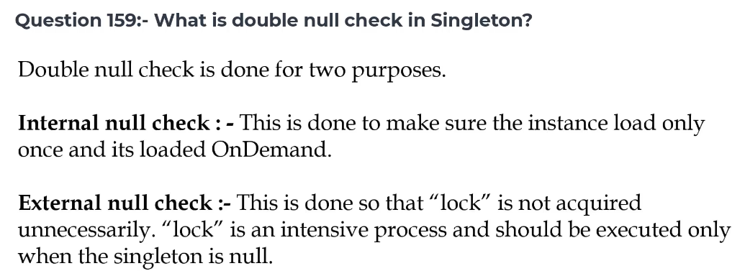

**Concurrency vs parallelism**

