Normalization –

1NF – A table is in first normal form when the columns have **Atomic values**, it should **not have repeating groups.**

2NF – first normal form should be satisfied. All non-key columns should be **fully dependent on the primary key.**

3NF – All 1st and 2nd normal form should be satisfied. No transient dependency should be present.

Non-key column should not be dependent on another non-key column

A – Atomic values

P – Partial dependency

T – Transient

**Index** – search becomes faster because of balance tree structure. Internally it creates Node and Leaf nodes to reach to the data quick.  
  
**Clustered index** – leaf node will point to actual data.

**Nonclustered Index** - leaf node takes help of clustered index.

**Trigger** –

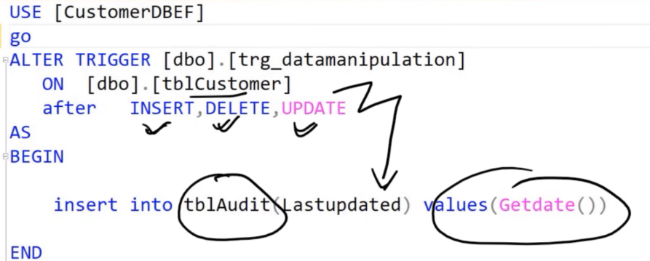

After trigger – after event has happened logic is executed.

instead of trigger - instead of the event the logic is executed.

Identity column – helps to define auto-incremented column.

Transaction – it treats series of activity as one single unit. Either everything is successful and or everything rollbacks.

CTE – common table expression