Dynamic Programming -

**Dynamic Programming** is a method used in mathematics and computer science to solve complex problems by breaking them down into simpler subproblems.  By solving each subproblem only once and storing the results, it avoids redundant computations, leading to more efficient solutions for a wide range of problems.

Rod cutting - maximum profit

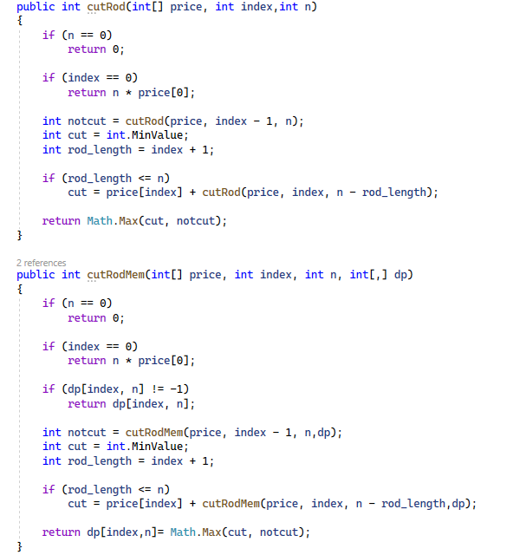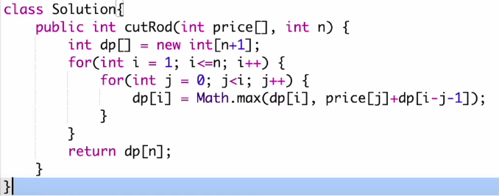

Knapsack problem –

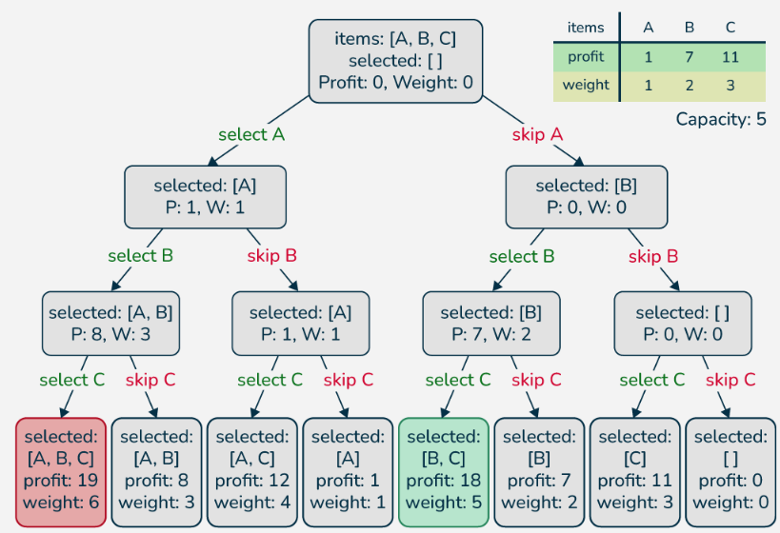

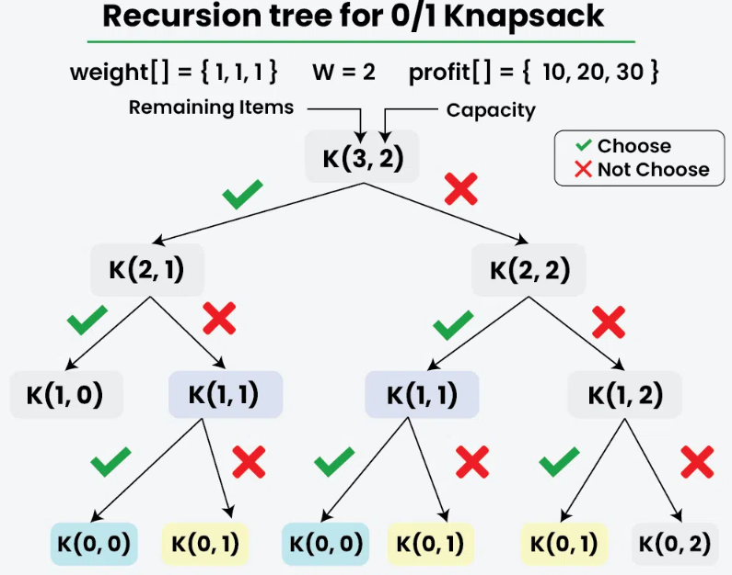

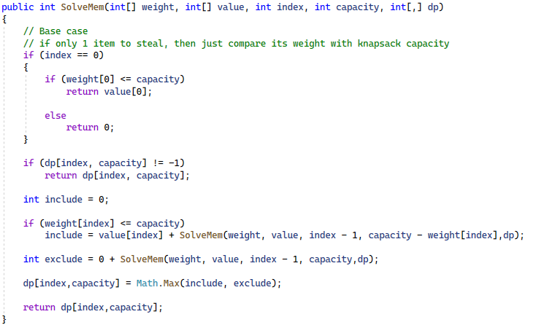

Tower of Hanoi –

Kadane algo

