Behavioral Entity Intelligence for Cyber Threat Detection
A Two-Layer Behavioral Method for Detecting Insider, Advanced-Persistent-Threat, and Living-off-the-Land Activity Below Conventional Thresholds
Academic edition. June 2026.
Abstract. The most damaging recent intrusions, including Volt Typhoon and Salt Typhoon, evaded the victims' own security tools entirely and were discovered only by outside agencies. Such campaigns operate with valid credentials and legitimate tools, remaining inside conventional statistical thresholds while shifting their behavior gradually over months. This paper presents Behavioral Entity Intelligence, a detection method that represents each user and system as a behavioral profile evolving over time and evaluates both the magnitude and the direction of behavioral change. The method combines two layers: a precision layer that matches named, measurable known-bad fingerprints scored relative to role-group peers, and a discovery layer built on text embeddings, cumulative-sum change-point detection, and concept-aligned drift direction. On a synthetic enterprise of 250 users observed over 485 days with four embedded campaigns, the precision layer detected four of four campaigns at zero false positives, while the strongest of four standard anomaly detectors detected one of four. All results derive from synthetic data and define a proof of concept that warrants validation on real telemetry. The algorithms named here are standard techniques; the contribution is their composition into an explainable detection system.
1. Introduction and Problem Statement
Enterprise security monitoring rests on two mechanisms: a Security Information and Event Management (SIEM) platform applying expert-written rules, and signature-based detection matching activity against known Indicators of Compromise. Both answer one question: does this activity match something already known to be malicious? Three threat families are engineered so the answer is no. Insider threats use legitimate access, and industry reporting (the Verizon Data Breach Investigations Report) attributes roughly 20 percent of breaches to insiders, with a median time to discovery exceeding 200 days. Advanced Persistent Threats (APTs) maintain a covert command-and-control (C2) channel throttled to a trickle, a check-in every few hours in kilobyte packets. Living-off-the-land (LOTL) attacks use only the administration tools already installed, so there is no malware to fingerprint and no rule to violate.
The common technique is termed slow and low: behavior changes so gradually that no single week is anomalous, while the cumulative change over months achieves the objective. The activity is visible only in the trajectory, never in a single snapshot (Figure 1). The documented record is unambiguous. Neither Volt Typhoon nor Salt Typhoon was detected by any victim's SIEM, intrusion detection, or endpoint tooling, because there was no signature to match and no threshold crossed; both were found by external intelligence operations, years or months after compromise. This is a structural limitation, addressed below.
1.1 Why threshold and signature monitoring fall short
- Threshold insensitivity. Rules and signature checks stay green while an entity drifts toward a known-bad pattern, because the individual actions remain authorized.
- Magnitude-only measurement. Conventional anomaly models measure how much a metric changes, not the direction in which the entity is evolving; an insider may hold file volume flat while shifting from public to confidential content.
- Single-entity, single-metric scope. An entity may look normal in isolation while its relationship to destinations, peers, or data has changed; one external address recurring every week for over a year is the fingerprint of covert infrastructure.
- Signature dependence. Detection that depends on a known-bad list cannot see a novel implant or a first-seen destination until it is catalogued, and LOTL activity offers nothing to fingerprint.
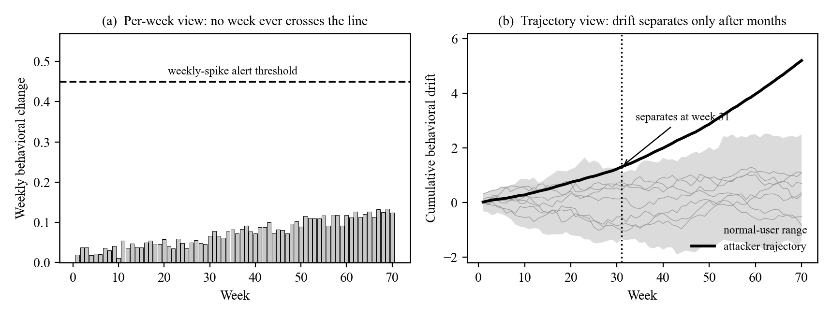
Figure 1. The slow-and-low evasion (illustrative). (a) A fixed-threshold detector evaluates each week alone, and the attacker's weekly change never crosses the alert line. (b) The same weeks accumulated as behavioral drift separate the attacker from the normal-user range within months.
2. Behavioral Entities and Zones
Behavioral Entity Intelligence represents an observable subject, a user, device, network segment, application, or session, as a profile that evolves over time rather than a static record. Each week, raw activity from five log sources (authentication, file access, endpoint activity, network traffic, and domain resolution) is distilled into roughly two dozen behavioral measurements per entity, organized into five behavioral zones (Table 1). Zone decomposition is the central representational choice: when the identity zone is stable while the data-behavior zone drifts, the system infers the same credentials reaching different data, which is the insider signature and which no single anomaly score expresses.
Behavioral zone | What it captures | What it catches when it drifts
Identity | Role, department, clearance, tenure. | Stability is itself a clue: insiders still look like the same person.
Access pattern | Sign-in frequency, failures, timing, sources. | Credential abuse and account takeover.
Data behavior | Data volume, sensitivity mix, read and write balance. | Insider data theft toward restricted material.
Network footprint | Destinations, external traffic, domain lookups. | Covert call-home and exfiltration routes.
Risk posture | Endpoint process activity and risk indicators. | Compromised machines and privilege escalation.
Table 1. The five behavioral zones and what each catches when it drifts.
3. Methods and Algorithms
The architecture runs two complementary layers over the per-entity behavioral profile. This section names the algorithms and reports the operating points used in this study. Every named technique is a standard, well-established method; the contribution is their composition, and no individual algorithm is claimed novel in isolation.
3.1 Behavioral feature construction and embedding
Let an entity u in week t have a profile across the five zones, written Z_{u,t}. The profile is serialized to a structured natural-language description and mapped to a 1,536-dimensional vector by the OpenAI text-embedding-3-small model, the same representation that powers large language models, giving the entity-week embedding in Equation (1).
All entity types share one embedding space, so behaviors that mean similar things are placed near one another even when their raw counts differ. Real OpenAI text-embedding-3-small embeddings are mandatory; the pipeline hard-fails without them. The raw per-zone measurements are retained in parallel, because Layer 1 scores them directly.
3.2 Layer 1: the multi-front threat-profile detector (precision)
Layer 1 matches named known-bad fingerprints across two complementary detection fronts, with a self-drift signal as corroboration, and raises a flag only on a defined profile match.
Front A, cohort-relative profiles. Each behavioral feature is scored with a cohort-segmented robust z-score. Within the role-group cohort g of entity u, feature c is centered on the cohort median m_{g,c} and scaled by the cohort interquartile range, with the denominator floored at a fraction of the global IQR so that near-constant baselines cannot inflate the score, as in Equation (2).
The robust median and IQR are used instead of the mean and standard deviation because behavioral features are heavy-tailed and a single busy week should not move the baseline. A named profile P is defined over a small feature set C_P and fires only when every member is jointly elevated past a profile threshold, which is what makes a match specific rather than a lone outlier, as in Equation (3).
A profile is therefore a conjunction, not a single anomaly: mass_collection requires unique-file and total-file activity to rise together, lotl_process requires administrative-process breadth and volume to rise together, and recon_fanout requires the spread of network destinations to rise sharply against peers. For the embedded campaigns the resulting cohort-relative deviations are 5.9 (insider mass collection), 4.5 (LOTL process breadth), and 8.2 (reconnaissance fan-out).
Front B, raw-event profiles. These are computed directly from logs with no labels. A covert command-and-control beacon is identified by the coefficient of variation of its inter-callout intervals, as in Equation (5): for a metronomic implant the standard deviation of the gaps is small relative to their mean, so CV collapses toward zero, whereas legitimate bursty services such as software updates and cloud synchronization sit near 0.8 to 1.0. A destination contacted persistently (at least 100 distinct days) with CV below 0.65 is flagged as a beacon; the slow-APT campaign's controller is flagged on 386 distinct days.
Algorithmically generated domains are identified by the Shannon entropy of the second-level domain label as in Equation (6). Generated names have high character-level randomness, so their entropy is high; a label whose entropy exceeds approximately 3.0 bits per character, resolved together with other high-entropy labels that share back-end infrastructure, is flagged as domain-generation activity. The slow-APT campaign resolves 160 such domains. Cohort-rare destinations, those contacted by a single entity within its cohort, are flagged when at least twenty are present; the insider campaign contacts 76.
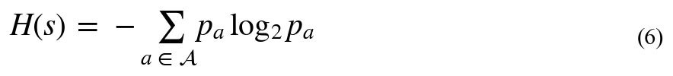
Self-drift corroboration. As a third, self-referential signal, an entity's late-window mean is compared to its early-window mean and scaled by the early-window standard deviation, giving a self-drift magnitude that corroborates the cohort-relative and raw-event fronts without depending on peers, as in Equation (4).
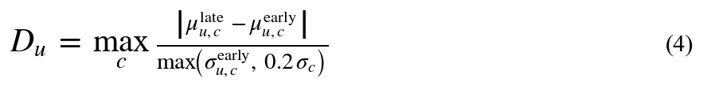
Because a flag denotes a named profile match rather than a bare statistical outlier, Layer 1 is both high-precision and self-explaining, and each detection is mapped to a MITRE ATT&CK technique. Figure 2 illustrates the label-free beacon test.
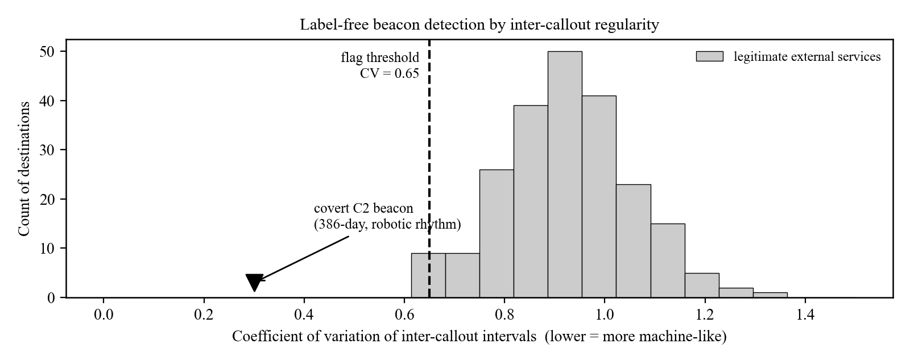
Figure 2. Label-free beacon detection. The coefficient of variation of inter-callout intervals separates the metronomic covert beacon (CV near 0.3) from legitimate bursty services (CV near 0.8 to 1.0); the flag threshold is 0.65. The detector reads the rhythm, not the destination, so it generalizes to unseen infrastructure.
3.3 Layer 2: drift, direction, and novelty (discovery)
Layer 2 is the unsupervised net for attacks the fingerprint library does not yet describe, and it supplies the direction that makes the precision layer interpretable. Slow drift along the entity's embedding trajectory is accumulated with cumulative-sum (CUSUM) change-point detection, from the same family used to catch slow degradation in industrial process control. The weekly drift d_t is one minus the cosine similarity between consecutive embeddings, the running statistic g_t accumulates drift above a slack constant k, and an alarm is raised when g_t exceeds a threshold h, as in Equation (7), so a long succession of small, same-direction changes eventually fires even though no single week is anomalous.
Drift direction is named by projecting the cumulative drift vector onto a library of pre-embedded reference threat concepts c_j aligned with MITRE ATT&CK, and taking the concept of maximum cosine similarity as in Equation (8). This turns a numerical drift into a labeled direction such as reconnaissance, data exfiltration, or living off the land. Novelty features additionally flag behavior never seen before that nonetheless recurs.
3.4 Baseline detectors
For comparison, the same weekly feature matrix is evaluated with four standard unsupervised anomaly detectors: Isolation Forest, One-Class Support Vector Machine (One-Class SVM), Local Outlier Factor, and a per-feature Z-Score. These represent the magnitude-based detection that conventional tooling approximates.
4. Threat Models and Case Analyses
This section sets out the four threats in depth, the behavioral trace each leaves, and the equations that recover it. The campaigns are synthetic but their tradecraft is modeled on publicly documented intrusions, and each is mapped to the relevant MITRE ATT&CK techniques. The unifying observation is that none of these campaigns breaks a rule; each is visible only as a peer-relative or directional change in behavior.
4.1 The trusted insider (USR-156)
The insider operates from inside the trust boundary, which is what makes the case definitional rather than incidental. Industry reporting attributes roughly one breach in five to insiders, and the median time to discovery exceeds 200 days precisely because the abuse accumulates slowly. In the synthetic campaign a long-serving business user escalates over 14 months: the sensitivity mix of files touched shifts from predominantly public toward restricted and then confidential, while total file volume and sign-in cadence stay inside the business unit's normal range. In zone terms the identity zone is stable while the data-behavior zone drifts, which is the canonical insider signature and which defeats any volume threshold by construction, since the counts never move.
Because the abuse is relative, it is detected relative to peers. The cohort-relative robust z-score of Equation (2) evaluates each data-behavior feature against the median and IQR of the user's business-unit cohort rather than the global population, so a shift that is unremarkable enterprise-wide becomes extreme among peers. The mass_collection profile of Equation (3) fires when unique-file and total-file activity are jointly elevated; here the cohort-relative deviation reaches 5.9. A second, independent match, cohort_rare_dst, counts 76 external destinations contacted by this user alone within its cohort, capturing the staging of an exfiltration path. The discovery layer corroborates, naming the data-behavior direction as data exfiltration through Equation (8) and separating the user from the population early in the campaign. Relevant techniques include Collection (TA0009) and Exfiltration (TA0010).
4.2 Living-off-the-land pre-positioning: Volt Typhoon (USR-042)
Volt Typhoon is a People's Republic of China state-sponsored campaign that, according to a joint CISA advisory (AA24-038A, February 2024), pre-positioned inside United States critical-infrastructure networks across the communications, energy, water, and transportation sectors, maintaining access for at least five years. Its defining tradecraft is living off the land: it operates through valid accounts (T1078) and built-in administration utilities and scripting (T1059) rather than malware, and obtains credentials from on-disk artifacts (T1003). There is, by design, no implant to fingerprint and no rule to violate, which is why no victim's signature-based tooling detected it.
The synthetic campaign models this behavior on a security-team account over 412 days. With nothing to fingerprint, detection must be behavioral and peer-relative. The lotl_process profile scores the breadth and volume of administrative-process activity with Equation (2) against security-team peers, because administrators are the only fair baseline: the same commands are routine for the role and abnormal only in their concentration. The cohort-relative deviation reaches 4.5, and the discovery layer aligns the risk-posture zone with the living-off-the-land concept through Equation (8). This campaign is also the one case a magnitude-based detector partially catches, as the per-feature Z-Score crosses its line at z = 3.04, but without any indication of which behavior changed or what it resembles.
4.3 Covert command-and-control: the slow APT (USR-234)
An advanced persistent threat's most fragile element is its command-and-control channel, and a patient adversary throttles it to a trickle. The synthetic slow-APT campaign runs 417 days on a developer account with an implant that checks in approximately every six hours in kilobyte packets and resolves algorithmically generated domains to locate its controller. Total traffic, domain lookups, and sign-ins all remain inside normal ranges, and the campaign never separates in magnitude space or in semantic-drift space: it is the hardest case in the study, and every baseline detector misses it.
It is nonetheless caught label-free on two raw-event signals. First, the beacon's regularity: over the inter-callout gaps the coefficient of variation of Equation (5) collapses toward zero for a metronomic implant, while legitimate persistent services remain bursty near 0.8 to 1.0; the controller is flagged on 386 distinct days with CV below 0.65. Second, the generated domains: the Shannon entropy of Equation (6) rises with character-level randomness, and 160 high-entropy domains sharing back-end infrastructure are flagged as domain-generation activity. Crucially, the detector reads the rhythm and the randomness, not the address, so it needs no prior knowledge of the adversary's infrastructure and generalizes to never-before-seen domains and addresses. Relevant techniques include Command and Control (TA0011), Application Layer Protocol (T1071), and Dynamic Resolution: Domain Generation Algorithms (T1568.002).
4.4 Telecommunications interception: Salt Typhoon (USR-118)
Salt Typhoon is a People's Republic of China state-sponsored intrusion into United States telecommunications providers, characterized by the chairman of the Senate Intelligence Committee as the worst telecom hack in the nation's history. Public reporting describes entry through edge networking devices, lateral movement across carrier networks, and access to the lawful-interception systems used for court-authorized wiretaps, with collection of call-detail records and metadata. As with Volt Typhoon, every individual action is authorized, so there is no signature to match.
The synthetic campaign models the lateral, reconnaissance-heavy phase on a developer account over 412 days. The recon_fanout profile scores the spread of distinct network destinations with Equation (2) against developer peers, and the cohort-relative deviation reaches 8.2, the largest of any campaign in the study, because mapping a network is, in peer-relative terms, a violent departure from a developer's normal footprint even when the absolute traffic is modest. The discovery layer separates this entity in semantic-drift space later in the campaign and aligns its data-behavior zone with the data-exfiltration concept through Equation (8). Relevant techniques include Reconnaissance (TA0043), Gather Victim Network Information (T1590), and Lateral Movement (TA0008).
5. Evaluation
All results derive from a synthetic enterprise of 250 users observed across 485 days (70 weeks), approximately 14 million events from five log sources, with the four campaigns of Section 4 embedded and calibrated to public CISA advisories: the insider over 14 months (USR-156), the slow APT over 417 days (USR-234), the Volt Typhoon-style LOTL campaign over 412 days (USR-042), and the Salt Typhoon-style telecom campaign over 412 days (USR-118).
5.1 Detection results
Table 2 and Figure 3 summarize detection performance. Three of the four baseline detectors identify none of the four campaigns, and the strongest identifies one, a single statistical spike. The threat-profile detector identifies all four and flags no normal user.
Method | Detected | False positives | Notes
Isolation Forest | 0 of 4 | 5.3% | All four campaigns lie inside the learned normal region.
One-Class SVM | 0 of 4 | 14.6% | High false-positive load and zero true detections.
Local Outlier Factor | 0 of 4 | 4.5% | Low false positives, zero detections.
Z-Score | 1 of 4 | 9.8% | Detects only the LOTL spike (USR-042, z = 3.04), barely over the line.
Threat-Profile detector (Layer 1) | 4 of 4 | 0% | All four matched to named fingerprints; no normal user flagged.
Table 2. Detection results across 250 users with four embedded campaigns (measured, synthetic data). False-positive rates are over 246 normal users.
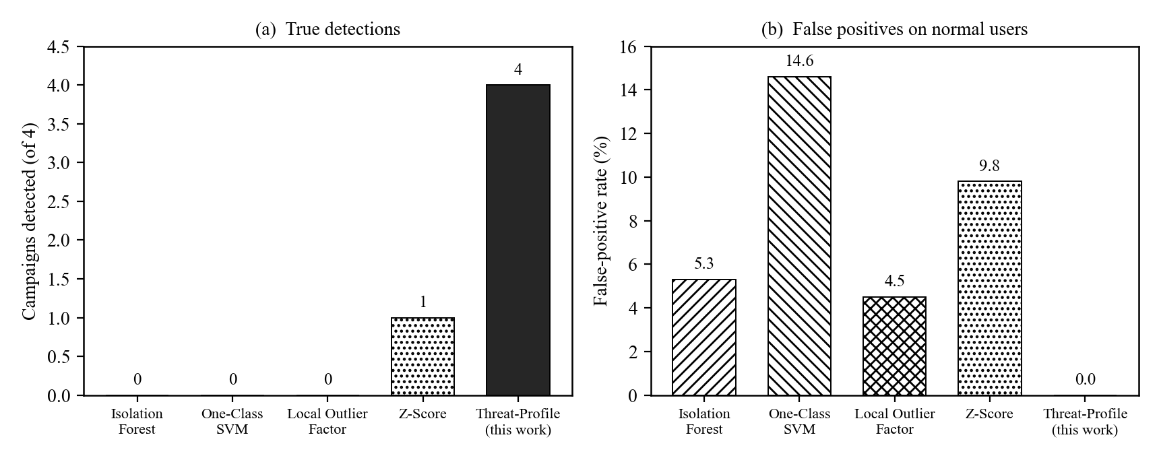
Figure 3. Detection performance (measured, synthetic data). (a) True detections of four embedded campaigns. (b) False-positive rate on the 246 normal users. The threat-profile detector attains four of four at zero false positives, while the best baseline attains one of four.
5.2 Per-campaign fingerprints
Table 3 lists the named profile that matched each campaign and the supporting evidence. Each campaign matched a different combination of fronts, and the two hardest cases, the slow APT and the insider, were each caught on two independent matches.
Campaign (entity) | Named profile match | Matches
Insider threat (USR-156) | mass_collection (IQR-z 5.9) and cohort_rare_dst (76 rare external addresses) | 2
Slow APT, covert C2 (USR-234) | c2_beacon (386-day, CV below 0.65) and dga_dns (160 generated domains) | 2
Living off the land (USR-042) | lotl_process (IQR-z 4.5, admin-tool breadth) | 1
Telecom infrastructure (USR-118) | recon_fanout (IQR-z 8.2, destination fan-out) | 1
Table 3. Per-campaign named-profile matches (measured, synthetic data). The Matches column counts independent profile matches per campaign.
5.3 Validation boundaries
The results are a proof of concept, not operational proof. The data is synthetic and calibrated to public advisories, so every figure, including the zero-false-positive result, must be re-measured on real telemetry. The Layer 1 operating point was selected with knowledge of the ground truth; in production, thresholds must be set blind and tuned per environment. The fingerprint library catches only techniques it describes, and Layer 2 is the noisier net for novel attacks by design.
6. Conclusion
Insider, APT, LOTL, and infrastructure campaigns share one property: they operate inside authorized access, beneath every signature and threshold, and reveal themselves only as a gradual change of behavioral direction over months. Behavioral Entity Intelligence reads the same enterprise logs as an evolving behavioral profile and runs two layers over it: a precision layer of named, IQR-scored, cohort-relative and label-free fingerprints, and a discovery layer of embedding drift (CUSUM) and concept-aligned direction (cosine similarity). On a 250-user, 485-day proof of concept, the precision layer detected four of four campaigns at zero false positives, against one of four for the best of four standard detectors. The algorithms are standard; the contribution is their composition into an explainable system, and the next step is validation on real operational telemetry.

