Behavioral Entity Intelligence for Cyber Threat Detection
A Two-Layer Behavioral Method for Detecting Insider, Advanced-Persistent-Threat, and Living-off-the-Land Activity Below Conventional Thresholds
Academic edition. June 2026.
Abstract. The most damaging recent intrusions, including Volt Typhoon and Salt Typhoon, evaded the victims' own security tools entirely and were discovered only by outside agencies. Such campaigns operate with valid credentials and legitimate tools, remaining inside conventional statistical thresholds while shifting their behavior gradually over months. This paper presents Behavioral Entity Intelligence, a detection method that represents each user and system as a behavioral profile evolving over time and evaluates both the magnitude and the direction of behavioral change. The method combines two layers: a precision layer that matches named, measurable known-bad fingerprints scored relative to role-group peers, and a discovery layer built on text embeddings, cumulative-sum change-point detection, and concept-aligned drift direction. On a synthetic enterprise of 250 users observed over 485 days with four embedded campaigns, the precision layer detected four of four campaigns at zero false positives, while the strongest of four standard anomaly detectors detected one of four. All results derive from synthetic data and define a proof of concept that warrants validation on real telemetry. The algorithms named here are standard techniques; the contribution is their composition into an explainable detection system.
1. Introduction and Problem Statement
Enterprise security monitoring rests on two mechanisms: a Security Information and Event Management (SIEM) platform applying expert-written rules, and signature-based detection matching activity against known Indicators of Compromise. Both answer one question: does this activity match something already known to be malicious? Three threat families are engineered so the answer is no. Insider threats use legitimate access, and industry reporting (the Verizon Data Breach Investigations Report) attributes roughly 20 percent of breaches to insiders, with a median time to discovery exceeding 200 days. Advanced Persistent Threats (APTs) maintain a covert command-and-control (C2) channel throttled to a trickle, a check-in every few hours in kilobyte packets. Living-off-the-land (LOTL) attacks use only the administration tools already installed, so there is no malware to fingerprint and no rule to violate.
The common technique is termed slow and low: behavior changes so gradually that no single week is anomalous, while the cumulative change over months achieves the objective. The activity is visible only in the trajectory, never in a single snapshot (Figure 1). The documented record is unambiguous. Neither Volt Typhoon nor Salt Typhoon was detected by any victim's SIEM, intrusion detection, or endpoint tooling, because there was no signature to match and no threshold crossed; both were found by external intelligence operations, years or months after compromise. This is a structural limitation, addressed below.
1.1 Why threshold and signature monitoring fall short
- Threshold insensitivity. Rules and signature checks stay green while an entity drifts toward a known-bad pattern, because the individual actions remain authorized.
- Magnitude-only measurement. Conventional anomaly models measure how much a metric changes, not the direction in which the entity is evolving; an insider may hold file volume flat while shifting from public to confidential content.
- Single-entity, single-metric scope. An entity may look normal in isolation while its relationship to destinations, peers, or data has changed; one external address recurring every week for over a year is the fingerprint of covert infrastructure.
- Signature dependence. Detection that depends on a known-bad list cannot see a novel implant or a first-seen destination until it is catalogued, and LOTL activity offers nothing to fingerprint.
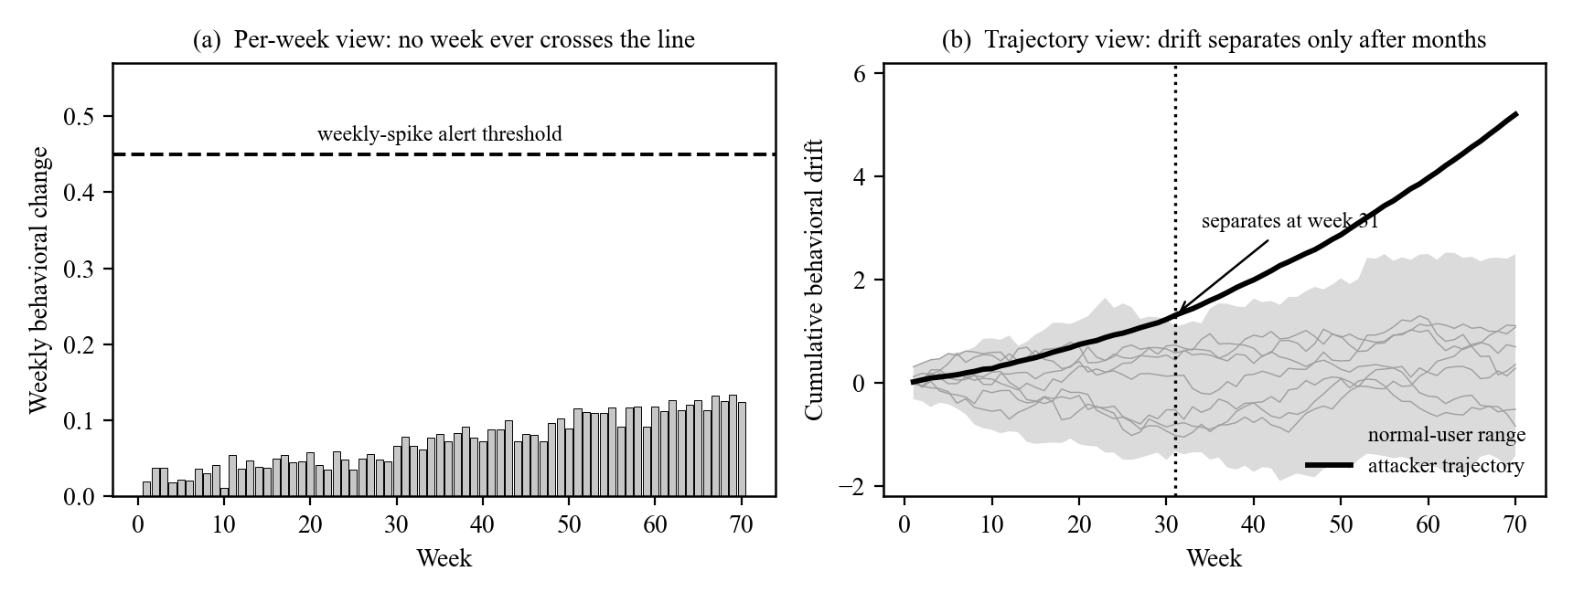
Figure 1. The slow-and-low evasion (illustrative). (a) A fixed-threshold detector evaluates each week alone, and the attacker's weekly change never crosses the alert line. (b) The same weeks accumulated as behavioral drift separate the attacker from the normal-user range within months.
2. Behavioral Entities and Zones
Behavioral Entity Intelligence represents an observable subject, a user, device, network segment, application, or session, as a profile that evolves over time rather than a static record. Each week, raw activity from five log sources (authentication, file access, endpoint activity, network traffic, and domain resolution) is distilled into roughly two dozen behavioral measurements per entity, organized into five behavioral zones (Table 1). Zone decomposition is the central representational choice: when the identity zone is stable while the data-behavior zone drifts, the system infers the same credentials reaching different data, which is the insider signature and which no single anomaly score expresses.
Behavioral zone | What it captures | What it catches when it drifts
Identity | Role, department, clearance, tenure. | Stability is itself a clue: insiders still look like the same person.
Access pattern | Sign-in frequency, failures, timing, sources. | Credential abuse and account takeover.
Data behavior | Data volume, sensitivity mix, read and write balance. | Insider data theft toward restricted material.
Network footprint | Destinations, external traffic, domain lookups. | Covert call-home and exfiltration routes.
Risk posture | Endpoint process activity and risk indicators. | Compromised machines and privilege escalation.
Table 1. The five behavioral zones and what each catches when it drifts.
3. Methods and Algorithms
The architecture runs two complementary layers over the per-entity behavioral profile. This section names the algorithms and reports the operating points used in this study. Every named technique is a standard, well-established method; the contribution is their composition, and no individual algorithm is claimed novel in isolation.
3.1 Behavioral feature construction and embedding
Each entity-week is summarized as a structured natural-language description of its five zones and converted to a 1,536-dimensional vector using the OpenAI text-embedding-3-small model. All entity types share one embedding space, so behaviors that mean similar things are placed near one another even when their raw counts differ. A deterministic mock embedder reproduces the pipeline offline for development without an API key.
3.2 Layer 1: the multi-front threat-profile detector (precision)
Layer 1 matches named known-bad fingerprints across two complementary detection fronts, with a self-drift signal as corroboration, and raises a flag only on a defined profile match.
- Front A, cohort-relative profiles. Each behavioral feature is scored with a cohort-segmented robust z-score: within each role-group cohort the feature is centered on the cohort median and scaled by the cohort interquartile range (IQR), with the denominator floored at a fraction of the global IQR to prevent near-constant baselines from inflating scores. A named profile (for example mass_collection, lotl_process, recon_fanout) fires only when its defined combination of features is jointly elevated against peers. Reported matches include peer-relative deviations of 5.9 (insider mass collection), 4.5 (LOTL process breadth), and 8.2 (reconnaissance fan-out).
- Front B, raw-event profiles. Computed directly from logs with no labels. A covert C2 beacon is identified by the coefficient of variation (CV) of its inter-callout intervals: a value below 0.65 indicates machine-like regularity, whereas legitimate, bursty services sit near 0.8 to 1.0. Algorithmically generated domains are identified by the Shannon entropy of the domain string (below approximately 3.0 bits per character indicates high randomness) together with shared second-level-domain infrastructure. Cohort-rare destinations are those contacted by a single entity within its cohort. Reported matches include a beacon persistent on 386 distinct days, 160 generated domains, and 76 cohort-rare external destinations.
- Self-drift corroboration. An entity's late-window mean is compared to its early-window mean and scaled by the early-window standard deviation, providing a self-referential drift magnitude that corroborates the cohort-relative and raw-event fronts.
Because a flag denotes a named profile match rather than a bare statistical outlier, Layer 1 is both high-precision and self-explaining, and each detection is mapped to a MITRE ATT&CK technique. Figure 2 illustrates the label-free beacon test.
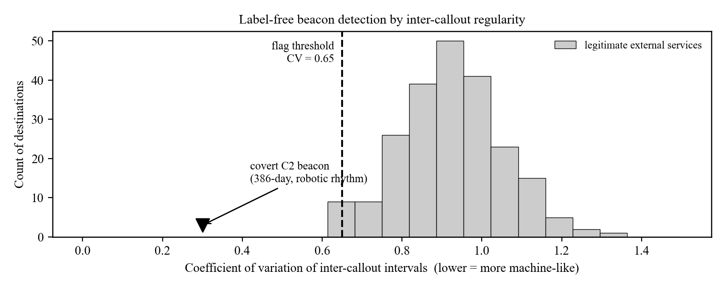
Figure 2. Label-free beacon detection. The coefficient of variation of inter-callout intervals separates the metronomic covert beacon (CV near 0.3) from legitimate bursty services (CV near 0.8 to 1.0); the flag threshold is 0.65. The detector reads the rhythm, not the destination, so it generalizes to unseen infrastructure.
3.3 Layer 2: drift, direction, and novelty (discovery)
Layer 2 is the unsupervised net for attacks the fingerprint library does not yet describe, and it supplies the direction that makes the precision layer interpretable. Slow drift along each entity's embedding trajectory is accumulated with cumulative-sum (CUSUM) change-point detection, from the same family used to catch slow degradation in industrial process control. Drift direction is projected by cosine similarity against a library of pre-embedded reference threat concepts aligned with MITRE ATT&CK, naming the behavioral direction (for example reconnaissance, data exfiltration, or living off the land). Novelty features flag behavior never seen before that nonetheless recurs.
3.4 Baseline detectors
For comparison, the same weekly feature matrix is evaluated with four standard unsupervised anomaly detectors: Isolation Forest, One-Class Support Vector Machine (One-Class SVM), Local Outlier Factor, and a per-feature Z-Score. These represent the magnitude-based detection that conventional tooling approximates.
4. Evaluation
All results derive from a synthetic enterprise of 250 users observed across 485 days (70 weeks), approximately 14 million events from five log sources, with four long-duration campaigns embedded and calibrated to public CISA advisories: an insider threat over 14 months (USR-156), a slow APT with a periodic C2 beacon over 417 days (USR-234), a Volt Typhoon-style LOTL campaign over 412 days (USR-042), and a Salt Typhoon-style telecom campaign over 412 days (USR-118).
4.1 Detection results
Table 2 and Figure 3 summarize detection performance. Three of the four baseline detectors identify none of the four campaigns, and the strongest identifies one, a single statistical spike. The threat-profile detector identifies all four and flags no normal user.
Method | Detected | False positives | Notes
Isolation Forest | 0 of 4 | 5.3% | All four campaigns lie inside the learned normal region.
One-Class SVM | 0 of 4 | 14.6% | High false-positive load and zero true detections.
Local Outlier Factor | 0 of 4 | 4.5% | Low false positives, zero detections.
Z-Score | 1 of 4 | 9.8% | Detects only the LOTL spike (USR-042, z = 3.04), barely over the line.
Threat-Profile detector (Layer 1) | 4 of 4 | 0% | All four matched to named fingerprints; no normal user flagged.
Table 2. Detection results across 250 users with four embedded campaigns (measured, synthetic data). False-positive rates are over 246 normal users.
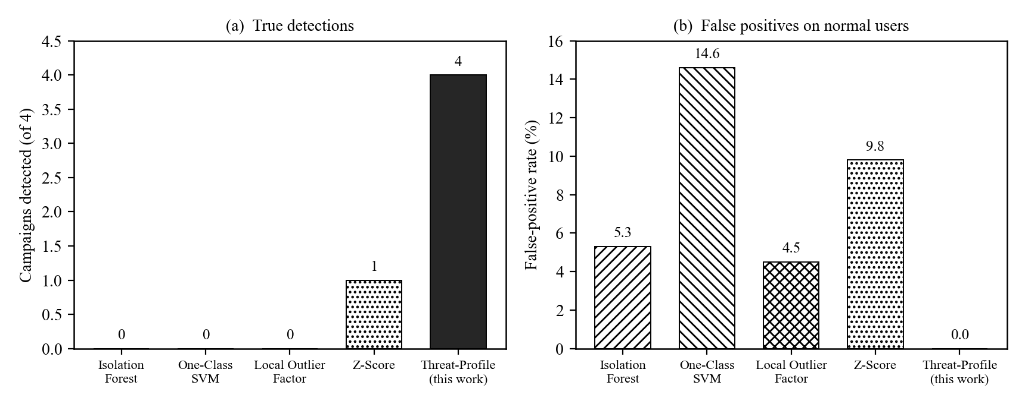
Figure 3. Detection performance (measured, synthetic data). (a) True detections of four embedded campaigns. (b) False-positive rate on the 246 normal users. The threat-profile detector attains four of four at zero false positives, while the best baseline attains one of four.
4.2 Per-campaign fingerprints
Table 3 lists the named profile that matched each campaign and the supporting evidence. Each campaign matched a different combination of fronts, and the two hardest cases, the slow APT and the insider, were each caught on two independent matches.
Campaign (entity) | Named profile match | Matches
Insider threat (USR-156) | mass_collection (IQR-z 5.9) and cohort_rare_dst (76 rare external addresses) | 2
Slow APT, covert C2 (USR-234) | c2_beacon (386-day, CV below 0.65) and dga_dns (160 generated domains) | 2
Living off the land (USR-042) | lotl_process (IQR-z 4.5, admin-tool breadth) | 1
Telecom infrastructure (USR-118) | recon_fanout (IQR-z 8.2, destination fan-out) | 1
Table 3. Per-campaign named-profile matches (measured, synthetic data). The Matches column counts independent profile matches per campaign.
4.3 Validation boundaries
The results are a proof of concept, not operational proof. The data is synthetic and calibrated to public advisories, so every figure, including the zero-false-positive result, must be re-measured on real telemetry. The Layer 1 operating point was selected with knowledge of the ground truth; in production, thresholds must be set blind and tuned per environment. The fingerprint library catches only techniques it describes, and Layer 2 is the noisier net for novel attacks by design.
5. Conclusion
Insider, APT, LOTL, and infrastructure campaigns share one property: they operate inside authorized access, beneath every signature and threshold, and reveal themselves only as a gradual change of behavioral direction over months. Behavioral Entity Intelligence reads the same enterprise logs as an evolving behavioral profile and runs two layers over it: a precision layer of named, IQR-scored, cohort-relative and label-free fingerprints, and a discovery layer of embedding drift (CUSUM) and concept-aligned direction (cosine similarity). On a 250-user, 485-day proof of concept, the precision layer detected four of four campaigns at zero false positives, against one of four for the best of four standard detectors. The algorithms are standard; the contribution is their composition into an explainable system, and the next step is validation on real operational telemetry.

