Demand Forecasting for Defense Logistics:
The Traditional Approach vs. EDM Vector Intelligence
A business and technology overview — what the innovation is, what it delivers, and what the evidence shows
22nd Century Technologies, Inc. · V-Intelligence DLA Program · June 2026 · Business Edition
Disclosure note: this edition describes the architecture and the innovation, and reports measured results. The exact model logic — formulas, thresholds, and adjustment parameters — is proprietary and is withheld here; it is available in the full technical edition under NDA (non-disclosure agreement).
Data note: all results in this paper come from a synthetic (simulated) dataset built to prove the concept — 500 items, 200 suppliers, 4 depots, 24 months, ~277,000 requisitions. They must be re-validated on real Defense Logistics Agency data before any operational claim.
1. Executive Summary
The Defense Logistics Agency (DLA) buys and positions spare parts for the Department of Defense. Every forecast it produces feeds a bet under uncertainty: how much to stock, where, and at what budget. Defense demand is intermittent (most weeks see zero orders), lumpy (order sizes swing widely), and regime-changing (exercises, deployments, and lifecycle shifts reshape it quickly). A single best-guess number cannot support that decision — the planner needs a calibrated range, and a system that reacts before the change is obvious.
The legacy forecaster extrapolates each item's own history and draws its uncertainty range in a single fixed shape: the range can slide up or down, but never tighten when demand calms or widen when it destabilizes. That frozen shape is the root cause of systematic over- and under-ordering.
EDM Vector Intelligence (EDM = Entity Digital Model) adds the dimension legacy structurally lacks. It represents every item-at-a-depot as a digital entity in a high-dimensional behavior space — the same kind of semantic representation that powers large language models, applied to supply-chain behavior instead of language. Re-profiling each entity monthly produces a trajectory; measuring that trajectory ("drift") tells us where the item is heading; and matching the drift direction against eight named supply-chain situations tells us what it is becoming. The forecast and its uncertainty bands are then adjusted early — before the shift appears in raw order counts.
The innovation in one line: legacy forecasts the past and freezes the bands; EDM detects where the item is heading and right-sizes both the plan and its uncertainty — early.
- Right-sized procurement. On a declining item (an adapter plate at Red River Army Depot), legacy planned 407 units over 8 weeks at the safety-stock level; EDM planned 218 — 189 fewer units, roughly $564,000 of avoided procurement on a single item.
- Early warning. On an item drifting toward a supply disruption, EDM raises the plan and widens the bands 1–3 months before the disruption shows in delivery counts.
- Trustworthy uncertainty. The probability model is exceptionally well-calibrated (when it says 70%, demand occurs about 70% of the time — Grade A in testing), so safety stock can target a real service level.
2. The Problem
Three properties of defense-parts demand defeat a single-number forecast:
- Intermittency. Most item-weeks have zero demand. Whether demand occurs at all is a separate question from how much — and both must be modeled.
- Lumpiness. When demand occurs it varies widely; the spread of outcomes matters as much as the center.
- Regime change. Exercises, deployments, and lifecycle transitions reshape demand by category and timing. A forecaster that cannot see the shift forming reacts only after it has happened.
The right output is therefore a calibrated distribution per item, location, and week — a low (P10), median (P50), and high (P90) estimate, where "P90" means the level demand stays under 90% of the time — produced by a system that can also reason across items, suppliers, and depots rather than one series at a time.
3. The Traditional (Legacy) Approach
The legacy forecaster examines one item's history at one depot, computes the recent average and trend, applies exercise and fiscal-calendar factors, and scales its historical demand percentiles by the combined ratio. It is transparent and fast — and it is the baseline EDM must beat.
Stage | What it does
1. Load & aggregate | Pull ~6 months of requisitions for this item at this depot into weekly buckets.
2. Empirical percentiles | Compute how often demand occurs and the historical low-to-high spread. A new item with no history forecasts zero.
3. Exercise calendar | Apply per-item exercise multipliers with ramp-up and wind-down periods.
4. Fiscal calendar | Adjust for Department of Defense fiscal-year quarter effects.
5. Trend & scale | Project the recent trend and scale every percentile by the same combined ratio.
6. Simulation | A shared Monte Carlo simulation converts weekly estimates into the 8-week cumulative safety-stock target (the same simulator EDM uses, for a fair comparison).

Why it is not enough
- Frozen band shape. Because every percentile scales by one ratio, the ratio of high-to-median never changes. The band cannot narrow on a calming item or widen on a destabilizing one — the direct cause of over- and under-ordering.
- Backward-looking. Trend extrapolation cannot anticipate a regime change; it reacts only after the counts move.
- Cold-start blindness. A new or sparse item receives a zero forecast, with no mechanism to borrow from similar items.
- Single-entity tunnel vision. One item, one depot, one data source — no cross-item learning, no behavioral signal.
4. The EDM Vector Intelligence Approach
4.1 The digital entity and its drift
First, the central concept in plain terms. A "digital entity" (sometimes called a digital twin) is a living profile of a real-world thing, maintained in software. Think of a patient's medical chart: it does not just record today's temperature — it accumulates history, vitals, and context, and a doctor reads its trend to act before a condition becomes acute. EDM keeps exactly such a chart for every part at every depot: not just "how many were ordered," but the full behavioral picture — and, critically, how that picture is changing month over month.
EDM models each item-location pair — identified by NSN (National Stock Number, the part's unique ID) and DODAAC (the code for a depot or activity) — as a digital entity in a unified 1,536-dimension semantic space: a mathematical "map of meaning" where items that behave alike sit near each other, even when their raw numbers differ. The entity is built from five behavioral signals: demand, supply, inventory, volatility, and operational context. Each signal's metrics are serialized into a structured natural-language description and converted into a numerical vector by an embedding model — the representational machinery of large language models, repurposed to understand demand behavior instead of language.
Each month the entity is re-embedded, so over 16–23 monthly snapshots it traces a trajectory through the behavior space. Forecasting then asks two questions a moving average cannot: what has this item been doing (a calibrated statistical baseline), and — the innovation — where is it heading (its drift), so the plan can adjust before the raw numbers move.
Behavioral signal | What it captures
Demand | Volume, frequency, trend, and variability of weekly demand.
Supply | Supplier count, sole-source exposure, concentration, and delivery performance.
Inventory | On-hand position, trajectory, and safety-stock posture.
Volatility | Zero-demand fraction, demand intervals, and stability of the pattern.
Context | Criticality, stock ratios, and operational setting.

The five signal vectors compose into one monthly entity state. Because every entity lives in the same space, the system can also find behavioral neighbors — which is what gives a brand-new item a meaningful forecast borrowed from items that behave like it (cohort transfer), something legacy cannot do at all.
4.2 Architecture and data
The system is a containerized service: an API (Application Programming Interface) layer over a PostgreSQL database with a vector store (fast similarity search over the entity embeddings), bi-temporal history (every fact is stored with both when it happened and when the system learned it), and point-in-time feature functions that guarantee no future information leaks into training. It ingests the requisition, order, inventory, and operational-calendar data DLA already produces — no new instrumentation. The production baseline uses 25 engineered features per item-depot-week; with all EDM layers active, the model ingests 67 features, adding embedding-derived zone signals, entity-trajectory measures, and cohort-transfer features.
4.3 The drift-augmented forecast — the innovation
The drift layer wraps a calibrated baseline in five steps. We describe what each step does; the exact formulas, thresholds, and adjustment parameters are proprietary and withheld in this edition.
Step | What it does
1. Calibrated baseline | A two-stage ("hurdle") model — first the probability that any demand occurs, then the size if it does, as a set of percentile estimates. This is the statistically correct shape for zero-inflated demand.
2. Trajectory load | Load the entity's monthly behavior snapshots. If too few exist, return the baseline unchanged — the system degrades gracefully rather than guessing.
3. Drift measurement | Measure how fast and how consistently the entity is moving through behavior space (its velocity, acceleration, and consistency).
4. Direction naming | Compare the drift direction against eight pre-embedded supply-chain concepts; the strongest match names what the entity is becoming.
5. Plan adjustment | Translate the named direction into a bounded adjustment of the plan and an independent reshaping of the uncertainty bands, then re-run the simulation on the adjusted estimates.

The eight named directions and how each moves the plan:
Concept | Plan effect | Meaning
Demand surge | Order more | Rising volume, depleting stock, stockout risk forming.
Supply disruption | Order more | Lead times stretching, supplier performance degrading.
Critical shortage | Order more | Approaching stockout on a high-mission-impact item.
Demand decline | Order less | Demand tapering off; excess-carry risk.
Excess inventory | Order less | On-hand position too high; obsolescence risk.
Stable consumption | No change | Predictable behavior; the baseline is already right.
Intermittent demand | Widen bands | Sparse demand; uncertainty honestly widened.
Volatility increase | Widen bands | Direction unknown; bands widen, median untouched.

Two design properties matter operationally. First, the bands move independently of the median — unlike legacy, the band shape itself changes with the situation: narrow on a calm decline, wide on a forming disruption. Second, the adjustment is deliberately conservative: it is capped to a modest maximum, damped when the drift signal is weak or inconsistent, and overridden entirely in defined safety cases — so noise never moves procurement, and the model nudges rather than lurches.
5. Results (Synthetic Data)
5.1 The honest scoreboard first: point accuracy
WAPE (Weighted Absolute Percentage Error) is the standard point-accuracy metric: total forecast error divided by total actual demand; lower is better. On WAPE, the production model on engineered features alone (0.791) and the same model with the embedding features added (0.789) are effectively tied — on synthetic data, the embedding features do not improve point accuracy. We say that plainly. But WAPE scores a single median number. The decision a planner actually makes — the safety-stock target, and how early the plan adapts — lives in the distribution and its direction, which WAPE does not measure at all.
5.2 The right scoreboard: procurement-plan accuracy
The decision the forecast feeds is the 8-week cumulative P90 — the safety-stock target. Three worked situations show the three things the drift layer does:
Situation | What happens | Outcome
Declining item — reduce  (real system output) | An adapter plate at Red River Army Depot, drifting toward "demand decline" across 23 monthly snapshots. EDM lowers the plan and tightens the bands. | Legacy plans 407 units (P90) over 8 weeks; EDM plans 218 — 189 fewer units, ~$564,000 avoided on one item. Most of the gap comes from the calibrated baseline and dynamic bands; the drift layer adds the directional nudge.
Disruption forming — increase  (illustrative) | A sole-source critical item whose trajectory aligns with "supply disruption." The adjustment reaches its cap and the bands widen. | EDM raises the plan 1–3 months before the disruption shows in deliveries; legacy reacts only once the shortage is already forming. This is the leading-indicator value a moving average cannot provide.
Destabilizing item — widen  (illustrative) | An item drifting toward "volatility increase." The median is left unchanged — the system does not pretend to know the direction. | The uncertainty bands widen substantially, signaling more buffer. Legacy's frozen narrow band would understate the risk and invite a surprise stockout.

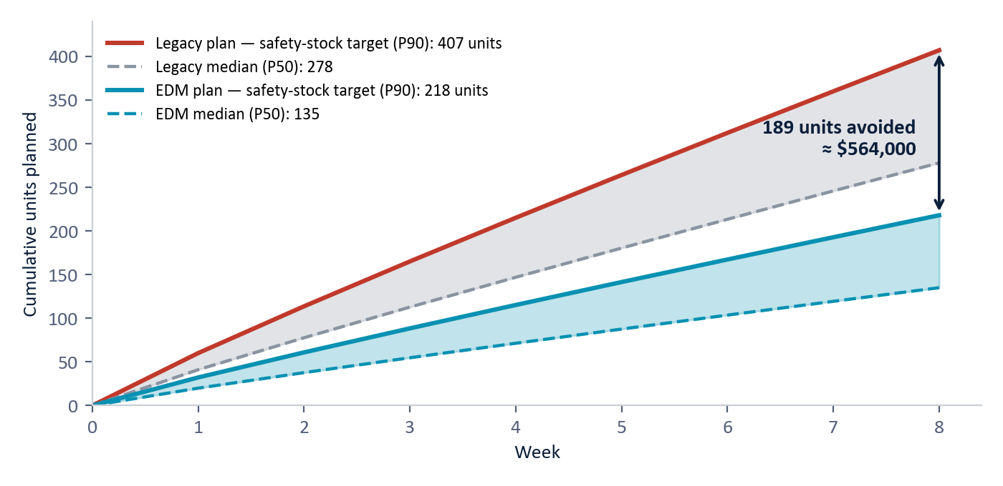
Figure 1 — The declining item (adapter plate, Red River Army Depot): 8-week cumulative procurement plan. Legacy's frozen, trend-extrapolated band plans to 407 units at the safety-stock level; EDM plans 218 — 189 fewer units, ≈ $564,000 avoided on one item. (System output, synthetic data.)
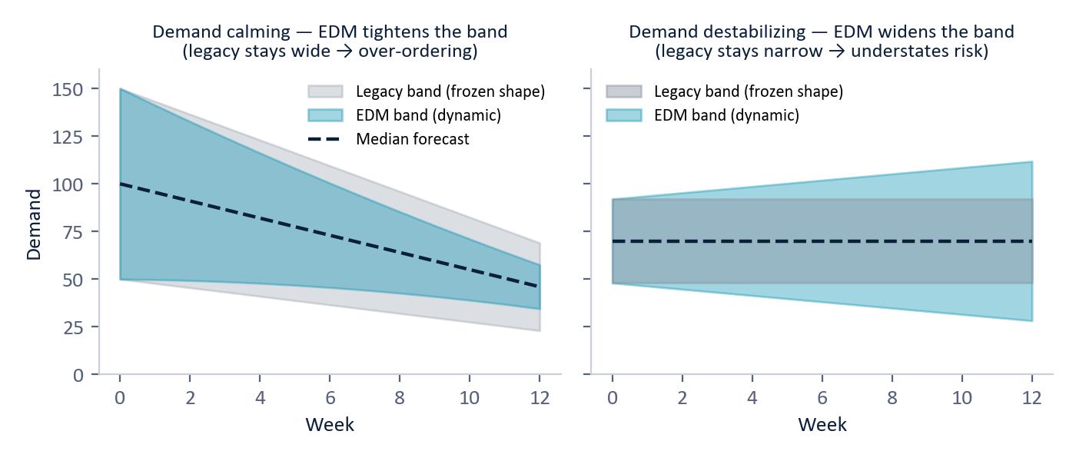
Figure 2 — Why the band shape matters. Legacy's band shape is frozen; EDM tightens it on a calming item (left, avoiding over-ordering) and widens it on a destabilizing one (right, surfacing the real risk). (Illustrative.)
5.3 Calibration — why the bands can be trusted
A probability model is trustworthy when its stated chances match reality. The occurrence model earned Grade A calibration (Expected Calibration Error 0.032), and the quantity percentiles cover close to their nominal targets — the median lands at 49.8% against a 50% target. The one deviation is conservative: the low (P10) percentile is slightly cautious, which is the safer failure mode for readiness.
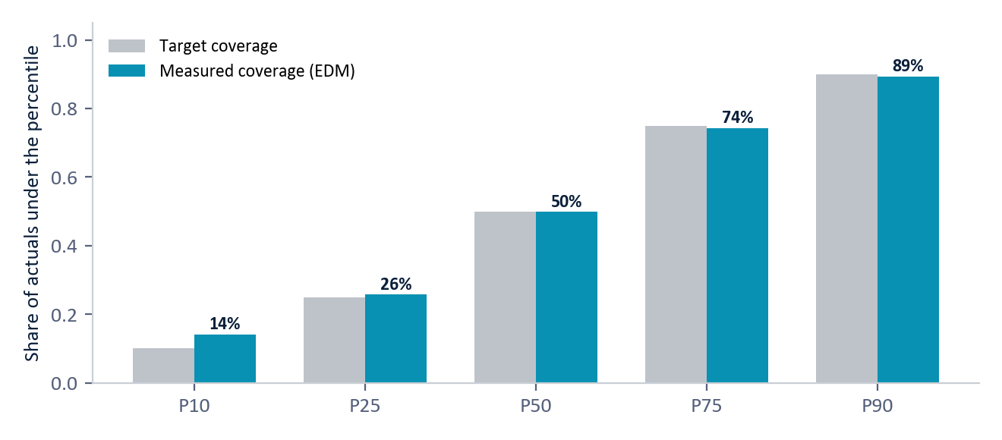
Figure 3 — Calibration: measured coverage tracks the target across all percentiles (synthetic data). The only deviation (P10) errs on the cautious side — the safer failure mode for readiness.
The demand is genuinely intermittent — the worked example item has 54% zero-demand weeks. A moving average smooths that away; the two-stage model handles occurrence and quantity separately, which is why its percentiles stay calibrated.
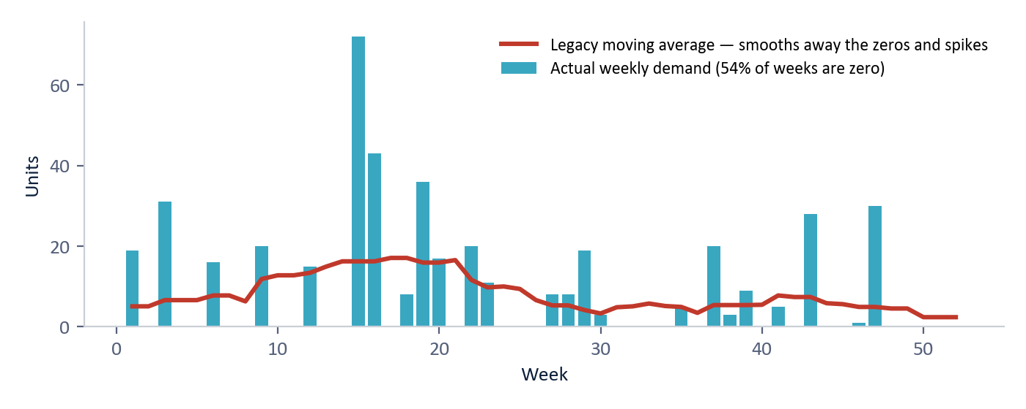
Figure 4 — What intermittent demand actually looks like (bars) versus the legacy moving average (line). The average smooths away the zeros and spikes that drive readiness risk. (Illustrative, synthetic.)
5.4 Model evaluation summary
Component | Metric | Result | Grade
Demand occurrence | Calibration (ECE) | 0.032 | A
Demand occurrence | Brier score | 0.089 | A
Demand quantity | Point accuracy (WAPE) | 0.791 | C
Demand percentiles | Median coverage (target 50%) | 49.8% | A
Lead time | Median error | 1.9 days | B
Drift adjustment | Capped, damped under weak signal, bands stay ordered | By design | —

Everything is scored out-of-time (the model is always tested on periods it never saw), with point-in-time features so no future data leaks into training. The honest verdict: the distribution a planner acts on is trustworthy (Grade A calibration); point accuracy is modest, which is the nature of intermittent demand and the wrong lens for this innovation; and the embedding/drift layer earns its place on capability — early direction, cold-start transfer, dynamic bands — not on WAPE.
6. Scale and Deployment
- Performance. Embeddings are cached, feature views are precomputed, and forecasts run in batch; entity-similarity lookups return in milliseconds.
- Latency. Legacy responds in ~50–150 ms per item; EDM in ~200–400 ms — both comfortably interactive.
- Footprint. Containerized and database-backed; deployable in a DLA data center or secure enclave. Ingests existing requisition, order, inventory, and calendar data — no new instrumentation.
- Air-gap option. The external embedding model can be swapped for a locally hosted one for air-gapped operation.
- Low-risk rollout. Run legacy and EDM side by side (the application's Live Explorer does exactly this), compare plans, then feed EDM into procurement.
7. Why This Is New
The contribution is the drift-augmented entity model, not a new point estimator. Classical methods (moving averages, exponential smoothing, statistical time-series models such as ARIMA, and the Croston family of methods for intermittent demand) model each series in isolation with static uncertainty. Modern machine-learning forecasters and foundation time-series models improve point accuracy but offer no cross-entity semantic space and no named direction of change.
A structured, source-verified review of the market and literature (2024–2026) found no commercially marketed platform, and no single published method, that forecasts this way. The major demand-planning platforms forecast with machine-learning models over tabular features; their generative AI is a conversational copilot layer, not the forecasting mechanism. Academic foundation models tokenize the numeric series directly rather than embedding entity behavior.
We are explicit about prior art: the individual ingredients — serializing structured data to text for embedding, detecting anomalies in embedding space, measuring embedding drift, and similarity-based transfer — each exist separately in the literature. What is not offered, commercially or in any single published system, is their composition: a unified entity-embedding space whose drift is measured, named against supply-chain concepts, and used to right-size both the procurement plan and its uncertainty bands, early. The innovation is the integrated architecture.
Scoping notes: vendor internals are not fully public (the comparison is against marketed methodology), and a formal freedom-to-operate review (a patent-clearance analysis by counsel) is recommended before any contractual assertion of uniqueness.
8. Limitations — Stated Plainly
- All metrics and dollar figures are synthetic and must be re-measured on real DLA data.
- On point accuracy (WAPE), EDM does not yet beat legacy; the case rests on procurement-plan accuracy, calibration, and capability.
- The drift layer currently adjusts how much to stock, not whether demand will occur — a deliberate simplification worth revisiting.
- The drift adjustment is applied uniformly across the forecast horizon rather than week by week.
- Exercise-related behavior depends on calendar flags being populated; missing flags would skew exercise-scenario comparisons.
- Real embeddings depend on an external model; air-gapped deployment requires re-characterizing a local replacement.
9. Conclusion
Judged on point accuracy, legacy and EDM tie — and that is the wrong test. Defense-logistics demand is intermittent and regime-changing, and the decision it feeds is a distribution, not a number. Legacy forecasts the past and freezes its uncertainty band, so it systematically over- and under-orders. EDM models each item-depot as a digital entity, detects where it is heading in behavior space, names the direction against eight supply-chain concepts, and right-sizes both the plan and its bands — early. On the system's own output, that is hundreds of thousands of dollars of avoided over-procurement on a single declining item, and a 1–3 month head start on a disruption.
Legacy answers "what is the expected demand?" EDM answers "where is this item heading, and what should we stock to be ready?" — and adjusts before the raw numbers move.
Appendix — Glossary
Term | Meaning
Digital entity / digital twin | A living software profile of a real-world thing — like a patient's medical chart for a part: history, vitals, context, and trend, updated monthly.
Semantic space | A mathematical "map of meaning": items whose behavior is similar sit near each other, even if their raw numbers differ.
DLA | Defense Logistics Agency — the Department of Defense organization that buys and distributes spare parts and supplies.
EDM Vector Intelligence | Entity Digital Model — our approach: a digital behavioral profile of each part whose movement over time drives the forecast.
NSN / DODAAC | National Stock Number (a part's unique ID) / the code identifying a depot or activity.
Embedding | A numerical vector that captures the meaning of a description — the core representation inside large language models.
Drift | How an entity's behavioral profile moves through the embedding space over time — speed, consistency, and direction.
P10 / P50 / P90 | Percentile estimates: demand stays under the P90 level 90% of the time. P50 is the median. The P10–P90 spread is the uncertainty band.
Safety stock | Buffer inventory held so a part does not run out; sized here from the 8-week cumulative P90.
Hurdle (two-stage) model | First predict whether any demand occurs, then how much if it does — the right structure for demand that is mostly zeros.
Calibration / ECE | Whether stated probabilities match observed reality; ECE (Expected Calibration Error) measures the gap — lower is better.
Brier score | A standard accuracy score for probability forecasts (0 is perfect, 1 is worst); lower is better.
WAPE | Weighted Absolute Percentage Error — total forecast error divided by total actual demand; a point-accuracy metric.
Cohort transfer | Borrowing demand patterns from behaviorally similar items to forecast a new or sparse item.
Monte Carlo simulation | Running thousands of simulated futures to turn weekly estimates into a cumulative safety-stock target.
Synthetic data | Simulated data built to prove the concept before access to real operational data.

Business Edition — architecture-level disclosure. Exact model logic, formulas, thresholds, and adjustment parameters are proprietary and available in the full technical edition under NDA. All results are synthetic and must be re-validated on real DLA operational data. Do not redistribute.

