V-INTELLIGENCE DLA · EDM VECTOR INTELLIGENCE · TECHNICAL PAPER
Traditional (Legacy) Demand Forecasting
vs. EDM Vector Intelligence
Drift-Augmented, Uncertainty-Aware Demand Forecasting for Defense Logistics

22nd Century Technologies, Inc.
V-Intelligence DLA Program
June 2026 — Technical Paper, Version 2.0

DISTRIBUTION: Conceptual Overview — Cleared for General Distribution

1. Executive Summary
Defense-logistics demand is intermittent, lumpy, and exercise-driven, and the decision it feeds — how much to stock, where, at what budget — is a bet under uncertainty. The legacy forecaster answers it with a moving average whose uncertainty band has a FROZEN shape: every quantile scales by one ratio, so the plan cannot tighten when demand is calming or widen when it is destabilizing. The result is systematic over- and under-ordering.
EDM Vector Intelligence adds what legacy structurally cannot: it represents each item-depot as a digital twin in a 1,536-dimension behavior space, detects WHERE that entity is heading (its drift), names the direction against eight supply-chain concepts, and adjusts both the procurement plan and its uncertainty bands BEFORE the shift shows up in raw counts. This is the drift-augmented forecast — the centerpiece of this paper.
EDM Vector Intelligence brings the representational power of large language models — the rich semantic space a transformer learns — into the supply-chain application layer, and couples it with rigorous forecasting mathematics: a calibrated two-stage (hurdle) model, drift geometry, and dynamic uncertainty bands. Where an LLM uses that space to understand language, we use it to understand demand.
The innovation, in one line: legacy forecasts the past and freezes the bands; EDM detects where the item is heading and right-sizes both the plan and its uncertainty — early.
What that buys, on the app's own (synthetic) output:
- Right-sized procurement: on a declining item (ADAPTER PLATE), legacy plans 407 units (P90) over 8 weeks; EDM plans 218 — avoiding 189 excess units (~87% over-order, ~$564,131 on one item).
- Early warning: on an item drifting toward disruption, EDM raises the plan and widens bands 1–3 months early to pre-position buffer before a stockout forms.
- Uncertainty you can plan against: calibrated occurrence probability (ECE 0.0322, Grade A) and dynamic P10–P90 bands, so safety stock can target a real service level.
All results are from synthetic data and are labeled as such; they establish the concept and must be re-validated on real DLA data.

2. Problem Statement
A demand forecast for defense logistics must support a stocking and budgeting decision under uncertainty. Three properties of the demand make a single-number forecast inadequate:
- Intermittency: most item-weeks are zero; the signal is whether demand occurs at all, separately from how much.
- Lumpiness: when demand occurs it is highly variable; the spread matters as much as the center.
- Regime change: exercises, deployments, and lifecycle shifts reshape demand by category and timing — and a forecast that cannot see the shift coming reacts too late.
The right output is a calibrated distribution per item-location-week whose bands move with the situation, produced by a system that can reason across items, suppliers, and depots — not one item at a time with a fixed-shape band.

3. The Traditional (Legacy) Approach
The legacy forecaster looks at one item's history at one depot, counts what happened, extrapolates the trend, factors in exercise and fiscal calendars, and simulates futures. It is transparent and fast — and it is the baseline EDM must beat.

3.1 The Six-Stage Pipeline
Stage | What it does
1. Load & aggregate | Load 180 days of requisitions for THIS NSN at THIS depot; weekly buckets
2. Empirical quantiles | p_demand = fraction of weeks with demand; P10–P90 from non-zero weeks; cold start = ZERO
3. Exercise calendar | per-item exercise multiplier (default 1.0), 14-day ramp / 7-day wind-down; deployments = 70%
4. Fiscal calendar | DoD FY Oct–Sep; fiscal_factor = quarter_avg / overall_avg, clipped [0.5, 2.0]
5. Trend × scale | linear trend; scale = trend × exercise × fiscal; ALL quantiles scale by the SAME ratio
6. Monte Carlo (shared) | the SAME 5,000-path AR(1) simulator EDM uses, applied to legacy's scaled quantiles for the cumulative-P90 safety-stock target (apples-to-apples) — not part of the legacy forecaster itself, which ends at stage 5

3.2 Why It Is Not Enough
- Frozen band shape: because every quantile scales by one combined ratio, the P90/P50 ratio never changes — the band cannot narrow when demand calms or widen when it destabilizes. This is the root cause of systematic over/under-ordering.
- Backward-looking: it extrapolates the recent trend; it cannot see a regime change forming until it already shows in the counts.
- Cold-start blindness: a new or sparse item gets a ZERO forecast — no way to borrow from similar items.
- Single-entity tunnel vision: one item at one depot, one data source; no cross-item learning and no behavioral signal.

4. The EDM Vector Intelligence Approach

4.1 Core Idea — the Digital Entity and Its Drift
EDM models each item-location as a digital entity in a unified 1,536-dimension semantic space, built from five behavioral signals (demand, supply, inventory, volatility, context). Each month re-embeds the entity, so the entity traces a trajectory. Forecasting becomes two questions a moving average cannot ask: what has this item been doing (a calibrated baseline), and — the innovation — where is it heading (drift), so the plan can adjust before the raw numbers move.
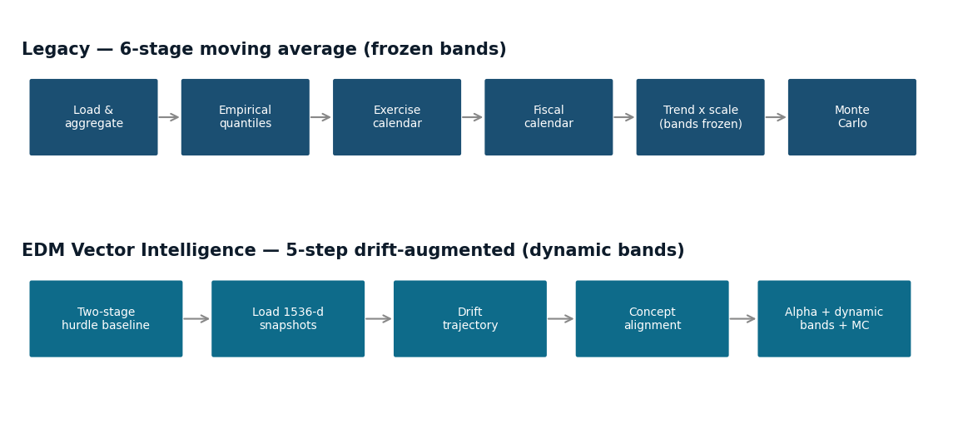
Figure 1 — The two pipelines. Legacy runs a 6-stage moving average with frozen bands; EDM runs a 5-step drift-augmented pipeline (calibrated baseline → 1,536-d snapshots → drift trajectory → concept alignment → alpha + dynamic bands).
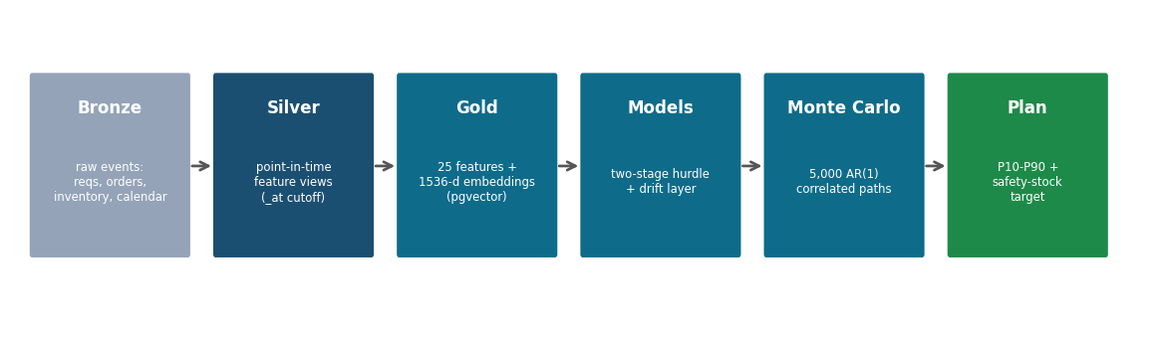
Figure 2 — End-to-end data flow. Raw events become point-in-time features and 1,536-d embeddings, feed the two-stage + drift models, and a Monte Carlo turns the per-week quantiles into the 8-week safety-stock target.
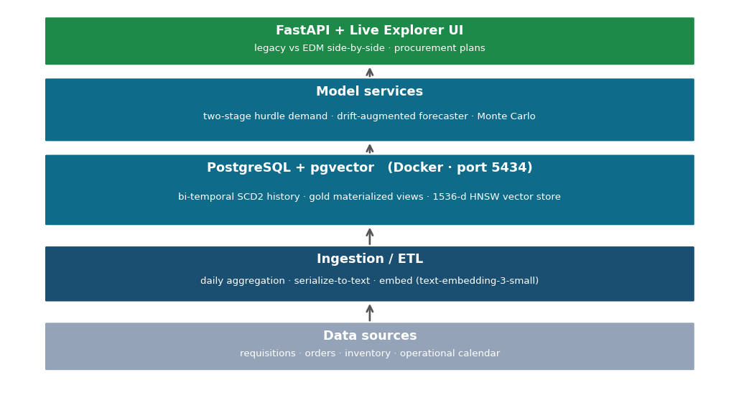
Figure 3 — System architecture. A containerized FastAPI service over PostgreSQL + pgvector (bi-temporal history, gold views, HNSW vector store) with the demand, drift, and Monte-Carlo model services behind the Live Explorer UI.

4.5 The Drift-Augmented Forecast (the Innovation)
The drift layer wraps the calibrated baseline in five steps. Steps 1–2 build the baseline and load the entity's snapshot trajectory; steps 3–5 are the innovation.
- Step 1, baseline: two-stage (hurdle) LightGBM — an occurrence classifier (will demand occur?) and five quantile regressors (P10–P90, monotonized) — the right shape for zero-inflated demand.
- Step 2, snapshots: load 16–23 monthly 1,536-d composite snapshots; if fewer than two exist, return the baseline unchanged (graceful degradation).
- Step 3, drift trajectory: L2 distances between consecutive snapshots give velocity, acceleration, mean-step drift, and consistency; from these, drift_intensity = velocity / mean_step and drift_norm = tanh(drift_intensity).
- Step 4, concept alignment: project the drift direction onto eight pre-embedded SCM concepts by cosine similarity; the highest-magnitude alignment names what the entity is becoming.
- Step 5, alpha + dynamic bands: convert the concept to a single bounded plan adjustment (alpha) and a band multiplier, then re-run the Monte Carlo on the adjusted, dynamically-banded quantiles.
The eight concepts and their adjustments (verified from the implementation):
Concept | Direction | Band | Meaning
demand_surge | +1 (order more) | 1.2x | rising volume, depleting stock, stockout risk
supply_disruption | +1 (order more) | 1.4x | lead times up, supplier performance down
critical_shortage | +1 (order more) | 1.5x | approaching stockout, high mission impact
demand_decline | -1 (order less) | 0.9x | demand tapering off, excess-carry risk
excess_inventory | -1 (order less) | 0.85x | on-hand too high, obsolescence risk
stable_consumption | 0 (no change) | 0.85x | predictable; baseline already good
intermittent_demand | 0 (no change) | 1.5x | sparse; widen bands for uncertainty
volatility_increase | 0 (no change) | 1.6x | direction unknown; widen bands

Two safety properties matter operationally: the adjustment is capped at ±30% (the model nudges, never lurches), and it is damped or zeroed when the drift is weak or inconsistent — so noise does not move procurement.

5. Results (Synthetic)
All numbers are from the app's synthetic data (500 items, 200 suppliers, 4 depots, 24 months) and must be re-validated on real DLA data. The worked examples are the app's own Live Explorer output. Results are reported honestly — including where point accuracy is a tie.

5.1 First, the Honest Scoreboard: Point Accuracy (WAPE)
WAPE — Weighted Absolute Percentage Error — is the standard point-accuracy metric: the sum of absolute forecast errors divided by the sum of actual demand. WAPE = Σ|actual − forecast| / Σ actual. Zero is perfect; a WAPE of 0.79 means the total error equals about 79% of total demand. It is volume-weighted (big items dominate) and it measures only how close the median forecast sits to actuals.
On WAPE, the engineered model (0.7908) and its EDM-enriched variant (0.7893) are effectively tied, and on synthetic data the embedding features do not improve point accuracy. We say this plainly — and then explain why WAPE is the wrong scoreboard for this innovation. WAPE scores a single median number; the EDM value is in the DISTRIBUTION and its DIRECTION — the safety-stock target and how early the plan adapts — which WAPE does not measure at all.

5.2 The Right Scoreboard: Procurement-Plan Accuracy
The decision the forecast feeds is the 8-week cumulative P90 — the safety-stock target. Legacy's frozen, trend-extrapolated band routinely over- or under-sizes it; EDM's calibrated baseline plus drift-adjusted dynamic bands right-size it. The three examples below show the three things the drift layer does — reduce, increase, and widen.
Example 1 — declining item (reduce): avoid over-ordering. [real Live Explorer output]
ADAPTER PLATE (NSN 5120-01-397-8469) at W25H1R (Red River Army Depot), criticality C. Across 23 monthly snapshots the entity drifts toward 'demand_decline' (alignment 0.056, drift velocity 0.770x normal), so EDM applies alpha -3.0% and narrows bands 0.90x. Over 8 weeks legacy plans P50 278 / P90 407; EDM plans P50 135 / P90 218 — 189 fewer units at P90 (~46% less), about $564,131 of avoided procurement on one item at $2,984.82/unit.
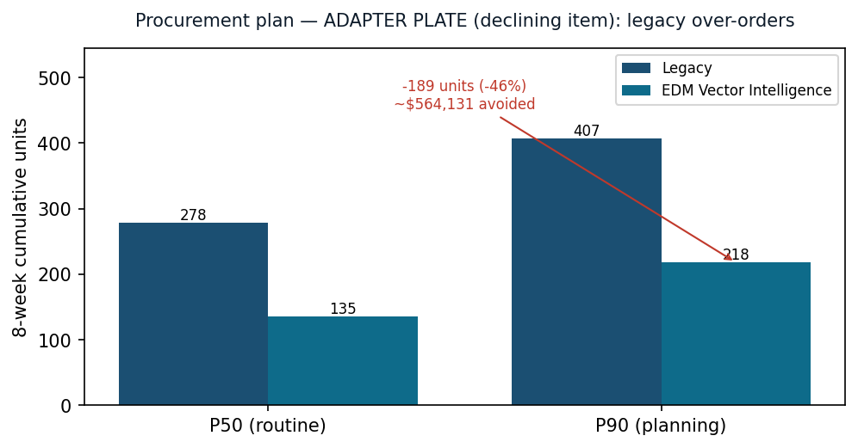
Figure 4 — Declining item: legacy over-orders. The 8-week cumulative plan (real Live Explorer output, synthetic data). Most of the gap is the calibrated baseline and dynamic bands; the drift layer adds the directional nudge.
Honest attribution: here the drift nudge is small (−3%); the bulk of the over-order avoidance comes from the calibrated two-stage baseline (a lower, tighter P50 than legacy's trend extrapolation) and from dynamic bands. The next example is where the drift layer itself dominates.
Example 2 — item drifting toward disruption (increase): avoid a stockout. [illustrative]
A sole-source critical item whose behavioral trajectory aligns with 'supply_disruption' (direction +1, band 1.4×). With strong, consistent drift the alpha saturates at its +30% cap and the bands widen 1.4×: EDM raises the plan and the safety-stock target 1–3 months before the disruption shows up in delivery counts, while legacy — which only extrapolates past requisitions — does not react until the shortage is already forming. This is the leading-indicator value a moving average cannot provide.
Example 3 — destabilizing item (widen): right-size uncertainty. [illustrative]
An item drifting toward 'volatility_increase' (direction 0, band 1.6×). The median plan is left unchanged — EDM does not pretend to know the direction — but the P10–P90 band widens 1.6× to reflect the higher uncertainty, signaling more buffer. Legacy's frozen, narrow band would understate the risk and invite a surprise stockout.
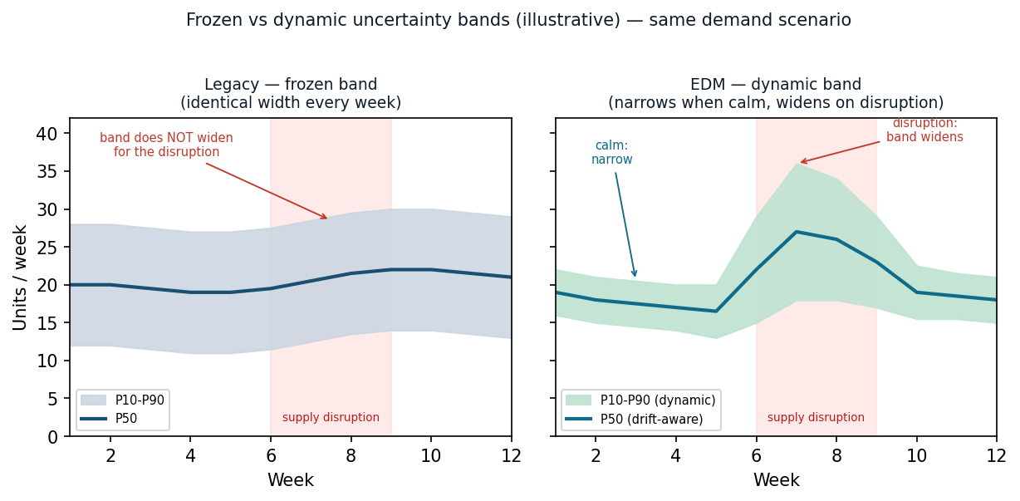
Figure 5 — Frozen vs dynamic bands (illustrative). Legacy's band shape is fixed; EDM narrows it on a calm decline and widens it on disruption/volatility — the mechanism behind right-sized safety stock.

5.3 Calibration and Intermittency
The probabilistic quality that makes the bands trustworthy: the occurrence classifier is well-calibrated (ECE 0.0322, Brier 0.0885 — Grade A), and the quantity quantiles cover close to nominal. P10 is slightly conservative (0.141 vs 0.10) — the safer failure mode for readiness; the median and upper quantiles track nominal.
Quantile | Nominal | Empirical (EDM) | Gap
p10 | 0.10 | 0.141 | +0.041
p25 | 0.25 | 0.257 | +0.007
p50 | 0.50 | 0.498 | -0.002
p75 | 0.75 | 0.743 | -0.007
p90 | 0.90 | 0.894 | -0.006

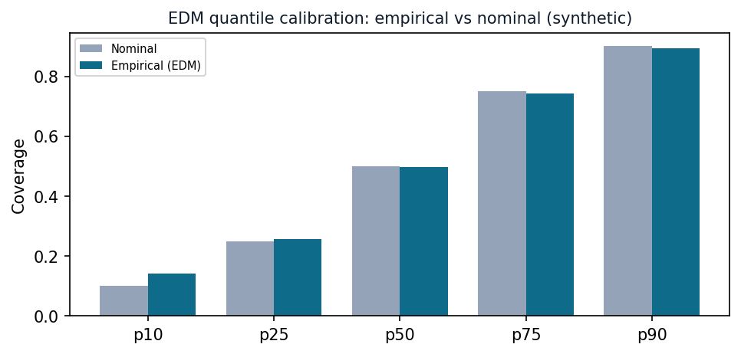
Figure 6 — EDM quantile calibration: empirical coverage tracks nominal across P10–P90 (synthetic). Calibrated bands are what let a planner trade safety stock for a target service level.
And the demand is genuinely intermittent — the example item has 54% zero-demand weeks. A legacy moving average smooths the intermittency away; the two-stage hurdle model handles occurrence and quantity separately, which is why its quantiles stay calibrated.
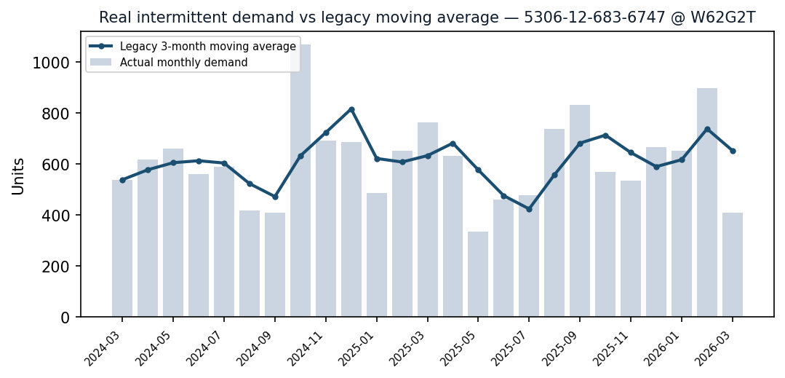
Figure 7 — Real intermittent demand (bars) vs the legacy moving average (line). The average smooths away the zeros and spikes that drive readiness risk.

5.4 AI / Model Evaluation
How the models are evaluated, and the honest verdict. Everything is scored out-of-time (rolling-origin, with point-in-time feature functions so no future data leaks into training). A probability model is judged by calibration — does a stated 70% actually happen about 70% of the time; a quantity model by point error (WAPE) and quantile coverage; and the drift layer by whether its directional adjustment is correct, bounded, and gated against noise. The consolidated scorecard (synthetic data):
Model / component | Metric | Value | Grade
Demand occurrence (Stage 1) | ECE (calibration) | 0.0322 | A
Demand occurrence (Stage 1) | Brier score | 0.0885 | A
Demand quantity (Stage 2) | WAPE (point accuracy) | 0.7908 | C
Demand quantiles (Stage 2) | P50 coverage (nominal 0.50) | 0.498 | A
Lead time | P50 MAE | 1.89 days | B
Drift adjustment | bounded ±30%, noise-gated, monotone bands | by design | —

AI-expert verdict, stated honestly. The occurrence model is excellently calibrated (Grade A) and the quantile bands cover near nominal, so the distribution a planner acts on is trustworthy — which is what makes the dynamic safety-stock target meaningful. Point accuracy (WAPE 0.79, Grade C) is modest, but that is the nature of intermittent demand and, as Section 5.1 argues, the wrong lens for this innovation. The embedding and drift layer earns its place on capability — leading-indicator direction, cohort cold-start, dynamic bands — not on WAPE; on synthetic data the embedding features do not improve point accuracy at all.
Two evaluation caveats: all figures are synthetic and must be re-measured on real DLA data; and the appropriate headline metrics for the real-data evaluation are MASE (error scaled by a naive baseline, so skill is comparable) and pinball loss (quantile sharpness), reported by forecast horizon — not WAPE alone.

6. Scalability and Performance
The synthetic environment covers 500 items, 200 suppliers, 4 depots, and 24 months (~277K requisitions).
The platform precomputes features and embeddings, caches aggressively, and uses indexed vector search to scale across the item-supplier-depot graph.

7. Deployment
Containerized and database-backed, deployable in a DLA data center or enclave.
Docker-based, ingests existing logistics data, runs on-prem or air-gapped, and deploys via a side-by-side comparison before cutover.

8. Relation to Prior Art
The contribution is the drift-augmented entity model, not a new point estimator.
- Classical forecasting: moving averages, ETS, and ARIMA are the classical baselines; Croston/SBA/TSB handle intermittent demand. All model each series in isolation with static uncertainty.
- Modern ML forecasting: LightGBM and foundation time-series models (e.g. Chronos) improve accuracy on tabular and dense series but give no cross-entity semantic space and no concept-named direction.
What is distinct here:
- (1) a calibrated occurrence/quantity (hurdle) baseline for intermittent demand.
- (2) a 1,536-d entity embedding whose DRIFT is measured and named against SCM concepts.
- (3) dynamic, concept-driven uncertainty bands instead of a frozen band shape.
- (4) cohort transfer for cold-start, and an explicit leading-indicator adjustment applied early.
Competitive landscape and defensible novelty.
A structured, source-verified review of the market and literature (2024–2026) found no commercially marketed platform, and no single published method, that forecasts the way this architecture does. Publicly described commercial demand/supply-chain platforms — SAP IBP, o9, Kinaxis — forecast with gradient-boosted trees and multi-model machine learning over tabular features on knowledge-graph data models; their generative AI is a conversational / copilot layer, not the forecasting mechanism. Academic foundation time-series models (Chronos, TimeGPT) tokenize NUMERIC series directly rather than serializing entity behavior to prose and embedding it.
We are explicit about prior art: serialize-to-prose-then-embed (TabLLM family), embed-then-detect pipelines (TAD-Bench), embedding drift by cosine (ZEDD), and embedding-similarity cohort transfer all exist individually in the literature. What is not offered, commercially or in any single published system, is their composition into a unified cross-domain entity-embedding space with concept-direction drift and drift-augmented dynamic forecast bands.
To the best of our knowledge — scoped to publicly described and marketed methodology — no commercial demand-planning platform represents items as drifting entities in a unified semantic space and right-sizes the plan by the DIRECTION of that drift. The contribution is the integrated architecture, not any single technique.
Scoping notes: vendor internals are not fully public (the comparison is against marketed methodology), and a formal patent / freedom-to-operate review is recommended before any contractual assertion of uniqueness.

9. Limitations and Threats to Validity
Stated plainly so claims are not over-read:
- Synthetic data: all metrics and worked examples are synthetic; magnitudes (including the dollar figures) must be re-measured on real DLA data.
- No WAPE win yet: on synthetic data EDM does not beat legacy on point accuracy (WAPE); the case rests on procurement-plan accuracy, calibration, and capability.
- Occurrence not drift-adjusted: the drift layer adjusts the quantity quantiles but passes the occurrence probability through unchanged — a detected surge raises how-much, not whether-it-occurs; this is a deliberate simplification worth revisiting.
- Flat adjustment: the drift adjustment is a single scalar applied uniformly across the horizon (e.g. −3% every week), not a per-week drift profile.
- Calendar-flag dependency: the exercise override and exercise uplift depend on item flags (is_exercise_sensitive, exercise_multiplier); if those columns are unpopulated the override never fires and legacy applies no exercise uplift, which would skew exercise-scenario comparisons.
- External dependency: real embeddings depend on an external model; air-gapped deployment needs a local embedding model whose behavior must be re-characterized.

10. Conclusion
Judged on point accuracy, legacy and EDM tie — and that is the wrong test. Defense-logistics demand is intermittent and regime-changing, and the decision it feeds is a distribution, not a number. Legacy forecasts the past and freezes its uncertainty band, so it systematically over- and under-orders. EDM models each item-depot as a digital entity, detects where it is heading in behavior space, names the direction against eight supply-chain concepts, and right-sizes both the plan and its bands — early. On the app's own output that is hundreds of thousands of dollars of avoided over-procurement on a single declining item, and a 1–3 month head start on a disruption.
Legacy answers 'what is the expected demand?' EDM answers 'where is this item heading, and what should we stock to be ready?' — and adjusts before the raw numbers move.
This is a conceptual overview; architectural and full-technical editions are available on request.
All results are from synthetic data and must be re-validated on real DLA operational data before any operational claim.

11. References
- [1] J. D. Croston, 'Forecasting and Stock Control for Intermittent Demands,' ORQ, 1972.
- [2] A. Syntetos and J. Boylan, 'The accuracy of intermittent demand estimates,' IJF, 2005.
- [3] G. Ke et al., 'LightGBM,' NeurIPS 2017.
- [4] A. Das et al. / Amazon, 'Chronos: Learning the Language of Time Series,' 2024.
- [5] R. Hyndman et al., 'Optimal combination forecasts for hierarchical time series,' 2011.
- [6] Y. Malkov and D. Yashunin, 'Approximate nearest neighbor search using HNSW,' IEEE TPAMI, 2018.
- [7] OpenAI, 'text-embedding-3-small' embedding model documentation.
- [8] DLA MVP — Live Explorer (Drift-Augmented Demand), model scorecard, and EDM analysis (companion app artifacts; numbers herein verified against models/drift_demand.py).
- [9] Competitive-landscape sources (publicly described methodology): SAP IBP Demand Sensing documentation; o9 AI/ML demand-forecasting; Kinaxis Planning.AI. Prior-art techniques: TabLLM-family tabular serialization (arXiv:2502.11596), TAD-Bench embed-then-detect (arXiv:2501.11960), ZEDD embedding drift (arXiv:2601.12359).

