V-INTELLIGENCE · BEHAVIORAL ENTITY INTELLIGENCE
Detecting What an Entity is Becoming
A New Detection Paradigm: Behavioral Entity Intelligence

22nd Century Technologies, Inc.
V-Intelligence UEBA Program
June 2026 — Innovation Brief, Version 1.0
Prepared for: Federal Cyber Defense Leadership

DISTRIBUTION: Proprietary & Technical — NDA Required, Do Not Distribute

1. Executive Summary
The mission problem
Modern adversaries — insiders, slow APTs, and living-off-the-land campaigns — operate inside authorized access, moving slowly enough that no single metric ever leaves its normal range. The defensive question is no longer 'did a threshold break?' but 'what is this entity becoming?'
Why today's tools miss it
Signature and threshold detection ask a binary question — did a metric exceed a limit? The most damaging modern threats are engineered to keep every metric inside its normal band. An insider does not log in more; they log in to different things. A slow APT does not flood the network; it beacons a few times a day for six months. Each day's change is statistically invisible. The damage is in the accumulation and in the direction of change — neither of which a threshold can represent.
Our innovation
We answer that question by modeling each user, device, and account as a digital entity whose behavior is embedded as language, decomposed into independent zones, and tracked as a trajectory through semantic space.
We treat every user, device, account, application, and session as a living digital twin. Each entity's behavior is serialized into natural language, embedded into a shared semantic space, decomposed into five independent behavioral zones, and tracked as a trajectory over time. We do not measure how much an entity changed; we measure what it is turning into — and we name the direction in the vocabulary of MITRE ATT&CK.
V-Intelligence brings the representational power of large language models — the rich semantic space a transformer learns — into the mission application layer, and couples it with rigorous vector mathematics: drift geometry, cohort statistics, and change-point detection. Where an LLM uses that space to understand language, we use it to understand behavior.
The core idea in one line: traditional analytics measure the MAGNITUDE of change. Behavioral Entity Intelligence measures the DIRECTION of change — and that is where the slow, deliberate threats live.
What it delivers
Validated on 250 entities over 485 days of synthetic telemetry (~14 million events across five log sources) with 4 embedded attack campaigns:
- Detection: All 4 of 4 embedded campaigns were surfaced in the top tier of the ranked output, at an 8.1% false-positive rate (20 of 246 normal entities at the recall-at-100% operating point).
- Baseline gap: Traditional detectors flag at most 1 of the 4 campaigns (Z-Score catches one; LOF, Isolation Forest, and OCSVM catch none) — and even that one alert is only an undirected anomaly score with no zone-level explanation of which behavioral dimension changed or toward what threat pattern.
- Hardest case caught: The 417-day slow APT is surfaced primarily by novelty persistence — recurring contact with never-before-seen infrastructure — even though its raw signal strength is among the lowest of any entity. A magnitude-based detector cannot see it; a direction-and-novelty detector ranks it as a top threat.

2. Seven Innovations
Behavioral Entity Intelligence is not one model; it is seven design choices that compound. Each is summarized below at the disclosure level of this document. The depth of architectural and mathematical detail increases with the distribution marking on the title page.

2.1 Behavior as Language
Raw telemetry — counts, ratios, byte totals — is first rendered into a short prose description of what the entity did, then embedded into a 1,536-dimension semantic vector. Activity that means the same thing lands near itself in the space, and a change in the *kind* of activity becomes a measurable change in direction.
How it works: Each entity-period produces five signal sentences (authentication, privilege, data access, network, communication). Each is embedded independently in the same unified space; embeddings are cached and reused across the corpus.
Exact formulation, parameters, and tuning for this component are given in Section 5 (Method Deep Dive).

2.2 The Digital Entity and Zone Decomposition
Every entity is modeled as five independent behavioral zones rather than a single blob. A real threat usually lights up one zone while the others stay normal — and a single composite would average that signal away. Zone decomposition prevents the dilution that defeats first-generation behavioral analytics.
How it works: Zones for a user are identity, access pattern, data behavior, network footprint, and risk posture. Each carries its own embedding and its own drift series; the entity's overall state is a context-weighted combination of zone states, not a flat average.
Exact formulation, parameters, and tuning for this component are given in Section 5 (Method Deep Dive).

2.3 Context-Adaptive Attention
What counts as suspicious depends on what you are hunting. The same entity is scored differently during a routine watch, an insider investigation, and an APT hunt, because the system re-weights which behavioral zones matter for that context.
How it works: An attention mechanism applies a context-specific weighting across the five zones — for example, emphasizing network footprint and risk posture during APT hunting and data behavior during an insider investigation — without retraining.
Exact formulation, parameters, and tuning for this component are given in Section 5 (Method Deep Dive).

2.4 Behavioral Trajectory and Phase State
We track each entity as a moving point in semantic space and characterize its motion: velocity (how fast it is changing), acceleration (whether change is speeding up), regime shifts (abrupt reorientations), and trend consistency (is it drifting steadily in one direction, the signature of a deliberate campaign?).
How it works: From the snapshot series we compute a phase-state vector per entity. Steady, consistent drift in a coherent direction separates a deliberate campaign from benign day-to-day variation that wanders without commitment.
Exact formulation, parameters, and tuning for this component are given in Section 5 (Method Deep Dive).

2.5 Direction via Reference Concepts (Explainable + MITRE-mapped)
Instead of an opaque anomaly score, we project an entity's direction of drift onto a library of natural-language threat concepts — data exfiltration, lateral movement, privilege escalation, C2 beaconing, and more. The output is a sentence an analyst can act on, pre-mapped to MITRE ATT&CK techniques.
How it works: Reference concepts are embedded in the same space as entity behavior. Alignment between an entity's drift vector and a concept vector yields an interpretable, ranked explanation and the associated ATT&CK tactic/technique IDs.
Exact formulation, parameters, and tuning for this component are given in Section 5 (Method Deep Dive).

2.6 Relationship Intelligence
Threats often show up not in any single entity but in how two entities interact — a user and an unusual device, an account and a foreign segment. We represent each entity pair as a first-class vector, so a change in a relationship is detectable even when neither participant individually looks abnormal.
How it works: Pairwise interactions are composed into relationship embeddings and tracked for drift alongside individual entities, enabling cohort and co-drift detection (botnet, worm, and supply-chain patterns where many entities move together).
Exact formulation, parameters, and tuning for this component are given in Section 5 (Method Deep Dive).

2.7 Multi-Phase Composite Scoring and Novelty Persistence
The final verdict fuses several independent lines of evidence — signal strength, breadth across zones, sustained deviation from baseline, divergence from peers in the same role, and novelty persistence (recurring contact with never-before-seen infrastructure). The result is one ranked list, ordered by genuine risk.
How it works: Each phase contributes a normalized sub-score; peer comparison is done within role cohorts (admin, security, developer, business, executive). Novelty persistence is the phase that catches the slowest APTs, which are quiet on every other axis.
Exact formulation, parameters, and tuning for this component are given in Section 5 (Method Deep Dive).

3. The Signal-Combination Effect: Why the Whole Reveals What the Parts Hide
The central reason this approach works is easy to state and hard to engineer: a deliberate threat hides in plain sight by keeping every individual signal inside its normal range. No single metric breaks. The risk becomes visible only when the signals are read together — and that combined reading is exactly what an entity embedding captures. A threshold tool scores each signal on its own axis and therefore sees nothing; the entity embedding scores the behavior as a whole and moves.
Individually, every signal looks normal. Combined, the entity embedding moves — and the movement is the threat.
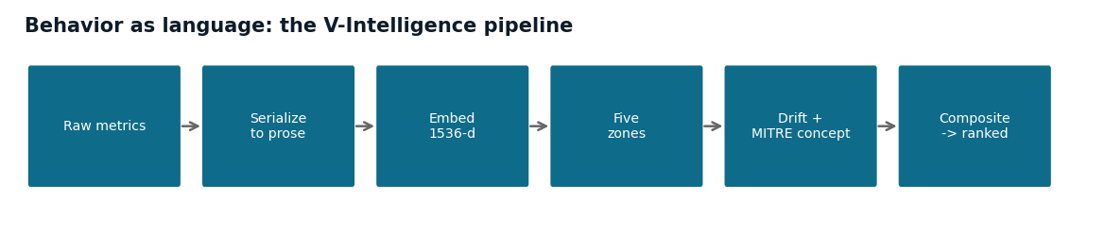
Figure 1 — Behavior as language: raw metrics are serialized to prose, embedded into a unified 1,536-d space, decomposed into zones, and the drift direction is named against MITRE concepts before a composite ranks the entity.
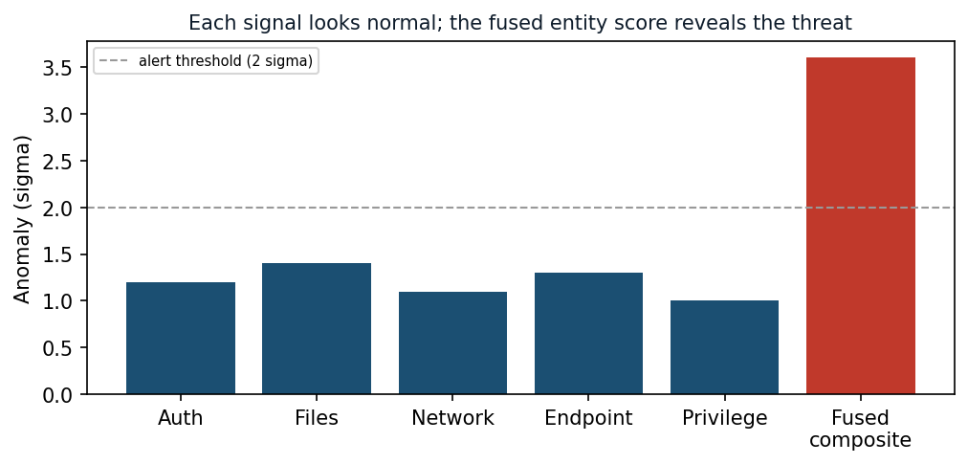
Figure 2 — The signal-combination effect (illustrative): each individual signal stays below the alert threshold, yet the fused entity score crosses it — the threat is visible only in combination.

3.1 A Concrete Case: The Insider Who Changed Nothing Measurable
Consider the embedded insider campaign (USR-156). Between two consecutive weeks the operator accessed the same number of files — but shifted from mostly public material to predominantly restricted and confidential material. Every count a threshold tool watches stayed put:
Metric | Week 1 | Week 2 | What a feature-distance detector sees
Files accessed (total) | 30 | 30 | 0 — identical, no drift
Restricted-file ratio | 1.2% | 15.0% | 0.138 — a tiny numeric contribution
Confidential-file ratio | 0.3% | 8.0% | 0.077 — a tiny numeric contribution
Feature-distance verdict |  |  | "Nothing changed."

The file count is identical, so it contributes zero. The restricted ratio rose more than twelve-fold, but in raw numeric terms that is a small distance next to high-variance features such as bytes transferred. A feature-distance detector concludes nothing happened.
Read as language, the same two weeks describe a different person: "30 files, 1.2% restricted, 0.3% confidential" becomes "30 files, 15% restricted, 8% confidential" — an operator who moved from public to sensitive material. That is a large change in MEANING, and the entity embedding moves accordingly. The insider changed WHAT they accessed, not HOW MUCH — invisible to magnitude, obvious to semantics.

3.2 Feature CUSUM vs. V-Intelligence Semantic CUSUM
Both pipelines use the same change-point engine (CUSUM) to accumulate small drifts that no single week would trip. They differ only in what they accumulate drift over — raw feature distance, or semantic distance between behavior embeddings.
Feature-Space CUSUM (traditional):
weekly features -> v = [auth_total, ..., dns_nxdomain_ratio]
-> || v_t2 - v_t1 || (numeric distance)
-> CUSUM accumulation -> threshold
Result: attackers stay inside the normal band -> no directional separation
V-Intelligence Semantic CUSUM:
weekly features -> prose description -> 1536-d behavior embedding
-> cosine distance between weekly embeddings
-> CUSUM accumulation -> threshold
Result: all attackers break above the normal band -> 4 of 4 detected
The only added step is serializing each week's behavior into prose before embedding. That single step is what lets the change-point engine accumulate drift in the KIND of behavior rather than the QUANTITY of it — and it is the difference between catching the insider and missing it.
Why raw feature distance misses it — three structural reasons:
- Scale dominance: high-variance features (bytes transferred) numerically swamp the low-variance ratios that actually carry the insider signal.
- No cross-signal pattern: each feature is treated as an independent axis, so "off-hours access + restricted files + high clearance" is never read as one combined pattern — yet that combination is the threat.
- "What" vs "how much": the same count of a different kind of thing is zero distance numerically, but a different meaning semantically.
The complementary design — raw features for numeric precision on volume spikes, embeddings for semantic shifts at constant volume, fused by the composite scorer — is detailed in Section 5 (Method Deep Dive).

4. System Architecture
The platform is a streaming behavioral pipeline. Telemetry is ingested daily, aggregated into per-entity features, serialized to language, embedded, decomposed into zones, and tracked as trajectories. Detection runs continuously on the trajectory store and emits ranked, explained, ATT&CK-mapped verdicts.
Telemetry (auth, network, DNS, endpoint, file, app, privilege)
|
v
[1] Daily feature aggregation --> per-entity quantitative features
|
v
[2] Text serialization --> five signal sentences per entity
|
v
[3] Embedding (unified 1536-d) --> cached semantic vectors
|
v
[4] Zone decomposition --> 5 zone embeddings + composite
|
v
[5] Trajectory + phase state --> velocity / accel / regime / drift
|
v
[6] Detection:
- CUSUM change-point (slow drift below per-period thresholds)
- Drift-direction projection onto reference concepts (MITRE)
- Cohort / co-drift clustering
- Multi-phase composite scoring + novelty persistence
|
v
[7] Ranked verdict: alert + kill-chain narrative + ATT&CK techniques

4.1 The Five Behavioral Zones (User Entity)
Zone | What it captures
Identity | Role, department, clearance, tenure — who the entity is supposed to be.
Access Pattern | Authentication behavior, off-hours activity, source/destination spread.
Data Behavior | Files touched, restricted/confidential ratios, read vs. write balance.
Network Footprint | Bytes out, external ratio, unique destinations and DNS domains.
Risk Posture | Endpoint risk indicators, suspicious-process and failed-resolution rates.

A C2-beaconing compromise drifts Network Footprint and Risk Posture while Identity and Data Behavior stay flat. An insider drifts Data Behavior while everything else stays flat. Zone decomposition is what lets a single platform catch both without one diluting the other.

4.2 Platform Components
Layer | Technology | Role
Embedding | OpenAI text-embedding-3-small (1536-d), cached | Semantic representation of behavior
Store | PostgreSQL + pgvector, temporal (SCD2) | Versioned snapshots & trajectories
Detection | CUSUM, drift projection, composite scorer | Ranked, explained verdicts
Serving | FastAPI | Entity, trajectory, detection, tier APIs
Deployment | Docker (portable, on-prem capable) | Air-gap / enclave friendly

5. Method Deep Dive (Proprietary)
This section is included only in the NDA / technical-exchange edition. It contains proprietary formulations. Treat as Business Sensitive — do not distribute.

5.1 Signal Composition
An entity's composite embedding is a weighted average of its five signal embeddings (weighted average, not concatenation — preserving the unified 1536-d geometry):
composite = normalize( Σ_i w_i · embed(signal_i) )
user signal weights (illustrative, tuned per deployment):
auth = 0.25, privilege = 0.20, data_access = 0.20,
network = 0.20, communication = 0.15

5.2 Drift Vector and Direction
drift_vector = V(t2) - V(t1)
alignment(concept) = cos( drift_vector, embed(concept) )
report concepts ranked by alignment; map top concepts -> MITRE ATT&CK

5.3 CUSUM Change-Point on Drift
Per-period drift below an alert threshold still accumulates. CUSUM sums the above-slack excess and fires when the cumulative sum crosses a decision interval — catching, e.g., 0.02/period sustained over six periods that no single-period threshold would flag.
S_0 = 0
S_t = max(0, S_{t-1} + (d_t - k)) # k = slack (allowable drift)
alarm when S_t > h # h = decision interval
change_point = argmin index where S began its sustained rise

5.4 Multi-Phase Composite Score
The composite fuses five normalized phases. Peer divergence is computed within role cohorts so an administrator is compared to administrators, not to accountants.
composite = f( signal_strength, # peak sustained zone deviation
breadth, # # zones simultaneously drifting
sustained_signal, # half-period mean deviation
context_divergence, # peer z-score within role cohort
novelty_persistence ) # recurring unseen infrastructure
phase weights and cohort normalization are deployment-tuned.
⟦ WITHHELD ⟧ Production weight values, slack/decision-interval settings, and the novelty-persistence window are environment-specific and tuned during deployment. Exact formulation, parameters, and tuning are proprietary and are disclosed only in the NDA / technical-exchange edition of this paper.

6. Empirical Validation
Validation used 250 entities over 485 days of synthetic telemetry with 4 embedded attack campaigns. The composite scorer produces a single ranked list; the table below shows where each embedded campaign landed and how it was caught.
Entity | Campaign | Rank | Composite | Primary detector
USR-118 | Salt Typhoon (telecom infrastructure) | #1 of 250 | 51.3 | Composite drift + breadth
USR-156 | Insider Threat (14-month escalation) | #2 of 250 | 46.2 | Composite drift + breadth
USR-234 | Slow APT (417-day C2 beaconing) | #7 of 250 | 19.4 | Novelty persistence
USR-042 | Volt Typhoon (living-off-the-land) | #24 of 250 | 13.7 | Composite drift + breadth

All 4 of 4 embedded campaigns surfaced in the ranked output at an 8.1% false-positive rate (20 of 246 normal entities at the recall-at-100% operating point). Traditional Traditional magnitude-based detectors can flag anomalies but provide no directional intelligence to distinguish threat type or guide analyst triage.

6.1 Case Study — The Slow APT That Magnitude Cannot See
USR-234 (Slow APT (417-day C2 beaconing)) is the hardest case in the corpus. Its per-day footprint is tiny: two to three beacons a day to algorithmically-generated domains, with slow file staging. Its raw signal strength is among the lowest of any entity — a magnitude detector ranks it as unremarkable.
Behavioral Entity Intelligence still ranks it #7 of 250, driven almost entirely by novelty persistence: the same never-before-seen infrastructure reappearing week after week. This is the axis no threshold tool measures, and it is the difference between catching a 417-day intrusion and missing it.

7. What This Enables for Your Mission
We answer that question by modeling each user, device, and account as a digital entity whose behavior is embedded as language, decomposed into independent zones, and tracked as a trajectory through semantic space.
Concretely, the platform lets your analysts:
- Triage by risk: Replace a daily flood of threshold alerts with one risk-ranked list of entities.
- Explainable verdicts: See WHY an entity is flagged, in plain language mapped to MITRE ATT&CK — not an opaque score.
- Slow-and-low coverage: Catch slow insiders and APTs that stay inside every threshold for months.
- Context-adaptive: Re-weight detection for the hunt at hand (insider vs. APT) without retraining.
- Deployable where you operate: Run on-premises / in an enclave; the platform is containerized and can use a local embedding model.

7.1 Deployment Path
- Phase 1 — Baseline: Stand up the pipeline against a historical telemetry window to establish baselines.
- Phase 2 — Shadow: Run in shadow alongside the existing SIEM; compare ranked output to current alerting.
- Phase 3 — Operate: Feed ranked verdicts into SOC triage and (for DISA) Zero Trust access decisions.

7.2 Why This Is Different — Competitive Landscape and Defensible Novelty
A structured, source-verified review (2024–2026) of commercial products and the published literature found no commercially marketed system, and no single published method, that combines all elements of this approach. Publicly described commercial UEBA — Exabeam, Securonix, Microsoft Sentinel UEBA — detects via statistical / p-value profiling, machine-learning baselines, rarity- and magnitude-based scores, and TF-IDF peer grouping; their generative-AI features are SOC copilots and conversational layers, not the detection mechanism. Commercial demand / supply-chain platforms (SAP IBP, o9, Kinaxis) forecast with gradient-boosted trees and machine learning over tabular features on knowledge-graph data models, with generative AI again only as a conversational layer.
We are explicit about prior art: the constituent techniques are individually established — LLM-embedding of serialized behavior (APT-LLM; LogBERT), serialize-to-prose-then-embed (TabLLM family), embed-then-detect pipelines (TAD-Bench), and embedding drift by cosine distance (ZEDD). Each, however, detects by MAGNITUDE and operates in a single domain; none projects the DIRECTION of drift onto named, pre-embedded threat concepts mapped to MITRE ATT&CK, nor spans cyber and supply-chain entities in one space.
To the best of our knowledge — scoped to publicly described and marketed methodology — no commercial platform and no single published system detects anomalies by the DIRECTION of behavioral drift in a unified, cross-domain semantic space. The contribution is the integrated architecture and the concept-direction (not magnitude/rarity) paradigm, not any single technique. (A formal patent / freedom-to-operate review is recommended before any contractual assertion of uniqueness.)

8. References and Further Reading
- [1] CISA AA23-144A, 'People's Republic of China State-Sponsored Cyber Actor Living off the Land' (Volt Typhoon).
- [2] MITRE ATT&CK Framework, Enterprise Matrix. attack.mitre.org.
- [3] Prior-art (constituent techniques, individually established): APT-LLM (arXiv:2502.09385); LogBERT (arXiv:2103.04475); TAD-Bench embed-then-detect (arXiv:2501.11960); TabLLM-family serialize-to-prose-embed (arXiv:2502.11596); ZEDD embedding drift (arXiv:2601.12359).
- [4] Competitive landscape (publicly described methodology): Exabeam, Securonix, Microsoft Sentinel UEBA; SAP IBP, o9, Kinaxis demand platforms.
- [5] NIST SP 800-207, 'Zero Trust Architecture,' 2020.
- [6] OMB M-22-09, 'Moving the U.S. Government Toward Zero Trust Cybersecurity Principles,' 2022.
- [7] E. S. Page, 'Continuous Inspection Schemes,' Biometrika, 1954 (CUSUM).
- [8] V-Intelligence UEBA Technical Specification (companion document, NDA edition).

This edition contains proprietary formulations and is provided under NDA. Do not redistribute.

