Supplier Risk for Defense Supply Chains:
Traditional Monitoring vs. Behavioral Entity Intelligence
A business and technology overview — what the innovation is, what it detects, and what the evidence shows
22nd Century Technologies, Inc. · V-Intelligence Supply Chain Risk Program · June 2026 · Business Edition
Disclosure note: this edition describes the architecture and the innovation, and reports measured results. The exact model logic — formulas, detection thresholds, zone weights, accumulator settings, and fusion parameters — is proprietary and is withheld here; it is available in the full technical edition under NDA (non-disclosure agreement).
Data note: all supply-chain results in this paper come from a synthetic (simulated) dataset built to prove the concept — 500 stock numbers, 200 suppliers, 4 depots, 24 months of transactions — and must be re-validated on real Defense Logistics Agency data before any operational claim. The cybersecurity results cited as the proven foundation come from the same framework's evaluation in its original security domain.
1. Executive Summary
The Defense Logistics Agency (DLA) — the Department of Defense organization that buys and distributes spare parts and supplies — depends on thousands of suppliers. The most damaging supplier risks are the ones no single performance metric shows: sourcing quietly shifting to factories in an adversary nation, counterfeit parts entering through layers of intermediaries, "independent" suppliers secretly sharing one fragile sub-tier source. These risks build over months and surface only after mission-critical systems are affected.
Traditional supplier monitoring checks individual metrics — on-time delivery, quality score, pricing — each against its own threshold. A supplier can pass every check while fundamentally changing what it sources and where. The numbers stay green; the behavior turns.
Behavioral Entity Intelligence (BEI) maintains a living behavioral profile — a "digital entity," like a patient's medical chart — for every supplier, part, and depot, and watches the direction each profile is moving. Each supplier is scored against its own history and against a peer cohort of comparable suppliers, the way a doctor reads results against patients of the same age and condition.
The innovation in one line: traditional monitoring measures how much each metric moved; BEI measures what the supplier is becoming — and flags the drift while it is still forming.
- Proven pattern. In a cybersecurity evaluation, the same framework detected all four advanced, long-duration attack campaigns it was challenged with; the best traditional method caught one of four, at a 9.8% false-positive rate, with no explanation of what changed.
- Measured supply-chain results. On a realistic synthetic supply-chain dataset, the supplier-risk model ranks failing suppliers well above chance (discrimination roughly 0.77–0.79 on held-out tests) and states failure probabilities at 30/60/90-day horizons with honest, measured calibration.
- Explainable by construction. Every risk score carries a plain-language reason — which behavioral dimension drifted, and toward what — so a contracting officer can act on it and defend the action.
2. The Problem: Risks No Single Metric Shows
Today's supplier monitoring has four structural weaknesses that adversaries and market dynamics routinely exploit:
- Threshold blindness. A supplier passes every individual check — delivery, quality, price all within bounds — while shifting component sourcing and substituting materials. No system is watching the combined trajectory.
- Single-entity tunnel vision. Suppliers and parts are each monitored in isolation. The risk often lives in a specific combination: one supplier's quality for one particular part degrades while both look healthy on average.
- Static risk scores. Annual risk assessments are snapshots. A supplier rated low-risk in January can be in financial distress by March and shipping substituted components by July — all before the next review.
- Sub-tier opacity. Prime suppliers pass audits, but their sub-tier sourcing is effectively invisible. The risk may sit two hops away, at an unknown third-tier factory in an adversary nation.
These are not hypothetical. A 2012 Senate Armed Services Committee investigation identified roughly one million suspected counterfeit electronic parts in the Department of Defense supply chain, most entering through multi-tier distribution. Components banned under Section 889 of the National Defense Authorization Act (the prohibition on specified Chinese telecommunications equipment) have surfaced in federal systems through intermediaries that obscured their origin. The SolarWinds compromise (2020) reached roughly 18,000 organizations through a supply chain that looked legitimate at every inspection point, and COVID-19 revealed "independent" suppliers sharing one hidden sub-tier source that failed together.
Supply-chain risk management (SCRM) regulations — counterfeit-parts rules under DFARS (the Defense Federal Acquisition Regulation Supplement), Section 889, Executive Order 14017, and the National Institute of Standards and Technology (NIST) SP 800-161 framework — all call for continuous monitoring. Current systems struggle to deliver it; that is the gap this work addresses.
3. The Traditional Approach (and Why It Falls Short)
Conventional supplier monitoring is built on a simple loop: define a metric, set a threshold, alert on a breach, and re-assess each supplier on a periodic (often annual) cycle. It is transparent and cheap to run — and it is the baseline BEI must beat.
Stage | What it does
1. Define metrics | On-time delivery rate, quality/rejection score, price compliance — each tracked separately.
2. Set thresholds | Each metric gets its own red line, usually written into the contract.
3. Periodic review | Each reporting period is judged on its own: is this month's number above the line?
4. Annual assessment | A point-in-time risk rating per supplier, refreshed on a yearly cycle.
5. Audit on exception | Investigation happens after a threshold breach or a field failure — that is, after the damage.

Why it is not enough
Four gaps follow from this loop. Magnitude metrics measure "how much," never "what" — and the most damaging changes are changes of kind: same volume, same price, same on-time rate, but the components now come from somewhere else. Slow drift of a little each month never crosses a monthly threshold, and nothing accumulates it. Every supplier is judged against the same population average — the wrong comparison group. And risks that live in a relationship (one supplier's quality for one part) or in the network (a shared hidden sub-tier source) sit structurally outside a per-supplier, per-metric view. Section 4 addresses each gap in turn.
4. The Behavioral Entity Intelligence Approach
4.1 The digital entity and its five behavioral zones
A "digital entity" (sometimes called a digital twin) is a living profile of a real-world thing, maintained in software — the patient's medical chart from the Executive Summary: not just today's temperature, but accumulated history, vitals, and context whose trend lets a doctor act before a condition becomes acute. BEI keeps such a chart for every supplier, every National Stock Number (NSN — a part's unique identifier), every depot, and every manufacturer.
Each supplier's chart is decomposed into five behavioral zones — independent dimensions tracked separately, so a shift in one (sourcing geography) is never masked by stability in another (excellent delivery performance):
Behavioral zone | What it captures
Identity | Registration status, certifications, contract status, tier level.
Performance trajectory | On-time delivery trend, lead-time consistency, quality scores over time.
Geographic / sourcing risk | Country-of-origin mix, manufacturing-site diversity, adversary-nation exposure.
Network position | How many depots served and items supplied; customer concentration; sole-source contracts.
Risk assessment | Financial-health indicators, insurance/bond status, expiring-contract exposure.

Each period, the raw metrics of each zone are written out as a short structured description and converted into a numerical vector by an embedding model — the representational machinery inside large language models, repurposed for supplier behavior. The result is a position in a semantic space: a mathematical "map of meaning" where suppliers that behave alike sit near each other. The risk signal is usually a change in the kind of behavior, not its size — a shift in where components come from barely moves the raw numbers, but it moves the supplier's position on the map.
4.2 Drift — direction, not just magnitude
Because the profile is re-computed every period, each supplier traces a trajectory across the map. Drift magnitude answers "did something change, and how much?" Drift direction answers the question traditional monitoring cannot ask: "what is this supplier turning into?" The direction is then given a name: a library of risk concepts — adversary-nation sourcing, counterfeit substitution, demand diversion, financial distress — is embedded into the same map and the drift is matched against it. The output is a plain-language reason ("drifting toward adversary-nation sourcing") that maps directly to the relevant regulation (Section 889, the DFARS counterfeit-parts clause). An analyst can act on it; a contracting officer can defend the decision.
Slow drift gets special treatment. The most damaging shifts move a little each month — below any single-period alert level. BEI keeps a running tally that accumulates the small monthly excesses and fires on the sustained trend (a classical cumulative-sum change detector; settings withheld in this edition). In the technical edition's worked example, a twelve-month adversary-nation sourcing migration that every monthly threshold would pass is flagged within roughly the first half-year, while still forming.
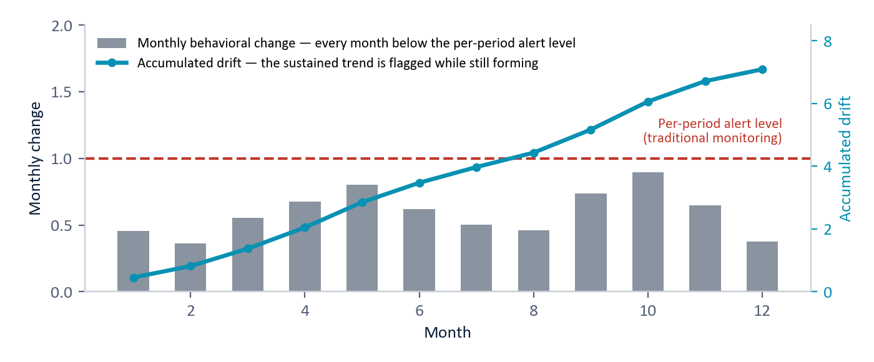
Figure 1 — Why slow drift defeats thresholds: every month's change (bars) stays below the alert level, so traditional monitoring never fires; the accumulated trajectory (line) reveals the sustained shift while it is still forming. (Illustrative.)
4.3 Peer cohorts — the right comparison group
A behavioral value is anomalous only relative to comparable suppliers. A dozen international sources is normal for a semiconductor fabricator and alarming for a domestic fastener maker; judging both against the population average would hide both signals. BEI segments the supplier base into peer cohorts along the dimensions that define "normal" — what they supply, where they are located, how critical they are, and their tier and size — and standardizes each supplier's behavior against the normal members of its own cohort.
Two baselines, one verdict: each supplier is scored against its own history (self-baseline drift) and against its cohort (peer-relative drift). A supplier flagged on both — drifting from its past and away from its peers — is a high-confidence risk.
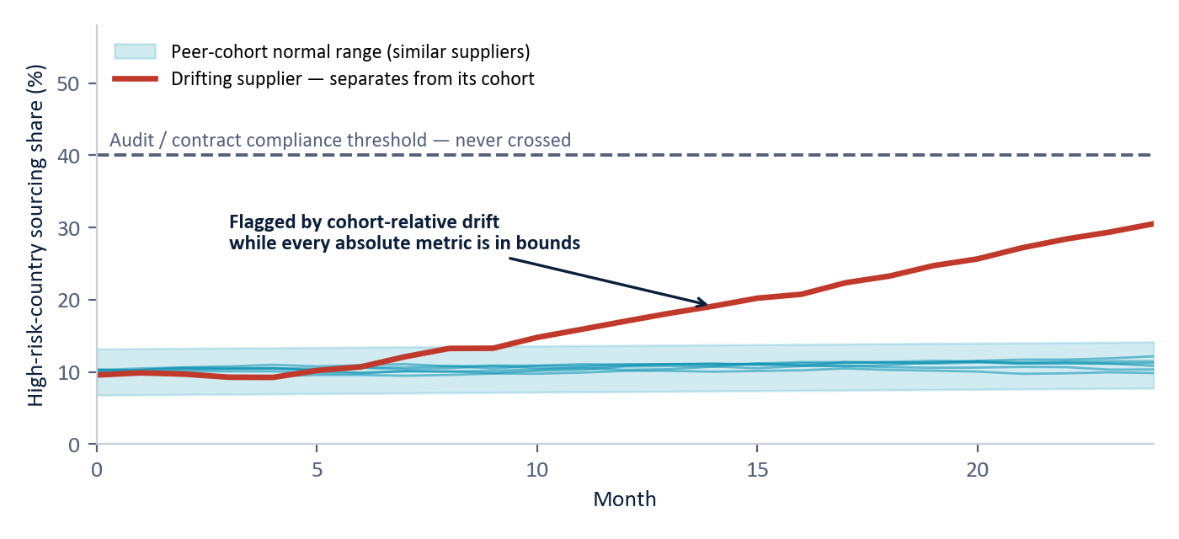
Figure 2 — Peer-cohort drift: comparable suppliers stay inside the cohort's normal band (teal); one supplier separates month after month while never crossing the audit threshold (dashed). Cohort-relative scoring surfaces it; threshold monitoring never would. (Illustrative.)
This cohort mechanism is not new for BEI: it is exactly the role-group scoring used in the operational cybersecurity deployment, where each user is judged against others in the same role. Suppliers substitute for users; cohorts substitute for roles.
4.4 Relationships and the network
Some risks live between entities, not in any one of them. BEI builds behavioral profiles for specific relationships — this supplier's performance for this part, this supplier's country-of-origin mix, this part's bill of materials (the SBOM, a product's "ingredients list") — and tracks their drift independently. A supplier and a part can each look healthy on average while the quality of that specific combination steadily degrades: targeted substitution, visible only at the relationship level.
Above the relationships sits the network view — a map of who depends on whom. It traces supply paths through multiple tiers to find adversary-nation connections two or three hops behind a compliant prime; it infers hidden common dependencies when two "independent" suppliers move in lockstep; and it propagates a hypothetical supplier failure through the graph to identify every part, depot, and mission affected.
4.5 The predictive risk layer
An implemented predictive layer turns the behavioral evidence into a calibrated, time-aware risk score, using two models. The first, a gradient-boosted classifier (XGBoost, a widely used machine-learning method), estimates the probability of a significant delivery failure within 90 days, constrained so the score can only move in the common-sense direction (more quality incidents can only raise risk; a better on-time rate can only lower it). The second, a survival model — an actuarial life table for suppliers — estimates the chance a supplier is still performing at 30, 60, and 90 days: when, not just whether, to expect trouble. Every score carries a factor-attribution readout (SHAP, a standard explanation method) showing which factors pushed it up or down.
Operational guardrails surround the models: a debarred supplier short-circuits to maximum risk regardless of the model (and if the debarment check itself fails, the system fails safe to manual review); a recent change of CAGE code (Commercial and Government Entity code, a supplier's federal identifier) is surfaced as an ownership-change warning; and scores blend in destination-specific performance when a depot is specified. Exact feature definitions, label rules, and blend settings are withheld in this edition.
5. Results
5.1 The proven foundation: cybersecurity
The framework is not a research proposal. In its original domain — insider-threat and intrusion detection — it was challenged with four advanced, long-duration attack campaigns deliberately designed to evade detection: a patient insider threat, a slow command-and-control intrusion, and two nation-state campaigns modeled on real adversary tradecraft. The best traditional statistical method caught one of the four, at a 9.8% false-positive rate (nearly one in ten normal entities incorrectly flagged), with no explanation. BEI detected all four, ranked each attacker among the highest-risk entities, and named the behavioral dimension that changed — the attackers never crossed a threshold; their behavioral direction changed. That is exactly the failure mode that defeats traditional supplier monitoring.
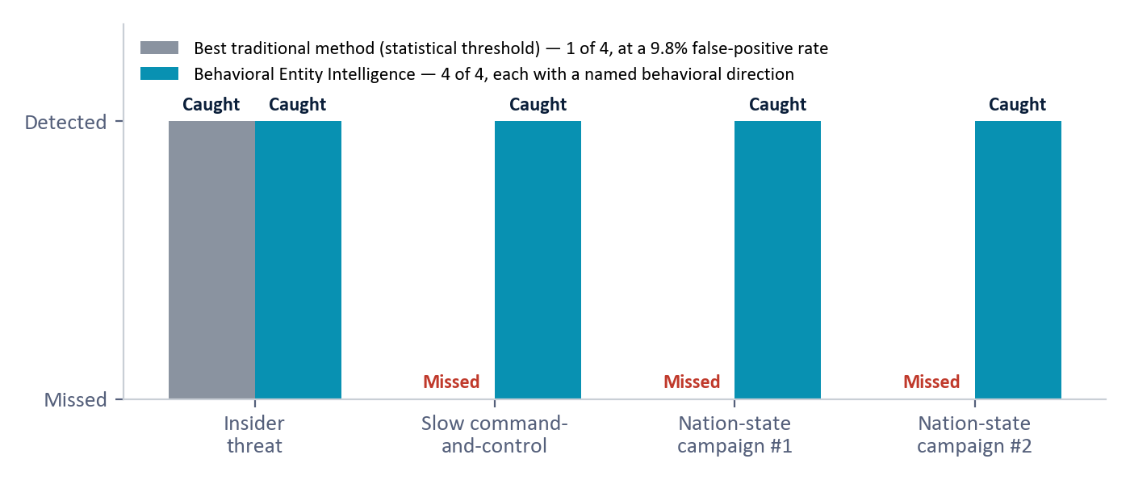
Figure 3 — The cybersecurity proof point: four advanced campaigns, deliberately built to stay under every per-metric threshold. Traditional statistical detection caught one; Behavioral Entity Intelligence caught all four with a named behavioral direction for each. (Measured results, cybersecurity evaluation, synthetic data.)
The same pattern has since proven out in a second domain, defense demand forecasting, where reading the direction of each item's behavioral drift produced calibrated forecasts a legacy moving average cannot match. Supplier risk is the third application of one proven pattern: in each domain, the damaging actor operates within authorized bounds — valid credentials there, compliant contracts here — while gradually shifting direction toward an objective.
5.2 The supply-chain proof of concept (synthetic data)
The framework has been fully instantiated for the supply-chain domain and exercised on a realistic synthetic dataset: 500 National Stock Numbers, 200 suppliers, 4 depots (3 Indo-Pacific, 1 in the continental United States), and 24 months of transactions with demand decomposed into six driver components. Demonstrated capabilities include regime detection (items flagged while transitioning from stable to depleting, before stockout), supplier health grades A through F reflecting behavioral direction rather than current-period metrics, four operating relationship types, and natural-language decision support ("Which Indo-Pacific parts are at risk of stockout in the next 90 days?").
5.3 Measured model performance — the honest scoreboard
The supplier-risk model was trained and audited on 1,174 supplier-evaluation windows (rolling 90-day snapshots, with features always computed strictly before the outcome window so no future information leaks in), with a stratified 20% held-out test set of 235 windows and a failure base rate of about 20%. A window counts as a failure if the supplier's delivery performance collapses in the following 90 days (defined by an on-time floor and repeated severely late deliveries; exact rule withheld).
Model | Metric (plain meaning) | Result | Grade
Risk classifier (12 base signals) | AUC (area under the curve) — how well failing suppliers are ranked above healthy ones (1.0 = perfect, 0.5 = chance) | 0.7709 | B
Risk classifier (+ behavioral features) | AUC | 0.7780 | B
Risk classifier | Average precision — usefulness of the top of the ranked list | 0.4918 | —
Risk classifier | Calibration — do stated probabilities match reality (Brier score / expected calibration error, ECE; lower = better) | Brier 0.1588 / ECE 0.1019 | C
Survival model | C-index — how well time-to-failure is ranked | 0.7935 | B
Survival model | Calibration error at 30 / 60 / 90 days | 0.084 / 0.090 / 0.129 | B / B / C

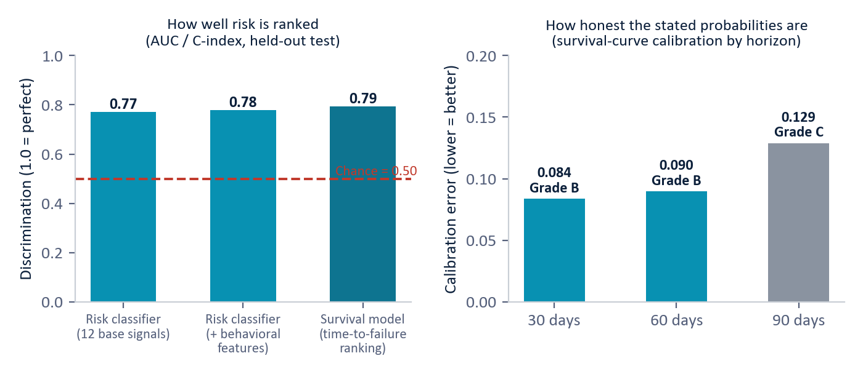
Figure 4 — Measured supplier-risk performance on the held-out test set (synthetic data). Left: all three discrimination scores sit well above chance; adding behavioral features nudges the classifier from 0.77 to 0.78. Right: survival-curve calibration is Grade B at the 30- and 60-day horizons, Grade C at 90 days. (Measured results, synthetic data.)
Reading it honestly: discrimination is solidly above chance but not perfect (Grade B); classifier calibration is Grade C and is the main area to improve; the survival horizons most useful for action (30 and 60 days) are Grade B. The most influential factors — quality incidents, recent order count, on-time rate, worst delay, count of critical parts supplied — form an operationally sensible ordering. The behavioral features add a modest measured lift; their distinctive value (directional explanation, cohort context, slow-drift accumulation) is capability the base signals do not provide at all.
6. Data and Deployment
- No new instrumentation. BEI consumes data the enterprise already produces — procurement transactions, delivery records, quality inspections, country-of-origin declarations, bills of materials, financial filings, and Government-Industry Data Exchange Program (GIDEP) counterfeit-and-defect alerts.
- Entity resolution. Suppliers appear under different identifiers across systems; BEI unifies them on the CAGE code and UEI (Unique Entity Identifier) so history follows the supplier through name and ownership changes.
- Graceful degradation and provenance. A supplier missing one data feed is scored on the remaining zones, with a data-coverage confidence indicator on every score; every feature traces back to its source record, so a score that informs a contract decision can withstand challenge or audit.
- Phased rollout. Four phases — data integration (2–4 weeks), baseline building (4–6 weeks), detection deployment (2–4 weeks), then production monitoring — with initial value targeted inside 8 weeks.
- Augments, not replaces. Scores feed existing workflows: DLA's supply-chain risk program, contracting-officer award screens (a drifting supplier is flagged before award, not after delivery), and priority inspection routing for parts from elevated-risk suppliers.
7. Why This Is New
Supplier scorecards, anomaly detection, and financial-risk ratings all exist; the contribution is not any single technique but their composition. Commercial supplier-risk platforms score current-period metrics and external risk feeds. None represents each supplier as a behavioral entity in a shared semantic space, measures the direction of its drift, names that direction against supply-chain risk concepts, scores it against the right peer cohort, and accumulates sub-threshold change over months into one explained, ranked verdict.
We are explicit about prior art: the individual ingredients — text serialization for embedding, anomaly detection in embedding space, embedding-drift measurement, cohort-relative scoring, cumulative-sum change detection, gradient-boosted risk models — each exist separately in the literature. What no commercial or published system offers is their integration into a pipeline in which each stage removes a blind spot of the others: direction over magnitude, zones over monoliths, cohorts over population baselines, accumulation over instantaneous thresholds, fusion over any single detector. The innovation is the integrated architecture — already proven in an adjacent domain.
Scoping notes: vendor internals are not fully public (the comparison is against marketed methodology), and a formal freedom-to-operate review is recommended before any contractual assertion of uniqueness.
8. Limitations — Stated Plainly
- All supply-chain metrics are from synthetic data and must be re-measured on real DLA data before any production claim; that re-measurement is the explicit next step.
- Classifier calibration is currently Grade C (the survival model's near horizons are Grade B); improving it is the top model-quality priority.
- On the synthetic set, the behavioral features add only a modest lift to ranking accuracy (0.77 to 0.78); the case for them rests on directional explanation, cohort context, and slow-drift detection — capabilities the base signals lack entirely.
- Several relationship types (supplier-country, part-SBOM, supplier-supplier) are designed extensions of the four built and demonstrated; they reuse proven machinery but are not yet exercised.
- Behavioral profiling is only as good as the data plumbing beneath it: entity resolution, feed latency, and sparse data all require the engineering treatment described in Section 6.
- The cybersecurity proof transfers by structural analogy; supply-chain detection efficacy against real adversarial behavior remains to be demonstrated on operational data.
9. Conclusion
Traditional supplier monitoring rates a supplier low-risk as long as every metric stays below its own threshold — regardless of what is changing beneath the surface. The most damaging risks exploit exactly that: the supplier changes WHAT it sources, not HOW MUCH it delivers. Delivery stays strong, quality stays acceptable — but the component origins shifted, the sub-tier factory changed, the bill of materials drifted.
Behavioral Entity Intelligence watches direction instead: a living behavioral chart per supplier, decomposed into independent zones, scored against its own history and its true peer cohort, accumulated over months, analyzed across relationships and the network, and translated into a calibrated, explainable, time-aware risk score. The pattern already caught every advanced campaign traditional methods missed in cybersecurity; the supply-chain instantiation now has measured results on a realistic synthetic dataset.
Traditional monitoring asks "is this metric within bounds?" BEI asks "what is this supplier becoming, and is it unlike its peers?" — and flags the answer while the drift is still forming. 22nd Century Technologies is prepared to conduct a 4-week proof of concept on DLA production data, against actual transaction history for a selected commodity group.
Appendix — Glossary
Term | Meaning
Behavioral Entity Intelligence (BEI) | Our approach: a living behavioral profile per supplier/part/depot whose direction of change — not any single metric — drives risk detection.
Digital entity / digital twin | A living software profile of a real-world thing — like a patient's medical chart for a supplier: history, vitals, context, and trend, updated continuously.
Behavioral zone | One independent dimension of an entity's profile (e.g. geographic sourcing), tracked separately so a shift in one is not masked by stability in others.
Embedding | A numerical vector that captures the meaning of a description — the core representation inside large language models.
Semantic space | A mathematical "map of meaning": suppliers whose behavior is similar sit near each other, even if their raw numbers differ.
Drift | How an entity's behavioral profile moves through the semantic space over time — its speed, consistency, and direction.
Peer cohort | The group of genuinely comparable suppliers (same commodity, geography, criticality, tier) against which a supplier's behavior is judged.
Cumulative-sum change detection | A running tally that adds up many small period-over-period changes and flags the sustained trend that no single period would reveal.
Regime | A named behavioral state (e.g. Stable, Drifting, Critical) assigned from the trajectory's speed and direction.
NSN | National Stock Number — a part's unique identifier in the federal supply system.
CAGE code / UEI | Commercial and Government Entity code / Unique Entity Identifier — the identifiers that resolve one supplier across federal systems.
SCRM | Supply-Chain Risk Management — the discipline (and regulatory regime) of managing risks in what is sourced, from whom, and through whom.
SBOM | Software/hardware Bill of Materials — the "ingredients list" of components inside a delivered product.
Section 889 / DFARS | The statutory ban on specified Chinese telecom components / the Defense Federal Acquisition Regulation Supplement, including counterfeit-parts rules.
GIDEP | Government-Industry Data Exchange Program — the federal alert network for counterfeit and defective parts.
XGBoost | A widely used gradient-boosted machine-learning classifier; here it estimates the probability of supplier failure within 90 days.
Survival model | A model of time-to-event — like an actuarial life table for suppliers: the chance a supplier is still performing at day 30, 60, 90.
AUC / C-index | AUC (Area Under the Curve) and C-index: discrimination scores — how well the model ranks failing suppliers above healthy ones (1.0 = perfect, 0.5 = chance). C-index is the survival-model equivalent.
Average precision | A discrimination score weighted toward the top of the ranked list — how useful the highest-risk rankings are.
Calibration / ECE / Brier | Whether stated probabilities match observed reality; ECE (Expected Calibration Error) and the Brier score measure the gap — lower is better.
SHAP | A standard explanation method showing which factors pushed an individual score up or down.
False-positive rate | The share of normal entities incorrectly flagged — the cost of detection paid in analyst review time.
Network graph analysis | Treating the supply chain as a map of who depends on whom, to find multi-tier adversary connections, hidden shared dependencies, and failure cascades.
Sole source | A part with only one qualified supplier — a built-in single point of failure.
Synthetic data | Simulated data built to prove the concept before access to real operational data.

Business Edition — architecture-level disclosure. Exact model logic, formulas, detection thresholds, zone weights, accumulator settings, and fusion parameters are proprietary and available in the full technical edition under NDA. All supply-chain results are synthetic and must be re-validated on real DLA operational data. Do not redistribute.

