Behavioral Entity Intelligence
for Supplier Risk Management

Detecting Hidden Supply Chain Risks Through
Entity Profiling, Relationship Dynamics, and Network Analysis

22nd Century Technologies, Inc.
June 2026 — Version 1.0
Prepared for: Defense Logistics Agency

Table of Contents
1. Executive Summary
2. The Supplier Risk Challenge
2.1. Why Traditional Supplier Monitoring Fails
2.2. Real-World Supply Chain Compromises
2.3. SCRM Regulatory Landscape
3. Behavioral Entity Intelligence for Supply Chain
3.1. The Entity Model
3.2. Supplier Behavioral Zones
3.3. NSN Item Behavioral Zones
3.4. The Time Dimension
3.5. Supplier Segmentation and Peer-Cohort Drift
4. Relationship-Level Risk Detection
4.1. Pairwise Relationships
4.2. Network-Level Risk
4.3. The What vs How Much Principle
5. Detection Capabilities
5.1. Counterfeit Part Detection
5.2. Adversary-Nation Sourcing (SCRM)
5.3. Supplier Concentration Risk
5.4. Demand Diversion and Fraud
5.5. Contract and Financial Risk
6. Operational Deployment
6.1. Data Sources and Collection
6.2. Deployment Phases
6.3. Integration Points
7. Proven Foundation: From Cybersecurity to Supply Chain
7.1. What Has Been Proven in Cybersecurity
7.2. Why the Proof Transfers
7.3. Supply Chain Proof of Concept
7.4. Illustrative Detection Scenarios
8. Technical Deep Dive: The Mathematics of Behavioral Drift
8.1. From Metrics to Meaning: Serialization and Embedding
8.2. Zone Composition and Context-Adaptive Attention
8.3. Drift: Measuring Direction, Not Just Magnitude
8.4. Naming the Direction: Reference-Concept Projection
8.5. Accumulating Slow Drift: CUSUM Change-Point
8.6. Peer-Cohort Scoring
8.7. Multi-Phase Composite Score
8.8. Relationship and Co-Drift Detection
8.9. Why the Composition Is the Innovation
8.10. The Predictive Risk Layer: XGBoost + Survival Model (Implemented MVP)
9. Business Value
10. Conclusion

1. Executive Summary
Defense supply chains face risks that are invisible to traditional monitoring. Suppliers gradually shift component sourcing to adversary nations. Counterfeit parts enter the supply chain through multi-tier intermediaries. Coordinated failures reveal hidden common dependencies that no single-supplier audit would uncover. These risks accumulate slowly, often over months, and become visible only after mission-critical systems are affected.
Traditional supplier monitoring checks individual metrics — on-time delivery rates, quality scores, pricing compliance — each against its own threshold. A supplier can pass every metric while systemic risks grow beneath the surface. The on-time rate stays within target. The quality score remains acceptable. The pricing stays within contract bounds. But the supplier has quietly shifted a substantial share of component sourcing from domestic manufacturers to facilities in an adversary nation. No single metric captures this.
Behavioral Entity Intelligence (BEI) detects these risks by tracking behavioral direction across three analytical layers: entity profiles that capture each supplier's multi-dimensional behavioral trajectory over time, pairwise relationships that reveal how specific supplier-part-location combinations are changing, and network graphs that expose hidden dependencies, single points of failure, and multi-hop adversary-nation connections.
This approach is not theoretical. The BEI framework has been proven in an operational cybersecurity deployment, where it detected all four advanced, long-duration attack campaigns — an insider threat, a slow command-and-control campaign, and two nation-state intrusions. Traditional threshold-based detection caught at most one of the four; the rest stayed within normal statistical ranges on every individual metric while shifting behavioral direction. BEI caught the directional change.
The same concept has since proven out in a second, very different domain — defense demand forecasting. There, modeling each item-at-a-location as a digital entity and reading the DIRECTION of its demand drift produced calibrated, drift-aware forecasts that right-size procurement where a legacy moving average cannot. Two domains, one pattern: model the entity as a digital twin, track where its behavior is heading, and act on the direction — not the magnitude of any single metric. Supplier risk is the natural third application of that proven pattern: a supplier rarely trips a single threshold, but its behavior drifts — sourcing shifts toward adversary nations, quality slips relative to its peer cohort, delivery patterns change — and the same approach surfaces the anomalous supplier before any one metric crosses a red line.
The framework has also been instantiated for the supply chain domain and exercised on a realistic synthetic dataset — 500 National Stock Numbers, 200 suppliers, 4 depots spanning the Indo-Pacific and CONUS, and 24 months of transaction history — demonstrating that the same behavioral profiling, regime detection, supplier risk grading, and relationship analysis operate directly on supply chain data. This whitepaper describes how that proven framework applies to defense supplier risk — and what it makes possible.
Key insight: The supplier changes WHAT it sources, not HOW MUCH it delivers. Traditional metrics measure magnitude; BEI measures behavioral direction. The same principle that exposed hidden cyber threats and sharpened defense demand forecasts now exposes hidden supply chain risk — the third domain for one proven pattern.

2. The Supplier Risk Challenge

2.1. Why Traditional Supplier Monitoring Fails
Current supplier monitoring systems operate on a simple model: define a metric, set a threshold, and alert when the threshold is breached. This approach has four structural weaknesses that adversaries and market dynamics routinely exploit.
Threshold Blindness
A supplier passes every individual threshold — on-time delivery, quality score, and pricing all within bounds — while simultaneously shifting component sourcing, reducing manufacturing oversight, and substituting materials. Each metric is within bounds. The composite behavioral trajectory tells a different story, but no system is watching the trajectory.
Single-Entity Tunnel Vision
Traditional monitoring evaluates suppliers in isolation and parts in isolation. Supplier A looks fine. Part X looks fine. But the relationship between Supplier A and Part X has changed: the failure rate for this specific supplier-part combination has risen sharply while the supplier's overall quality score remains stable. The risk lives in the relationship, not in either entity.
Static Risk Scores
Annual risk assessments produce a point-in-time snapshot. Between assessments, supplier behavior can drift significantly. A supplier assessed as low-risk in January may experience financial distress in March, begin substituting components in May, and deliver counterfeit parts in July — all before the next annual review. Continuous behavioral monitoring closes this gap.
Tier-2/3 Opacity
Prime suppliers pass audits, but their sub-tier sourcing is effectively invisible. A Tier-1 supplier in good standing may source critical components from a Tier-2 distributor who sources from a Tier-3 manufacturer in an adversary nation. The prime supplier's metrics look clean because the risk is two hops away.

2.2. Real-World Supply Chain Compromises
The following incidents illustrate the types of supply chain risks that traditional monitoring consistently fails to detect.
Counterfeit Electronic Components in DoD Systems
The Senate Armed Services Committee investigation (2012) identified approximately 1 million suspected counterfeit electronic parts in the Department of Defense supply chain. These counterfeits entered through multi-tier distribution networks where components were relabeled, remarked, or entirely fabricated. Many passed initial quality inspections because the counterfeits were functionally adequate for standard testing but failed under operational stress conditions.
Section 889 Violations
Section 889 of the National Defense Authorization Act for Fiscal Year 2019 prohibits federal agencies from procuring telecommunications equipment from specified Chinese companies (Huawei, ZTE, and others). Despite the prohibition, components from these manufacturers have been found embedded in systems sold to federal agencies through multi-tier supply chains where the ultimate origin was obscured by intermediary distributors.
SolarWinds Supply Chain Attack
The SolarWinds compromise (2020) demonstrated that software supply chains carry the same risks as physical supply chains. A compromised software build system injected malicious code into a legitimate software update, affecting approximately 18,000 organizations including multiple federal agencies. The attack succeeded because the SBOM (Software Bill of Materials) was compromised at the build stage — the software appeared legitimate at every inspection point.
COVID-19 Supply Chain Disruptions
The pandemic exposed hidden single points of failure across defense supply chains. Suppliers that appeared independent shared common sub-tier sources for raw materials, specialized components, or manufacturing capacity. When one facility shut down, multiple supposedly independent supply lines failed simultaneously, revealing concentration risks invisible to supplier-by-supplier monitoring.

2.3. SCRM Regulatory Landscape
Defense supply chain risk management is governed by an expanding set of regulations, each addressing a specific dimension of supply chain risk. BEI provides the continuous monitoring capability that these regulations require but current systems struggle to deliver.
Regulation / Directive | Scope | BEI Relevance
DFARS 252.246-7008 | Counterfeit electronic parts  detection and avoidance | BEI tracks supplier-part-manufacturer  relationship drift to detect sourcing  changes indicative of counterfeit risk
Section 889, NDAA FY2019 | Prohibition on Chinese telecom  components in federal systems | BEI monitors country-of-origin  relationships continuously, not just  at contract award
Executive Order 14017 | Supply chain resilience  across critical sectors | BEI identifies hidden concentration  risks and single points of failure  through network analysis
NIST SP 800-161 Rev 1 | Cybersecurity Supply Chain  Risk Management (C-SCRM) | BEI provides the continuous  assessment and monitoring  layer that C-SCRM frameworks require
DLA SCRM Program | DLA-specific supply chain  risk management processes | BEI integrates with existing DLA  SCRM workflows, adding behavioral  intelligence to current risk scoring

3. Behavioral Entity Intelligence for Supply Chain

3.1. The Entity Model
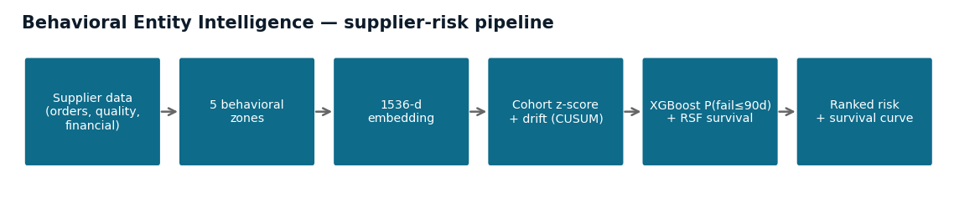
Figure 1 — The BEI supplier-risk pipeline: supplier data → five behavioral zones → 1,536-d embedding → cohort-relative z-scores and drift → a calibrated XGBoost + survival model → a ranked risk score with a time-dependent survival curve.
BEI models the defense supply chain as a network of interacting entities, each with a multi-dimensional behavioral profile that evolves over time. Four primary entity types capture the key actors and objects in the supply chain.
Entity Type | Examples | Behavioral Profile
Supplier | Prime contractors, distributors,  small businesses, foreign vendors | Delivery performance, pricing behavior,  geographic sourcing patterns,  financial health indicators
NSN (Part) | Consumables, repairables,  critical components, assemblies | Demand patterns, failure rates,  supplier concentration,  inventory position trajectories
Location  (Depot/Base) | DLA depots, military installations,  forward operating locations | Demand composition, requisition urgency  patterns, consumption velocity,  seasonal profiles
Manufacturer | Original equipment manufacturers,  component fabricators,  authorized distributors | Production consistency, quality trends,  country-of-origin stability,  certification status

Each entity maintains a behavioral profile composed of multiple independent dimensions — behavioral zones — that are tracked over time. The zones decompose entity activity into orthogonal dimensions so that a change in one dimension (e.g., geographic sourcing) is detected even when other dimensions (e.g., delivery timeliness) remain stable.

3.2. Supplier Behavioral Zones
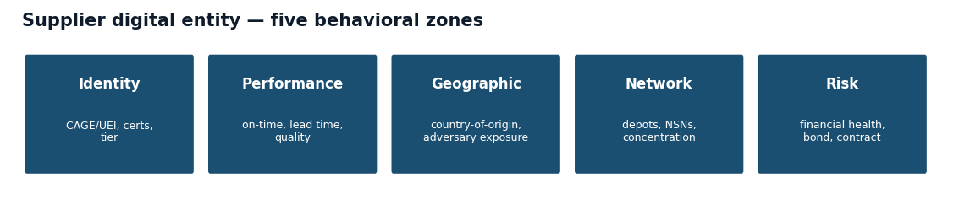
Figure 2 — The supplier digital entity, decomposed into five independently-tracked behavioral zones so a shift in one (e.g. geographic sourcing) is not masked by stability in the others (e.g. delivery performance).
Each supplier's behavioral profile is decomposed into five zones that capture independent dimensions of supplier activity. This decomposition ensures that a change in sourcing geography is detected even if delivery performance remains exemplary.
Zone | What It Captures | Example Indicators
Identity | Registration, certifications,  contract status, tier level | CAGE code stability, SAM.gov status,  ISO certification currency,  small business classification
Performance  Trajectory | Delivery timeliness trends,  lead time consistency,  quality scores over time | On-time delivery rate trajectory,  average days early/late trend,  quality rejection rate direction
Location /  Geographic Risk | Sourcing geography,  geographic concentration,  geopolitical risk exposure | Country-of-origin distribution,  manufacturing site diversity,  adversary-nation exposure percentage
Network  Position | How many depots served,  how many items supplied,  supplier ecosystem role | Customer concentration index,  product breadth score,  sole-source contract count
Risk  Assessment | Composite risk indicators,  financial health,  contract urgency | Altman Z-score trajectory,  insurance/bond status,  expiring contract percentage

Why zones matter: A supplier's on-time delivery stays strong (Performance zone stable) while sourcing shifts from domestic to adversary-nation origins (Geographic Risk zone drifting). Without zone decomposition, the stable performance masks the geographic risk.

3.3. NSN Item Behavioral Zones
Each National Stock Number (NSN) has its own behavioral profile decomposed into five zones. Tracking items independently from suppliers enables detection of risks that emerge from the item's lifecycle rather than from any single supplier.
Zone | What It Captures | Example Indicators
Identity | Nomenclature, criticality,  platform, supply class | Federal Supply Class, criticality code,  weapon system association,  shelf life classification
Demand  Profile | Demand patterns, seasonality,  exercise sensitivity | Monthly demand trajectory,  seasonal demand coefficients,  exercise-driven demand spikes
Supply  Network | Supplier count, sole source  flag, supplier concentration | Active supplier count trend,  Herfindahl concentration index,  new entrant / exit frequency
Inventory  Position | On-hand levels, safety stock  ratios, consumption velocity | Days of supply trajectory,  safety stock adequacy ratio,  stockout frequency trend
Financial  Profile | Unit pricing, shelf life,  substitutability | Unit price trajectory,  price variance across suppliers,  authorized substitute count

3.4. The Time Dimension
The critical distinction between BEI and traditional supplier monitoring is the treatment of time. Traditional systems evaluate each reporting period independently: is this month's delivery rate above threshold? BEI evaluates behavioral trajectory: is this month's delivery rate consistent with the supplier's established pattern, and if not, in which direction is it moving?
- Continuous Monitoring: Weekly or monthly behavioral snapshots capture entity state over time, building a trajectory of behavioral evolution.
- Drift Detection: Gradual changes invisible to point-in-time audits become visible when the system tracks cumulative behavioral displacement over weeks and months.
- Regime Detection: Each entity is classified into a behavioral regime — Stable, Drifting, or Critical — based on the velocity, acceleration, and direction of its behavioral trajectory.
A supplier classified as Drifting in the Geographic Risk zone and Stable in all other zones is exhibiting the behavioral signature of gradual adversary-nation sourcing shift — precisely the pattern that annual audits miss.

3.5. Supplier Segmentation and Peer-Cohort Drift
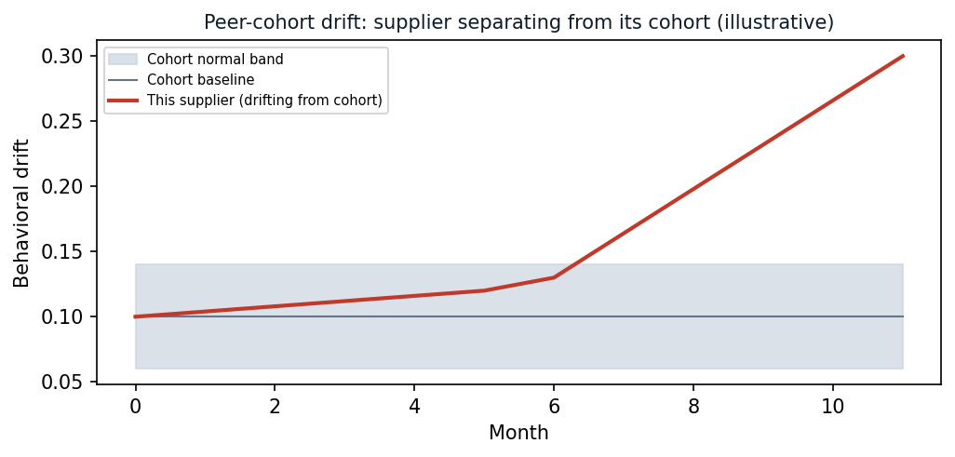
Figure 3 — Peer-cohort drift (illustrative). Each supplier is scored against the normal band of its cohort (commodity, geography, criticality); the one separating from its cohort is surfaced even while every absolute metric stays in bounds.
Tracking a supplier against its own history answers one question — is this supplier behaving the way it used to? A second, equally important question is: is this supplier behaving the way its peers do? A behavioral value that is unremarkable for one kind of supplier can be a strong risk signal for another. A semiconductor fabricator drawing on a dozen international sources is normal; a domestic fastener manufacturer suddenly doing the same is anomalous. The signal is meaningful only relative to comparable suppliers.
BEI therefore segments the supplier population into peer cohorts and evaluates each supplier's behavioral drift against the baseline of its cohort — not against the population as a whole. Cohorts are defined along the dimensions that determine what normal behavior should look like:
- What they supply: Federal Supply Class / commodity group — electronics, fasteners, textiles, chemicals, subsistence, aviation spares. What a supplier provides shapes its normal sourcing geography, lead times, and price volatility.
- Where they are located: Domestic vs. foreign, region, and proximity to adversary-nation manufacturing. Geography sets the baseline for country-of-origin mix and logistics behavior.
- Criticality: Sole-source status, weapon-system association, and mission-essential designation. Critical suppliers warrant a tighter cohort baseline and a lower drift tolerance.
- Tier and size: Prime, distributor, or sub-tier manufacturer, and small-business / large-business classification, which shape expected breadth and concentration.
For each cohort, BEI establishes a cohort behavioral baseline from the suppliers in that cohort that are behaving normally, then measures how far each individual supplier has drifted relative to that baseline. A supplier whose drift is indistinguishable from its cohort is left alone; a supplier whose drift separates it from its cohort — even while every absolute metric stays within contract bounds — is surfaced for review.
Two baselines, one verdict: BEI scores each supplier against its OWN history (self-baseline drift) and against its COHORT (peer-relative drift). A supplier flagged on both — drifting from its past and away from its peers — is a high-confidence risk.
This peer-cohort method is not new or unproven for BEI. It is exactly the mechanism the framework already uses in its operational cybersecurity deployment, where users are segmented into role groups and each user's behavioral drift is scored relative to the normal baseline of its group. Suppliers simply substitute for users, and supply-chain cohorts substitute for workforce roles.
Element | Cybersecurity (proven) | Supplier Risk (applied)
Population | Workforce of users | Vendor base of suppliers
Peer cohort | Role group: admin, security, developer,  business, executive | Cohort: commodity / FSC, geography,  criticality, tier
Cohort baseline | Normal behavior of users in the role group | Normal behavior of suppliers in the cohort
Anomaly signal | User drifts away from its role group | Supplier drifts away from its cohort
Why it works | An action normal for an admin is alarming  for an accountant | A sourcing pattern normal for one commodity  is alarming for another

Peer-cohort drift also strengthens the relationship and concentration analysis of Section 4: when several suppliers in the same cohort drift together in the same direction, the correlated movement points to a shared sub-tier dependency or a common market or geopolitical shock affecting that segment — a cohort-level risk no single-supplier review would surface.

4. Relationship-Level Risk Detection
Entity-level monitoring — tracking each supplier or part independently — misses risks that live in the relationships between entities. BEI extends behavioral analysis to pairwise relationships and network-level structures.

4.1. Pairwise Relationships
A pairwise relationship captures how two specific entities interact. The behavioral profile of the relationship can change even when both individual entity profiles appear normal.
Relationship | What It Captures | Risk Detected
Supplier x NSN | How does THIS supplier perform  for THIS specific part? | Quality drift for one part while  stable for others = targeted  substitution
Supplier x  Country of Origin | Where is THIS supplier sourcing  components? | Gradual shift to adversary-nation  origins = SCRM risk
NSN x Location | Demand patterns for THIS part  at THIS depot | Unusual demand composition at  specific locations = diversion
NSN x Bill of  Materials | Component composition  changes without notification | SBOM drift = counterfeit or  unauthorized substitution risk
Supplier x  Supplier | Behavioral correlation between  "independent" suppliers | Hidden common sub-tier source  = concentration risk

Example: Supplier A's overall quality rate looks healthy. Part X's quality rate across all suppliers looks healthy. Both entities pass at the aggregate level. But Supplier A's quality specifically for Part X has been steadily degrading over months — a targeted degradation invisible at the entity level, visible only when the specific supplier-part relationship is tracked over time.
The Supplier-NSN and NSN-Location relationships are already built and demonstrated in the supply chain proof of concept (Section 7.3). The Supplier-Country, NSN-Bill-of-Materials, and Supplier-Supplier relationships use the identical relationship machinery and are added by introducing the corresponding entity profiles — country-of-origin, SBOM component, and supplier peer entities — making them direct, low-risk extensions rather than new research.

4.2. Network-Level Risk
Beyond pairwise relationships, BEI analyzes the supply chain as a network graph to detect structural risks that no entity-level or pairwise analysis can reveal.
Multi-Hop Risk Propagation
A Tier-1 supplier is fully compliant with all SCRM requirements. Its Tier-2 sub-supplier sources from an unknown Tier-3 manufacturer in an adversary nation. Entity-level monitoring of the Tier-1 supplier shows all green. Network analysis traces the supply path through multiple hops and identifies the adversary-nation connection.
Hidden Single Points of Failure
Two suppliers appear independent: different CAGE codes, different locations, different contract vehicles. But both source a critical sub-component from the same Tier-2 manufacturer. If that manufacturer fails, both supply lines fail simultaneously. BEI detects this through behavioral correlation analysis — when two supposedly independent suppliers exhibit correlated behavioral changes, the system infers a hidden common dependency.
Cascade Prediction
When one supplier fails, which depots are affected? Which missions are degraded? Network analysis propagates the impact of a supplier disruption through the supply graph, identifying every NSN, depot, and mission that depends on the failed supplier either directly or through sub-tier dependencies.

4.3. The What vs How Much Principle
The foundational principle of BEI for supply chain risk is the distinction between what changed and how much changed.
Consider a supplier that delivers the same volume, at the same price, with the same on-time rate — but quietly shifts component sourcing from domestic origins to Chinese origins. Traditional metrics are all green: volume unchanged, price unchanged, delivery unchanged. Every threshold-based monitor shows a healthy supplier.
BEI relationship analysis detects the change: the Supplier x Country of Origin behavioral relationship has drifted. The supplier's Performance zone is stable. The Geographic Risk zone is changing direction. The system flags this as a SCRM risk — not because any magnitude threshold was crossed, but because the behavioral direction changed.
This is the supply chain equivalent of the insider threat: behavior changes WHAT, not HOW MUCH. The supplier looks the same by every traditional measure while fundamentally altering its sourcing strategy.

5. Detection Capabilities
BEI's multi-layer analysis — entity profiles, pairwise relationships, and network graphs — enables detection of five categories of supply chain risk that traditional monitoring consistently misses.

5.1. Counterfeit Part Detection
Counterfeit parts enter the defense supply chain through sophisticated distribution networks where components are relabeled, remarked, or entirely fabricated. BEI detects counterfeit risk through three behavioral signatures.
- Failure Rate Divergence: NSN failure rate diverges between locations receiving from different suppliers. When the same part fails markedly more often from one supplier than another, the NSN x Supplier relationship drift signals a sourcing quality difference that aggregate part-level statistics conceal.
- Manufacturer Relationship Drift: The NSN x Manufacturer relationship changes — a different manufacturer of origin appears on inspection records while the label remains the same. BEI tracks this relationship continuously, not just at contract award.
- SBOM Composition Drift: The component composition of a delivered assembly changes without engineering notification. BEI monitors SBOM behavioral profiles for drift in component identity, source, or specification.

5.2. Adversary-Nation Sourcing (SCRM)
Adversary-nation sourcing risk is the gradual shift of component origins to countries designated as supply chain risks. This shift typically occurs over months, making it invisible to annual audits.
- Supplier x Country Drift: The Supplier x Country of Origin relationship drifts over months as sourcing geography shifts incrementally. Each monthly snapshot looks similar to the previous one; the cumulative trajectory reveals a fundamental change.
- Multi-Hop Network Analysis: Network analysis traces supply paths through intermediaries to identify adversary-nation connections that are two or three hops removed from the prime supplier. A compliant Tier-1 supplier may unknowingly source from an adversary-nation Tier-3 manufacturer.
- Section 889 Compliance: BEI provides continuous behavioral monitoring of country-of-origin relationships, extending Section 889 compliance beyond the point-in-time assessment at contract award to ongoing operational monitoring.

5.3. Supplier Concentration Risk
Concentration risk arises when the supply chain depends on fewer independent sources than it appears to have. BEI detects hidden concentration through behavioral correlation and network centrality analysis.
- Supplier Behavioral Correlation: When two supposedly independent suppliers exhibit correlated behavioral changes — simultaneous delivery delays, coordinated price increases, or synchronized quality shifts — BEI infers a hidden common dependency at the sub-tier level.
- Network Centrality Analysis: Graph analysis identifies entities whose removal would disproportionately impact the supply network. A supplier that appears minor by contract value may be the sole source for a component used in 30 weapon systems.
- Impact Propagation Modeling: If Supplier X fails, the system propagates the impact through the supply graph to identify every affected NSN, depot, and mission — including indirect impacts through sub-tier dependencies.

5.4. Demand Diversion and Fraud
Demand diversion occurs when parts ordered for one purpose are redirected to unauthorized uses. BEI detects diversion through relationship-level anomalies.
- Requestor x NSN x Urgency Drift: The same part is requisitioned by a different set of requestors with elevated urgency codes. The total volume looks normal; the requestor composition has changed.
- Location Demand Composition: Demand volume at a specific location remains within normal bounds, but the mix of items being demanded changes. BEI detects the composition shift through NSN x Location relationship analysis.
- Sequence Anomaly Detection: Orders that progress through acceptance without standard inspection steps create a behavioral sequence anomaly — the expected workflow pattern has changed.

5.5. Contract and Financial Risk
Supplier financial distress frequently precedes quality degradation and delivery failures. BEI correlates behavioral drift with financial health indicators to provide early warning.
- Behavioral-Financial Correlation: When a supplier's Performance Trajectory zone begins drifting concurrently with deterioration in its Risk Assessment zone, BEI flags the correlation as a financial distress indicator.
- Contract Expiry Risk: Contracts approaching expiration combined with degrading delivery performance signal a supplier that may be disinvesting in the relationship — a flight risk for critical supply lines.
- Price-Quality Divergence: A supplier maintains stable pricing while failure rates increase. The cost per unit is unchanged, but the cost per functioning unit is rising. BEI detects this through the divergence between the financial and performance behavioral zones.

6. Operational Deployment

6.1. Data Sources and Collection
BEI integrates data from existing DLA and DoD systems. No new data collection is required — the system operates on transaction records, quality reports, and supplier profiles already maintained across the enterprise. The categories of data the framework consumes are summarized below; the subsections that follow describe the specific systems of record they come from, how each behavioral zone is populated, and how suppliers are resolved across systems.
Data Source | Description | Cadence | Integration
Procurement  Transactions | Purchase orders, delivery orders,  contract actions | Daily | Batch extract from  contracting systems
Delivery  Records | Receipt confirmations, delivery  dates, quantity variances | Daily | Automated feed from  warehouse management
Quality  Inspections | Inspection results, rejection rates,  defect classifications | Per event | Quality system  integration
Country-of-Origin  Declarations | Manufacturer origin certifications,  trade compliance records | Per shipment | Customs and trade  compliance systems
SBOM  Registries | Software and hardware bills of  materials, component lists | Per delivery | Engineering data  management systems
Financial  Filings | Supplier financial health indicators,  bond and insurance status | Quarterly | SAM.gov, D&B,  commercial sources
GIDEP  Alerts | Government-Industry Data Exchange  Program notifications | As issued | GIDEP automated  alert feed

How Each Behavioral Zone Is Populated
Each supplier behavioral zone (Section 3.2) is computed from a specific set of source records. The mapping below shows where the inputs for each zone originate and how they are collected, making explicit that every behavioral signal traces back to an authoritative system the enterprise already maintains.
Behavioral Zone | Example Inputs | Primary Source System(s) | Collection / Cadence
Identity | CAGE/UEI status, certifications,  tier, small-business class | SAM.gov, CAGE registry,  Joint Certification Program | Registry sync / API,  daily
Performance  Trajectory | On-time delivery, lead time,  quality rejection rate | PIEE / WAWF (receipt &  acceptance), SPRS, PDREP | Batch extract,  daily / per-event
Geographic /  Sourcing Risk | Country-of-origin mix,  adversary-nation exposure | Country-of-origin declarations,  customs/CBP, contract COO clauses | Per-shipment feed
Network  Position | Depots served, NSNs supplied,  customer concentration | DLA EBS, DIBBS,  FPDS-NG contract actions | Batch extract,  daily
Risk /  Financial | Financial health, bond/insurance,  exclusions, debarment | Dun & Bradstreet, SAM.gov  exclusions, SPRS risk | Quarterly (financial),  daily (exclusions)

Authoritative Systems of Record
BEI is fed from the established DoD and DLA systems that already govern supplier registration, performance, quality, and procurement. The exact set is tailored per deployment to the data the program office can provide; the systems below are the typical sources.
System of Record | What It Provides | Steward
SAM.gov | Registration, Unique Entity ID (UEI),  CAGE linkage, exclusions / debarment | GSA
SPRS (Supplier Performance  Risk System) | Supplier performance and risk scores,  NIST SP 800-171 cybersecurity scores | DoD (Navy)
PDREP (Product Data Reporting  & Evaluation Program) | Quality deficiency reports, supplier  audits, test and inspection results | DoD (Navy)
GIDEP | Counterfeit and nonconformance  alerts across government and industry | DoD / Industry
PIEE / WAWF, FPDS-NG | Receiving, acceptance, invoicing;  federal contract action history | DoD / GSA
DLA EBS, DIBBS | DLA procurement, solicitation, award,  and inventory transactions | DLA
Dun & Bradstreet  (commercial) | Independent supplier financial-health  indicators and corporate linkage | Commercial

No new instrumentation. BEI consumes data the enterprise already produces. The CAGE code (with UEI) is the universal join key that resolves a single supplier across SAM.gov, SPRS, PDREP, EBS, and commercial financial data.
Entity Resolution and Data Quality
Behavioral profiling is only as trustworthy as the data plumbing beneath it. Four engineering concerns are addressed during integration:
- Entity resolution: A single supplier appears under different identifiers across systems. BEI keys on the CAGE code and UEI to unify records, and reconciles name changes, address changes, and parent/subsidiary structures so that a supplier's history follows it across re-registrations.
- Latency and cadence: Sources update on different clocks — daily transactions, per-shipment origin declarations, quarterly financials. Behavioral snapshots are computed on a fixed cadence (weekly or monthly) and tolerate slower-moving inputs by carrying the last known value forward with an age flag.
- Missing and sparse data: A supplier missing one data category is not dropped. Zones degrade gracefully: a supplier with no commercial financial feed is still scored on the other four zones, and a data-coverage confidence indicator accompanies every risk score so analysts know how complete the picture is.
- Provenance and auditability: Every behavioral feature traces back to the source record that produced it. This provenance is essential when a behavioral risk score informs a contract-award decision and must withstand supplier challenge or audit.

6.2. Deployment Phases
BEI deployment follows a four-phase approach designed to deliver initial value within 8 weeks while building toward full production capability.
Phase | Duration | Activities | Deliverables
Phase 1:  Data Integration | 2-4 weeks | Connect to procurement, delivery,  quality, and supplier databases.  Entity resolution across systems.  Data quality assessment. | Integrated data pipeline  Entity resolution map  Data quality report
Phase 2:  Baseline  Establishment | 4-6 weeks | Ingest 4-6 weeks of historical data.  Build behavioral profiles for all  entities. Establish zone baselines.  Calibrate drift detection thresholds. | Entity behavioral profiles  Baseline reference points  Calibration report
Phase 3:  Detection  Deployment | 2-4 weeks | Deploy detection capabilities.  Threshold tuning against known  historical incidents. SOC analyst  training on alert triage. | Detection rules deployed  Alert triage procedures  Analyst training complete
Phase 4:  Production  Monitoring | Ongoing | Continuous behavioral monitoring.  Integration with acquisition and  SOC workflows. Quarterly model  recalibration. | Operational dashboard  Weekly risk reports  Acquisition decision support

6.3. Integration Points
BEI is designed to integrate with DLA's existing systems and workflows, augmenting current capabilities rather than replacing them.
- DLA SCRM Program: BEI's behavioral risk scores feed into DLA's existing SCRM risk assessments, providing continuous monitoring between annual reviews.
- GIDEP Integration: GIDEP alerts are correlated with BEI behavioral detections. A GIDEP alert about a supplier coinciding with behavioral drift in that supplier's profile elevates the risk score and triggers accelerated investigation.
- CAGE/SAM.gov Databases: BEI cross-references entity profiles against CAGE and SAM.gov registrations. Changes in supplier registration status (new CAGE codes, SAM.gov exclusions, changed addresses) trigger behavioral profile updates.
- Contracting Officer Workflow: Behavioral risk scores are presented to contracting officers at the point of contract award decision. A supplier with a drifting Geographic Risk zone is flagged before the award, not after delivery.
- Quality Assurance Routing: Parts from suppliers with elevated behavioral risk scores are routed to priority inspection queues. Limited inspection resources are allocated based on behavioral intelligence rather than random sampling.

7. Proven Foundation: From Cybersecurity to Supply Chain

7.1. What Has Been Proven in Cybersecurity
The behavioral detection concept described in this whitepaper is not a research proposal. It has been built, deployed, and proven in an operational cybersecurity setting. In that deployment, the BEI framework analyzed a large population of users over an extended period and was challenged with four advanced, long-duration attack campaigns deliberately designed to evade detection: a patient insider threat, a slow command-and-control intrusion, and two nation-state campaigns modeled on real-world adversary tradecraft.
Traditional detection methods — the statistical and threshold-based techniques that are the supply chain equivalent of on-time-rate and quality-score monitoring — catch at most one of the four campaigns (Z-Score detects 1 of 4 at 9.8% FP) and provide no directional intelligence to distinguish threat types or guide triage. The BEI framework detected all four while adding zone-level explanation, ranking each attacker among the highest-risk entities and telling analysts WHICH behavioral dimension changed. The attackers were caught not because any single value crossed a threshold, but because their behavioral direction changed — exactly the failure mode that defeats traditional supplier monitoring.
The proof point is concrete: in cybersecurity, BEI matched traditional detection rates while adding zone-level directional intelligence that traditional methods cannot provide. The actionable triage came from behavioral direction, not metric magnitude — the same signal that exposes hidden supplier risk.

7.2. Why the Proof Transfers
The cybersecurity and supply chain problems are structurally identical. In both, the most damaging actors operate within authorized bounds — valid credentials in one case, compliant contracts in the other — while gradually shifting behavioral direction toward an objective. The BEI framework is domain-agnostic: the same analytical architecture that profiles a user profiles a supplier; the same relationship analysis that links a user to a device links a supplier to a part and a country of origin; the same temporal trajectory analysis that detects an escalating insider detects a supplier drifting toward distress.
Framework Element | Proven In Cybersecurity | Applied To Supplier Risk
Entity profile | User, device, application behavioral baselines | Supplier, NSN, location, manufacturer baselines
Behavioral zones | Identity, access, data, network, risk | Identity, performance, geographic, network, risk
Peer-cohort scoring | Group-relative drift vs. role group  (admin, security, developer, ...) | Group-relative drift vs. supplier cohort  (commodity, geography, criticality)
Relationship analysis | User-device, user-application interactions | Supplier-part, supplier-country, part-SBOM interactions
Temporal trajectory | Detecting escalating insider over months | Detecting supplier drift toward distress or substitution
Directional detection | Caught all 4 advanced campaigns missed by traditional methods | Designed to catch sourcing shifts, counterfeits, hidden concentration

What changes between domains is the vocabulary of the entities and the data sources that feed them. What stays constant is the detection principle and the analytical machinery — both proven.

7.3. Supply Chain Proof of Concept
The BEI framework has been instantiated for the supply chain domain and exercised on a realistic synthetic dataset. This proof of concept demonstrates that the framework's capabilities — entity profiling, zone decomposition, relationship analysis, temporal trajectory, and regime detection — operate on supply chain data exactly as they operate on cybersecurity data.
Parameter | Value
National Stock Numbers (NSNs) | 500
Suppliers | 200
Depots | 4 (3 Indo-Pacific, 1 CONUS)
Transaction History | 24 months
Demand Components Modeled | 6 (baseline, exercise, seasonal,  maintenance, combat, failure)
Supplier Risk Grades | A through F (composite behavioral +  financial + performance)

Demonstrated Capabilities
- Phase Space Regime Detection: The framework identifies items transitioning from STABLE to DEPLETING behavioral regimes before stockout occurs, providing actionable lead time for procurement intervention.
- Supplier Risk Scoring: Each supplier receives a composite health grade (A through F) incorporating behavioral trajectory, financial health indicators, and delivery performance trends. The grade reflects behavioral direction, not just current-period metrics.
- Demand Decomposition: Demand for each NSN is decomposed into six independent components, enabling the system to distinguish exercise-driven demand spikes from baseline consumption changes and combat-related surges.
- Relationship Analysis: Four relationship types are built and operating: Supply (Supplier-NSN), Demand (NSN-Location), Transit (NSN-Route), and Fulfillment (Supplier-NSN-Location). The country-of-origin, bill-of-materials, and supplier-to-supplier relationships described in Section 4 are natural extensions of the same relationship machinery, added by introducing the corresponding entity profiles.
- LLM-Powered Decision Support: Analysts query the system in natural language — 'Which Indo-Pacific parts are at risk of stockout in the next 90 days?' — and receive answers contextualized with behavioral intelligence, not just inventory snapshots.
Measured Supplier-Risk Results (Synthetic MVP)
Beyond demonstrating the capabilities, the supply chain MVP implements a calibrated, explainable supplier-risk model and measures it. The model was trained and audited on 1,174 supplier-evaluation windows (walk-forward 90-day snapshots), with a stratified 20% held-out test set (235 windows) and a failure base rate of approximately 20%. A supplier-window is labeled a failure if, in the following 90 days, its on-time rate falls below 0.5 or it incurs two or more severely late (>15-day) deliveries. The architecture and features are detailed in Section 8.10; the measured results are below.
Model | Metric | Value | Grade
XGBoost classifier  (P(failure ≤ 90d)) | AUC (V1, 12 features) | 0.7709 | B
XGBoost classifier | AUC (V2, +behavioral features) | 0.7780 | B
XGBoost classifier | Average Precision | 0.4918 | —
XGBoost classifier | Brier / ECE (calibration) | 0.1588 / 0.1019 | C
Random Survival Forest | C-index (held-out) | 0.7935 | B
Random Survival Forest | Survival ECE @ 30 / 60 / 90d | 0.084 / 0.090 / 0.129 | B / B / C

The model's most influential features (by SHAP) are quality incidents, recent order count, on-time rate, worst delay, and critical-NSN count — an explainable, operationally sensible ordering. Monotone constraints guarantee the score moves in the intuitive direction (more quality incidents and sole-source exposure raise risk; higher on-time rate lowers it).
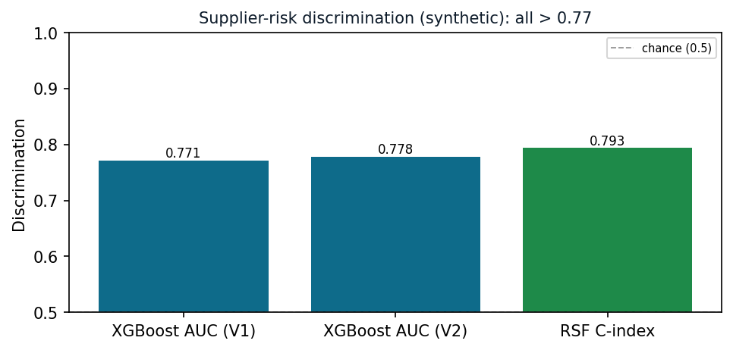
Figure 4 — Supplier-risk discrimination (synthetic): XGBoost AUC 0.77 (V1) / 0.78 (V2) and survival C-index 0.79 — all well above chance.
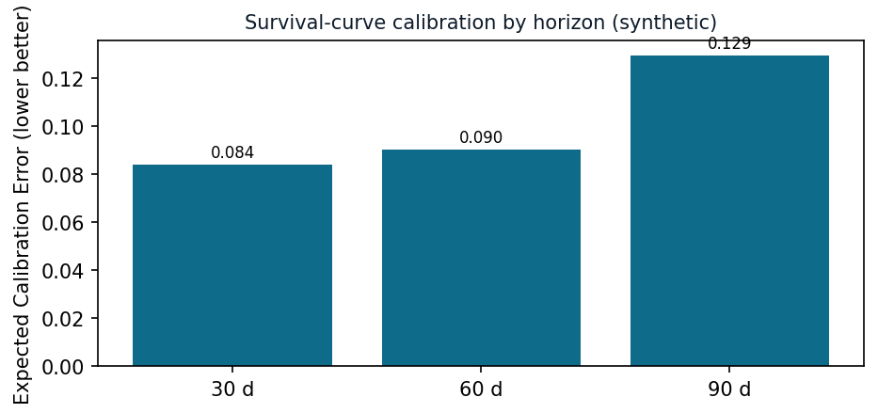
Figure 5 — Survival-curve calibration by horizon (synthetic): Expected Calibration Error 0.084 / 0.090 / 0.129 at 30 / 60 / 90 days — Grade B at the near horizons.
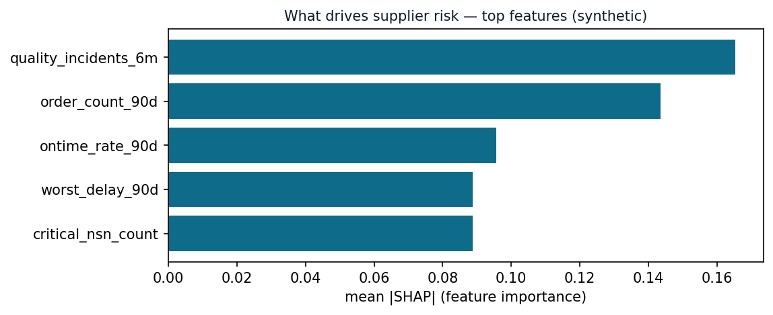
Figure 6 — What drives supplier risk (top SHAP features, synthetic): quality incidents, recent order count, on-time rate, worst delay, critical-NSN count — an operationally sensible, explainable ordering.
The cybersecurity deployment proved detection efficacy quantitatively. The supply chain MVP now adds a measured, calibrated supplier-risk model — AUC 0.77, survival C-index 0.79 — built and audited on a realistic synthetic dataset. ALL supply-chain numbers are from synthetic data and must be re-validated on real DLA data before any production claim; the next step is that real-data re-measurement.

7.4. Illustrative Detection Scenarios
The following scenarios illustrate what BEI is designed to surface when applied to defense supplier data. They describe the behavioral signal and the mechanism by which BEI exposes it — the same class of directional signal proven detectable in the cybersecurity deployment and demonstrated operationally in the supply chain proof of concept.
Scenario | Behavioral Signal | Traditional  Visibility | How BEI Surfaces It
Supplier sourcing shift  to adversary nation | Geographic Risk zone drifting  while Performance zone stable | Invisible until  next annual audit | Continuous zone-level  drift detection flags the  geographic shift as it forms
Hidden supplier  concentration | Two suppliers show correlated  behavioral changes (delivery,  pricing, quality) | Invisible —  suppliers appear  independent | Network cohort analysis  flags the correlated  behavior as a shared  dependency
NSN transitioning  to stockout | Inventory Position zone  accelerating toward depletion  regime | Visible only when  stockout occurs | Regime detection flags  the STABLE-to-DEPLETING  transition before depletion
Counterfeit part  entry | NSN failure rate diverges  between supplier sources | Detected only after  field failure | Relationship analysis  flags the supplier-part  failure divergence
Supplier financial  distress | Performance and Risk  zones drift concurrently | Detected at next  quarterly review | Multi-zone trajectory  flags the concurrent drift  as it develops

8. Technical Deep Dive: The Mathematics of Behavioral Drift
The preceding sections describe BEI conceptually. This section makes the innovation explicit — the representations, transforms, and detection algorithms that turn raw supply-chain records into a ranked, explained risk verdict. The notation is kept deliberately concrete so a technical evaluator can reason about, and reproduce, the method. The central claim is stated up front and demonstrated through the section: no single equation is the innovation; the innovation is the COMPOSITION of a semantic representation in which the direction of behavioral change is measurable, decomposed into independent zones, scored against the right peer cohort, accumulated over time, and fused across mutually-reinforcing detection phases.
Traditional analytics live in raw feature space and measure magnitude — how far a metric moved. BEI lives in a semantic embedding space and measures direction — what the supplier is becoming. Everything below follows from that single change of space.

8.1. From Metrics to Meaning: Serialization and Embedding
For each supplier i and period t, the raw features of each behavioral zone z are first serialized into a short natural-language description, then mapped to a high-dimensional semantic vector by an embedding model:
e[i,z,t] = Embed( serialize( features(i, z, t) ) ) ∈ R^1536
example serialization (Geographic / Sourcing zone):
"Supplier 7731, electronics, prime. Country-of-origin mix:
72% domestic, 18% allied, 10% high-risk foreign. 4 manufacturing
sites across 3 countries. 1 new high-risk site this period."
Why embed text rather than compute distance on the raw numbers? Because the risk signal is often a change in the KIND of value, not its size. A shift from 1% to 12% high-risk-foreign sourcing is a small Euclidean distance among features dominated by large-magnitude quantities (dollars, units), yet it is an enormous change in MEANING. The embedding places semantically similar behavior near itself, so a change in kind becomes a measurable change in geometry.

8.2. Zone Composition and Context-Adaptive Attention
Each supplier's overall state at period t is a composition of its five zone vectors. The baseline composition is a weighted average, renormalized to the unit sphere:
V[i,t] = normalize( Σ_z w_z · e[i,z,t] )
illustrative supplier zone weights (tuned per deployment):
performance = 0.25, geographic = 0.25, network = 0.20,
risk = 0.20, identity = 0.10
Innovation — zone independence. Because zones are composed rather than collapsed into a single average of raw metrics, a strong signal in one zone (geographic drift) is not washed out by four stable zones. A single monolithic score would average the signal away; zone decomposition preserves it.
Context-adaptive attention takes this further. Rather than fixed weights, the contribution of each zone is set by a context-biased linear normalization of zone salience (routine monitoring, SCRM hunt, financial-distress review):
α_z = (||e[i,z,t]|| · b_z(context)) / Σ_z (||e[i,z,t]|| · b_z(context)) # linear norm
V[i,t] = normalize( Σ_z α_z · e[i,z,t] )
under a SCRM-hunt context, b_z raises attention on the geographic
and risk zones; under a distress review, on risk and performance.
The same supplier is therefore scored differently depending on what is being hunted — without retraining the model.

8.3. Drift: Measuring Direction, Not Just Magnitude
Behavioral change between consecutive periods is captured two ways. The magnitude of change is the cosine distance between snapshots; the direction of change is the unit vector of their difference:
drift magnitude: d[i,t] = 1 − cos( V[i,t−1], V[i,t] ) ∈ [0, 2]
drift direction: u[i,t] = ( V[i,t] − V[i,t−1] ) / || V[i,t] − V[i,t−1] ||
Magnitude answers "did something change, and how much?" Direction answers "what is this supplier turning into?" The second question is the one traditional monitoring cannot ask, because raw-feature distance has magnitude but no interpretable direction. The next subsection gives the direction a name.

8.4. Naming the Direction: Reference-Concept Projection
A library of risk concepts {c_k} — for example adversary-nation sourcing, counterfeit substitution, demand diversion, financial distress — is embedded into the SAME semantic space as supplier behavior. The drift direction is projected onto each concept by cosine alignment:
align_k = cos( u[i,t], Embed(c_k) )
primary risk = argmax_k align_k (with benign anchor concepts to suppress
false alignment from routine variation)
Innovation — explainability by construction. The output is not an opaque anomaly score but a ranked, plain-language reason ("drifting toward adversary-nation sourcing") that maps directly to the relevant SCRM authority (e.g., Section 889, DFARS 252.246-7008). An analyst can act on it, and a contracting officer can defend the decision.

8.5. Accumulating Slow Drift: CUSUM Change-Point
The most damaging supply-chain shifts are slow: a supplier moves sourcing a little each month, so no single period crosses an alert threshold. A one-sided cumulative-sum (CUSUM) accumulates the small excesses and fires on the sustained trend:
S_0 = 0
S_t = max( 0, S_{t−1} + ( d[i,t] − k ) ) # k = baseline drift allowance
alarm when S_t ≥ h for ≥ r consecutive periods # h = decision threshold
change-point = index where the triggering run began
operational defaults from the proven deployment: k = 0.02, h = 0.05, r = 2
Worked example. A supplier drifts d = 0.03 per month toward foreign sourcing — well below any single-period alert level. Each month S grows by 0.03 − 0.02 = 0.01, so S crosses h = 0.05 after roughly five months and flags a change-point at the start of the drift. A twelve-month adversary-nation migration that every monthly threshold would pass is caught while it is still forming.

8.6. Peer-Cohort Scoring
A behavioral value is anomalous only relative to comparable suppliers. Each supplier is assigned to a cohort g by stable identity attributes — commodity / Federal Supply Class, geography, criticality, tier — and every feature is standardized against the NORMAL members of that cohort:
cohort: g(i) = ( commodity, geography, criticality, tier )
μ[g,f] , σ[g,f] estimated over normal suppliers in cohort g
z[i,f] = ( x[i,f] − μ[g(i),f] ) / σ[g(i),f]
Innovation — the right reference group. A multinational sourcing footprint is normal for a semiconductor cohort and alarming for a domestic-fastener cohort; scoring against the population would hide both signals, scoring against the cohort exposes them. This is exactly the role-group standardization proven in the cybersecurity deployment (users scored against administrators, analysts, executives), with supplier cohorts substituting for workforce roles.

8.7. Multi-Phase Composite Score
The final verdict fuses five independent phases computed from the cohort z-vector and the drift series. Each phase targets a different evasion strategy:
signal_strength = Σ top-3 of { z[i,f] } # peak deviation
breadth = | { f : z[i,f] > 1.5 } | # how many features elevated
sustained = Σ top-2 of { late-window mean z[i,zone] } # persistence
divergence = z of context-specific composite spread # cohort/context
novelty = recurrence of never-before-seen entities
(new country-of-origin, new sub-tier manufacturer)
composite = β1·signal + β2·breadth + β3·sustained
+ β4·divergence + β5·novelty # rank suppliers by composite
Innovation — evasion resistance through independence. A supplier that suppresses magnitude still fails breadth; one that limits breadth still fails sustained deviation or novelty persistence. No single masking strategy defeats the fused score. Novelty persistence in particular is the phase that catches the slowest campaigns, which are quiet on every other axis — the supply-chain analogue of the slow APT whose only tell is the same never-before-seen infrastructure reappearing period after period.

8.8. Relationship and Co-Drift Detection
Risk that lives between entities is captured by composing a relationship vector as the element-wise (Hadamard) product of two entity vectors, renormalized:
R[a×b, t] = normalize( V[a,t] ⊙ V[b,t] )
drift in R[a×b] while V[a] and V[b] are individually stable reveals
targeted change: Supplier×NSN (one part degrading), Supplier×Country
(sourcing shift), NSN×SBOM (composition change).
Hidden concentration is detected as co-drift: cluster suppliers whose drift directions are mutually aligned above a coherence threshold τ — cos(u[a,t], u[b,t]) ≥ τ — and a cluster of "independent" suppliers moving together points to a shared sub-tier dependency or a common geopolitical shock no single-supplier review would surface.

8.9. Why the Composition Is the Innovation
Each component above exists, in some form, elsewhere. The defensible innovation is their integration into a single pipeline in which each stage compensates for the blind spot of the others:
Stage | What it adds | Blind spot it removes
Semantic embedding | Direction of change is measurable | Raw-feature distance has magnitude but no meaning
Zone decomposition | One drifting zone is not diluted | Monolithic scores average the signal away
Context attention | Scoring adapts to the hunt | Fixed weights miss context-specific risk
Reference concepts | Plain-language, authority-mapped reason | Opaque anomaly scores are not actionable
CUSUM | Slow, sub-threshold drift accumulates | Per-period thresholds miss gradual shifts
Peer cohort | Right reference group | Population baselines hide cohort-specific anomalies
Multi-phase fusion | Evasion resistance | Any single detector can be gamed

End to end: a supplier's monthly records are serialized and embedded; zone vectors are composed under the active context; drift magnitude and direction are computed; the direction is named against the concept library and mapped to SCRM authority; CUSUM accumulates the slow trend; cohort z-scores place the behavior against true peers; and the five-phase composite produces a single ranked, explained verdict. That integrated path — not any one formula — is what detects the supply-chain threats that magnitude-based monitoring is structurally unable to see.
The moat is the pipeline, not a single equation. Direction over magnitude, zones over monoliths, cohorts over population baselines, accumulation over instantaneous thresholds, and fusion over any single detector — composed into one explainable, ranked verdict.

8.10. The Predictive Risk Layer: XGBoost + Survival Model (Implemented MVP)
The behavioral layer of Sections 8.1–8.9 produces features and embeddings that describe how a supplier is behaving and in what direction it is drifting. The implemented MVP turns that behavioral evidence into an actionable, calibrated, explainable risk score with a time dimension, using a dual predictive model. The behavioral embeddings and cohort/drift features plug in as inputs; the predictive layer adds probability calibration, a survival curve, and SHAP explanations.
Two models, two jobs.
- Model 1 — XGBoost classifier: Gradient-boosted classifier estimating P(significant delivery failure within 90 days). It provides the headline risk score and, via SHAP, the per-feature explanation. Monotone constraints force the score in the intuitive direction — higher on-time rate lowers risk; sole-source status, quality incidents, and worst delay raise it — so the model can never produce a counter-intuitive, indefensible ranking.
- Model 2 — Random Survival Forest: A survival model estimating the full curve P(supplier still OK at day T), reported at 30, 60, and 90 days. This time-dependent risk feeds inventory and sourcing decisions (when, not just whether, to expect trouble).
Features (V1 = 12 leakage-free signals; V2 adds the behavioral layer):
delivery / performance : ontime_rate_90d, ontime_trend_slope,
avg_lead_time_ratio, delivery_variance_90d,
worst_delay_90d, order_count_90d, order_volume_trend
quality : quality_incidents_6m
structural / exposure : is_sole_source, geographic_risk,
critical_nsn_count, sole_source_nsn_count
V2 behavioral add-ons : supplier zone-embedding features (delivery, portfolio,
capacity, stability, network) + drift velocity
Labels are built walk-forward: every 90 days each supplier is snapshotted, features are computed from the prior 90-day window, and the label is read from the next 90 days (failure = future on-time < 0.5 or two-plus deliveries more than 15 days late). The survival target is the number of days to the first severely late delivery. All metadata is read point-in-time from a bi-temporal store so training never sees the future.
Operational guardrails (where the model defers to hard rules):
- Debarment pre-filter: A debarred supplier short-circuits to maximum risk with a directive to verify status on SAM.gov; if the debarment check itself fails, the model fails closed (risk = max, manual review) rather than guessing.
- CAGE-code change: A CAGE-code change in the last 12 months (from bi-temporal history) is surfaced as an ownership/restructuring/re-registration warning — an enrichment signal, not a silent model feature.
- Destination-aware blend: When a destination depot is specified, the global score is blended with destination-specific performance (0.6 global / 0.4 destination) so risk reflects how the supplier performs to that location.
Measured performance on the synthetic MVP — AUC 0.7709, RSF C-index 0.7935, calibration ECE in the 0.08–0.13 range — is reported in Section 7.3. The relationship between the two layers is the point: the behavioral pipeline supplies direction and novelty that raw performance features miss, while the predictive layer supplies calibration, a survival horizon, and defensible explanations. Neither alone is sufficient; together they produce a ranked, time-aware, explainable supplier-risk verdict.
Behavioral layer answers "what is this supplier becoming, and is it unlike its peers?" Predictive layer answers "what is the calibrated probability and timing of failure, and why?" The MVP implements both — measured, explainable, and guardrailed — on synthetic data pending real-data re-validation.

9. Business Value
BEI delivers measurable value across six dimensions of supply chain risk management, transforming reactive monitoring into proactive risk intelligence.
Reduced Counterfeit Exposure
Continuous behavioral monitoring of supplier-part-manufacturer relationships detects counterfeit risk signals months before parts fail in the field. The Government Accountability Office estimates average counterfeit remediation costs at $1.8 million per incident, including recall, inspection, replacement, and mission impact assessment. BEI's early detection capability reduces both the frequency and severity of counterfeit incidents.
Earlier Detection of SCRM Risks
Traditional SCRM assessments operate on annual review cycles. BEI monitors supplier behavior continuously, surfacing adversary-nation sourcing shifts as the behavioral change forms rather than at the next scheduled review. For slow-moving supply chain compromises that unfold over quarters, the difference between continuous detection and periodic review is the difference between prevention and remediation.
Reduced Mission Impact from Supply Disruptions
Cascade prediction identifies the mission impact of supplier failures before they occur. When a supplier enters the Drifting regime, the system immediately identifies every depot, NSN, and mission that would be affected, enabling proactive sourcing decisions rather than reactive scrambling.
Compliance Automation
Continuous monitoring of Section 889 and DFARS compliance replaces periodic manual audits. The system continuously tracks country-of-origin relationships and flags compliance deviations as they emerge, reducing both compliance risk and the labor cost of manual reviews.
Acquisition Intelligence
Behavioral risk scores inform contract award decisions at the point of decision. A contracting officer evaluating two suppliers can see not just current performance metrics but behavioral trajectory: is this supplier's quality improving or degrading? Is its geographic sourcing stable or shifting? This intelligence transforms acquisition from a backward-looking assessment to a forward-looking prediction.
The Scale of the Problem BEI Addresses
The following figures describe the documented cost of the supply chain risks that BEI is designed to detect earlier. They establish the scale of the problem, drawn from external sources; the value of earlier behavioral detection is proportional to these stakes.
Risk Category | Documented Cost of the Problem | Source | Where BEI Helps
Counterfeit  Remediation | ~$1.8M average per incident | GAO reports | Behavioral monitoring of  supplier-part-manufacturer  relationships surfaces  counterfeit risk signals
Stockout /  Mission Impact | Mission-dependent, can reach  tens of millions per event | DLA readiness  assessments | Regime detection flags  depletion trajectories  before stockout
SCRM Compliance  Violation | Significant remediation and  reporting cost per finding | DFARS enforcement  history | Continuous country-of-origin  monitoring replaces  periodic audits
Supplier Failure  Cascade | Scope-dependent, can be  substantial across a portfolio | COVID-19 supply  chain analyses | Network analysis exposes  hidden concentration before  it cascades

10. Conclusion
Traditional supplier monitoring measures individual metrics at points in time. Each metric has a threshold. Each threshold is evaluated independently. A supplier that stays below every threshold is classified as low-risk, regardless of what is changing beneath the surface.
Behavioral Entity Intelligence measures behavioral direction across entity relationships continuously. It asks not 'Is this metric within bounds?' but 'Is this entity behaving the same way it has historically?' and 'In which dimension is the behavior changing?' The decomposition into independent behavioral zones, the tracking of pairwise relationships, and the analysis of network structure together create a detection capability that addresses the four structural weaknesses of traditional monitoring: threshold blindness, single-entity tunnel vision, static risk scores, and sub-tier opacity.
The central insight applies to supply chains as it does to cybersecurity: the supplier changes WHAT it sources, not HOW MUCH it delivers. The delivery rate stays strong. The quality score stays acceptable. But the component origins shifted. The sub-tier manufacturing site changed. The SBOM composition drifted. These changes are invisible to traditional metrics and visible to behavioral intelligence — as proven when the same framework caught every advanced threat that traditional methods missed in the cybersecurity domain.
Next step: 22nd Century Technologies is prepared to conduct a 4-week proof of concept on DLA production data, demonstrating BEI detection capabilities against actual supply chain transaction history across a selected commodity group.

22nd Century Technologies, Inc.

V-Intelligence UEBA Program — Supply Chain Risk Management

June 2026

