Catching the Cyber Threats That Never Trip an Alarm:
Traditional Security Monitoring vs. V-Intelligence UEBA
A business and technology overview — what behavioral intelligence is, what it detects that today's tools miss, and what the evidence shows
22nd Century Technologies, Inc. · V-Intelligence UEBA Program · June 2026 · Business Edition
Prepared for: Defense Logistics Agency - Office of the CIO and PEO
Disclosure note: this edition describes the architecture and the innovation, and reports measured results. The exact detection logic — formulas, thresholds, weights, and parameters — is proprietary and is withheld here; it is available in the full technical edition under NDA (non-disclosure agreement).
Data note: all results in this paper come from a synthetic (simulated) dataset built to prove the concept — 250 users, 485 days, approximately 15 million log events across five log sources, with four embedded long-duration attack campaigns modeled on real, publicly documented intrusions. Results must be re-validated on real operational telemetry before any production claim.
1. Executive Summary
The most damaging cyber attacks of the past decade did not trip a single alarm. Volt Typhoon — a Chinese state-sponsored campaign against U.S. critical infrastructure — sat inside victim networks for at least five years undetected. Salt Typhoon — described by the chairman of the Senate Intelligence Committee as "the worst telecom hack in our nation's history" — operated inside major U.S. telecommunications providers for months. In both cases, the victims' own security tools never fired; the campaigns were discovered by outside intelligence agencies. These attackers succeed by using valid credentials and legitimate tools, staying within the statistical bounds of "normal," and shifting their behavior gradually over months.
This paper presents the business case for User and Entity Behavior Analytics (UEBA) — a detection approach that establishes a behavioral baseline for every user and system, then watches not just how much behavior changes, but in which direction it is trending. The V-Intelligence UEBA program validated this approach on a realistic simulated enterprise: 250 users, 485 days, roughly 15 million events, and four embedded attack campaigns — a 14-month insider threat, a 417-day slow nation-state intrusion with covert call-home traffic, a 412-day Volt Typhoon-style campaign, and a 412-day Salt Typhoon-style telecom campaign.
What the evidence shows, stated honestly:
- Traditional methods miss these attacks. Of four industry-standard anomaly-detection algorithms run against the same data, three detected none of the four attack campaigns, and the best detected exactly one — a single statistical spike, with no explanation of which behavior changed or what kind of threat it resembled.
- 4 of 4 detected — with direction. V-Intelligence's multi-phase composite scoring detects all four attack campaigns at an 8.1% false-positive rate (20 of 246 normal users flagged), and tells the analyst which behavioral dimension drifted and toward what known threat pattern.
- The "undetectable" attack, detected. The hardest case — a slow nation-state intrusion whose behavior barely changes in volume — is invisible to every magnitude-based method, and is caught by one behavioral question: has a never-before-seen contact point recurred every single week? It had — for 60 straight weeks.
The key insight in one line: the insider changes WHAT they access, not HOW MUCH. Traditional algorithms measure magnitude. V-Intelligence UEBA measures direction.
2. The Problem: Attacks Built to Stay Under the Alarm
Enterprise security monitoring today rests on two pillars. The first is the SIEM (Security Information and Event Management system) — the central log-collection platform that applies expert-written rules to spot known attack patterns. The second is signature-based detection — antivirus and intrusion-detection tools that match activity against IOCs (Indicators of Compromise: known-bad file fingerprints, addresses, and domains). Both answer the same question: does this activity match something we already know is bad?
Modern adversaries are engineered to make the answer "no." Three threat families dominate:
- Insider threats. A trusted employee or contractor who misuses access they legitimately hold. Industry data (the Verizon Data Breach Investigations Report) attributes roughly 20% of breaches to insiders, with a median time to detection exceeding 200 days. Every individual action uses valid credentials; only the pattern over months reveals intent.
- Advanced persistent threats. An APT (Advanced Persistent Threat) is a patient, well-resourced intrusion — typically nation-state — that gains a foothold and stays for months or years. Its covert "command and control" (C2) channel, through which the implant calls home for instructions, is deliberately throttled to a trickle: a check-in every 12 hours, kilobytes of traffic, invisible inside enterprise volume.
- Living-off-the-land attacks. "Living off the land" (LOTL) attacks use only the administration tools already installed on every system — PowerShell, remote desktop, management utilities. There is no malware to fingerprint and no rule to violate: every action is, in isolation, an authorized one.
The common technique is called "slow and low": change behavior so gradually that no single week looks unusual, while the cumulative change over months achieves the objective. In the simulated slow-APT campaign, the implant's call-home traffic begins at one or two domain lookups per day and roughly 8 kilobytes of traffic — indistinguishable from software-update checks — and even at full operation stays below every volume threshold. After 26 weeks the attacker has staged and removed gigabytes of data in packets too small to trigger any single alert. The attack is visible only in the trajectory — never in a snapshot.
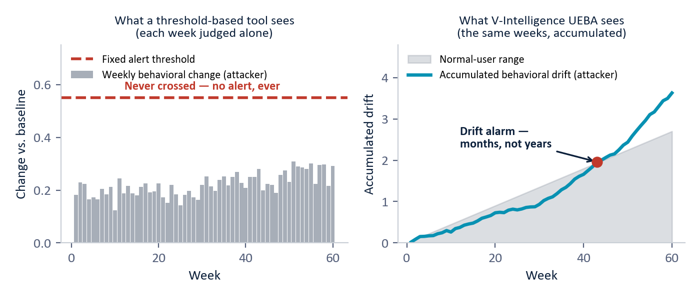
Figure 1 — The "slow and low" evasion. Left: a threshold-based tool judges each week alone, and the attacker's weekly change never crosses the fixed alert line — no alert is ever raised. Right: the same weeks accumulated as behavioral drift separate the attacker from the normal-user range in months, not years. (Illustrative, based on the simulated 60-week slow-APT campaign.)
The real-world consequence is documented: neither Volt Typhoon nor Salt Typhoon was detected by any victim organization's own monitoring — SIEM, intrusion detection, and endpoint tools all failed, because there was no signature to match and no threshold crossed. Both were found by external intelligence operations, years or months after compromise. That structural gap — not a tuning problem — is what behavioral analytics addresses.
3. What Is UEBA — and What Is Different Here
User and Entity Behavior Analytics (UEBA) inverts the traditional question. Instead of defining what is malicious and watching for it, UEBA learns what is normal — for every user, device, application, and network segment individually — and flags departures from that personal baseline. Three principles define it:
Principle | Question asked | Traditional answer | UEBA answer
Baseline | What is normal? | One statistical threshold for everyone. | A personal behavioral profile per entity — each has its own "normal."
Deviation | Has something changed? | A measurement exceeded a fixed limit. | The entity's behavioral trajectory is drifting from its own baseline.
Direction | What kind of change? | Not considered — magnitude only. | Which behavioral dimension is drifting, and toward what known threat pattern.

The third principle is the one that matters. A user whose file activity rises 50% might be on a deadline (benign) or staging data for theft (critical) — a magnitude-only tool flags both identically, or neither. The discriminating signal is the direction of change: toward restricted data, toward unusual hours, toward known adversary behavior. Direction is what turns an anomaly score into an investigation lead.
4. The V-Intelligence Approach: A Living Chart for Every Entity
4.1 The digital entity — a patient's medical chart for behavior
The central concept in plain terms: V-Intelligence maintains a "digital entity" — a living behavioral profile — for every monitored user and system. Think of a patient's medical chart. It does not just record today's temperature; it accumulates history, vitals, and context, and a doctor reads the trend to act before a condition becomes acute. The digital entity is that chart for behavior: not just "how many files were opened," but the full picture — and, critically, how that picture is changing week over week.
Each week, raw log activity from five sources (sign-ins, file access, endpoint activity, network traffic, and domain lookups) is distilled into 23 behavioral measurements per user. Those measurements are organized into five behavioral zones — five distinct dimensions of who the entity is and what it does:
Behavioral zone | What it captures | What it catches when it drifts
Identity | Who the entity is — role, department, clearance, tenure. | Stability here is itself a clue: insiders and credential thieves look like the same person.
Access pattern | How the entity signs in — frequency, failures, timing, sources. | Credential abuse and account takeover.
Data behavior | What data it touches — volume, sensitivity mix, read/write balance. | Insider data theft: a shift toward restricted and confidential material.
Network footprint | Where it communicates — destinations, external traffic, domain lookups. | Covert call-home channels and data removal routes.
Risk posture | Endpoint health — suspicious process activity and risk indicators. | Compromised machines and privilege-escalation tooling.

Zone decomposition is the architectural breakthrough. When the identity zone is stable but the data-behavior zone is drifting, the system can conclude: same person, same credentials — but accessing different data than before. That sentence is the insider-threat signature, and no single composite score can express it.
4.2 Semantic embeddings — a map of meaning
How does software compare "behaviors"? V-Intelligence borrows the core representation of large language models. Each week's measurements are first written out as a structured plain-language description — not just "30 files" but "30 files, 15% restricted, 8% confidential" — and that description is converted into a high-dimensional numerical vector called an embedding. The result is a semantic space: a map of meaning, where behaviors that mean similar things sit near each other, even when their raw numbers differ.
This matters because of a specific failure of raw numbers. The simulated insider accessed about 30 files per week before and during the campaign — on raw counts, nothing changed. But week one was public files and week forty was restricted files. On the map of meaning, those two weeks sit far apart. In validation, cumulative drift was measured both ways: on raw numbers, all four attackers stayed buried in the crowd of 246 normal users — ranked between #90 and #133, indistinguishable. On semantic embeddings, three of the four climbed clear of the crowd — the insider to #1, above every normal user. The fourth, the slow APT, stays buried even in drift space; it is caught by the novelty question (Section 5.3) — the empirical reason no single signal is enough and the scoring is composite.
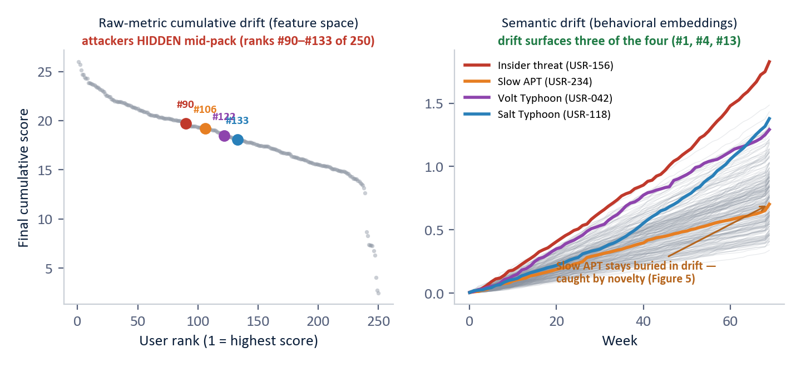
Figure 2 — All 250 users, both representations (measured, synthetic data). Left: each user's final cumulative-drift score on the 23 raw metrics, sorted — the four attackers (colored) land mid-pack at ranks #90–#133, indistinguishable from normal users. Right: cumulative drift in semantic embedding space over the full 70 weeks — the insider rises to #1 (above every normal user), Salt Typhoon to #4, Volt Typhoon to #13. The slow APT stays buried in drift and is caught by novelty persistence instead (Figure 5).
4.3 Drift, direction, and naming the threat
Tracking each entity's weekly position on the map produces a trajectory, and the trajectory yields drift — the direction behavior is trending, plus how fast and how consistently. A cumulative change-detection technique (the same family used to catch slow degradation in industrial quality control) accumulates small weekly shifts until they become statistically undeniable — this is what catches "slow and low." The exact accumulation logic, thresholds, and parameters are proprietary and withheld in this edition.
Direction is then named. The system maintains a library of reference threat concepts — plain-language descriptions of known adversary behaviors, themselves embedded into the same map — aligned with MITRE ATT&CK, the industry-standard public catalog of adversary tactics and techniques. When an entity's drift points toward "data staging for exfiltration" or "covert beaconing," the alert says so, with the matching ATT&CK techniques attached. Each simulated campaign was built from, and is reported against, real documented technique sets.
Each attack family writes a recognizably different signature on the chart:
Threat | Behavioral signature | Real-world parallel
Insider threat | Identity zone stable; data-behavior zone drifting steadily for months. | Snowden, Manning; departing-employee IP theft.
Slow APT (covert C2) | Identity stable; network-footprint zone drifting — new recurring external contacts. | SolarWinds/SUNBURST: 9 months undetected, 18,000+ organizations.
Living off the land | A regime shift — all five zones step to a new operating mode at once. | Volt Typhoon: 5+ years undetected in U.S. critical infrastructure.
Telecom infrastructure | Persistent multi-zone drift — network and data zones moving together for 100+ days. | Salt Typhoon: at least 9 U.S. telecom providers compromised.

4.4 Multi-phase composite scoring — five questions, one ranked list
No single signal catches all four families — each attack evades a different detector. The production answer is composite scoring: five independent behavioral questions are asked of every user, and the answers fuse into a single ranked risk score. A normal user may score high on one question by chance; an attacker scores high on several at once. The questions (exact scoring logic withheld):
Phase | The question it asks
Signal strength | How extreme are this user's strongest deviations, compared with peers in the same role?
Breadth | How many different behavioral measurements are elevated at once — one noisy metric, or a pattern?
Sustained deviation | Does the anomaly persist week after week, or was it a one-off event?
Context divergence | Does the user look anomalous when viewed through attack-specific lenses (insider lens, APT-hunt lens, privilege-audit lens)?
Novelty persistence | Has a never-before-seen behavior — a new external contact point, a new domain — appeared and kept recurring?

Each phase alone is insufficient; combined, they create a detection surface no single evasion defeats. An attacker who suppresses magnitude still registers on breadth; one who stays narrow still registers on persistence or novelty. The SOC (Security Operations Center — the analyst team) receives one ranked list, not thousands of raw alerts.
5. What the Evidence Shows (Synthetic Data)
5.1 The honest scoreboard first
Four industry-standard anomaly-detection algorithms — Z-Score statistics, Isolation Forest, Local Outlier Factor, and One-Class SVM (Support Vector Machine) — were run against the full 250-user population alongside composite scoring. We report the result without spin — every number below is reproduced directly from the evaluation data.
Method | Attacks detected | False-positive rate | What the analyst gets
Local Outlier Factor | 0 of 4 | 4.5% | Low false positives — and zero detections. All four campaigns sit inside its normal range.
Z-Score | 1 of 4 | 9.8% | Catches only the Volt Typhoon spike (z = 3.04, barely over the 3.0 line). The other three never cross it — Salt Typhoon peaks at z = 1.71.
Isolation Forest | 0 of 4 | 5.3% | All four attackers look statistically normal in feature space.
One-Class SVM | 0 of 4 | 14.6% | 36 false positives and zero true detections.
V-Intelligence Composite | 4 of 4 | 8.1% | All four detected, each with zone-level explanation: which dimension drifted, toward what threat.

The value claim, stated precisely: the best traditional method catches 1 of 4 campaigns — and its one catch is a single-feature spike with no explanation attached. The composite catches all four at a comparable false-positive rate, and tells the analyst which behavioral zone changed and toward what threat pattern — which is what triage actually consumes. The product is not just a better alarm; it is a better lead.
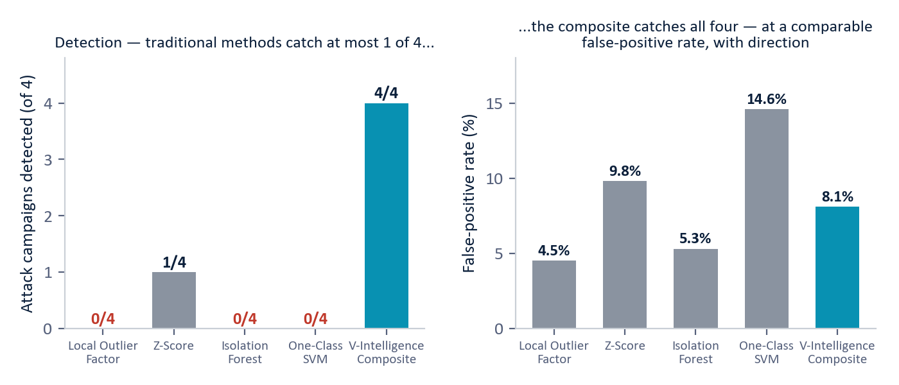
Figure 3 — The detection scoreboard across 250 users with four embedded attack campaigns (measured, synthetic data; verified against the evaluation dataset). Traditional methods catch at most 1 of 4; composite scoring catches 4 of 4 at 8.1% false positives, each detection explained.
5.2 Four attacks, four different fingerprints
Each campaign was caught by a different combination of the five phases — the empirical proof that no single method would have sufficed:
- Salt Typhoon telecom (rank #1): the strongest overall anomaly, ranked #1 of 250 (score 51.3). The attack touches sign-in, network, and domain-lookup behavior simultaneously — 18 measurements elevated at once.
- Insider threat (rank #2): ranked #2 (score 46.2), caught by sustained deviation and breadth: a 14-month drift from public toward restricted files while total volume stayed flat — the textbook "same credentials, different data" signature.
- Slow APT (rank #7): ranked #7 (score 19.4) — the case that justifies the architecture, detailed below.
- Volt Typhoon living-off-the-land (rank #24): ranked #24 of 250 (score 13.7) — a deliberately quiet campaign using only legitimate admin tools, still inside the top 10% and above the detection threshold via breadth plus signal strength.
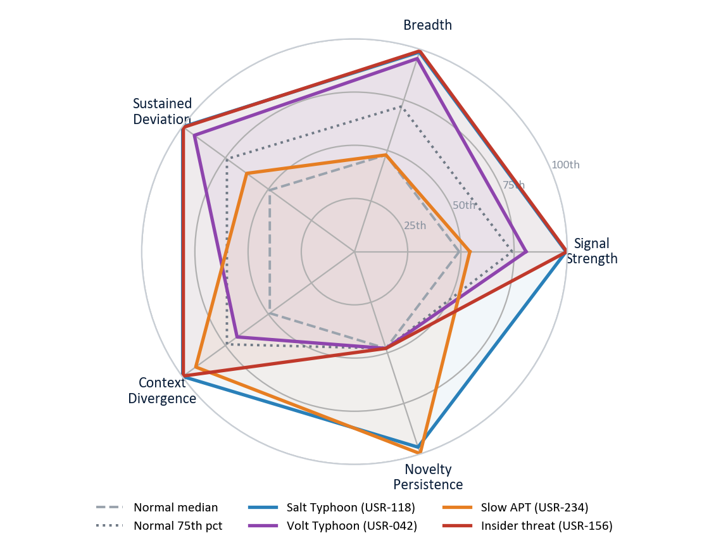
Figure 4 — The drift projected onto the five scoring dimensions, as percentiles across the 250-user population (measured, synthetic data). Normal users cluster near the center (grey dashed = median, dotted = 75th percentile). Each attacker breaks out on a different combination — the insider on signal strength and breadth, the slow APT on novelty persistence, Salt Typhoon on nearly every dimension at once. No normal user reaches these extremes on several dimensions simultaneously.
5.3 Case study: the attack that was "undetectable"
The slow APT (user USR-234) is the hardest detection problem in the study. For 417 days, its implant called home roughly every 12 hours; total traffic, lookups, and sign-ins all stayed within normal ranges. On every magnitude-based phase its scores are negligible. Without the novelty question, its composite score would be 6.4 — rank roughly #105 of 250, far below any sane threshold. Undetectable.
Novelty persistence asks a different question: has something never seen before kept coming back? One external address that never appeared in the user's baseline now appeared in every one of the 60 post-baseline weeks — 100% persistence. Normal users contact new addresses occasionally, but those contacts are transient. A new contact that recurs every week for over a year is the behavioral fingerprint of command-and-control infrastructure. That single signal contributes 13.0 points — the largest phase contribution of any attacker — lifting USR-234 from rank ~#105 to rank #7, firmly inside the detected set.
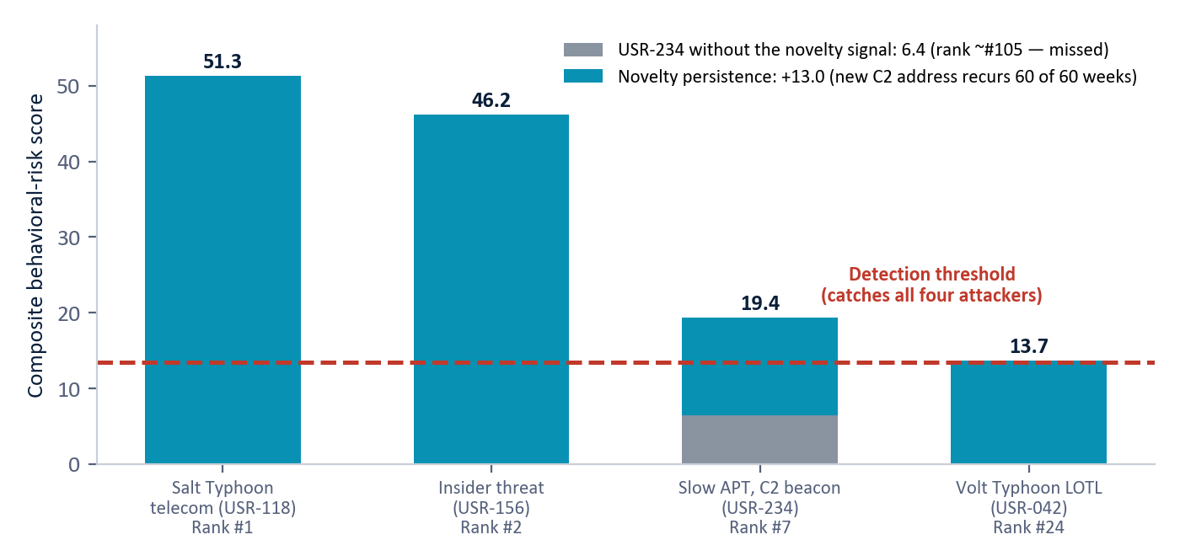
Figure 5 — Composite scores of the four attack users against the detection threshold (measured, synthetic data). The slow APT (USR-234) splits into its parts: without the novelty signal it scores 6.4 and is missed; the recurring never-before-seen contact adds 13.0 points and detects it.
5.4 False positives, treated as a budget
At the operating point that catches all four attackers, 20 of 246 normal users (8.1%) are flagged alongside them. Operationally these are not noise: they are a prioritized queue of the highest-behavioral-risk normal users, each explained by the phases that drove its score. The threshold is tunable — a stricter cut trades detection margin for fewer flags. And the simulated real-world parallels held: the two campaigns that no real victim organization ever self-detected (Volt Typhoon, Salt Typhoon) were both detected here, at ranks #24 and #1.
5.5 Were the attackers actually hard to find?
A detection result is only as strong as the difficulty of the problem it solved. Before trusting the scoreboard above, the fair question is whether the simulated attackers were genuinely evasive — or merely obvious. Three measured checks confirm they were hard to find. The hardest case, the slow APT (USR-234), is used throughout.
Statistical twins. Averaged across all weeks, the slow APT is indistinguishable from an ordinary user — and on two measures it is actually quieter:
Weekly measure | Slow APT | Normal user | Verdict
File accesses | 70.9 | 68.7 | ~ identical
Restricted-file ratio | 0.046 | 0.060 | attacker LOWER
Network bytes sent | 782M | 711M | within variance
Failed-DNS ratio | 0.039 | 0.044 | attacker LOWER
A whisper in a stadium. In the raw logs, the attacker's command-and-control beacon moves 120-487 bytes across a whole day - roughly 380,000 times smaller than the single largest ordinary network flow on the same day (184 MB). No volume threshold can isolate the whisper without drowning in normal traffic.
Ordinary among peers. Measured against its 62 role peers (the developer cohort), the attacker sits inside the normal middle-50% range on file access, restricted-file ratio, and network volume. By volume, it is an unremarkable developer. Only the direction of its behavior over time - and the recurrence of one novel address in 60 of 60 weeks - sets it apart.
5.6 How invisible weekly changes add up
If the attacker never spikes, how is it caught? By accumulation. Each week the system measures how far behavior moved, subtracts a small allowance for normal week-to-week wobble (measured at 0.0138 on this data), and adds the remainder to a running total that resets to zero whenever a week looks normal. A sustained attacker drifts a little further in the same direction every week, so the total climbs and never resets; a normal user's keeps resetting. This running total is called CUSUM - the mathematical answer to 'slow and low.'
Entity | Type | Cumulative drift | vs. normal user
USR-156 | Insider threat | 0.779 | 29x
USR-042 | Volt Typhoon (LOTL) | 0.474 | 18x
USR-234 | Slow APT (C2 beacon) | 0.162 | 6x
USR-118 | Salt Typhoon (telecom) | 0.131 | 5x
USR-001 | Normal user | 0.026 | baseline
Every attacker accumulates between 5 and 29 times the normal user's drift - even though, in any single week, none of them crossed an alarm threshold. Accumulation converts many invisible weekly changes into one unmistakable signal. (Every figure in 5.5-5.6 is reproducible live in the platform's interactive 'Proof of Realism' view, which lets a reviewer pick any two users and watch volume statistics overlap while cumulative-drift curves diverge.)
6. Deployment in Practice
V-Intelligence UEBA is designed to complement, not replace, the existing security stack. The recommended operating model is three layers: the existing fast magnitude-based tools as a familiar pre-filter; composite scoring as the primary detection engine producing the ranked list; and an investigation-context layer that enriches each lead with drift direction, MITRE ATT&CK technique mapping, and attack-chain correlation.
- Data requirements. Five standard log sources most enterprises already collect — sign-ins, file access, endpoint telemetry, network flow, and domain lookups — plus data-sensitivity labels. No new sensors.
- Timeline. A phased rollout: 4–6 weeks of baseline building, 2–4 weeks of detection tuning (target: false positives under 10%), 2–4 weeks of red-team validation, then production.
- Footprint. Containerized, standard infrastructure, no specialized hardware; suitable for enterprise data centers, cloud, or disconnected secure environments. Behavioral profiles are computed incrementally, so ongoing cost after the initial baseline is small.
- Integration. Alerts feed existing SIEM/SOAR (Security Orchestration, Automation and Response) workflows with behavioral context attached; behavioral risk scores can feed Zero Trust continuous-verification policies — the federal architecture mandate that no user or device is trusted by default.
- Scale. Validation used 250 users; larger populations improve, not degrade, the statistics, because peer baselines get richer.
7. Why This Is New
Commercial UEBA products exist, and the better ones do per-entity baselining with statistical or machine-learning anomaly scores. What they produce is magnitude: a number that says "different," not a direction that says "different in the way an insider exfiltration looks." The individual ingredients used here — serializing structured data to text for embedding, anomaly detection in embedding space, cumulative change-detection, novelty tracking — each exist separately in the literature.
What is not offered, commercially or in any single published system we have found, is the composition: every entity maintained as a digital behavioral profile in one shared semantic space; the profile decomposed into five behavioral zones so the system can say which dimension of behavior moved; drift measured cumulatively so "slow and low" accumulates into a signal; the direction named against an embedded library of threat concepts mapped to MITRE ATT&CK; and five independent detection phases fused into one ranked, explained list. The innovation is the integrated architecture, not any single technique.
Scoping notes: vendor internals are not fully public (the comparison is against marketed capability), and a formal freedom-to-operate review is recommended before any contractual assertion of uniqueness.
8. Limitations — Stated Plainly
- All results are from synthetic telemetry. The attack campaigns are carefully calibrated to public CISA (Cybersecurity and Infrastructure Security Agency) advisories, but real enterprise behavior is messier; every figure must be re-measured on real data.
- The detection threshold reported here is the operating point that catches all four attackers; it was chosen with knowledge of the answers. In production the threshold must be set blind and tuned per environment.
- An 8.1% false-positive rate means 20 flagged normal users per 250; acceptable as a ranked triage queue, but it is a real analyst cost — and it is not an auto-blocking threshold.
- Baselines need 4–6 weeks of history before detection is meaningful, and legitimate behavioral shifts — role changes, project transitions — are the main source of false flags.
- Data-sensitivity labels on file activity materially strengthen the insider signature; environments without classification metadata lose part of that signal.
- Semantic embeddings rely on an embedding model; fully disconnected deployments require a locally hosted replacement, which must be re-validated.
9. Conclusion
The threats that matter most — insiders, nation-state intrusions, living-off-the-land campaigns, and infrastructure compromises — share one property: they operate inside authorized access, beneath every signature and threshold, and reveal themselves only as a gradual change of behavioral direction over months. The documented record is unambiguous: the victims of Volt Typhoon and Salt Typhoon did not detect them; outside agencies did, years and months late.
V-Intelligence UEBA gives every user and system a living behavioral chart, reads it in a map of meaning rather than raw numbers, accumulates slow drift until it is undeniable, names the direction against known adversary behavior, and fuses five independent behavioral questions into one ranked, explained list. On a 250-user, 485-day validation with four embedded campaigns, it detected 4 of 4 — where the best traditional method caught 1 of 4 — at an 8.1% false-positive rate, with every detection explained.
The insider changes WHAT they access, not HOW MUCH. The APT changes WHERE it communicates, not HOW OFTEN. Traditional tools measure magnitude; V-Intelligence UEBA measures direction — and direction is where these attacks live.
Appendix — Glossary
Term | Meaning
UEBA | User and Entity Behavior Analytics — detecting threats by learning each entity's normal behavior and flagging departures, rather than matching known-bad patterns.
Digital entity | A living software profile of a user or system — like a patient's medical chart for behavior: history, vitals, context, and trend, updated weekly.
Semantic space / embedding | A numerical "map of meaning" produced by the same representation that powers large language models; behaviors that mean similar things sit near each other.
Behavioral zone | One of five dimensions of an entity's profile: identity, access pattern, data behavior, network footprint, risk posture.
Drift | The movement of an entity's behavioral profile over time — how fast, how consistently, and in which direction it is trending.
SIEM | Security Information and Event Management — the central log-collection and rule-correlation platform of enterprise security.
SOC | Security Operations Center — the analyst team that monitors alerts and investigates incidents.
SOAR | Security Orchestration, Automation and Response — tooling that automates incident-response workflows.
IOC | Indicator of Compromise — a known-bad artifact (file fingerprint, address, domain) used by signature-based tools.
APT | Advanced Persistent Threat — a patient, well-resourced (typically nation-state) intrusion that remains hidden for months or years.
C2 (command and control) | The covert channel through which an implanted attacker tool "calls home" for instructions and ships out data.
LOTL | Living off the land — attacking with only the legitimate administration tools already present on target systems; nothing to fingerprint.
MITRE ATT&CK | The industry-standard public catalog of adversary tactics and techniques, used as a common language for describing attacker behavior.
CISA | Cybersecurity and Infrastructure Security Agency — the U.S. government agency that publishes authoritative threat advisories.
Composite scoring | Fusing five independent behavioral questions (signal strength, breadth, persistence, context divergence, novelty) into one ranked risk score per user.
Novelty persistence | A never-before-seen behavior (e.g., a new external contact) that keeps recurring week after week — the fingerprint of covert C2 infrastructure.
False-positive rate | The share of normal users incorrectly flagged; here 8.1% = 20 of 246 normal users at the chosen threshold.
Z-Score / Isolation Forest / Local Outlier Factor / One-Class SVM | The four industry-standard statistical and machine-learning anomaly detectors used as the traditional comparison baseline in this study.
Zero Trust | The federal security architecture mandate that no user or device is trusted by default; every access is continuously verified.
Synthetic data | Simulated telemetry built to prove the concept — here calibrated against public CISA advisories — before access to real operational data.

Business Edition — architecture-level disclosure. Exact detection logic, formulas, thresholds, weights, and parameters are proprietary and available in the full technical edition under NDA. All results are synthetic and must be re-validated on real operational telemetry. Do not redistribute.

