V-INTELLIGENCE UEBA · TECHNICAL PAPER
Traditional Anomaly Detection
vs. V-Intelligence UEBA
Why Detection Without Direction Fails the Analyst — and How a Behavioral Digital Twin Provides Actionable Intelligence

22nd Century Technologies, Inc.
V-Intelligence UEBA Program
June 2026 — Technical Paper, Version 1.0

DISTRIBUTION: Conceptual Overview — Cleared for General Distribution

1. Executive Summary
The most damaging insiders and intrusions are engineered to stay within normal ranges on every individual metric — so traditional, magnitude-based anomaly detection largely misses them. An insider shifts from public to restricted content — a change in kind that stays inside normal per-metric ranges. A slow APT beacons a few times a day for months. No single metric breaks, so threshold and outlier detectors rank these users among ordinary ones — on this benchmark they catch at most 1 of the 4 campaigns. And on the rare occasion one does fire, the alert says only 'outlier' — it never says which behavioral zone changed, in what direction, or toward what threat pattern, so the analyst still faces manual triage.
The core idea, in one sentence:
build a digital twin of every entity. For each user — and equally each device, application, network segment, and session — the system maintains a living digital twin: a rich profile of how it behaves across distinct behavioral zones, how it relates to other entities, and how both change week over week. Because the twin captures the MEANING of behavior (not just raw metrics) and is tracked as a trajectory through time, advanced algorithms run directly on it — drift direction, peer-cohort comparison, relationship analysis, change-point detection, and multi-phase fusion. Anomaly detection becomes a question asked of the twin: not 'did a number spike,' but 'what is this entity becoming?'
Every entity — user, device, application, network segment, session — gets a living digital twin that captures its behavior, relationships, and change over time. Detection is simply what we ask of the twin.
V-Intelligence brings the representational power of large language models — the rich semantic space a transformer learns — into the security application layer, and couples it with rigorous vector mathematics: drift geometry, cohort statistics, and change-point detection. Where an LLM uses that space to understand language, we use it to understand behavior.
This paper documents, step by step, three generations of detection benchmarked on a single synthetic enterprise — Traditional (Tier 1), an intermediate embedding-drift approach (Tier 2), and V-Intelligence UEBA's digital-entity approach (Tier 3) — and shows why only the last provides the actionable directional intelligence that turns a detection into an investigation.
The most damaging threats hide inside normal ranges, so traditional analytics largely miss them — and even when one fires, it says only 'anomalous.' V-Intelligence UEBA both surfaces these campaigns AND tells the analyst what the entity is becoming — which zone changed, in what direction, toward which MITRE ATT&CK pattern. That is the difference between a missed threat and an actionable investigation.
Headline result (synthetic validation):
- Tier 1: On this benchmark, traditional detectors mostly MISS the stealthy campaigns — LOF 0 of 4 at 4.5% FP, Z-Score 1 of 4 at 9.8% FP, Isolation Forest 0 of 4 at 5.3% FP, OCSVM 0 of 4 at 14.6% FP — and even when one fires it gives no directional intelligence: it says 'anomalous' without telling the analyst WHICH behavioral zone changed or TOWARD WHAT threat pattern.
- Tier 2: Embedding-drift with direction begins to surface the slow insider and APT that magnitude cannot see.
- Tier 3 (V-Intelligence UEBA): The digital-entity multi-phase composite ranks all 4 of 4 campaigns in the top tier of 250 entities — a false-positive rate of 8.1% (20 of 246 normal users at the recall-at-100% operating point).
Why this matters: the two China-state campaigns modeled here are real-world nightmares — Volt Typhoon dwelled in U.S. critical infrastructure UNDETECTED for at least five years (CISA AA24-038A), and Salt Typhoon compromised U.S. telecommunications infrastructure (U.S. Government joint reporting, 2024–2025). V-Intelligence surfaces BOTH — indeed all four embedded campaigns — at the 8.1% operating point, where every traditional, magnitude-based detector ranks them among ordinary users. Catching threats that stayed invisible for years is the capability gap this approach closes.
All results in this paper are from synthetic telemetry and are labeled as such; they establish the concept and must be re-validated on production data.

2. Problem Statement
User and Entity Behavior Analytics (UEBA) exists to answer one question: which users or entities are behaving in a way that signals compromise or malice? The hard cases share a defining property — they operate within authorized activity and within normal statistical ranges:
- The insider: uses valid credentials and accesses the same volume of files, but shifts toward restricted/confidential content and off-hours activity.
- The slow APT: beacons a few times a day to new infrastructure for months; no single day exceeds any threshold.
- Living-off-the-land: uses native, signed tools (certutil, wmic, PowerShell) so nothing looks like malware — the Volt Typhoon pattern.
- Infrastructure pivot: pivots quietly across network segments inside infrastructure — the Salt Typhoon pattern.
The defensive question is therefore not 'did a metric exceed a limit?' but 'what is this entity becoming, and is that direction dangerous?' This paper shows that the first question cannot be made to answer the second by better tuning — it requires a different representation of behavior.

3. The Traditional Approach (Tier 1)
The traditional pipeline reduces each entity to a fixed-length numeric feature vector and applies statistical or unsupervised-ML outlier detection. It is fast, mature, and well understood — and it is the baseline V-Intelligence UEBA is measured against.

3.4 Algorithms
Five families of detector operate on the numeric feature vectors:
- Isolation Forest: isolates anomalies via random partitioning depth.
- One-Class SVM: learns a boundary around 'normal' in feature space.
- Local Outlier Factor: flags points in low-density neighborhoods.
- Z-Score: flags features beyond a fixed standard-deviation threshold from baseline.
- Feature-CUSUM: accumulates per-week feature drift — the only traditional method designed to catch slow cumulative drift, yet at a top-decile cutoff it still misses all four campaigns.

3.5 Results
On this benchmark, traditional detectors largely MISS the campaigns — LOF catches 0 of 4 at 4.5% FP, Z-Score 1 of 4 at 9.8% FP, Isolation Forest 0 of 4 at 5.3% FP, and OCSVM 0 of 4 at 14.6% FP. Because the campaigns are engineered to stay within per-feature norms, magnitude-based detectors rank them among ordinary users. And even when one does fire, the alert says only 'anomalous' — it does not tell the analyst WHICH behavioral zone changed or TOWARD WHAT threat pattern, so every flagged user requires the same manual triage whether they are a genuine insider or a developer who simply had a busy week.
Method | Campaigns detected | FP rate | Directional intelligence
LOF | 0 of 4 | 4.5% | None — says 'anomalous' only
Z-Score | 1 of 4 | 9.8% | None — says 'anomalous' only
Isolation Forest | 0 of 4 | 5.3% | None — says 'anomalous' only
OCSVM | 0 of 4 | 14.6% | None — says 'anomalous' only
Feature-CUSUM (top-decile) | 0 of 4 | 10.2% | Temporal trend only
V-Intelligence Composite | 4 of 4 | 8.1% | Zone + direction + MITRE concept

3.6 Two Gaps: Detection and Intelligence
The results above expose two gaps. The DETECTION gap: magnitude-based methods miss most of these campaigns (at most 1 of 4) because no single metric leaves its normal range. The INTELLIGENCE gap: even when a detector does fire, it cannot say what the anomaly means. Both trace to the same structural limitations:
- No directional intelligence: the detector says 'anomalous' but never in what direction — a shift from public to restricted files at constant count looks identical to a developer who ran extra builds. The analyst must manually investigate every alert.
- No threat-concept alignment: there is no mapping to threat taxonomy — the alert cannot say 'drifting toward data-exfiltration pattern' or name a MITRE ATT&CK technique.
- No zone localization: the alert is one undifferentiated score; there is no decomposition into which behavioral zone changed (access, data, network, risk).
- Feature independence: each feature is an independent axis, so 'off-hours + restricted files + high clearance' is never read as one combined pattern.
- Scale dominance: high-variance features (bytes transferred) numerically swamp the low-variance ratios that actually carry the insider signal.

4. The V-Intelligence UEBA Solution

4.1 Core Idea — the Living Digital Twin
V-Intelligence UEBA represents every entity — user, device, application, network segment, session — as a living digital twin: its behavior is serialized into language, embedded into a shared semantic space, decomposed into independent behavioral zones, and tracked as a trajectory across three dimensions — temporal (how it drifts over time), relational (how it interacts with other entities), and network (its position in the ecosystem). Detection asks what the entity is becoming, and names the direction in the vocabulary of MITRE ATT&CK.
The twin is not a record; it is a moving point in meaning-space. We watch where it is heading, how fast, in which behavioral zone, and toward which threat concept.
A concrete example makes the idea tangible. Consider the insider across two weeks. The numbers a threshold tool watches barely move — the file count is identical — yet the behavior means something completely different. Crucially, the platform does not embed raw decimals; it serializes each metric INTERPRETIVELY — relative to the population (z-score), the entity's own baseline (ratio), and its recent trend — and embeds that analyst-style prose:
Week 1 -> "Analyst USR-156 in Finance: data-access behavior within normal
parameters. Restricted-file ratio 0.012, unremarkable."
Week 2 -> "ELEVATED data-access anomaly for Analyst USR-156 in Finance.
Restricted-file ratio 0.150 — high percentile, ~12x the employee's
own baseline, trend: rising. Shift from public toward
restricted/confidential material."
Feature-distance verdict : ~0 (same file count -> 'nothing changed')
Embedding-direction verdict : large semantic shift toward the
data-exfiltration / insider region of meaning-space
The file count is identical, so a numeric detector sees nothing. Read as language, the two weeks describe a different operator, and the digital twin moves toward the data-exfiltration region of meaning-space. The insider changed WHAT they accessed, not HOW MUCH: invisible to magnitude, visible to semantics. (The interpretive serialization encodes analyst context by design — a choice whose benefits and caveats are discussed in Section 10, Limitations.)
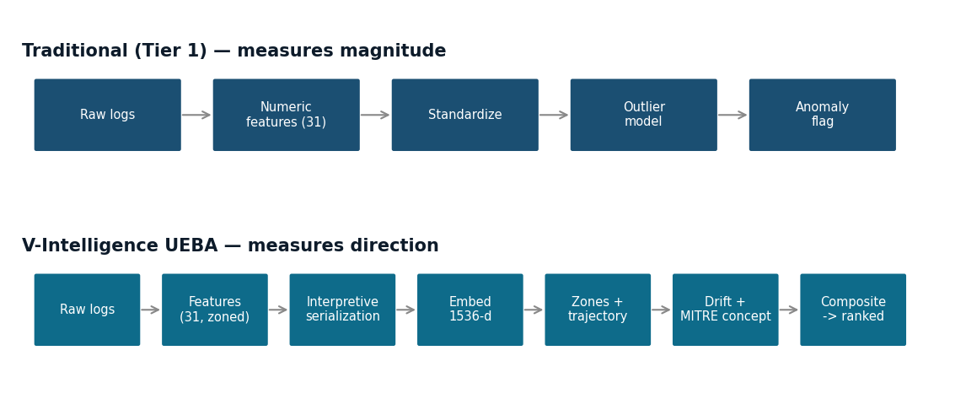
Figure 1 — The two pipelines. Traditional reduces behavior to numeric distance; V-Intelligence serializes behavior to interpretive language, embeds it, and measures directional drift toward MITRE-mapped threat concepts.

4.5 Algorithms — Intermediate (Tier 2) then Latest (Tier 3)
The solution evolved through two generations, mirrored in the platform's own detection-comparison view.
Tier 2 — intermediate (embedding drift + direction).
Each entity's per-period behavior is embedded and composed into a single vector. Drift magnitude is the cosine distance between consecutive vectors; drift direction is the unit difference vector, projected onto the reference-concept library to name what the entity is becoming and map it to MITRE. A CUSUM accumulates slow drift the per-period view misses.
Why this was not enough. Tier 2 collapses the whole entity into one vector, so a signal confined to a single zone — the hallmark of a real intrusion — is averaged against four stable zones and diluted. That dilution is what motivates the zone decomposition of Tier 3.
Tier 3 — latest (digital entity / V-Intelligence).
The entity becomes a full digital twin. The four dynamic zones are composed with context-adaptive attention (linearly-normalized weights); a rolling window yields velocity, acceleration, regime shifts, and trend consistency; zone-divergence catches 'identity stable but network footprint drifting' (a C2 signature); relationship embeddings (Hadamard product of two entity vectors) catch interaction change; and a multi-phase composite fuses five independent phases into one ranked, evasion-resistant verdict.
- Signal strength: peak deviation vs the peer cohort.
- Breadth: how many features are simultaneously elevated.
- Sustained: persistence of deviation across the late window.
- Context: divergence across investigation contexts.
- Novelty persistence: recurring contact with never-before-seen infrastructure (the slow-APT tell).
From score to action.
The pipeline closes the loop two ways. The multi-phase composite produces one number per entity, so the entire population is returned as a single risk-ranked list — analysts work top-down instead of triaging a flood of independent alerts. In parallel, change-points from the drift and trajectory analysis are written as discrete events, each tagged with its aligned reference concept and MITRE ATT&CK techniques, severity, and the contributing zones — an auditable record of why the entity was flagged and what it appears to be becoming.

5. Results: The Three-Tier Comparison (Synthetic)
All three generations were benchmarked on one synthetic enterprise — 250 users over 485 days (~14 million events across seven log sources) with four embedded, long-duration campaigns: a 14-month insider, a 417-day slow APT with C2 beaconing, a 412-day Volt Typhoon living-off-the-land campaign, and a 412-day Salt Typhoon infrastructure pivot.
Validation methodology. Embeddings were real (OpenAI text-embedding-3-small). The false-positive rate is reported at a defined operating point: the score threshold that recalls all four campaigns. At that point, the false-positive rate is the fraction of the 246 normal entities that rank at or above the lowest-ranked campaign. This is a recall-at-100% operating point on four positives — a demonstration, not a statistically powered evaluation (see Section 10).
Tier | Representative method | Detection | Directional intelligence
1 — Traditional | LOF | 0 of 4 (4.5% FP) | None — 'anomalous' only
1 — Traditional | Z-Score | 1 of 4 (9.8% FP) | None — 'anomalous' only
1 — Traditional | Isolation Forest | 0 of 4 (5.3% FP) | None — 'anomalous' only
1 — Traditional | OCSVM | 0 of 4 (14.6% FP) | None — 'anomalous' only
1 — Traditional | Feature-CUSUM (top-decile) | 0 of 4 (10.2% FP) | Temporal trend only
2 — Intermediate | Embedding drift + direction | surfaces insider + APT | Direction visible, no zone decomposition
3 — V-Intelligence | Multi-phase composite | 4 of 4 (8.1% FP) | Zone + direction + MITRE concept

Per-campaign breakdown — Tier 3 multi-phase composite:
Entity | Campaign | Rank | Composite | Primary detector
USR-118 | Salt Typhoon (telecom infrastructure) | #1 of 250 | 51.3 | Composite drift + breadth
USR-156 | Insider Threat (14-month escalation) | #2 of 250 | 46.2 | Composite drift + breadth
USR-234 | Slow APT (417-day C2 beaconing) | #7 of 250 | 19.4 | Novelty persistence
USR-042 | Volt Typhoon (living-off-the-land) | #24 of 250 | 13.7 | Composite drift + breadth

All 4 campaigns surface in the top tier at a false-positive rate of 8.1% (20 of 246 normal users at the recall-at-100% operating point) WITH actionable directional intelligence — which zone changed, toward what threat pattern, mapped to MITRE ATT&CK. Traditional methods miss most of these campaigns, and even when they flag one they provide none of this directional context.
An important nuance — fusion is the point. Taken individually, the Tier-3 detectors (velocity, regime, zone-divergence, contextual, relationship) are each noisy; a combined, unfused Tier-3 detection flags roughly 19% of normal entities. The low-false-positive result above belongs to the multi-phase COMPOSITE used as a ranker, not to any single detector. Fusing independent, individually-noisy phases into one ranked score is precisely what converts many weak signals into a precise verdict — and it is the core of the Tier-3 innovation.

5.1 Case Study — the Slow APT Magnitude Cannot See
USR-234 (Slow APT (417-day C2 beaconing)) has among the lowest raw signal strength of any entity — two to three beacons a day. Magnitude ranks it unremarkable. V-Intelligence UEBA still ranks it #7 of 250, driven by novelty persistence: the same never-before-seen infrastructure recurring week after week — the axis no threshold tool measures.

5.2 Exactly How an Anomaly Is Detected
This subsection walks an entity through the pipeline the way the product's detection-comparison view does, with the actual data at each stage. Detection is not a single test; it is four stages, and the figures show what each one adds.
Stage 1 — drift over time (does the entity separate from the crowd?).
Each week, the entity's serialized behavior is embedded and compared to the prior week; the drift accumulates. Traditional feature-space CUSUM buries the attacker inside the normal band — the attacker line is one of the crowd. Semantic drift lifts the insider out of the band as its campaign matures. Note the detail in Figure 2: the slow APT (USR-234) still rides within the band on raw drift alone — which is precisely why drift is necessary but not sufficient, and why later stages matter.
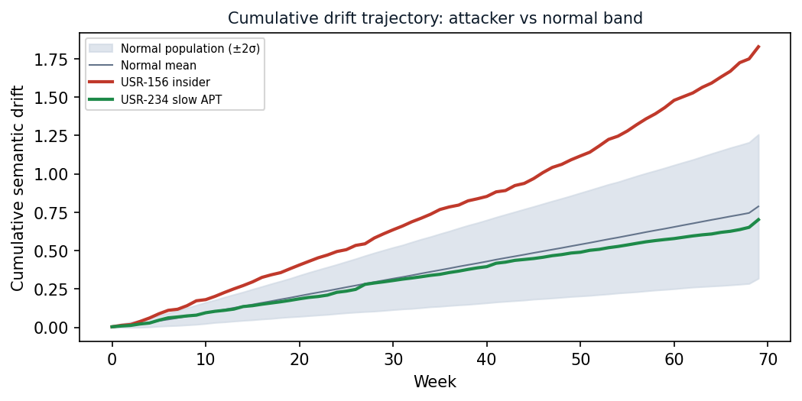
Figure 2 — Semantic drift over time vs the normal ±2σ band. The insider (USR-156) separates as it matures; the slow APT (USR-234) stays inside the band on raw drift and is only caught downstream by composite novelty scoring. Each weekly step is tiny — the accumulation is what a per-period threshold misses.
Stage 2 — localize the drift by zone (what is changing?).
Drift is decomposed across the behavioral zones. The signal lives in one zone, not across all five: the insider's drift concentrates in the data-behavior zone while identity stays flat; the APT's concentrates in the network zone. This asymmetric, single-zone signature — 'identity stable but network drifting' — is exactly what a single blended score averages away, and what zone divergence surfaces.
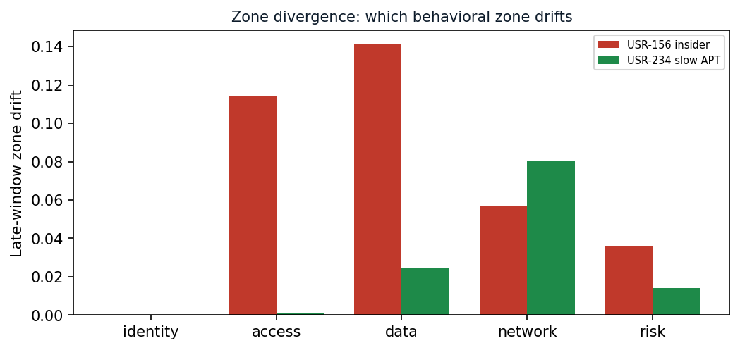
Figure 3 — Zone divergence: late-window drift per behavioral zone. Detection localizes the change to a zone rather than reporting one undifferentiated score.
Stage 3 — fuse five questions into one score (is this actually an attacker?).
A single drifting metric is not proof. The composite scorer asks five independent questions at once: is the drift stronger than the entity's peer cohort (signal strength); across how many features (breadth); does it persist over time (sustained); does it appear under multiple analytical contexts (context divergence); and are never-before-seen behaviors recurring (novelty persistence)? A normal user may score high on one question by chance; an attacker usually scores high on more than one — and even an attacker that spikes on just one phase (USR-234 rides novelty alone) is caught once the scores are fused. The fused score separates the attackers from the normal mass.
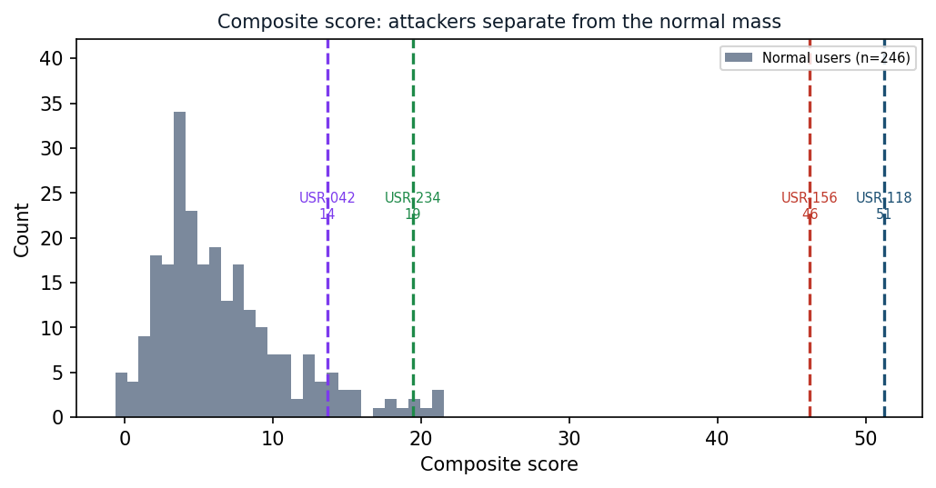
Figure 4 — Composite-score distribution. Three campaigns (USR-118, USR-156, USR-234) sit above the bulk of normal users; the hardest, the Volt Typhoon LOTL campaign (USR-042 at 13.7), sits within the upper normal tail — which is why recalling all four admits ~20 normal users (the 8.1% operating point).
Stage 4 — why fusion is essential (no single phase catches everyone).
The five phases are complementary, not redundant. The slow APT (USR-234) is caught almost entirely by novelty persistence and is unremarkable on the others; the insider (USR-156) is caught by signal strength, breadth, and sustained deviation in the data zone. Each attacker traces a different shape across the five phases, and none of them could be caught by any single phase alone — which is the whole reason for fusion.
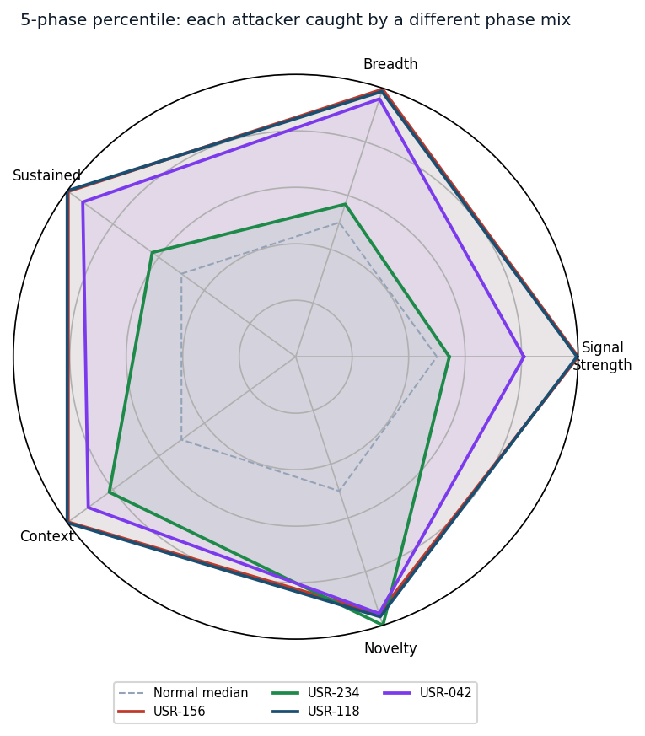
Figure 5 — Five-phase percentile profile. Normal users cluster near the median ring; each attacker extends far on a DIFFERENT mix of phases (USR-234 on novelty, USR-156 on signal/breadth). No normal user reaches these extremes across multiple phases simultaneously.

5.3 Ranking Quality and the Value of Fusion
The walkthrough above is made quantitative here. Treated as a ranking problem, each phase has a measurable quality: ROC AUC is the probability a random campaign outranks a random normal entity (0.5 = chance, 1.0 = perfect); precision@k is the share of the top-k ranked entities that are real campaigns. Measured on the 250-user set with real embeddings:
Detection phase | ROC AUC | Precision@4 | Precision@10
Signal strength | 0.840 | 0.50 | 0.20
Breadth | 0.858 | 0.50 | 0.20
Sustained | 0.893 | 0.50 | 0.20
Context | 0.935 | 0.50 | 0.20
Novelty | 0.734 | 0.25 | 0.20
Composite (fused) | 0.976 | 0.50 | 0.30

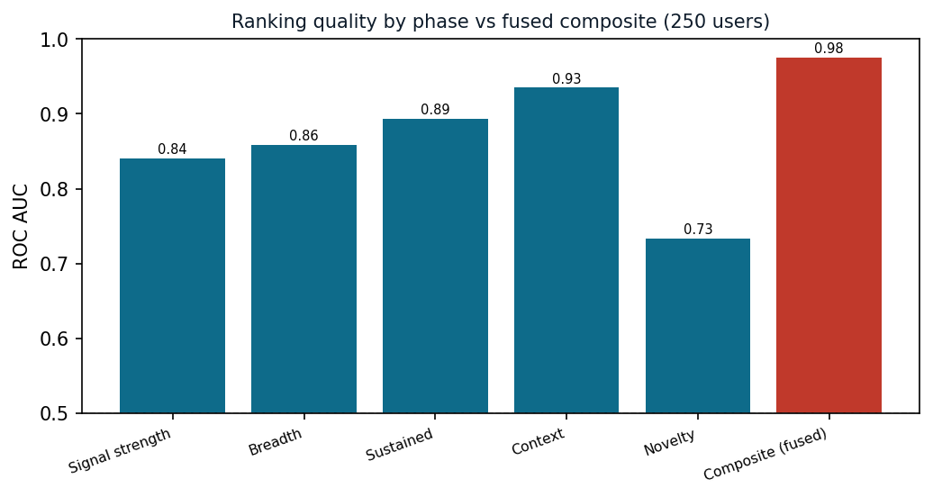
Figure 6 — Ranking quality by phase versus the fused composite (250 users, real embeddings). Every individual phase is only a partial discriminator; fusion lifts AUC to ~0.98.
Every individual phase is a partial discriminator (AUC roughly 0.73–0.94); the fused composite reaches AUC ~0.98 and the best precision — the quantitative form of the radar in Figure 5. With only four positives these figures are indicative, not powered (Section 10); for context, on the separate 50-user comparison run the best traditional discriminator (temporal Z-Score) reached AUC ≈ 0.81 and the simple Z-Score ≈ 0.55 — well short of the fused composite, though measured on a different, smaller run.

6. Other Possible Use Cases
The method is domain-agnostic: anywhere an entity can be observed over time, its behavior can be embedded, decomposed into zones, compared to a peer cohort, and watched for directional drift. The same pipeline has been instantiated for defense supply-chain supplier-risk; other natural targets include:
- Supply chain: supplier-risk and counterfeit/sourcing drift (defense supply chain).
- Healthcare fraud: provider upcoding and referral-ring detection.
- Financial crime: account behavior and structuring (AML).
- Prescriptive maintenance: equipment degradation from multi-sensor behavioral drift.
- Counter-intelligence: person-of-interest activity across travel, comms, and finance.
Each requires only a domain-specific serialization and zone definition; the embedding, drift, cohort, and composite-scoring machinery is unchanged.

7. Scalability and Performance
The validation environment processed 250 entities over 485 days (~14 million events). The design scales along well-understood axes:
The pipeline caches embeddings, parallelizes per-entity processing, and uses indexed vector search for scale.
Cost scales with the number of entity-periods, not raw event volume, because events are aggregated to features before embedding. The dominant external cost is embedding calls, which the cache and a local-model option both reduce.

8. Deployment
V-Intelligence UEBA is containerized and database-backed, deployable in an enterprise data center, a tactical edge, or an air-gapped enclave.
Docker-based, ingests existing SIEM data, runs on-prem or air-gapped with a local embedding model, and deploys via a baseline-then-shadow rollout.

9. Relation to Prior Art
Behavioral analytics is a mature field; the contribution here is a specific combination, not the invention of anomaly detection. It is worth being precise about what is and is not new.
- Commercial UEBA: Exabeam, Securonix, and Microsoft Sentinel UEBA — and similar commercial UEBA platforms — baseline entities statistically and score deviations on numeric features and peer groups (per their publicly described methodology). They are strong at volume and rule-aligned anomalies but measure magnitude; a constant-volume change of kind (the insider) is their blind spot.
- Academic anomaly detection: autoencoders, isolation forests, one-class methods, LSTM sequence models, and graph neural networks for entity anomaly detection are well studied. Most operate on numeric or sequence features and produce opaque scores without an analyst-ready, threat-named direction.
What is distinct here is the composition:
- (1) behavior serialized to language and embedded in a unified semantic space, so the DIRECTION of change is measurable, not just its magnitude.
- (2) independent behavioral zones, so a one-zone signal is not diluted.
- (3) drift projected onto natural-language threat concepts mapped to MITRE ATT&CK — explanations an analyst and an auditor can use.
- (4) peer-cohort relative scoring and multi-phase fusion into one ranked verdict.
Each ingredient exists somewhere in isolation; their integration into one explainable, direction-aware, fusion-ranked pipeline is the claimed innovation.

9.1 Competitive Landscape and Defensible Novelty
A structured, source-verified review of the market and literature (2024–2026) found no commercially marketed product, and no single published method, that detects intrusions the way this architecture does. Publicly described commercial UEBA — Exabeam, Securonix, Microsoft Sentinel UEBA — detects via statistical / p-value profiling, machine-learning baselines, rarity- and magnitude-based scores, and count- or TF-IDF-based peer grouping; their 2024–2026 generative-AI features are SOC copilots and conversational layers, not the detection mechanism.
We are explicit about prior art. The constituent techniques are individually established: LLM-embedding of serialized behavior for anomaly detection (APT-LLM; LogBERT), serializing raw metrics to prose before embedding (TabLLM and related work), embed-then-detect pipelines (TAD-Bench), and embedding drift measured by cosine distance (ZEDD). Every one of these, however, detects by MAGNITUDE — reconstruction error, distributional deviation, or rarity — and operates in a single domain; none projects the DIRECTION of drift onto named, pre-embedded threat concepts mapped to MITRE ATT&CK.
To the best of our knowledge — scoped to publicly described and marketed methodology — no commercial UEBA platform and no single published system detects anomalies by the DIRECTION of behavioral drift in a unified semantic space. The contribution is the integrated architecture and the concept-direction (not magnitude/rarity) paradigm, not any single technique.
Two scoping notes: vendor internals are not fully public, so the comparison is against publicly described and marketed methodology; and a formal patent / freedom-to-operate review is recommended before any contractual assertion of uniqueness.

10. Limitations and Next Steps
The results establish the concept; they do not yet establish operational performance. The following constraints are stated plainly so claims are not over-read.
- Synthetic data: all results here are on synthetic data, and the approach works on it. On real production data we expect the same behavior with minor calibration adjustments — thresholds and cohort baselines tuned to live traffic. Real-data validation is the planned next step.
- Small test set: the test embeds four attack campaigns — enough to demonstrate the concept end to end. A larger, more varied set of injected campaigns is the next step to harden the numbers.
- Hardest-class threat, surfaced anyway: Volt Typhoon-class living-off-the-land is the hardest threat there is — in the real world this actor dwelled in U.S. critical infrastructure UNDETECTED for at least five years (CISA AA24-038A), and magnitude-based detectors rank it among ordinary users (0 of 4 on this benchmark). V-Intelligence still surfaces it inside the top ~10% of all entities (rank 24 of 250) at the all-recall operating point — the difference between catching a five-year-invisible campaign and missing it entirely. The one caveat: of the four campaigns it sits closest to the decision boundary (USR-042), so a stricter threshold trades it off; characterizing that recall/false-positive curve on larger data is the next step.
- Threshold tuning: the 8.1% figure is measured at the alert threshold that catches all four campaigns. On a larger dataset we will publish the full detection-vs-false-alarm curve so each operator can set the threshold to their own alert budget.
- Wording can prime the result: each behavior is described in words — including interpretive cues such as 'restricted' or 'increasing' — not just raw numbers. This helps the model, but it also means part of the match to a threat concept comes from how the behavior is phrased. A plain-numbers run is planned to confirm the signal holds without the suggestive wording.
- Adaptive adversary (an ongoing contest): a model-aware attacker will adapt, and we will keep improving the model — detection is an ongoing contest. Multi-phase fusion, novelty-persistence, and relationship signals raise the bar today and are designed to evolve as adversaries do.
- Air-gapped deployment is supported: for air-gapped or classified environments the embedding model can be self-hosted on-premise — suitable open models exist — so no external API is required.

11. Conclusion
Three generations on one dataset make the case plainly. Traditional detection largely MISSES these stealthy campaigns — LOF 0 of 4 at 4.5% FP, Z-Score 1 of 4 at 9.8% FP, Isolation Forest 0 of 4 at 5.3% FP, OCSVM 0 of 4 at 14.6% FP — and even when one fires, every alert says only 'anomalous' with no indication of which behavioral zone changed or toward what threat pattern. The analyst still faces the same manual triage. An intermediate embedding-drift approach begins to recover direction; and the V-Intelligence UEBA digital twin — zones, trajectory, relationships, peer cohorts, and multi-phase composite scoring — finds all four embedded campaigns at 8.1% FP WITH actionable directional intelligence: zone localization, drift direction, and MITRE ATT&CK concept alignment that traditional methods cannot provide.
Traditional analytics miss the quiet, directional threats that do the most damage — and even when they flag one, detection without direction is triage without intelligence. V-Intelligence UEBA surfaces these campaigns AND tells the analyst WHICH zone changed, TOWARD WHAT threat pattern, mapped to MITRE ATT&CK — the difference between a missed threat and an actionable investigation.
This is a conceptual overview; architectural and full-technical editions are available on request.
All results are from synthetic data and must be re-validated on production telemetry before any operational claim.

12. References
- [1] CISA, 'PRC State-Sponsored Actors Compromise and Maintain Persistent Access to U.S. Critical Infrastructure' (Volt Typhoon), Advisory AA24-038A, 2024.
- [2] CISA AA23-144A, 'People's Republic of China State-Sponsored Cyber Actor Living off the Land,' 2023.
- [3] U.S. Government joint reporting on Salt Typhoon intrusions into telecommunications infrastructure, 2024–2025.
- [4] MITRE ATT&CK Framework, Enterprise Matrix. attack.mitre.org.
- [5] E. S. Page, 'Continuous Inspection Schemes,' Biometrika 41(1/2), 1954 (CUSUM).
- [6] NIST SP 800-207, 'Zero Trust Architecture,' 2020.
- [7] OpenAI, 'text-embedding-3-small' embedding model documentation.
- [8] Y. Malkov and D. Yashunin, 'Efficient and robust approximate nearest neighbor search using Hierarchical Navigable Small World graphs (HNSW),' IEEE TPAMI, 2018.
- [9] APT-LLM: LLM-embedded provenance traces for anomaly detection, arXiv:2502.09385, 2025 (prior art — magnitude / autoencoder detection).
- [10] H. Guo et al., 'LogBERT: Log Anomaly Detection via BERT,' arXiv:2103.04475, 2021 (prior art — self-supervised, distributional deviation).
- [11] TAD-Bench: benchmarking LLM-embedding + anomaly detectors, arXiv:2501.11960, 2025 (prior art — embed-then-detect).
- [12] Serialize-tabular-to-text then LLM-embed (TabLLM family), arXiv:2502.11596, 2025 (prior art — prose serialization).
- [13] ZEDD: embedding-drift (1 − cosine) for prompt-injection defense, arXiv:2601.12359, 2026 (prior art — cosine drift, different application).
- [14] V-Intelligence UEBA Technical Specification (companion document, full edition).

