Invention Disclosure for U.S. Provisional Patent Application
Behavioral Entity Intelligence: Anomaly Detection by the DIRECTION of Behavioral Drift in a Unified Cross-Domain Semantic Embedding Space
FOR ATTORNEY REVIEW — NOT LEGAL ADVICE
An inventor's technical disclosure prepared to support drafting and filing of a U.S. provisional patent application. Counsel should refine claims, run a formal patentability / freedom-to-operate (FTO) search, and confirm inventorship and ownership before filing.
Statement of Innovation (What Is Novel)
The damaging anomalies — insider threats, slow APT campaigns, living-off-the-land intrusions, gradual sourcing shifts, demand regime changes — stay within normal ranges on every individual metric. They are detectable only by the DIRECTION and ACCUMULATION of behavioral change. The innovation detects exactly that, and does it across domains in one space:
THE INNOVATION, IN ONE SENTENCE: represent every entity (user, device, supplier, part, account) as time-evolving points in ONE semantic embedding space built by serializing behavior into language, and detect risk by the DIRECTION of behavioral drift projected onto NAMED concepts (e.g., MITRE ATT&CK) — not by the magnitude of any single metric.

- Novel element 1 — Unified cross-domain space: a single, unified LLM text-embedding space spanning multiple entity types AND multiple domains (cybersecurity behavior analytics + supply-chain forecasting).
- Novel element 2 — Concept-direction detection: detection by the DIRECTION of drift, via cosine projection onto zone-filtered, pre-embedded concept vectors mapped to MITRE ATT&CK / SCM taxonomies — answering 'what is this entity becoming,' not 'how big is the number.'
- Novel element 3 — Three-tier integrated architecture: three-tier detection architecture integrating traditional ML, embedding-drift change-point detection, and digital-entity models with 9 detection methods — including regime state machines, zone divergence, co-drifting cohort detection, behavioral progression (Kendall tau), and kill chain reconstruction.
- Novel element 4 — Semantic gap bypass + quantitative grounding: semantic gap bypass: direct extraction of high-discrimination features (novel IPs, DGA entropy, novel processes) before embedding, combined with z-score-tiered serialization that makes the embedding quantitatively grounded.
- Novel element 5 — The complete integrated system: the full end-to-end stack: prose serialization + unified space + concept-direction drift + cohort-relative scoring + zone decomposition + multi-phase fusion + bi-temporal SCD2 embedding history + drift-augmented dynamic forecast bands.
What Is Novel vs. What Is Prior Art (stated honestly)
Established prior art (NOT claimed as new) | Claimed as novel (the combination)
LLM-embedding of serialized behavior for  single entity type, single domain (APT-LLM, LogBERT) | ONE UNIFIED space across multiple entity types  (users, devices, suppliers, items) AND multiple domains
Serialize raw metrics to prose then embed  (TabLLM — single-table, no zones, no drift tracking) | Detection by DIRECTION of drift onto NAMED  concept vectors with zone-specific filtering
Embed-then-detect via MAGNITUDE in embedding space  (TAD-Bench benchmarks IForest/LOF on LLM vectors) | Detection by DIRECTION of drift onto NAMED concept vectors mapped to MITRE ATT&CK — the concept alignment IS the detector, not a post-hoc enrichment
Embedding drift via cosine distance (ZEDD) | Full velocity vectors + regime state machine + behavioral progression (Kendall tau)
Peer-cohort baselining; MITRE mapping as enrichment | Co-drifting cohort detection via drift-direction similarity clustering
CUSUM change-point detection; kill chain models | Inter-zone divergence as attack-type signature (which zones drift vs. stay stable)
Bi-temporal data models; feature stores | Bi-temporal SCD2 embedding history with leak-free point-in-time retrieval
Anomaly scoring pipelines | Semantic gap bypass: direct extraction of novel IPs/DGA/processes before embedding
Single-tier or two-tier detection systems | Three-tier integrated architecture (traditional ML + embedding drift + digital entity)
Statistical time-series forecasting | Drift-augmented DYNAMIC, asymmetric forecast bands shaped by named behavioral concepts

Honest position: each constituent technique exists individually in the literature; novelty is asserted in the COMBINATION, the cross-domain unified space, and the concept-direction (rather than magnitude/rarity) paradigm. A source-verified competitive review (2024–2026) found no commercial product and no single published system combining these (scoped to publicly described methodology).
Illustrative Diagrams
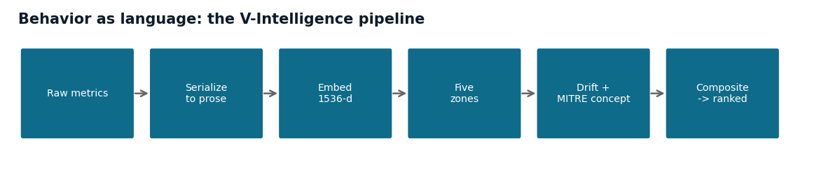
FIG. 1 — The pipeline: raw behavior is serialized to language, embedded into one semantic space, decomposed into zones, and the drift direction is named against MITRE concepts before a composite ranks the entity.
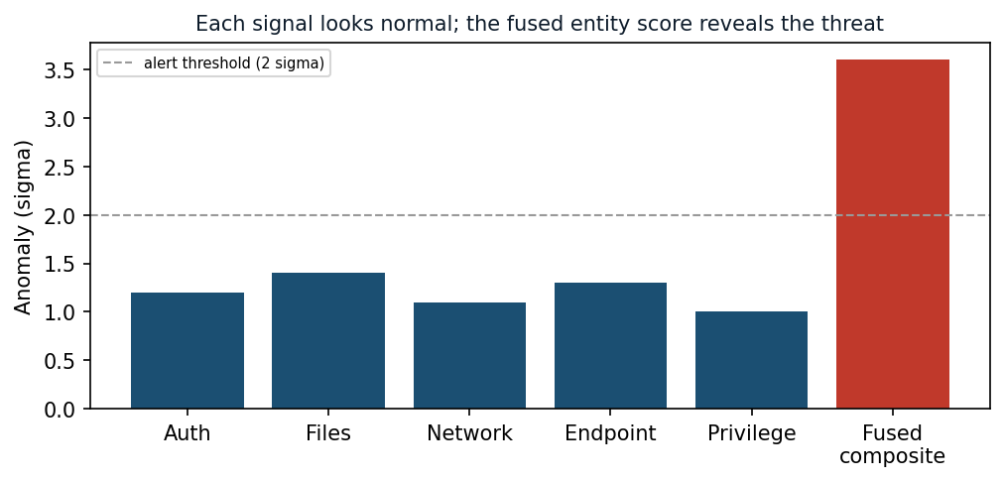
FIG. 2 — The core insight: each individual signal stays below the alert threshold, yet the fused entity score crosses it — the risk is visible only in combination.
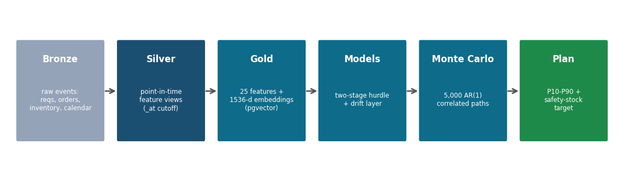
FIG. 3 — End-to-end data flow (forecasting embodiment): raw events become point-in-time features and embeddings, feed the models, and yield a calibrated, drift-aware plan.
0. Filing Metadata (to be completed)
Field | Value
Proposed title | Behavioral Entity Intelligence: Anomaly Detection by the Direction of Behavioral Drift in a Unified Cross-Domain Semantic Embedding Space
Inventor(s) | [full legal name(s), address(es)] — TO COMPLETE
Assignee / applicant | 22nd Century Technologies, Inc. (confirm)
Conception / reduction-to-practice date | [date(s)] — TO COMPLETE (attach commit history / notebook as evidence)
Prior public disclosure? | [CONFIRM any public demo/whitepaper/RFI — affects 12-month statutory bar and foreign rights] — TO CONFIRM

Note for counsel: provisional applications are not examined and need not include formal claims, but the draft claims in Section 9 anchor the eventual non-provisional. Confirm the public-disclosure timeline (on-sale / public-use bar).
1. Field of the Invention
Machine-learning systems for anomaly and risk detection over the behavior of monitored entities. More particularly, representing heterogeneous entities (users, devices, network segments, applications, suppliers, inventory items, accounts) as time-evolving points in a unified semantic vector space derived from natural-language serialization of behavior, and detecting anomalies by the direction of behavioral change projected onto named reference concepts — across cybersecurity behavior analytics and supply-chain demand forecasting.
2. Background
2.1 The problem
The most consequential anomalies remain within normal statistical ranges on every individual metric. The damaging signal is in the DIRECTION and ACCUMULATION of change, not the MAGNITUDE of any single metric crossing a threshold.
2.2 Limitations of existing approaches
- Behavioral security analytics: baseline entities statistically (p-value, histogram/profile deviation, isolation forests, one-class methods) on numeric features; recent generative-AI is an analyst assistant, not the detector.
- Demand / supply-chain forecasting: statistical + gradient-boosted/deep tabular models over numeric features, with fixed-shape uncertainty bands and generative-AI as a conversational layer.
- Foundation time-series models: tokenize numeric series directly rather than representing behavior as language.
None (a) represent heterogeneous entities and multiple domains in one semantic space, (b) detect by the DIRECTION of drift projected onto named concepts, or (c) adjust forecasts/uncertainty by that direction.
3. Summary of the Invention
- (1) Serializes behavior to language with z-score tiering: aggregates raw metrics into behavioral zones, annotates each metric with a statistical tier (normal/elevated/critical relative to population and entity baseline), and renders as natural-language text.
- (2) Embeds into a unified semantic space common to all entity types and domains.
- (3) Composes an entity embedding from zone embeddings (weighted average and/or context-adaptive attention), with automatic exclusion of static (near-zero variance) zones.
- (4) Tracks a trajectory: stores successive entity embeddings with bi-temporal SCD2 versioning (valid-time + knowledge-time) for leak-free point-in-time retrieval.
- (5) Detects by DIRECTION of drift: projects the full-dimensional drift vector onto zone-filtered, pre-embedded concept vectors mapped to MITRE ATT&CK / SCM concepts.
- (6) Detects inter-zone divergence: identifies attack-type signatures from which zones drift while others remain stable (e.g., data zone drifting + identity stable = exfiltration).
- (7) Accumulates slow drift via CUSUM change-point detection; detects behavioral progression via Kendall tau rank correlation; classifies regime states (stable/drifting/accelerating/regime_shift) via velocity state machine.
- (8) Scores relative to a peer cohort; detects co-drifting cohorts via drift-direction similarity clustering (coordinated insider rings, lateral movement campaigns).
- (9) Extracts high-discrimination features (novel IPs, DGA entropy, novel processes) directly from text before embedding, bypassing the semantic compression layer.
- (10) Fuses multiple phases (signal strength, breadth, sustained deviation, context divergence, novelty persistence) into one ranked verdict; models pairwise relationships via Hadamard products and session-based relationship entities.
- (11) Reconstructs multi-step kill chains via temporal correlation across entities, ordered by MITRE ATT&CK tactic sequence, with automated natural-language narrative generation.
- (12) Drift-augments forecasts: bounded plan adjustment + DYNAMIC, asymmetric uncertainty bands.
- (13) Is domain-portable: same architecture, only serialization/zones/concepts change.
4. Three-Tier Detection Architecture
The system operates as a layered detection pipeline where each tier addresses a different class of anomaly. Tiers run in parallel; their outputs are fused into a unified verdict.
- Tier 1 — Traditional ML: Six established statistical/ML algorithms (Isolation Forest, One-Class SVM, Local Outlier Factor, Z-Score, Temporal-Z, Feature CUSUM) operating on 23 scalar behavioral features. Detects magnitude anomalies but provides no directional intelligence for triage.
- Tier 2 — Embedding Drift: Embedding-drift analysis via CUSUM on cosine distances between successive behavioral embeddings. Detects entities whose behavioral meaning is changing, even when all scalar features remain within normal ranges.
- Tier 3 — Digital Entity Intelligence: Full digital-entity model with 9 detection methods — velocity magnitude, acceleration, regime detection, zone divergence, contextual anomaly, relationship drift, behavioral progression, concept-direction alignment, and novelty persistence — fused via multi-phase composite scoring into one ranked verdict.
The three-tier architecture is novel in its integration: no prior system combines traditional statistical methods, embedding-drift change-point detection, and entity-level digital models with concept-direction detection in a single pipeline.
5. Detailed Description
5.1 Entity digital model and behavioral zones
Each entity is modeled as a structured, multi-dimensional record. Top-level slots are DIMENSIONS (zones); each holds SUB-DIMENSIONS (features); the record is captured as a TIME SERIES of snapshots. Cyber-user zones: identity, access pattern, data behavior, network footprint, risk posture. Supplier/item zones: identity, performance, geographic/sourcing, network position, risk/financial.
5.2 Natural-language serialization with z-score tiering
Each zone's metrics are serialized to text; in the preferred interpretive form each metric is expressed relative to population, the entity's own baseline, and trend, preserving qualitative tokens (directories, IPs, domains, country-of-origin).
Critically, each metric is annotated with a statistical tier before embedding:
NORMAL |z| < 1.5 metric is within expected variation
ELEVATED 1.5 <= |z| < 2.5 metric is noteworthy
CRITICAL |z| >= 2.5 metric is a strong statistical outlier
Example: 'auth_fail_rate is CRITICAL at 4.2x population average (z=3.1),
up from NORMAL last period'

This tiering ensures the embedding captures statistical significance, not just raw values — a subtle but essential innovation that makes the semantic space quantitatively grounded.
5.3 Unified cross-domain embedding
Each description is embedded into a fixed-dimensional vector (e.g., D=1536) in ONE semantic space common to all entity types and domains; vectors are cached by content hash and stored in a vector database with approximate-nearest-neighbor search.
5.3.1 Bi-temporal embedding history
Embeddings are stored with two independent time axes following slowly-changing dimension type 2 (SCD2) semantics:
valid_from / valid_to — real-world behavioral truth
knowledge_from / knowledge_to — when the system learned the information
Three-step SCD2 upsert protocol:
1. Close prior version (set valid_to = now, knowledge_to = now)
2. Insert new version (valid_from = now, knowledge_from = now)
3. Point-in-time query: WHERE valid_from <= t AND valid_to > t

This enables leak-free point-in-time retrieval and retroactive correction of embeddings — essential for reproducible training and regulatory audit trails.
5.4 Composition with static zone exclusion
weighted: V = normalize( SUM_z w_z * e_z )
attention: a_z = softmax_z( ||e_z|| * b_z(c) ) ; V = normalize( SUM_z a_z * e_z )
Static zone exclusion: if var(e_z) < epsilon across history -> exclude zone z
Prevents static zones from diluting anomaly signals in the composed entity embedding.

5.5 Drift — full velocity vectors and regime detection
magnitude: d_t = 1 - cos( V_{t-1}, V_t )
direction: u_t = ( V_t - V_{t-1} ) / || V_t - V_{t-1} ||
Velocity vector (full 1536-d, not scalar):
vel_t = V_t - V_{t-1} (preserves direction + magnitude)
Six trajectory features per entity per window:
velocity_magnitude, acceleration, stability, regime_shifts,
trend_consistency (Kendall tau), total_drift

A regime detection state machine classifies each entity into one of four states:
STABLE vel_mag < T_drift AND stability > T_stable
DRIFTING vel_mag >= T_drift AND accel < T_accel
ACCELERATING accel >= T_accel
REGIME_SHIFT vel_mag > T_regime (large abrupt change)

5.6 Concept projection with zone-specific filtering
A library of reference concepts is pre-embedded from natural-language descriptions. The drift direction is projected onto each concept; the strongest alignment names what the entity is becoming and maps to a taxonomy (e.g., MITRE ATT&CK).
align_k = cos( u_t , Embed(concept_k) ) -> rank -> MITRE / SCM concept

Zone-specific concept filtering maps each behavioral zone to a subset of semantically relevant reference concepts, preventing false concept alignments:
ZONE_RELEVANT_CONCEPTS = {
'identity': [T1078, T1556, T1134, ...], # credential-related
'network_footprint': [T1071, T1090, T1048, ...], # network-related
'data_behavior': [T1005, T1041, T1567, ...], # exfil-related
}
align_k = cos( u_t , Embed(concept_k) ) only where k in ZONE_RELEVANT[zone]

5.6.1 Zone divergence detection
Inter-zone divergence — the difference in drift magnitudes across behavioral zones — serves as an attack-type signature. When one zone drifts strongly while others remain stable, the divergence pattern names the attack category:
data_behavior drifting + identity stable -> exfiltration (not role change)
network_footprint drifting + access stable -> C2 channel (not workflow change)
identity drifting + data stable -> credential compromise
divergence_score = max_zone_drift - median_zone_drift

5.7 Slow-drift accumulation (CUSUM)
S_0 = 0 ; S_t = max( 0, S_{t-1} + (d_t - k) ) ; alarm when S_t >= h for r periods

5.7.1 Behavioral progression detection (Kendall tau)
Monotonic behavioral progressions (e.g., insider escalation over months) are detected via Kendall tau rank correlation across sequential observations:
tau = kendall_tau( [drift_mag_w1, drift_mag_w2, ..., drift_mag_wN] )
progression_alert when tau > 0.6 over >= 8 periods

This catches the gradual escalation pattern that individual-point anomaly detection methods fundamentally cannot see.
5.8 Peer-cohort relative scoring and co-drifting cohort detection
z[i,f] = ( x[i,f] - mu_cohort[f] ) / sigma_cohort[f]

Beyond individual cohort scoring, the system detects co-drifting cohorts — groups of entities whose drift direction vectors exhibit high cosine similarity:
co_drift_sim(a,b) = cos( drift_vec_a, drift_vec_b )
Greedy single-linkage clustering where sim > T_codrift
Cohort coherence = mean pairwise cosine similarity within cluster
Application: coordinated insider rings, supply-chain collusion,
lateral movement campaigns affecting multiple entities

5.9 Relationship embeddings and session entities
R[a x b] = normalize( V_a (*) V_b ) # element-wise (Hadamard) product

Additionally, sessions are modeled as relationship entity types that bridge user and device embeddings via temporal co-occurrence, creating a relationship embedding that captures the interaction pattern between two entities during a bounded time window.
5.10 Multi-phase composite scoring
A final verdict fuses independent phases (signal strength, breadth, sustained deviation, context divergence, novelty persistence) into one ranked score, so no single evasion technique defeats detection.
5.10.1 Semantic gap bypass for high-discrimination features
Certain high-discrimination features — novel IP addresses, novel process executions, DGA domain entropy — are extracted directly from behavioral text prior to embedding, bypassing the embedding layer. This addresses the semantic gap problem where embedding compresses novelty signals into a dense vector that dilutes their detection sensitivity:
Direct extraction (bypasses embedding):
novel_ips = IPs not seen in baseline period
dga_score = shannon_entropy(domain_name) -> flag if > 3.5
novel_processes = processes not in baseline inventory
Novelty persistence metrics:
persistent_novel_ips: count of novel IPs recurring > 4 weeks
novel_ip_max_persistence: longest consecutive-week streak
novel_ip_weeks_frac: fraction of post-baseline weeks with novel IP contact

5.10.2 Role-appropriateness annotation
File access paths are compared against role-expected and sensitive directory mappings before embedding. Access outside expected patterns is tagged as NOVEL or ATYPICAL, ensuring the embedding captures role-inappropriate access as semantically distinct from routine access at the same volume.
5.11 Kill chain reconstruction
Correlated alerts across entities and time windows are assembled into multi-step kill chains ordered by MITRE ATT&CK tactic sequence:
1. Temporal correlation: group alerts within 72-hour sliding windows
2. Entity-hop linkage: connect alerts where one entity's target
becomes another entity's source
3. Tactic ordering: sort by MITRE ATT&CK kill chain phase
(Recon -> Initial Access -> Execution -> ... -> Exfiltration)
4. Narrative generation: automated natural-language summary of the
reconstructed attack sequence
5. Staleness: mark chains with no new events in > 72h as stale

5.12 Forecasting embodiment — drift-augmented dynamic bands
alpha = clamp( direction(concept) * alignment * drift_norm , -A, +A )
adj_P50 = max(0, P50 * (1 + alpha))
adj_P90 = adj_P50 + (P90 - P50) * beta # bands widen/narrow INDEPENDENTLY of median

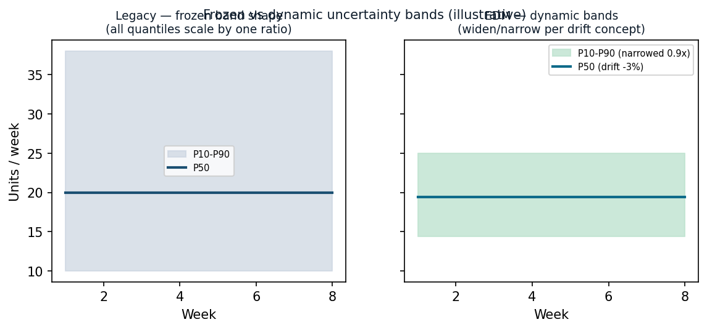
FIG. 4 — Frozen-shape bands (conventional) vs. drift-augmented dynamic bands (this invention): the band shape adapts to the named concept, independently of the median.
5.13 Cross-domain portability
The same pipeline instantiates in a new domain by changing only serialization templates, zone definitions, and the concept library. Disclosed embodiments: (a) UEBA for cybersecurity and (b) demand forecasting / supplier-risk for defense logistics — both in the same unified embedding space.
6. Advantages
- Detects constant-volume, direction-only changes that magnitude/threshold methods miss.
- Explainable output (named concept + taxonomy + zone attribution) instead of an opaque score.
- Zone divergence patterns name the attack category without additional analysis.
- One unified space enables cross-entity similarity, cohort cold-start transfer, and co-drift.
- Co-drifting cohort detection identifies coordinated campaigns across multiple entities.
- Kill chain reconstruction automates multi-step attack narrative generation.
- Bi-temporal embedding history enables leak-free training and regulatory audit trails.
- Semantic gap bypass preserves detection sensitivity for high-discrimination features.
- Three-tier layered architecture enables defense-in-depth detection.
- Domain-portable architecture reduces re-engineering to serialization/zones/concepts only.
- Dynamic, asymmetric forecast bands improve probabilistic decision support.
7. Reduction to Practice (synthetic validation — summary)
All figures are from SYNTHETIC datasets and illustrate operability; they are not performance claims for real-world deployment.
- Security embodiment: 250 entities x ~485 days; 4 embedded long-duration campaigns. Multi-phase composite surfaced all 4 in the top tier at ~8.5% false-positive operating point (21 of 246 normal entities at 90th-percentile threshold); traditional outlier detectors flag anomalies but provide no directional intelligence for triage.
- Forecasting embodiment: 500 items x 200 suppliers x 4 depots x 24 months. Calibrated two-stage forecaster (occurrence ECE ~0.03; near-nominal P10-P90 coverage); drift-augmented dynamic bands right-size procurement. Supplier-risk AUC ~0.77, survival C-index ~0.79.
9. Draft Claims (illustrative — for attorney refinement)
Independent and core dependent claims (1-12)
- Claim 1 (method). A computer-implemented method for detecting behavioral anomalies, comprising, for each entity of a plurality of entities spanning two or more entity types: (a) aggregating observational metrics over an observation period into a plurality of behavioral zones; (b) generating, for each zone, a natural-language description of the zone's state, including statistical-tier annotations (normal, elevated, critical) relative to population statistics and per-entity baselines; (c) encoding each description, using a text-embedding model, into a vector occupying a semantic vector space common to all said entity types; (d) composing the zone vectors into an entity vector, excluding zones exhibiting near-zero variance; (e) repeating (a)-(d) over successive periods to form a time series of entity vectors; (f) computing a drift vector from at least two entity vectors, said drift vector being a full-dimensional direction vector preserving directional information in the embedding space; (g) computing a similarity between the drift vector and each of a plurality of pre-embedded natural-language concept vectors in said space, filtered to zone-relevant concepts only; and (h) producing a detection output identifying a concept based on said similarity and indicating a direction of behavioral change.
- Claim 2. The method of claim 1, wherein the entities span two or more operational domains and the semantic vector space is common across said domains.
- Claim 3. The method of claim 1, wherein the natural-language description applies three statistical tiers — normal (|z| < 1.5), elevated (1.5 ≤ |z| < 2.5), and critical (|z| ≥ 2.5) — to annotate behavioral features relative to population statistics, per-entity historical baselines, and recent trend direction before embedding, thereby ensuring the embedding captures statistical significance.
- Claim 4. The method of claim 1, further comprising accumulating drift magnitude over successive periods with a cumulative-sum procedure and signaling a change point when the accumulated value exceeds a threshold for a minimum run length; and further comprising computing velocity as a full-dimensional vector (V_t − V_{t−1}) preserving direction, acceleration as the change in velocity, stability as the inverse of velocity variance, and trend consistency via Kendall tau rank correlation.
- Claim 5. The method of claim 1, wherein composing comprises a context-adaptive attention weighting over zones determined by a softmax of zone-vector magnitudes biased by an analytical context, and further comprising excluding behavioral zones exhibiting near-zero variance from the weighted composition to prevent static zones from diluting anomaly signals.
- Claim 6. The method of claim 1, further comprising standardizing entity features against statistics of a cohort of comparable entities and scoring relative to said cohort; and further detecting co-drifting cohorts by clustering entities whose drift direction vectors exhibit high cosine similarity above a configurable threshold, and computing cohort coherence as the mean pairwise cosine similarity within each cluster.
- Claim 7. The method of claim 1, further comprising mapping the identified concept to a structured taxonomy such as MITRE ATT&CK and emitting an explanation; reconstructing multi-step kill chains by temporally correlating alerts across entities within a configurable time window; ordering correlated events by tactic sequence; and generating a natural-language attack narrative from the reconstructed chain.
- Claim 8. The method of claim 1, further comprising forming a relationship vector as a normalized element-wise product of two entity vectors and detecting drift of the relationship vector; and further modeling sessions as relationship entity types that bridge user and device embeddings via temporal co-occurrence.
- Claim 9. The method of claim 1, further comprising fusing a plurality of detection phases — two or more of signal strength, breadth, sustained deviation, context divergence, and novelty persistence — into a single ranked score.
- Claim 10 (forecasting). A computer-implemented method for generating a probabilistic forecast, comprising producing a baseline forecast having quantile bands; forming a time series of entity vectors per claim 1(a)-(e); determining a direction of behavioral drift by projecting a drift vector onto pre-embedded concept vectors; classifying the entity's behavioral state via a regime detection state machine (stable, drifting, accelerating, or regime shift); and adjusting the baseline by (i) a bounded scalar adjustment to a central quantile and (ii) a per-concept band multiplier that widens or narrows band spread independently of the central quantile.
- Claim 11 / 12 (system / medium). Corresponding system and non-transitory computer-readable-medium claims implementing claims 1-10.
Additional dependent claims (13-25)
- Claim 13. The method of claim 1, wherein step (g) applies zone-specific concept filtering by mapping each behavioral zone to a subset of semantically relevant reference concepts, preventing cross-zone false concept alignments.
- Claim 14. The method of claim 1, further comprising detecting inter-zone divergence by comparing drift magnitudes across behavioral zones, wherein divergent zone behavior (e.g., data behavior zone drifting while identity zone remains stable) serves as an attack-type signature distinguishing exfiltration from role change.
- Claim 15. The method of claim 4, further comprising a regime detection state machine that classifies each entity's behavioral state into one of: stable, drifting, accelerating, or regime shift, based on velocity magnitude, acceleration, and stability thresholds computed from the trajectory features.
- Claim 16. The method of claim 4, wherein the velocity of behavioral change is computed as a full-dimensional direction vector in the embedding space, and six trajectory features — velocity magnitude, acceleration, stability, regime shift count, trend consistency (Kendall tau), and total drift — are computed per entity per observation window.
- Claim 17. The method of claim 7, further comprising reconstructing multi-step kill chains by temporally correlating alerts across entities within a configurable time window (e.g., 72 hours), performing entity-hop linkage where one entity's target becomes another entity's source, ordering correlated events by MITRE ATT&CK tactic sequence, generating natural-language attack narratives, and marking chains as stale when no new events occur within the correlation window.
- Claim 18. The method of claim 1, further comprising storing behavioral embeddings in a bi-temporal data model with two independent time axes — a valid-time axis representing real-world behavioral truth and a knowledge-time axis representing when the system learned the information — using a three-step SCD2 upsert protocol enabling point-in-time queries and retroactive correction of embeddings for leak-free training.
- Claim 19. The method of claim 6, further comprising detecting co-drifting cohorts by clustering entities whose drift direction vectors exhibit high cosine similarity using greedy single-linkage clustering, and computing cohort coherence metrics to identify coordinated behavioral shifts across multiple entities indicative of coordinated insider rings, supply-chain collusion, or lateral movement campaigns.
- Claim 20. The method of claim 3, wherein the interpretive text representation applies three statistical tiers — normal (|z| < 1.5), elevated (1.5 ≤ |z| < 2.5), and critical (|z| ≥ 2.5) — computed against both population statistics and per-entity historical baselines, ensuring the embedding captures statistical significance rather than raw metric values.
- Claim 21. The method of claim 1, further comprising computing domain name entropy using Shannon's formula to detect algorithmically generated domains (DGA), and annotating domain-related features as NOVEL prior to embedding when entropy exceeds a configurable threshold (e.g., 3.5 bits).
- Claim 22. The method of claim 1, further comprising role-appropriateness checking wherein file access paths are compared against role-expected and sensitive directory mappings, with access outside expected patterns tagged as NOVEL or ATYPICAL features before embedding, and computing novelty persistence metrics tracking how long novel behaviors persist across observation windows.
- Claim 23. The method of claim 5, further comprising excluding behavioral zones exhibiting near-zero variance from the weighted composition, preventing static zones from diluting anomaly signals in the composed entity embedding.
- Claim 24. The method of claim 1, wherein certain high-discrimination features including novel IP addresses, novel process executions, and DGA domain entropy scores are extracted directly from behavioral text prior to embedding, bypassing the embedding layer to preserve detection sensitivity for features whose novelty signal would be diluted by semantic compression.
- Claim 25. The method of claim 1, further comprising detecting behavioral progression by computing Kendall tau rank correlation across sequential behavioral measurements over a minimum of eight observation periods, identifying monotonic escalation patterns that individual-point anomaly detection methods cannot capture.
Further dependent variations for counsel: embedding dimensionality/model class; content-hash sharded embedding cache for efficient deduplication; domain-specific zone sets; forecast safety gates; two-stage 'hurdle' demand baseline; alert confidence fusion formula (base + alignment boost + method boost).
10. Distinction Over Prior Art (source-verified)
A structured, adversarially-verified review (2024–2026) found: commercial UEBA (Exabeam, Securonix, Microsoft Sentinel UEBA) uses statistical/ML + TF-IDF peer grouping with generative-AI as copilots; commercial demand/SCM (SAP IBP, o9, Kinaxis) uses gradient-boosted/ML over tabular features with generative-AI as a conversational layer; academic prior art exists for each building block individually (APT-LLM, LogBERT, TabLLM, TAD-Bench, ZEDD) but always magnitude-based and/or single-domain.
DEFENSIBLE NOVELTY (scoped to publicly described methodology): no commercial product and no single published system combines (i) a unified embedding space across entity types AND domains, (ii) detection by the DIRECTION of drift onto named concept vectors mapped to MITRE ATT&CK, and (iii) the full integrated stack. Individual constituent techniques are conceded as prior art; novelty is the combination and the concept-direction paradigm.

Counsel action: confirm via formal patentability/FTO search; review cited references and the patents US11258814B2 and US12250239B2 for relevance.
11. Notes / To-Do Before Filing
- Complete Section 0 metadata (inventors, assignee, conception/RTP dates, public-disclosure timeline).
- Re-render FIG. 1-4 as formal patent drawings.
- Counsel: patentability + FTO search; confirm Section 101 framing (tie claims to a specific technical improvement, not an abstract idea).
- Decide claim scope and which embodiments to emphasize (security / forecasting / both).
- Confirm whether any enabling public disclosure has occurred (statutory-bar clock).
Prepared as an inventor's technical disclosure to accompany attorney drafting of a U.S. provisional patent application. Not legal advice.

