Agentic Ticket Support System
Architecture Specification
A multi-agent, continuously-learning customer support platform built on
Amazon Bedrock and CockroachDB.

Prepared for | CockroachDB × AWS Hackathon — “Build the Future of Agentic Memory”
Document status | Authoritative — supersedes all prior architecture notes
Version | 1.0
Date | 25 July 2026
Companion files | plan.md (build order) · agentic-ticket-system.png (original whiteboard design)

Table of Contents
Right-click here and choose “Update Field” (or press F9) to generate the table of contents.

This is the authoritative technical specification.
If any other document — including the original whiteboard diagram — conflicts with this
file, this file wins. The plan of record and build order live in plan.md; the visual
companion is agentic-ticket-system.png.

An earlier architecture.md in this repository's git history describes a superseded design
(Intent / Memory / Resolution / Tool / Response agents). It must not be used — this
document replaces it.

1. System Purpose
A multi-agent customer support platform for e-commerce-style tickets — order tracking, refunds, disputes — built for the CockroachDB × AWS Hackathon, “Build the Future of Agentic Memory.”
The differentiator is continuously learning memory: every ticket outcome — agent-resolved, customer-rejected, or human-resolved — is embedded and written back to CockroachDB, so future tickets retrieve and benefit from it. A rejection plus the customer's stated reason is treated as learning signal, not discarded failure.

2. Tech Stack
Layer | Choice
Language | TypeScript, everywhere (app, Lambdas, IaC)
AI orchestration | Managed Amazon Bedrock Agent (supervisor) + action groups
Specialist execution | AWS Lambda, one function per action group
Entry point | Lambda Function URL (not API Gateway — avoids its 29s integration timeout)
Memory & data | CockroachDB Cloud — operational tables + distributed vector index
Embeddings | Amazon Titan Text Embeddings V2, single model, single dimension
Policy documents | S3, read-only
Observability | CloudWatch structured logs
Web app | Next.js — public submit flow + gated human queue
IaC | AWS CDK (TypeScript)
Monorepo | pnpm workspaces, Vitest

3. Component Map
The system is a straight pipe from customer or human agent, through a shared Next.js application, into a Bedrock-orchestrated agent chain backed by CockroachDB, S3, and CloudWatch.
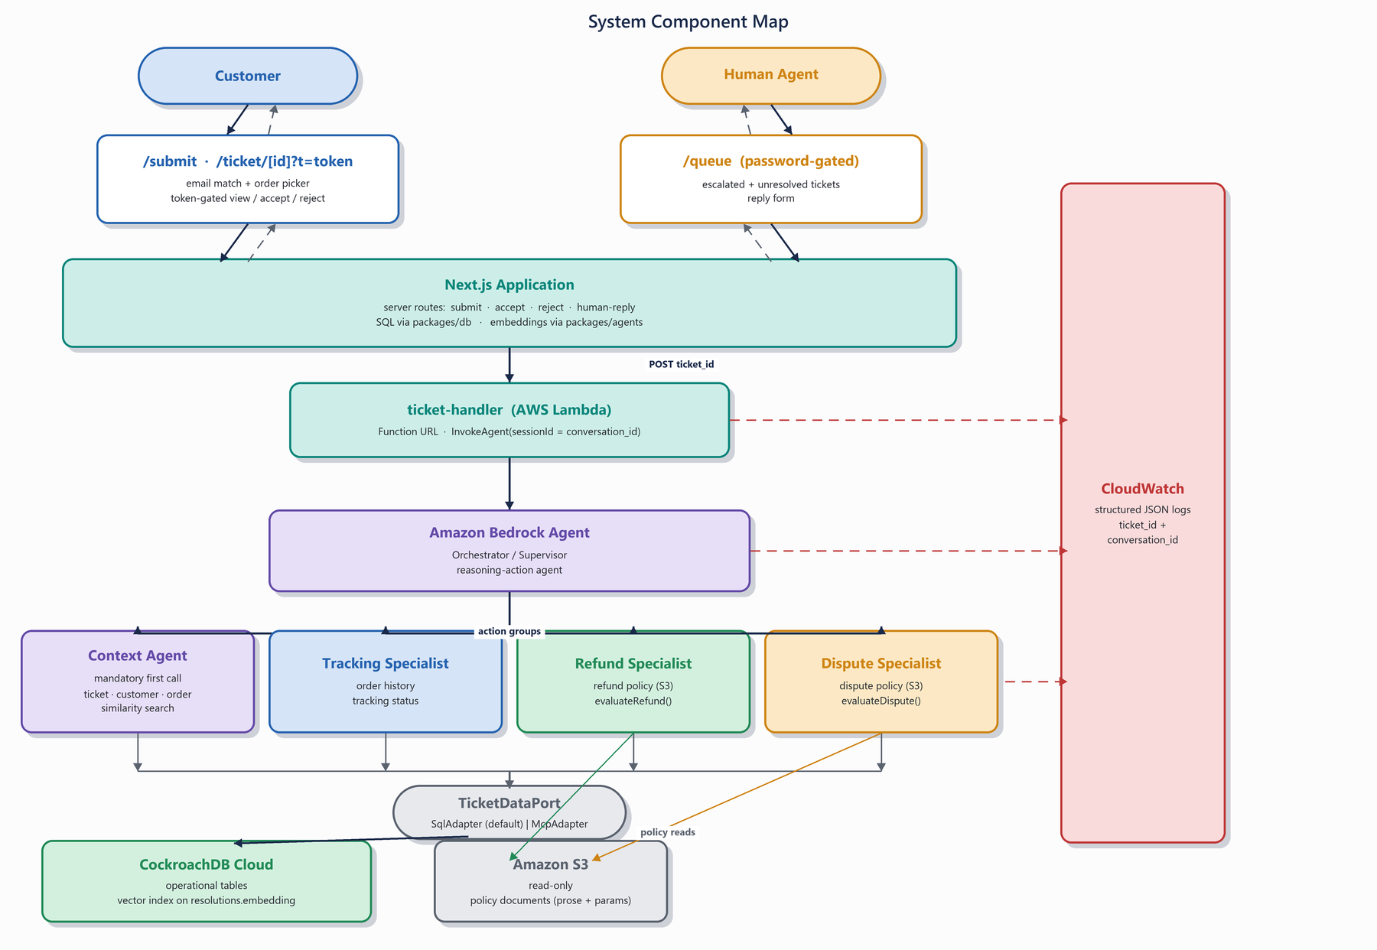
Figure 1. System component map — request flow from actors through the orchestrator to storage.

4. The Agents
One managed Bedrock Agent is the Orchestrator. It is a reasoning-action agent: it analyzes the ticket, forms a plan chasing the objective “do I have everything I need to respond to this ticket and achieve resolution?”, calls specialists to gather inputs, re-evaluates after every response, and either assembles a customer-friendly reply or escalates.
The four specialists are action groups, each backed by one Lambda. They are not separate Bedrock Agent resources.

4.1 Context Agent — mandatory first call
The orchestrator must call this before any other action group (enforcement in §5).
- Tools: ticket lookup, conversation history, resolution-embedding similarity search
- Input: ticket_id, conversation_id
- Does: stamps orchestration_state.context_called_at; loads the ticket, its customer, its linked order (if any); runs a similarity search over past resolutions (§9)
{
"ticket": { "id": "…", "title": "…", "description": "…", "status": "open" },
"customer": { "id": "…", "name": "…", "email": "…" },
"order": { "id": "…", "status": "shipped", "orderValueCents": 24999,
"createdAt": "…", "shippedAt": "…", "receivedAt": null },
"similarResolutions": [
{ "summary": "…", "outcome": "resolved", "source": "human", "similarity": 0.91 }
]
}

order is null when the ticket has no linked order — specialists must treat order-specific questions as escalations in that case.

4.2 Tracking Specialist
- Tools: order history, tracking status (via TicketDataPort)
- Returns: the order's current status and timeline in structured form. No policy decisions.
{ "orderId": "…", "status": "shipped", "shippedAt": "…", "estimatedNarrative": "…" }

4.3 Refund Specialist
- Docs: refund policy from S3 (read-only; prose + params, §6.3)
- Does: loads current PolicyParams (TTL-cached), calls evaluateRefund(order, request, now, params) from packages/policy (§6). The LLM never decides eligibility — it only explains the deterministic verdict, citing the current policy prose.
{ "verdict": "auto_approve" | "escalate", "reasonCode": "WITHIN_7_DAYS_PRE_SHIPMENT",
"policyCitation": "…", "explanation": "…" }

On escalate, the Lambda itself sets tickets.status = 'escalated' (deterministic side effect, not left to the LLM).

4.4 Dispute Specialist
- Docs: dispute policy from S3 (read-only; prose + params, §6.3)
- Does: loads current PolicyParams, calls evaluateDispute(dispute, now, params). On auto_resolve, drafts a response informed by the similar past resolutions the context agent retrieved. On escalate, sets tickets.status = 'escalated' directly.
{ "verdict": "auto_resolve" | "escalate", "reasonCode": "UNDER_300_THRESHOLD",
"draftResponse": "…", "informedBy": ["resolution-id-1", "resolution-id-2"] }

5. Orchestration Contract — Invariants and Their Enforcement
The instruction prompt states all three rules below so the agent usually complies unaided. But prompts are requests, not guarantees — so each invariant also has a code-level backstop. The backstops are what get unit-tested.
State: one orchestration_state row per (ticket_id, conversation_id): context_called_at TIMESTAMPTZ NULL, cycle_count INT NOT NULL DEFAULT 0.
# | Invariant | Enforcement
1 | Context agent is always called first (note 4) | Every specialist Lambda's first step: if context_called_at IS NULL, return a structured refusal — { error: CONTEXT_REQUIRED } — and do no work. The context Lambda stamps the timestamp.
2 | At most 3 plan→call→evaluate cycles before escalating (note 10) | cycle_count increments on every specialist (non-context) invocation. A specialist invoked when cycle_count ≥ 3 performs no work, sets status = 'escalated', and returns { error: CYCLE_LIMIT }. “Cycle” is defined as specialist invocations — the only thing a Lambda can observe, and the closest enforceable proxy for the diagram's intent.
3 | Never force a resolution the system doesn't have (note 7) | Post-hoc safety net in ticket-handler: if the agent chain returns an empty/blank response, or finishes open with no verdict recorded, the handler escalates and substitutes a hand-off reply.

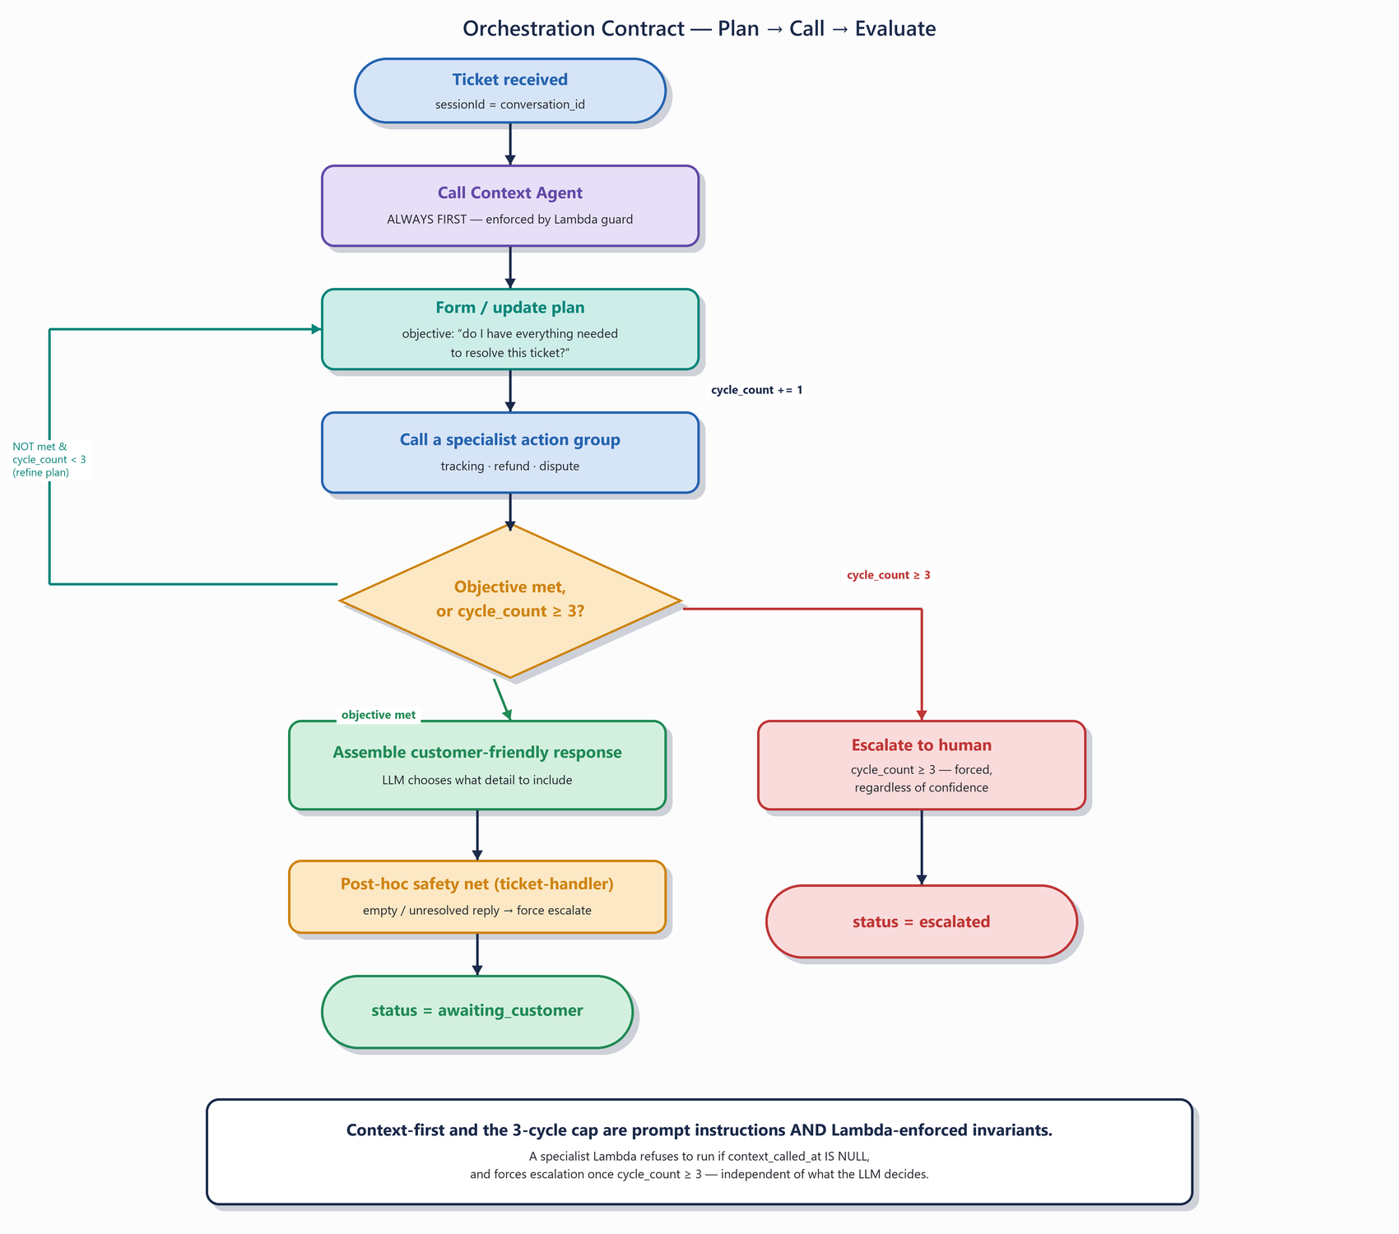
Figure 2. The orchestration loop — every invariant has both a prompt instruction and a Lambda-level backstop.
Conversation history persists with the orchestrator (Bedrock session, sessionId = conversation_id) and is passed to specialists on a need basis — specialists are otherwise stateless between invocations.

6. Deterministic Policy Rules
Implemented as pure functions in packages/policy — zero I/O, zero LLM. The LLM's only role is explaining the verdict. Source: diagram notes 17–18, with boundary semantics pinned down here.
The thresholds are not hardcoded.
Policy values (dollar limits, day windows) live in the S3 policy documents — which get
edited over time — so the engines take them as an explicit PolicyParams argument:
evaluateRefund(order, request, now, params). The tables below show the v1 defaults; the
loading and refresh mechanism is §6.3.

Boundary semantics (normative):
- “within N days of X” means now − X ≤ N × 24h, inclusive — exactly N days still qualifies.
- “< $300” is strictly less than 30,000 cents — exactly $300.00 does not qualify.
- All comparisons in UTC; now is injected into the function (never read from the clock inside) so tests are deterministic.

6.1 evaluateRefund(order, request, now, params)
Rules evaluated in order; first match wins.
# | Order status | Order value | Time condition | Verdict | Reason code
R1 | not yet shipped (processing) | any | now − created_at ≤ 7 days | auto_approve | WITHIN_7_DAYS_PRE_SHIPMENT
R2 | shipped_back_to_sender | < $300 | now − received_at ≤ 30 days | auto_approve | RETURNED_UNDER_300_WITHIN_30_DAYS
R3 | anything else (incl. no linked order) | — | — | escalate | REFUND_POLICY_ESCALATION

Mandatory test boundaries: day 6 / 7 / 8 for R1; day 29 / 30 / 31 and $299.99 / $300.00 / $300.01 for R2; every order_history.status value through R3.

6.2 evaluateDispute(dispute, now, params)
# | Dispute value | Verdict | Reason code
D1 | < $300 | auto_resolve — respond, informed by similar past dispute resolutions | UNDER_300_THRESHOLD
D2 | ≥ $300 or no linked order | escalate | OVER_300_THRESHOLD

Mandatory test boundaries: $299.99 / $300.00 / $300.01.

6.3 Policy documents as single source of truth — loading and refresh
Each policy object in S3 is one JSON document pairing the human-editable prose with the machine-readable parameters, so the two can never drift apart in separate files:
{
"version": 3,
"updatedAt": "2026-07-25T00:00:00Z",
"params": {
"preShipmentRefundWindowDays": 7,
"returnedRefundWindowDays": 30,
"autoApprovalLimitCents": 30000
},
"prose": "## Refund Policy\n\nRefunds requested before shipment …"
}

- One consumer, two uses. The specialist Lambda loads the document once per (cached) fetch: params feeds the deterministic engine; prose is what the LLM quotes and explains from. An edited policy changes both the verdicts and the explanations, atomically.
- Refresh without redeploy. The loader caches at module scope with a short TTL (default 5 minutes) and revalidates by S3 ETag — no code deploy, no agent re-preparation.
- Validated on load, fail loudly. params is schema-validated (zod); a missing or malformed field throws rather than silently falling back. The last-known-good copy is kept in the module cache so a transient S3 failure degrades to slightly-stale policy, never to no policy.
- Auditable verdicts. Every verdict log line and every resolutions row records the policy version that produced it.
- The agent prompt stays policy-free. The Bedrock Agent's baked instruction prompt contains routing behavior only — never thresholds, windows, or amounts. Updating a managed Agent's instructions requires UpdateAgent + PrepareAgent (slow, versioned, easy to forget), so nothing that changes with policy edits is allowed to live there.

7. Ticket Lifecycle
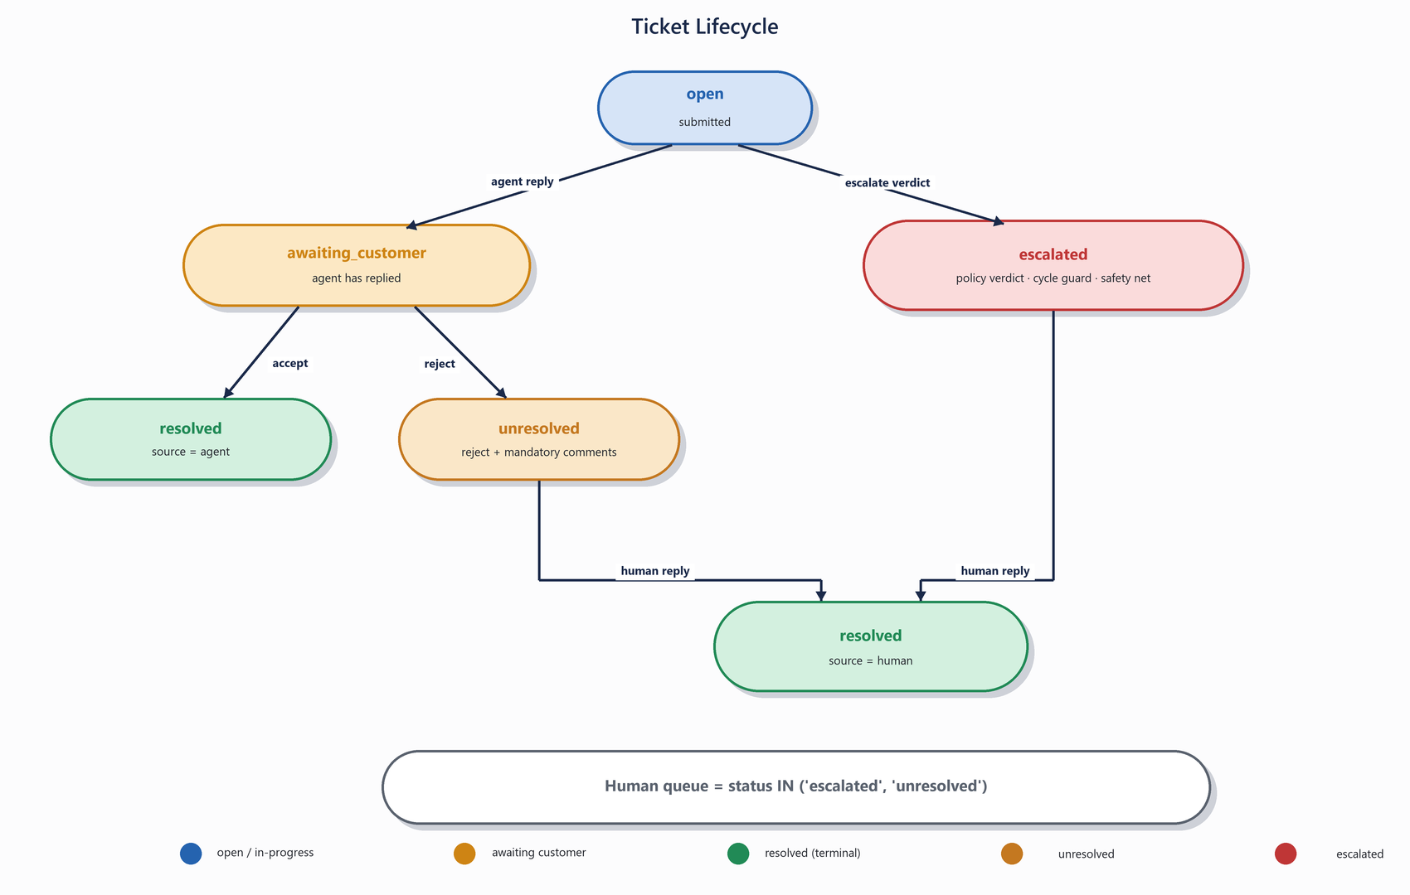
Figure 3. Ticket status state machine — human queue is escalated ∪ unresolved.
Status | Meaning
open | Submitted; agent chain in progress.
awaiting_customer | Agent replied; customer must accept or reject. Set by ticket-handler after a successful (non-escalated) chain.
resolved | Terminal. resolutions.source records 'agent' or 'human'.
unresolved | Customer rejected the agent's answer, with mandatory comments. Appears in the human queue alongside escalated.
escalated | The system chose not to answer (policy verdict, cycle guard, or safety net).

Human queue = status IN ('escalated', 'unresolved'). A human reply from the queue always transitions to resolved with source = 'human'. Every terminal or queue-entering event (accept, reject, human reply) writes a resolutions row and embeds it (§9).

8. Customer Flow and Access Control
- Submit: the public form takes email, title, description. The server route matches the email against customers (case-insensitive); on match it lists that customer's orders so they pick the one the ticket concerns → tickets.order_id. An unknown email creates a customer row with no orders — order-specific questions on such tickets escalate via R3/D2.
- Token: submit generates tickets.access_token (cryptographically random, e.g. 32 bytes base64url). The ticket URL — /ticket/[id]?t=<token> — is the customer's only credential. Every customer-facing route compares tokens with a constant-time check and returns 404 on mismatch (not 403 — don't confirm the ticket exists).
- Wait on page: the browser holds the submit request while the chain runs (~30–90s), showing progress, then renders the agent's reply with accept / reject-with-comments inline. Known risk: if real latency exceeds browser/Function-URL comfort, fall back to polling the tokenized ticket route — same token model, no schema change.
- Return visits: the same tokenized link shows current status — including the human's reply once an escalated/unresolved ticket is answered.
- Human queue: /queue is gated by a single shared password (env var). No RBAC; anyone past the gate can see and answer every queued ticket. Deliberate hackathon scope.

9. Learning Loop
Write path (shared functions in packages, consumed by both ticket-handler and the Next.js server routes):
Event | Writes
Agent replies | conversation_history row (role='agent'); ticket → awaiting_customer
Customer accepts | ticket → resolved; resolutions row: outcome='resolved', source='agent' → embed
Customer rejects | ticket → unresolved; resolutions row: outcome='unresolved', source='agent', rejection_comments = customer's stated reason → embed
Human replies | ticket → resolved; conversation_history row (role='human_agent'); resolutions row: outcome='resolved', source='human' → embed

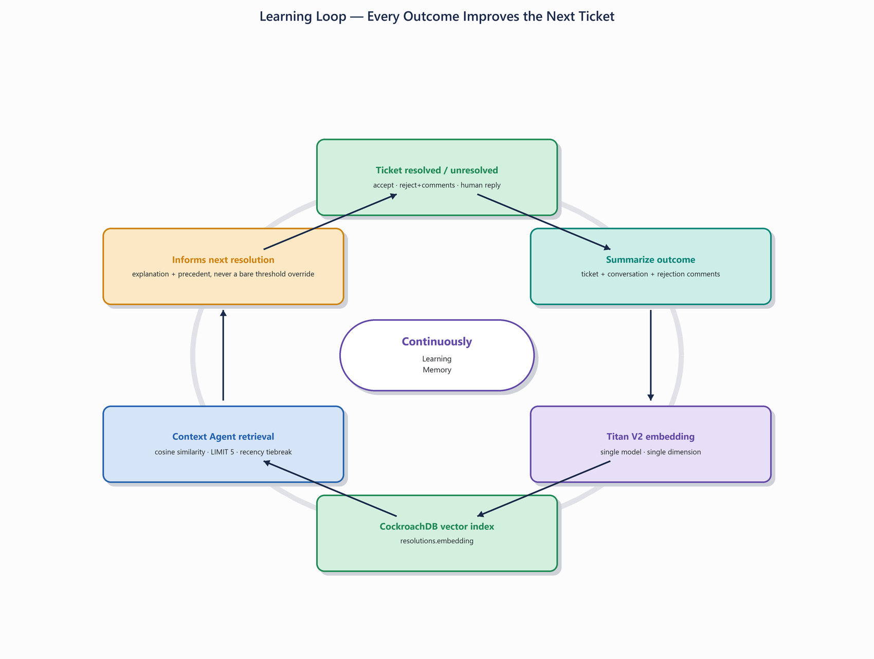
Figure 4. The continuous learning loop — every outcome, good or bad, feeds the next resolution.
- Embed = summarize the ticket + conversation + outcome into resolutions.content, generate a Titan V2 embedding, store it in resolutions.embedding. Both good and bad outcomes are embedded (diagram note 13) — the rejection comments are the system's richest learning signal.
- Retrieval (context agent): cosine similarity via the CockroachDB vector index, always with a LIMIT (default 5), ordered by similarity with recency as tiebreak. Optional filters on outcome/source. Unbounded or unfiltered scans of the embedding column are forbidden.
- Dimension safety: EMBEDDING_DIM is a single exported constant in packages/core, consumed by the DDL and the embedding client, and asserted against the actual returned vector length on every embed call — a model swap fails fast instead of silently corrupting the table.

10. Data Model
CockroachDB. Columns and tables marked [added] do not appear in the original whiteboard diagram — rationale in §12. Full DDL is in Appendix A.

customers
Column | Type | Notes
id | UUID PK
name | STRING
email | STRING UNIQUE
created_at | TIMESTAMPTZ

order_history
Column | Type | Notes
id | UUID PK
customer_id | UUID FK | → customers(id)
status | STRING | 'processing' | 'shipped' | 'delivered' | 'shipped_back_to_sender'
order_value_cents | INT8 | [added] refund/dispute rules need order value
shipped_at | TIMESTAMPTZ NULL | [added] R1 needs pre-shipment state
received_at | TIMESTAMPTZ NULL | [added] R2 needs days-since-received
created_at | TIMESTAMPTZ

tickets
Column | Type | Notes
id | UUID PK
customer_id | UUID FK | → customers(id)
order_id | UUID NULL FK | [added] ties ticket to the order under discussion
title / description | STRING
category / priority | STRING NULL | advisory, LLM-assigned; nothing branches on it
status | STRING | open | awaiting_customer | resolved | unresolved | escalated [added: awaiting_customer, unresolved]
assigned_to | STRING NULL | null until a human picks up a queued ticket
access_token | STRING | [added] gates public customer routes
created_at | TIMESTAMPTZ

conversation_history
Column | Type | Notes
id | UUID PK
ticket_id | UUID FK | → tickets(id)
role | STRING | 'customer' | 'agent' | 'human_agent' | 'system'
message | STRING
timestamp | TIMESTAMPTZ

orchestration_state
[added] invariant enforcement, §5
Column | Type | Notes
ticket_id, conversation_id | UUID, UUID | composite PK
context_called_at | TIMESTAMPTZ NULL
cycle_count | INT DEFAULT 0
updated_at | TIMESTAMPTZ

resolutions
materializes the diagram's “Resolution embeddings” box
Column | Type | Notes
id | UUID PK
ticket_id | UUID FK | → tickets(id)
content | STRING | summary of ticket + conversation + outcome
outcome | STRING | 'resolved' | 'unresolved'
source | STRING | 'agent' | 'human'
rejection_comments | STRING NULL | [added] customer's stated reason — key learning signal
embedding | VECTOR(1024) | dimension = EMBEDDING_DIM constant; Titan V2 only
created_at | TIMESTAMPTZ

Plus: CREATE VECTOR INDEX resolutions_embedding_idx ON resolutions (embedding).
CockroachDB's vector index is public preview.
Fine to build on, not to present as a battle-tested GA capability.

11. Data Access and Storage Layers
- TicketDataPort (in packages/db) is the single interface for all agent-side data access. Two implementations, selected by DB_ACCESS_MODE: SqlAdapter (default) — pooled pg connection, cached at module scope and reused across warm Lambda invocations; McpAdapter — the CockroachDB managed MCP server (diagram note 14), tried at activation and abandoned via config flip, not code change, if authentication doesn't work. The web app's reads always use direct pooled SQL regardless of mode — MCP is the agent's tool surface, not a CRUD API.
- S3 — read-only policy documents (refund-policy.json, dispute-policy.json, generic-policy.json), each pairing prose with machine-readable params (§6.3), loaded behind an interface so unit tests mock them, TTL-cached at module scope. Lambdas get s3:GetObject on this bucket and nothing else.
- CloudWatch — every Lambda emits structured JSON logs carrying ticket_id, conversation_id, action group name, verdict/reason codes, and latency. No free-text-only log lines on the request path.

12. Refinements & Rationale — Every Deviation from the Diagram
Review this list to veto any refinement; everything not listed here follows the diagram verbatim.
# | Deviation | Why
1 | Invariants (context-first, 3-cycle cap) enforced by Lambda guards over orchestration_state, not just the agent prompt | A managed Bedrock Agent can only be asked, not forced; prompt-only rules are untestable. §5
2 | Refund/dispute rules are pure TypeScript functions, parameterized by S3 policy documents; the LLM only explains verdicts | Notes 17–18 are precise financial rules; LLMs get boundary cases wrong. Parameterization keeps documents authoritative while enforcement stays deterministic. §6, §6.3
3 | order_history gains order_value_cents, shipped_at, received_at; tickets gains order_id | The diagram's own refund rules reference order value, ship state, and days-since-received — unanswerable from its four columns. §10
4 | Status enum extended with awaiting_customer and unresolved | Note 12 requires an unresolved outcome; accept/reject needs an awaiting state. §7
5 | resolutions table with outcome, source, rejection_comments, embedding column | Materializes the diagram's “Resolution embeddings” box; rejection comments captured as learning signal. §9–§10
6 | TicketDataPort with SqlAdapter (default) + McpAdapter, chosen by DB_ACCESS_MODE | Lambda→managed-MCP auth is unverified; an adapter turns the unknown into a config flip instead of a build blocker. §11
7 | “Cycle” defined as specialist (non-context) invocations, capped at 3 | Note 10's “plan call evaluate cycle” is unobservable from outside the agent; specialist calls are the closest enforceable proxy. §5
8 | tickets.access_token gating public customer routes | Not in the diagram, but without it anyone could read or act on anyone's ticket. §8
9 | Submit flow: email match + order picker populates tickets.order_id | The diagram never says how a ticket ties to a customer/order; picking deterministically keeps order identification out of LLM judgment. §8
10 | Accept/reject/human-reply handled by Next.js server routes calling shared package functions | The diagram has no write path for these events; routes reuse the same tested code the Lambdas use, with no extra Lambda. §9
11 | One embedding model (Titan V2), dimension as a shared constant, runtime length assertion | The diagram names no embedding model; mixing models or dimensions silently corrupts similarity search. §9
12 | escalate verdicts set tickets.status in the specialist Lambda itself | Status changes are deterministic side effects of deterministic verdicts — not left to the LLM to remember to do. §4
13 | Policy documents are JSON (prose + params) with TTL/ETag refresh; the agent's baked instruction prompt carries no policy values | Policy docs get edited over time; verdicts and explanations must track the current document without redeploys or Agent re-preparation. §6.3

13. Out of Scope — Deliberately
- Multi-turn customer chat (one-shot + accept/reject-with-comments only)
- Email intake or outbound email
- RBAC (single shared password for the queue; per-ticket tokens for customers)
- Real payment/refund execution — verdicts are recorded and communicated, no money moves
- Bedrock multi-agent collaboration (one supervisor Agent + action groups only)
- Production hardening: multi-region, rate limiting, PII handling beyond the demo dataset

A. Appendix — Full Data Definition Language
Complete DDL corresponding to the data model in §10, for direct use by the migration scripts.
CREATE TABLE customers (
id UUID PRIMARY KEY DEFAULT gen_random_uuid(),
name STRING NOT NULL,
email STRING NOT NULL UNIQUE,
created_at TIMESTAMPTZ NOT NULL DEFAULT now()
);
CREATE TABLE order_history (
id UUID PRIMARY KEY DEFAULT gen_random_uuid(),
customer_id UUID NOT NULL REFERENCES customers(id),
status STRING NOT NULL,
order_value_cents INT8 NOT NULL,
shipped_at TIMESTAMPTZ NULL,
received_at TIMESTAMPTZ NULL,
created_at TIMESTAMPTZ NOT NULL DEFAULT now()
);
CREATE TABLE tickets (
id UUID PRIMARY KEY DEFAULT gen_random_uuid(),
customer_id UUID NOT NULL REFERENCES customers(id),
order_id UUID NULL REFERENCES order_history(id),
title STRING NOT NULL,
description STRING NOT NULL,
category STRING NULL,
priority STRING NULL,
status STRING NOT NULL DEFAULT 'open',
assigned_to STRING NULL,
access_token STRING NOT NULL,
created_at TIMESTAMPTZ NOT NULL DEFAULT now()
);
CREATE TABLE conversation_history (
id UUID PRIMARY KEY DEFAULT gen_random_uuid(),
ticket_id UUID NOT NULL REFERENCES tickets(id),
role STRING NOT NULL,
message STRING NOT NULL,
timestamp TIMESTAMPTZ NOT NULL DEFAULT now()
);
CREATE TABLE orchestration_state (
ticket_id UUID NOT NULL REFERENCES tickets(id),
conversation_id UUID NOT NULL,
context_called_at TIMESTAMPTZ NULL,
cycle_count INT NOT NULL DEFAULT 0,
updated_at TIMESTAMPTZ NOT NULL DEFAULT now(),
PRIMARY KEY (ticket_id, conversation_id)
);
CREATE TABLE resolutions (
id UUID PRIMARY KEY DEFAULT gen_random_uuid(),
ticket_id UUID NOT NULL REFERENCES tickets(id),
content STRING NOT NULL,
outcome STRING NOT NULL,
source STRING NOT NULL,
rejection_comments STRING NULL,
embedding VECTOR(1024) NOT NULL,
created_at TIMESTAMPTZ NOT NULL DEFAULT now()
);
CREATE VECTOR INDEX resolutions_embedding_idx ON resolutions (embedding);

