Operant Event
Complete User Guide
A Plain-English Guide to Running Conferences, Managing Papers,
Reviews, Registrations, and More

Version: 1.0
Prepared: September 2026
Audience: Organizers, Reviewers, Authors, Attendees, Speakers, and Event Staff
Reading time: Approximately 45–60 minutes

Table of Contents
1. Welcome to Operant Event
2. Who Uses This Application
3. Where Do You Log In? The Six Portals
4. Getting Started: Creating Your Account
5. Your Organization: The Workspace Behind Every Event
6. Managing Your Team: Members, Roles & Permissions
7. Conferences: The Life of an Event
8. Setting Up a New Conference
9. Tracks and the Submission Form Builder
10. Submitting a Paper: The Author's Journey
11. The Peer Review Process
12. Registration and Payments
13. Building the Conference Programme
14. Event Day: Checking In Delegates
15. Certificates
16. Sponsors and Exhibitors
17. Notifications and Automated Emails
18. Reports and Dashboards
19. Exporting and Importing Data
20. Your Account and Security
21. Roles and Permissions Reference
22. What This Application Does Not Do Yet
23. Frequently Asked Questions
24. Glossary of Terms

1. Welcome to Operant Event
Operant Event is a complete, all-in-one platform for planning and running conferences, seminars, and academic or professional events — from the very first announcement to handing out certificates after the closing ceremony.
Think of it as the digital 'control room' for your event. Instead of juggling spreadsheets for paper submissions, a separate tool for collecting registration fees, a mailing list for reminders, and a printed sign-in sheet at the door, everything lives in one connected system:
Researchers and speakers submit their papers or abstracts online and track their status.
Your review committee evaluates submissions and records decisions — accept, reject, request changes, or waitlist.
Delegates register and pay online, and instantly receive a personal QR code.
Your team builds the day-by-day programme, assigning speakers and sessions.
On the big day, staff check people in with a quick scan at the door.
After the event, the system automatically works out who has earned a certificate and lets you issue them with one click.
Throughout, everyone receives automatic email updates at the right moments — no one has to remember to send them.
One organization can run as many conferences as it likes, and each conference moves through the same clear, predictable stages described in Section 7.
This guide is written for everyone who touches the system — not just the people setting it up. Whether you're an event organizer, a committee member reviewing papers, an author submitting your research, a delegate registering to attend, or a volunteer scanning badges at the entrance, this guide has a section written for you.
💡 How to use this guide: You don't need to read it front to back. Use the Table of Contents to jump straight to the section that matches what you're trying to do right now.

2. Who Uses This Application
Operant Event is built around two broad groups of people: the team that organizes the event, and the people who take part in it. Nobody needs special software or training — everything happens through a normal web browser.
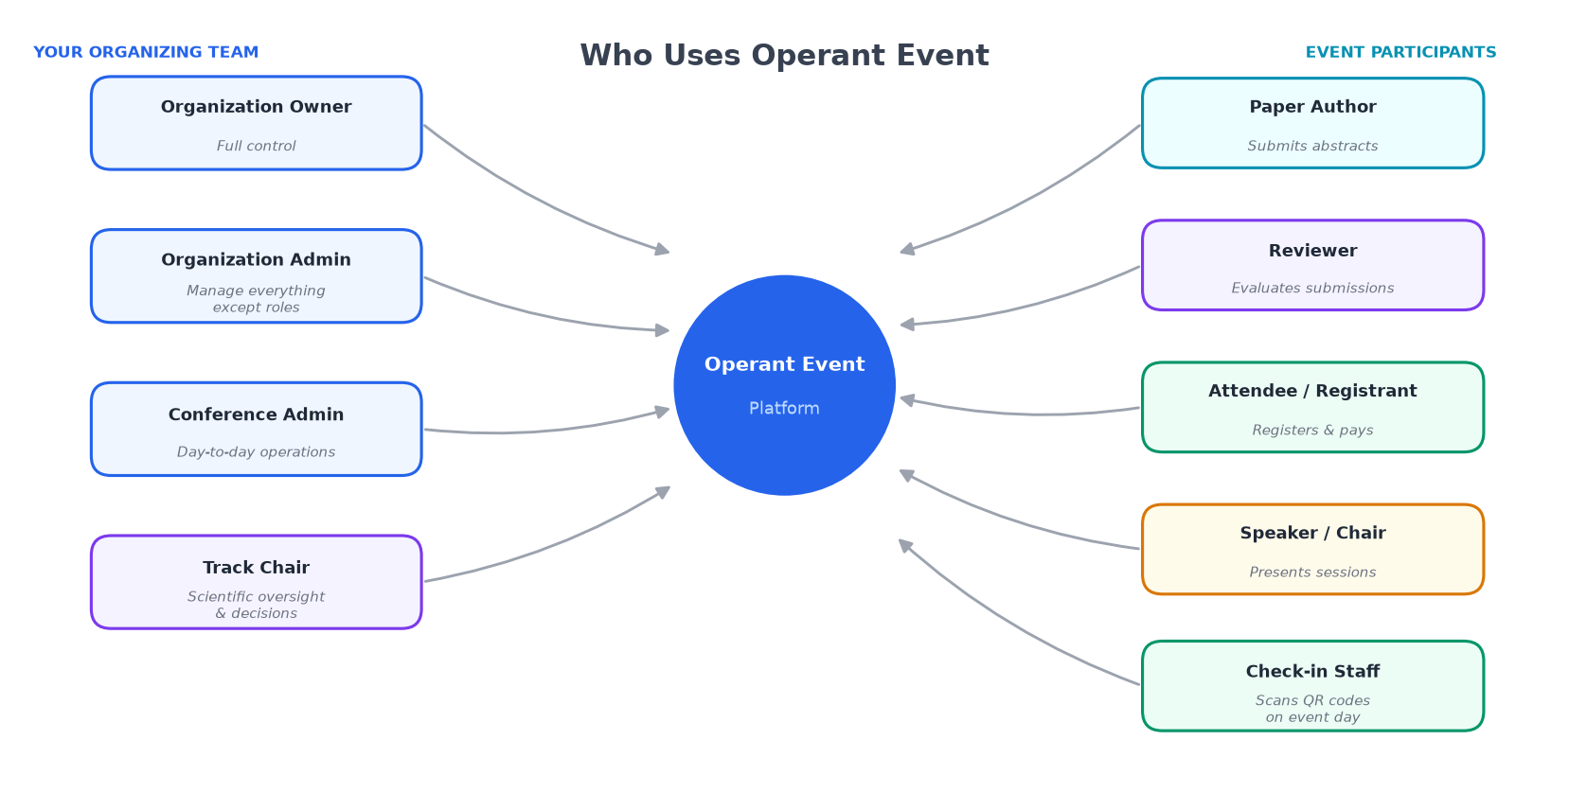
Figure 1 — Everyone who uses Operant Event and the role they play

Your Organizing Team
These are the people inside your organization (your society, university, or event company) who plan and run the show. They log in to a shared organizer back-office.
Role | In plain terms
Organization Owner | The person who created the workspace, or someone promoted to full control. Can do absolutely everything, including deciding who else gets which powers.
Organization Admin | Almost as powerful as the Owner — can manage every part of every conference and the whole team — except they cannot hand out or change high-level roles.
Conference Admin | The day-to-day event manager. Runs registration, payments, the programme, check-in, certificates, sponsors, and reporting. Does not handle the academic review side.
Track Chair | The academic/scientific lead. Manages the reviewer pool, assigns papers to reviewers, and makes final accept/reject decisions. Does not handle money or logistics.

Everyone Who Takes Part in Your Event
These people never need to be added to your organization's team. They simply create a free personal account and the system automatically gives them the right screens.
Who they are | What they do in the system
Author / Submitter | Submits papers, abstracts, or proposals to one of your conferences.
Reviewer | A subject-matter expert invited by the Track Chair to evaluate assigned papers.
Attendee / Registrant | Registers to attend, pays the applicable fee, and checks in on the day.
Speaker / Session Chair | Presents at or chairs a session — added to the programme by your team.
Check-in Staff | Uses the purpose-built scanning screen on event day at the registration desk.
Exhibitor / Sponsor contact | Tracked as a record by your team — does not currently have a self-service login.

3. Where Do You Log In? The Six Portals
Operant Event shows a different, purpose-built screen depending on who you are — so a delegate never has to wade through organizer settings, and an author never sees a reviewer's scoring form by mistake.
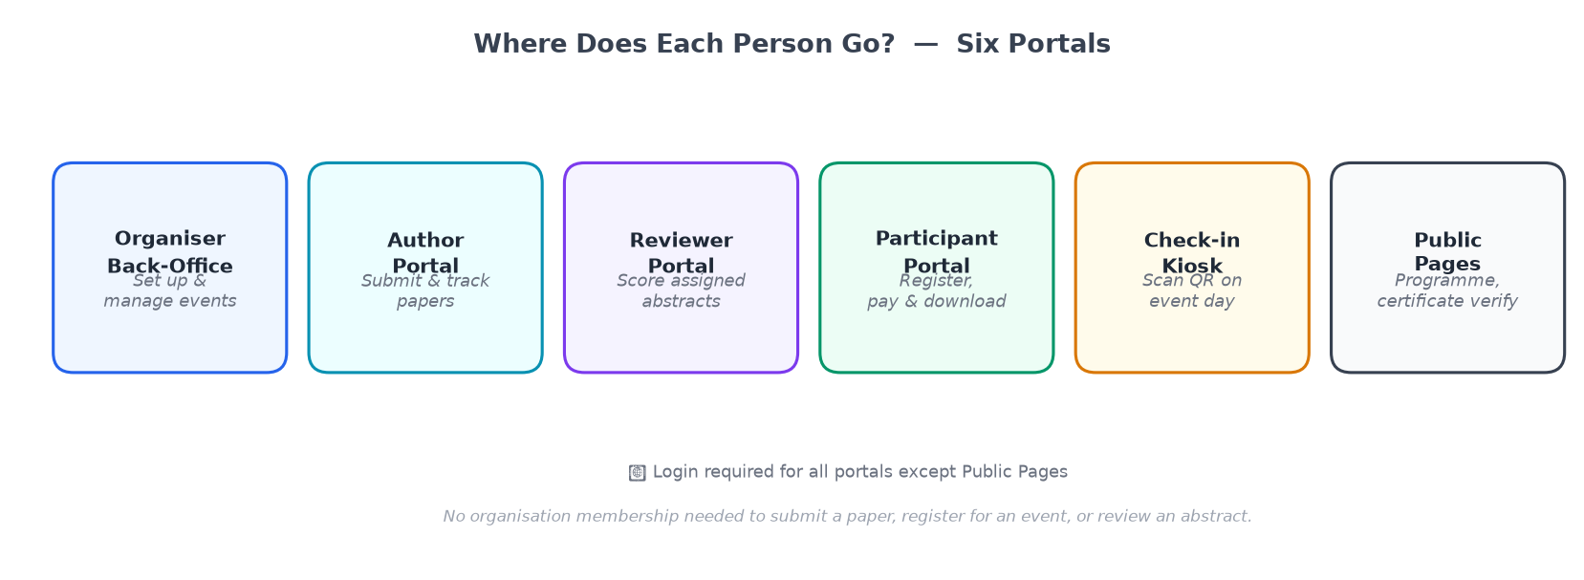
Figure 2 — The six portals and who uses each one
Portal | Who uses it | What it's for
Organizer Back-Office | Organizing team | Setting up and running conferences end-to-end
Author Portal | Paper submitters | The submission wizard and 'My Abstracts' list
Reviewer Portal | Reviewers | 'My Reviews' — assignments and the scoring form
Participant Portal | Attendees / delegates | Choosing a category, paying, viewing tickets
Check-in Kiosk | Registration desk staff | Full-screen QR scanning on event day
Public Pages | Anyone | Sign up, sign in, public programme, certificate verification

4. Getting Started: Creating Your Account
Everyone starts the same way — with a free personal account.
Step 1: Go to the sign-up page (shared by your organizer, or linked from a conference's public page).
Step 2: Enter your name, email address, and a password. The system tells you immediately if your password is too weak.
Step 3: Check your inbox — you'll receive a welcome email confirming your account is active.
Step 4: Sign in. This one login works everywhere in Operant Event — as an author, reviewer, delegate, or organizer.
If you were invited by an organizer: you'll receive an invitation email with a special link. Clicking it lets you set your password and immediately access the organizer back-office with the role you were invited to hold.
One account, many hats: the same email and password can be an Organization Owner for your own society's conferences, a Reviewer for someone else's conference, and an Attendee registering for a third — all at once.

5. Your Organization: The Workspace Behind Every Event
An Organization is the umbrella workspace for everything your society, university department, or event company does in Operant Event. Every conference belongs to exactly one organization.

What Lives Inside an Organization
Every conference you've ever run or are currently planning — visible in one dashboard.
Your whole team — everyone with organizer-side access and their role.
Organization-wide settings — branding, default email sender address, and payment gateway connections.
Cross-conference reporting — see totals and trends across every event, not just one at a time.
Multiple organizations: a freelance conference manager can belong to more than one organization. When they log in, they simply pick which workspace to work in — each one's data, team, and conferences stay completely separate.

6. Managing Your Team: Members, Roles & Permissions

Inviting a Team Member
Open Team → Members in the organizer back-office.
Click Invite Member, enter their email, and choose their role.
They receive an invitation email. Once accepted, they appear in your member list.

Built-in Roles vs. Custom Roles
Operant Event ships with four ready-made roles: Organization Owner, Organization Admin, Conference Admin, and Track Chair. For most organizations, these are all you'll ever need.
If you need something more specialized — say, a Finance Officer who sees payment reports but nothing else — an Owner can build a custom role by selecting exactly which individual permissions it should have from the full permission catalogue (see Section 21).

Per-Conference Assignment
Conference Admin and Track Chair are assigned per conference — one person can be Conference Admin for one event while someone else manages a different event in the same organization.

7. Conferences: The Life of an Event
Every conference moves through the same series of clear stages — from a first idea to a wrapped-up archive.
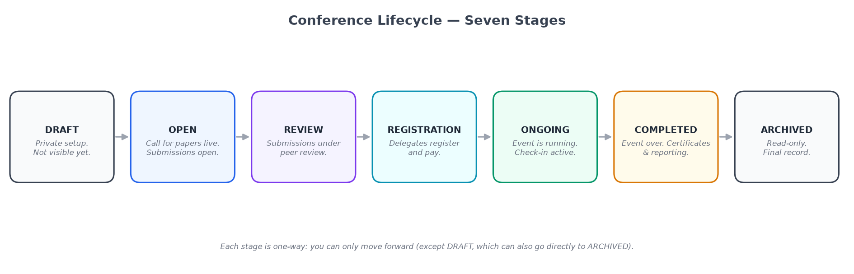
Figure 3 — The seven stages of a conference lifecycle
Stage | What's happening
Draft | Private idea — filling in details; nothing visible to the public yet.
Published | Public page is live; abstract submission and/or registration may be open.
Submissions Open | Authors can submit papers/abstracts to your tracks.
Under Review | Submissions closed; reviewers and Track Chair are evaluating them.
Programme Building | Decisions are in; team assembles the day-by-day schedule.
Live / Ongoing | The event is happening; check-in is active.
Completed / Archived | Event ended; certificates can be issued; final reports available.

8. Setting Up a New Conference
Creating a conference is a guided, step-by-step process. You can adjust any of these later.
1. Basic details: Name, short description, start and end dates, time zone, and venue.
2. Branding: Upload a logo and choose accent colours so public pages feel like your event.
3. Feature toggles: Turn on only what this conference needs: Abstract Submissions, Peer Review, Paid Registration, Certificates, Sponsors.
4. Tracks: Create subject tracks authors can submit to (if abstracts are enabled).
5. Registration categories: Define who can register and at what price (if registration is enabled).
6. Publish: Move from Draft to Published when you're ready for the public to see it.
💡 Cloning: running the same annual event? Duplicate a previous conference — carrying over its tracks, form fields, and registration categories — then update the dates.

9. Tracks and the Submission Form Builder
A Track is a subject area that authors submit to — for example, 'Machine Learning' or 'Poster Presentations'. Each track has its own Track Chair, reviewer pool, and custom submission form.

The Submission Form Builder
The form builder offers a library of field types:
Field type | What it collects
Short text | One-line answers: a title, author name, affiliation
Long text / rich text | Multi-paragraph text — ideal for the abstract body
Dropdown | One selection from a fixed list you define
Checkboxes | One or more selections from a list
File upload | PDF, DOCX, or other files up to the maximum size shown
Date picker | A calendar selector
Author / co-author block | Repeating group for each author's name, affiliation, email, ORCID

💡 Tip: Changing a form after authors have already submitted will not retroactively alter existing submissions — plan your form before opening submissions.

10. Submitting a Paper: The Author's Journey
If you're an author submitting a paper to a conference, this section is written for you.
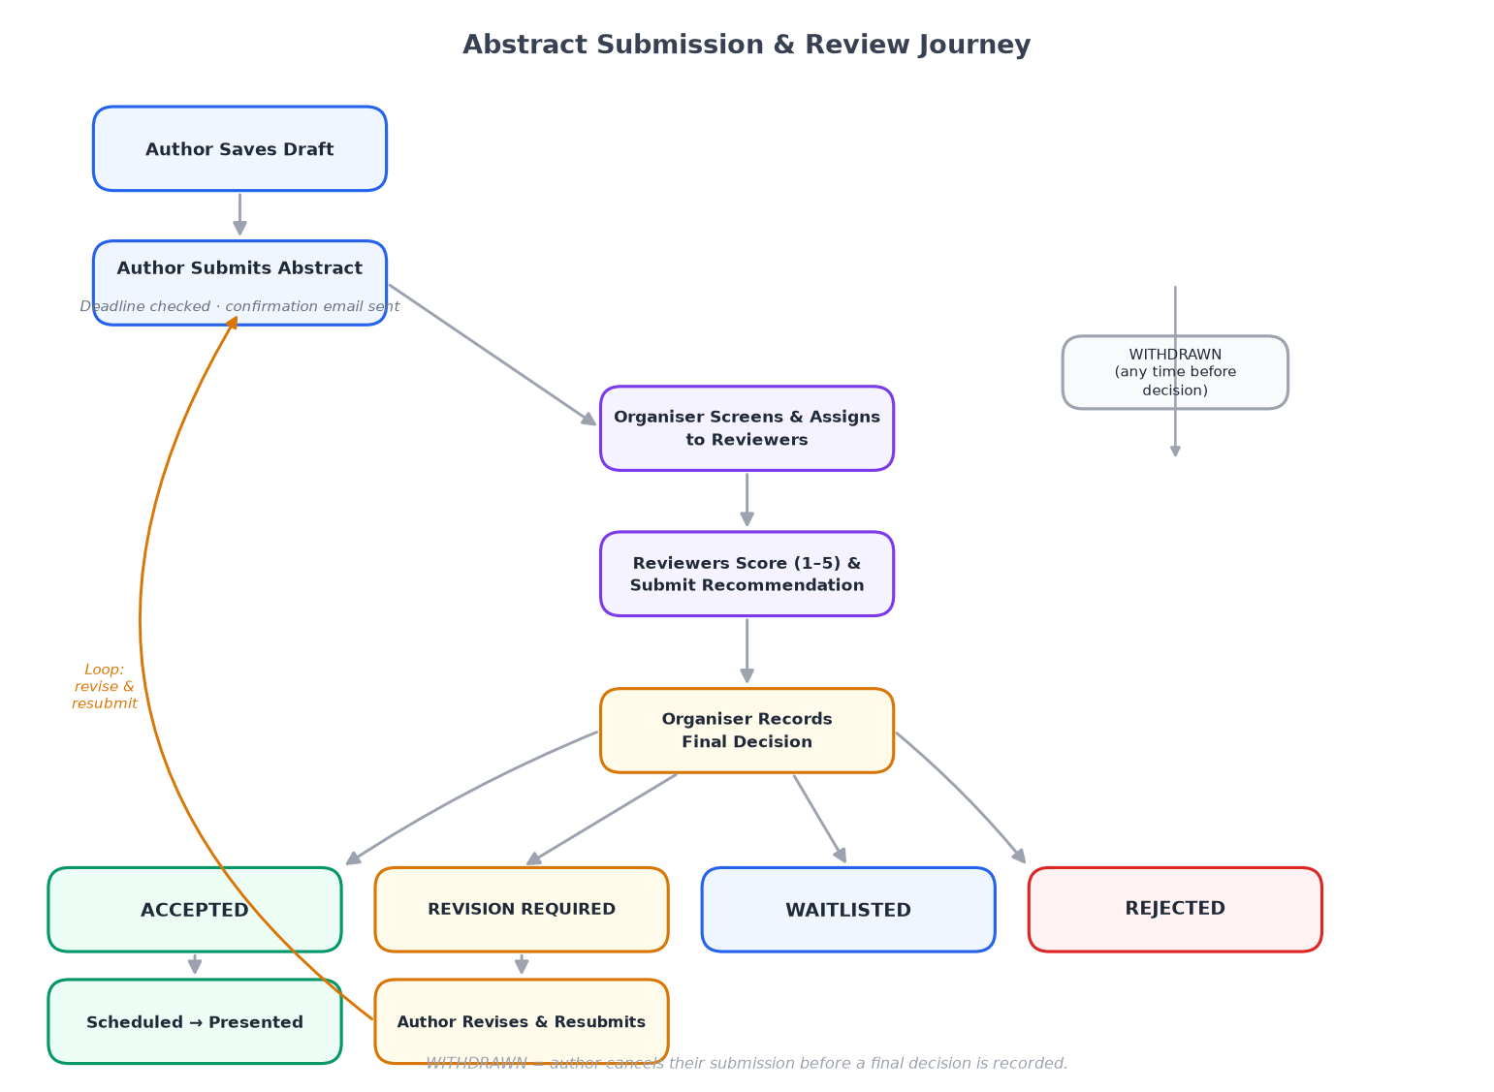
Figure 4 — The five steps of the abstract submission journey

Step 1 — Find the Conference and Track
The organization will share a link to the submission page. Select the track you're submitting to and click Submit to this track.

Step 2 — Create or Sign In to Your Account
If you don't have an account yet, you'll be prompted to create one — name, email, password. Free, takes under a minute.

Step 3 — Fill In the Submission Form
Work through the form. Fields marked * are required. You can Save Draft at any time and return later — your draft is private until you actually submit.

Step 4 — Submit
Click Submit. You'll see a confirmation page and receive an email confirmation immediately. Keep it — it's your record of arrival before the deadline.

Step 5 — Track Your Submission
Sign in any time and go to My Submissions. Possible statuses:
Status | What it means
Submitted | Received and queued for reviewer assignment.
Under Review | Reviewers are currently reading and scoring your work.
Revision Requested | The Track Chair has asked for changes before a final decision.
Accepted | Your paper has been accepted for the conference.
Waitlisted | May still be included if space allows after all decisions.
Rejected | Not accepted for this round.
Withdrawn | You withdrew the submission yourself.

11. The Peer Review Process

For the Organizing Team (Track Chair)
Once submissions close, the Track Chair manages the review pipeline in four steps:
Build the Reviewer Pool: Add reviewers by email (Track → Reviewers → Add Reviewers). New reviewers receive an invitation; existing account-holders are in immediately.
Assign Papers: Use Auto-assign for even distribution or Manual assign for expertise matching. Each paper can have multiple reviewers.
Monitor Progress: The Assignments dashboard shows how many reviews each reviewer has completed and how many are overdue. Send nudge reminders from this screen.
Record the Final Decision: After reviews are in, the Track Chair records Accept, Reject, Revision, or Waitlist. Authors are notified automatically.

For Reviewers
Accept the invitation email.
Open 'My Reviews' — a list of every paper assigned to you with deadlines.
Read the paper and fill in the review form (scores, comments to authors, confidential comments to chair, overall recommendation).
Declare a Conflict of Interest if you know the author or have any other reason you can't review impartially — the paper is then reassigned.
Submit your review. You can edit it while the review window is still open.

12. Registration and Payments
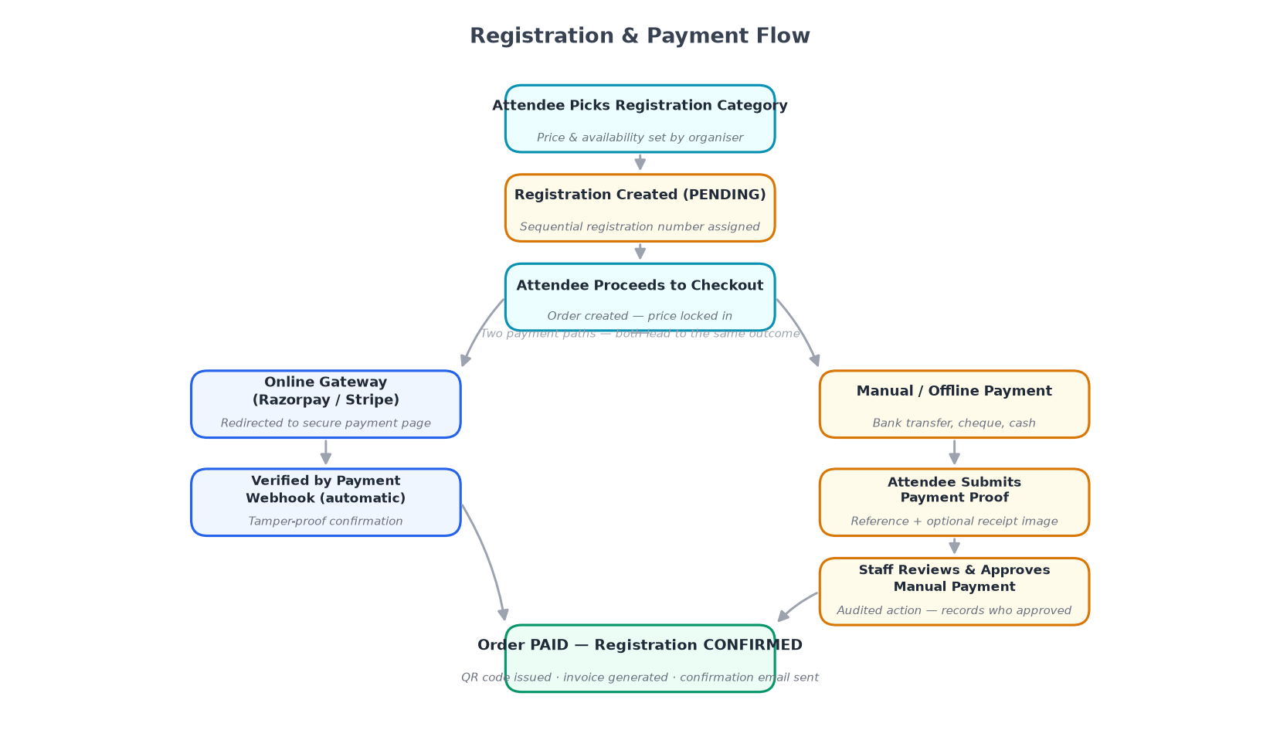
Figure 5 — The registration and payment flow for delegates

For Delegates
Step 1: Find the registration page (linked by the organizer) and review available registration categories.
Step 2: Select your category (e.g. Early Bird, Student, Day Pass). Categories have capacity limits — if 'Sold out', choose an alternative.
Step 3: Fill in your details and answer any additional questions (dietary needs, T-shirt size).
Step 4: Pay online by card (Razorpay or Stripe) or by bank transfer if the organizer allows it.
Step 5: Receive your confirmation email with a personal QR code and PDF ticket.
Step 6: View your ticket anytime under My Registrations.

For the Organizing Team — Setting Up Registration Categories
Open Conference → Registration → Categories → Add Category. For each category:
Setting | What it does
Name | What delegates see (e.g. 'Academic / Full Access')
Price | Amount charged; set to 0 for a free category
Currency | Selected once per conference — shared by all categories
Capacity | Maximum registrations in this category (blank = unlimited)
Visibility period | Dates between which this category is available — use for early-bird pricing
Included items | Optional description of what this ticket includes

💡 Note: Discount codes and coupon codes are not available in the current version. See Section 22 for a full list of features not yet built.

13. Building the Conference Programme
Once papers are accepted, build the public-facing timetable that speakers and attendees follow.
Add your days: Pre-filled from conference dates; add or remove as needed.
Add rooms / venues: Name each space: 'Main Hall', 'Meeting Room A', 'Online Stream 2'.
Add sessions: Pick a day, room, start/end time, and title. Mark breaks or special events distinctively.
Add session items: Link accepted abstracts (title/authors pull in automatically) or add free-form items for keynotes and invited talks.
Assign speakers: Link to an Operant Event account for certificate eligibility, or enter as a free-form name.
Set a session chair: Assign a chair by account or free-form name.
💡 Publishing: the programme is private until you click 'Publish Programme'. Once published, updates take effect immediately — great for last-minute room swaps on the day.

14. Event Day: Checking In Delegates
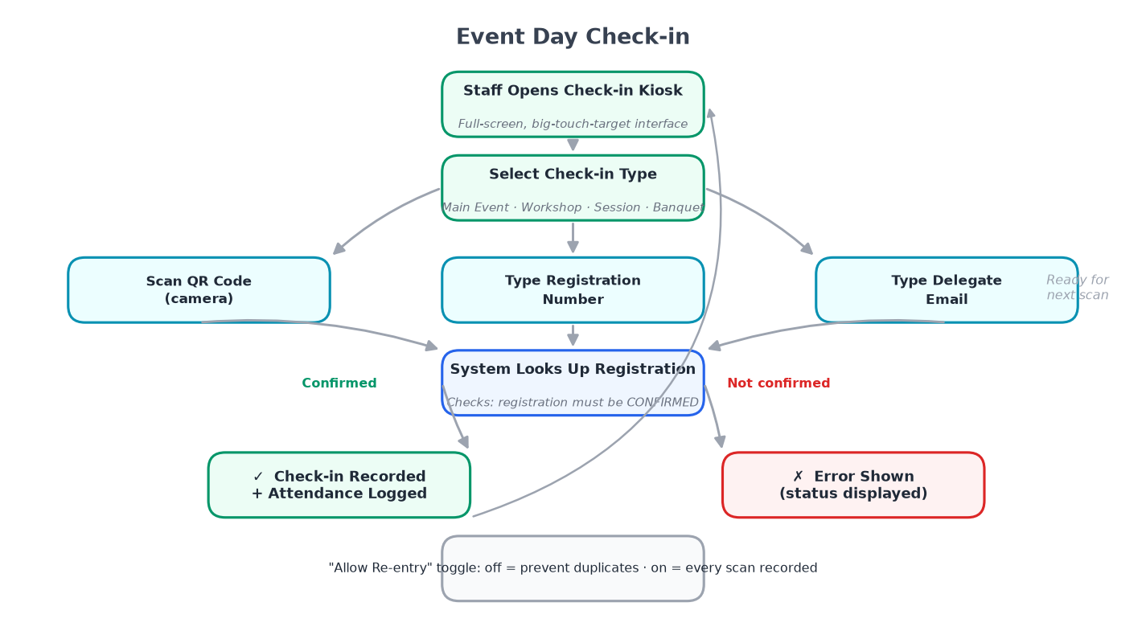
Figure 6 — Event-day check-in: two routes to confirming arrival

Before the Day
Ensure all desk staff have the Check-in Staff permission (or higher) in Team → Members.

On the Day: Two Ways to Check Someone In
Option A — Scan QR Code (Recommended): Click the camera/scanner button and hold the delegate's QR code up to the camera. The system shows a green tick and marks them checked in in about two seconds.
Option B — Name or Email Search: Type into the search box to find the registrant, verify identity verbally, then click Check In.

Real-time Counts
A live counter at the top of the kiosk shows expected registrants, checked-in so far, and still expected — updating instantly across all simultaneously-running devices.
💡 Session-level check-in: if your conference has ticketed workshops or a gala dinner, enable session-level check-in so staff pick a session first and each has its own attendee list.

15. Certificates
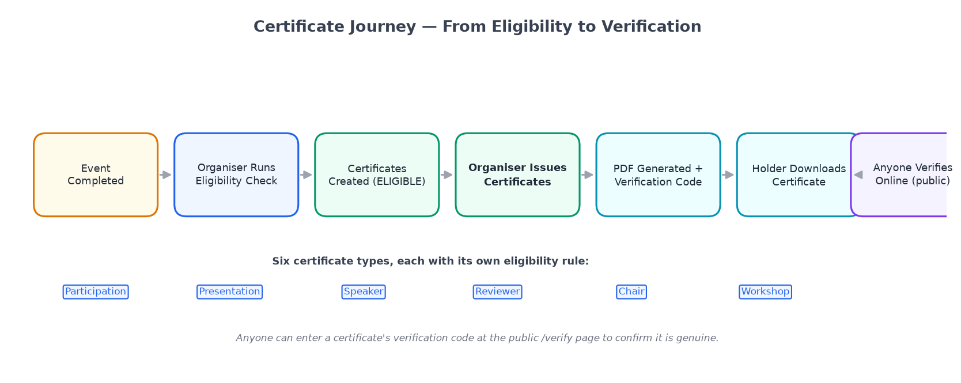
Figure 7 — Certificate eligibility check and issuance process

Types of Certificates
Type | Typically goes to
Attendance Certificate | Delegates who registered and checked in
Presentation Certificate | Speakers whose paper or talk appeared in the programme
Review Certificate | Reviewers who completed at least the minimum number of assigned reviews

Issuing Certificates
Step 1: Go to Certificates in the back-office after the event ends and check-in is closed.
Step 2: Click Check Eligibility — the system evaluates everyone against the conditions you set.
Step 3: Review the eligibility list; manually override if needed.
Step 4: Click Issue Certificates — personalized PDFs are generated and download links emailed automatically.
💡 Verification: every certificate has a unique code. Anyone can visit the public conference page and enter the code to confirm the certificate is genuine — no account required.

16. Sponsors and Exhibitors
Track your event's financial supporters and exhibitors inside the same system you use for everything else.

Sponsors
Go to Conference → Sponsors → Add Sponsor. Record the company name, logo, sponsorship tier, website, payment status, and any internal notes. Sponsors with logos appear on the public conference page in tier order.

Exhibitors
Tracked similarly — company name, contact person, booth number, payment status. Currently managed entirely by your team; exhibitors do not have a self-service portal.

17. Notifications and Automated Emails
Operant Event sends emails at every key moment automatically — no one has to remember to trigger them.
Trigger | Recipient
Account created | New user
Password reset requested | Requesting user
Conference invitation (organizer) | Invited team member
Reviewer invitation | Invited reviewer
Abstract submitted | Author (confirmation)
Abstract status changed | Author
Review assigned | Reviewer
Registration confirmed | Registrant
Registration pending (awaiting manual payment) | Registrant
Certificate issued | Certificate recipient

Customizing Email Templates
Go to Settings → Email Templates to edit the subject line and body of any automatic email. Use merge fields (e.g. {{author_name}}, {{conference_name}}) for personalization. A preview mode shows how the email looks with sample data.

Sending a Manual Broadcast
Use Communications → Broadcast to send a one-off message to a specific audience — all registrants, reviewers with pending reviews, accepted speakers, etc.

18. Reports and Dashboards
The conference home dashboard gives an at-a-glance view: submission counts by status, registration counts by category, review progress, check-in totals, revenue summary, and upcoming tasks.

Detailed Reports Available
Report | What it shows
Registrations Report | Full list with payment status, date, and category
Submissions Report | All submissions, status, track, and decision date
Reviews Report | Reviewer activity, scores, completion rates
Attendance Report | Who checked in, when, and across which sessions
Revenue Report | Income by category, payment method, and timeline
Certificate Report | Eligibility status and download confirmations
Sponsor / Exhibitor Report | Sponsorship fee payment status and records

Each report can be exported as CSV or Excel. Organization Owners and Admins also have a cross-conference overview dashboard for year-over-year trends.

19. Exporting and Importing Data

Exporting
Look for the Export button on any report or list page. Available formats: CSV and Excel (.xlsx). Common exports: full registrant list, accepted abstracts, reviewer assignments, attendance data.

Importing
Bulk import is available for two things:
Bulk reviewer upload — upload a CSV of reviewer names and emails instead of adding them one by one (Reviewers → Import).
Bulk submission import — import submissions from a previous system as a one-time migration step (Submissions → Import).
💡 Data security: exported files contain personal information. Store them securely, share only with people who genuinely need them, and do not leave them unprotected on shared drives.

20. Your Account and Security

Updating Your Profile
Click your name or avatar → profile. Update your full name, email address, profile photo, and ORCID. Name changes take effect everywhere immediately.

Changing Your Password
Profile → Security → Change Password. Enter your current password, then the new one twice. Changing your password invalidates all other active sessions on other devices.

Privacy
Operant Event stores only the personal information you provide and uses it solely to run the events you take part in. It is not sold to third parties. For the full privacy statement, contact the event organizer or your platform administrator.

21. Roles and Permissions Reference
This is a complete listing of every individual capability. Most users will never need this section — it's for Organization Owners creating custom roles, or team members wanting to understand their access exactly.
Capability | Owner | Admin | Conf Admin | Track Chair
Create a new organization | ✅ | — | — | —
Edit organization settings | ✅ | ✅ | — | —
Invite / remove team members | ✅ | ✅ | — | —
Change a team member's role | ✅ | — | — | —
Create a new conference | ✅ | ✅ | — | —
Edit conference settings | ✅ | ✅ | ✅ | —
Publish / unpublish a conference | ✅ | ✅ | ✅ | —
Delete a conference | ✅ | ✅ | — | —
Manage registration categories | ✅ | ✅ | ✅ | —
View / export registrations | ✅ | ✅ | ✅ | —
Confirm manual payments | ✅ | ✅ | ✅ | —
Manage payment gateway settings | ✅ | ✅ | — | —
Create and manage tracks | ✅ | ✅ | — | ✅
Build / edit submission forms | ✅ | ✅ | — | ✅
View all submissions | ✅ | ✅ | — | ✅
Assign reviewers to submissions | ✅ | ✅ | — | ✅
Record a decision on a submission | ✅ | ✅ | — | ✅
View all reviews | ✅ | ✅ | — | ✅
Manage the programme | ✅ | ✅ | ✅ | —
Manage sponsors and exhibitors | ✅ | ✅ | ✅ | —
Manage and perform check-in | ✅ | ✅ | ✅ | —
Configure and issue certificates | ✅ | ✅ | ✅ | —
View reports and dashboards | ✅ | ✅ | ✅ | ✅
Export reports | ✅ | ✅ | ✅ | ✅
Manage email templates / broadcast | ✅ | ✅ | ✅ | —
Create custom roles | ✅ | — | — | —

22. What This Application Does Not Do Yet
This section lists current limitations honestly so you can plan accordingly.
Feature | Current Status
Two-factor authentication (2FA) | Not available. Accounts are protected by email and password only.
Discount codes and coupons | Promotional pricing cannot be applied at registration.
Tax / VAT on fees | The system does not calculate or display tax separately.
Group registrations | Delegates must register one at a time.
Self-cancellation by delegates | An organizer must cancel a registration on a delegate's behalf.
Badge printing | QR codes can be printed on a ticket, but designed event badges require a separate tool.
Partial refunds | Refunds are all-or-nothing; partial amounts require manual processing outside the platform.
Sponsor / exhibitor self-service portal | Their information is managed entirely by the organizing team.
Audit log viewer | Changes are stored internally but there is no screen to browse the history.
Report date-range filtering | Reports show all-time data; filtering to a date range is not yet available.
Waitlist auto-promotion | Waitlisted registrants must be manually moved to registered.
Co-author notifications | Only the primary submitting author receives status-change emails.
In-app messaging | No real-time chat within the platform.

23. Frequently Asked Questions
Q: Is Operant Event free to use?
Pricing for organizations is set by your platform administrator. For delegates, authors, and reviewers, creating a personal account is free. Whether you pay to attend depends on the organizer's fees.
Q: I can't find the conference I want to register for.
Ask the organizer to share the direct link. Conferences are not in a public directory by default.
Q: My paper shows as 'Submitted' — has anyone looked at it yet?
'Submitted' means it arrived and is queued, but not yet assigned to a reviewer. Once assigned, the status changes to 'Under Review'. Contact the Track Chair if you're worried about a deadline.
Q: Can I edit my submission after submitting?
Once submitted, the paper is locked. Contact the Track Chair — they can return it to draft status for revision, though this may not be possible once review has begun.
Q: I missed the submission deadline. Can I still submit?
Deadlines are enforced automatically. Contact the Track Chair or Conference Admin directly — extending the deadline is entirely at their discretion.
Q: I've paid but haven't received my confirmation email.
Check your spam folder. Then sign in and check My Registrations — your payment status shows there even if the email didn't arrive.
Q: My QR code doesn't scan at check-in.
The desk staff can look you up by name or email search and check you in manually in about ten seconds.
Q: I want to attend AND submit a paper. Do I need two accounts?
No. One account handles everything — register as a delegate and submit your paper using the same login.
Q: Can I review for a conference I didn't submit to?
Yes. Being a reviewer is completely independent of whether you submitted a paper.
Q: How do I transfer organization ownership to someone else?
Go to Team → Members, find the new owner's profile, and promote them to Organization Owner.
Q: Is there a mobile app?
No dedicated app. Every page works well in a mobile browser (Chrome, Safari, Firefox, Edge).

24. Glossary of Terms
Definitions for every term used in Operant Event, in plain English.
Term | Definition
Abstract | A short summary of a paper or research work submitted to a conference track.
Assignment | Connecting a reviewer to a specific paper they will evaluate.
Attendee | A person who registers to attend a conference. Also: registrant, delegate.
Back-office | The organizer-facing screens for managing a conference.
Broadcast | A one-off email sent by an organizer to a defined group.
Camera-ready | A final, print-ready version of an accepted paper for publication.
Capability | One individual permission in the system. Custom roles are built from capabilities.
Certificate verification code | A unique code on every certificate for public verification of authenticity.
Check-in | Confirming a delegate's arrival by scanning their QR code or searching by name/email.
Conference | A single event — academic conference, workshop, or summit — managed in Operant Event.
Conference Admin | Organizer role for logistics: registration, payments, programme, check-in, certificates.
Conflict of interest | A connection between a reviewer and an author that prevents impartial evaluation.
Custom role | A role created by an Owner with a hand-picked set of individual capabilities.
Draft | The private earliest stage of a conference before it is publicly visible.
Exhibitor | A company with a booth at the event; tracked by the organizing team.
Export | Downloading a list from Operant Event as CSV or Excel.
Import | Uploading a CSV to add reviewers or submissions in bulk.
Kiosk | The check-in screen designed for full-screen tablet or laptop use at the registration desk.
Merge field | A placeholder in an email template (e.g. {{author_name}}) replaced with real data on send.
ORCID | Open Researcher and Contributor ID — a unique academic identifier. Optional in Operant Event.
Organization | The umbrella workspace that owns conferences, the team, and organization-wide settings.
Peer review | Evaluation of submitted papers by subject-matter experts before an accept/reject decision.
Portal | One of the six purpose-built views, each designed for a specific type of user.
Programme | The published schedule: which sessions happen when, where, with which speakers.
QR code | A square barcode on a delegate's ticket, scanned at check-in to confirm identity.
Registration | The process of signing up to attend a conference, including payment if required.
Registration category | A ticket type with its own price, capacity, and availability window.
Reviewer | An expert invited to evaluate submitted papers and recommend a decision.
Session | A time slot in the programme in a specific room, containing one or more session items.
Session Chair | The person who introduces and manages a session.
Session item | A single presentation, talk, or activity within a session.
Slug | A short, URL-friendly version of a name used in web addresses.
Speaker | A person presenting at a session in the programme.
Sponsor | A company or organization financially supporting the conference.
Submission | A paper, abstract, or proposal sent by an author to a conference track.
Track | A thematic sub-group within a conference collecting submissions in one subject area.
Track Chair | Academic lead for a track — manages reviewers, assigns papers, records decisions.
Waitlist | A decision status meaning possible acceptance if space opens after main decisions.
Withdrawal | An author's decision to remove their own submission. Cannot be undone via the platform.

Quick Reference: Who Does What
I am a… | My first step | My main section
Conference organizer (new) | Create an organization, then create your first conference | Sections 5, 8
Track Chair | Open your conference track, add reviewers | Sections 9, 11
Author submitting a paper | Sign in (or create account), click the submission link | Section 10
Reviewer | Accept the invitation email, open 'My Reviews' | Section 11
Attendee / delegate | Click the registration link from the organizer | Section 12
Check-in desk staff | Open the Check-in screen on event day | Section 14
Anyone expecting a certificate | Wait for the certificate email, download via personal link | Section 15

Thank you for using Operant Event. We hope your conference is a great success.
This document was last updated: September 2026.

