DATA SECURITY ON AWS CLOUD-BASED STORAGE AND PRIVACY PROTECTION
Matta Ravindra Babu
Information Technology Department
Bournemouth University
Bournemouth, Dorset
s5627218@bournemouth.ac.uk

Abstract— This study aims to comprehensively examine the cloud storage systems' data security and privacy procedures. Data security has long been a key concern in information technology. It becomes perilous in the cloud computing environment since the data is scattered globally [1]. Users' biggest worries regarding cloud technology are data security and privacy protection. Cloud storage has become an integral part of data management. The enormous volume of data generated means a continual need for data storage, which drives the rapid growth of the whole storage industry. Because they offer data administration and storage, cloud storage solutions have become a necessity in today's world. Small and medium enterprises are actively migrating to public cloud storage, and some government and multinational companies are migrating to private or hybrid cloud storage. A massive volume of data may generate enormous profits. However, this raises the possibility of data leaks, sensitive information exposure, illegal access, and privacy violations. A third-party remote storage system where user data is stored can also be called the "cloud". This implies that data is sent from the client's computer to a distant database via the hard drive or other storage devices, with the user's computer and the database linked over the internet. Outsourcing data to the cloud compromises its security. Data security is one of the main barriers preventing cloud computing from being widely used [2]. In this study, we conduct a thorough literature analysis on data encryption technologies, privacy and security concerns, and relevant countermeasures for cloud storage systems. I begin by providing an overview of cloud storage, including its definition, categories, architecture, and uses. Secondly, I examine the challenges and standards associated with data security and privacy protection in cloud storage systems. Finally, here is an overview of data encryption technology and security approaches.
Keywords— Cloud computing, Data security
- INTRODUCTION
I have chosen Amazon Web Services as a cloud platform for this literature work. It is one of the most popular cloud platforms. Mainly, we can call it a game-changer in technology. Cloud computing has completely changed how we store, access, and handle data, apps, and services. It signifies a paradigm shift from conventional on-premises computing to a more adaptable and scalable architecture. Essentially, cloud computing is delivering many kinds of computer resources like servers, storage, databases, networking, software, and more through the internet, often known as "the cloud." Numerous advantages are available to individuals and enterprises using this technology, such as cost-effectiveness, scalability, adaptability, and accessibility [1]. Cloud computing has become a crucial component of contemporary IT infrastructure, allowing businesses to innovate, optimize processes, and adjust to the quickly changing digital environment.
- DEFINITION OF CLOUD COMPUTING
Cloud computing is a concept that allows users to connect to a shared pool of computer resources such as servers, storage, applications, and services via the internet. It enables simple and quick provisioning and release of these resources with little management effort or intervention from the service provider. In essence, cloud computing allows users to use computer resources easily and conveniently when they are required [3].
Categories of Cloud Computing: -
It can be categorized into several deployment and Service models.
Deployment Models: -
1. Public Cloud: A cloud service provider is responsible for owning and operating services and infrastructure accessible to the public over the Internet. This infrastructure typically includes servers, storage, and networking tools that enable users to access cloud services on demand. By leveraging these resources, users can easily access a wide range of applications, services, and data without having to invest in the hardware and software necessary to maintain them [4].
Eg: -AWS, Azure, and Google Cloud
2. Private Cloud: Private cloud computing is typically used by individual business owners who require a dedicated infrastructure for their computing needs. This infrastructure can be provided on-premises or by a third-party vendor, depending on the user's preferences. Private cloud computing is prevalent in government sectors because it ensures data privacy and security. By using a private cloud, businesses can maintain greater control over their data and computing resources while still enjoying the benefits of cloud technology [4].
3. Hybrid Cloud: A hybrid cloud is a type of cloud computing that integrates public and private cloud resources. Organizations may share data and apps between the two clouds while keeping their own identities by integrating these resources. This solution gives organizations the best of both worlds, allowing them to benefit from the scalability and cost-effectiveness of public clouds while still using the protection and control of private clouds. Overall, the hybrid cloud strategy gives enterprises more flexibility and customization options when it comes to optimizing their cloud computing infrastructure [4].
4. Community Cloud: A community cloud is a subset of cloud computing infrastructure that is utilized by a group of businesses or individuals that have similar concerns, such as regulatory requirements or industry-specific demands. By leveraging shared cloud infrastructure, these businesses can access the computing resources they need while enjoying the benefits of collaborative resource sharing. Community clouds are often owned and managed by a third-party provider, who oversees maintaining the cloud infrastructure and ensuring that it fulfills the specific demands of the user community. Overall, community clouds offer a cost-effective and efficient way for businesses with similar needs to access the computing resources they require [4].
Service Models: -
Cloud computing is available in several service models, each with varying levels of control and administration, such as Infrastructure as a Service (IaaS), Platform as a Service (PaaS), and Software as a Service (SaaS). It is a crucial component of contemporary corporate operations, allowing organizations to expand quickly, innovate, and adjust to constantly changing technological environments.
- IAAS (Infra As a Service): It provides the virtual resources of the computer through the Internet. IaaS enables pay-as-you-go access and management of core IT infrastructure elements for enterprises, including virtual machines, storage, networking, and occasionally additional resources like load balancers and firewalls. By abstracting the administration of data centers and physical hardware, this paradigm frees users to concentrate on developing, setting up, and overseeing software applications.
- PAAS (Platform as a Service): It provides a platform for developers and the environment to create, maintain and deploy the applications. By managing and abstracting the underlying infrastructure, PaaS offerings simplify the software development process and free up developers to concentrate on writing code and developing applications rather than worrying about hardware, operating system complexity, or server maintenance.
- Software as a Service (SaaS): It allows software programs to be delivered online to users on a subscription basis. Instead of installing and executing software programs on their computers or in data centre’s, customers of software as a service (SaaS) access them through a third-party provider's hosting and management. For both people and enterprises, this cloud-based strategy has several benefits, such as lower maintenance costs, easier access, and the flexibility to expand resources as required [5].

- SECURITY ISSUE IN CLOUD-BASED STORAGE
Although there are many advantages to storing and managing data in the cloud, like scalability and accessibility, there are also several problems and obstacles associated with data. The following are some typical cloud data issues:
1. Data Security and Privacy Issues: One of the main concerns is making sure that data stored in the cloud is secure and private. Data leaks, illegal access, and breaches are among the problems. It is imperative to adhere to data protection requirements (such as GDPR and HIPAA) and implement appropriate encryption and access restrictions [6].
2. Insufficient Encryption: Inadequate encryption might expose sensitive data to possible risks when it is not encrypted at rest.
3. Insider Threats: Data security issues may arise from the malevolent or careless conduct of authorized users. Monitoring and appropriate identity and access management (IAM) are essential.
4. Shared Responsibilities Model: AWS has a shared responsibility approach in which AWS secures the cloud infrastructure, but users are responsible for protecting their data and applications. Failure to recognize and perform these tasks might result in security weaknesses.
5. Data Loss and Recovery: This can occur because of accidental deletion, hardware failures, or software problems. Although most cloud providers provide backup and disaster recovery services, it is critical to have a data backup policy in place.
- PRIVACY PROTECTIONS FOR AWS CLOUD-BASED STORAGE
1. Identity and Access Management: -IAM allows users to manage who has access to AWS services and resources. You can define roles, policies, and permissions to manage and restrict access to sensitive data [7].
For example, to allow the user to utilize the AWS Console to control (start, stop, and reboot the instances).
Create a user by using the below steps: -
- Go to IAM -> Create a user ->Access type select both programmatic access, AWS management console->customized, password->Copy the Access key & secret access key.
- Create two test users Test users -1 & 2
- Create two instances of Test server-1 & 2

I restrict the access of IAM Identity to specific Amazon EC2 resources. (Source of the below code from official AWS Documentation) [8].
{
"Version": "2012-10-17",
"Statement": [
{
"Effect": "Allow",
Describe policy is used to visible the instances to test user.

"Action": "ec2:Describe*",
"Resource": "*"
},
{
"Effect": "Allow",
"Action": [
AWS Account number (copy from the test user instances Owner-A/c number).
"ec2:StartInstances",
"ec2:StopInstances",
"ec2:RebootInstances"
],
"Resource": [
"arn:aws:ec2:us-east-1:111122223333:instance/*"
],
"Condition": {
"StringEquals": {
"ec2:ResourceTag/Owner": "Test user-1"
}
}
}
]
}

- Create policy->select Json ->paste the above code->policy name (Test-user1 policy) -> create policy.
- Create policy->select Json ->paste the above code->policy name (Test-user2 policy) -> create policy.
- Go to created Test-user1->add permissions->Add existing policy->select test-user1 policy->add.
- Go to created Test-user2->add permissions-> Add existing policy->select Test-user2 policy->add.
- Select created test user-1 instance ->select tags->Add tags – (key -Owner), (value-Test user-1)
- Select created test user-2 instance ->select tags->Add tags – (key -Owner), (value-Test user-2)
- To access test server2 from the same account as test server1 by using the Inline policy
- Go to test user 2 -> Add permission -> Create Inline policy (the policy which is not visible to anyone) paste the code of test user-1 -> Create a policy.
Go to the IAM dashboard Copy sign in IAM user link ->paste on the new tab & username Test_user1 & and password Ravindramic@97 sign in and access the operations of Test server instances.
2. Virtual private cloud: -
One of the main features of Amazon Web Services (AWS) is the virtual private cloud (VPC), which enables you to construct a logically isolated region of the AWS cloud to launch AWS resources. It offers a private network environment inside the public AWS cloud, giving you control over the subnets, routing, IP address range, and security settings of the virtual network.
By default, it creates a logical boundary between different servers. Due to this logical boundary, we overcame the security issues(data) from one server to another server & and IP Overlap issues as well [9].
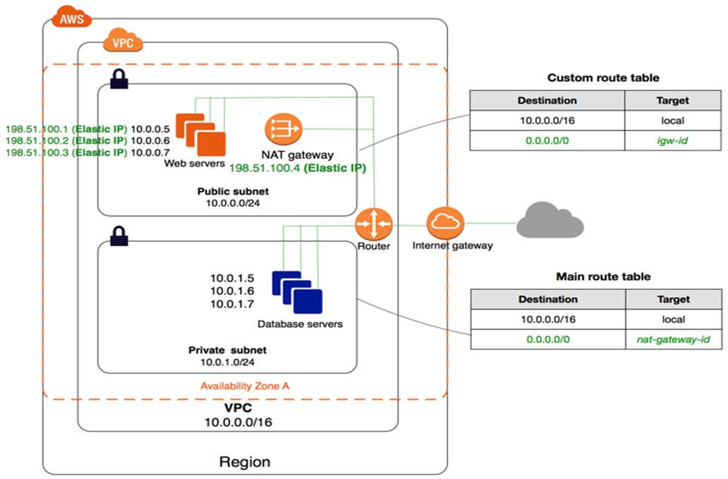
Figure 1: Virtual private cloud
we restrict to access Important data in private subnets through VPC.
Step 1: - Create VPC and enable the DNS hostname.
- By clicking on VPC ->edit VPC-> Enable the DNS Hostname.
- VPC Name (R Jio-VPC) & IP ad->10.1.0.0/16
Step: -2 Create the subnets
- Subnet name (Subnet 01)-> VPC name (R Jio-VPC)->region-(US-east-1a)->Ip-address (10.1.1.0/24)
- Edit Subnet settings by right-clicking on Subnet-> Enable auto-assign public IPv4 address.
- Subnet name (Subnet 02)-> VPC name (R Jio-VPC)->region-(US-east-1b)->
IP address (10.1.2.0/24)
- Edit Subnet settings by right-clicking on Subnet then Enable auto-assign public IPv4 address.
- Subnet name (Subnet 03)-> VPC name (R Jio-VPC)->region(US-east-1c)->IP.ad(10.1.3.0/24)
- Edit Subnet settings by right-clicking on Subnet-> Enable auto-assign public IPv4 address.
Step 3: -Create the Internet Gateway (IGW)
Attach to the VPC by right-clicking (IGW)-Attach to VPC & Select the VPC Name you want to attach.
Step 4: -Create the Router table.
- Then Subnet Association->edit subnet association->Select the whole subnet which you want to add to the route
- Edit route ->0.0.0.0/0->Internet gateway->save changes.
Step 5: -Create a Security Group
- Give the name of the security group.
- Inbound ->Add rule->Type->All traffic, Source (Anywhere)->0.0.0.0/0->create.
Step 6: -Create a Key Pair which is used for EC2.
All Services->EC2->Key pairs->File name->File format (PPK file for Windows) (PEM file for Linux & Mac).
Step 7: -Deployment
- Create instance ->launch Instance->Name->Amazon Linux 2023 AMI->Instance type ->Tier 2 micro ->Keypair->PPK file, Network ->VPC & Subnet & select existing security group->Launch instance.
3. Security groups: - A Security Group is a crucial component of network security in Amazon Web Services (AWS) that functions as a virtual firewall to regulate inbound and outgoing traffic to and from AWS services. Security Groups relate to AWS resources such as Amazon EC2 instances and aid in the management and protection of your cloud infrastructure.
Key features and functions of security groups: -
Stateful Firewall: - Security Groups are stateful, which implies that if you let traffic enter your network from a certain IP address or range, then the same traffic leaving your network is also permitted, and vice versa.
Inbound Rules: You can configure the inbound rules to designate which IP addresses or IP address ranges are permitted to access your AWS resources. Inbound rules can be based on IP protocols (e.g., TCP, UDP), port numbers, and IP addresses.
We can customize the inbound rule to allow the server or subnet by mentioning the source- shh ->type-custom->subnet IP address- or the individual’s or security group's name.
Outbound Rules: These rules specify the locations to which Amazon resources can establish connections. All outgoing traffic is permitted by default; however, you can limit it if necessary [10].
4. Network Access Control List (NACL): - It is a security feature that regulates incoming and outgoing traffic at the subnet level by functioning as a stateless firewall. Subnet-related NACLs let you create rules that specifically allow or prohibit communication based on IP addresses, IP address ranges, and protocols. It is created by default at the time of creating VPC.
Key features and functions of NACL: -
Stateless: NACLs are stateless, as opposed to Security Groups, which are stateful. This means that distinct rules must be set for inbound and outgoing traffic. If you accept incoming traffic, you must also expressly allow outbound traffic.
Subnet Isolation: NACLs may be used to isolate various subnets inside a VPC, ensuring that communication between subnets complies with your network security regulations.
4. Data Encryption technology in AWS: - Amazon Web Services (AWS) data encryption is a critical component of protecting the security and privacy of your data in the cloud. AWS provides a variety of encryption technologies to safeguard data at rest, in transit, and during processing.
Server-side encryption for data at rest: -
Amazon S3 Encryption: SSE-S3, SSE-KMS, and SSE-C are server-side encryption solutions provided by Amazon Simple Storage Service (S3).
AWS maintains the encryption keys for SSE-S3.
SSE-KMS: The AWS Key Management Service (KMS) is used to manage encryption keys, providing greater control over key management.
SSE-C: For S3 object encryption, you provide your encryption keys.
Amazon RDS Encryption: Amazon Relational Database Service (RDS) provides encryption for database instances at rest using either AWS Key Management Service (KMS) or Transparent Data Encryption (TDE) for Oracle and SQL Server [3] [11].
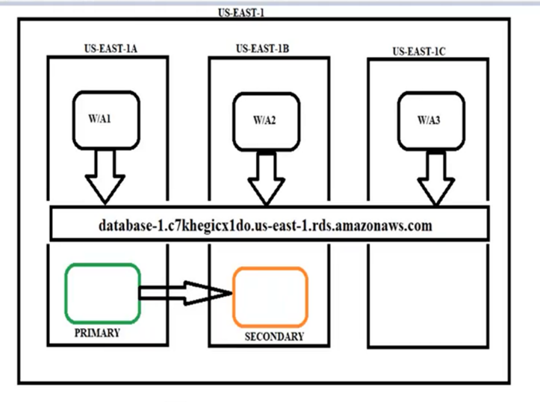
Figure 2: Relational Database Service flow
Amazon EBS Encryption: You may encrypt data on Amazon Elastic Block Store (EBS) volumes using AWS-managed keys or customer-managed keys using AWS Key Management Service (KMS).
Amazon EFS Encryption: By default, Amazon Elastic File System (EFS) provides encryption for data at rest, with keys held by AWS.
Server-Side Encryption for Data in Transit: -
TLS/SSL: AWS services support the Secure Sockets Layer (SSL) and Transport Layer Security (TLS) protocols for encrypting data in transit. TLS/SSL is used, for example, by Amazon API Gateway, Amazon CloudFront, and AWS Elastic Load Balancer (ELB) for secure connections [12].
Client-side Encryption: -Data can be encrypted on the client side before being sent to AWS. This guarantees that data is secure from client to server. Client-side encryption can be aided by tools such as AWS SDKs, AWS Encryption SDK, and AWS Key Management Service (KMS).
Database Encryption: Amazon RDS, Amazon Redshift, and Amazon Aurora provide database-level encryption using AWS KMS to protect customer data while it is stored in these services.
- CONCLUSION
Firstly, AWS offers a comprehensive collection of security tools and capabilities, like as encryption, identity and access management, and network security, which, when configured properly, contribute to a robust defense against unwanted access and data breaches. It is critical to update and monitor these setups regularly to respond to changing security threats.
Second, it is critical to understand shared accountability under the AWS shared security paradigm. While AWS maintains cloud infrastructure security, customers are responsible for safeguarding their data within the cloud. This involves a proactive approach to security best practices implementation, frequent audits, and remaining updated about evolving security risks.
Third, data privacy is an essential component of data security, and compliance with legal frameworks such as GDPR or HIPAA is required. Although AWS provides compliance capabilities and tools, enterprises must actively manage their data to maintain compliance with applicable rules and industry standards.
In Conclusion, a detailed study on data security and privacy preservation in cloud storage systems in this article. To begin with, the excellent performance of cloud computing and cloud storage in the digital economy, business digital transformation, Internet of things, and other disciplines confirms that cloud computing and cloud storage will remain the mainstream.
References:-
[1 ] | N. Leavitt, "Is Cloud Computing Really Ready for Prime Time?," vol. 42, no. 1, pp. 15 - 20, 20 January 2009.
[2] | P. Yang, N. Xiong and J. Ren, "Data Security and Privacy Protection for Cloud Storage," Special Section on Emerging Approaches to Cyber Security, vol. 8, no. 16 July 2020, pp. 131723 - 131740, 28 June 2020.
[3] | L. Qian, Z. Luo, Y. Du and L. Guo, "Cloud Computing: An Overview," 2009. [Online]. Available: https://link.springer.com/chapter/10.1007/978-3-642-10665-1_63.
[4] | J. Keung and F. Kwok, "Cloud Deployment Model Selection Assessment for SMEs: Renting or Buying a Cloud," 2012. [Online]. Available: https://computer.org/csdl/proceedings/ucc/2012/4862/00/4862a021.pdf.
[5] | A. P. Rajan and Shanmugapriyaa, Evolution of Cloud Storage as Cloud Computing Infrastructure Service, 2013.
[6] | A. LARKIN, "Disadvantages of Cloud Computing," no. July-7,2023.
[7] | E. . Bertino and K. . Takahashi, "Identity Management: Concepts, Technologies, and Systems," , 2010. [Online]. Available: https://amazon.com/identity-management-concepts-technologies-information/dp/1608070395.
[8] | https://repost.aws/knowledge-center/restrict-ec2-iam, Can I restrict the access of IAM Identity to specific Amazon EC2 resources?, Amazon Web Services.
[9] | "Internet Gateways - Amazon Virtual Private Cloud," , . [Online]. Available: http://docs.aws.amazon.com/AmazonVPC/latest/UserGuide/VPC_Internet_Gateway.html.
[10] | "Amazon Virtual Private Cloud (VPC)," , . [Online]. Available: http://aws.amazon.com/vpc/.
[11] | "AWS Free Tier," , . [Online]. Available: https://aws.amazon.com/free/.
[12] | "AWS Management Console," , . [Online]. Available: https://aws.amazon.com/console/. Data protection in Amazon EC2 - Amazon Elastic Compute Cloud

