docker pull bde2020/hadoop-datanode:latest

docker pull bde2020/hadoop-historyserver

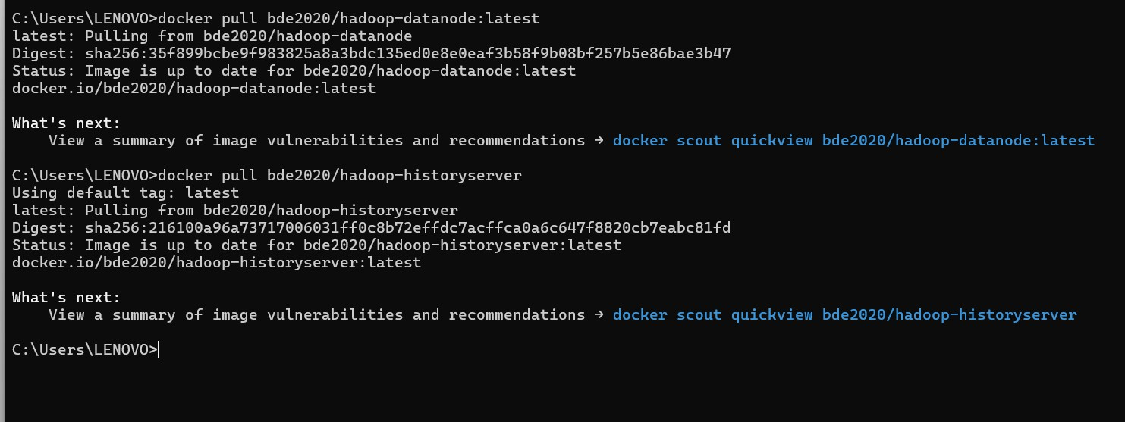

docker volume create namenode

docker volume create datanode

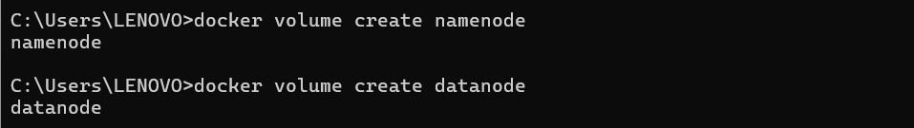

docker-compose up -d

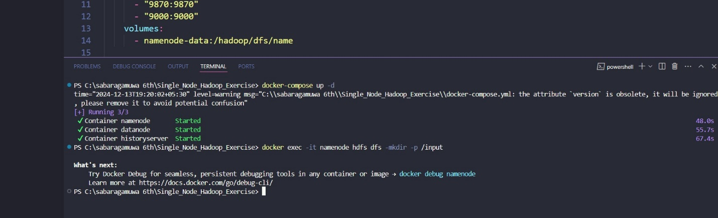

opening http://localhost:9870

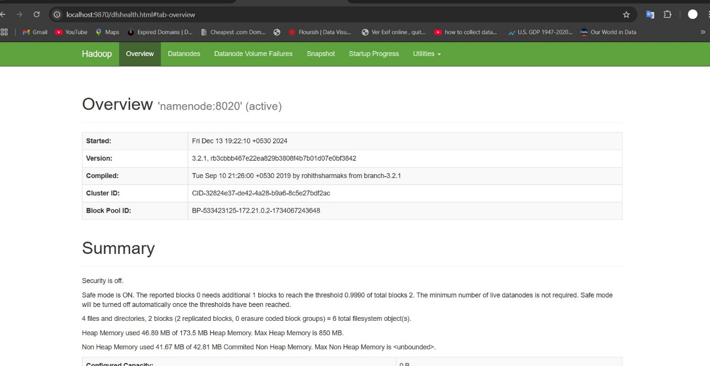

docker exec -it namenode hdfs dfs -mkdir -p /input

docker cp "F:\SE\VI Semester\SE6103 Parallel and Distributed Systems\repo\sample.txt" namenode:/sample.txt

docker exec -it namenode hdfs dfs -put /sample.txt /input



Download the .jar file

<https://repo1.maven.org/maven2/org/apache/hadoop/hadoop-mapreduce-examples/2.7.1/>

docker cp C:\Users\user\Downloads\hadoop-mapreduce-examples-2.7.1.jar namenode:/root/

docker exec -it namenode hadoop jar /root/hadoop-mapreduce-examples-2.7.1.jar wordcount /input /output

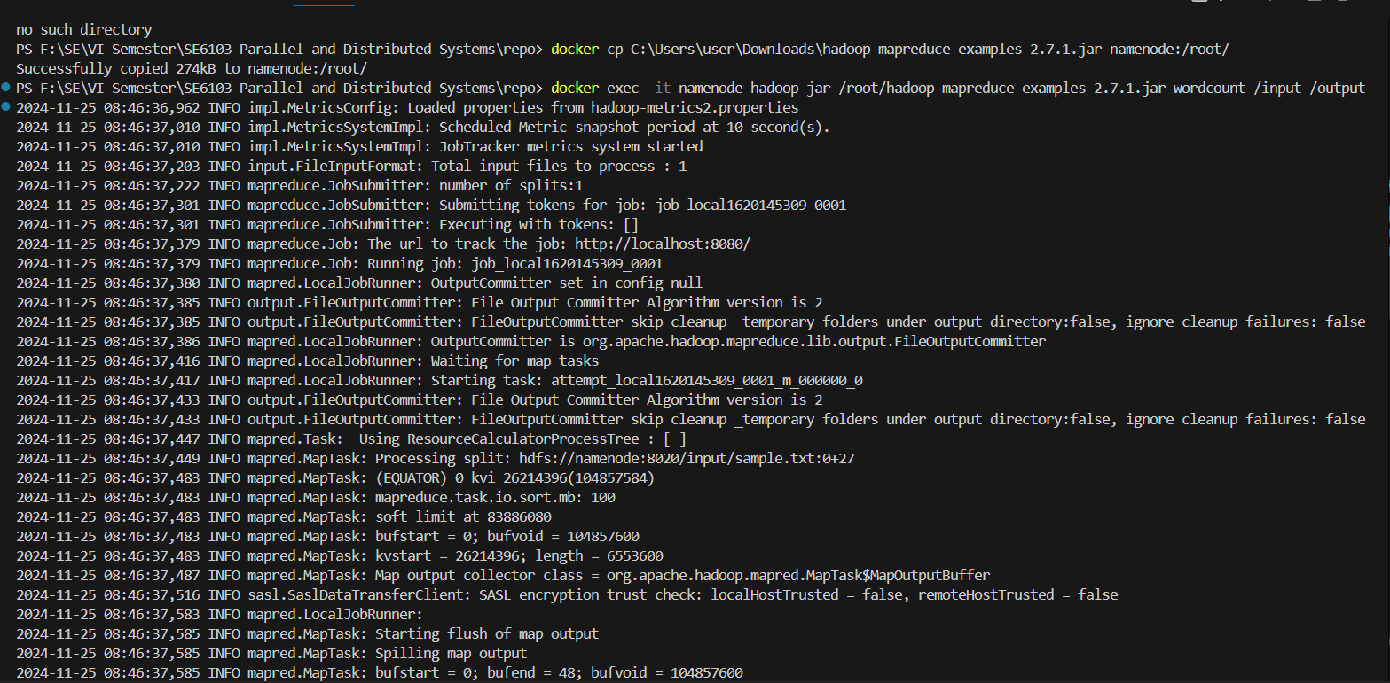

http://localhost:8088 run you should add the

docker-compose.yaml update



Then we can run 8088 port

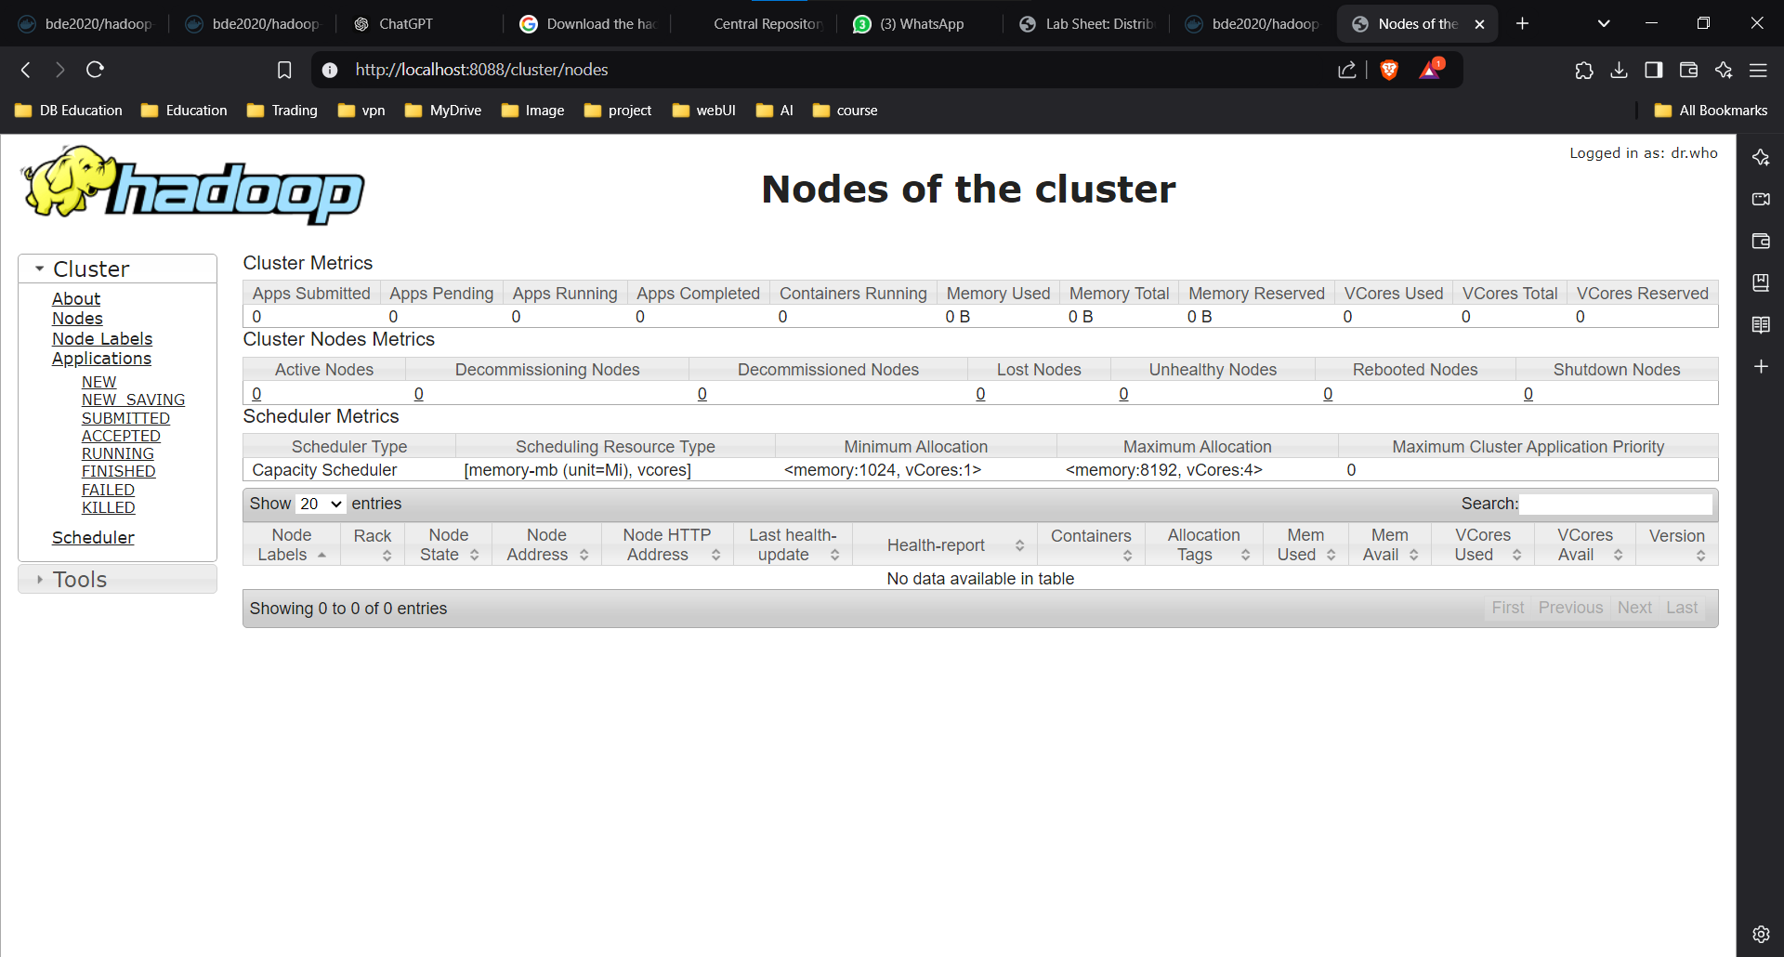

docker exec -it namenode hdfs dfs -ls /output



docker exec -it namenode hdfs dfs -ls /output

docker exec -it namenode hdfs dfs -cat /output/part-r-00000

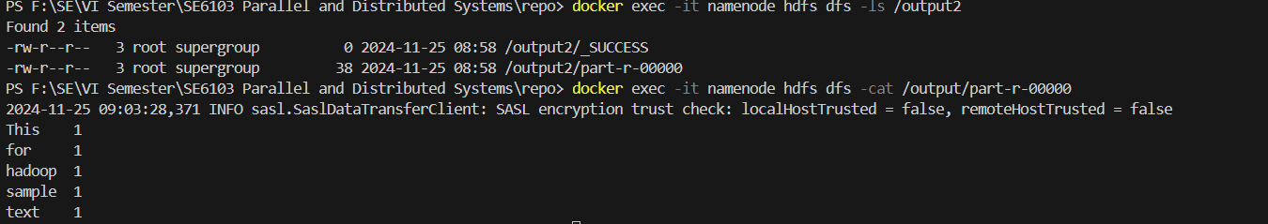

docker-compose down