**CIC Testing:**

Check #1. Extra text marked in red box.

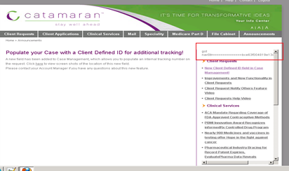

Check #2. Design of sxc ecperience page ( image and left alignment).

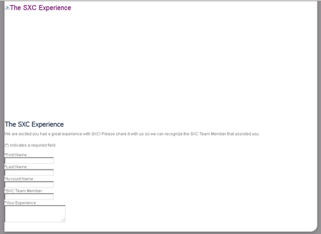

Check #3. Account Team in not coming on home page.



Check #4 JavaScript error on page.

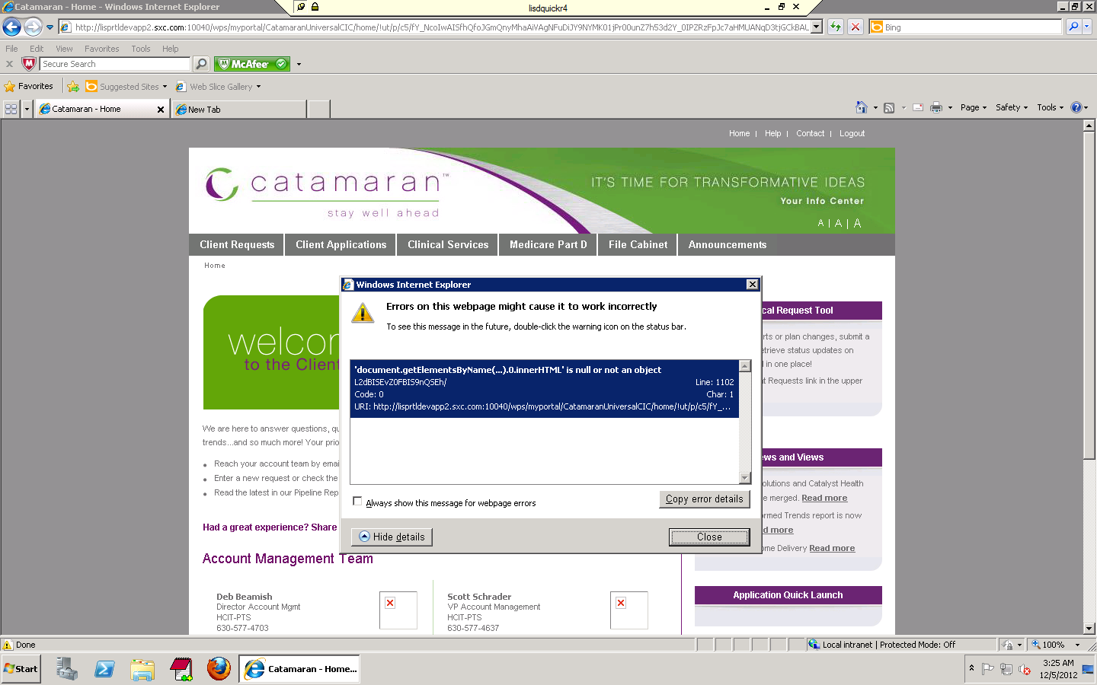

Check #5 most of the read more is not woring on announcement link of home page

Read more link in not woring

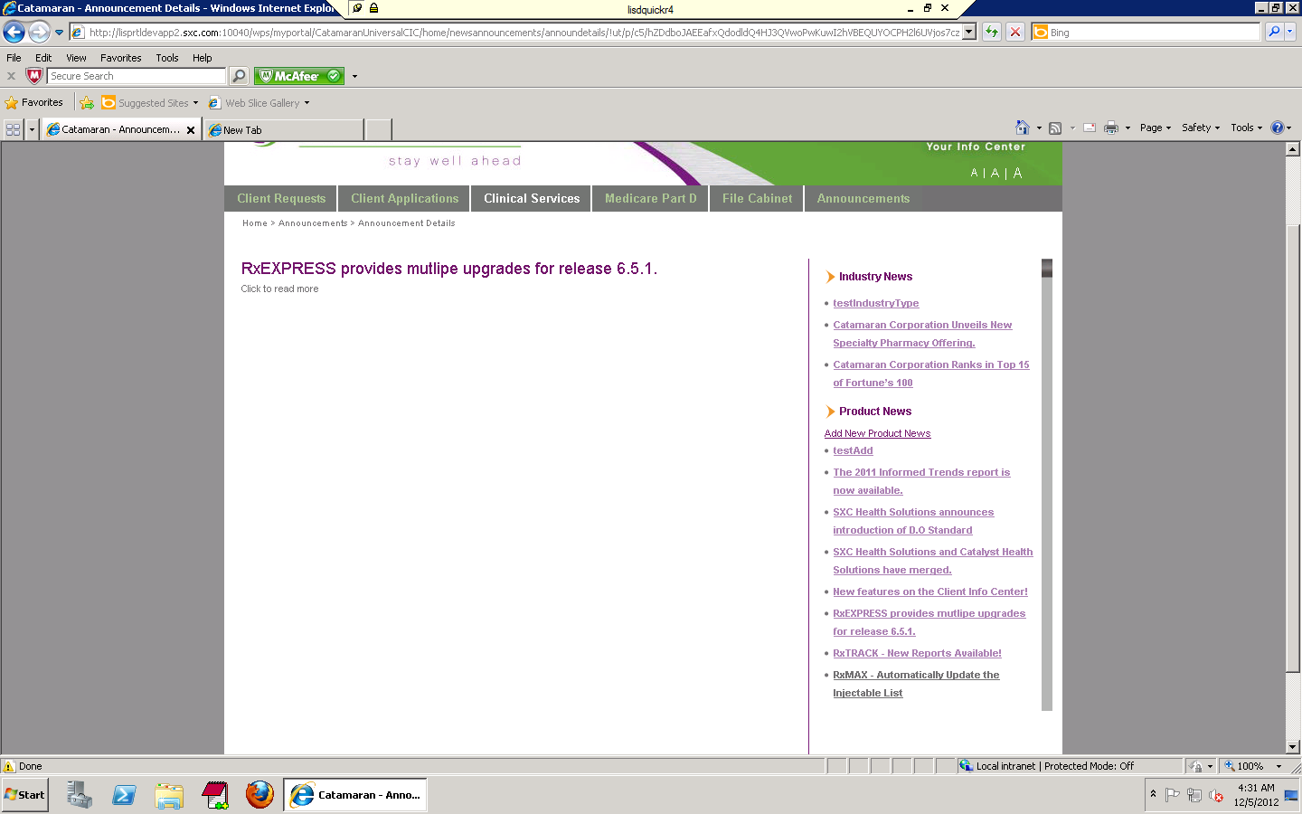

Top of Form 1

Bottom of Form 1

**RxTRACK - New Reports Available!**

Click here to read the full article.

(Same page is getting open)

Check # 8

In Announcement section most of the link’s read more section is not working if working then it is opening the same page.

Check #9

[Home](/wps/myportal/!ut/p/c5/hY_djoIwEEafhQcwnUoVuGz50VarUhCBG6OuIiqixqzI069s9mZN1Jm7OTnzzaAUPfq4-M6zxTUvj4sDilHandsYgDFMwZz0XOCCyajHhQJMHjx5zQf4gz1DydBGAqXZoVw2adJ-zNJ_1piYJnA1HvGerXRit5_409buB-7De97c3HB4UfTPV0Y0_fV77tAGTgXjViBg3Dfe78c6GvXLYo0SlBovvmREBxSiGMg82N1PvN7Xage3StZ2NXJWN-kWlXStcRiqQeh4g2BfVteaTSRk7eAiAa8sHHm-S73WBHcS7X2W0pssZ3U2nITeHBrTWZTRDdlV5n3nV36hBsIpZ8JabeIwaC0XBrS84rhdky_OdOyF4kLJRu8HLqT32gzO21RJkUcskpbtLOd7VvnSGGWahk7F9LuweM7zyfbSKbUfvveRvw!!/dl3/d3/L2dJQSEvUUt3QS9ZQnZ3LzZfQzEwMEJCMUEwOFBHRTBJ) | [Help](/wps/myportal/!ut/p/c5/hY_djoIwEEafhQcwnUoVuGz50VarUhCBG6OuIiqixqzI069s9mZN1Jm7OTnzzaAUPfq4-M6zxTUvj4sDilHandsYgDFMwZz0XOCCyajHhQJMHjx5zQf4gz1DydBGAqXZoVw2adJ-zNJ_1piYJnA1HvGerXRit5_409buB-7De97c3HB4UfTPV0Y0_fV77tAGTgXjViBg3Dfe78c6GvXLYo0SlBovvmREBxSiGMg82N1PvN7Xage3StZ2NXJWN-kWlXStcRiqQeh4g2BfVteaTSRk7eAiAa8sHHm-S73WBHcS7X2W0pssZ3U2nITeHBrTWZTRDdlV5n3nV36hBsIpZ8JabeIwaC0XBrS84rhdky_OdOyF4kLJRu8HLqT32gzO21RJkUcskpbtLOd7VvnSGGWahk7F9LuweM7zyfbSKbUfvveRvw!!/dl3/d3/L2dJQSEvUUt3QS9ZQnZ3LzZfQzEwMEJCMUEwTzQ4ODBJ) | [Contact](/wps/myportal/!ut/p/c5/hY_djoIwEEafhQcwnUoVuGz50VarUhCBG6OuIiqixqzI069s9mZN1Jm7OTnzzaAUPfq4-M6zxTUvj4sDilHandsYgDFMwZz0XOCCyajHhQJMHjx5zQf4gz1DydBGAqXZoVw2adJ-zNJ_1piYJnA1HvGerXRit5_409buB-7De97c3HB4UfTPV0Y0_fV77tAGTgXjViBg3Dfe78c6GvXLYo0SlBovvmREBxSiGMg82N1PvN7Xage3StZ2NXJWN-kWlXStcRiqQeh4g2BfVteaTSRk7eAiAa8sHHm-S73WBHcS7X2W0pssZ3U2nITeHBrTWZTRDdlV5n3nV36hBsIpZ8JabeIwaC0XBrS84rhdky_OdOyF4kLJRu8HLqT32gzO21RJkUcskpbtLOd7VvnSGGWahk7F9LuweM7zyfbSKbUfvveRvw!!/dl3/d3/L2dJQSEvUUt3QS9ZQnZ3LzZfQzEwMEJCMUEwTzQ4ODBJ) | [Logout](/wps/myportal/!ut/p/c5/hY_djoIwEEafhQcwnUoVuGz50VarUhCBG6OuIiqixqzI069s9mZN1Jm7OTnzzaAUPfq4-M6zxTUvj4sDilHandsYgDFMwZz0XOCCyajHhQJMHjx5zQf4gz1DydBGAqXZoVw2adJ-zNJ_1piYJnA1HvGerXRit5_409buB-7De97c3HB4UfTPV0Y0_fV77tAGTgXjViBg3Dfe78c6GvXLYo0SlBovvmREBxSiGMg82N1PvN7Xage3StZ2NXJWN-kWlXStcRiqQeh4g2BfVteaTSRk7eAiAa8sHHm-S73WBHcS7X2W0pssZ3U2nITeHBrTWZTRDdlV5n3nV36hBsIpZ8JabeIwaC0XBrS84rhdky_OdOyF4kLJRu8HLqT32gzO21RJkUcskpbtLOd7VvnSGGWahk7F9LuweM7zyfbSKbUfvveRvw!!/dl3/d3/L3dDb1ZJQSEhL3dPb0JKTnNBLzREMGo5ZWtBU0VFIS9r)

[HIPAA](/wps/myportal/!ut/p/c5/hY_djoIwEEafhQcwnUoVuGz50VarUhCBG6OuIiqixqzI069s9mZN1Jm7OTnzzaAUPfq4-M6zxTUvj4sDilHandsYgDFMwZz0XOCCyajHhQJMHjx5zQf4gz1DydBGAqXZoVw2adJ-zNJ_1piYJnA1HvGerXRit5_409buB-7De97c3HB4UfTPV0Y0_fV77tAGTgXjViBg3Dfe78c6GvXLYo0SlBovvmREBxSiGMg82N1PvN7Xage3StZ2NXJWN-kWlXStcRiqQeh4g2BfVteaTSRk7eAiAa8sHHm-S73WBHcS7X2W0pssZ3U2nITeHBrTWZTRDdlV5n3nV36hBsIpZ8JabeIwaC0XBrS84rhdky_OdOyF4kLJRu8HLqT32gzO21RJkUcskpbtLOd7VvnSGGWahk7F9LuweM7zyfbSKbUfvveRvw!!/dl3/d3/L2dJQSEvUUt3QS9ZQnZ3LzZfQzEwMEJCMUEwTzQ4ODBJ) | [Legal Terms](/wps/myportal/!ut/p/c5/hY_djoIwEEafhQcwnUoVuGz50VarUhCBG6OuIiqixqzI069s9mZN1Jm7OTnzzaAUPfq4-M6zxTUvj4sDilHandsYgDFMwZz0XOCCyajHhQJMHjx5zQf4gz1DydBGAqXZoVw2adJ-zNJ_1piYJnA1HvGerXRit5_409buB-7De97c3HB4UfTPV0Y0_fV77tAGTgXjViBg3Dfe78c6GvXLYo0SlBovvmREBxSiGMg82N1PvN7Xage3StZ2NXJWN-kWlXStcRiqQeh4g2BfVteaTSRk7eAiAa8sHHm-S73WBHcS7X2W0pssZ3U2nITeHBrTWZTRDdlV5n3nV36hBsIpZ8JabeIwaC0XBrS84rhdky_OdOyF4kLJRu8HLqT32gzO21RJkUcskpbtLOd7VvnSGGWahk7F9LuweM7zyfbSKbUfvveRvw!!/dl3/d3/L2dJQSEvUUt3QS9ZQnZ3LzZfQzEwMEJCMUEwTzQ4ODBJ)

HIPAA, Legal Terms, Help and contact is not working properly.

Check #10

[Home](/wps/myportal/!ut/p/c5/hY_LcoJAEEW_xQ-wZmCQxxKGhwPyGhCBDUWIIiKilkbk6wOpLBKr1O5dnzp9u0EKhj7kX1WZX6r2kO9BDFI-wwyEisLIUHRUBAnlJUPgbdYX4cCTv9wzNEhMxY4MYlJoMW_sFUgcDEyQlvv2Y0xz8TBL_1kuJ4qD5TrEwBRxmH3gD5n8G-7D13y8eeTwScm_PhWi5Y9vaAsMiWwqRApM6M6F1_sZBJx526xBAlLhyZcKhyAIQQy5LNjdj6Sve7qDt87uceeoxc3Wms7WJDcMqRWquhXUbXfpFc-GJRucbcgUEhPpvibrU4-ZJZPXWRSNWWpxEtREvqlyLK-iUt6wi8Xm5PrqttPbGlcJYu5SZByySyLxZrXqU5TSOj9yQa9FqdZd4xDnBYrWyrp1qEZa63wNltKUvWWforXRwbFZfjUSqUjlbc-zdvINtZ84wA!!/dl3/d3/L2dJQSEvUUt3QS9ZQnZ3LzZfQzEwMEJC) > [Medicare Part D](/wps/myportal/!ut/p/c5/hY_LcoJAEEW_xQ-wZmCQxxKGhwPyGhCBDUWIIiKilkbk6wOpLBKr1O5dnzp9u0EKhj7kX1WZX6r2kO9BDFI-wwyEisLIUHRUBAnlJUPgbdYX4cCTv9wzNEhMxY4MYlJoMW_sFUgcDEyQlvv2Y0xz8TBL_1kuJ4qD5TrEwBRxmH3gD5n8G-7D13y8eeTwScm_PhWi5Y9vaAsMiWwqRApM6M6F1_sZBJx526xBAlLhyZcKhyAIQQy5LNjdj6Sve7qDt87uceeoxc3Wms7WJDcMqRWquhXUbXfpFc-GJRucbcgUEhPpvibrU4-ZJZPXWRSNWWpxEtREvqlyLK-iUt6wi8Xm5PrqttPbGlcJYu5SZByySyLxZrXqU5TSOj9yQa9FqdZd4xDnBYrWyrp1qEZa63wNltKUvWWforXRwbFZfjUSqUjlbc-zdvINtZ84wA!!/dl3/d3/L2dJQSEvUUt3QS9ZQnZ3LzZfQzEwMEJC)

CMS CORNER link is not working.

Check #11

[Home](/wps/myportal/!ut/p/c5/hY_LcoJAEEW_xQ-wZmCQxxKGhwPyGhCBDUWIIiKilkbk6wOpLBKr1O5dnzp9u0EKhj7kX1WZX6r2kO9BDFI-wwyEisLIUHRUBAnlJUPgbdYX4cCTv9wzNEhMxY4MYlJoMW_sFUgcDEyQlvv2Y0xz8TBL_1kuJ4qD5TrEwBRxmH3gD5n8G-7D13y8eeTwScm_PhWi5Y9vaAsMiWwqRApM6M6F1_sZBJx526xBAlLhyZcKhyAIQQy5LNjdj6Sve7qDt87uceeoxc3Wms7WJDcMqRWquhXUbXfpFc-GJRucbcgUEhPpvibrU4-ZJZPXWRSNWWpxEtREvqlyLK-iUt6wi8Xm5PrqttPbGlcJYu5SZByySyLxZrXqU5TSOj9yQa9FqdZd4xDnBYrWyrp1qEZa63wNltKUvWWforXRwbFZfjUSqUjlbc-zdvINtZ84wA!!/dl3/d3/L2dJQSEvUUt3QS9ZQnZ3LzZfQzEwMEJC) > [Medicare Part D](/wps/myportal/!ut/p/c5/hY_LcoJAEEW_xQ-wZmCQxxKGhwPyGhCBDUWIIiKilkbk6wOpLBKr1O5dnzp9u0EKhj7kX1WZX6r2kO9BDFI-wwyEisLIUHRUBAnlJUPgbdYX4cCTv9wzNEhMxY4MYlJoMW_sFUgcDEyQlvv2Y0xz8TBL_1kuJ4qD5TrEwBRxmH3gD5n8G-7D13y8eeTwScm_PhWi5Y9vaAsMiWwqRApM6M6F1_sZBJx526xBAlLhyZcKhyAIQQy5LNjdj6Sve7qDt87uceeoxc3Wms7WJDcMqRWquhXUbXfpFc-GJRucbcgUEhPpvibrU4-ZJZPXWRSNWWpxEtREvqlyLK-iUt6wi8Xm5PrqttPbGlcJYu5SZByySyLxZrXqU5TSOj9yQa9FqdZd4xDnBYrWyrp1qEZa63wNltKUvWWforXRwbFZfjUSqUjlbc-zdvINtZ84wA!!/dl3/d3/L2dJQSEvUUt3QS9ZQnZ3LzZfQzEwMEJC) :- Announcements.

