Docker Steps:

Click on launch instance

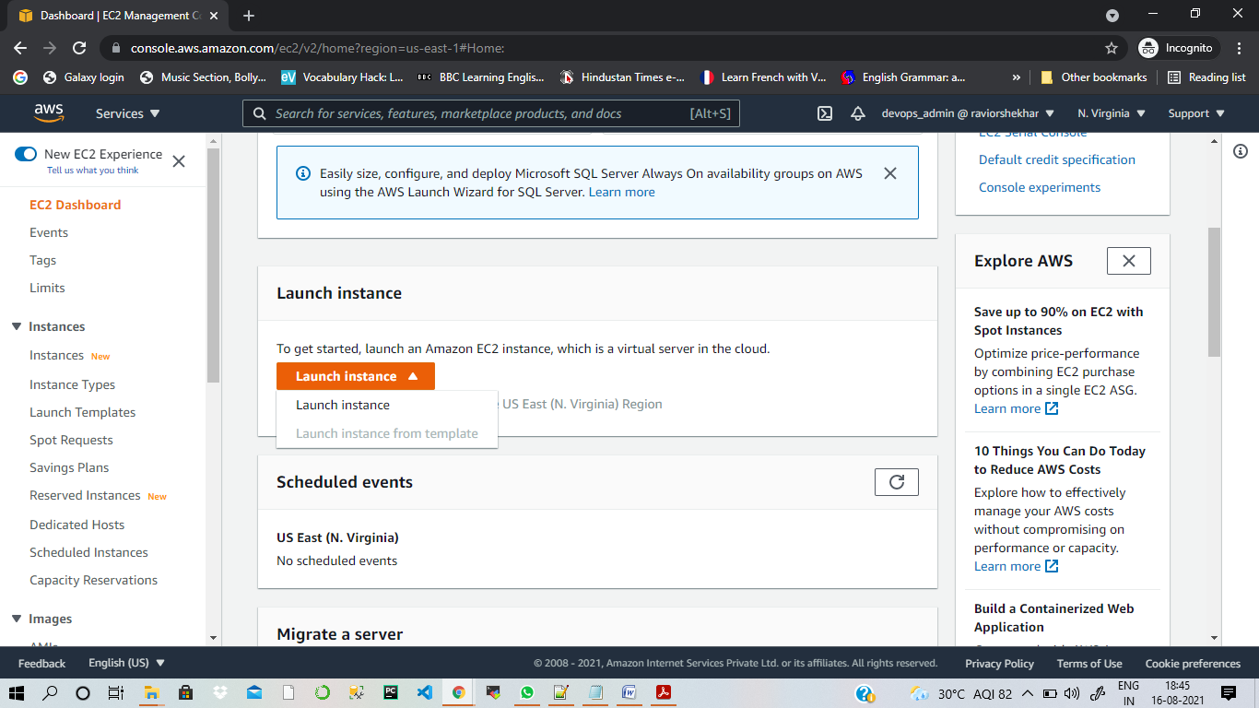

Search for ubuntu and select 1st option:

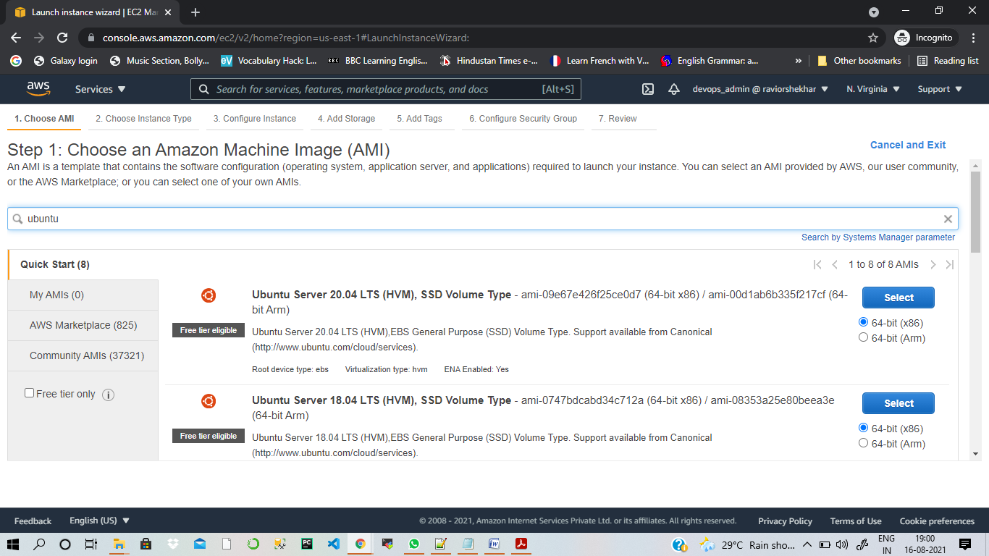

Select t2 micro

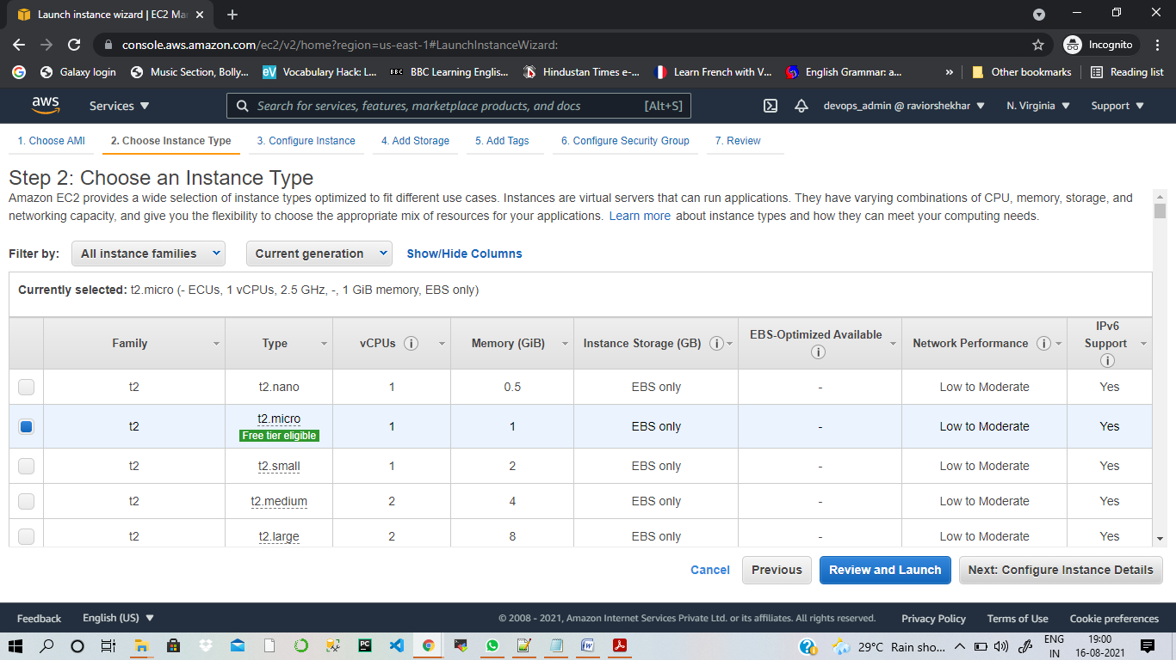

No need to change here , click on Storage:

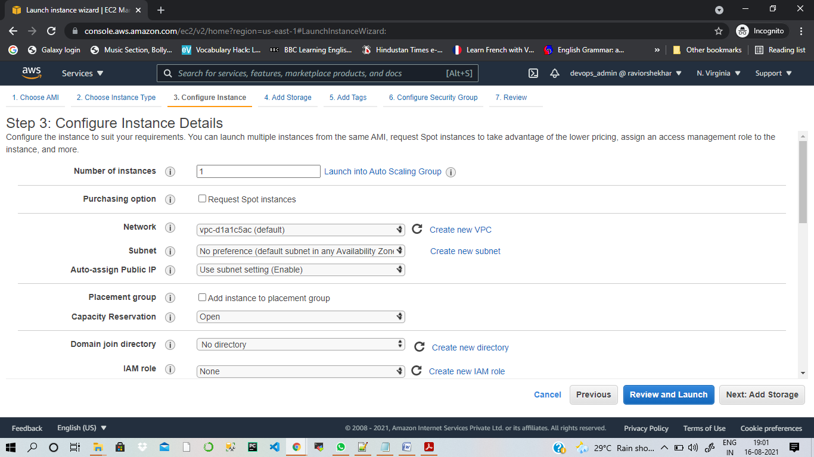

Select storage 20GB and click Add tag

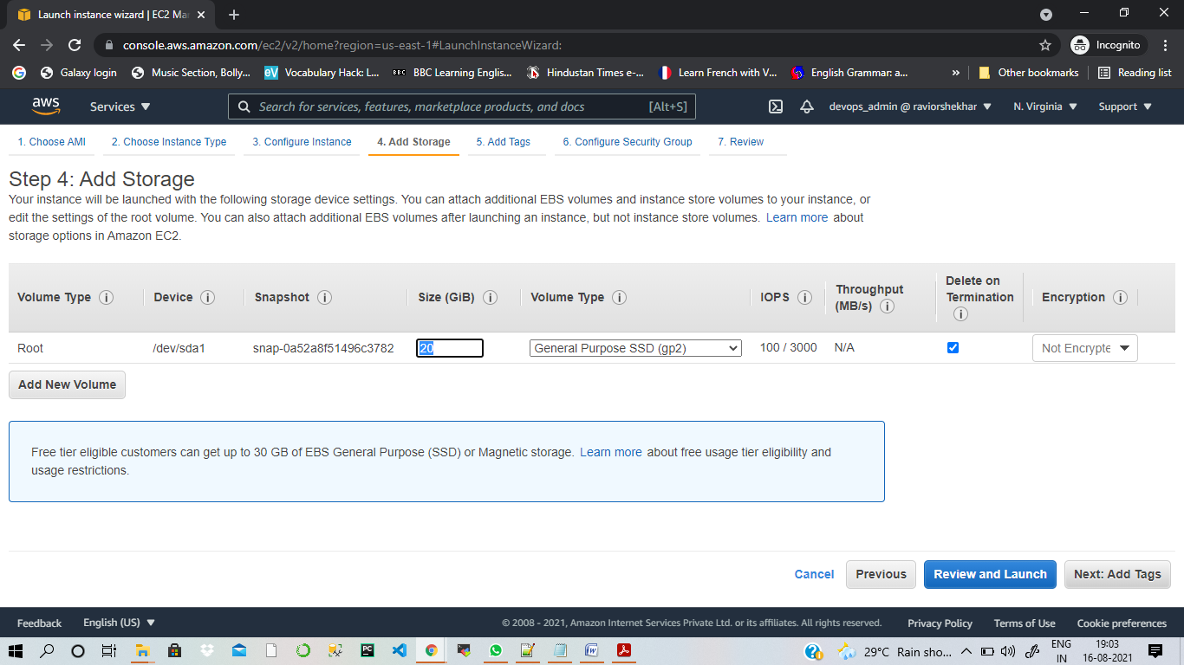

Give the name

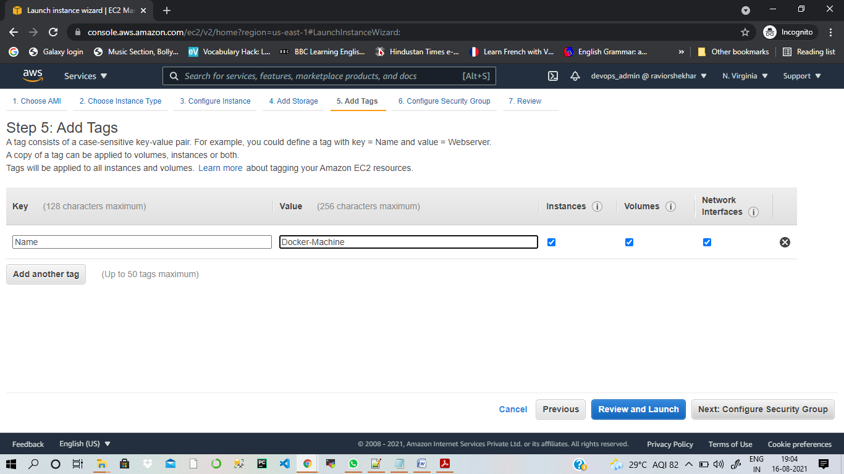

Add HTTP and HTTPS in Security Group

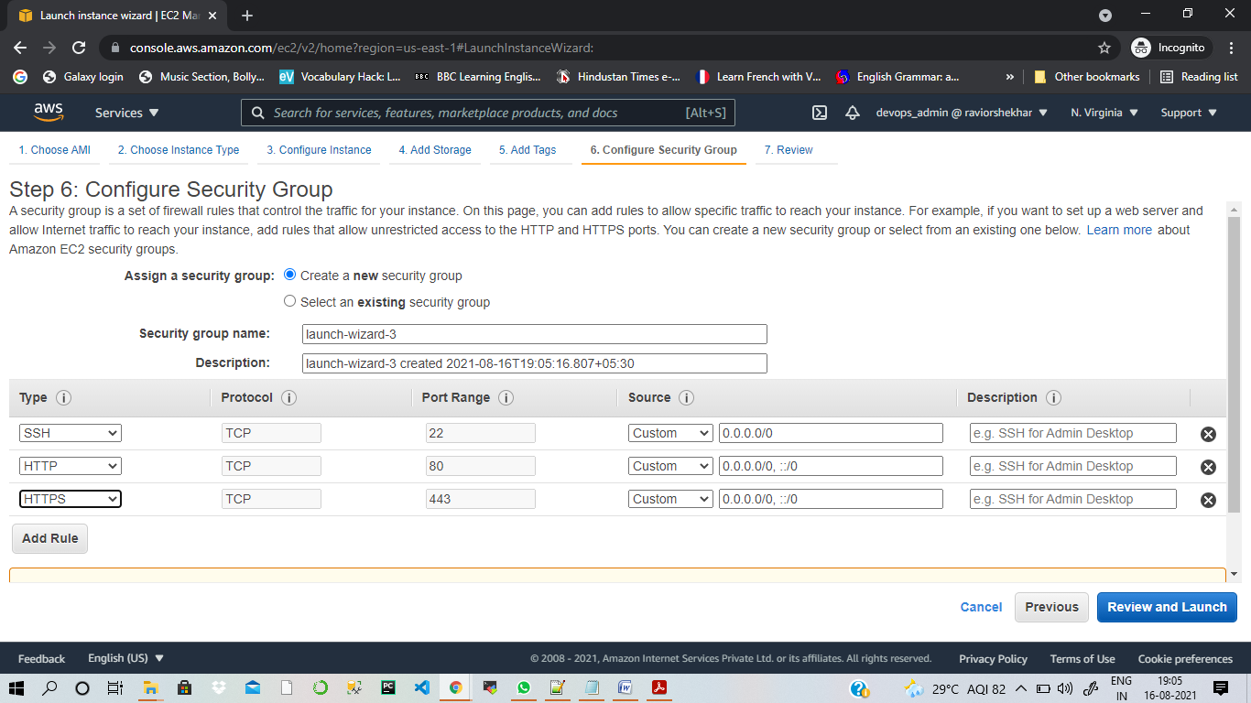

Review launch and Key pair (Create new) and launch the instance:

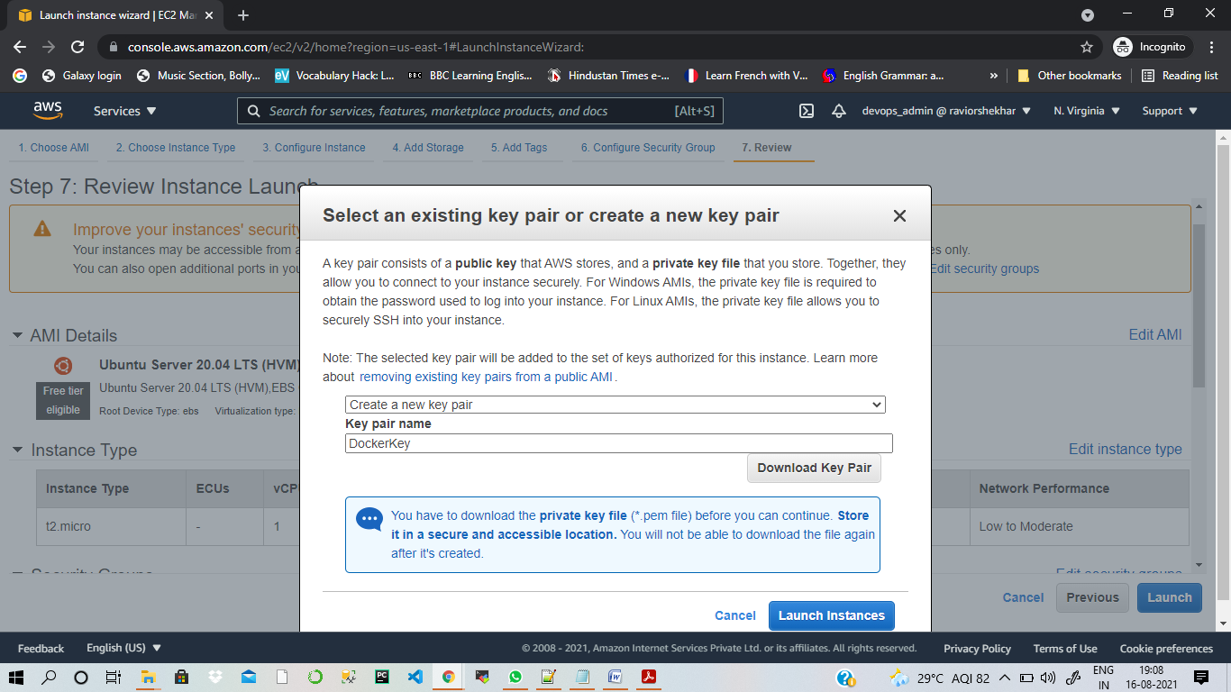

Now login to the instance through MobaXtreme

Run – sudo apt update – to update the terminal

Now install docker – sudo apt install docker.io

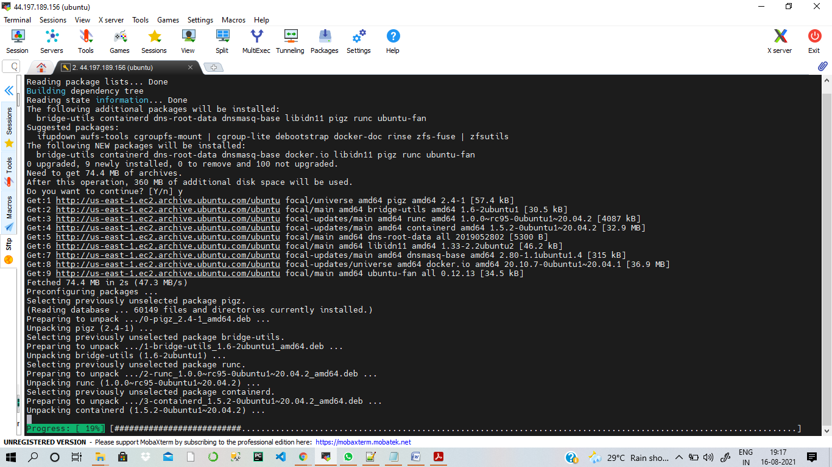

Now docker is installed – Check its version – sudo docker –version

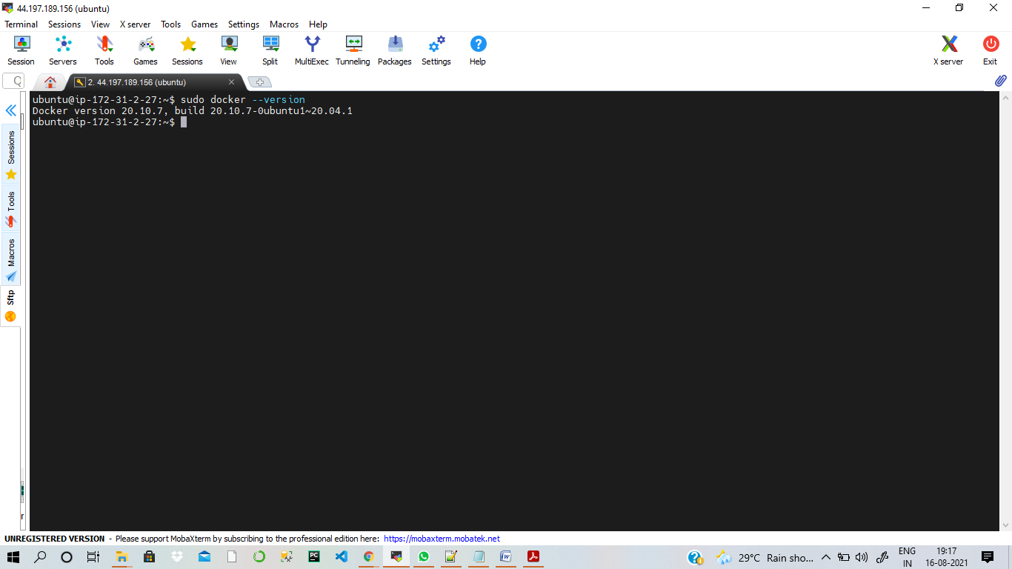

Now run – sudo service docker start – to start the service

Run – sudo systemctl enable docker

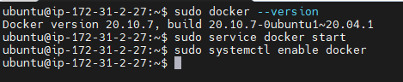

Run – sudo service docker status – to check the status of docker, and we can see that docker is up and running

